Week 2 — Executive Summary
I reconfigured CTGAN for a full-scale retrain to correct Week 1's undertrained baseline. The 1,500-row generation cap and 50-epoch budget were removed entirely: each minority family — Ransomware, Trojan, and Spyware — was now trained for a full 320 epochs on its complete real row count, with generator and discriminator loss logged every few epochs and model checkpoints saved periodically throughout so a Kaggle session timeout would not cost the run. The stratified train/test split was rebuilt so that the held-out test set stayed 100% real and completely untouched by any synthetic data at every stage, giving a stricter evaluation protocol than Week 1's.
Ransomware went from 7,833 real rows to 15,605 generated synthetic rows, Trojan from 7,589 real to 15,849 synthetic, and Spyware from 8,016 real to 15,422 synthetic, with every family balanced up to the same 23,438-row Benign training count and no cap applied this time. Before trusting any of this synthetic data, I read the generator/discriminator loss curves for all three families to check for mode collapse: across the full 320-epoch run the losses oscillated and settled into a stable band rather than diverging, which is the signal that the retrain didn't collapse the way a badly undertrained run typically does.
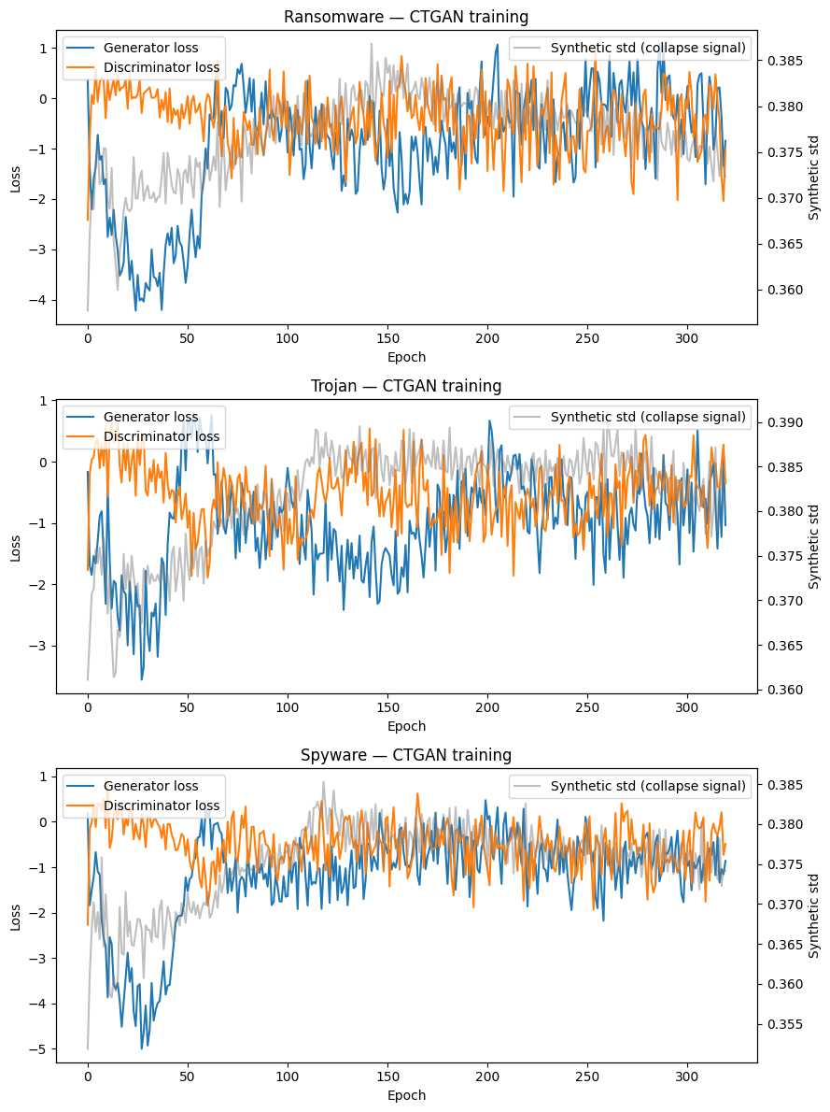
Generator / discriminator loss curves across the full 320-epoch retrain for Ransomware, Trojan, and Spyware.
I then ran a per-feature Kolmogorov–Smirnov test comparing each family's real distribution against its synthetic counterpart, before any classifier ever touched the data. The mean KS statistic came out to 0.147 for Ransomware, 0.147 for Trojan, and 0.148 for Spyware — noticeably lower than Week 1's undertrained CTGAN, which sat around 0.19 at the whole-dataset level, confirming that the longer, uncapped run did measurably close the distributional gap between real and synthetic minority samples. That said, this is still far from SMOTE's fidelity on the same dataset (mean KS statistic of roughly 0.03 in Week 1's evaluation), so classical interpolation continues to reproduce the real feature distributions far more faithfully than CTGAN does even at full scale.
With the retrained, fully balanced training set in hand, I benchmarked Random Forest, XGBoost, and LightGBM and evaluated all three on the real, untouched held-out test set. Random Forest reached 87.25% accuracy with a Macro-F1 of 0.8082, weighted F1 of 0.8724, MCC of 0.8088, and ROC-AUC (macro) of 0.9693. XGBoost came in lower at 84.87% accuracy and a Macro-F1 of 0.7725. LightGBM was the strongest of the three, reaching 87.95% accuracy, Macro-F1 of 0.8183, weighted F1 of 0.8792, MCC of 0.8194, ROC-AUC (macro) of 0.9732, and PR-AUC (macro) of 0.8875. Per-class behaviour matched Week 1's pattern closely: Benign was classified almost perfectly (F1 near 1.00) while Ransomware, Spyware, and Trojan all sat in the 0.71–0.80 F1 range, with Trojan again the hardest family to separate from the rest.
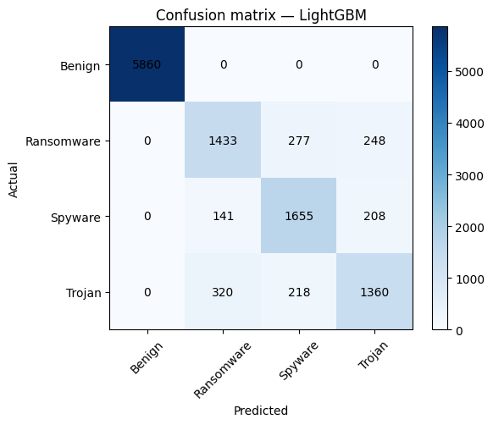
Final classifier comparison — Random Forest, XGBoost, and LightGBM evaluated on the real held-out test set.
Taken as a whole, the full-scale retrain measurably improved CTGAN's raw distributional fidelity to the real data, but that improvement did not translate into a meaningfully stronger downstream classifier — LightGBM's accuracy and Macro-F1 on CTGAN-v2 landed within a fraction of a point of Week 1's capped run, and every CTGAN-v2 model still trails the SMOTE plus Random Forest baseline (Macro-F1 0.932, ROC-AUC 0.990) by a wide margin. This is a useful, fairly conclusive result in its own right for the augmentation comparison: even a properly converged, full-epoch CTGAN run on this feature space does not close the gap with classical interpolation-based oversampling, and the bottleneck now looks like it sits in what CTGAN can represent about this particular tabular feature distribution rather than in how long it is trained.

