Week 3 Executive Summary
Quantum-Classical Malware Family Classification — CTGAN-v2 Augmented Data Track (Version 1)
This week delivered a working version-1 pipeline: the CTGAN-v2 augmented malware-memory dataset was passed through the shared preprocessing stage — variance filtering (11 near-constant features dropped), a 0.95 correlation filter (nothing further removed), standardization, and PCA to the agreed 8-qubit budget (54.65% cumulative variance retained) — and fed directly into the existing QSVM and VQC code.
At a matched n=200 train / 60 test split, QSVM (fidelity kernel, angle-CNOT-angle feature map) reached 63.33% accuracy / 0.625 macro-F1, narrowly beating a classical RBF-SVM control at 60.00% / 0.592. The VQC (8-qubit AngleEmbedding + 1-rep StronglyEntanglingLayers, SPSA-trained, depth cut from 2 reps to curb vanishing gradients) trailed at 43.33% / 0.409 — architecture still a placeholder pending a revised ansatz. Scaled to n=1,000 (QSVM via 50-landmark Nyström approximation, since the exact kernel is intractable at this size), QSVM rose to 69.00% / 0.683, but the classical control scaled further to 71.00% / 0.712, overtaking it. VQC barely moved — 43.00% / 0.360 — despite 400 SPSA steps and a larger batch, and final training loss stayed flat (1.03 → 1.11), so extra data was not the bottleneck.
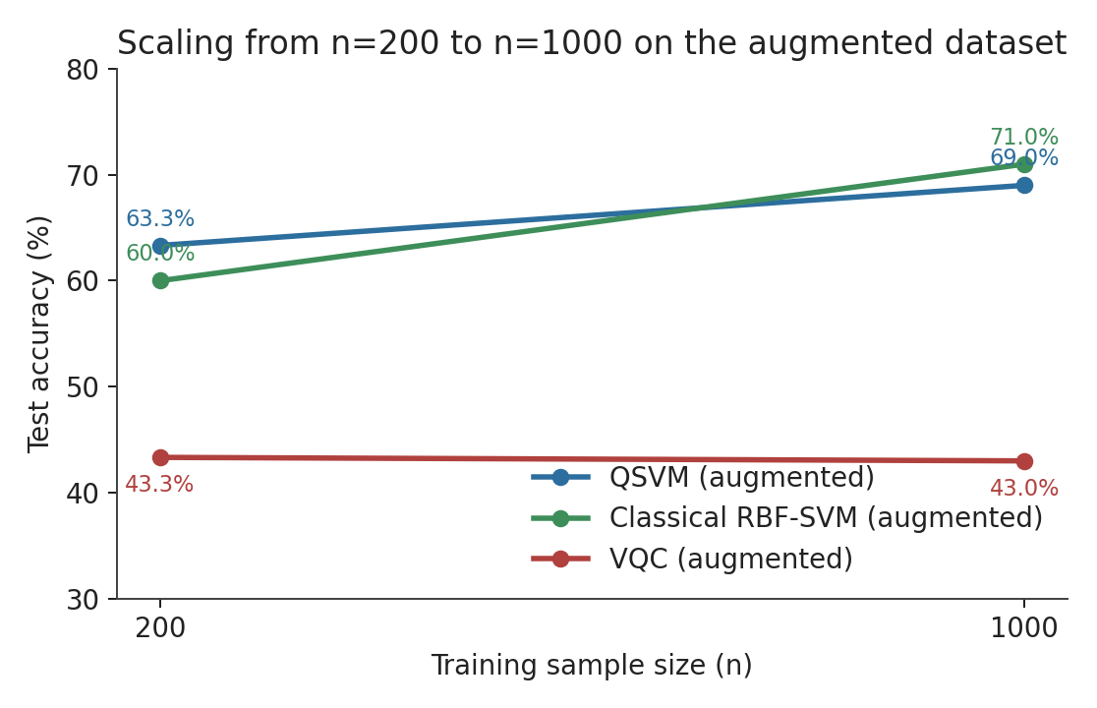
Accuracy vs. training size (n=200→1,000) for QSVM, VQC, and the classical baseline.
A three-way test isolated whether augmentation specifically helps the quantum model. On the original, family-imbalanced data, QSVM accuracy collapsed to 36.67% / 0.284 macro-F1, with the Trojan class entirely unpredicted (0 precision/recall/F1 across all 19 test cases). The classical RBF-SVM degraded more gracefully on the same imbalanced split, to 45.00% / 0.433. Augmentation therefore lifted QSVM by +26.66 points (36.67%→63.33%) versus +15.00 points for the classical model over the same transition — the fidelity kernel is disproportionately hurt by imbalance and disproportionately rescued by balanced synthetic data.
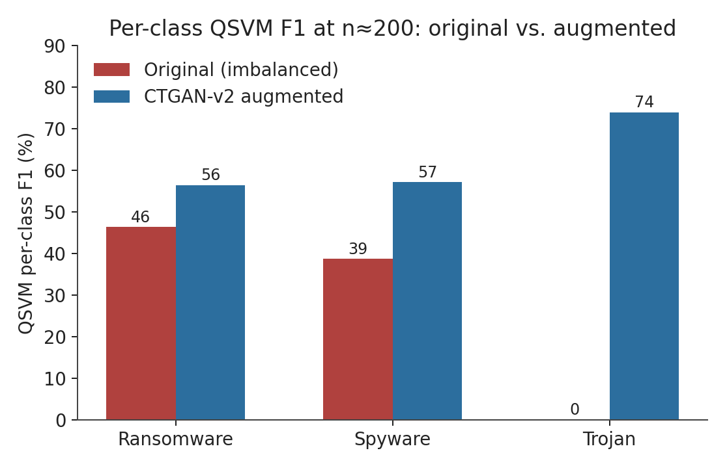
QSVM per-class F1 at n≈200: the Trojan class goes from total collapse to the strongest-performing class once augmented.
On whether the shortfall is quantum capacity or data fidelity: since QSVM and VQC consume the identical augmented input as the classical baseline, and only VQC lags badly (43% vs. 63–71%), this points to a VQC-specific circuit-expressivity / optimization bottleneck, not the augmented data. Separately, the 8-qubit PCA embedding keeps only 54.65% of post-filter variance, capping what any quantum model can see regardless of classifier design — a real information ceiling, distinct from data fidelity. The same augmented samples support strong classical (60–71%) and genuine QSVM gains, so fidelity is not implicated.
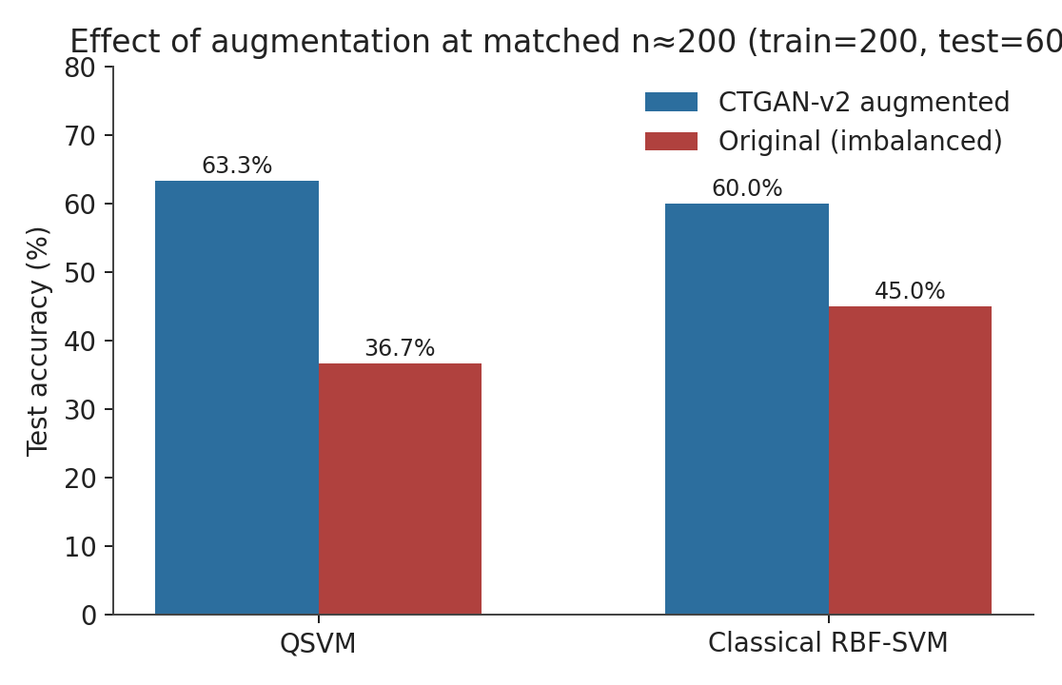
Test accuracy with vs. without augmentation, matched at n=200 train / 60 test.
Version 1 closes with a reproducible end-to-end pipeline, a real but scale-shrinking QSVM edge (+3.3 points at n=200, overtaken by classical at n=1,000), VQC flagged as the weak link needing an ansatz/optimizer revision for version 2, and augmentation confirmed as a genuine quantum-specific gain — most visibly in preventing total Trojan-class collapse.

