QTagger+ Week 5 Summary
Quantum-Augmented Malware Classification — Continuous Pipeline Narrative
Week 5 began with one unfinished thread from Week 3: the QGAN's synthetic malware data had only ever been produced by a broken 30-epoch training run, so every comparison downstream of it was provisional. The first job was to redo that run properly at 100 epochs, and once the corrected data was in hand, the week turned into a single continuous pipeline — the same corrected QGAN output was pushed through every test already built for SMOTE and CTGAN, one after another, so all three synthetic-data methods and the untouched original data could finally be judged on identical ground. Each test fed the next: the downstream-classifier run raised a question that the fidelity metrics answered differently than expected, which in turn was checked against the quantum classifier pipeline, which produced a headline result that then had to be stress-tested and, in the end, partly overturned. In parallel, a full week-long thread went into understanding why the QGAN itself was the weakest of the three generators in the first place, tracing that all the way down to a known failure mode in variational quantum circuits and running seven separate attempts to fix it. What follows is that whole chain, in the order it actually happened.

From a broken baseline to a fair four-way comparison
With the 100-epoch QGAN run corrected, the same four downstream classifiers already used for SMOTE and CTGAN — Random Forest, XGBoost, LightGBM, and SVM — were pointed at it, all scored against one shared, untouched, held-out test split. Before trusting any of the numbers, that fairness was checked directly rather than assumed: every classifier's “original-only” baseline F1 matched to six decimal places across all four runs, which meant whatever spread showed up next could only be coming from the augmentation method itself. Getting to that point required fixing a real problem first — a plain merge of real and synthetic rows broke on this dataset because of duplicate rows, so a hash-based, duplicate-safe split had to be built for SMOTE and CTGAN before any comparison could be trusted. That fix surfaced its own finding: SMOTE keeps every real row untouched and adds synthetic rows on top, while CTGAN's output is 100% synthetic — part of why the two behave so differently once a classifier is trained on them.
The results that came out the other side were not close. SMOTE produced clear, consistent gains everywhere — Random Forest moved from 0.8127 to 0.8988 (+8.6 F1 points), XGBoost from 0.8211 to 0.8681 (+4.7 points), LightGBM from 0.8129 to 0.8419 (+2.9 points). CTGAN went the other way, mildly negative on every classifier tested (XGBoost dropped from 0.8211 to 0.8083). The corrected QGAN numbers came in essentially flat against the original baseline (Random Forest 0.8121, XGBoost 0.8200, SVM 0.6039) — not because training had failed this time, but because the augmentation scheme only ever generates enough synthetic rows to reach 2–5% of the affected classes' training volume, too small a share to move a classifier's F1 in either direction.
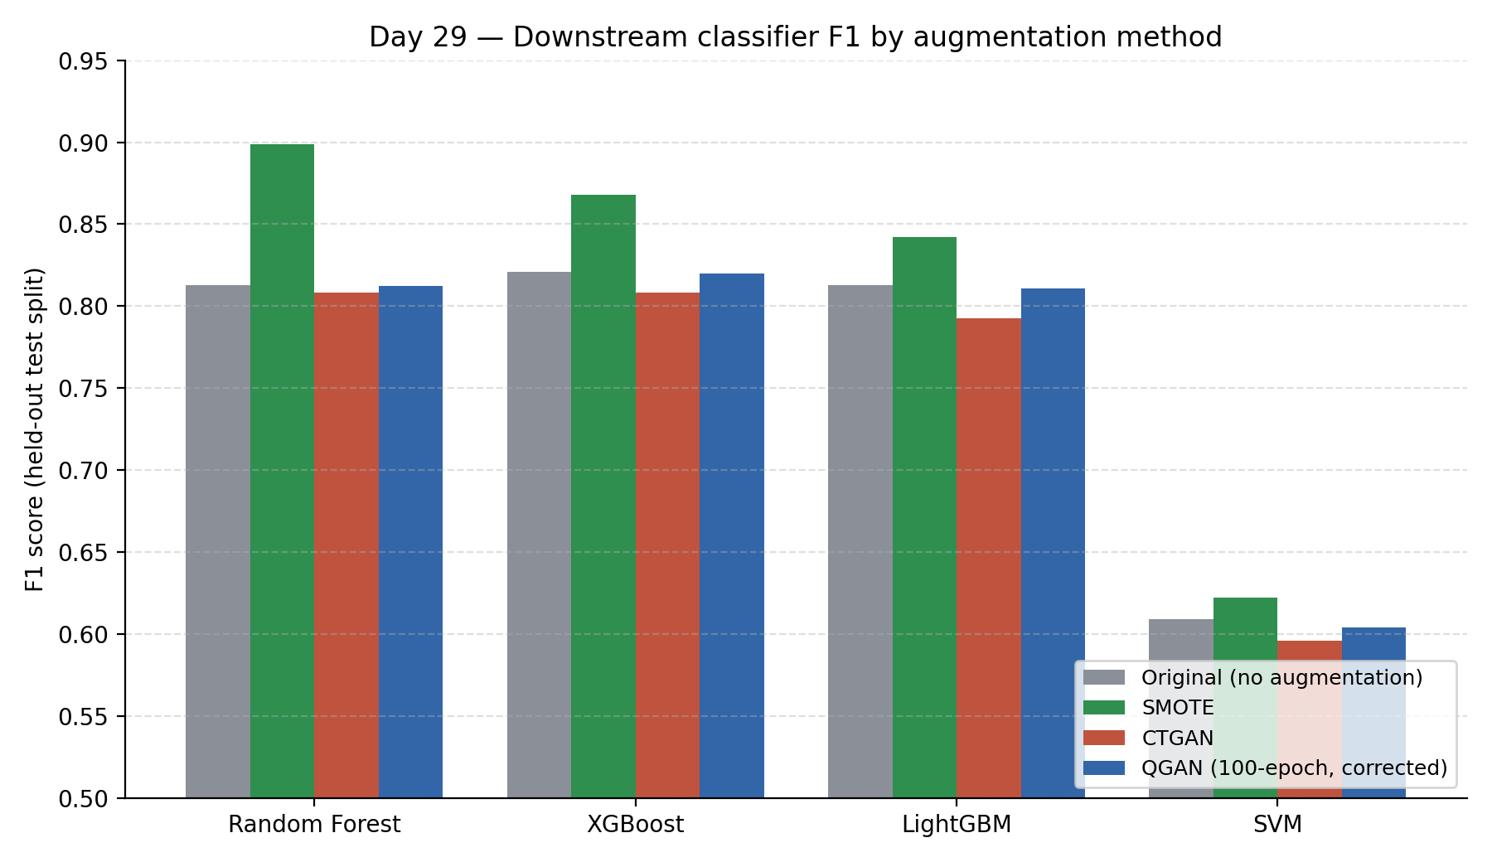
Figure 1. Downstream classifier F1 by augmentation method, all four evaluated on one shared held-out split. SMOTE is the only method with a consistent lift; CTGAN is mildly negative everywhere; the corrected QGAN run is flat by design, not by failure.
That downstream result immediately raised a second question: was QGAN just contributing too little volume to matter, or was its synthetic data actually a poor statistical match for the real distribution regardless of volume? To answer that, the KS statistic, Wasserstein distance, and MMD were computed for all four methods, per malware class, using one identical scoring function so the comparison would again be apples-to-apples. The ranking that came out was completely clean and held on every single class and every single metric: SMOTE beat CTGAN, and CTGAN beat QGAN, by wide margins. On Ransomware, SMOTE's KS_median was 0.012 against CTGAN's 0.091 and QGAN's 0.328 — roughly a 10x gap between SMOTE and CTGAN, then a further 3x gap down to QGAN. Trojan showed the same pattern (0.013 / 0.112 / 0.293); on Spyware, QGAN generated no synthetic rows at all, since the real count already met target, leaving SMOTE (0.010) well ahead of CTGAN (0.133).
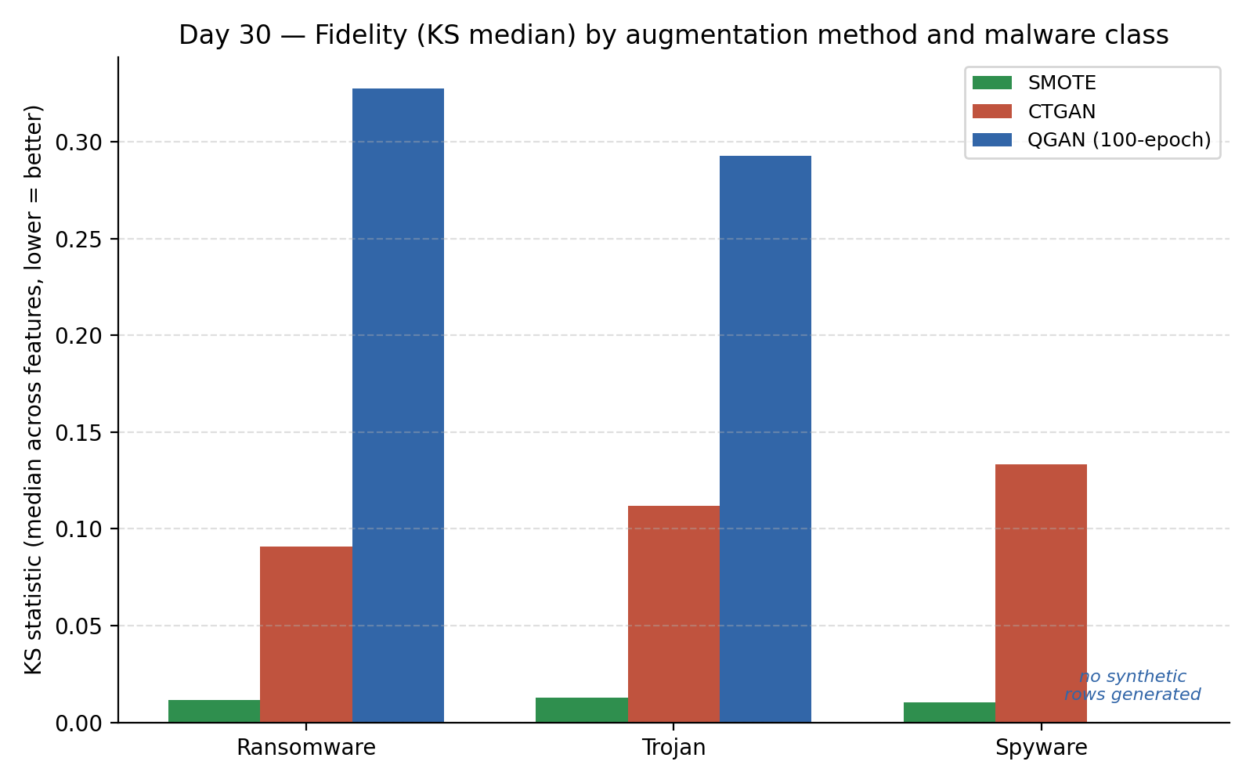
Figure 2. KS-statistic fidelity (median across features, lower is better) by method and class. SMOTE sits roughly an order of magnitude closer to the real distribution than CTGAN, which in turn sits roughly three times closer than QGAN.
Putting the two results side by side produced the finding that shaped how the rest of the week was read: fidelity rank does not predict downstream impact. CTGAN beat QGAN cleanly on every fidelity metric, yet lost to it on downstream classifier impact — CTGAN was mildly negative, QGAN was flat rather than negative. Looking statistically close to real data and actually helping a classifier learn turned out to be two different properties of synthetic data, not one proxy for the other.

Carrying the corrected data into the quantum classifier pipeline
With downstream impact and fidelity both settled, the corrected QGAN data was carried one step further, into the same V3 QSVM/VQC architecture already used for CTGAN and SMOTE — identical code, only the input swapped, to keep the test fair. The first run was caught before it could be trusted: QGAN's as-uploaded data was only about 2–5% synthetic against CTGAN's roughly 33–40%, so QGAN's data was rebuilt at matched scale and re-run. With that corrected, all three QSVM architecture versions were tested at a single seed: V1 scored 0.350 against a classical best of 0.567, V2 scored 0.550 against 0.633, and V3 scored 0.625 against 0.587 — the only version where QGAN's single-seed number beat its classical counterpart.
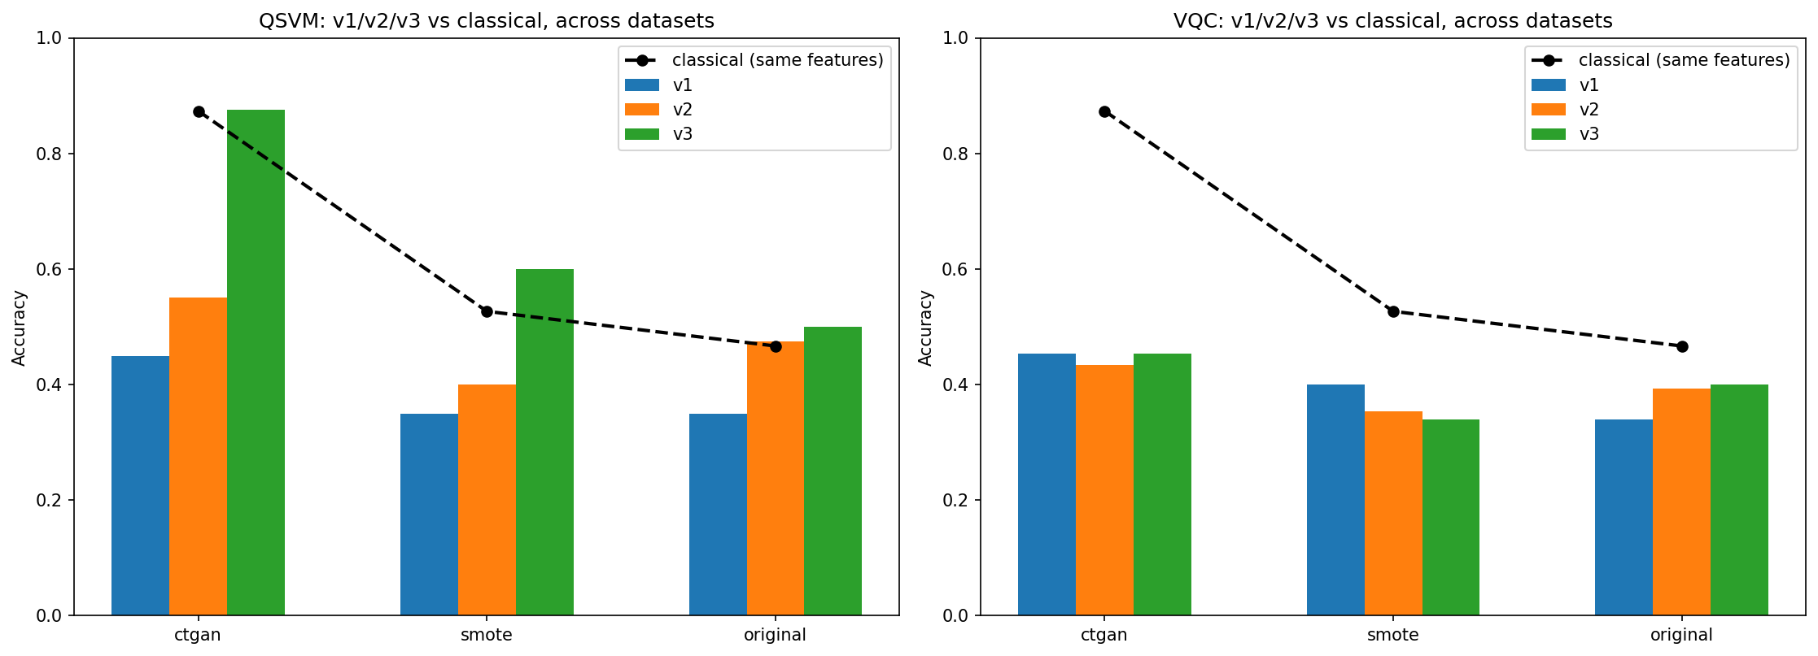
Figure 3. QSVM/VQC pipeline versions 1–3 against their classical baselines (single-seed exploratory comparison, before the multi-seed correction below).
That 0.625 result, and the more striking 0.875 CTGAN result sitting alongside it from earlier in the project, did not survive closer scrutiny — and the way they were checked is worth keeping on its own merits. An uploaded 18-config comprehensive study was independently verified by matching its CTGAN seed = 7 result to this project's own run to four decimal places, and that verified code was then used to expand every dataset from one or two seeds to three-to-five. The expansion overturned the original headline entirely: CTGAN's reported 0.875 collapsed to a mean of 0.708 ± 0.170 with only a 1-in-3 win rate against classical models; SMOTE's 0.600 became 0.444 ± 0.094 (1-in-4); QGAN's 0.625 became 0.540 ± 0.049 (1-in-5). Only the original, unaugmented data held its ground — 0.542 ± 0.031, a 3-out-of-3 win rate, and by far the lowest variance of the four datasets tested.
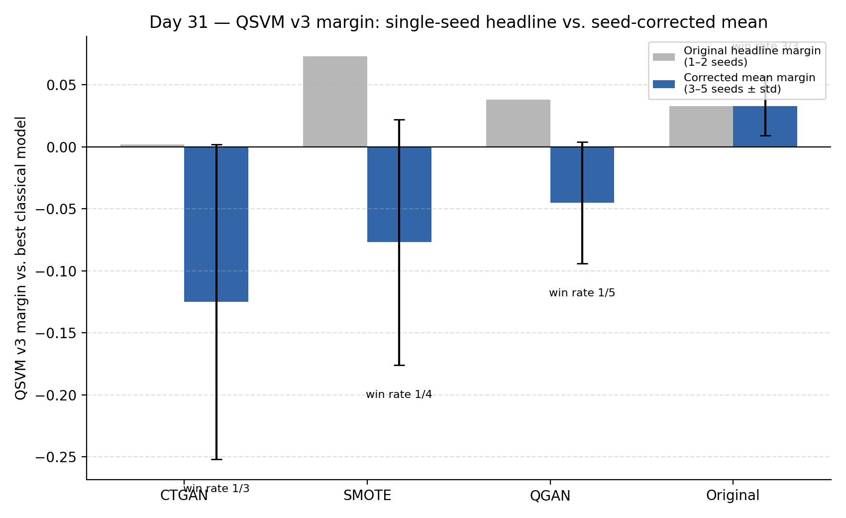
Figure 4. QSVM v3 margin over the best classical model: the original single/best-of-two-seed headline (grey) versus the corrected multi-seed mean ± std (blue). Only Original data keeps a positive, low-variance margin once more seeds are sampled.
So the corrected picture is the opposite of the first-pass headline: QGAN loses to classical models at every architecture version once properly seed-tested, and it is only the original, unprocessed, unaugmented data that shows a robust, low-variance quantum advantage. That correction was then checked against an entirely separate piece of evidence — a pre-existing 27-config V2 grid, run independently and earlier in the project, which had already found the same shape of result (Original 56% quantum win rate, SMOTE 33%, CTGAN 11%). Two different pipeline versions, two different seed sets, and the same conclusion both times: quantum's edge shows up reliably only on harder, messier, unaugmented data, and not on any of the three synthetic-data methods tested, regardless of which one generated the data.
Comparison axis | Best method | Worst method | Consistent across…
Fidelity (KS / Wasserstein / MMD) | SMOTE | QGAN | every class, every metric
Downstream classifier F1 | SMOTE (clear lift) | CTGAN (mildly negative) | all 4 classifiers
Quantum vs. classical (QSVM v3, corrected) | Original data (3/3 win rate) | CTGAN (1/3 win rate) | V2 grid and corrected V3, independently
Table 1. The three axes of comparison, consolidated once all three threads above were complete. None of the three ranks the four methods the same way.

Why the QGAN kept losing: diagnosing discriminator dominance and the barren-plateau wall
Running QGAN's data through every one of the comparisons above only sharpened the question the fidelity numbers had already raised: why was the QGAN's synthetic data so much further from the real distribution than either CTGAN's or SMOTE's in the first place? Answering that meant going back to the QGAN's own training process rather than its output, using the full per-batch loss history saved across all 7,400–7,800 batch-steps per class over the full 100-epoch run, not just the periodic epoch printouts most training logs keep. All three malware classes showed the identical failure signature: the discriminator's loss fell steadily while the generator's loss climbed, and the gap between the two widened and grew noisier as training went on instead of settling into a stable equilibrium. Ransomware's discriminator loss fell from 1.356 to 1.136 while its generator loss rose from 0.837 to 1.140, with the second half of training roughly 1.8x noisier than the first; Trojan and Spyware showed the same shape, with Spyware's oscillation nearly tripling by the end of the run.
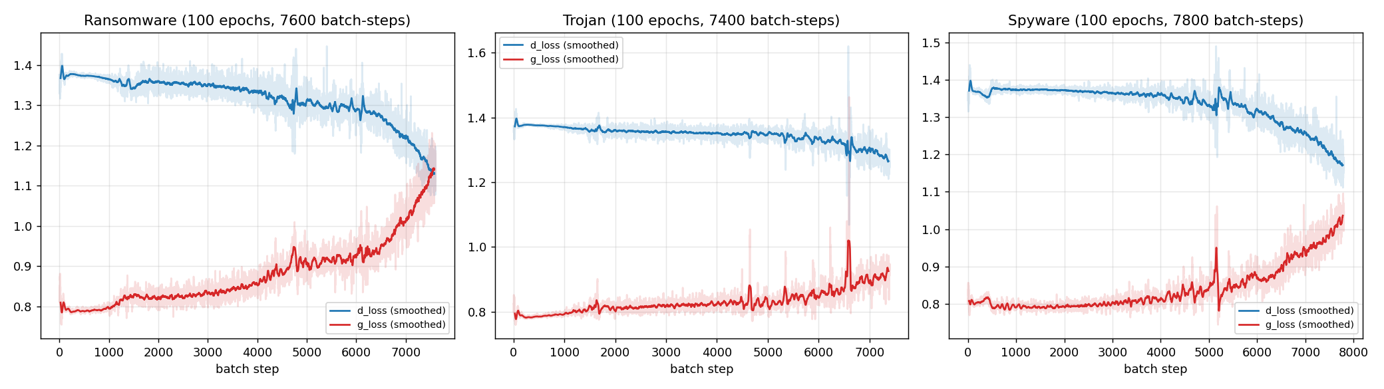
Figure 5. Discriminator loss (falling) versus generator loss (rising) across all three malware classes, full 100-epoch baseline run. The gap widens and gets noisier in every class instead of converging — the signature of discriminator dominance.
The obvious first suspect was a learning-rate imbalance, and it was ruled out directly rather than assumed away: the generator's learning rate (7e-3) was already 3.5x higher than the discriminator's (2e-3), and both networks received exactly one update per batch, a confirmed 1:1 ratio in the training loop. So the generator already had a nominal training-speed advantage over its adversary and still lost consistently. That ruled-out explanation pointed toward something structural instead: a representational capacity mismatch. The generator was a 4-layer variational quantum circuit built on 6 qubits, whose expressive power is bounded by circuit depth and qubit count rather than by a freely scalable parameter count the way a classical network's is. The discriminator, by contrast, was a classical multilayer perceptron with only 16 and 8 hidden units in its two layers — small by classical standards, but still comfortably more than enough capacity for its own sub-task, which was just binary real-versus-fake classification, a fundamentally easier problem than reproducing an entire data distribution from noise.

Increasing generator depth: the direct test of the capacity diagnosis, and the barren-plateau wall it hit
Once the diagnosis pointed at generator capacity, the most direct-sounding fix was also the most obvious one: give the generator more capacity by adding more variational layers. That instinct runs into a well-documented limitation of variational quantum circuits known as a barren plateau. As a variational circuit gets deeper or wider, under fairly general conditions the gradients used to train it shrink exponentially with the number of qubits involved — not gradually, but to the point where the optimizer effectively receives no usable signal at all. The practical consequence is counter-intuitive: a deeper circuit is not automatically easier to train just because it has more nominal expressive capacity on paper. The added depth can make the loss landscape flatter and harder to navigate at exactly the same time it makes the circuit theoretically more expressive, and for gradient-based training, a flat landscape with no gradient to follow is worse than a slightly-too-small circuit that can still be trained.
This is exactly what was tested, and exactly what happened. The generator's depth was increased from 4 layers to 6, isolated to a single class (Trojan) and retrained from scratch so the comparison against the untouched 4-layer checkpoints would be clean. The result was the direct opposite of the hypothesis, and by a wide margin: the discriminator/generator loss gap ended up larger, not smaller, than the original 4-layer run, and fidelity (KS_median) got worse — moving from 0.216 to 0.254 in the PCA-encoding space, with the Wasserstein distance increasing by roughly 74%. In other words, giving the generator more qubits and layers did not close the capacity gap — it pushed the generator into a barren-plateau regime where its gradients became noisier and less useful, and training got measurably worse on every measure tracked. That single negative result matters more than a positive one would have here: it is direct, first-hand evidence that this specific circuit family cannot be fixed simply by adding depth, and it ruled out the single most intuitive fix before any further time was spent on it.

What was tried, in the order it was tried
With the most direct capacity-side fix ruled out, five things had already been checked by the point the diagnosis was complete: the full per-batch loss history had been pulled and inspected class by class; the learning-rate imbalance had been checked and ruled out; the generator's depth had been increased from 4 to 6 layers and found to make training worse, consistent with a barren plateau; a cheap post-hoc output-bias calibration had been tried, matching the synthetic data's mean and standard deviation to the real data's after generation; and quantile mapping — remapping each synthetic feature to the real data's empirical rank distribution — had been tried as a stronger, non-parametric alternative.
The output-bias calibration did not help: the moment-matching loss already active during training had already closed most of the first- and second-moment gap on its own, and forcing it to exactly zero through a post-hoc affine correction distorted the shape of the distribution instead, making fidelity worse on two of the three classes tested.

Quantile mapping: what it was meant to fix, what it actually produced, and why it was thrown out
Quantile mapping was tried next as a stronger, non-parametric alternative to the output-bias calibration above, and it is worth walking through in full because the gap between what it promised and what it actually delivered is itself an important, honestly-reported result. The KS statistic and Wasserstein distance — the two fidelity metrics used everywhere else in this project — are both, by construction, direct comparisons of distribution shape between a real sample and a synthetic one. The hypothesis behind quantile mapping was to target that shape comparison as directly as possible rather than only matching the first two moments (mean and standard deviation) the way the output-bias calibration had: for every one of the 54 real-valued features, per malware class, each synthetic value would be re-mapped onto the rank position of the corresponding real value under an empirical cumulative distribution function (CDF) built from the same held-out real sample used for scoring.
What was actually implemented matched that description exactly — a per-feature empirical-CDF rank remap, applied after generation, using the held-out real sample as the reference distribution for every class. What it produced looked, on paper, like the best result of the entire stabilization effort by a wide margin. Across all three malware classes, the KS_median statistic collapsed from a baseline of roughly 0.25–0.28 down to about 0.0001 — effectively zero — and the Wasserstein distance fell in the same way, from roughly 0.6–0.9 down to about 0.004–0.009. Ransomware's KS_median moved from 0.2808 to 0.0001, Trojan's from 0.2467 to 0.0001, and Spyware's from 0.2685 to 0.0001, with Wasserstein distance falling by two to three orders of magnitude alongside it on every class.
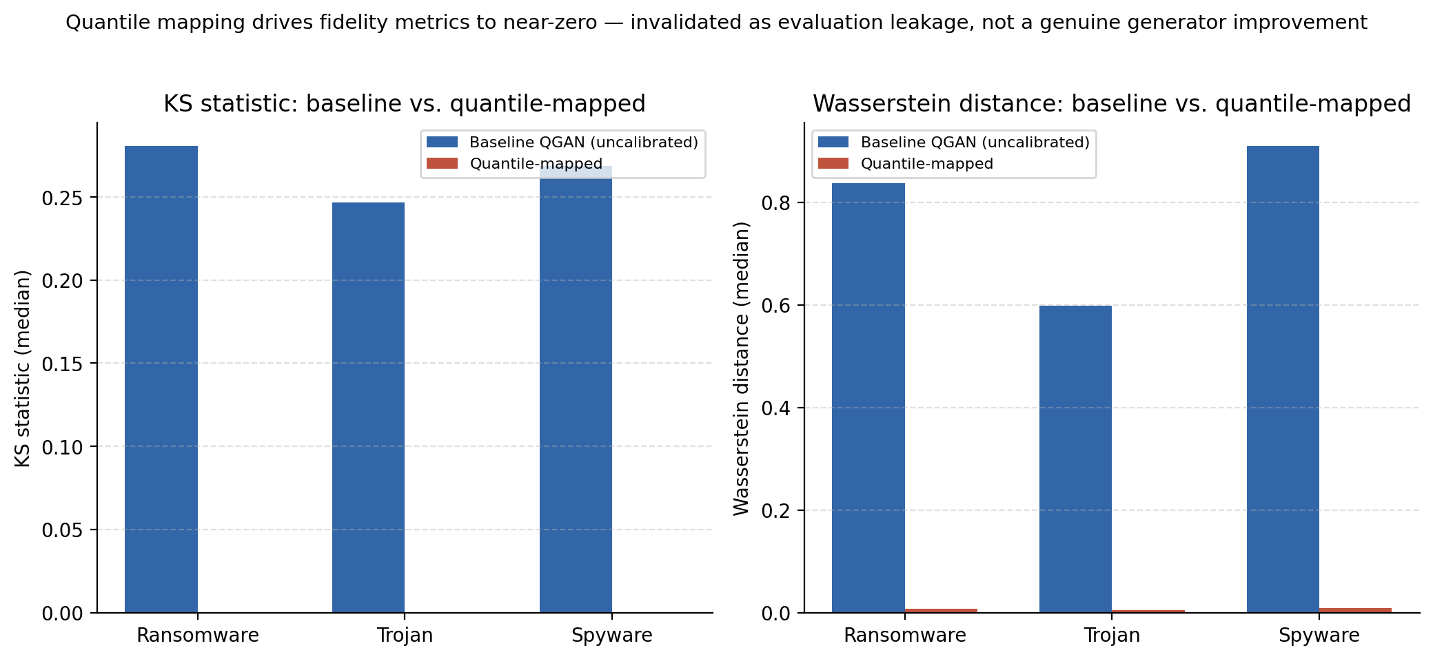
Figure 6. KS statistic and Wasserstein distance, baseline QGAN versus quantile-mapped output, all three malware classes. The near-total collapse to zero is not a sign the generator improved — it is the signature of the evaluation metric being answered with its own reference data.
That result was not reported as a win, and the reason is the same reason it looks too good in the first place: with equal real and synthetic sample counts, remapping every synthetic value onto the rank position of a real value forces the synthetic feature's marginal distribution to become a near-exact copy of the real data it is being scored against. The generator itself produced nothing different — the transformation was applied entirely after generation, using the evaluation set as its own reference, so the KS test was effectively comparing the real held-out sample to a rank-sorted copy of itself. This is evaluation leakage: the metric can be driven to its best possible value by a purely post-hoc bookkeeping step that has nothing to do with whether the underlying generator can produce new, realistic, previously-unseen samples, which is the actual property the fidelity metrics are meant to stand in for. Because of that, the quantile-mapped numbers were explicitly excluded from every other table, chart, and comparison used across the rest of the project — including the master comparison table and every downstream and fidelity result discussed earlier in this summary — and the attempt is documented here specifically as a negative methodological lesson: a metric that can be forced to its optimum by leakage is not, on its own, sufficient evidence that a generator has actually improved.
With the capacity-side fix (more qubits/layers) ruled out by the barren-plateau result, attention shifted to training-dynamics fixes that work around the capacity mismatch instead of trying to close it directly. Three further directions were identified and tested to completion: weakening the discriminator so its task became relatively harder — through dropout, one-sided label smoothing, and a smaller network; rescheduling the learning rate so it could change independently per circuit layer rather than globally; and the two-timescale update rule (TTUR), which gives the generator and discriminator genuinely different learning rates rather than a single shared schedule, to compensate directly for the generator's structural disadvantage.
Removing label smoothing turned out to be the single strongest result of the whole stabilization effort. The baseline configuration already softened the discriminator's target for real samples from 1.0 to 0.9 as a standard stabilization technique — but removing that softening entirely, and testing the counter-intuitive hypothesis that it was giving an already-dominant discriminator an even easier target, produced a clear, fully-confirmed improvement on both classes tested: Ransomware's KS_median improved from 0.328 to 0.253 (about 23% better) and Trojan's from 0.293 to 0.274 (about 6.5% better), with the discriminator/generator loss gap narrowing on both classes rather than widening. Shrinking the discriminator's hidden layers from 16+8 down to 8+4 units gave a mixed result: the loss gap narrowed on both classes, matching the same qualitative direction as label-smoothing removal, but fidelity only improved on Ransomware (0.297) while Trojan regressed slightly (0.308) — a useful negative-adjacent finding on its own, since it shows a narrowing loss gap does not guarantee improved fidelity on every class. Widening the generator-to-discriminator learning-rate ratio through TTUR gave a modest, confirmed gain at 10x (Ransomware 0.314, Trojan 0.263) without resolving the underlying dominance pattern, and a rough 30x check showed no further improvement, flat-to-worse on Ransomware specifically. A per-layer generator learning-rate schedule, giving each of the four variational layers its own decay rate, was tested as a fast, short-epoch check and came back inconclusive, and also surfaced a real, non-fatal checkpoint-saving bug that needs fixing before that variant can be trusted for a full run.
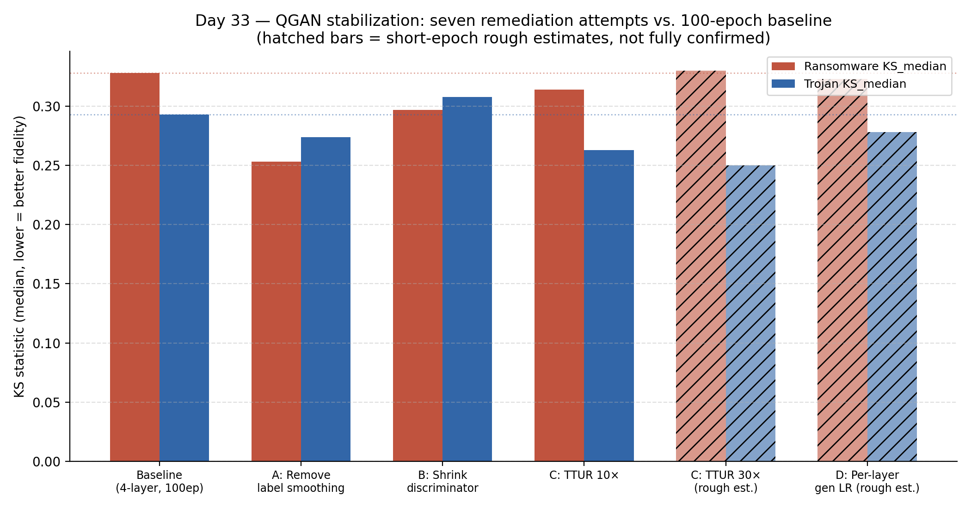
Figure 7. All seven remediation attempts against the 100-epoch baseline. Removing label smoothing is the only fully-confirmed improvement on both classes; hatched bars are short-epoch rough estimates, not full 100-epoch confirmations.
Intervention | Ransomware KS_median | Trojan KS_median | Verdict
Baseline (no fix) | 0.328 | 0.293 | reference
Verify per-batch loss history | — | — | diagnosis step — confirmed discriminator dominance
Check learning-rate imbalance | — | — | ruled out as the cause
Increase generator depth (4→6 layers) | — | 0.254 (PCA space)* | did not work — barren-plateau signature
Output-bias calibration | worse (2/3 classes) | — | did not work
Quantile mapping | ≈ 0 (invalid) | ≈ 0 (invalid) | did not work — evaluation leakage
Remove label smoothing | 0.253 (−23%) | 0.274 (−6.5%) | worked — strongest confirmed result
Shrink discriminator | 0.297 (−9%) | 0.308 (+5%, worse) | partial
TTUR, 10× ratio | 0.314 (−4%) | 0.263 (−10%) | partial, confirmed
TTUR, 30× ratio (rough est.) | ≈ 0.33 (flat) | ≈ 0.25 (rough) | did not clearly improve on 10×
Per-layer generator LR schedule (rough est.) | ≈ 0.32 (flat) | ≈ 0.28 (−5%) | inconclusive; checkpoint bug found
Table 2. Every diagnosis step and remediation attempt, in the order it was run. *Capacity-increase figures were measured in the PCA-encoding space and are not on the same numerical scale as the original-feature-space baseline. None of the round-two variants has been adopted as the project's official QGAN checkpoint — the downstream and fidelity numbers used everywhere earlier in this summary still reflect the original, unmodified generator.
Put together, four of the seven things tried gave no benefit or made fidelity worse — including the generator-depth increase, which is itself useful evidence precisely because it directly tested the capacity-mismatch diagnosis and hit the barren-plateau wall predicted by it. Two gave partial, mixed, or unconfirmed improvements. One — removing label smoothing — gave a clear, fully confirmed improvement on both evaluated classes without resolving the underlying dominance pattern: even under that best-performing fix, the generator's own loss still rose over training, meaning the discriminator still ended up ahead, just less overwhelmingly than in the untreated baseline. The state of the QGAN at the end of Week 5 is therefore: partially stabilized through training-dynamics interventions, with the deeper architectural capacity mismatch — and the barren-plateau ceiling on the most direct fix for it — still an open problem.

Where the week left off
The last two days of the week were spent making sure everything above actually held together. The project's best single quantum-classifier number — 0.875 accuracy on CTGAN using the V3 pipeline's XGBoost feature selection at 8 qubits, seed 7 — was verified directly against its raw run data, saved model file, and ablation results rather than taken on faith, and the ablation confirmed both of V3's components were necessary: a local kernel alone reached 0.825, KTA alignment alone reached 0.725, and the two combined reached the full 0.875. That headline was explicitly caveated against the same seed-correction finding from earlier in the week — the independently-run 27-config V2 grid had already found CTGAN to be the worst dataset for quantum overall, at a 1-in-9 win rate — so the 87.5% number is real and reproducible from the raw data, but represents one favorable configuration rather than a general result.
Everything was then packaged into one consolidated repository, and a final consistency check confirmed that the newly-completed Original baseline matched QGAN's originally-computed baseline to six decimal places, verifying that an identical test split had held across separate work sessions run at different times. No open items remained by the end of the week. The state the pipeline was left in: SMOTE wins clearly on both fidelity and downstream classifier impact; QGAN and CTGAN both trail it, for different reasons and in different ways; quantum shows a real, low-variance advantage only on the original, unaugmented, harder data, and not on any synthetic-data method tested; and the QGAN's own instability is understood down to its root cause, partially treatable through training-dynamics fixes, and still blocked at the architectural level by the barren-plateau limitation on directly increasing generator capacity.

