**Experiment 4: Create a simple cloud software application for Car Booking Reservation System using any Cloud Service Provider to demonstrate SaaS.**

**Aim:** To design and implement a cloud-based Car Booking Reservation System using Zoho Creator as a Software-as-a-Service (SaaS) model, which allows customers to easily book cars online, manage reservations, and calculate rental charges automatically, while providing administrators with tools to manage cars, customers, and bookings efficiently.

**Procedure:**

1. Login to Zoho Creator – Start a new application.
2. Form 1: Cars – Fields: Car ID, Car Name, Registration Number, Hourly Rate, Status.
3. Form 2: Customers – Fields: Customer ID, Full Name, Email, Phone Number.
4. Form 3: Car Bookings – Fields: Booking ID, Customer (Lookup), Car (Lookup), Pickup DateTime, Dropoff DateTime, Total Hours (Formula), Total Amount (Formula), Status, Payment Status.
5. Deploy – Save, test with sample data, and publish as a SaaS app accessible via cloud**.**

**Output:**

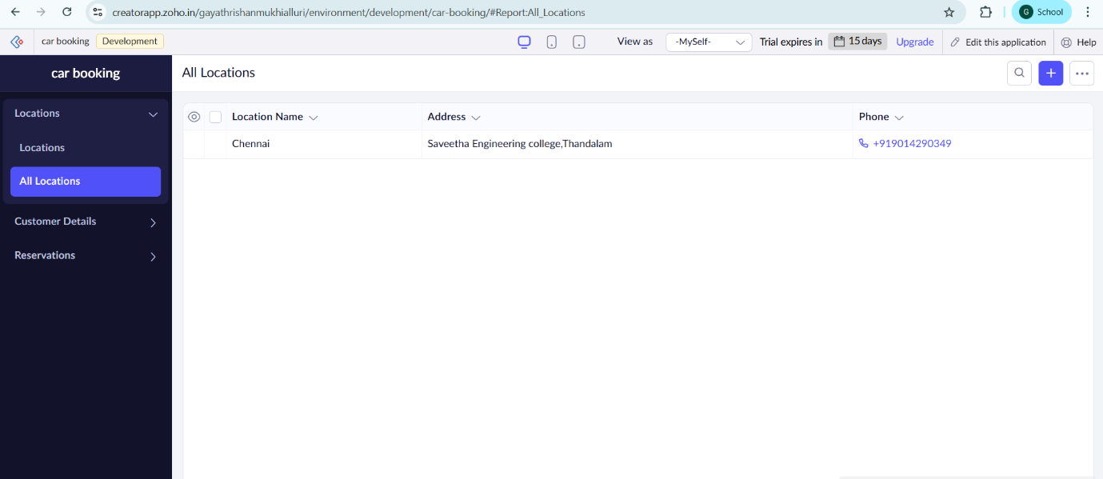

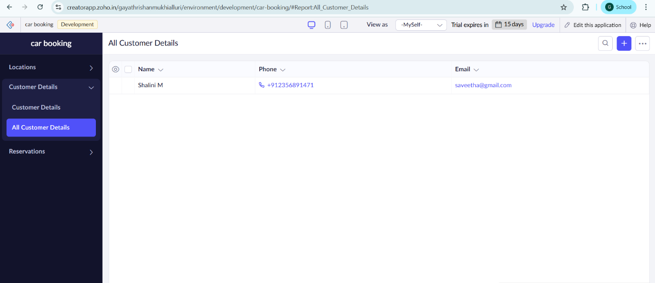

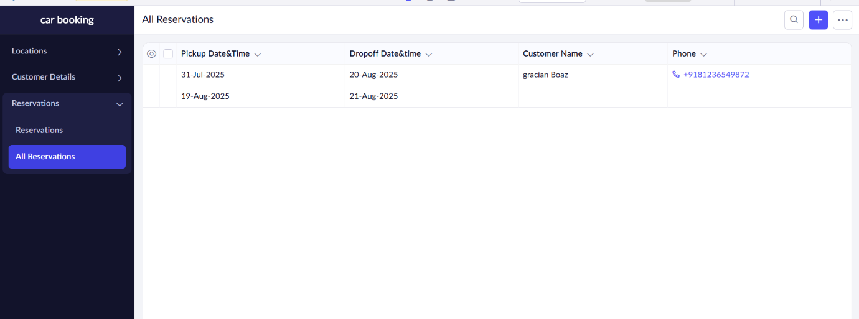

**Result**

The Car Booking Reservation System was successfully created in Zoho Creator as a SaaS application. It allows managing cars, customers, and bookings with automatic fare calculation and provides an easy cloud-based solution for online car reservations.