Name:-T.shanmuki

Roll number:-26001426

Branch:-CSD

Section:-1

Title:-

Python Activity-Based Learning (ABL) Assignment
Case Studies 91–100 | Beginner-friendly Python solutions

Prepared according to the college circular: each case study includes a problem statement, objectives, assumptions, algorithm, flowchart, pseudocode, Python source code, test cases, output evidence, and conclusion.

Important note: The datasets and records are illustrative. Review the rules and practise explaining each program. The output images are generated from actual program runs; Case Study 100 uses sample menu inputs to display the summary and exit.

Submission checklist
- Replace student details in your README with your own name, roll number, branch, and section.
- Run each .py file on your own computer and capture screenshots if your faculty expects screenshots from your own IDE.
- Check that the scoring/priority rules match the original case-study specifications provided by your faculty.
- Upload all programs, report, pseudocode, algorithms, flowcharts, test cases, and screenshots to the required GitHub repository.

Case Study 91: Advanced String-Based Registration Record Analyzer

Problem statement
Develop a program that reads structured registration records, checks each field's length and format, extracts the fields, detects duplicate registration IDs, and classifies errors.

Objectives
  - Parse a pipe-separated record into ID, name, email, and phone fields.
  - Validate field count, ID length, name, email format, and phone digits.
  - Detect duplicate IDs and report clear error classifications.

Assumptions
  - Each record uses ID|Name|Email|Phone.
  - IDs contain 4–8 letters/digits; names contain letters and spaces; email contains @ and a dot after @; phone contains exactly 10 digits.
  - The sample records are illustrative, not real personal data.

Algorithm
- Start.
- Store sample registration strings in a list.
- For each record, split by '|'.
- Check field count, then validate each field and check whether the ID was seen before.
- Print extracted fields and either VALID or the list of errors.
- Stop.

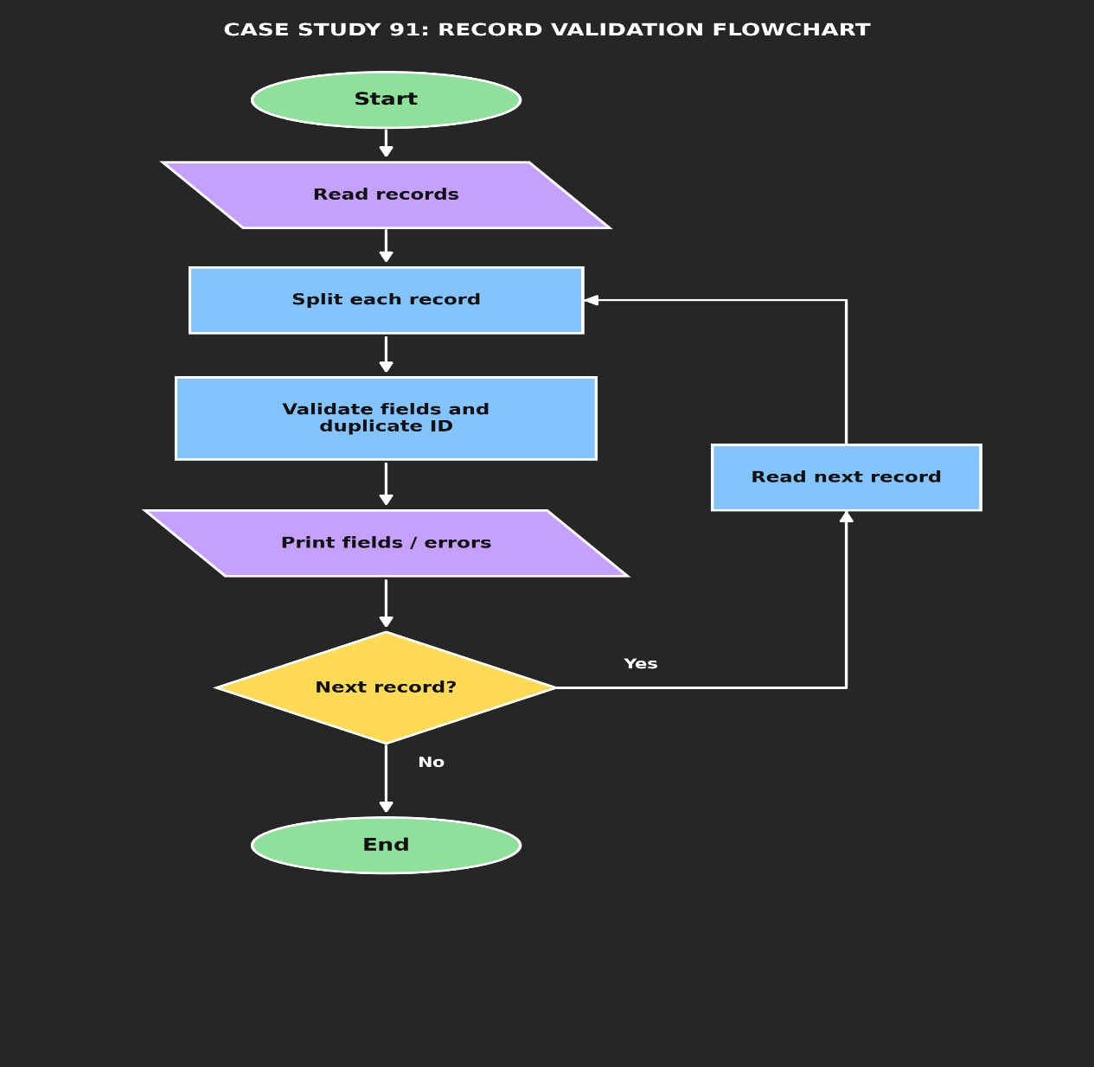

Pseudocode
START
records ← sample registration strings seen_ids ← empty list
FOR each record IN records fields ← split record by '|' errors ← empty list
IF field count is not 4: add FIELD_COUNT error
ELSE validate ID, name, email, and phone; detect duplicate ID PRINT record and result
END FOR STOP

Python source code

records = [

"A102|Ravi Kumar|ravi@example.com|9876543210",

"B205|Anu Rao|anu.example.com|9876543211",

"A102|Maya Das|maya@example.com|9876543212",

"C3|John Lee|john@example.com|12345"

]

seen_ids = []

for record in records:

fields = record.split("|")

errors = []

if len(fields) != 4:

errors.append("FIELD_COUNT")

else:

reg_id, name, email, phone = fields

if not (4 <= len(reg_id) <= 8) or not reg_id.isalnum():

errors.append("INVALID_ID")

if not name.replace(" ", "").isalpha():

errors.append("INVALID_NAME")

if "@" not in email or "." not in email.split("@")[-1]:

errors.append("INVALID_EMAIL")

if len(phone) != 10 or not phone.isdigit():

errors.append("INVALID_PHONE")

if reg_id in seen_ids:

errors.append("DUPLICATE_ID")

seen_ids.append(reg_id)

if errors:

print(record, "-> INVALID:", ", ".join(errors))

else:

print(

"ID:", reg_id,

"| Name:", name,

"| Email:", email,

"| Phone:", phone,

"-> VALID"

)

Test cases

Test | Input / condition | Expected result
Valid record | A102|Ravi Kumar|ravi@example.com|9876543210 | VALID
Email missing @ | B205|Anu Rao|anu.example.com|9876543211 | INVALID_EMAIL
Duplicate ID | A102|Maya Das|maya@example.com|9876543212 | DUPLICATE_ID
Short ID and phone | C3|John Lee|john@example.com|12345 | INVALID_ID, INVALID_PHONE

Sample output
ID: A102 | Name: Ravi Kumar | Email: ravi@example.com | Phone: 9876543210 -> VALID B205|Anu Rao|anu.example.com|9876543211 -> INVALID: INVALID_EMAIL
A102|Maya Das|maya@example.com|9876543212 -> INVALID: DUPLICATE_ID C3|John Lee|john@example.com|12345 -> INVALID: INVALID_ID, INVALID_PHONE

ERROR:
Spreadsheet runtime warmup failed during python startup Traceback (most recent call last):
File "/tmp/tmp.QlpUkOUI9D/artifact_tool_v2-2.8.66/artifact_tool/patches/warm_spreadsheet_runtime_on_startup.py", line 26, in warm_sprea File "/tmp/tmp.QlpUkOUI9D/artifact_tool_v2-2.8.66/artifact_tool/spreadsheet_warmup.py", line 785, in warm_spreadsheet_runtime
File "/tmp/tmp.QlpUkOUI9D/artifact_tool_v2-2.8.66/artifact_tool/spreadsheet_warmup.py", line 718, in _warm_feature_flows
File "/tmp/tmp.QlpUkOUI9D/artifact_tool_v2-2.8.66/artifact_tool/spreadsheet_warmup.py", line 509, in _warm_drawing_and_image_flows File "/tmp/tmp.QlpUkOUI9D/artifact_tool_v2-2.8.66/artifact_tool/generated/interface/models.py", line 32861, in bring_to_front
File "/tmp/tmp.QlpUkOUI9D/artifact_tool_v2-2.8.66/artifact_tool/rpc/remote.py", line 764, in call File "/tmp/tmp.QlpUkOUI9D/artifact_tool_v2-2.8.66/artifact_tool/rpc/client.py", line 175, in call
artifact_tool.rpc.client.RemoteError: Element ordering requires an owning element collection.
Output screenshot: output_screenshots/case_study_91_output.png

Conclusion
The program demonstrates string splitting, validation with conditions, list use, and duplicate detection. It classifies invalid records so they can be corrected.

Screenshot:-program output:-

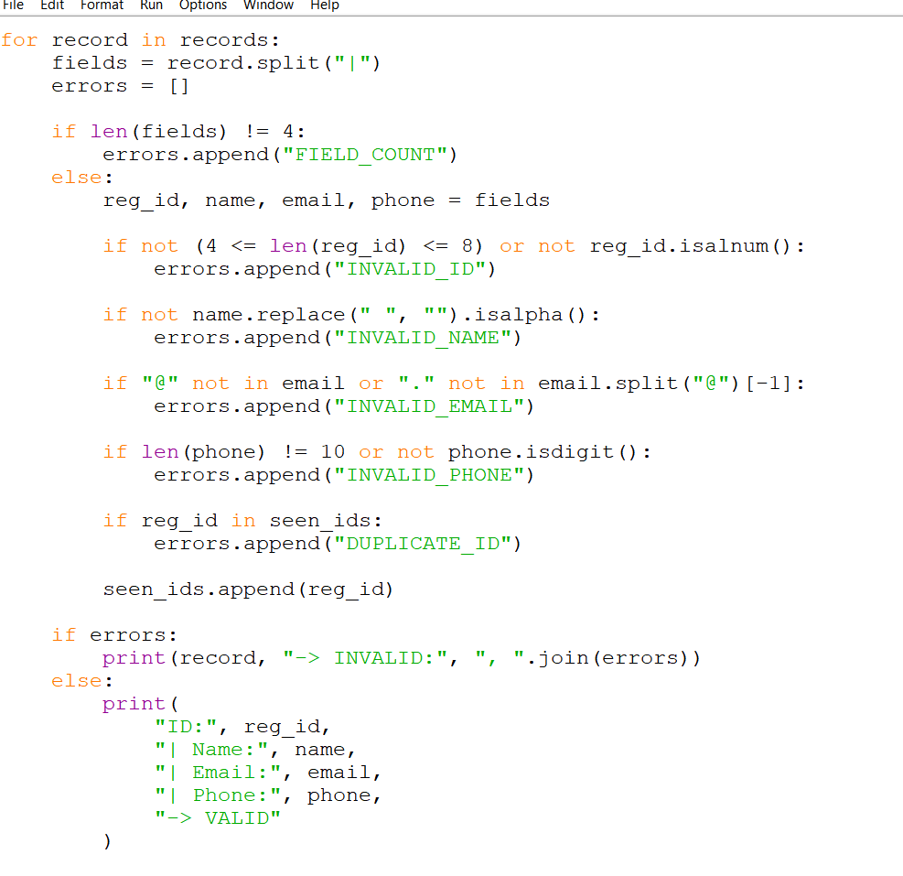
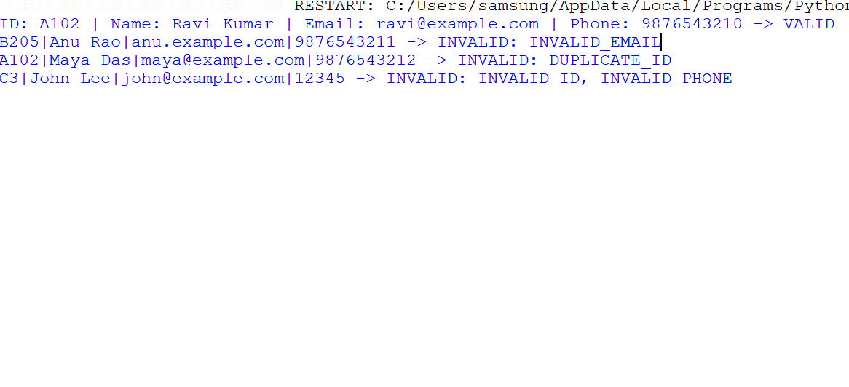

Case Study 92: Multi-Event Sports Scheduling and Scoring

Problem statement
Represent sports fixtures and team scores using lists and tuples, find time-slot conflicts, calculate total points, and rank teams.

Objectives
  - Store fixtures as tuples and scores in a list.
  - Identify teams scheduled in more than one match in the same time slot.
  - Calculate points and display teams from highest to lowest.

Assumptions
  - A win earns 3 points, a draw earns 1 point, and a loss earns 0 points.
  - A team cannot play two matches in the same time slot.
  - Sample scores are fictional.

Algorithm
- Store fixtures as (time, team1, team2) tuples.
- Compare fixtures sharing a time slot and report repeated teams.
- Read the scores for each match.
- Award points based on the result.
- Sort teams by points and print rankings.

Flowchat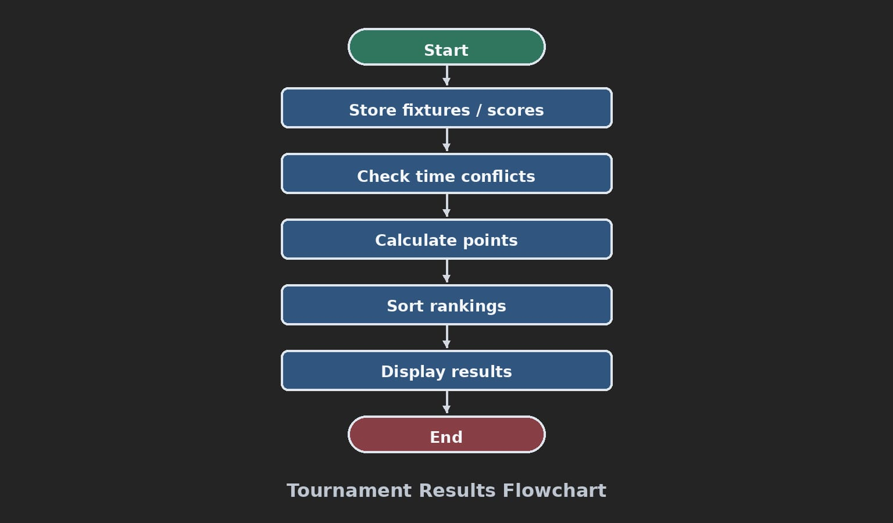

Pseudocode
START
fixtures ← list of (time, team1, team2) tuples
check each pair of fixtures for same time and shared team points ← zero for every team
FOR each match score
award 3 points to winner, or 1 each for draw sort teams by points descending
print conflicts and rankings STOP

Python source code
# Case Study 92: Sports Scheduling and Scoring fixtures = [
("10:00", "Tigers", "Eagles"),
("10:00", "Lions", "Wolves"),
("11:00", "Tigers", "Lions")
]

scores = [
("Tigers", "Eagles", 2, 1),
("Lions", "Wolves", 0, 0),
("Tigers", "Lions", 1, 3)
]

print("SCHEDULING CONFLICTS")
found = False
for i in range(len(fixtures)):
for j in range(i + 1, len(fixtures)): time1, a1, b1 = fixtures[i] time2, a2, b2 = fixtures[j]
if time1 == time2 and ({a1, b1} & {a2, b2}): print(time1, ":", "a team is scheduled twice") found = True
if not found:
print("No conflicts")

points = {"Tigers": 0, "Eagles": 0, "Lions": 0, "Wolves": 0} for team1, team2, score1, score2 in scores:
if score1 > score2: points[team1] += 3
elif score2 > score1: points[team2] += 3
else:

points[team1] += 1
points[team2] += 1

print("\nFINAL RANKING")
ranking = sorted(points.items(), key=lambda item: item[1], reverse=True) for rank, (team, total) in enumerate(ranking, start=1):
print(rank, team, "-", total, "points")

Test cases

Test | Input / condition | Expected result
Tigers beat Eagles | 2–1 | Tigers get 3 points
Lions-Wolves draw | 0–0 | Each gets 1 point
Same team in same slot | Tigers and Eagles at 10:00; Tigers and Lions at 10:00 | Conflict reported

Sample output
SCHEDULING CONFLICTS
No conflicts

FINAL RANKING
- Lions - 4 points
- Tigers - 3 points
- Wolves - 1 points
- Eagles - 0 points

ERROR:
Spreadsheet runtime warmup failed during python startup Traceback (most recent call last):
File "/tmp/tmp.QlpUkOUI9D/artifact_tool_v2-2.8.66/artifact_tool/patches/warm_spreadsheet_runtime_on_startup.py", line 26, in warm_sprea File "/tmp/tmp.QlpUkOUI9D/artifact_tool_v2-2.8.66/artifact_tool/spreadsheet_warmup.py", line 785, in warm_spreadsheet_runtime
File "/tmp/tmp.QlpUkOUI9D/artifact_tool_v2-2.8.66/artifact_tool/spreadsheet_warmup.py", line 718, in _warm_feature_flows
File "/tmp/tmp.QlpUkOUI9D/artifact_tool_v2-2.8.66/artifact_tool/spreadsheet_warmup.py", line 509, in _warm_drawing_and_image_flows File "/tmp/tmp.QlpUkOUI9D/artifact_tool_v2-2.8.66/artifact_tool/generated/interface/models.py", line 32861, in bring_to_front
File "/tmp/tmp.QlpUkOUI9D/artifact_tool_v2-2.8.66/artifact_tool/rpc/remote.py", line 764, in call File "/tmp/tmp.QlpUkOUI9D/artifact_tool_v2-2.8.66/artifact_tool/rpc/client.py", line 175, in call
artifact_tool.rpc.client.RemoteError: Element ordering requires an owning element collection.
Output screenshot: output_screenshots/case_study_92_output.png

Conclusion
The program uses tuples to represent fixtures, nested loops to detect conflicst, and sorting to produce a points-based ranking.
Screenshot:-program output:-

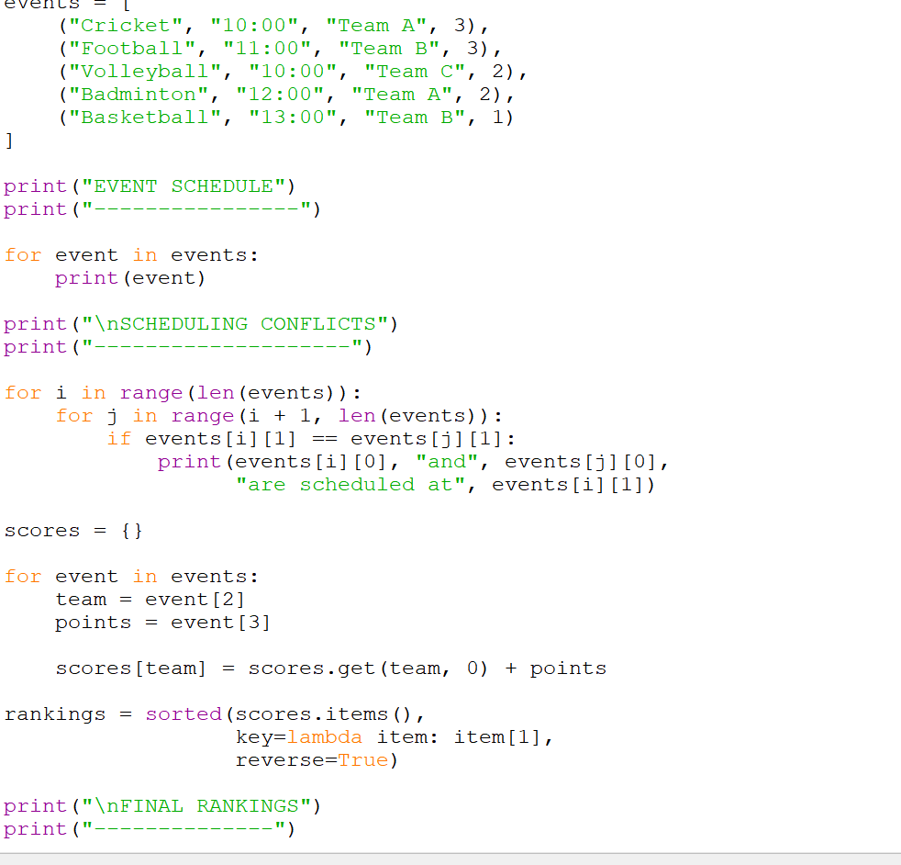
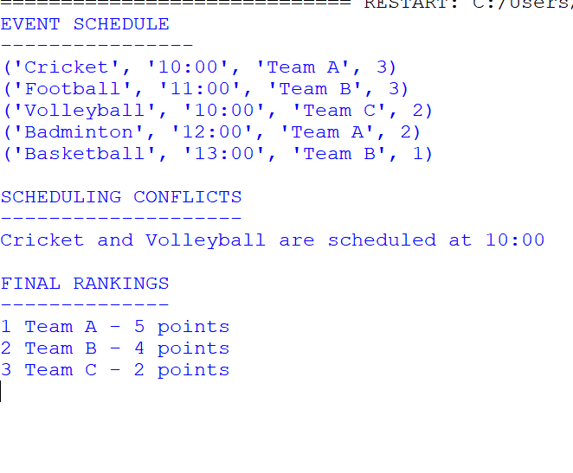

Case Study 93: Smart Public Transport Fare Reconciliation

Problem statement
Calculate passenger fares across routes and categories, compare expected fares with collected amounts, and identify overpayments or shortages.

Objectives
  - Apply route fares and passenger-category discounts.
  - Calculate expected revenue and compare it with collected revenue.
  - Report each transaction's discrepancy and the overall difference.

Assumptions
  - Route fares are one-way adult fares.
  - Students receive 50% discount; seniors receive 30% discount; adults pay full fare.
  - Collected amounts are provided as sample data.

Algorithm
- Create a route-fare dictionary and category discount dictionary.
- For each passenger, calculate fare after discount.
- Compare expected fare with collected fare.
- Add expected and collected revenue totals.
- Print transaction-level differences and final reconciliation.

Flowchart

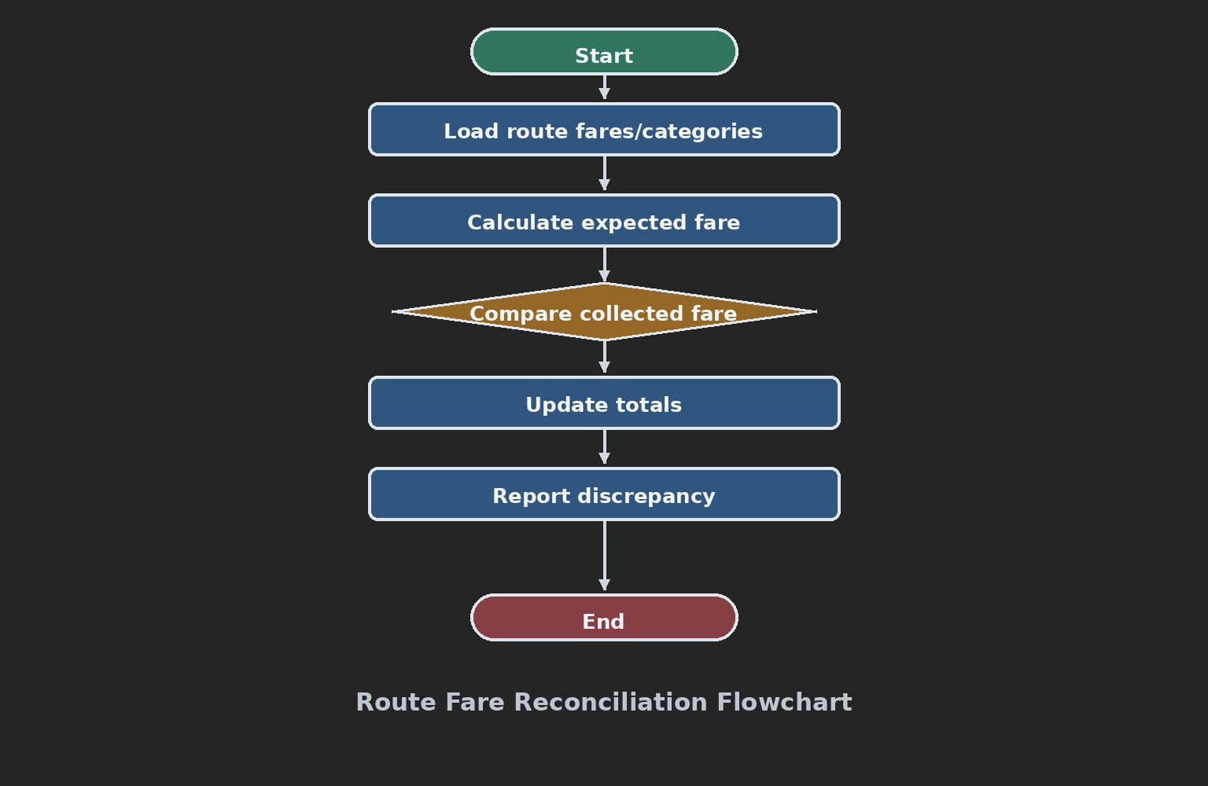

Pseudocode
START
route_fares ← route and adult fare mapping discounts ← category mapping expected_total ← 0; collected_total ← 0 FOR each passenger transaction
expected ← route fare × (1 − discount) difference ← collected − expected
update totals and print difference PRINT totals and net discrepancy
STOP

Python source code
# Case Study 93: Transport Fare Reconciliation route_fares = {"A-B": 40, "A-C": 60, "B-C": 35}
discounts = {"adult": 0.0, "student": 0.5, "senior": 0.3} passengers = [
("P01", "A-B", "adult", 40),
("P02", "A-C", "student", 30),
("P03", "B-C", "senior", 25),
("P04", "A-B", "student", 15)
]

expected_total = 0
collected_total = 0

print("ID Expected Collected Difference")
for pid, route, category, collected in passengers:
expected = route_fares[route] * (1 - discounts[category]) difference = collected - expected
expected_total += expected collected_total += collected
print(pid, expected, collected, difference)

print("\nExpected revenue:", expected_total) print("Collected revenue:", collected_total)
print("Net discrepancy:", collected_total - expected_total)

Test cases

Test | Input / condition | Expected result
Adult A-B | Fare 40, collected 40 | Difference 0
Student A-C | Fare 60, 50% discount, collected 30 | Difference 0
Student A-B underpaid | Expected 20, collected 15 | Difference -5

Sample output
ID Expected Collected Difference P01 40.0 40 0.0
P02 30.0 30 0.0
P03 24.5 25 0.5
P04 20.0 15 -5.0

Expected revenue: 114.5
Collected revenue: 110
Net discrepancy: -4.5

ERROR:
Spreadsheet runtime warmup failed during python startup Traceback (most recent call last):
File "/tmp/tmp.QlpUkOUI9D/artifact_tool_v2-2.8.66/artifact_tool/patches/warm_spreadsheet_runtime_on_startup.py", line 26, in warm_sprea File "/tmp/tmp.QlpUkOUI9D/artifact_tool_v2-2.8.66/artifact_tool/spreadsheet_warmup.py", line 785, in warm_spreadsheet_runtime
File "/tmp/tmp.QlpUkOUI9D/artifact_tool_v2-2.8.66/artifact_tool/spreadsheet_warmup.py", line 718, in _warm_feature_flows
File "/tmp/tmp.QlpUkOUI9D/artifact_tool_v2-2.8.66/artifact_tool/spreadsheet_warmup.py", line 509, in _warm_drawing_and_image_flows File "/tmp/tmp.QlpUkOUI9D/artifact_tool_v2-2.8.66/artifact_tool/generated/interface/models.py", line 32861, in bring_to_front
File "/tmp/tmp.QlpUkOUI9D/artifact_tool_v2-2.8.66/artifact_tool/rpc/remote.py", line 764, in call File "/tmp/tmp.QlpUkOUI9D/artifact_tool_v2-2.8.66/artifact_tool/rpc/client.py", line 175, in call
artifact_tool.rpc.client.RemoteError: Element ordering requires an owning element collection.
Output screenshot: output_screenshots/case_study_93_output.png

Conclusion
The program applies fare rules consistently and highlights discrepancies between expected and collected revenue.
Screenshot:-program code output:-
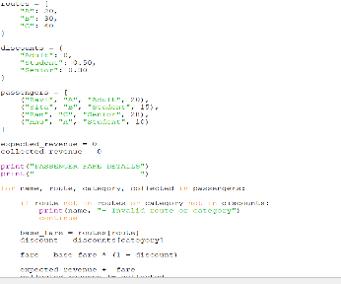
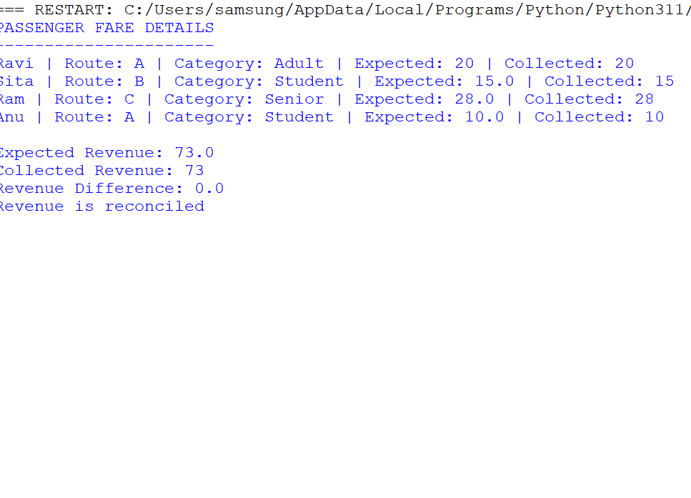

Case Study 94: Disaster Relief Supply Allocation

Problem statement
Compare available supplies with area-wise demand, prioritize urgent shortages, allocate limited stock, and calculate unmet demand.

Objectives
  - Calculate shortages by area and supply type.
  - Prioritize urgent areas before normal-priority areas.
  - Allocate stock without exceeding available quantities and report unmet demand.

Assumptions
  - Allocation is done separately for each supply item.
  - Areas are processed by priority: HIGH first, then MEDIUM, then LOW.
  - Within a priority, areas are handled in the order listed.

Algorithm
- Store available stock and area requirements.
- Sort areas by priority.
- For each area and item, allocate the smaller of demand and available stock.
- Reduce remaining stock and demand.
- Print allocations and unmet demand.

Flowchart

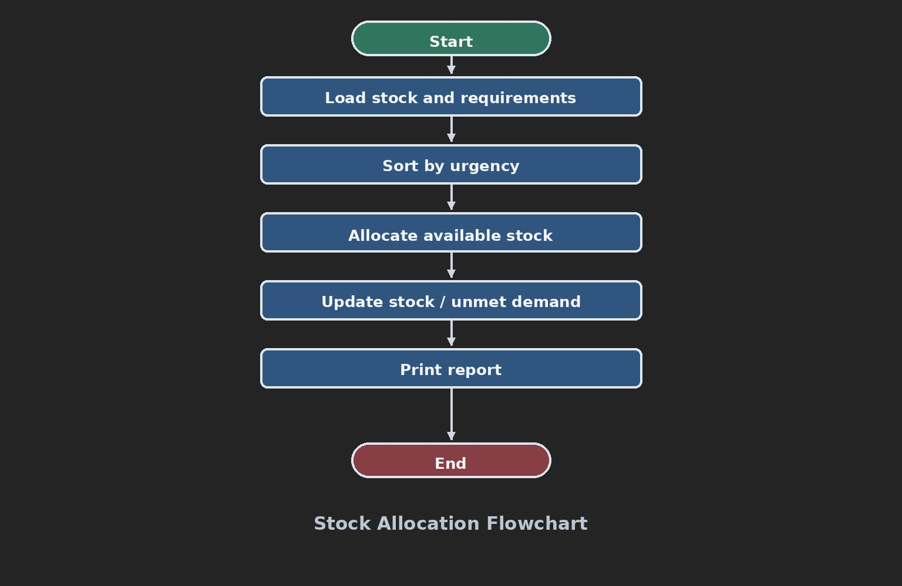

6.Pseudocode
START
stock ← available quantities requirements ← area needs sort areas by priority
FOR each area in priority order FOR each supply item
allocation ← minimum(demand, stock)
reduce stock by allocation unmet ← demand − allocation print allocation and unmet
print remaining stock STOP

Python source code
# Case Study 94: Disaster Relief Supply Allocation stock = {"water": 100, "food": 80}
areas = [
("Area North", "HIGH", {"water": 60, "food": 50}),
("Area South", "LOW", {"water": 40, "food": 30}),
("Area East", "MEDIUM", {"water": 30, "food": 25})
]
priority_order = {"HIGH": 1, "MEDIUM": 2, "LOW": 3} areas.sort(key=lambda area: priority_order[area[1]])

print("AREA ITEM NEEDED ALLOCATED UNMET")
for name, priority, needs in areas: for item, needed in needs.items():
allocated = min(needed, stock[item]) stock[item] -= allocated
unmet = needed - allocated
print(name, item, needed, allocated, unmet) print("\nRemaining stock:", stock)

Test cases

Test | Input / condition | Expected result
Urgent area | High priority needs 60 water, stock 100 | Receives 60 before lower priority
Shortage | Need 50 food, stock 30 | Allocate 30, unmet 20
No stock left | Demand remains after stock is zero | Allocation 0, unmet equals demand

Sample output
AREA ITEM NEEDED ALLOCATED UNMET
Area North water 60 60 0
Area North food 50 50 0
Area East water 30 30 0
Area East food 25 25 0
Area South water 40 10 30
Area South food 30 5 25

Remaining stock: {'water': 0, 'food': 0}

ERROR:
Spreadsheet runtime warmup failed during python startup Traceback (most recent call last):
File "/tmp/tmp.QlpUkOUI9D/artifact_tool_v2-2.8.66/artifact_tool/patches/warm_spreadsheet_runtime_on_startup.py", line 26, in warm_sprea File "/tmp/tmp.QlpUkOUI9D/artifact_tool_v2-2.8.66/artifact_tool/spreadsheet_warmup.py", line 785, in warm_spreadsheet_runtime
File "/tmp/tmp.QlpUkOUI9D/artifact_tool_v2-2.8.66/artifact_tool/spreadsheet_warmup.py", line 718, in _warm_feature_flows
File "/tmp/tmp.QlpUkOUI9D/artifact_tool_v2-2.8.66/artifact_tool/spreadsheet_warmup.py", line 509, in _warm_drawing_and_image_flows File "/tmp/tmp.QlpUkOUI9D/artifact_tool_v2-2.8.66/artifact_tool/generated/interface/models.py", line 32861, in bring_to_front
File "/tmp/tmp.QlpUkOUI9D/artifact_tool_v2-2.8.66/artifact_tool/rpc/remote.py", line 764, in call File "/tmp/tmp.QlpUkOUI9D/artifact_tool_v2-2.8.66/artifact_tool/rpc/client.py", line 175, in call
artifact_tool.rpc.client.RemoteError: Element ordering requires an owning element collection.
Output screenshot: output_screenshots/case_study_94_output.png

Conclusion

The program demonstrates priority-based allocation and transparently reports remaining stock and unmet neat

Screenshot:-

Output:-
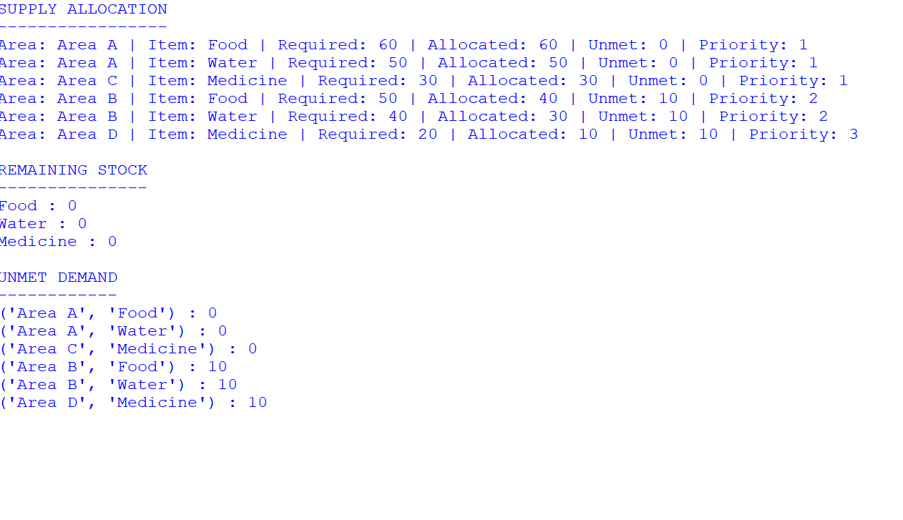
Code:-
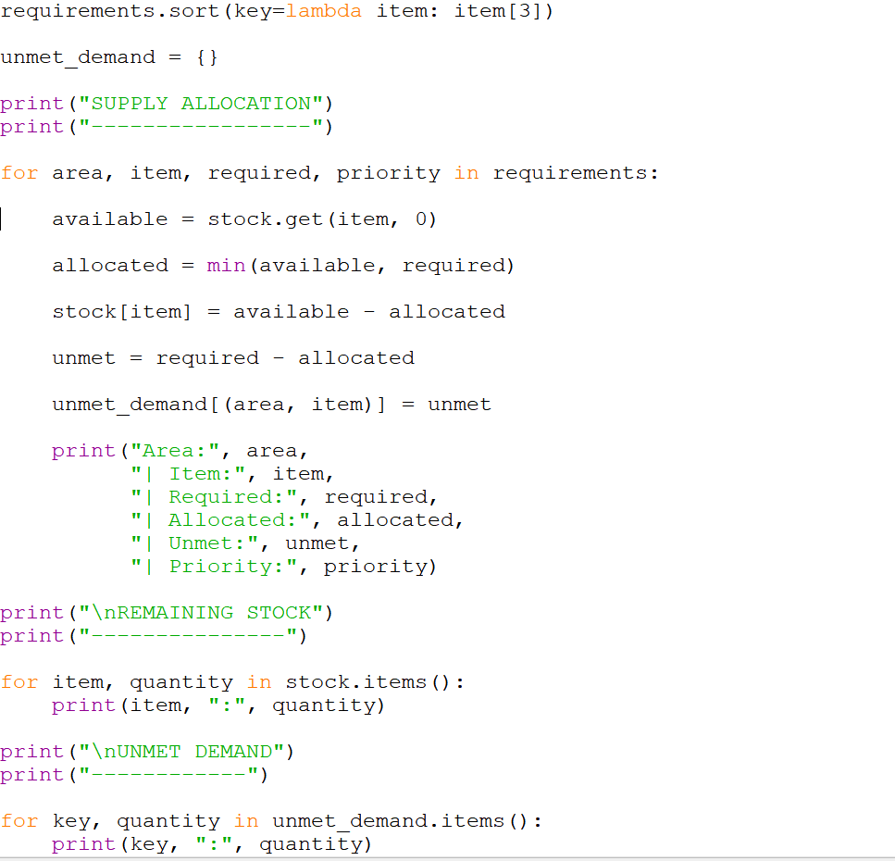

Case Study 95: Integrated Manufacturing Production Planner

Problem statement
Check whether raw materials can meet production demand, calculate production quantities and defects, and identify shortages or quality violations.

Objectives
  - Calculate the maximum feasible production from available materials.
  - Compare planned production with order demand.
  - Calculate defect rate and check it against the allowed limit.

Assumptions
  - Each unit needs 2 kg of material A and 1 unit of material B.
  - Defect rate limit is 5%.
  - Only whole units can be produced.

Algorithm
- Read available material quantities, planned units, order demand, and defect count.
- Calculate feasible units from each material.
- Find maximum feasible production.
- Calculate defect percentage.
- Report shortages and whether quality passes.
5.flowchat:

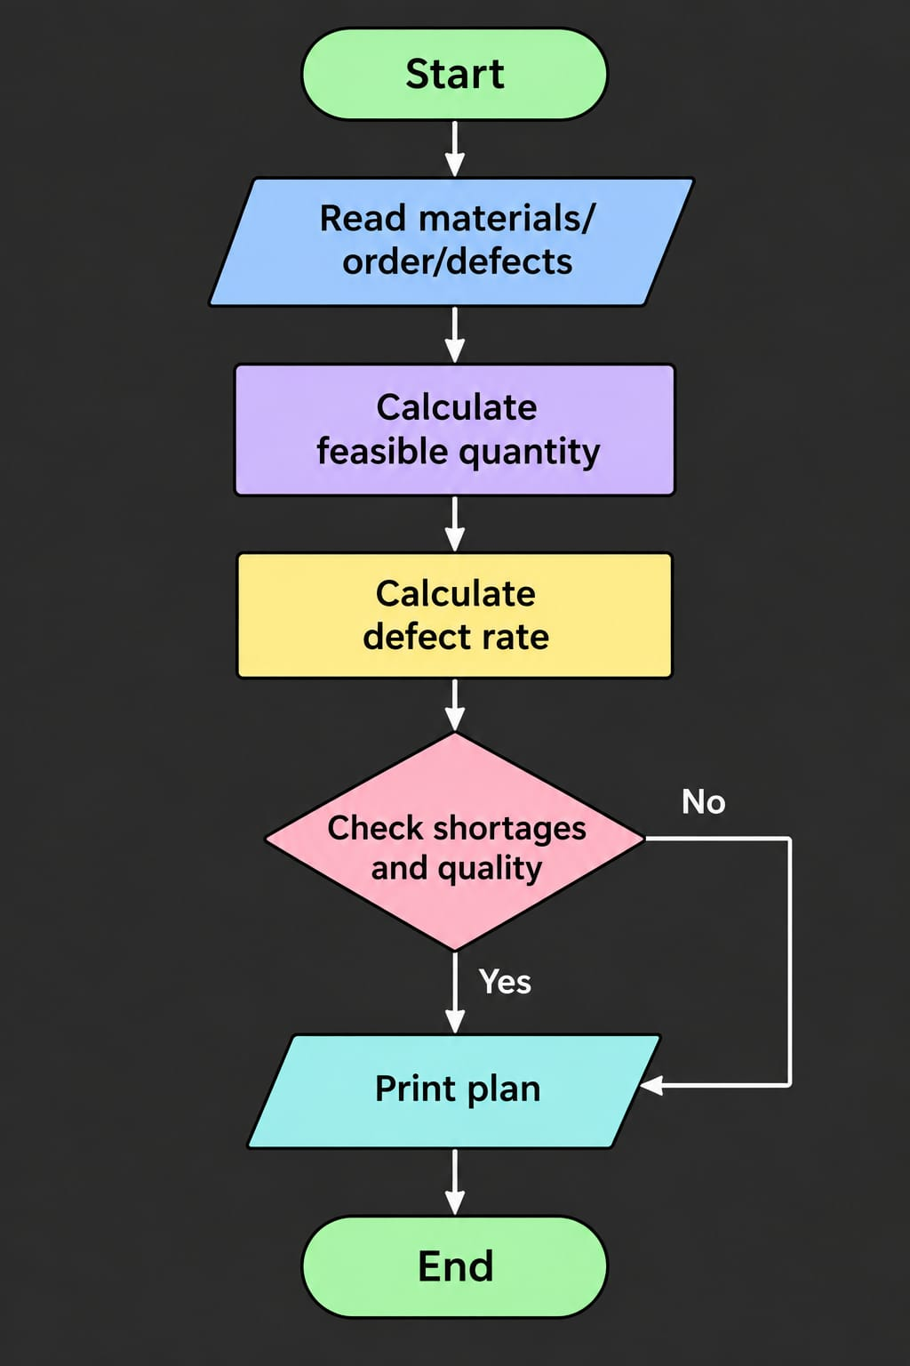

Pseudocode
START
read material A, material B, planned quantity, demand, defects capacity_A ← material_A / 2
capacity_B ← material_B
feasible ← minimum(capacity_A, capacity_B, planned quantity) defect_rate ← defects / planned quantity × 100
report demand shortage and quality status STOP

Python source code
# Case Study 95: Manufacturing Production Planner material_a = 150 # kg; 2 kg needed per unit material_b = 90 # 1 unit needed per product planned_units = 100
order_demand = 95
defects = 4
defect_limit = 5

capacity_a = material_a // 2 capacity_b = material_b
feasible_units = min(capacity_a, capacity_b, planned_units) defect_rate = defects / planned_units * 100

print("Material A capacity:", capacity_a, "units") print("Material B capacity:", capacity_b, "units") print("Feasible production:", feasible_units) print("Order demand:", order_demand)
print("Unmet demand:", max(0, order_demand - feasible_units)) print("Defect rate:", round(defect_rate, 2), "%")
if defect_rate <= defect_limit: print("Quality status: PASS")
else:
print("Quality status: VIOLATION") if feasible_units < planned_units:
print("Production warning: material shortage")

Test cases

Test | Input / condition | Expected result
Enough materials | Capacity 100, planned 100 | Feasible production 100
Material shortage | Material B supports 90, demand 95 | Unmet demand 5
Quality check | 4 defects out of 100 | 4%, PASS

Sample output
Material A capacity: 75 units Material B capacity: 90 units Feasible production: 75
Order demand: 95
Unmet demand: 20 Defect rate: 4.0 % Quality status: PASS
Production warning: material shortage

ERROR:
Spreadsheet runtime warmup failed during python startup Traceback (most recent call last):
File "/tmp/tmp.QlpUkOUI9D/artifact_tool_v2-2.8.66/artifact_tool/patches/warm_spreadsheet_runtime_on_startup.py", line 26, in warm_sprea File "/tmp/tmp.QlpUkOUI9D/artifact_tool_v2-2.8.66/artifact_tool/spreadsheet_warmup.py", line 785, in warm_spreadsheet_runtime
File "/tmp/tmp.QlpUkOUI9D/artifact_tool_v2-2.8.66/artifact_tool/spreadsheet_warmup.py", line 718, in _warm_feature_flows
File "/tmp/tmp.QlpUkOUI9D/artifact_tool_v2-2.8.66/artifact_tool/spreadsheet_warmup.py", line 509, in _warm_drawing_and_image_flows File "/tmp/tmp.QlpUkOUI9D/artifact_tool_v2-2.8.66/artifact_tool/generated/interface/models.py", line 32861, in bring_to_front
File "/tmp/tmp.QlpUkOUI9D/artifact_tool_v2-2.8.66/artifact_tool/rpc/remote.py", line 764, in call File "/tmp/tmp.QlpUkOUI9D/artifact_tool_v2-2.8.66/artifact_tool/rpc/client.py", line 175, in call
artifact_tool.rpc.client.RemoteError: Element ordering requires an owning element collection.
Output screenshot: output_screenshots/case_study_95_output.png

Conclusion
The program combines material planning, integer calculations, demand comparison, and quality checks to support a basic production decision.
Screenshot:-program code
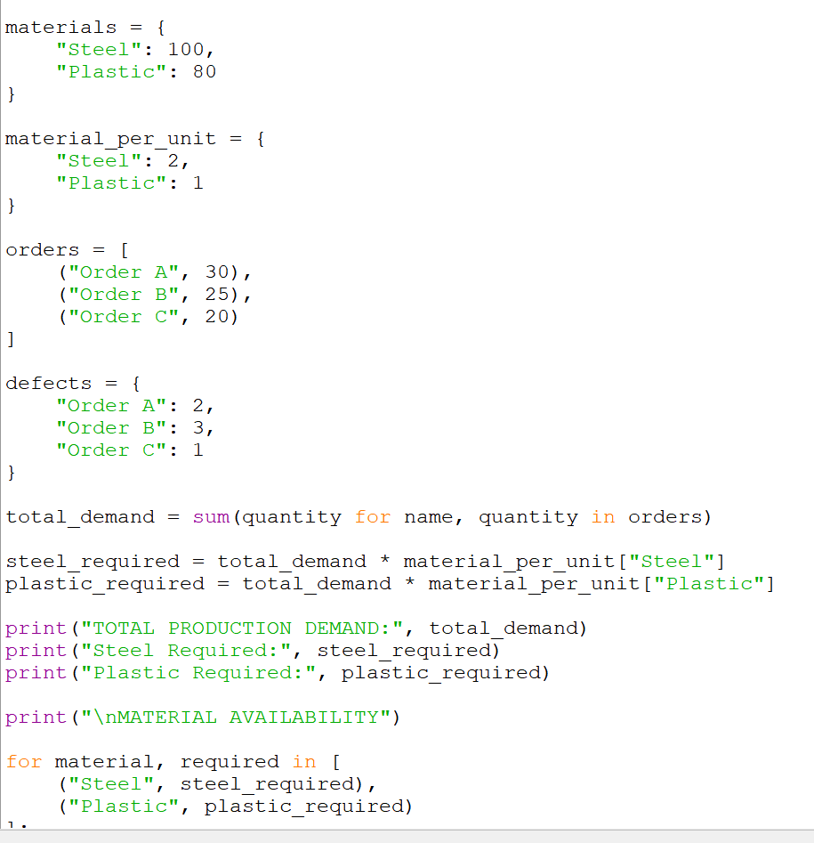

Output:-

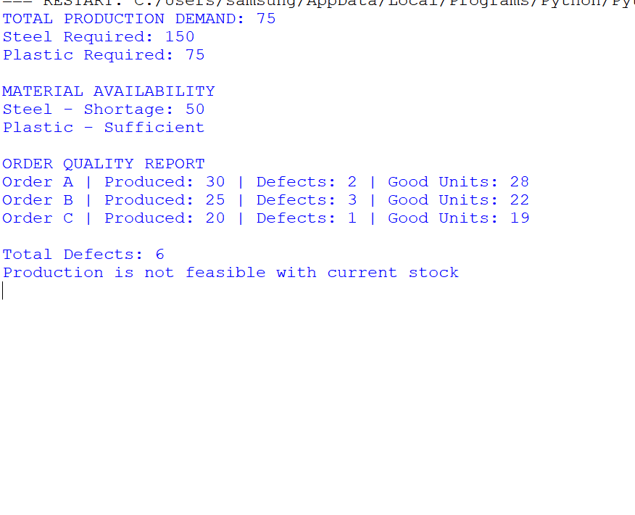

Case Study 96: Multi-Criteria Library Resource Distribution

Problem statement
Distribute limited book copies to library branches according to borrowing demand and priority, then calculate unmet demand.

Objectives
  - Store branch requirements and demand.
  - Allocate copies using priority and demand rules.
  - Report allocations, unmet demand, and remaining copies.

Assumptions
  - A single book title is being allocated.
  - High-priority branches are handled first; ties are handled by larger demand first.
  - Copies are indivisible.

Algorithm
- Set available copies and branch requests.
- Sort requests by priority and demand.
- Allocate the minimum of requested and remaining copies.
- Calculate unmet demand.
- Print final stock.

Flowchart
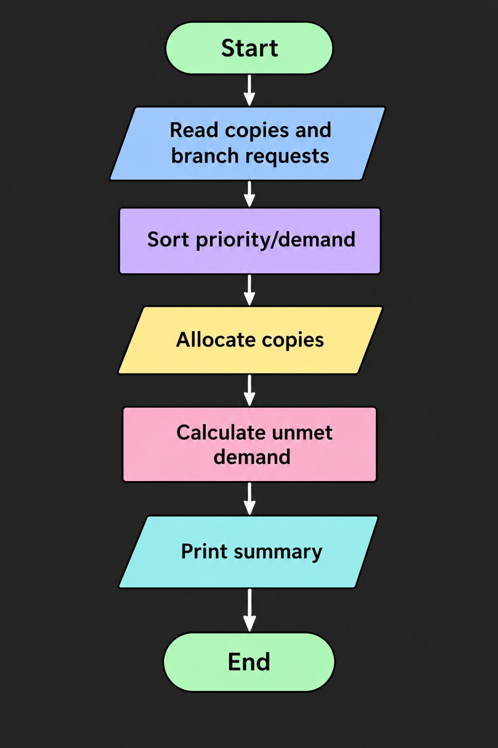

Pseudocode
START
available ← number of copies requests ← branch, priority, demand
sort by priority ascending then demand descending FOR each request
allocated ← minimum(demand, available)
available ← available − allocated unmet ← demand − allocated
print branch, allocated, unmet print available copies
STOP

Python source code
# Case Study 96: Library Resource Distribution available_copies = 50
requests = [
("Main Library", "HIGH", 30), ("Engineering Branch", "MEDIUM", 25), ("Arts Branch", "LOW", 15),
("Science Branch", "HIGH", 20)
]
priority = {"HIGH": 1, "MEDIUM": 2, "LOW": 3}
requests.sort(key=lambda row: (priority[row[1]], -row[2]))

print("Branch Demand Allocated Unmet") for branch, level, demand in requests:
allocated = min(demand, available_copies) available_copies -= allocated
unmet = demand - allocated print(branch, demand, allocated, unmet)

print("Copies remaining:", available_copies)

Test cases

Test | Input / condition | Expected result
Demand within stock | Demand 20, stock 50 | Allocate 20, unmet 0

Test | Input / condition | Expected result
Limited stock | Demand 25, remaining stock 20 | Allocate 20, unmet 5
No copies left | Demand 10, stock 0 | Allocate 0, unmet 10

Sample output
Branch Demand Allocated Unmet Main Library 30 30 0
Science Branch 20 20 0
Engineering Branch 25 0 25
Arts Branch 15 0 15
Copies remaining: 0

ERROR:
Spreadsheet runtime warmup failed during python startup Traceback (most recent call last):
File "/tmp/tmp.QlpUkOUI9D/artifact_tool_v2-2.8.66/artifact_tool/patches/warm_spreadsheet_runtime_on_startup.py", line 26, in warm_sprea File "/tmp/tmp.QlpUkOUI9D/artifact_tool_v2-2.8.66/artifact_tool/spreadsheet_warmup.py", line 785, in warm_spreadsheet_runtime
File "/tmp/tmp.QlpUkOUI9D/artifact_tool_v2-2.8.66/artifact_tool/spreadsheet_warmup.py", line 718, in _warm_feature_flows
File "/tmp/tmp.QlpUkOUI9D/artifact_tool_v2-2.8.66/artifact_tool/spreadsheet_warmup.py", line 509, in _warm_drawing_and_image_flows File "/tmp/tmp.QlpUkOUI9D/artifact_tool_v2-2.8.66/artifact_tool/generated/interface/models.py", line 32861, in bring_to_front
File "/tmp/tmp.QlpUkOUI9D/artifact_tool_v2-2.8.66/artifact_tool/rpc/remote.py", line 764, in call File "/tmp/tmp.QlpUkOUI9D/artifact_tool_v2-2.8.66/artifact_tool/rpc/client.py", line 175, in call
artifact_tool.rpc.client.RemoteError: Element ordering requires an owning element collection.
Output screenshot: output_screenshots/case_study_96_output.png

Conclusion
The program uses tuples, sorting, and controlled allocation to distribute a limited resource according to explicit priority rules.
Screenshot:-code program
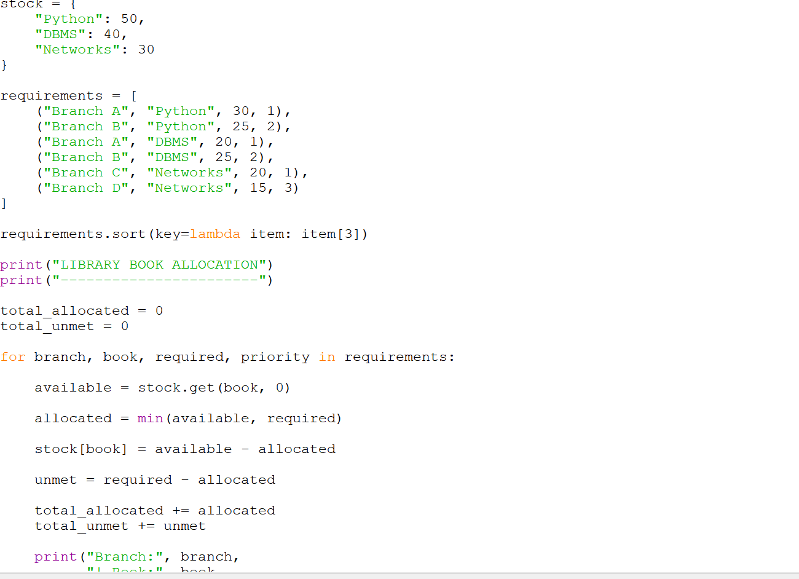
Output:-

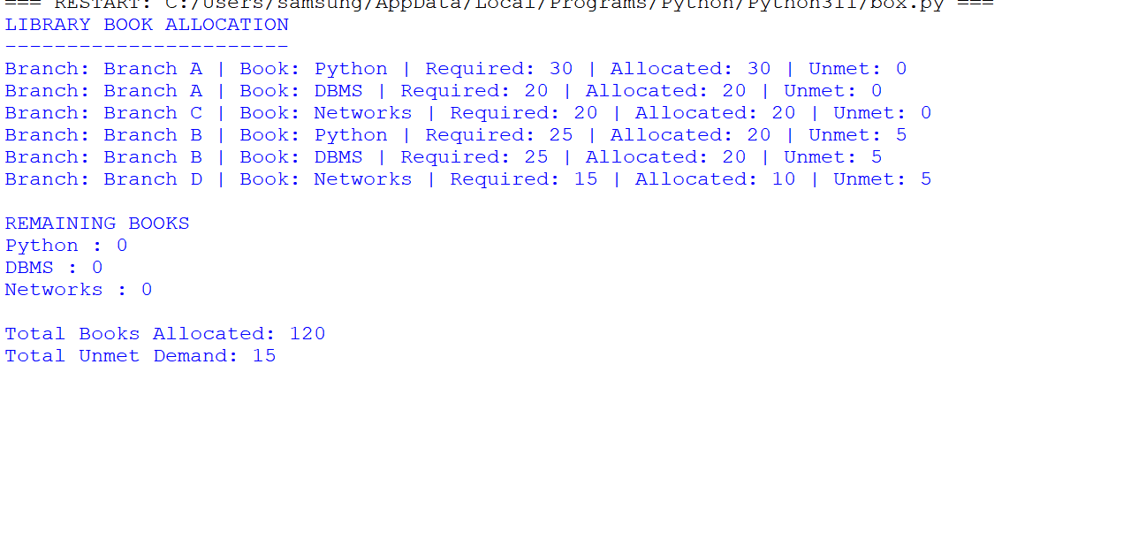

Case Study 97: Smart Campus Incident and Maintenance Prioritization

Problem statement
Classify hypothetical maintenance reports using severity, location, and report frequency, rank cases by a defined score, and summarize priorities.

Objectives
  - Calculate a score from severity, location importance, and frequency.
  - Rank incidents from highest score to lowest.
  - Assign priority labels and count high-priority cases.

Assumptions
  - Score = severity × 3 + location weight × 2 + frequency.
  - Severity is 1–5; location weight is 1–3; frequency is a non-negative count.
  - Scores of 20 or above are HIGH, 12–19 MEDIUM, below 12 LOW.

Algorithm
- Store each incident with ID, issue, severity, location weight, and frequency.
- Calculate score using the stated formula.
- Assign a priority label from the score.
- Sort incidents by score descending.
- Print ranked list and priority counts.

Flowchart
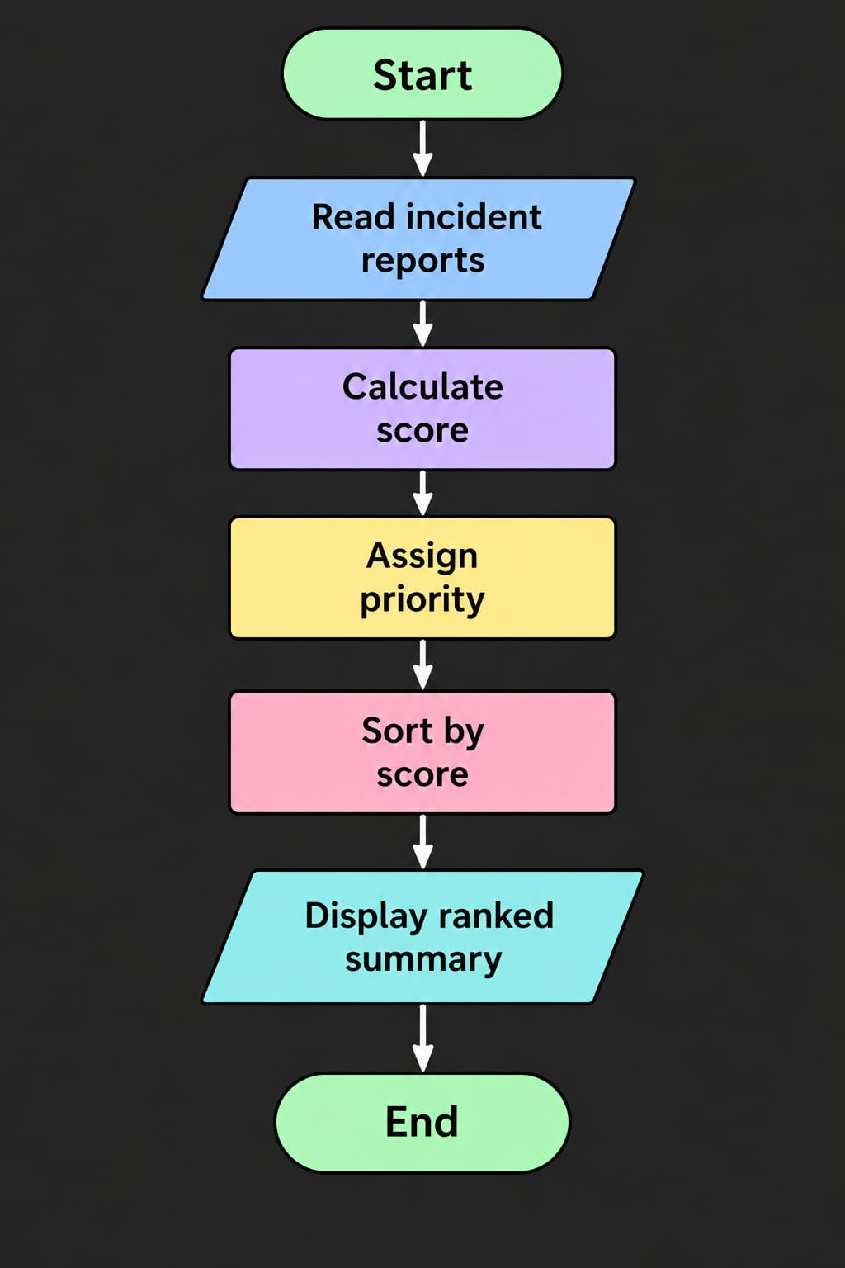

Pseudocode
START
incidents ← sample report list FOR each incident
score ← severity × 3 + location_weight × 2 + frequency
assign HIGH/MEDIUM/LOW by thresholds sort incidents by score descending
print ranked incidents and summary counts STOP

Python source code
# Case Study 97: Campus Incident Prioritization incidents = [
("I01", "Electrical fault", 5, 3, 4),
("I02", "Broken chair", 1, 1, 2),
("I03", "Water leakage", 4, 3, 3),
("I04", "Projector issue", 2, 2, 5)
]
ranked = []
counts = {"HIGH": 0, "MEDIUM": 0, "LOW": 0}

for incident_id, issue, severity, location_weight, frequency in incidents: score = severity * 3 + location_weight * 2 + frequency
if score >= 20: level = "HIGH"
elif score >= 12: level = "MEDIUM"
else:
level = "LOW"
ranked.append((score, incident_id, issue, level)) counts[level] += 1

ranked.sort(reverse=True)
print("RANK ID SCORE PRIORITY ISSUE")
for rank, (score, incident_id, issue, level) in enumerate(ranked, start=1): print(rank, incident_id, score, level, issue)
print("Priority summary:", counts)

Test cases

Test | Input / condition | Expected result
Severe electrical fault | Severity 5, location 3, frequency 4 | Score 25, HIGH
Low severity chair | Severity 1, location 1, frequency 2 | Score 7, LOW
Ranking | Compare all calculated scores | Highest score appears first

Sample output
RANK ID SCORE PRIORITY ISSUE
- I01 25 HIGH Electrical fault
- I03 21 HIGH Water leakage
- I04 15 MEDIUM Projector issue
- I02 7 LOW Broken chair
Priority summary: {'HIGH': 2, 'MEDIUM': 1, 'LOW': 1}

ERROR:
Spreadsheet runtime warmup failed during python startup Traceback (most recent call last):
File "/tmp/tmp.QlpUkOUI9D/artifact_tool_v2-2.8.66/artifact_tool/patches/warm_spreadsheet_runtime_on_startup.py", line 26, in warm_sprea File "/tmp/tmp.QlpUkOUI9D/artifact_tool_v2-2.8.66/artifact_tool/spreadsheet_warmup.py", line 785, in warm_spreadsheet_runtime
File "/tmp/tmp.QlpUkOUI9D/artifact_tool_v2-2.8.66/artifact_tool/spreadsheet_warmup.py", line 718, in _warm_feature_flows
File "/tmp/tmp.QlpUkOUI9D/artifact_tool_v2-2.8.66/artifact_tool/spreadsheet_warmup.py", line 509, in _warm_drawing_and_image_flows File "/tmp/tmp.QlpUkOUI9D/artifact_tool_v2-2.8.66/artifact_tool/generated/interface/models.py", line 32861, in bring_to_front
File "/tmp/tmp.QlpUkOUI9D/artifact_tool_v2-2.8.66/artifact_tool/rpc/remote.py", line 764, in call File "/tmp/tmp.QlpUkOUI9D/artifact_tool_v2-2.8.66/artifact_tool/rpc/client.py", line 175, in call
artifact_tool.rpc.client.RemoteError: Element ordering requires an owning element collection.
Output screenshot: output_screenshots/case_study_97_output.png

Conclusion
The program applies a transparent scoring formula to rank maintenance cases and summarize workload by priority.
Screenshot:-program code

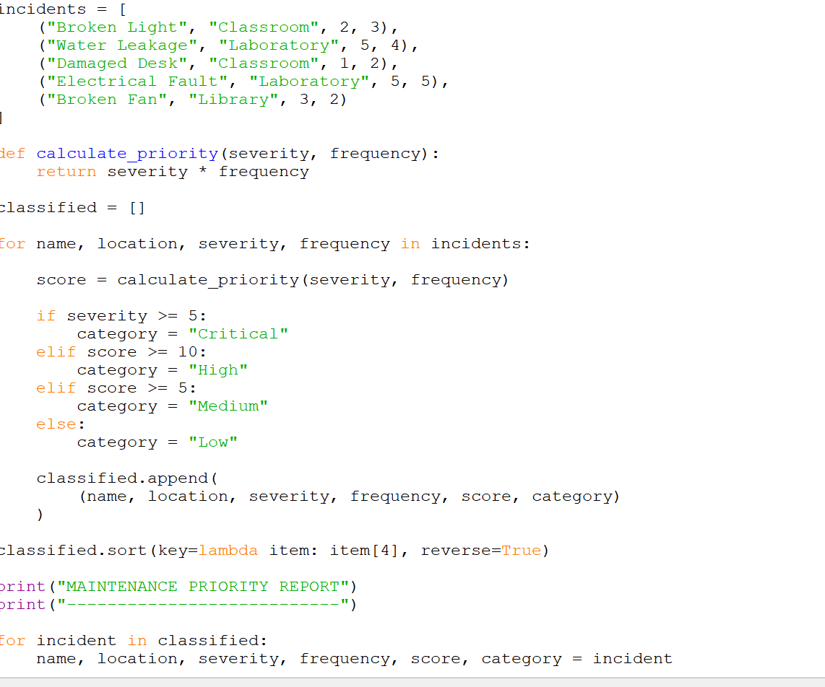
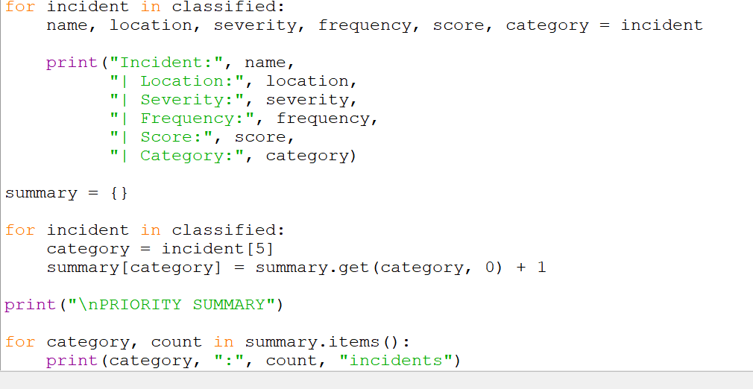

Output:-
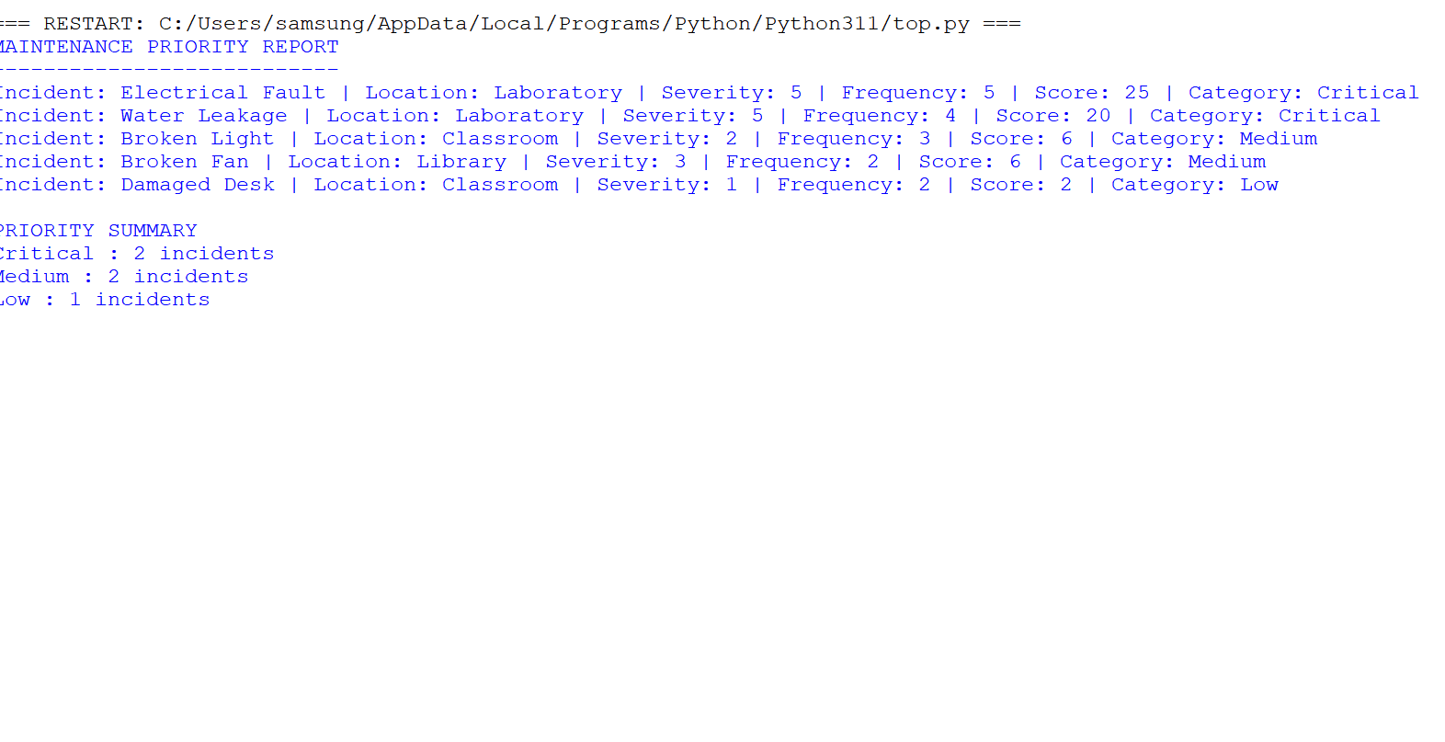

Case Study 98: University Academic Progression Audit

Problem statement
Combine marks, attendance, pass requirements, and prerequisite completion to decide whether a student may progress and list outstanding requirements.

Objectives
  - Check each subject against its minimum pass mark.
  - Check attendance against the required percentage.
  - Check prerequisite completion.
  - Give an eligibility result and list reasons for ineligibility.

Assumptions
  - Pass mark is 40 out of 100 for each subject.
  - Minimum attendance is 75%.
  - Progression requires all subjects passed, sufficient attendance, and prerequisite completion.

Algorithm
- Store marks, attendance, and prerequisite status.
- Check every subject mark against 40.
- Check attendance against 75%.
- Check prerequisite status.
- Print each failed condition and overall eligibility.

Flowchart
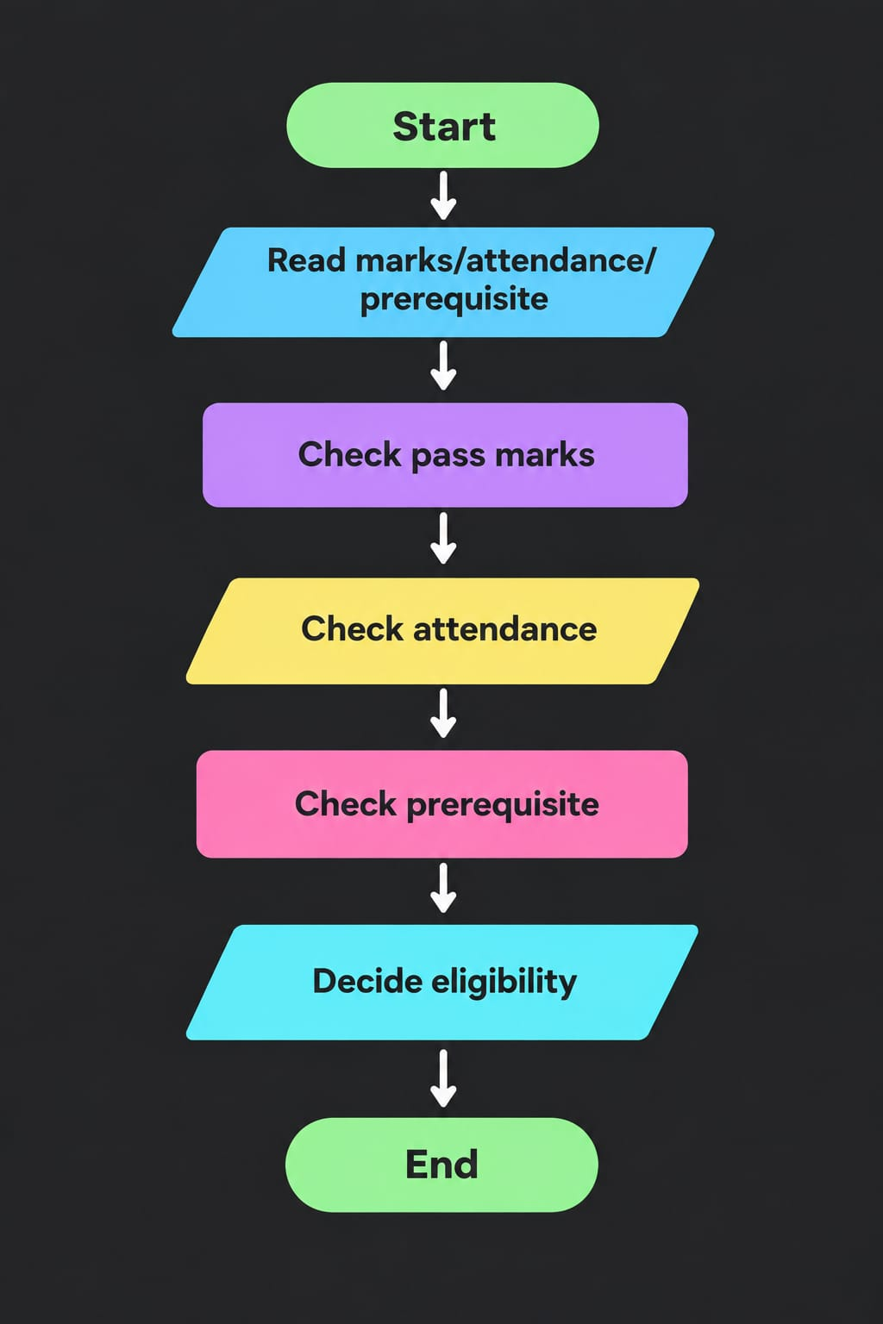

Pseudocode
START
marks ← subject-to-mark mapping attendance ← percentage prerequisite_done ← true or false outstanding ← empty list
FOR each subject, mark
IF mark < 40 add subject to outstanding IF attendance < 75 add attendance requirement
IF prerequisite not done add prerequisite requirement
IF outstanding empty print ELIGIBLE ELSE NOT ELIGIBLE and list reasons STOP

Python source code
# Case Study 98: Academic Progression Audit
marks = {"Python": 72, "Mathematics": 38, "English": 65}
attendance = 82 prerequisite_completed = True pass_mark = 40
minimum_attendance = 75

outstanding = []
for subject, mark in marks.items(): if mark < pass_mark:
outstanding.append(subject + " pass requirement")

if attendance < minimum_attendance: outstanding.append("Attendance requirement")
if not prerequisite_completed: outstanding.append("Prerequisite completion")

print("Academic Progression Audit") print("Marks:", marks) print("Attendance:", attendance, "%") if outstanding:
print("Progression: NOT ELIGIBLE") print("Outstanding requirements:") for item in outstanding:
print("-", item)

else:
print("Progression: ELIGIBLE")

Test cases

Test | Input / condition | Expected result
All conditions met | All marks >=40, attendance 80, prerequisite done | ELIGIBLE
Subject failed | Mathematics 38 | NOT ELIGIBLE; subject listed
Low attendance | Attendance 70 | Attendance requirement listed

Sample output
Academic Progression Audit
Marks: {'Python': 72, 'Mathematics': 38, 'English': 65}
Attendance: 82 % Progression: NOT ELIGIBLE Outstanding requirements:
- Mathematics pass requirement

ERROR:
Spreadsheet runtime warmup failed during python startup Traceback (most recent call last):
File "/tmp/tmp.QlpUkOUI9D/artifact_tool_v2-2.8.66/artifact_tool/patches/warm_spreadsheet_runtime_on_startup.py", line 26, in warm_sprea File "/tmp/tmp.QlpUkOUI9D/artifact_tool_v2-2.8.66/artifact_tool/spreadsheet_warmup.py", line 785, in warm_spreadsheet_runtime
File "/tmp/tmp.QlpUkOUI9D/artifact_tool_v2-2.8.66/artifact_tool/spreadsheet_warmup.py", line 718, in _warm_feature_flows
File "/tmp/tmp.QlpUkOUI9D/artifact_tool_v2-2.8.66/artifact_tool/spreadsheet_warmup.py", line 509, in _warm_drawing_and_image_flows File "/tmp/tmp.QlpUkOUI9D/artifact_tool_v2-2.8.66/artifact_tool/generated/interface/models.py", line 32861, in bring_to_front
File "/tmp/tmp.QlpUkOUI9D/artifact_tool_v2-2.8.66/artifact_tool/rpc/remote.py", line 764, in call File "/tmp/tmp.QlpUkOUI9D/artifact_tool_v2-2.8.66/artifact_tool/rpc/client.py", line 175, in call
artifact_tool.rpc.client.RemoteError: Element ordering requires an owning element collection.
Output screenshot: output_screenshots/case_study_98_output.png

Conclusion
The program checks academic requirements systematically and explains which conditions must be completed before progression.
Screenshot:-program code:-

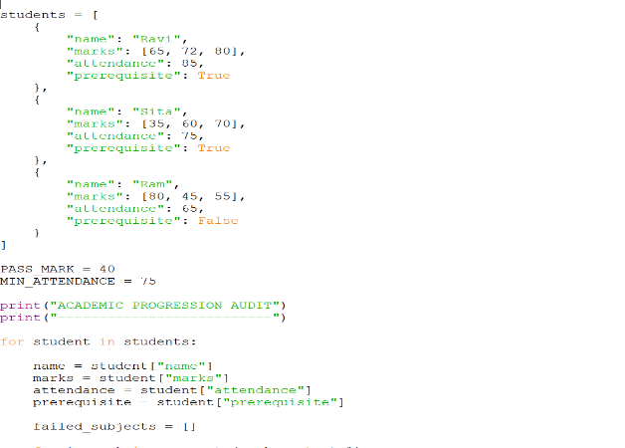
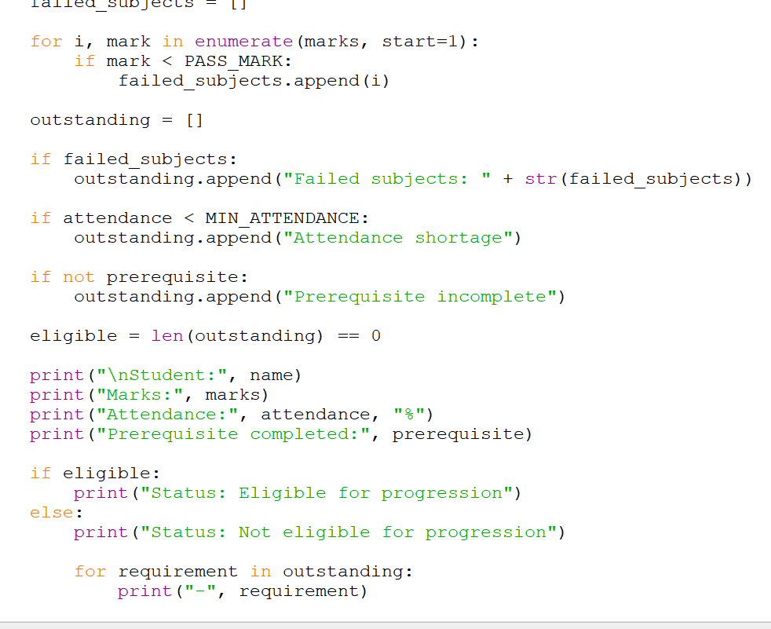
Output:-

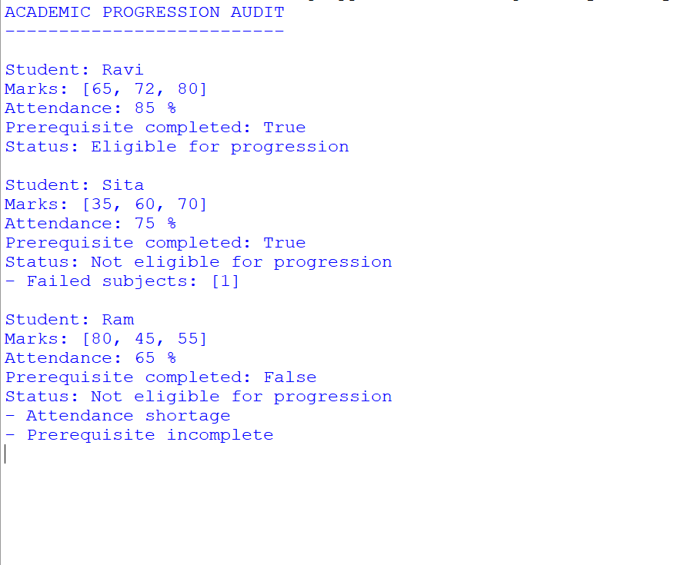

Case Study 99: Integrated E-Commerce Order Processing and Reconciliation

Problem statement
Process product orders, discounts, dispatches, returns, and stock updates; calculate net revenue and identify inventory discrepancies.

Objectives
  - Calculate order totals after discounts.
  - Update stock for dispatched and returned quantities.
  - Compare expected stock with recorded stock and report discrepancies.

Assumptions
  - Discount is a percentage of the order subtotal.
  - Dispatch reduces inventory; a returned item that is restocked increases inventory.
  - The sample data contains one order and one return.

Algorithm
- Set product price and starting stock.
- Calculate subtotal, discount, and net order amount.
- Reduce stock by dispatched quantity.
- Increase stock by returned quantity if restocked.
- Compare calculated stock with recorded stock and print reconciliation.

Flowchart

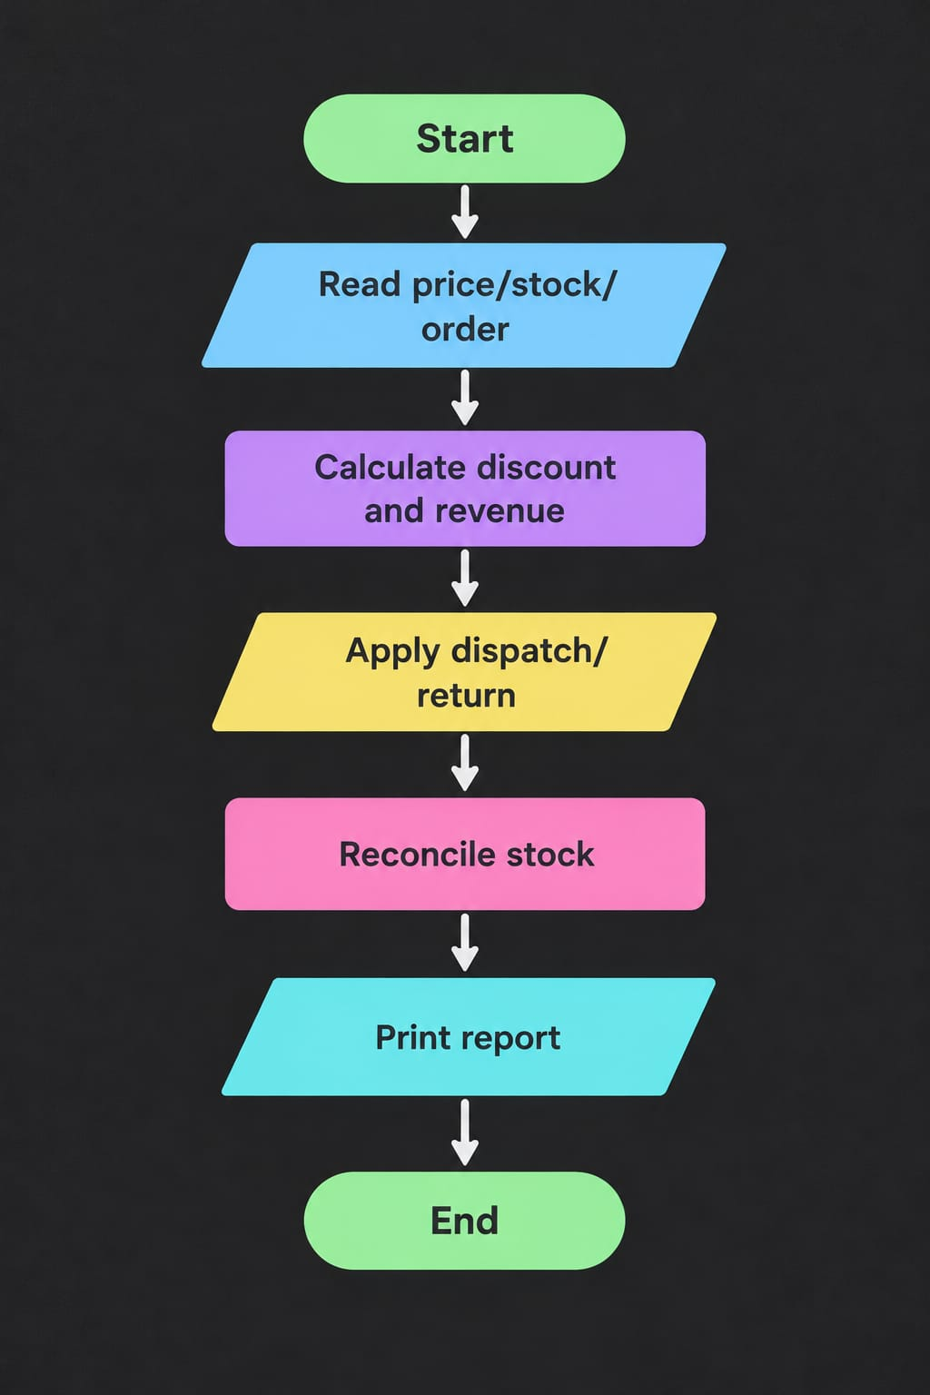

Pseudocode
START
price, stock, order quantity, discount, dispatch, return, recorded stock ← sample values subtotal ← price × order quantity
net revenue ← subtotal × (1 − discount/100)
calculated stock ← starting stock − dispatched + restocked returns discrepancy ← recorded stock − calculated stock
print order and inventory report STOP

Python source code
# Case Study 99: E-Commerce Order Reconciliation product = "Wireless Mouse"
price = 800
starting_stock = 100
order_quantity = 5
discount_percent = 10
dispatched_quantity = 5
returned_quantity = 1 return_restocked = True recorded_stock = 96

subtotal = price * order_quantity
discount = subtotal * discount_percent / 100 net_revenue = subtotal - discount

calculated_stock = starting_stock - dispatched_quantity if return_restocked:
calculated_stock += returned_quantity discrepancy = recorded_stock - calculated_stock

print("Product:", product) print("Subtotal: Rs.", subtotal) print("Discount: Rs.", discount) print("Net revenue: Rs.", net_revenue)
print("Calculated stock:", calculated_stock) print("Recorded stock:", recorded_stock) print("Stock discrepancy:", discrepancy)
if discrepancy == 0:

print("Inventory status: MATCH") else:
print("Inventory status: DISCREPANCY")

Test cases

Test | Input / condition | Expected result
Discount calculation | 5 × Rs.800, 10% discount | Net revenue Rs.3600
Return restocked | 100 - 5 + 1 | Calculated stock 96
Mismatch | Recorded stock 95, calculated 96 | Discrepancy -1

Sample output
Product: Wireless Mouse Subtotal: Rs. 4000
Discount: Rs. 400.0
Net revenue: Rs. 3600.0 Calculated stock: 96
Recorded stock: 96
Stock discrepancy: 0 Inventory status: MATCH

ERROR:
Spreadsheet runtime warmup failed during python startup Traceback (most recent call last):
File "/tmp/tmp.QlpUkOUI9D/artifact_tool_v2-2.8.66/artifact_tool/patches/warm_spreadsheet_runtime_on_startup.py", line 26, in warm_sprea File "/tmp/tmp.QlpUkOUI9D/artifact_tool_v2-2.8.66/artifact_tool/spreadsheet_warmup.py", line 785, in warm_spreadsheet_runtime
File "/tmp/tmp.QlpUkOUI9D/artifact_tool_v2-2.8.66/artifact_tool/spreadsheet_warmup.py", line 718, in _warm_feature_flows
File "/tmp/tmp.QlpUkOUI9D/artifact_tool_v2-2.8.66/artifact_tool/spreadsheet_warmup.py", line 509, in _warm_drawing_and_image_flows File "/tmp/tmp.QlpUkOUI9D/artifact_tool_v2-2.8.66/artifact_tool/generated/interface/models.py", line 32861, in bring_to_front
File "/tmp/tmp.QlpUkOUI9D/artifact_tool_v2-2.8.66/artifact_tool/rpc/remote.py", line 764, in call File "/tmp/tmp.QlpUkOUI9D/artifact_tool_v2-2.8.66/artifact_tool/rpc/client.py", line 175, in call
artifact_tool.rpc.client.RemoteError: Element ordering requires an owning element collection.
Output screenshot: output_screenshots/case_study_99_output.png

Conclusion
The program combines order calculations and stock movement rules to produce a basic revenue and inventory reconciliation report.

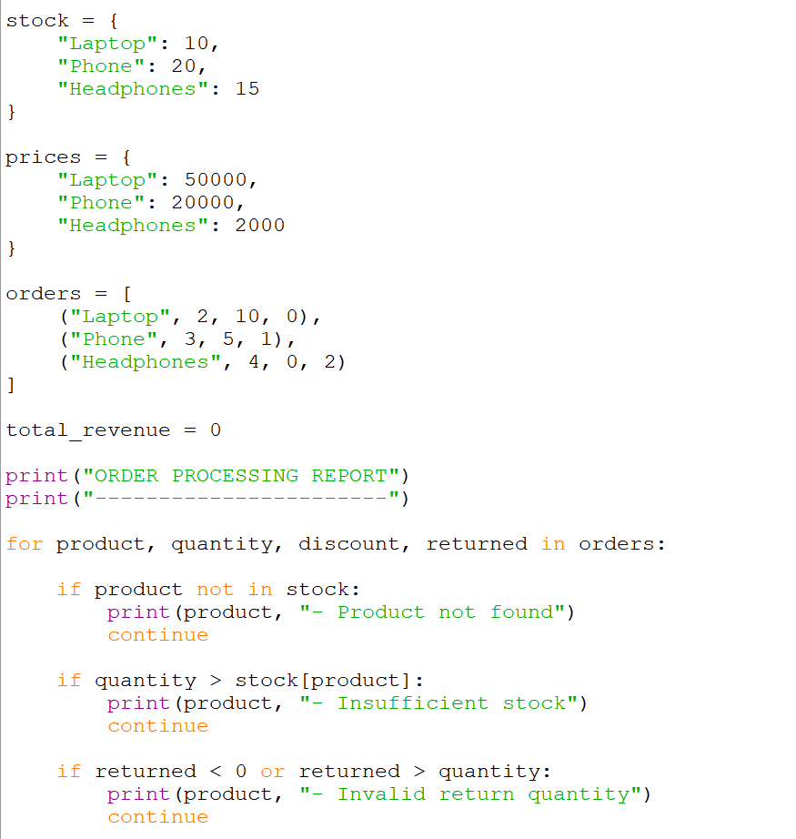
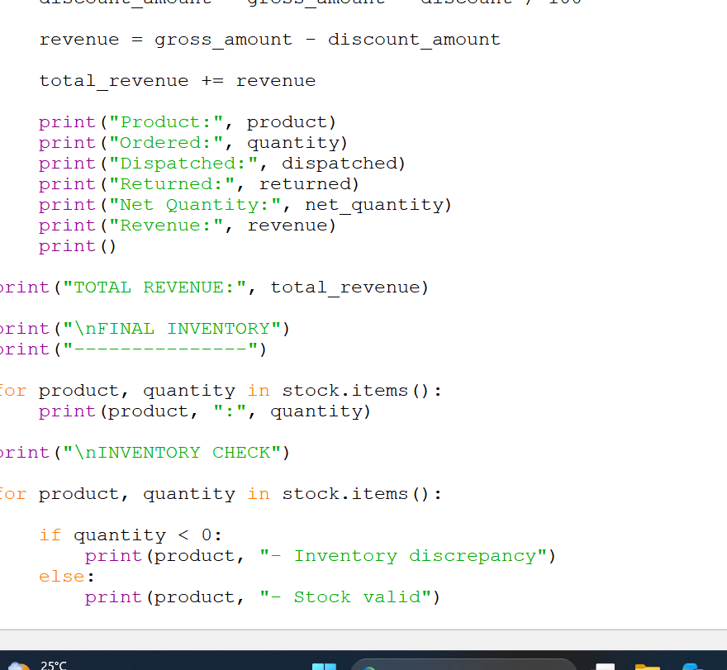
Output:-

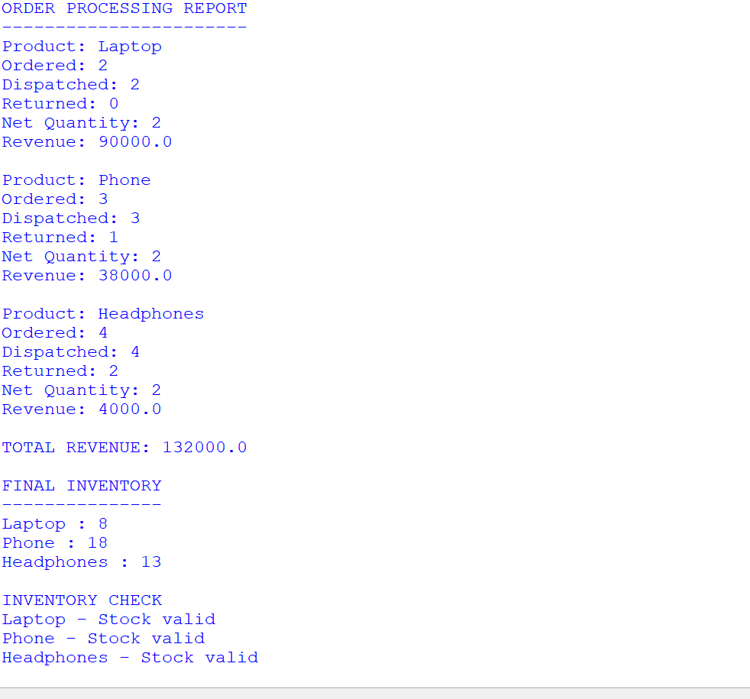

Case Study 100: Comprehensive Smart Campus Management Simulation

Problem statement
Create a menu-driven program that combines student records, attendance, marks, event registration, resource allocation, and summary reporting.

Objectives
  - Add and display student records.
  - Record attendance and marks.
  - Register students for events.
  - Allocate limited campus resources.
  - Generate a summary using lists, nested lists, tuples, and tuple unpacking.

Assumptions
  - This is a small demonstration using in-memory sample data; data is not saved after program exit.
  - Student IDs are unique in the sample.
  - Attendance is recorded as present/total classes; event and resource limits are illustrative.

Algorithm
- Initialize student, attendance, marks, event, and resource data structures.
- Display a menu in a loop.
- Run the selected operation: view students, record attendance, enter marks, register event, allocate resource, or summary.
- Validate simple inputs and update lists/dictionaries.
- Repeat until the user selects Exit.

Flowchat

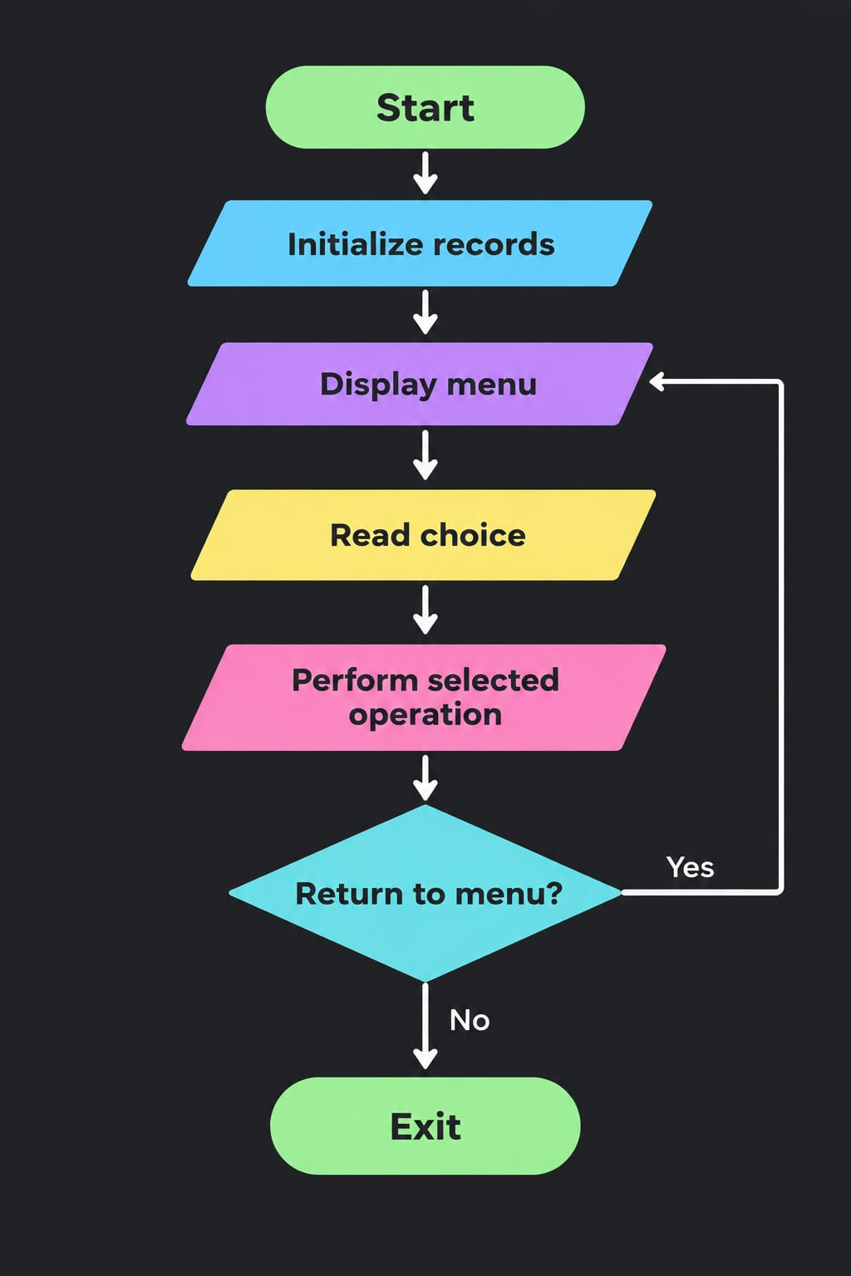

Pseudocode
START
initialize student records, attendance, marks, event list, resource stock REPEAT
display menu read choice
IF choice is 1 display students
ELSE IF choice is 2 record attendance ELSE IF choice is 3 enter marks
ELSE IF choice is 4 register event ELSE IF choice is 5 allocate resource ELSE IF choice is 6 show summary
UNTIL choice is 0 STOP

Python source code
# Case Study 100: Smart Campus Management Simulation students = [
["S101", "Asha", "CSM"],
["S102", "Rahul", "CSE"]
]
attendance = {"S101": [8, 10], "S102": [7, 10]}
marks = {"S101": [78, 85], "S102": [66, 72]}
events = []
resources = {"Projector": 2, "Laptop": 3}

while True:
print("\nSMART CAMPUS MANAGEMENT")
print("1. View students") print("2. View attendance") print("3. View marks") print("4. Register for event") print("5. Allocate resource") print("6. Summary report") print("0. Exit")
choice = input("Enter choice: ")

if choice == "1":
for student_id, name, branch in students: print(student_id, name, branch)
elif choice == "2":
for student_id, record in attendance.items(): present, total = record
percent = present / total * 100
print(student_id, "Attendance:", round(percent, 1), "%") elif choice == "3":
for student_id, subject_marks in marks.items():
print(student_id, "Marks:", subject_marks, "Average:", sum(subject_marks) / len(subject_marks)) elif choice == "4":
student_id = input("Student ID: ") event_name = input("Event name: ")
known_ids = [student[0] for student in students] if student_id in known_ids:
events.append((student_id, event_name)) print("Registration successful")
else:
print("Student ID not found") elif choice == "5":
resource_name = input("Resource name (Projector/Laptop): ")
if resource_name in resources and resources[resource_name] > 0: resources[resource_name] -= 1
print("Resource allocated. Remaining:", resources[resource_name]) else:
print("Resource unavailable or invalid") elif choice == "6":
print("Total students:", len(students)) print("Event registrations:", len(events)) print("Resources remaining:", resources)
elif choice == "0":
print("Exiting Smart Campus Management. Goodbye!") break
else:
print("Invalid choice. Please try again.")

Test cases

Test | Input / condition | Expected result
View students | Choose menu option 1 | Displays S101 Asha and S102 Rahul
Register known student | S101, Coding Contest | Registration successful
Register unknown student | S999, Coding Contest | Student ID not found
Allocate resource | Projector when stock is 2 | Remaining Projector stock becomes 1
Exit | Choose 0 | Program exits

Sample output
SMART CAMPUS MANAGEMENT
- View students
- View attendance
- View marks
- Register for event
- Allocate resource
- Summary report
- Exit
Enter choice: Total students: 2 Event registrations: 0
Resources remaining: {'Projector': 2, 'Laptop': 3}

SMART CAMPUS MANAGEMENT
- View students
- View attendance
- View marks
- Register for event
- Allocate resource
- Summary report
0. Exit
Enter choice: Exiting Smart Campus Management. Goodbye!

ERROR:
Spreadsheet runtime warmup failed during python startup Traceback (most recent call last):
File "/tmp/tmp.QlpUkOUI9D/artifact_tool_v2-2.8.66/artifact_tool/patches/warm_spreadsheet_runtime_on_startup.py", line 26, in warm_sprea File "/tmp/tmp.QlpUkOUI9D/artifact_tool_v2-2.8.66/artifact_tool/spreadsheet_warmup.py", line 785, in warm_spreadsheet_runtime
File "/tmp/tmp.QlpUkOUI9D/artifact_tool_v2-2.8.66/artifact_tool/spreadsheet_warmup.py", line 718, in _warm_feature_flows
File "/tmp/tmp.QlpUkOUI9D/artifact_tool_v2-2.8.66/artifact_tool/spreadsheet_warmup.py", line 509, in _warm_drawing_and_image_flows File "/tmp/tmp.QlpUkOUI9D/artifact_tool_v2-2.8.66/artifact_tool/generated/interface/models.py", line 32861, in bring_to_front
File "/tmp/tmp.QlpUkOUI9D/artifact_tool_v2-2.8.66/artifact_tool/rpc/remote.py", line 764, in call File "/tmp/tmp.QlpUkOUI9D/artifact_tool_v2-2.8.66/artifact_tool/rpc/client.py", line 175, in call
artifact_tool.rpc.client.RemoteError: Element ordering requires an owning element collection.

Output screenshot: output_screenshots/case_study_100_output.png

Conclusion
The program integrates multiple campus activities in one menu-driven application and demonstrates loops, conditions, strings, lists, nested lists, dictionaries, tuples, and tuple unpacking.
Screenshot:-programcode
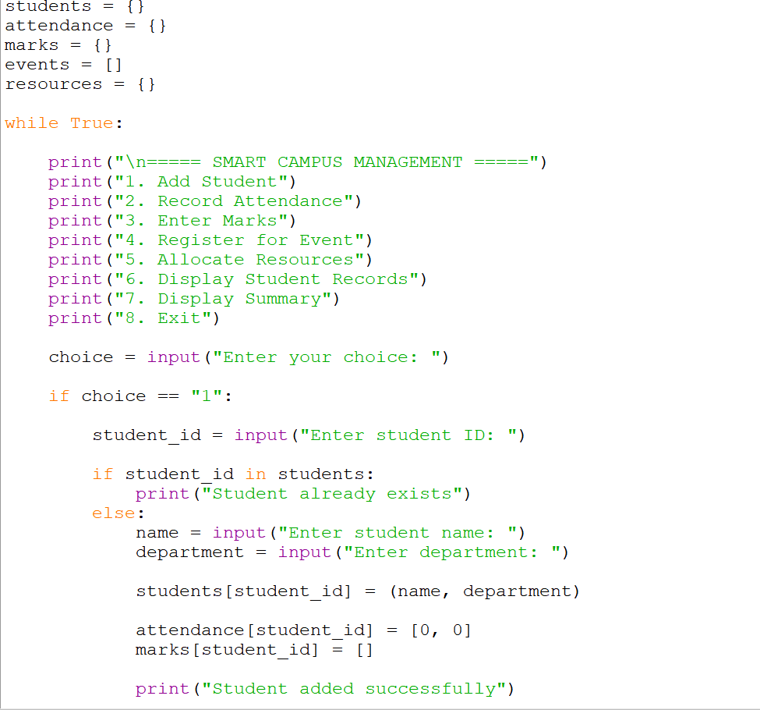
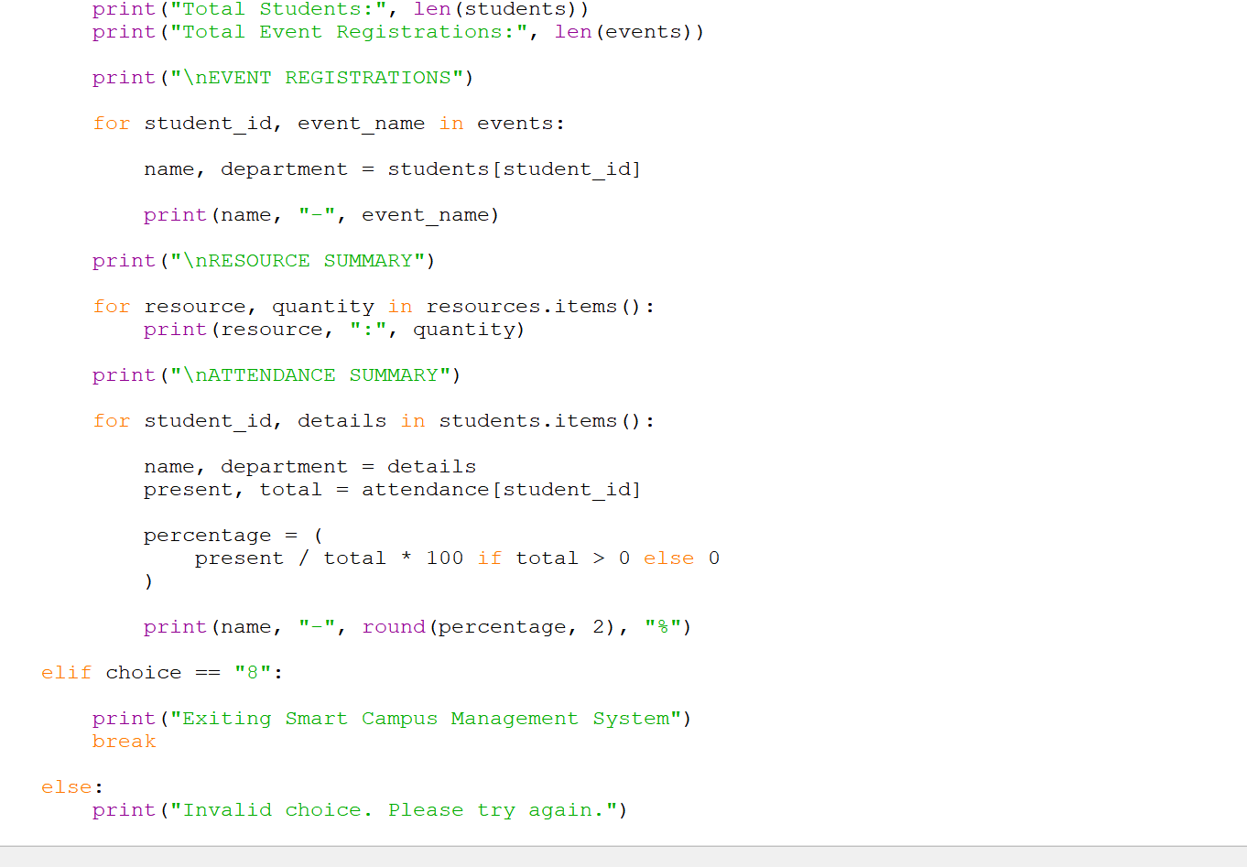
Output:-
