Pandranki

Shanmukha Rao

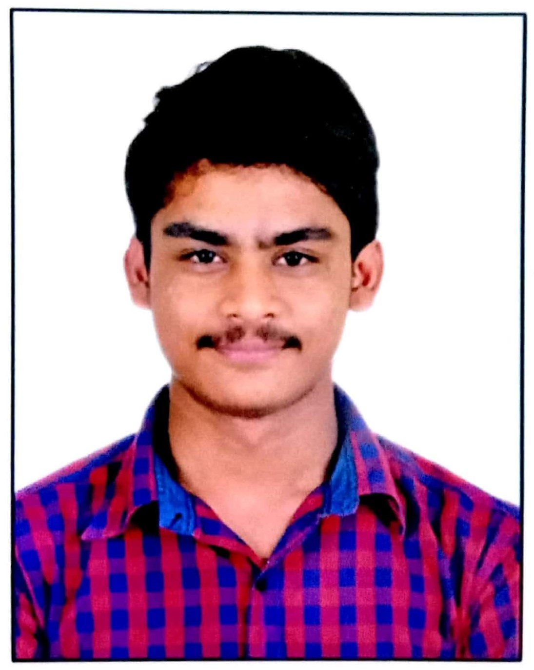

[+919490463466](https://api.whatsapp.com/send?phone=+919490463466)

shanmukmichael@gmail.com

Vizag, Andhra Pradesh, IN

[shanmukmichael](https://www.linkedin.com/in/shanmukmichael)

[shanmukmichael](https://www.github.com/shanmukmichael)

**SUMMARY**

I'm passionate about continuously

learning in the IT field and supporting

people to solve their technical problems.

**EDUCATION**

**BTech** 2018 – 2022 **Vignan's Institute of Information Technology**

• Percentage – 76.08%

**Intermediate**  2016 - 2018

**Sri Chaitanya Junior College**

• Percentage – 95.10%

**SSC**

**Narayana e-techno school** 2016

• Percentage – 93%





**SKILLS**

**Languages**

• C, C++, Java, Python

**Database System**

• MySQL

**Operating System**

• Windows, Ubuntu, Kali Linux

**Ongoing add-on courses**

• CCNA

**Additional Skills**

• Networking, Troubleshooting, AWS EC2,

Git & Github, Ethical Hacking, Flask, App

Development, Bootstrap, Unity3D,

Figma, Illustrator

Drawing

**CERTIFICATIONS**

[•](https://www.credly.com/earner/earned/badge/0db47c6a-4747-485b-943d-5ba463f879b5) **[CCNA : Introduction to Networks](https://www.credly.com/earner/earned/badge/0db47c6a-4747-485b-943d-5ba463f879b5)**

[– Cisco](https://www.credly.com/earner/earned/badge/0db47c6a-4747-485b-943d-5ba463f879b5)

• **[AWS Academy Graduate -](https://www.credly.com/badges/a3aae5e8-ce4b-4d46-9659-2f85b84eeb3b/linked_in)**

**[AWS Academy Cloud Foundation](https://www.credly.com/badges/a3aae5e8-ce4b-4d46-9659-2f85b84eeb3b/linked_in)**

[- AWS](https://www.credly.com/badges/a3aae5e8-ce4b-4d46-9659-2f85b84eeb3b/linked_in)

• **[Google IT Support Professional](https://www.credly.com/earner/earned/badge/ce582a1c-24d4-48de-8822-bb9b708d4ce7)**

**[Certificate](https://www.credly.com/earner/earned/badge/ce582a1c-24d4-48de-8822-bb9b708d4ce7)** [– Coursera](https://www.credly.com/earner/earned/badge/ce582a1c-24d4-48de-8822-bb9b708d4ce7)

• **[Google IT Automation with Python](https://www.credly.com/earner/earned/badge/2834ff07-5176-4d0b-bc2e-3d28f73043fe)**

**[Certificate](https://www.credly.com/earner/earned/badge/2834ff07-5176-4d0b-bc2e-3d28f73043fe)** [– Coursera](https://www.credly.com/earner/earned/badge/2834ff07-5176-4d0b-bc2e-3d28f73043fe)

**Projects**

[**Asset Discovery Tool**](https://github.com/shanmukmichael/Asset-Discovery-Tool)

• Scanned local & remote locations (using SSH tunnels) & maintained

a database of last seen status, with IP & MAC addresses,

hostname, operating system on Web – flask.

[**Graphical Password to avoid Shoulder Surfing Attacks**](https://github.com/shanmukmichael/Graphical-Password-to-Avoid-Shoulder-Surfing)

• Authenticated & authorized graphical password system which

would prevent the shoulder surfing attacks on websites – flask . **Virtual Mouse Controller Al**

• Controlled mouse & resolved smooth movements virtually infront

of camera by finger gestures – opencv, mediapipe.

[**License Plate Recognition Using Tensorflow**](https://github.com/shanmukmichael/License-Plate-Recognition-Using-Tensorflow)

• Trained a dataset by tensorflow model & detected the License

Plate on vehicles with >95% accuracy – tensorflow.

**EXPERIENCE**

**Intern – Cyber Security** 2020 **Techionary Info**

• Developed a new way of graphical password authentication

system which would prevent the effect of shoulder surfing.

**Volunteer - Developer Student Club (VIIT)** 2020 - 2021

**UI/UX Designer**

• Conducted workshops on various trending technologies – Git &

Github, Flutter, UI/UX, etc.