Customer Behavior Analytics and Conversion Optimization in E-Commerce

Project Overview
The E-Commerce Customer & Purchase Analytics Dashboard project was developed to analyze customer behavior, engagement, and purchasing patterns in an e-commerce environment. The project focuses on transforming raw customer data into meaningful business insights through interactive visualizations and analytical dashboards.
The dashboard provides a comprehensive overview of key business metrics such as customer engagement, purchase conversion, returning users, device usage, and customer journey stages. Various visualizations including KPI cards, funnel charts, donut charts, clustered column charts, and matrix analysis were used to identify patterns and trends in customer behavior.
The project also includes customer segmentation, advertisement and discount impact analysis, and engagement-based insights to support data-driven business decisions. Interactive slicers and filters were implemented to allow dynamic exploration of customer and sales data.
Overall, the dashboard helps businesses understand customer interactions more effectively and supports strategies for improving engagement, retention, and conversion performance.

Objectives

To analyze customer behavior and purchasing patterns in an e-commerce environment
- To identify key factors influencing customer engagement and purchase conversion
- To visualize customer journey stages and user interaction trends using interactive dashboards
- To perform customer segmentation based on demographics, engagement, and purchasing behavior
- To evaluate the impact of advertisements, discounts, and device usage on customer purchases
- To create meaningful KPI metrics such as conversion rate, engagement score, returning users, and average time on site
- To design a professional and interactive Power BI dashboard for business analytics and decision-making
- To generate actionable business insights that can help improve customer retention, engagement, and sales performance
- To transform raw customer data into clear and easy-to-understand visual reports using data visualization techniques
- Perform exploratory data analysis (EDA)
- Build a simple recommendation system

Dataset Features
The dataset contains user activity and engagement-related features such as:
Feature | Description
pages_viewed | Number of pages visited by the user
cart_items | Number of products added to cart
time_on_site | Time spent on the website
bounce_rate | User bounce behavior
purchase | Whether the user purchased or not
device_type | Device used by the customer
discount_seen | Whether user saw discount offers
ad_clicked | Whether user clicked advertisements

Technologies Used

Programming Language
- Python

Libraries
- Pandas
- NumPy
- Matplotlib
- Seaborn

Tools
- Google Colab
- Power BI

Data Preprocessing
The following preprocessing steps were performed:
- Data cleaning
- Handling missing values
- Feature selection
- Data transformation
- Created custom columns for business analysis and interactive reporting
- Organized customer data into meaningful categories for analysis and visualization
- Prepared the dataset for interactive dashboard development and KPI analysis.

Engagement Score Calculation
An engagement score was created to measure user activity on the website.
The engagement score was calculated using:
- Pages viewed
- Cart activity
- Time spent on the website
Users with higher interaction activity received higher engagement scores.

Engagement Level Segmentation
Users were categorized into:
- Low Engagement
- Medium Engagement
- High Engagement
This helped identify highly active users and low-engagement users.

Funnel Stage
- Shows the customer journey from visitor to purchase
- Helps identify where users drop off
- Useful for conversion analysis and marketing optimization
Customer Stage
- Categorizes users based on engagement and buying behavior
- Helps understand customer lifecycle stages
- Useful for targeted campaigns and retention strategies
Customer Recommendation
- Provides suggested business actions for each customer segment
- Helps improve engagement and conversion
- Supports personalized marketing decisions
Predicted Buyer
- Indicates users likely to make a purchase
- Helps identify high-potential customers
- Useful for predictive analytics and sales targeting
Buyer Label
- Classifies users as Buyer or Non-Buyer
- Simplifies purchase behavior analysis
- Useful for segmentation and KPI tracking.
Age Group
- Segments users by age categories
- Helps analyze demographic behavior patterns
- Useful for customer targeting and personalization

Exploratory Data Analysis (EDA)
EDA was performed to understand data patterns and user behavior.

Univariate Analysis
Analyzed single variables using:
- Countplot
- Histogram
Examples:
- Device type distribution
- PagesViewed

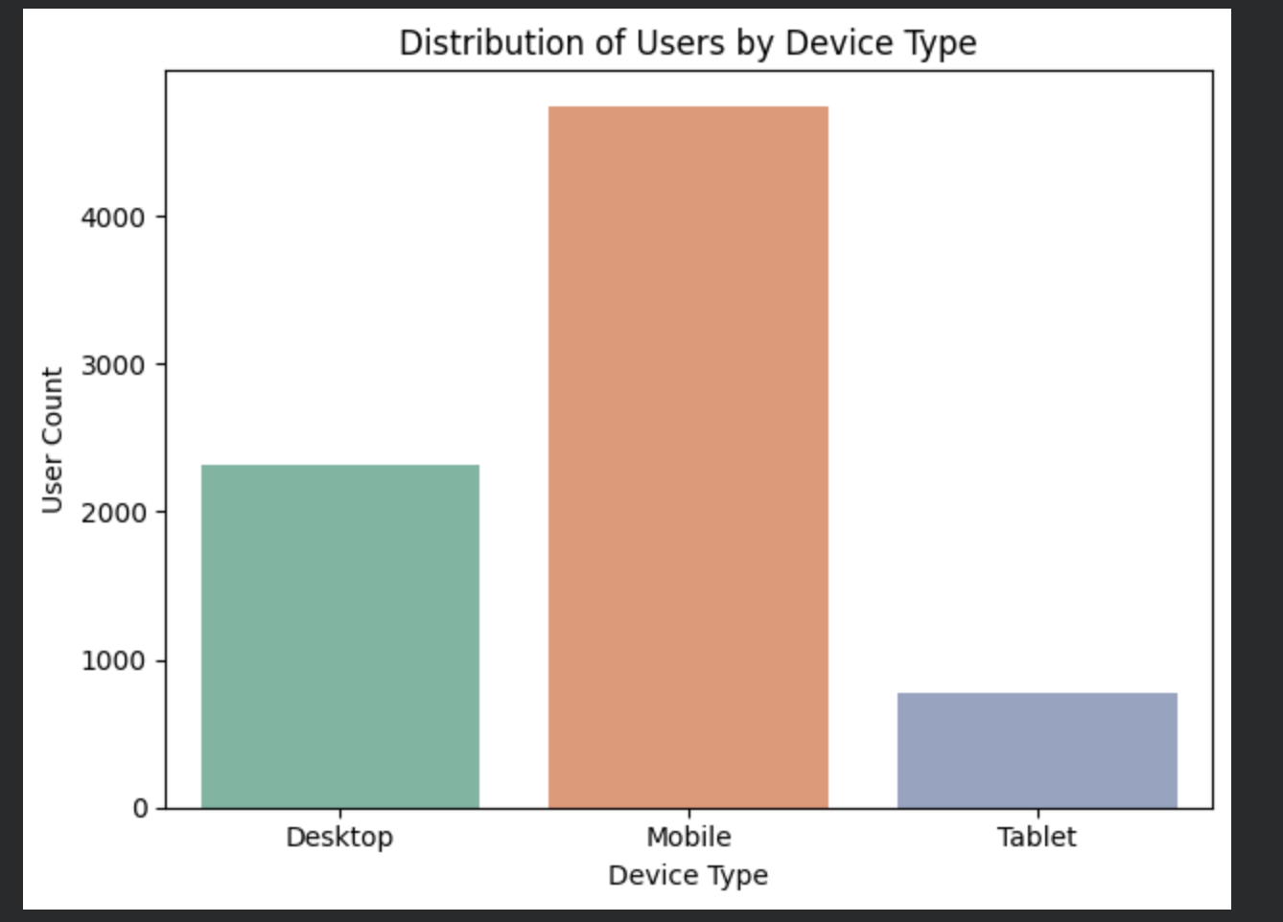

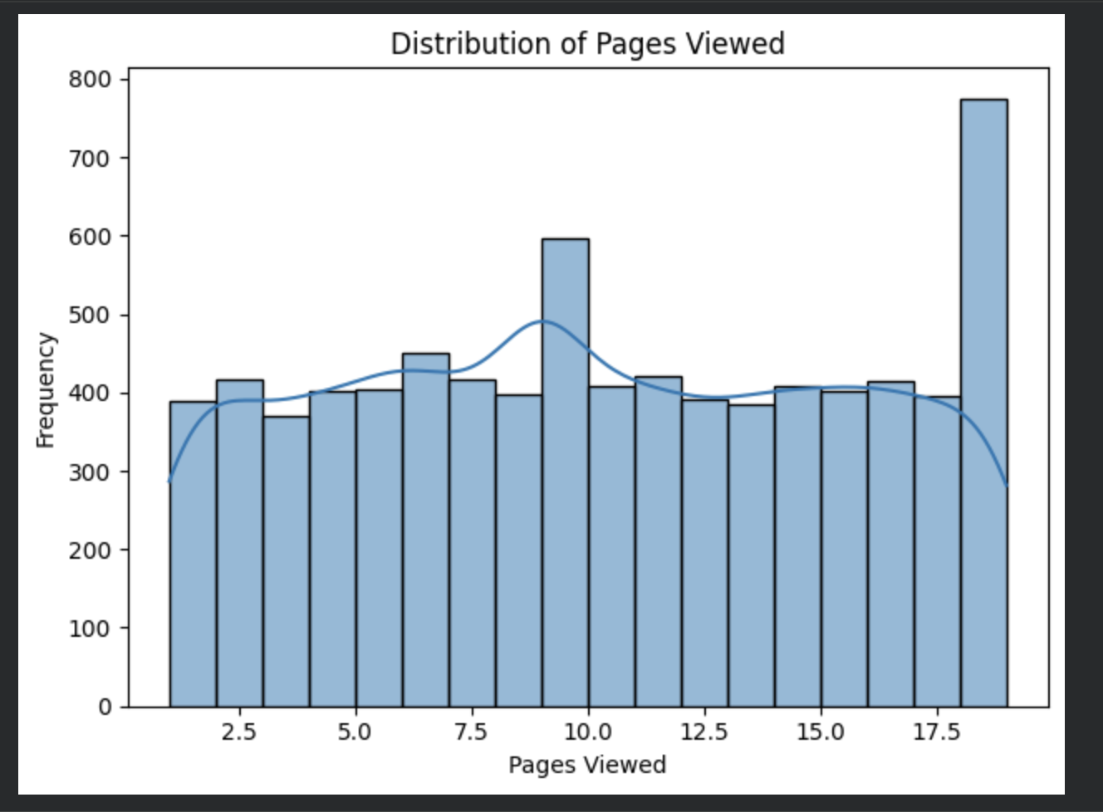

Bivariate Analysis
Analyzed relationships between two variables using:
- Barplot
- Scatterplot
Examples:
- It shows how bounce rate differs based on purchase behavior.
- Lower bounce rate indicates users are more engaged with the platform.
- It helps identify patterns, trends, positive/negative relationships,and possible outliers between two variables.
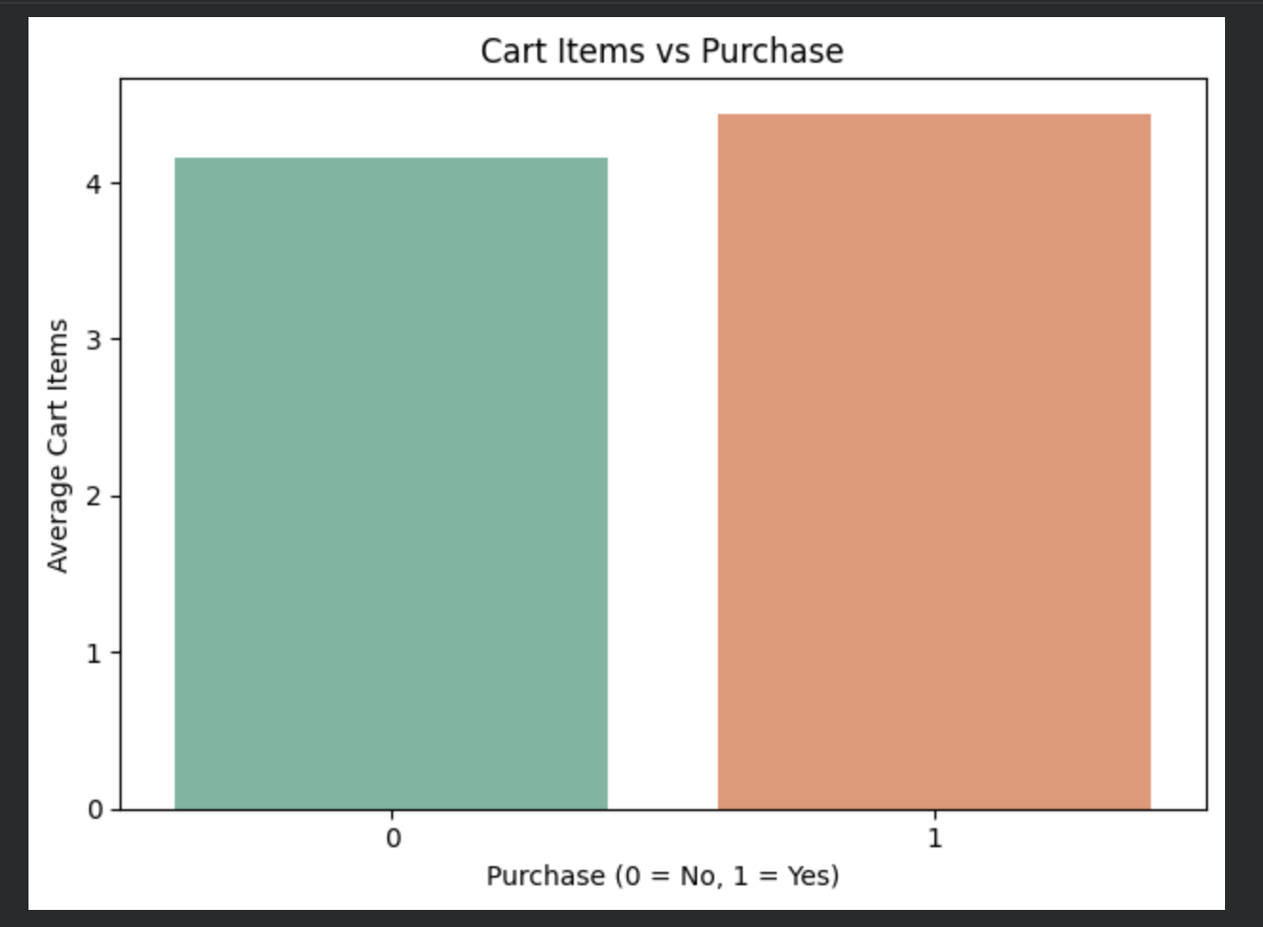
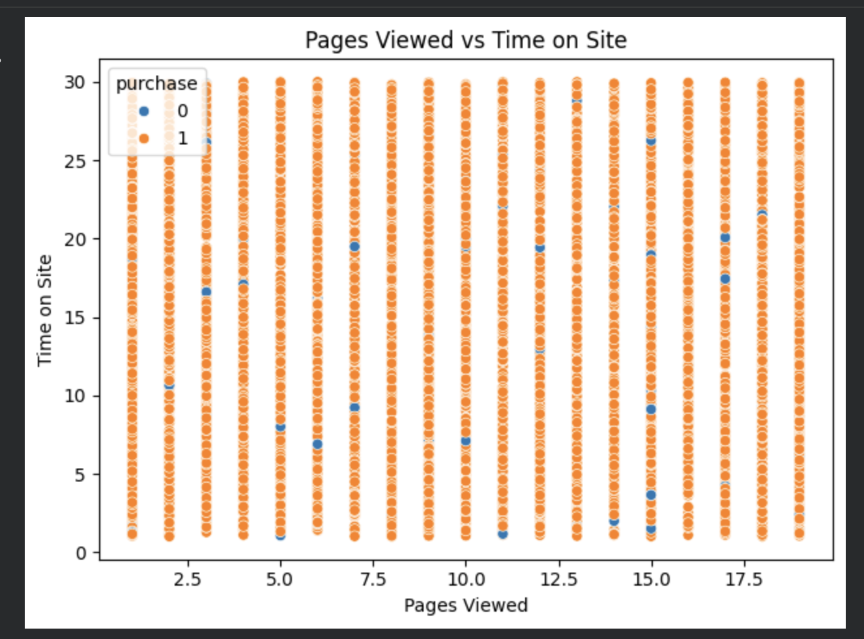

Multivariate Analysis
Analyzed relationships among multiple variables using:
- Pairplot
- Pivot Tables
- Heatmap
Examples:
- This grouped analysis compares average cart items,across different engagement levels and purchase categories.
- A pivot table is used to summarize and analyze relationships between multiple variables.
- Advanced plots are used to visualize complex relationships among multiple variables in a more detailed way.

Card Visual

- Displays a single important KPI or metric in a clear and prominent format
- Used to highlight key business insights such as Total Users, Conversion Rate, Returning Users, Time Spent on site and Avg Engagement
- Helps users quickly understand overall performance without analyzing detailed charts
- Improves dashboard readability and decision-making
- Commonly placed at the top of dashboards for quick summary insights
- Supports custom formatting, icons, colors, and KPI indicators for better visualization
Gender Distribution Donut Chart
- Visualizes the proportion of users based on gender categories
- Helps analyze demographic distribution of customers
- Displays percentage contribution of Male, Female, and Not Specified users
- Useful for understanding audience segmentation and user diversity
- Donut chart format provides a clean and easy-to-read comparison of categories.
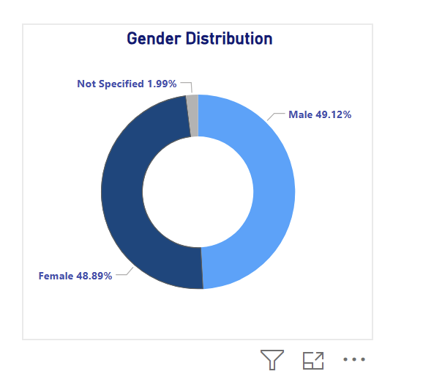

Funnel Analysis
- Represents the progression of users through different stages of the customer journey
- Helps identify user movement from visitors to highly engaged customers
- Useful for analyzing customer conversion and engagement flow
- Highlights drop-off points between stages to improve marketing and retention strategies
- Funnel visualization provides an easy understanding of user behavior and conversion performance

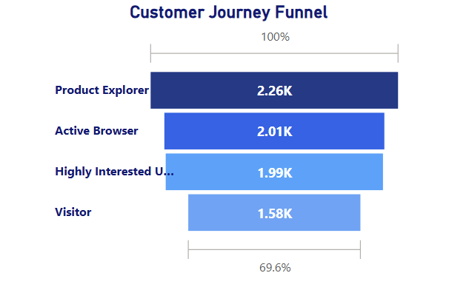

Device Usage by Age Group Chart
- Displays device preferences across different age groups
- Compares Desktop, Mobile, and Tablet usage among users
- Helps identify which devices are most commonly used by each demographic segment
- Useful for optimizing platform design and improving user experience across devices
- Clustered column chart enables easy comparison of device usage patterns between age groups

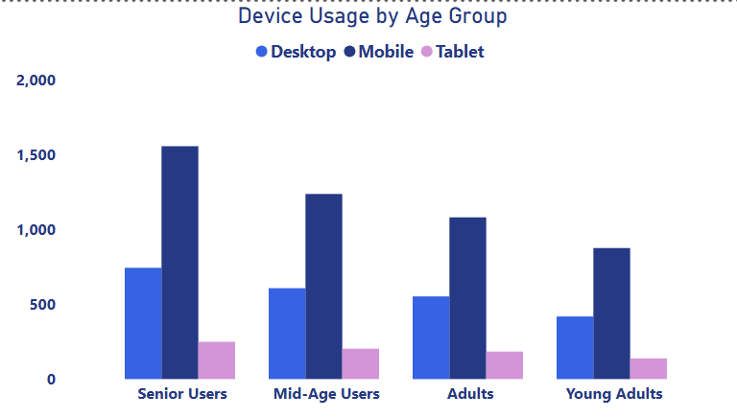

Purchase Rate by Ads & Discounts Matrix
- Analyzes the relationship between advertisement clicks, discount visibility, and purchase rate
- Compares purchase percentages for users who interacted with ads and discounts
- Helps identify the effectiveness of marketing campaigns and promotional strategies
- Useful for understanding how discounts and advertisements influence customer purchasing behavior
- Matrix visualization provides a structured comparison of multiple business factors in a compact format
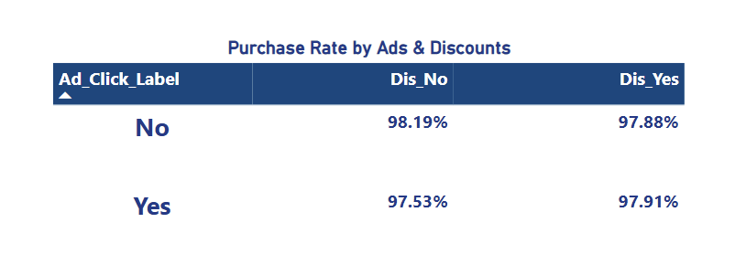
Customer Performance Analysis Matrix
- Provides a detailed comparison of customer segments based on engagement and purchasing behavior
- Displays key metrics such as Total Customers, Engagement Score, Bounce Rate, and Purchase Rate
- Helps identify high-performing and low-retention customer groups
- Includes product recommendations tailored to each customer segment for targeted marketing strategies
- Matrix visualization enables structured analysis of customer behavior and business performance in a single view

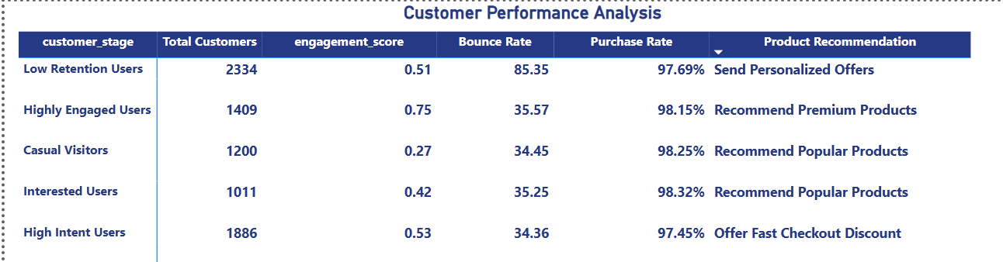

E-Commerce Customer & Purchase Analytics Dashboard
- This dashboard provides a comprehensive analysis of customer behavior, engagement, and purchasing patterns in an e-commerce environment
- It combines KPI cards, funnel analysis, demographic insights, device usage trends, and customer performance metrics into a single interactive dashboard
- The dashboard helps identify customer engagement levels, purchase trends, returning customer behavior, and the impact of advertisements and discounts on conversions
- Interactive slicers and visualizations enable dynamic filtering and deeper exploration of customer insights
- The dashboard supports business decision-making by providing actionable insights for improving customer retention, engagement, and sales performance
- Designed using Power BI with a professional blue-themed layout for clear visualization and enhanced user experience

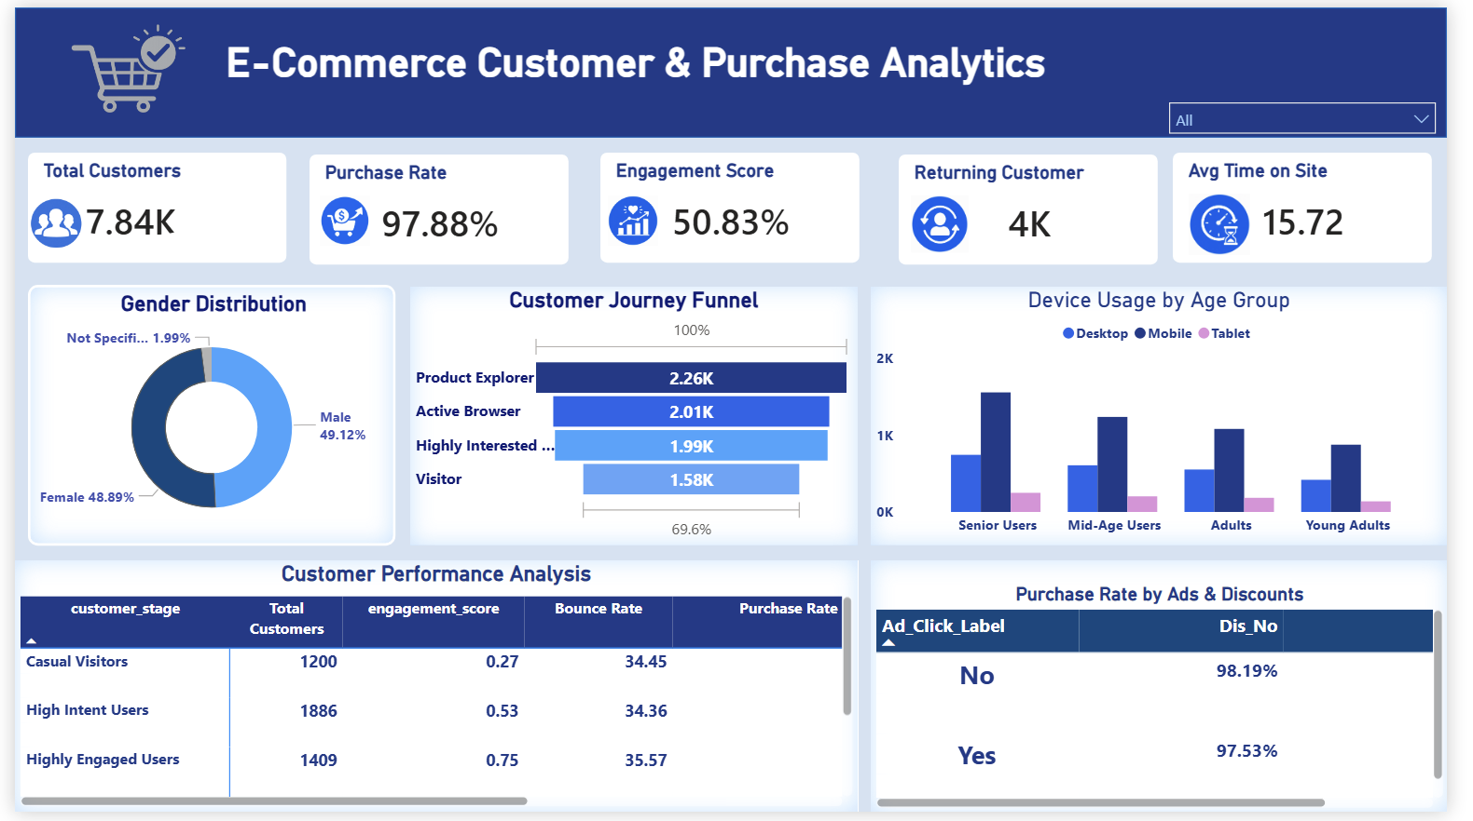

Business Insights
- The majority of users access the platform through mobile devices, indicating the importance of mobile-friendly user experience and responsive design
- Male and female user distribution is almost equal, showing balanced customer participation across genders
- Highly engaged users demonstrate better purchase rates and lower bounce rates, highlighting the strong relationship between engagement and conversions
- Low retention users have significantly higher bounce rates, indicating the need for personalized offers and re-engagement strategies
- Discounts and advertisement interactions positively influence customer purchase behavior and conversion performance
- Product Explorer and Active Browser stages contain the highest number of users, suggesting strong initial customer interest in products
- Returning customers contribute significantly to overall platform activity, emphasizing the importance of customer retention strategies
- Different age groups show varying device preferences, which can help optimize marketing campaigns and platform experience for targeted audiences
- Personalized product recommendations can improve customer engagement and increase purchase opportunities across different customer segments
- The dashboard enables data-driven business decisions by providing insights into customer behavior, engagement trends, and sales performance.

Challenges Faced
- Handling and cleaning large customer datasets for accurate analysis and visualization
- Managing missing and inconsistent data values in customer demographic and behavioral fields
- Designing meaningful KPI measures such as engagement score, purchase rate, and returning customer metrics
- Creating interactive and user-friendly dashboard layouts while maintaining visual clarity
- Customizing Power BI visuals, slicers, and matrix tables to achieve a professional dashboard design
- Selecting suitable chart types to represent customer behavior and purchase trends effectively
- Implementing conditional formatting and color themes for better readability and visual consistency
- Analyzing relationships between advertisements, discounts, and purchase behavior using matrix and analytical visuals
- Optimizing dashboard space and alignment to fit multiple visuals without affecting usability
- Ensuring the dashboard provides actionable business insights while maintaining good performance and responsiveness.
- Dataset imbalance due to large number of purchased users
- Funnel stages were not strictly sequential

Conclusion
- The E-Commerce Customer & Purchase Analytics Dashboard successfully provides a comprehensive view of customer behavior, engagement, and purchasing patterns
- The dashboard enables effective analysis of customer demographics, device usage, engagement levels, and conversion trends through interactive visualizations
- Business insights derived from the dashboard help identify high-value customers, improve retention strategies, and optimize marketing efforts
- Analytical visuals such as funnel charts, KPI cards, matrix analysis, and device usage comparisons support data-driven decision-making
- The project demonstrates how Power BI can transform raw customer data into meaningful and actionable business intelligence
- Overall, the dashboard improves understanding of customer behavior and supports strategies for increasing engagement, conversions, and overall business performance

