

Lab 2

[Click here to Register Attendance](https://goo.gl/forms/J9WP2kj83JC1mKYU2)

| Name |  |
| --- | --- |
| Date |  |
| Student No |  |
| Student Email |  |

### **GitHub**

1. Go to <http://github.com> and sign in
2. Install GitHub Desktop from here: <https://desktop.github.com/> and sign-in
3. Using GitHub Desktop, Clone the FirstRepo repository from your GitHub account and screenshot it here   
   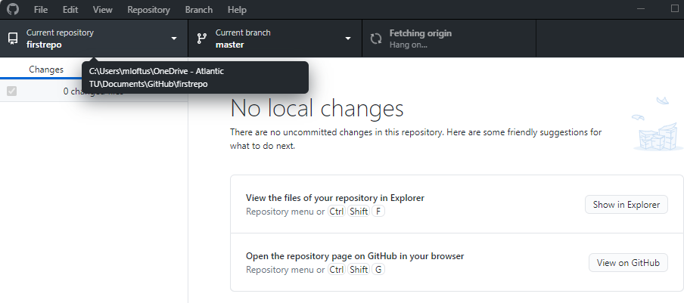
4. **Using Github Desktop**, create a repository called **secondrepo**
5. In your secondrepo folder add a file and save it, then **commit** the change and **push** it to your GitHub account
6. Paste a screenshot below (replace mine) of your pushed **secondrepo** repository on GitHub.com

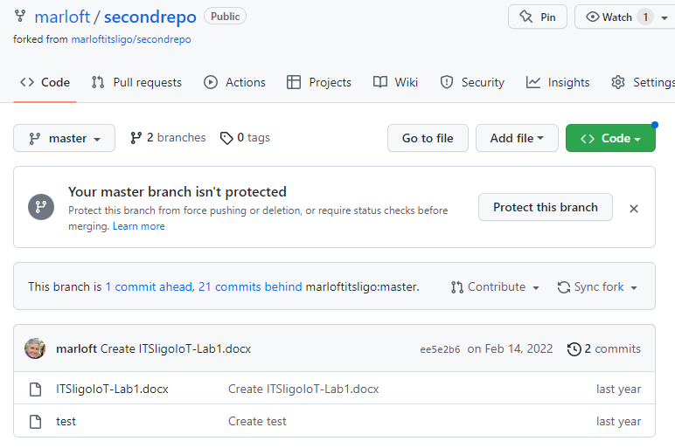

### **Arduino IDE & Coding Basics**

1. Find the Button tutorial on the Arduino Website and get familiar with it:

<https://docs.arduino.cc/built-in-examples/digital/Button>

1. Open the Arduino Integrated Development Environment (IDE), click File ->Examples -> Digital… and choose the Button sketch:  
     
   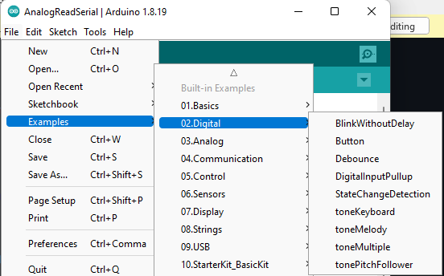
2. Wire up a button and an LED according to the picture below and run the button sketch  
   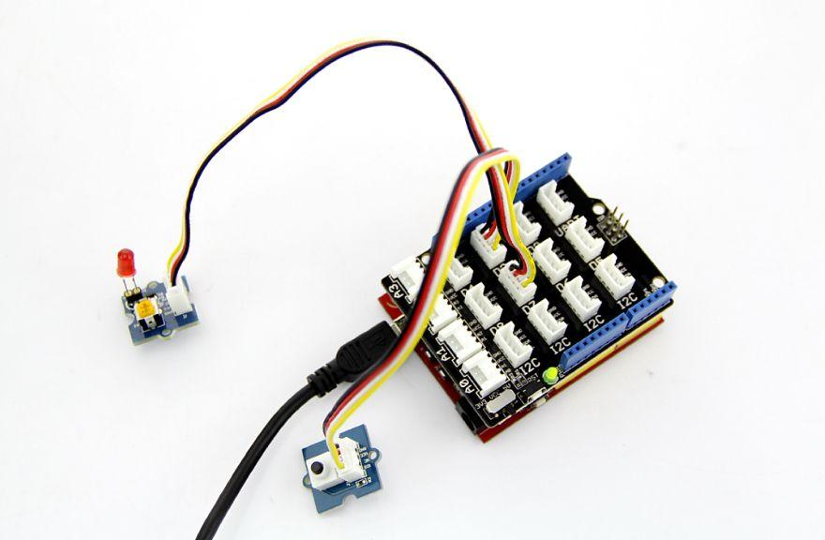
3. Take a picture of your Button hardware setup with your phone and paste it below:

1. Change the button sketch so that it **blinks** when the button is pressed
2. Upload your revised button sketch to your SecondRepo repository and screenshot below:
3. Add any analog sensor (light, sound, temperature) and run the Analog Read Serial sketch from File -> Examples -> Basics. Take a picture of the sketch running and showing analog data scrolling on the screen:
4. **Upload your Lab to Moodle!**