QMS Portal

System Requirement Specification Version 2.0

For

ANGLER Technologies

Developed By



ANGLER Technologies India Pvt. Ltd.

1144 Trichy Road, Coimbatore – 641045, India

Phone: 91-422-2312707 / 2313938 Fax: 91-422-2313936
www.angleritech.com info@angleritech.com
Document Release Notice

Document Details
Doc ID | ANGLER/SRS/QMS Portal Development/V2.0/Jun/12 |  | Ver. No. | 2.0 | Date | 25 Jun, 2012
Client | ANGLER Technologies
Project Name |  | QMS Portal Development
Project Code |  | ANGQMS0109
Doc. Title |  | System Requirement Specification Document for QMS Portal Development
Doc. Type |  | System Requirement Specification Document
Security |  | Confidential. Unauthorized copying is prohibited.
File Name |  | QMS_Portal_SRS_V2.0.doc
Doc. Ref |  | 2.1:EIT/D 01/1.1

Revision History
Version No. | Author | Description of Revisions
1.0 | ANGLER Technologies India Pvt Ltd | New document developed by ANGLER.
1.1 | ANGLER Technologies India Pvt Ltd | Updated document as per CTO’s inputs
1.2 | ANGLER Technologies India Pvt Ltd | Updated document as per CTO’s inputs
1.3 | ANGLER Technologies India Pvt Ltd | Updated document as per CTO’s inputs during the meeting held on 23-Apr-09
1.4  1.5 | ANGLER Technologies India Pvt Ltd  ANGLER Technologies India Pvt Ltd | Updated document as per CTO’s comments during the meeting held on 05-Jun-09  Revised the document with following changes  - Reports have been included for Tasks and Schedule Management, IQA  - Tasks and Schedule Management modules have been modified with recent process changes in Angler  - Approval Authority feature has been included in Article management section
2.0 | ANGLER Technologies India Pvt Ltd | Revised document based on the discussion had with MR team on 2-Apr-12 and the subsequent discussion had with CTO.

System Study Log
Date & Time | Duration | Further Iteration Required?

ANGLER Technologies
Last updated By : Kavitha | Approved By :
Date: 25-Jun-12 | Date:
Table of Contents
1. Overview 6
1.1. Proposed System 6
1.2. List of deliverables 6
2. Functional Description 7
2.1. Admin Panel 8
2.1.1. Login and User Authentication 8
2.1.2. Change Password 9
2.1.3. General Functionality 9
2.1.4. Masters 11
2.1.4.1. Department Master 11
2.1.4.2. User Group Master 13
2.1.4.3. Schedule Category Master 15
2.1.4.4. Schedule Subcategory Master 17
2.1.4.5. Process Master 18
2.1.4.6. Audit Checklist Master 20
2.1.4.7. Meeting Room Master 22
2.1.5. User Management 24
2.1.6. Article Management 27
2.1.6.1. Add Articles 28
2.1.6.2. Delete Articles 31
2.1.6.3. Edit Articles 32
2.1.6.4. Documents Approval 36
2.1.7. Schedule Management 37
2.1.7.1. Audit Schedule 37
2.1.7.1.1. Add Schedule 37
2.1.7.1.2. Edit Schedule 39
2.1.7.1.3. Delete Schedule 40
2.1.7.1.4. Schedule – Acknowledge / Reschedule Request 40
2.1.7.1.5. Reschedule Request Management 42
2.1.7.1.6. Rescheduled 42
2.1.7.1.7. Audit Completed 42
2.1.7.1.8. Report submission 43
2.1.7.1.9. Audit findings report update 44
2.1.7.1.10. Load Audit checklist 45
2.1.7.1.11. CAR Report Generation 47
2.1.7.1.12. Correction Closed 47
2.1.7.1.13. Corrective Action Closed 48
2.1.7.1.14. CAR Closed - Short Term Corrective Action 49
2.1.7.1.15. CAR Closed - Long Term Corrective Action 49
2.1.7.1.16. CAR Resent 50
2.1.7.1.17. Schedule Cancellation 50
2.1.7.1.18. Audit Status Vs Privilege Management 51
2.1.7.2. Schedule Management – Other Schedules (Meetings, Demos, Training Sessions etc) 52
2.1.7.2.1. Add Schedule 52
2.1.7.2.2. Reschedule 54
2.1.7.2.3. Completed 55
2.1.7.2.4. Delete Schedule 56
2.1.7.2.5. Canceled 56
2.1.7.2.6. Outlook integration 56
2.1.8. Task Management 57
2.1.8.1. Add Tasks 58
2.1.8.2. View Tasks 60
2.1.8.3. Edit Tasks 60
2.1.9. Reports 61
2.1.9.1. Schedule Report 61
2.1.9.2. Audit Reports 62
2.1.9.2.1. Audit Findings Report 62
2.1.9.2.2. Audit TAT Report 63
2.1.9.2.3. Consolidated Audit Findings Report 63
2.1.9.2.3.1. Month wise Report 64
2.1.9.2.3.2. PL wise Report 65
2.1.9.2.4. Trend Report 67
2.1.9.2.5. OI Implementation Report 68
2.1.9.3. Tasks Report 69
2.1.9.3.1. Detailed Report 69
2.1.9.4. Source wise Report 70
2.1.9.5. Status wise Report 71
2.1.9.6. % POA Completion Report 72
2.1.10. Remainder Mail 72
2.1.11. Delay% Calculation 73
3. Operating Environment Requirements 74
3.1. Hardware 74
3.2. Software 74
3.3. Browser Compatibility 74
4. Software Application Project Development Approach 75
5. SRS Signoff 76

Overview
The proposed system would support Administrator / MR team to manage QMS documents / articles and QMS activities such as managing Schedules & tasks for various people. The Administrator / MR team can manage the QMS documents & sample templates thru this system. They can also manage schedules by planning and update the post schedule documents and reports. The users of the system can manage list of tasks with the details such as responsibility, Status, Expected date of completion etc.

Proposed System
The proposed system would include the following features:
- User Management with access privileges
- Document Management
- Activity Management
- Task Management
- Reports
- Settings

List of deliverables
The following are the list of overall deliverables.

- Completed Application
- User Manual
- System Manual

Functional Description
QMS Portal

Reports
Activity
Management
Task (POA)
Management
Settings
QMS Docs
Management

Privilege based access
of the below reports
1. Audit Status Report
2. Task Report

1. Plan & Scheduling of
Audit & Meeting etc
2. Update post activity
observations
Upload QMS Docs

1 PMDs.
2. Templates
3. Sample Docs
Update tasks

- POAs generated from various sources’
- Audit OIs

Masters
User Management
Privilege Management
(Department wise /
Executive wise)
Preference Settings

1. Department
2. User Group
3. Schedule category
4. Activity Category
5. Process Master
6. Audit checklist Master
7. Meeting Room Master

Admin Panel
This part of the application would facilitate the Super Administrator to control the entire application.

Login and User Authentication

Module Functionality - The administrator will access the admin panel using login module. Access to the admin panel is controlled by username & password.

Privilege Details – Administrators will only be allowed to access this module.

Design Screen Fields
Sl No | Field Name | Description | Validation
1 | User Name | Admin user name to login | Mandatory
2 | Password | Admin password to login | Mandatory

Change Password

Module Functionality - The administrator can change the password after they login to the system. Administrator has to provide the following information in order to change their password.

Privilege Details – Administrator will be allowed to access this section.

Design Screen Fields
Sl No | Field Name | Description | Validation
 | Old Password | The existing password of the admin | Mandatory
 | New Password | The new password of admin | Mandatory
 | Confirm New Password | Retype the new password for confirmation | Mandatory

Forgot password link shall be provided in the Login page. If the Administrator forgets the password, he can make a request by entering the username. The password would then be sent to that user to the email id.

Settings

We can the below parameters under Settings.

General Settings

Type of Audit process General Extensive (checkbox would be given)

Audit - CAR Mandatory Yes No (Radio button would be given)

Meetings - POA Mandatory Yes No (Radio button would be given)

Do we need to validate CAR & POAs as mandatory under schedule?

Extensive Audit Process

Audit rescheduling Yes No (Radio button would be given)

Log audit findings Form Excel Import (Radio button would be given)

CAR Consolidated audit report form Import CAR (Radio button would be given)

OI Implementation Yes No

Audit Reports

Audit Findings Report (Checkbox would be given)
Audit TAT Report (Checkbox would be given)
Consolidated Audit Findings Report
Monthwise PLwise Trend Report (Checkbox would be given)

Access Privileges
Access privileges will be set based on the User group wise, Department wise & Module wise, Section wise.
User group wise - MRs will have access privilege to both Admin panel & portal. Also MR will have limited privileges to the Admin panel. Other users will have only portal privilege. But the Administrator will have complete privilege to both admin panel & portal.
Eg: Administrator can access the Settings, Articles Management, Schedule Management, Task Management & Reports.
Sr. MR will have privilege to Articles Management, Schedule Management, Task Management & Reports.
Auditor will have privilege to Schedule Management in the Admin panel.
Other executives will have privilege to access the allocated documents / articles in the portal and can access the schedules & tasks based on the given privilege.

User wise – Can set privilege to individual user to view set of articles / a single article. If the user is an auditor, some set of articles has to be temporarily given access to him, it is possible using this option.

Article wise – To set privilege to a particular group of users to a single article. Privileges can be set article wise.

Master - General Functionality

List screen – Available details of a module would be listed in a grid. The grid will have the below features:

- Name / Title will be listed in Alphabetical order. On clicking the Name / Title, the details will be listed in ASC & DESC order. Eg: In user management – User Name would be listed in alphabetical order.
- To view details of specific alphabet, click on the alphabet, will load the User names from the specific alphabet.
- Add New Privilege would be given to create a new entry.
- Details can be modified by clicking the icon under Edit column.
- Status of the user can be changed by clicking the icon (Enable / Disable) under Status column.
- Details of the entry can be viewed by clicking the icon under View Details column.
- Delete – Delete privilege will be given to delete a particular entry. To delete a particular entry, the Administrator / privileged user has to select the checkbox against the row. Details of the enabled check box will only can be deleted.
- Pagination – Pagination will be given to view the records of 10, 15, 20, 25, 40 rows.
- Search Feature – will be given to search for a particular entry

Delete - Checkbox will be available in the list screen against each entry. Checkbox will be enabled / disabled based on the below criteria

Disabled - If there are availability of transactions for the respective data. To enable the checkbox, Administrator needs to delete all the transaction details.

Enabled – If there is no transaction against the respective data.

Masters

Module Functionality - Administrator can create entries for the various masters available.

Privilege Details – Administrator will be allowed to access this section.

Department Master

This module would have details related to the various departments belongs to the company.

List – would list out the available department details in the below format.

Add – This module would facilitate the Administrator to add a new department. The following details will be captured while adding a department.
S.No | Field Name | Description | Validation
 | Department Name | Textbox would be given to enter the Department Name | Mandatory  Max of 100 chars would be allowed
 | Status | Radio button with Active & Inactive options would be given | Mandatory  Default would be Active

On giving the required details and by clicking on the Save button would store the Department details in the database.

Modify – On clicking the Edit option given in the list screen, will take the user to the Edit page where the Administrator can update the department details and save the same.

Status - Status of the department can be changed by clicking the icon (Enable /Disable) under the status column.

Delete - Checkbox will be available in the list screen against each Department. Checkbox will be enabled / disabled based on the below criteria

User Group Master

This module would have details related to various User groups available in the company.

List – would list out the available status details in the below format.

Department

(Department filter would be given to filter the Department wise User groups .

Add – This module would facilitate the Administrator to add a new user group. The following details will be captured while adding a user group.

S.No | Field Name | Description | Validation
 | Department | Dropdown would be given with the available Departments created under the Master | Mandatory
 | User Group Name | Textbox would enter User Group Name | Mandatory  Max of 100 chars would be allowed
 | Status | Radio button with Active & Inactive options would be given | Mandatory  Default would be Active

On giving the required details and by clicking on the Save button would store the user group details in the database.

Modify – On clicking the Edit option given in the list screen, will take the user to the Edit page where the Administrator can update the user group details and save the same.

Delete - Checkbox will be available in the list against each user group.

On selecting the enabled checkbox against the User group in the list screen and by clicking the delete button ask conformation from the Administrator. On giving the conformation, system will delete the user group details.

Schedule Category Master

This module gathers information about the Schedule categories. These schedule categories will be used in the Schedule Management module.
S.No | Field Name | Description | Validation
 | Schedule Type | Dropdown would display Audit, Other schedules | Mandatory
 | Schedule Category Name | Textbox would be given to enter the name of the schedule category. Eg: EIT SDLC Audit | Mandatory
 | Status | Radio button with Active & Inactive options would be given | Mandatory  Default would be Active

Schedule Subcategory Master

This module gathers information about the Schedule subcategories. These schedule subcategories would be used in the Schedule Management module.
S.No | Field Name | Description | Validation
 | Schedule Type | Dropdown would display Audit, Other schedules | Mandatory
 | Schedule Category Name | Dropdown would display the available Schedule categories from the master based on the schedule type selected | Mandatory
 | Schedule Category Name | Textbox would be given to enter the name of the schedule subcategory. Eg: I Qtr | Mandatory
 | Status | Radio button with Active & Inactive options would be given | Mandatory  Default would be Active

Process Master

This module would have details related to the various processes.
List – would list out the available process details in the below format.

Schedule Category

(Filter would be given to filter the Processes based on the Schedule category)

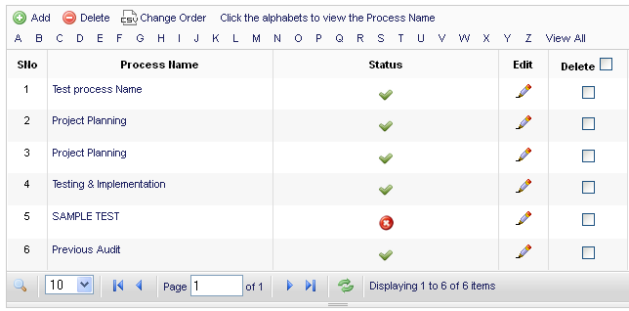

Add – This module would facilitate the Administrator to add a new process. The following details will be captured while adding a process details.

S.No | Field Name | Description | Validation
 | Process Name | Textbox would enter Process Name | Mandatory  Max of 100 chars would be allowed
 | Status | Radio button with Active & Inactive options would be given | Mandatory  Default would be Active

On giving the required details and by clicking on the Save button would store the process details in the database.

Modify – On clicking the Edit option given in the list screen, will take the user to the Edit page where the Administrator can update the process details and save the same.

Status - Status of the process can be changed by clicking the icon (Enable /Disable) under the status column.

Delete - Checkbox will be available in the list against each process. Checkbox will be enabled / disabled based on the below criteria

On selecting the enabled checkbox against the process in the list screen and by clicking the delete button ask conformation from the Administrator. On giving the conformation, system will delete the process details.

Audit Checklist Master

This module would be used to manage Audit checklists for various processes and schedule categories.

List – would list out the available process details in the below format.

Department
Schedule Category

Process

(Filter would be given to fetch the Audit checklist details based on Schedule category & Process)
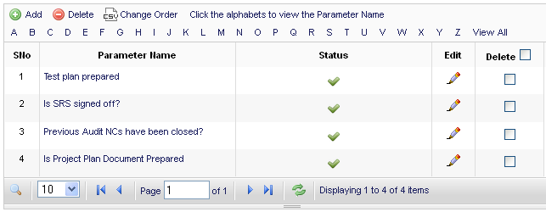

Add – This module would facilitate the Administrator to add a new parameter. The following details will be captured while adding a parameter details.

S.No | Field Name | Description | Validation
 | Department | Dropdown would display the available departments | Mandatory
 | Process Name | Dropdown would display the available processes | Mandatory
 | Parameter Name | Textbox would be given to enter the Process Name | Mandatory  Max of 100 chars would be allowed
 | Status | Radio button with Active & Inactive options would be given | Mandatory  Default would be Active

On giving the required details and by clicking on the Save button would store the audit checklist details in the database.

Modify – On clicking the Edit option given in the list screen, will take the user to the Edit page where the Administrator can update the parameter details and save the same.

Status - Status of the parameter can be changed by clicking the icon (Enable /Disable) under the status column.

Delete - Checkbox will be available in the list against each parameter. Checkbox will be enabled / disabled based on the below criteria

On selecting the enabled checkbox against the parameter in the list screen and by clicking the delete button ask conformation from the Administrator. On giving the conformation, system will delete the parameter details.

Meeting Room Master

This module would have details related to the various meeting room details.

List – would list out the available meeting room details in the below format.
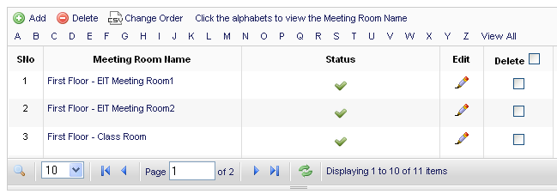

Add – This module would facilitate the Administrator to add a new meeting room. The following details will be captured while adding a meeting room details.

S.No | Field Name | Description | Validation
 | Meeting Room Name | Textbox would enter Process Name | Mandatory  Max of 100 chars would be allowed
 | Description | Text area would enter description | Optional
 | Status | Radio button with Active & Inactive options would be given | Mandatory  Default would be Active

On giving the required details and by clicking on the Save button would store the meeting room details in the database.

Modify – On clicking the Edit option given in the list screen, will take the user to the Edit page where the Administrator can update the meeting room details and save the same.

Status - Status of the meeting room can be changed by clicking the icon (Enable /Disable) under the status column.

Delete - Checkbox will be available in the list against each meeting room. Checkbox will be enabled / disabled based on the below criteria

On selecting the enabled checkbox against the meeting room in the list screen and by clicking the delete button ask conformation from the Administrator. On giving the conformation, system will delete the meeting room details.

User Management
Module Functionality - This section enables the administrator to manage User details. This module will enable the Administrator to Add / Modify / Delete & View the user details.

Privilege Details – Only Administrator will be given privilege to access this module.

List - This provision will list out the available user details to the Administrator. The list screen will be as follows.

Department
(To view department wise users)
User Group

(To view User group wise users)
Status

(To view Active / Inactive users)
View

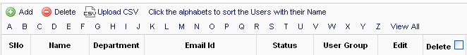

The filter conditions are optional. Based on the selection criteria, the result will be displayed in the grid.

Add - This provision will enable the Administrator to add a new user. The following details will be captured while adding a user.
Design Screen Fields
S.No | Field Name | Description | Validation
 | Title | Dropdown would list out common salutations used from a static table | Mandatory
 | First Name | Textbox would be available to enter the First Name of the user | Mandatory  Max of 100 chars would be allowed
 | Last Name | Textbox would be available to enter the Last Name of the user | Optional  Max of 100 chars would be allowed
 | Designation | Textbox would be given to enter the designation of the user | Optional.  Max of 100 chars would be allowed
 | Email Id | Textbox would be available to enter the Email Id of the user | Mandatory  Max of 100 chars would be allowed
 | Department | Dropdown would be display for the Departments from the department master | Mandatory
 | User Group | List of user groups will get displayed in the checkbox | Mandatory  A user can be mapped with multiple user groups
 | User Name | Textbox would be available to enter the User name | Mandatory  Max of 50 chars would be allowed
 | Password | Textbox would be available to enter the User's Password used during access | Mandatory  Max of 15 chars would be allowed
 | Confirm Password | Textbox would be available to enter the User's Password used during access | Mandatory  Max of 15 chars would be allowed
 | Status | Radio button will be available with 2 options such as Active & Inactive. Active as default | Only Active users will be able to access the portal

On giving the required details and by clicking on the Save button would store the User details in the database.

Modify – On clicking the Edit option given in the list screen, will take the user to the Edit page where the Administrator can update the user details and save.

Delete – Checkbox will be available in the list against each user. Checkbox will be enabled / disabled based on the below criteria
- Disabled – if there are availability of transactions for the respective user(s).
- Enabled – if there is no transactions against the respective user(s).

On selecting the enabled checkbox against the user in the list screen and by clicking the Delete button will ask for confirmation from the Administrator. On giving confirmation, system will delete the user details.
Note:
- The administrator will map the user groups at the time of user creation.
- One user could be belongs to more than 1 user group.
- Administrator has the privileges to activate / deactivate / edit / delete a user.

Synchronization
If the company is already using an application in which User details is available, on creating a user in the existing application, required fields will be filled in QMS Portal automatically. User groups have to be mapped by the administrator manually.

Note: If Synchronization is not enabled under Preference Settings, this feature will not be available / visible.

CSV Document upload
To retrieve and store the user details from an already existing application, the administrator can use this option. Administrator has to create a CSV file with the fields such as Title, First Name, Last Name, Department, Email Id, User Name, Password, User group, Status.
Note: Departments will be created during CSV upload / synchronization. If the relevant department is already exists, system will use the same. Otherwise it will create the department and store the user details.
Note: If CSV Upload is not enabled under Preference Settings, this feature will not be available / visible.

Article Management

Module Functionality - This module would facilitate the privileged user to upload the QMS documents / templates. There is no limitation for the levels. There can be any number of child articles under one parent article. Privileged user can view the list of articles created under various levels. Based on the below filter conditions, grid will display the list of available articles.

Access credentials

- Administrator can add / modify / delete QMS documents / articles through the admin panel
- Based on the given access, MR team will have Add / Edit / Delete privilege. Add / Edit / Delete buttons will be visible only if the logged in user have the privilege
- Administrator / MR team can change the sequence of the articles display. There will be a drag and drop option given to change the sequence

List Screen
Parent (dropdown)

View
Drop down will display the list of parent articles in various levels. On selecting the parent article in nth level and by clicking the view button will display the list of child articles of the selected parent as below:

Note: Click on the Article name to View / Edit / Delete the article.
EIT Documents -> Document usage guidelines

Delete | Article Name | Date of Posting | Display From | Expiry Date | View Document | Related Articles | Status
 | EIT Email Formats | 05-Feb-07 | 05-Feb-07 | 05-Feb-08 | View | Click Here | Forwarded
 | Guidelines for sending emails | 10-Feb-07 | 15-Feb-07 | 10-Feb-10 | View | Click Here | Approved
 | SRS Checklist | 16-Jan-09 | 20-Jan-09 | 20-Feb-09 | View | Click Here | Approved
Add
Delete

On clicking the Article name will show the view screen with the article details. There will be options available to Edit & Delete the article.

Add Articles

This provision enables privileged user to add articles in the admin panel. Admin shall give the following details.
Article Name
Reference Number
Textbox would be given to enter the article / document ref number

Author (Executive dropdown)
Keywords

Keywords Desc

Date of Posting

Article Description

(WYSIWYG editor will be available so that there won't be any limitation to enter the article content)
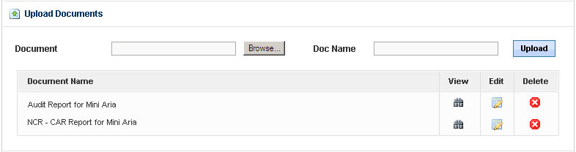
Approval Authority (Drop down)

The names of user groups will be listed in the dropdown. The user can select anyone of the user group (Eg: QMS Manager) from the list.
Authentication Authentication field is used to display the articles only for the authorized users.

On clicking the Authentication checkbox, below radio buttons will get displayed with 2 options.
Usergroup wise Individual
On clicking Usergroup wise option, a drop down with the list of user groups will be displayed. The person who is creating the article can select the user groups and give authentication to access the article.
On clicking Individual option, there will be 1 drop down with the list of user groups. On selecting an user group will load the list of executives mapped with the user group in another drop down. Administrator can select the authenticated users by using the Ctrl key.

User Groups Executives

EIT
IM
Mktg
Management
SBU Heads
Sr. Middle Management
Middle Management
MRs
QA Team
.
.
.

Note: If authentication checkbox is not checked, the article will be considered as open article and visible to everyone.
Parent Articles
Level 1 – Article 1
Level2 - Article1
Level2 - Article2
Level3 - Article 1
Level 1 – Article2
.
.
.

A drop down will display the list of available articles level wise. Administrator can choose more than one parent article. Based on the parent article selected, current article will display as a child for the selected parent articles.
Display from

Date picker will be given. Article will get displayed to the users from the Display from dt.
Expiry Date

Date picker will be given. Article will available for the users till the selected expiry date.
Archive

Archive option will be available only at the time of Edit. On clicking the checkbox and updating the article, an archival copy of the article will be saved.
Edit option for Privileged people

(If this checkbox is checked, Edit link will be available for the people who are having the Edit privilege).
Enable Survey / Poll

(On clicking the checkbox, a drop down will appear with the list of Survey / Poll titles, On selecting the title, Survey / Poll option will be displayed along with the article details)
Enable Print

(On clicking the checkbox, a Print icon would appear in the User’s login to take a print out of the article)
Enable PDF

(On clicking the checkbox, a PDF icon would appear in the User’s login which would facilitate the User’s to download the PDF of the article)

Save
Reset
Cancel
Save – To save the entered details. Once the user added the article it will be forwarded to approval authority. Mail will be triggered to the approval authority.
Reset – To clear all the entered fields in the page
Cancel – To go back to previous page
Below details would be stored into the article_details table at the time of creating a new article.

Id, article_name, ref_number, keywords, keyword_desc, article_desc, authentication_reqd, authentication_type, department, display_from, expiry_date, archive, edit_privilege, enable_survey, enable_print, enable_pdf, status, created_by, created_date, parent_exist, display_status

Note:
- As soon as the privileged user creates an article, Article Status would be New & display_status would be active.
- The respective approval authority, on approving the article, the status would be changed as Approved.
- Created article would be visible to the end users only when the article is approved by the respective approval authority.

Delete Articles

Privileged user can delete the articles by selecting the checkboxes and click the Delete button. On clicking delete button, the system would check for the availability of the child articles. If child article is available, it will prompt the user to delete the child articles before delete the selected one. If there is no child article available, the selected article will be deleted.

Note:
- On deleting a particular article, the status of the article would be changed as Deleted. The entry will not be deleted from the table & relevant documents will not be deleted from the folder. Instead the deleted documents would be moved to a Deleted folder under Articles main folder.
- Obsolete document details can be retrieved from the Deleted entries

Edit Articles
Privileged user can edit the existing article details by clicking the Article name. Once the user clicked the Article name Edit screen would get opened. User can edit all the fields.
Edit, Reset and Cancel buttons would be available in the Edit screen at the center bottom of the page. User can save the changes by clicking the Edit button and by clicking the Cancel button user can leave the screen without saving any changes.
This provision enables privileged user to edit the article / document. Following fields would be available.
Article Name
Reference Number
2.1:EIT/D 01/1.2
SRS Template
Author (executives dropdown)
Name of the author
Keywords
SRS template, SRS sample
Keywords Desc
SRS template, SRS sample
Date of posting
23-Apr-12
Article Description
This template will have various topics / standards to be covered in the SRS

(WYSIWYG editor will be available so that there won't be any limitation to enter the article content)
Note: Number of documents can be uploaded based on the allowed limit.
Approval Authority (Drop down)

The names of user groups will be listed in the dropdown. The user can select anyone of the user group (Eg: QMS Manager) from the list.
Authentication Authentication field is used to display the articles only for the authorized users.

On clicking the Authentication checkbox, below radio buttons will get displayed with 2 options.
Usergroup wise Individual
On clicking Usergroup wise option, a drop down with the list of user groups will be displayed. The person who is creating the article can select the user groups and give authentication to access the article.
On clicking Individual option, there will be 1 drop down with the list of user groups. On selecting an user group will load the list of executives mapped with the user group in another drop down. Administrator can select the authenticated users by using the Ctrl key.

User Groups Executives

EIT
IM
Mktg
Management
SBU Heads
Sr. Middle Management
Middle Management
MRs
QA Team
.
.
.

Note: If authentication checkbox is not checked, the article will be considered as open article and visible to everyone.

Parent Articles
Level 1 – Article 1
Level2 - Article1
Level2 - Article2
Level3 - Article 1
Level 1 – Article2
.
.
.

A drop down will display the list of available articles level wise. Administrator can choose more than one parent article. Based on the parent article selected, current article will display as a child for the selected parent articles.
Display from

Date picker will be given. Article will get displayed to the users from the Display from dt.
Expiry Date

Date picker will be given. Article will available for the users till the selected expiry date.
Archive

Archive option will be available only at the time of Edit. On clicking the checkbox and updating the article, an archival copy of the article will be saved.
Edit option for Privileged people

(If this checkbox is checked, Edit link will be available for the people who are having the Edit privilege).
Enable Survey / Poll

(On clicking the checkbox, a drop down will appear with the list of Survey / Poll titles, On selecting the title, Survey / Poll option will be displayed along with the article details)
Enable Print

(On clicking the checkbox, a Print icon would appear in the User’s login to take a print out of the article)
Enable PDF

(On clicking the checkbox, a PDF icon would appear in the User’s login which would facilitate the User’s to download the PDF of the article)
When editing an article / document / template, below details will be captured along with the above fields.
Details of the change done *

With reason
Save – To save the entered details. The article will be forwarded to approval authority. Mail will be triggered to the approval authority.
Reset – To clear all the entered fields in the page
Cancel – To go back to previous page
When updating an article / document, below fields would be updated in the database.
article_name, ref_number, keywords, keyword_desc, article_desc, authentication_reqd, authentication_type, department, display_from, expiry_date, archive, edit_privilege, enable_survey, enable_print, enable_pdf, status, created_by, created_date, parent_exist, updated_by, updated_date. display_status
Note:
- On updating a particular article, the updated details will not be visible to the end users till the approval authority approves the same.
- The respective approval authority, on approving the article, the status would be changed as Approved & the updated document / content would be visible to the end users.
- Individual entries would be maintained in the database for each update of the respective article / document to track / manage the version controls.

Documents Approval

The Privileged user can access this page. The following fields will be available along with view screen page.
Comments *

Approved
Feedback

Note:
- Approved - If the approval person clicks ‘Approved’ then document status would get change to ‘Approved’ and it will be published to all the authorized users. Mail will be triggered to the respective persons (Author & MR team)
- Comments given by the approval authority would be stored in the database.
- Unapproved - Approval person can ask queries about the changes and feedbacks by using Comments edit box and Feedback button. The feedback / queries will be sent to the author for his/her reply and Mail will be triggered.
- On declining the approval, the status of the article / document would be changed as Rejected.
- The article will be listed in the authorized user’s login where the user can view the comments given by the approval authority. Based on the comments, the privileged user can make the necessary changes and can ask for approval from the authority.

When updating the approval details, below fields would be updated in the article_details table.

Updated_by, updated_date, approval_authority, published_by, published_date, published_remarks

(or)

Updated_by, updated_date, approval_authority, rejected_by, rejected_date, rejected_remarks, status

Approval / Change Log Management

Whenever the approval authority approves an article / document, details such as comments, date of approval, approval authority would be stored in the database as an individual entry for each update. These details can be generated as report.

Schedule Management

Audit Schedule

Add Schedule

Schedule Management would have 2 submenus named as Internal Audit Schedule & Other Schedules

Audit Schedule

The Privileged user can create the schedule. The page looks like below

Department
Dropdown would load the departments from the department master
Schedule Category

Dropdown would display the Schedule categories created under schedule type - Audit in the schedule category master.
(Ex: SDLC Audit, VODC Audit, SBU Audit etc)

Schedule subcategory

Dropdown would display the Schedule sub categories created under the selected schedule category
(Ex: I Qtr, II Qtr, III Qtr etc)

Auditor *
Dropdown would display the users under the selected user group

Supporting Auditor
Dropdown would display the users under the selected user group

Dropdown would display the users under the selected user group
Auditee *

Dropdown would display the users under the selected user group
Supporting Auditee

Dropdown would display the users under the selected user group
Organizer *

Project Name
Textbox would be given to enter the name (Optional)
Max of 200 chars would be allowed

Dropdown would display the processes created under the above selected schedule category from the process master table
Process to be audited *

Datepicker would be given to select the audit date & time
Audit Date & Time *

Meeting Room *
Dropdown would display the Meeting room names from the meeting room master
Approval authorities of various user groups would be loaded in a dropdown
Reschedule Approval
Authority *
Cancel
Save

The privileged user, on providing the above required details and by clicking the Save button would check for the below validation

Schedule clash for auditee / auditor

Application would validate for the Auditor / Auditee is assigned with some other schedule in the same date & time. If some other schedule is there, the system would throw an alert message stating the clash of the schedule for the auditor / auditee.

Meeting room clash

Application would validate whether any other schedule is planned in the same meeting room & for the same date and time. If yes, it would throw an alert message and will not allow creating the schedule.

If there is no such clash of auditee / auditor / meeting room, the application will store the schedule in the database. Status of the created schedule will be - Assigned at this stage.

Insert the data for the below fields in the table (schedule_master)
Id, sch_type, dept_id, sch_cat_id, sch_subcat_id, auditor, sup_auditor, auditee, sup_auditee, organizer, project_name, process_id, audit_date_time, meeting_room_id, resch_app_auth_id, status, created_by, created_on

Email – As soon as a schedule is created, a mail will be triggered to the auditee with cc to the Auditor, organizer and reschedule approval authority.

Created schedules would be listed in the respective Auditee’s login under Audit Schedule module as below.

Schedule type | Schedule Title | Date & Time | Auditor | Auditee | Meeting Room | Status | Update | Reschedule
SDLC Audit | iLink eCom | 13-Jun-12 | Rajendran | Kavitha | 427 | Assigned | Click Here | Click Here

Edit Schedule

If there is any issue in the schedule, the organizer who has raised the schedule can edit it before acknowledged by the respective schedule in charge. The organizer can be able to edit entire data.

On updating the required details and by submitting, below conditions would be verified.

- Schedule clash for Auditee / Auditor
- Meeting Room clash

update the data for the below fields in the table (schedule_master)
Id, sch_type, dept_id, sch_cat_id, sch_subcat_id, auditor, sup_auditor, auditee, sup_auditee, organizer, project_name, process_id, audit_date_time, meeting_room_id, resch_app_auth_id, status, created_by, created_on, updated_by, updated_on

Email – As soon as there is a change in the schedule details, a mail will be triggered to the auditee with cc to the Auditor, organizer and reschedule approval authority.

Delete Schedule

The schedule organizer can be able to delete the schedule before getting into the acknowledge status.

Email – As soon as any schedule is deleted, a mail will be triggered to the auditee with cc to the Auditor, organizer and reschedule approval authority.

Schedule – Acknowledge / Reschedule Request

The auditee can be able to acknowledge the schedule by clicking the Click Here link under Update column.

On clicking the update link will open the Edit page as below,

Department EIT
Schedule Category SDLC Audit

Auditor * Rajendran

Supporting Auditor NA

Auditee * Kavitha

Supporting Auditee Mohanapriya

Organizer * Sai Anand

Project Name iLink eCommerce Web Portal

Process to be audited Customer support services

Audit Date & Time * 13-May-12 11.45 – 12.30 P.M

Meeting Room First floor meeting room (427)

Reschedule Approval Parthiban
Authority

Acknowledge Reschedule Request

On selecting the Reschedule Request, would load the below fields.

Reason for reschedule
Textarea would be given to enter the reason for reschedule request
Datepicker would be given to select the feasible reschedule date
Reschedule date
Note: Except the Acknowledge & Reschedule Request, other fields to be given as label (non-editable)

Save
Cancel

On clicking the Reschedule checkbox would disable Acknowledge checkbox and vice versa.

Acknowledge – User on clicking the acknowledge checkbox and by pressing the Save button would store the status of the schedule as Acknowledged & store the date & time of the acknowledgement.

Reschedule Request – On updating the Reason & Feasible reschedule date and by pressing the Save button would change the status of the schedule as Reschedule Requested and date & time of the request.

Email - A mail will be triggered to the respective Reschedule approval authority with CC to the Schedule Organizer & schedule incharge (auditee).

Reschedule Request Management

The reschedule requests would be visible in the approval authority login.

Reschedule approval - If the reschedule responsibility is satisfied with the reason for reschedule, he would approve the reschedule request. The status of the schedule would be changes as Reschedule Approved.

Reschedule approval comments - The reschedule responsibility would enter the comments for approval / rejection of the reschedule request.

Email - A mail will be triggered to the schedule organizer with CC to the Schedule Responsibility (Auditee), Auditor & reschedule approval authority.

Reschedule cancel – If the reschedule responsibility is not satisfied with the reason and cancelling the reschedule, a popup would open to enter the comments for the cancellation. On cancelling the status would be changed as assigned.

Email - A mail will be triggered to the schedule Responsibility (auditee) with CC to the Schedule organizer, Auditor & reschedule approval authority.

Rescheduled

The reschedule approved entries would be visible in the schedule organizer login. The schedule organizer would reschedule the plan in discussion with the respective auditor. The status of the entry would be changed as Rescheduled.

Outlook Request – Outlook request would be updated with the latest schedule date.

Email - A mail will be triggered to the schedule in charge (Auditee) with the reschedule details with CC to the Auditor, Reschedule approval authority & schedule organizer.

Audit Completed

As soon as the audit is over, the auditee has to update the status as Audit Completed. Actual Audit date and actual audit time have to be filled by the Auditee. Then the audit schedule responsibility would be reassigned to the respective auditor. On updating the status as Audit completed, the respective schedule entry would disappear from Auditee’s login.

Report submission

Audit report can be generated during the time of audit / after audit completion. Schedule entry would display in the Auditor’s login as below.

Schedule type | Schedule Title | Date & Time | Auditor | Auditee | Status | Generate Report
SDLC Audit | iLink eCom | 13-Jun-12 | Rajendran | Kavitha | Audit Completed | Click Here
SDLC Audit | Mayava Finance | 14-Jun-12 | Rajendran | Srinivasan | Acknowledged | Click Here

Auditor on clicking the Generate Report link would be taken to the below screen where he can be able to update the report.

Audit findings report update

Auditor can be able to update the audit findings report even before the status of the audit is changed as audit completed. During the audit itself, the auditor can update the findings report.
Load Checklist
On clicking the Generate Audit Findings button would open a form as below

S.No Process Name Parameter Observation Status Clause Ref, if any

Textbox
Dropdown
Textbox
Dropdown
Dropdown
1

Save
Submit
Cancel

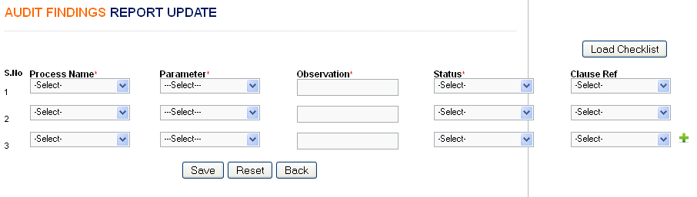

Process Name – Dropdown would display processes created under the schedule category
Parameter - Textbox would be given to enter the parameter details. Max of 200 chars would be allowed
Observation - Textbox would be given to enter the parameter details. Max of 200 chars would be allowed
Status – Dropdown would display the observation types such as O+, Minor NC, Major NC, OI. This data would be fetched from a static master table.
Clause Ref – Dropdown would display the clause ref details from a static master table

Note:
    - By default there would be 50 rows given
    - On clicking the Load checklist would load the checklists created under the respective schedule category in the form. Process Name, Parameter would be populated. Parameter textbox would be allowed to update the details if required.
    - Add New option will also be given for the auditor to add additional rows if needed.

Load Audit checklist

By default the application should display empty grid to fill the audit observation. If there is a scenario that there is no predefined checklist & the auditor would fill the points, the user can make use of the empty grid. If there are situations where there are pre-defined audit checklists, on clicking a button, the respective checklist to be loaded in the grid.

On updating the report and by clicking the Save button would store the details in the database. On clicking the Submit button would change the status of the schedule as Report Submitted and trigger a mail with the audit report in Excel format (sample audit report).

Mail content would be as below:
_______________________________________________________________________
Dear <!—Schedule Responsibility (Auditee),

Please find attached audit report for the <!—Schedule Name conducted on <!—Schedule_date.

Audit Results
Total O+ | 9
Total Major NC | 0
Total Minor NC | 1
Total OI | 2

Please update the Corrective Action Report for Major & Minor NC.

Regards,
<!—Auditor Name
System Generated Mail
_______________________________________________________________________
Audit observation type details
Audit observation details would be maintained in a static table. Below details would be stored in the table.

Type | Correction | Root cause analysis | Corrective Action | Effectiveness Review
O+ | No | No | No | No
Minor NC | Yes | Yes | No | No
Major NC | Yes | Yes | Yes | Yes

Status wise Privileges
Privilege for different user groups for different status would be maintained in this module.

Click the link to understand the privileges set for various user groups.

Note: User Groups & Status of Audit schedules can be dynamically defined based on the customer’s requirement. Privilege can be set based on the customer’s requirement using this module.

CAR Report Generation

Based on the type of NCs, the application would calculate the correction / corrective action required. If correction / corrective action are required, the responsibility will be reassigned to the Auditee. If there is no NC & no correction / corrective action required, the auditor can be able to close the status of the schedule.

Correction Closed

For minor NCs, Auditee has to fill the following details.
- S.No - Read only and filled
- Type of NC - Read only and filled
- Description of the finding - Read only and filled
- Correction
- Responsibility
- EDC for Correction
- ADC for Correction
- Action for Effectiveness Review
- Responsibility
- EDC for Effectiveness Review
- ADC for Effectiveness Review

Sample fields while clicking “Raise Consolidated Audit Report”

S.No Type of NC Description Reference Correction Responsibility

1

EDC – Correction ADC - Correction Eff review Responsibility

Eff review - EDC Eff review - ADC

Save
Submit
Cancel

On filling the above details, the status would be changed as Correction Closed.

Corrective Action Closed

By clicking ‘Raise Consolidated Audit Report’, necessary fields would be populated based on the Findings type.
Following columns will be available for major NCs
- S.No - Read only and filled
- Type of NC - Read only and filled
- Description of the finding - Read only and filled
- Correction
- Responsibility
- EDC for Correction
- ADC for Correction
- Root cause analysis
- Corrective Action
- Type of Corrective Action
- Responsibility
- EDC for Corrective Action
- ADC for Corrective Action
- Action for Effectiveness Review
- Responsibility
- EDC for Effectiveness Review
- ADC for Effectiveness Review

S.No Type of NC Description Reference Correction Responsibility

1

EDC – Correction ADC - Correction Root cause Corrective Corrective
action act type

Responsibility EDC – Corr Action ADC – Corr Action Eff review Responsibility

Eff review - EDC Eff review - ADC

Save
Submit
Cancel

At the end of this page Submit, Reset & Cancel button would be available.
Save – To save the Consolidated Audit Report for later purpose.
Submit – Submit button would be enabled only if all required data is filled against each entry. On clicking the submit button would store the CAR report details in the database.

CAR Closed - Short Term Corrective Action

If the ADC Corrective Action is filled for all the Short Term (Corrective Action Type) corrective action, the status would be changed as CAR Closed – Short Term Corrective Action.

CAR Closed - Long Term Corrective Action

If the ADC Corrective Action is filled for all the Long Term (Corrective Action Type) corrective action, the status would be changed as CAR Closed – Long Term Corrective Action.

Email – For all the above status, CAR report would be generated to the respective auditor with cc to the organizer & Auditee.

Mail would be in the below format
_______________________________________________________________________
Dear <!—Schedule Responsibility (Auditor),

Please find attached Consolidated audit report for the <!—Schedule Name conducted on <!—Schedule_date.

Action | Total | Closed
Correction | 2 | 2
Corrective Action | 1 | 1
Kindly review the effectiveness and close the case.

Thank you

Regards,
<!—Auditee Name
System Generated Mail
_______________________________________________________________________

Once the ADC column for Corrective Action gets filled for all NCs then Status of the case will be automatically changed to Corrective Action completed.
Cancel – By clicking the Cancel button it will return to previous page.

Case Owner will be changed as Auditor (name of the respective auditor).

CAR Resent

Auditor can resend the CAR to Auditee if Corrections & CAs are not completed/wrongly filled. On changing the status as Resend, system would ask for comments. During resend Auditee will be the case owner. The status would be changed as CAR Resent. Mail would be triggered.

Email – Reason / Comments for resending the CAR would be triggered to the auditee with cc to the organizer & auditor.

Once ADC for effectiveness review has been filled for all NCs then the case will get close.

Note: Date of update & Updated by on each status would be tracked in the system.
- For all the updates in the Audit Schedule, Mail will be triggered to the respective Case Owner and the associated persons in cc list.
- There would be a privilege given in the application to update the mailing template against each status.
- Wherever required, contents would be replaced with the required data and the contents in the template would be triggered as email.
- ADC for each Status (Audit Completion, Report Submission, etc…) would be stored.

Schedule Cancellation

Organizer would only have this privilege to cancel the schedule due to some reasons. On clicking the Cancel button would ask for comments / remarks. On filling the details and by submitting would store the details in the application.

Email – A mail would be triggered to the respective auditee with cc to auditor & organizer.

Audit Status Vs Privilege Management

This module would facilitate the Administrator to manage various status of audit schedule & various privileges to different user group.

The Administrator can be able to give privilege for a particular user group as below:
Dropdown
User Group
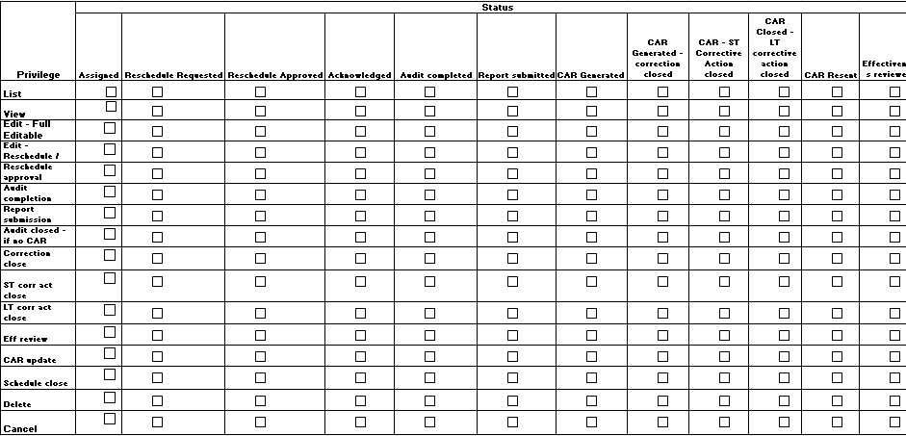

On selecting the required checkboxes would store the access privileges for various statuses.

Note: Status & Privileges would be stored in a static table so that any changes in the privileges would be made easy.

Schedule Management – Other Schedules (Meetings, Demos, Training Sessions etc)

Add Schedule

The Privileged user can create the schedule. The page looks like below

Department
Schedule Category

Dropdown would display the Schedule categories created under Other schedules in the schedule category master.
(Ex: MMRM with PM, MMRM with PLs, SDLC MRM, VODC MRM, PM CoE Meeting etc)
Schedule Title

(Title of the schedule can be entered here)

Mandatory Attendees *
Dropdown would display the users under the selected user group

Optional Attendees
Dropdown would display the users under the selected user group

Dropdown would display the users under the selected user group
Presenter

Dropdown would display the users under the selected user group
Organizer *

Agenda
Agenda for the selected schedule category would be populated. If required this can be edited.

Datepicker would be given to select the date & time
Date & Time *

Meeting Room
Dropdown would display the Meeting room names from the meeting room master

Cancel
Save

The privileged user, on providing the above required details and by clicking the Save button would check for the below validation

Schedule clash for auditee / auditor

Application would validate for the attendees / Presenter / organizer is assigned with some other schedule in the same date & time. If some other schedule is there, the system would throw an alert message stating the clash of the schedule for the attendees / Presenter / organizer.

Meeting room clash

Application would validate whether any other schedule is planned in the same meeting room & for the same date and time. If yes, it would throw an alert message and will not allow creating the schedule.

If there is no such clash of attendees / Presenter / organizer / meeting room, the application will store the schedule in the database. Status of the created schedule will be Assigned at this stage.

Created schedules would be listed in the respective attendees / Presenter / organizer login under Other Schedules module as below.

Schedule type | Schedule Title | Date & Time | Meeting Room | Status | Update
SDLC MRM | II Qtr – EIT - SDLC MRM | 13-Jun-12 | 427 | Assigned | Click Here

Edit Schedule - If there is any issue in the schedule, the organizer who has raised the schedule can edit it only when the status is Assigned. The organizer can be able to edit entire data.

On updating the required details and by submitting, below conditions would be verified.

- Schedule clash for attendees / Presenter / organizer
- Meeting Room clash
If there is any change in the date / time, the status should be changed as Rescheduled.

Reschedule

The organizer can reschedule the meeting / demo etc if there is any change in the date / time. On clicking the Edit button would display the below screen.

The Privileged user can edit the schedule. The page looks like below
EIT
Department
Schedule Category
SDLC MRM
Dropdown would display the Schedule categories created under Other schedules in the schedule category master.
(Ex: MMRM with PM, MMRM with PLs, SDLC MRM, VODC MRM, PM CoE Meeting etc)
Schedule Title
II Qtr – EIT – SDLC MRM
(Title of the schedule can be entered here)

Mandatory Attendees *
Dropdown would display the users under the selected user group

Optional Attendees
Dropdown would display the users under the selected user group

Dropdown would display the users under the selected user group
Presenter

Dropdown would display the users under the selected user group
Organizer *

Agenda
Agenda for the selected schedule category would be populated. If required this can be edited.

Datepicker would be given to select the date & time
Date & Time *

Meeting Room
Dropdown would display the Meeting room names from the meeting room master
Dropdown would display the status such as Assigned, Rescheduled, Completed and Cancelled
Status
Textarea would be given to enter the comments
Comments

Cancel
Save

On changing the date & time and by selecting the status would update the details in the database and a mail would be triggered to the attendees, Presenter, organizer etc.

Whenever there is a change done in the schedule, a mail to be triggered to the attendees.

Completed

The organizer can update the status once the respective meeting / demo is over. On clicking the Edit button and by updating the status as Completed, the system would ask for the attendees & absentees details.
Name of the attendees to be selected from the dropdown. Dropdown would display the mandatory attendees
Attendees *

Absentees *
Names of the absentees to be selected from the dropdown. Dropdown would display the mandatory attendees.

Reason for absent to be updated. Other comments if any can be updated.
Comments *

POA Generated * Checkbox would be available

Below form would be available to update the minutes.

There will be a privilege given to update the minutes of the meeting. Below form would be given.
Textarea would populate the agend for the respective schedule (meeting / demo)
Agenda
Add New

Agenda Point | Minutes | Delete
Textarea would be given to update agenda point | Textarea would be given to update minutes
Textarea would be given to update agenda point | Textarea would be given to update minutes

On clicking the Add New button would load another row to update the minutes.

POA Creation Click Here

Submit
Cancel

On clicking the POA creation link will open a popup with POA capture screen (Refer page 55 – 2.1.8.1).

On clicking the submit button would change the status as completed.

Delete Schedule

The schedule organizer can be able to delete the schedule only if the status is assigned.

Canceled

The organizer can cancel the schedule due to some reasons. On changing the status as cancel, text area would appear to enter the comments / remarks. On filling the details and by submitting, a mail would be triggered to the attendees, Presenter with cc to organizer.

Outlook integration

On creating a schedule would be integrated with outlook & schedule would be created in outlook for the selected attendees.

Task Management
Privileged User can create the tasks under this module. Tasks can be created under various sources. Created tasks will be assigned to the responsible executives. Privileged users can view the list of tasks created under various sources.
Below filters would be given to search for required tasks
Dropdown would list department names
Schedule categories would loaded in a dropdown
Department Source
Dropdown would list all active users
Users of selected department
Raised by Responsibility
Dropdown would list Low, High, Medium
Dropdown would load the status from task_status_master table
Task Category Status
Dropdown would list references from task_ref_master table
Dropdown would list All, Raised to me, Raised by me, Associated to me
Reference Task Type
Datepicker would be available
Datepicker would be available
EDC From To
Datepicker would be available
Datepicker would be available
ADC From To

Expected Man Hrs
Datepicker would be available
Datepicker would be available
From To
Dropdown with all the fields available would be given. User can select the required fields. Selected fields would be shown in the grid

Fields to display

Search

Note: Above filters are optional. If nothing is selected, application would display all tasks raised to the user, raised by the user & associated with the user. Users who have higher privilege can be able to view tasks of other users.

Task details would be listed in a grid as below:

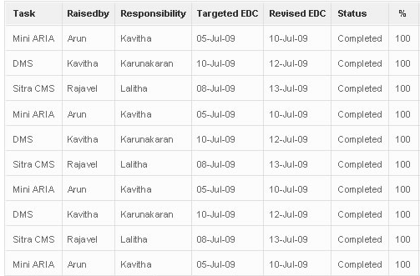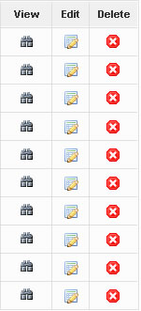

Add Tasks

Source of the Task Mandatory
Dropdown would load the schedule categories from the master

List the schedule_category_name from from qms_sch_cat_master table
Dropdown would display the department names from the master
Department Mandatory

Load the department_name from qms_department_master table

Task Title

Task Description Textarea Optional

Task Raised by Mandatory

(Dropdown should display all users (first_name last_name) from qms_user_management table)

Date Picker would be given
Task Raised on Mandatory

Responsibility Mandatory

(Dropdown should display users of the above selected department (first_name last_name) from qms_user_management table)
List box with multiple selection option would be given
Supporting Person Optional

(Dropdown should display users of the above selected department (first_name last_name) from qms_user_management table) – multiple list box

Task category (Drop down will have High, Medium & low) Mandatory
Textbox would be given

Man Hrs Required
Mandatory

Man Hrs Spent Optional at the time of task creation. When changing the status as completed, it should be mandatory
Textbox would be given

Date Picker would be given

EDC Mandatory

Date Picker would be given

Revised EDC Optional

ADC Optional at the time of task creation. When changing the status as completed, it should be mandatory
Date Picker would be given

Status
Dropdown would display the status

(Not started, Inprogress, Pending, Completed, Hold, Cancelled / Closed)
Dropdown would display the references from the master

Reference

(Dropdown would load the references from the task_ref_master table)
Age
Delay %
Save
Cancel
Reset

Tasks will be in In-Progress status after creation. Mail will be triggered to the responsible person of the task with copy to their PM.
Task id would be auto generated.

(Task would be created in outlook. Whenever any update made, a mail would be triggered and the details would be updated in outlook)

View Tasks

View Tasks would have ‘Assigned by me’, ‘Assigned to me’ & Associated to Me tabs

Assigned to Me – The tasks which are assigned to the logged-in user would be listed in this tab. Logged In user has edit privilege to update the status of the tasks
Associated to Me – Tasks which are having the logged-in users name in associated list would be listed in this tab. Logged In user doesn’t have edit privilege.
Assigned by Me – The tasks which are created by the logged-in user would be listed in this tab. Edit privilege will be available.

User can view the list of tasks assigned to him/her by clicking the ‘Assigned to Me’ and the following details would be displayed in that.
- Task No (Auto Generated field)
- Source of the tasks
- Initiated Date
- Tasks description
- Category
- Responsibility
- Supporting person
- Status
- EDC
- Revised EDC
- ADC
- Age (Auto calculate)
- Delay% (Auto calculate)

Edit Tasks

By clicking the Task description user can edit the task details.
The following fields are editable for the user who has responsibility to complete the tasks.
  - Supporting Person
  - Status
  - Revised EDC
  - ADC
Organizer of the task can edit all the fields in task. Mail will be triggered for all the edited tasks to the respective stakeholders.

Reports

Reports menu will have the following Reports.
- Schedule Report
- Audit Reports
  - Audit Findings Reports
  - Audit TAT Reports
  - Consolidated Audit Findings Report
- Tasks Report

All the reports can be exported to Excel.

Schedule Report

All the users can filter the schedule details by using the following fields.
        - SBU / Department
        - Schedule Category
        - Schedule Sub Category
        - Duration (Start date & End date)
        - Status

The Filtered schedules will display in the same one by one.

Audit Reports

Audit Findings Report

This page would have the following fields horizontally in top of the page for filter.
          - SBU / Department
          - Audit Type
          - Project Name, if Audit type is Project Audit
          - PL Name (Auto fill)
          - Process Name (Will get auto loaded based on the SBU selection from Process Master)
          - Finding Types (Major NC, Minor NC, OI)
          - Duration (Start and End dates)
By clicking ‘Generate Report’ button, following kind of report would get generated based on the filter conditions.
S.No | SBU / Department | Group | Project Name | PL Name | Process | Type | Description
1
2
3
4
5

Audit TAT Report

This page would have following fields horizontally in top of the page for filter.
        - Department Name, if SBU = EIT / IM
        - Audit Type
        - Auditor
        - Auditee
        - Duration (Start date & End date)
        - Status
Two buttons named as ‘Generate Report’ and ‘Cancel’ would be available just below the above fields.

Filtered Report would be displayed in the same page one by one horizontally. TAT field would be available along with the above mentioned fields.

For Example, If we select Status as “Report Submitted”, TAT would be displayed like below
        - Audit Completion – No deviation
        - Report Submission – 200% deviation

Consolidated Audit Findings Report

This Report would have the following sub reports
        - Month wise Report
        - PL wise Report
        - Trend Report

Month wise Report

Privileged User can generate this report based on the following fields
      - Department Name
      - Audit Type, if SBU = EIT / IM
      - Audit Month
      - Process Name
      - Type of findings (All, Major, Minor, OI)
The Report would be like below
Process wise Audit Findings
Process | Major NC | Minor NC | OI
Customer Requirement Specification | 2 | 6 | 6
Project Planning | 2 | 7 | 3
Design, Development & Outsourcing | 5 | 4 | 1
Testing & Implementation | 5 | 3 | 2
Customer Support Services | 0 | 0 | 1
Process Monitoring & Improvement | 3 | 3 | 5
Previous Audit | 0 | 0 | 0

The following Bar chart will be generated based on the data in the above table.
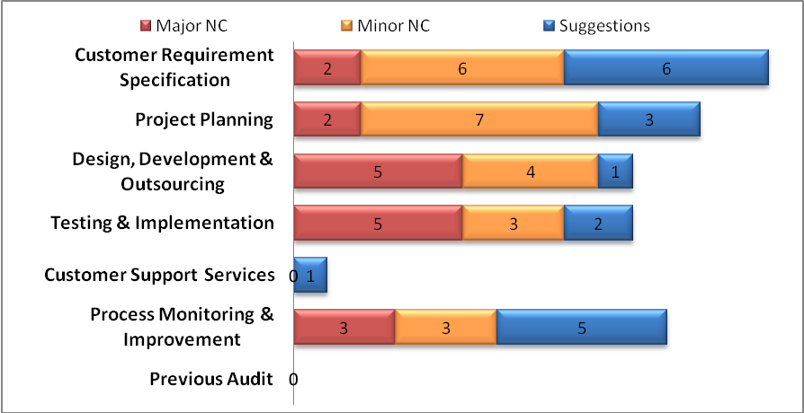

PL wise Report

Privileged User can generate this report based on the following fields
        - SBU / Department
        - Audit Type
        - Audit Category
        - Duration (Start date & End Date)
Following kind of report would get generated.
PL wise Audit Findings
PL Name | Major NC |  | Minor NC
PL Name | Open | Closed | Open | Closed
Kavitha | 3 | 2 | 1 | 2
Arun | 1 | 5 | 0 | 4
Senthilnayaki | 3 | 6 | 1 | 3
Ramya | 1 | 7 | 0 | 6
Santhosh | 2 | 8 | 8 | 7
Krishnakumar | 2 | 4 | 3 | 6
Diwakar | 4 | 1 | 6 | 4
Poornima | 3 | 3 | 2 | 2

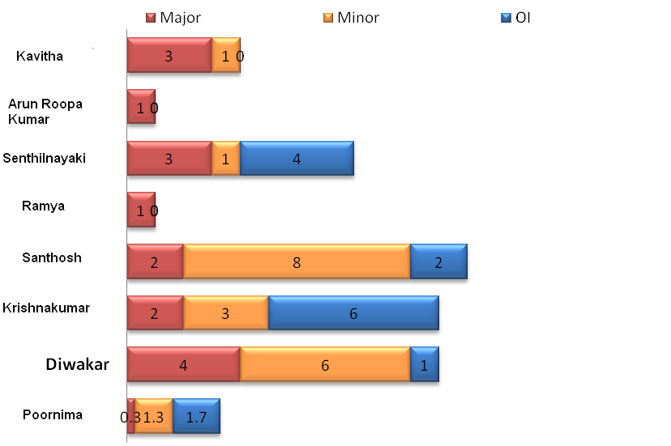

Trend Report

Privileged User can generate this report based on the following fields
      - Department, If SBU = EIT / IM & Audit Type = Project Audit
      - Audit Type
      - Audit Category
      - Duration (Start date & End Date)
      - Type of findings (All, Major, Minor, OI)
The Report would be like below
Month wise Audit Findings Trend
Month | Major NC | Minor NC | OI
Jan'11 | 47 | 34 | 35
Feb'11 | 6 | 15 | 13
Mar'11 | 6 | 7 | 8
Apr'11 | 17 | 23 | 18

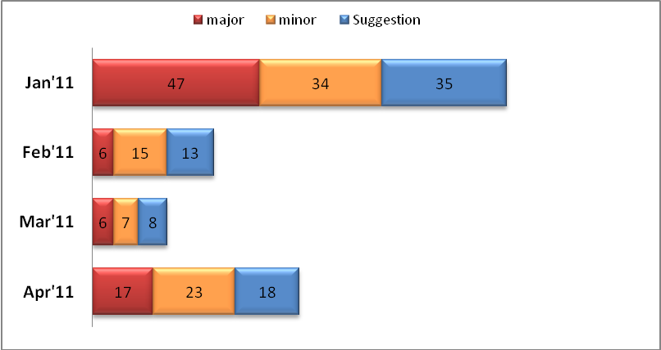

OI Implementation Report

Privileged user can view the list OIs generated from Internal Audit.
This page has the following fields.
  - S.No
  - Schedule Category
  - Source - This will have name of audit month
  - Initiated Date - OI entered date
  - Audit Type (Radio button for Project Audit & SBU Audit)
  - Drop down – Name of project from where OI is generated if Project Audit, SBU Names for SBU Audit
  - Description of OI
  - Decision – Drop down box and it would have Valid, Invalid & Duplicate as values
  - Reason – This box would be enable if the OI is invalid / Duplicate
  - Generate POA – A link will be given to generate POA against the OI. On clicking the link will take the user to the popup where POA creation feature would be given.

Source, Initiated Date, Project Name and Description of OI are auto generated fields from Audit Findings Report.
User can view a particular OI by clicking the respective row. All the fields are editable except Initiated date, Project name and Description of OI for the Privileged user (Respective SBU Head / MR Team)

Tasks Report

User can get the following Reports in this menu
    - Detailed Report
    - Source wise Report
    - Status wise Report
    - % POA Completion Report

Detailed Report

Privileged User (SBU Heads / SBU Coordinators for their respective SBU, PMs for their respective resources, Administrator for all SBU and MR Team for their respective SBUs) can filter the tasks based on the following fields
- SBU
- Source
- Initiated date range (Start date & End date)
- Category
- Responsibility
- Supporting person
- Status
- EDC range
- Age
- Delay %

Filtered data would display in a row one by one.

Source wise Report

This page will generate the report based on the source in which POA has been generated.
Source wise POA
 | In-progress | Completed
Meeting Name 1 | 1 | 1
Meeting Name 2 | 1 | 2
Meeting Name 3 | 1 | 1
Meeting Name 4 | 2 | 1
Meeting Name 5 | 0 | 1
Meeting Name 6 | 1 | 0
Meeting Name 7 | 1 | 1
Meeting Name 8 | 1 | 0
Meeting Name 9 | 0 | 1
Meeting Name 10 | 2 | 0
Total | 10 | 8

The following Column type Chart would be generated based on the data in the above table.
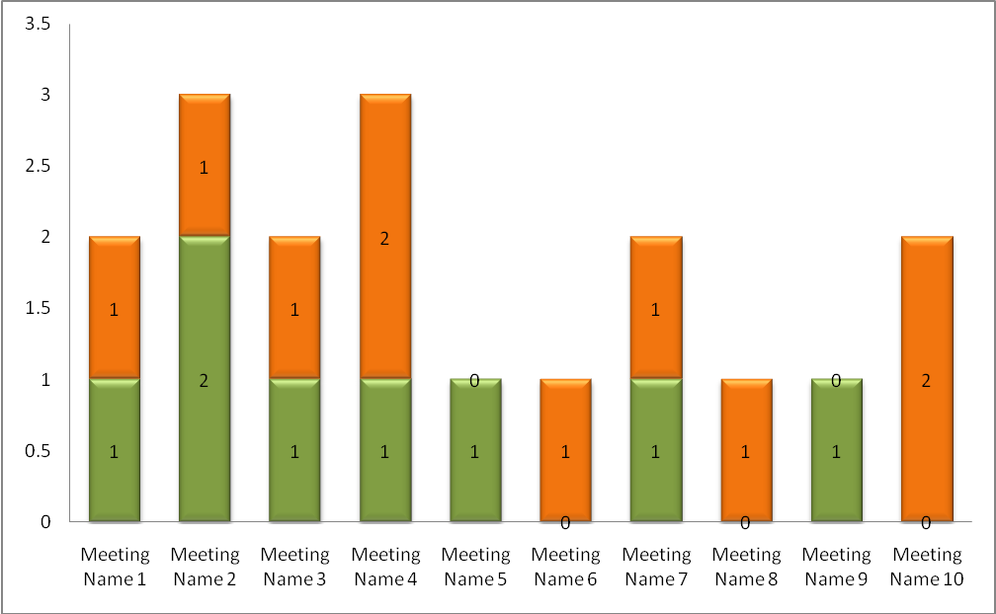

Status wise Report

This page generate the report based on the Status of the tasks like In-Progress, Completed, etc
Status wise POAs
Executive | Completed |  | In progress |  |  |  | Cancelled | Hold
Executive | within EDC | Overdue | Within EDC | 0< Delay% < 50 | 50 < Delay% < 100 | Delay% > 100 | Cancelled | Hold
Exec. Name 1 | 1 | 0 | 0 | 0 | 0 | 1 | 0 | 1
Exec. Name 2 | 1 | 3 | 0 | 1 | 0 | 4 | 1 | 0
Exec. Name 3 | 0 | 2 | 0 | 0 | 0 | 1 | 0 | 0
Exec. Name 4 | 0 | 0 | 0 | 0 | 0 | 2 | 0 | 0
Exec. Name 5 | 0 | 1 | 0 | 0 | 0 | 1 | 0 | 1
Total | 2 | 6 | 0 | 1 | 0 | 9 | 1 | 2

The following Pie chart would be generated based on the above data.
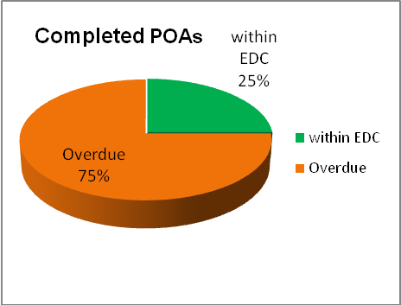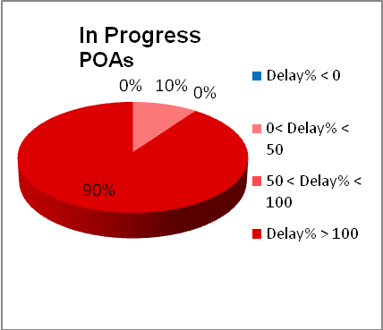

% POA Completion Report

Privileged User can generate the % POA Completion for executive wise. The following fields would be available in this page.
- SBU / Department Name
- Executive Name
- Duration (Start date & End date)
Generate Report
Cancel

The Generated Report will have the following fields horizontally.
            - S.No
            - Executive Name
            - SBU
            - Duration
            - % POA Completion

Remainder Mail

Remainder mails would triggered for Schedule reminders, upcoming task completion EDC, Task delays, NCs / CAR reports supposed to be closed during that period. Reminder mails would be triggered in the pre-defined interval.

Delay% Calculation

Delay% will be mentioned for the each task which has crossed EDC.
Following Conditional formatting will be used to differentiate the delay %
Yellow – 0 > delay % < 50
Orange – 50 > delay % < 100
Red - delay % > 100
Note: Duration of sending the remainder mails is configurable. Based on the configured duration, mails would be triggered.

Operating Environment Requirements

Hardware

Web Server | Client’ Server (Intel P4, 1 GB RAM)
Internet Connectivity | Broadband Connection

Software

Software | PHP 5.0  MySQL 5.0

Browser Compatibility

Browser | Internet Explorer 8 & 9 & Firefox 14 & 15

Software Application Project Development Approach

The pictorial representation will give you the procedure that is followed for the completion of project.

Responsibilities Project Development Approach and Phases
Is there any Change?

Approval from Client
No
Client & ANGLER
ANGLER
ANGLER
Client & ANGLER
Client & ANGLER
Client

Client
Requirement Study & SRS Documentation
Sample / Prototype Screens & Project Plan
Design and Development
Testing
Implementation / Documentation
No
Yes
Project is Live

The project shall be moved from one stage to another after getting the approval / confirmation from the client wherever applicable.

SRS Signoff

The requirements for the list of modules specified in the SRS document are confirmed and the scope is freezed.

The Project shall be developed as per this SRS document (QMS_Portal_SRS_V2.0.doc). Any thing other than this would be considered as change request. The developer has the privileges to accept / reject the change. This change request shall be considered as enhancement if it crosses the original scope of the project. Time requirement may vary depending on the changes.

ANGLER Technologies Pvt Ltd  Sign & Seal | ANGLER Technologies Pvt Ltd  Sign & Seal
Name:
Role:
Date:

