WISER × BQP Quantum Challenge 2026
Team Research Proposal
Benchmark of Quantum-Assisted Physics-Informed Neural Networks for Navier–Stokes Shock Tube Simulation
Submission Deadline: 7 August 2026
Team member: David Liu, Shan Zeng

1. Executive Summary
This proposal describes our team's research plan for the WISER × BQP Quantum Challenge 2026. We address the challenge core question: when, why, and how does introducing a quantum layer change the learning dynamics of a physics-informed neural network (PINN) [1, 2, 3]?
Our use case is the heatlow approaching a hypersonic vehicle surface, modelled by the three conservation laws of a viscous gas: mass, momentum, and energy that are solved together on a single shared grid. We train four surrogate machine learning models spanning the classical-to-quantum spectrum, using a field-level architecture where the model input is [x, t, p_ratio, μ, ρ_L, ρ_R, p_R] (7 scalars) and the output is a gas field value. This is an ideal PINN test case: it combines multiple coupled PDEs and enables true PDE-residual losses via automatic differentiation through the network.
The four models are:
- Classical MLP and PINN: classical baselines (100 parameters), without and with the physics loss.
- QAPINN: hybrid models (100 parameters) with a variational quantum circuit (VQC) layer at different layers with the physics loss.
- QPINN: fully quantum mo, with all computation inside the VQC and zero classical layers, with classical and quantum physics loss, using LCU to combine the five physics loss terms.
Our key contributions are: (1) a physically self-consistent 1-D compressible gas simulation governed by the mass, momentum, and energy conservation laws on a single shared grid; (2) a field-level surrogate enabling a true PDE-residual physics loss built as a complete set of physical constraints; (3) a fully quantum QPINN that matches hybrid accuracy with similar or fewer parameters; (4) systematic studies of circuit depth, encoding scheme, ancilla count, and quantum-layer position at different layer or loss function; and (5) interpretation of every result through XAI attribution linked back to the governing physics.

2. Problem Statement

2.1 Physical Background
The Navier–Stokes shock tube is a canonical benchmark in computational fluid dynamics. A diaphragm initially separates a high-pressure left state from a low-pressure right state inside a one-dimensional tube; when the diaphragm bursts at $t=0$, three distinct wave fa a left-travelling rarefaction fan, a contact discontinuity, and a right-travelling shock whose inviscid limiting solution is given analytically by the Euler equations [4]. This problem is a stringent test for any surrogate model because it combines smooth, continuous regions with sharp discontinuities and nonlinear coupling between density, velocity, pressure, and temperature.
Predicting the full shock tube solution requires solving the compressible Navier–Stokes equations, and high-resolution direct numerical simulation is expensive when sweeping across many initial conditions (pressure ratio, viscosity, initial state). A fast, accurate surrogate that reproduces the shock tube state (the density, velocity, and pressure fields as functions of position and time) at query time is therefore of direct relevance to BQP's BQPhy platform. The same compressible-flow physics governs internal ballistics, supersonic nozzle flows, and blast wave propagation, so the surrogate target generalises well beyond the canonical shock tube.

2.2 The System-Level Question
Primary engineering question: Given the initial conditions (pressure ratio $p_{L}/p_{R}$, left and right densities $ρ_{L}$, $ρ_{R}$, right pressure $p_{R}$, and dynamic viscosity $μ$), how do the density, velocity, and pressure fields evolve in space and time inside the shock tube, and where do the shock front, contact discontinuity, and rarefaction fan travel?
This is answered by simulating the Navier–Stokes shock tube. A high-pressure gas on the left drives a shock rightward while a rarefaction fan travels left; between them a contact discontinuity separates gas originating from each side. Capturing this correctly requires the three conservation laws of compressible gas: mass, momentum, and energy that are solved together. This is because they are physically inseparable: the velocity field transports mass (continuity), the pressure gradient accelerates the flow (momentum), and compression and expansion change the internal energy (energy). The shock speed and the post-shock state that emerge are exactly the quantities a downstream blast-wave or nozzle analysis needs. In our simulator the shock position is tracked as the location of maximum pressure gradient, and the peak post-shock density rise is the key scalar diagnostic. The surrogate's task is therefore to reproduce the full ρ(x, t), u(x, t), and p(x, t) fields accurately enough that these wave-front positions are recovered correctly.

2.3 The Governing Equations — One Gas, Three Conservation Laws
Rather than three separate PDEs on artificially separated regions, we model a single physical domain: a 1-D compressible viscous tube. All three fields are properties of the same gas at each location, so they legitimately share one grid. At every point the gas has a density, a velocity, and a pressure simultaneously.
Field | Conservation law | Equation (non-dimensional) | Role
ρ (density) | Mass continuity | ∂ρ/∂t + ∂(ρu)/∂x = 0 | gas compresses as it decelerates
u (velocity) | Momentum balance | ∂u/∂t + u·∂u/∂x = −(1/ρ)·∂p/∂x + ν·∂²u/∂x² | pressure and viscosity slow the flow
T (temperature) | Energy balance | ∂T/∂t + u·∂T/∂x = −(γ−1)·T·∂u/∂x + (κ/ρ)·∂²T/∂x² | compression work heats the gas

The system is closed by the ideal-gas law p = ρT, with κ = ν/Pr linking momentum and thermal diffusion (Pr = 0.72). The three equations are genuinely coupled: pressure ties density and temperature into the momentum balance, the mass flux ρu ties velocity into continuity, and the compression term −(γ−1)T·∂u/∂x converts flow work into heat.
Relation to the classical benchmark PDEs. The momentum equation reduces to Burgers' equation (∂u/∂t + u·∂u/∂x = ν·∂²u/∂x²) when the pressure gradient is neglected — Burgers is exactly its constant-density, pressure-free limit. The energy equation is an advection–compression equation whose source drives the temperature jump across the shock. The Navier–Stokes shock tube model therefore contains both the nonlinear-advection physics of Burgers' equation and the advection–diffusion physics of the heat equation, now unified and augmented by the mass-conservation law and a pressure coupling that generates discontinuous wave structures.

2.4 Classical Simulation Model Setup
Our ground-truth simulator (Step1_simulation_1D_navier_stokes_shock_tube.py) solves the full one-dimensional compressible Navier–Stokes equations including dynamic viscosity $μ$ and Fourier heat conduction $κ=μC_{p}/Pr$ on a uniform 256-point finite-volume grid. It uses an operator-split scheme: an explicit Lax–Friedrichs step for the inviscid fluxes (CFL $=0.45$) followed by an unconditionally stable backward-Euler implicit solve for the viscous and thermal diffusion terms. The dataset is generated by a Latin Hypercube Sampling (LHS) sweep [McKay, Beckman & Conover, 1979] [5] over five independent physics parameters simultaneously: pressure ratio $p_{L}/p_{R}∈[2,20]$ (log-uniform), dynamic viscosity $μ∈[0,0.02]$, left density $ρ_{L}∈[0.5,2.0]$, right density $ρ_{R}∈[0.05,0.5]$, and right pressure $p_{R}∈[0.05,0.3]$. Each of the 500 scenarios records 41 evenly-spaced time snapshots across $t∈[0,0.2]$, yielding 500 × 41 × 256 = 5,248,000 labelled rows of $\left(ρ , u , p , T\right)$ at every $\left(x , t\right)$point. Every scenario passes an integral mass-conservation check (mean density drift $<2\%$) before its snapshots are admitted to the training dataset; scenarios failing this criterion are logged separately and excluded.
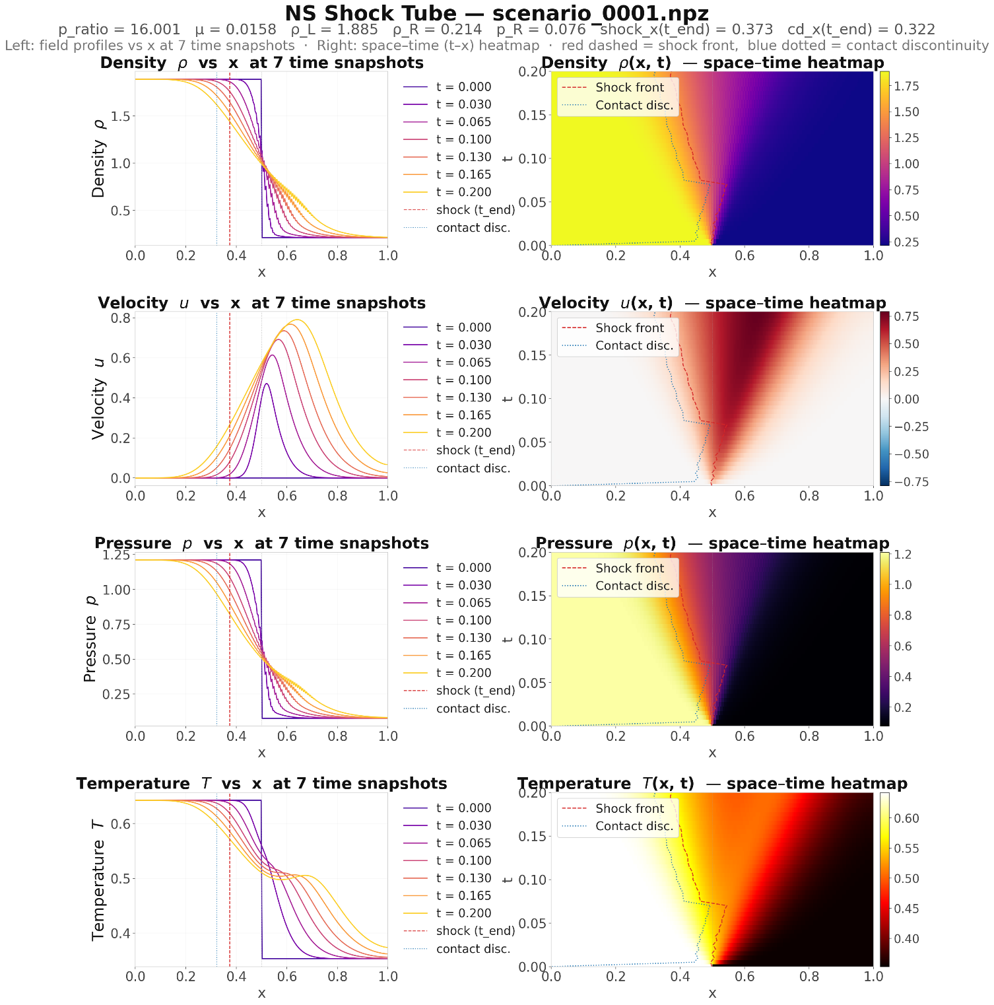
Figure 1: A scenario of Viscous shock tube fields: ρ, u, p, T over space and time

3. Machine Learning Model Configurations and Physics Loss

3.1 ML Inputs and Outputs
We train a field-level model where each sample is a single point in space and time at a given physical parameter. This allows the model to compute PDE residuals via automatic differentiation through the network.
Component | Value | Why it matters for PINN
Model input | [x, t, p_ratio, μ, ρ_L, ρ_R, p_R] — 7 scalars | x and t enable ∂/∂t and ∂²/∂x² via autograd; the 5 physics parameters condition the network on the specific scenario
Model output | field value — 1 scalar | one model per field: ρ(x,t), u(x,t), p(x,t), or T(x,t)
Scenario parameterisation | LHS over 5 parameters: p_ratio ∈ [2,20], μ ∈ [0,0.02], ρ_L ∈ [0.5,2.0], ρ_R ∈ [0.05,0.5], p_R ∈ [0.05,0.3] | LHS guarantees uniform c-D parameter space with the minimum number of simulations [5]
Training data | 10,496,000 rows per field | 1,000 scenarios × 256 spatial pts × 41 snapshots
Split | 80% train / 20% test | 8,396,800 train rows / 2,099,200 held-out test rows per field

3.2 Model Architectures
All four models share the field-level [x, t, p_ratio, μ, ρ_L, ρ_R, p_R] → field-value interface (one model per tube field). Parameter counts differ by three orders of magnitude, isolating the effect of the quantum layer.
Model | Params | Type | Architecture
MLP / PINN | 750 | classical | 7 → 16 → 16 → 5, Tanh (~750 params); PINN adds the physics loss
QAPINN / Hybrid | 700 | hybrid | VQC (3 qubits, 3 layers, angle encoding, ring CNOT) → classical tail; Hybrid adds the physics loss
QPINN | 100 | full quantum | 6 qubits (3 data + 3 ancilla for LCU loss), 3–4 layers, re-upload encoding, ring CNOT, ⟨Z₀⟩ output; no classical layers

The fully quantum QPINN uses different encoding, and prediction would include both prediction and loss with LCU decomposition.
Quantum-layer position (QAPINN). The VQC can replace the i-th hidden layer. Results will show where to place it as a bottleneck between a classical encoder and decoder is better.

3.3 Physics Loss — a Complete Set of Physical Constraints
The physics loss is not merely the interior PDE residual. It is redesigned as the complete set of physical constraints of the coupled simulation. Each term enforces a real balance law or physical admissibility condition, and all derivatives are dimensionally consistent.
L_physics = w_pde·L_pde + w_ic·L_ic + w_bc·L_bc + w_bound·L_bound + w_cons·L_cons
Constraint | Physical meaning | What it enforces
L_pde | Conservation law (interior) | Mass continuity, momentum, and energy residuals for the Navier–Stokes shock tube at random interior collocation points
L_ic | Initial condition | The physical starting state of the gas column (quiescent cooler gas)
L_bc | Boundary conditions | Fixed hot-fast inflow at x=0; soft zero-gradient outflow at x=1
L_bound | Physical admissibility | Positivity of density and temperature (ρ > 0, T > 0) via ReLU penalties
L_cons | Global conservation (integral form) | d/dt ∫ρ dx = net mass flux (ρu at inflow − outflow) — the continuity balance imposed on the network via quadrature

The physics loss trains the fully quantum QPINN on all constraints, not just the data. The continuity balance is verified directly in the simulator, where the mass stored equals net inflow minus outflow to within 1%.

4. Design of Experiments
Step 1 — Gas-flow ground-truth generation
Run the 1-D Navier–Stokes shock tube solver (mass + momentum + energy) across 500 initial scenarios, verifying the mass-continuity balance each run. Export all four fields ( ρ(x,t), u(x,t), p(x,t), T(x,t)) together with the scenario parameters [p_ratio, μ, ρ_L, ρ_R, p_R] and diagnostics (shock position, contact-discontinuity position, post-shock density ratio)
Step 2 — Classical baselines (MLP, PINN)
Train both classical models for 200 epochs. MLP uses data loss only; PINN adds the five-constraint physics loss. Tests whether enforcing the physics improves generalization to unseen parameters.
Step 3 — Hybrid models (QAPINN, Hybrid)
Replace one hidden layer of the classical PINN with a variational quantum circuit (VQC) and retrain with the five-constraint physics loss, using qiskit.
Step 4 — VQC layer-depth study
QAPINN with L = 1–4 variational layers; also the full QPINN with L = 1–4. Compares how depth affects learning dynamics for hybrid vs pure-quantum models and classical models.
Step 5 — Encoding-scheme comparison
At L = 3, compare angle, amplitude, IQP, and re-upload encodings on accuracy, convergence speed, and XAI feature attribution.
Step 6 — Ancilla-qubit study
NA = 0, 1, 2 ancilla qubits × physics on/off (3×2 factorial); link the ancilla benefit to each PDE's physical coupling structure or loss structure.
Step 7 — Quantum-layer-position study
VQC at hidden layer 1, 2, or 3, and a position × parameter-budget matched study isolating the position effect from parameter count.
Step 8 — Full-QPINN depth and quantum-loss study
Full quantum QPINN depth L = 1–4 with zero classical tail, showing how a pure quantum model's expressivity depends entirely on circuit depth. This step also introduces a two-branch fully quantum model in which the circuit exposes two measurement channels from the same wavefunction: branch A (a data-register observable, ⟨Z₀⟩) is the field prediction, and branch B (an ancilla-register observable) is a quantum-native loss channel. Rather than computing the physics residual classically after measurement, branch B block-encodes the differential operator (a linear combination of shift unitaries) so the PDE residual norm is read directly as an ancilla expectation value. Prediction and loss are therefore both quantum measurements of the circuit; the two branches co-train, and on real hardware the residual derivatives would be obtained by the parameter-shift rule on the encoding gates. This connects directly to BQP's own quantum-loss research direction.
Step 9 — XAI analysis
Captum Integrated Gradients on all models; per-feature attribution over [x, t, p_ratio, μ, ρ_L, ρ_R, p_R] linked to each PDE's physical character.
Step 10 — Controlled matched comparison
The decisive fairness test: shrink PINN, QAPINN, and the full QPINN to the SAME parameter count (~100) and train for the SAME number of epochs (100) on the same data and split. Because the full quantum circuit has a natural parameter ceiling (18L+2), all three are matched near that ceiling. Report accuracy (MSE), R², and a full metric panel (MAE, RMSE, max error) on both the benchmark heat equation and the Navier–Stokes shock tube density field.

5. Timeline
Week | Dates | Deliverable
Week 1 | 8–14 July | Finalize the use case classical simulation. Compressible gas-flow data with verified mass-continuity balance; classical baselines (MLP R² > 0.99, PINN with decaying constraints)
Week 2 | 15–21 July | Hybrid QAPINN + full QPINN training; depth studies L=1–4 for both
Week 3 | 22–28 July | Encoding, ancilla for loss, and quantum-layer-position studies
Week 4 | 29 Jul–4 Aug | XAI analysis and physical interpretation across all models
Week 5 | 5–7 Aug | Final report (10–15 pages), slides, reproducible code (Step 1/2/3 + experiments)

6. References
[1] Raissi, M., Perdikaris, P., Karniadakis, G. (2017). Physics-Informed Deep Learning (Part I). arXiv:1711.10561.
[2] Pérez-Salinas, Cervera-Lierta, Gil-Fuster, Latorre (2020). Data re-uploading for a universal quantum classifier. Quantum, 4, 226 .
[3] Shah, Lineswala, Chopra (2024). Benchmarking QA-PINN for Computational Fluid Dynamics. IEEE QCE 2024, vol. 01, pp. 1707–1712.
[4] Sod, G.A. (1978). A survey of several finite difference methods for systems of nonlinear hyperbolic conservation laws. Journal of Computational Physics, 27(1), 1–31.
[5] McKay, M. D., Beckman, R. J., & Conover, W. J. (1979). A comparison of three methods for selecting values of input variables in the analysis of output from a computer code. Technometrics, 21(2), 239–245.

