PRACTICAL # 11

OBJECT:
Classifying iris flowers with Support Vector Machine

THEORY:
Support Vector Machine is a supervised learning and classification algorithm. It is a discriminating classifier defined by a separating hyperplane. Given labeled training data, the algorithm outputs an optimal hyperplane which classifies new inputs. In two dimensional space this hyperplane is a line dividing a plane in two parts where each class lies on either side of the hyperplane. In figure 1, the hyperplane is the green line separating two classes. Any point that is left of line falls into black circle class and on right falls into blue square class. In training, SVM finds out a line/hyperplane (in multidimensional space that separate outs classes). In testing, the SVM model predicts by checking on which side of the plane this new example lies.

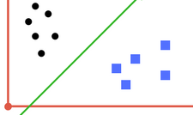

Figure 1: Hyperplane separating two classes.

Regularization parameter and gamma are tuning parameters in SVM classifier. By adjusting these parameter values we can achieve better classification line with more accuracy in reasonable amount of time. Another tuning parameter is kernel. It defines whether we want a linear or non-linear hyperplane of separation.

Kernels:
The three types of SVM-Kernels are shown in Figure 2. The polynomial and RBF are especially useful when the data-points are not linearly separable.
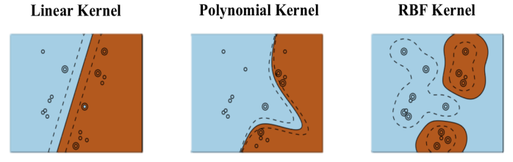
Figure 2: Three types of SVM kernels

CODE:
We use the support vector machine implementation from sklearn to classify iris flower data. The iris dataset has three classes. The classes are named

We create models for linear, rbf and polymomial kernels of SVM.

from sklearn.model_selection import train_test_split
from sklearn import svm, datasets
from sklearn.metrics import accuracy_score

iris = datasets.load_iris()
X = iris.data
y = iris.target

X_train, X_test, y_train, y_test = train_test_split(X, y, test_size=0.4)

C = 1.0 # SVM regularization parameter
# create three models of SVM with linear, rbf and polynomial kernels.
models = (svm.SVC(kernel='linear', C=C),
svm.SVC(kernel='rbf', gamma=0.7, C=C),
svm.SVC(kernel='poly', degree=3, C=C))

modelLinear = models[0].fit(X_train, y_train)
modelRBF = models[1].fit(X_train, y_train)
modelPolynomial = models[2].fit(X_train, y_train)

#models = (clf.fit(X, y) for clf in models)

print('Accuracy of linear kernel SVM on test set: {:.2f}'.format(modelPolynomial.score(X_test, y_test) * 100))

pred = modelLinear.predict(X_test)
print("accuracy of linear kernel SVM ", accuracy_score(y_test, pred))

pred = modelRBF.predict(X_test)
print("accuracy of linear kernel SVM ", accuracy_score(y_test, pred))

pred = modelPolynomial.predict(X_test)
print("accuracy of polynomial kernel SVM ", accuracy_score(y_test, pred))

C Parameter:
The cost or regularization parameter C controls the trade-off between maximising the margin and minimising the training error.
Gamma Parameter:
The gamma hyperplane parameter in the RBF kernel controls the nonlinearity of the SVM boundaries. The larger the gamma, the more non-linear the boundaries surrounding individual samples. Lower values of gamma lead to broader, more linear boundaries.
Degree Parameter
The degree parameter in polynomial kernel controls the flexibility of the decision boundary. Higher degree kernels yield a more flexible decision boundary.

You might see the following warning while training the model.
/home/shan/.local/lib/python3.6/site-packages/sklearn/svm/base.py:922: ConvergenceWarning: Liblinear failed to converge, increase the number of iterations. "the number of iterations.", ConvergenceWarning)

This happens in SVM (or generally an optimization algorithm) does not converge, usually because the training data is not well-conditioned, perhaps due to a poor scaling of the decision variables. There are a few things you can try.

(1) Normalize your training data so that the problem hopefully becomes more well conditioned, which in turn can speed up convergence. One possibility is to scale your data to 0 mean, unit standard deviation using Scikit-Learn's StandardScaler for an example. Note that you have to apply the StandardScaler fitted on the training data to the test data.
(2) Related to 1), make sure the other arguments such as regularization weight, C, is set appropriately.
(3) Set max_iter to a larger value. The default is 1000.

ACTIVITIES:
Activity 1:
Using SVM implementation, train and classify any other dataset of your choice. The train – test split should be 80:20. Show accuracy, precision and recall score.

REVIEW QUESTIONS:

Q1: What is the support vector or hyperplane in SVM?

Q2: What problems may occur in SVM while finding the hyperplane?

Q2: What are the kernels in SVM?

Q4: What is convergence in SVM?

