Assembly Instructions for the PBJ-Duino

S. Vance Greenface Labs

4/13/2019

Circuit Board

1. Install H7 on the bottom side of the circuit board.
2. Install discrete components and ICs. (save the longer trimmed leads for step 3.)
3. Install Jacks. (note: Photo shows discontinued jack board.) Align the solder tabs with the associated holes and connect by soldering trimmed component leads from the jack to the hole in the circuit board.
4. Install the rest of the headers. (try to keep the Arduino headers aligned and level to make connecting the Arduino easier.)
5. Clean the board with flux remover. (optional)
6. Install the 3 Arduino-mounting standoffs.
7. Install the four rubber feet.
8. Mate the protoboards by sliding the tabs into the slots. Remove adhesive backing and affix to the circuit board inside the lines marked A1 and A2.
9. Test it.
10. If everything works, you're ready to plug in your Arduino Uno R3 and go!

The photo below is not current. But it can be used as a guide. We will get a photo of the current revision as soon as possible.

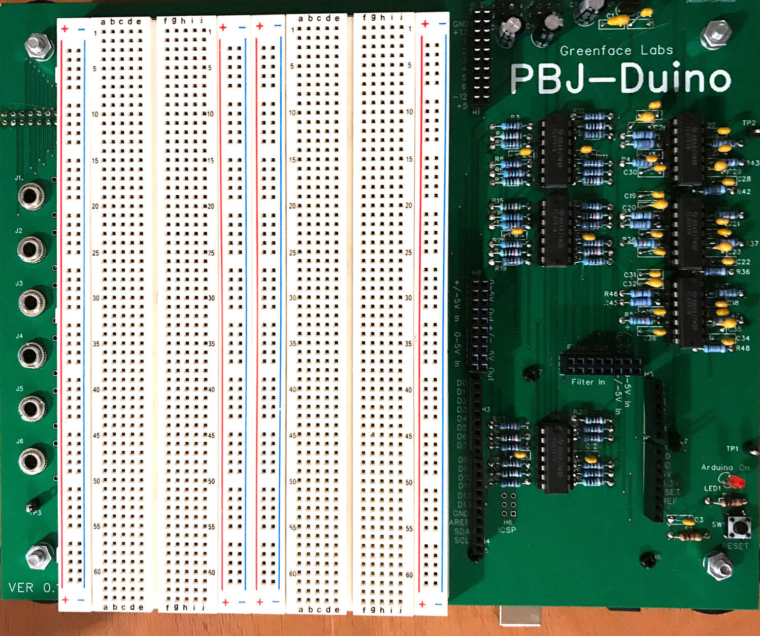

Bottom View

