Assembly Instructions for the PBJ-Solo

S. Vance Greenface Labs

4/13/2019

Circuit Board

1. Install discrete components R1, D1-D3, U1, C1-C4. U1 may need heat sinking depending on your requirements.
2. Install H1 on the bottom side of the circuit board.
3. Install H2, H3 and Test Points.
4. Install Jacks. Align the solder tabs with the associated holes and connect by soldering wire or trimmed component leads from the jack to the hole in the circuit board.
5. Install battery holders. Battery holders are mounted using double-sticky tape (recommended) or M3x10 countersunk machine screws with nut and lock washer. Solder after mounting.
6. Clean the board with flux remover. (optional)
7. Mate the protoboards by sliding the tabs into the slots. Remove adhesive backing and affix to the circuit board inside the lines marked A1 and A2.
8. Attach rubber feet with M4x20 pan-head screws with nuts and lock washers.
9. Test it.
10. If everything works, you're ready to plug it into your Eurorack and go!

The photo below is not current. But it can be used as a guide. We will get a photo of the current revision as soon as possible.

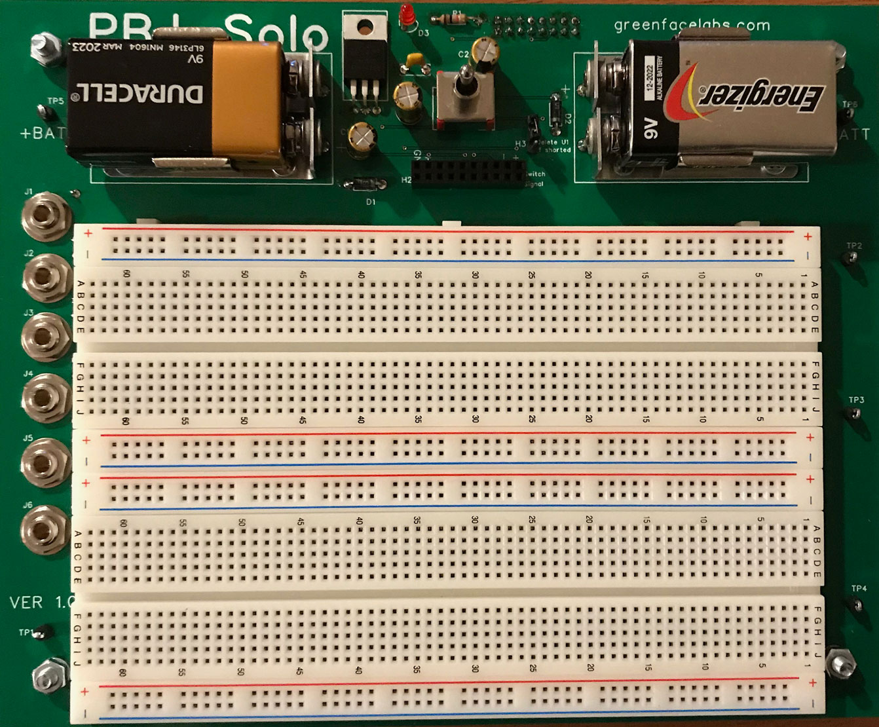

Bottom View