Melper Assembly Instructions
  - Skill Level – Beginner

OK for 1st build if practiced beforehand – see Tips section
Please read this entire document before starting the build.

Tools and Materials
- The documents: GitHub Repo
  - The schematic: Melper.pdf
  - The BOM (bill of materials): bom\Digi-Key\Melper_full.csv
- The Melper:
  - The revision of the board should match the revision of the schematic.
  - The schematic revision is located in the lower right corner of the schematic.
- Components: Verify that you have all the components specified in the BOM.
  - Note that the LEDs and the 1.8uH inductor are specified twice in the BOM. Choose one or the other depending on availability. The through-hole versions of the parts are preferred. Refer to the schematic for more details.
- Soldering Iron and Solder:
  - A fine-tipped soldering iron A .8mm conical tip is suggested.
  - Use rosin-core solder.
  - .8mm diameter solder is good for through hole work such as the Melper.
  - Lead-based solder has increased health risks but is much easier to use.
- Solder braid and or solder sucker (in case of mistakes).
- Diagonal cutters and Needle-Nose Pliers: Make sure to use tools that are designed for circuit assembly.
  - We like Hakko tools for electronics work.
  - A lead-bending tool is not required but is very helpful. This one looks like it would work.
- Multimeter: Use to verify the three voltage rails and to troubleshoot.
- A solder fume extractor is recommended. A fan to suck the fumes away from the work area is better than nothing if an extractor isn’t available.
- Circuit vise: Optional, but highly recommended. Example - Velleman VTHH6-VP on Amazon
- Magnifying Glass: Helps inspect solder joints and components.

Assembly
Note that both reference designators and component values are printed on the circuit board. This greatly reduces the risk of misplacing components.
It pays to double-check the component placement before soldering.
You’ll need to position the clamp in various places on the circuit board to make room for soldering. The image below shows that the board is positioned for soldering the Eurorack power connectors.
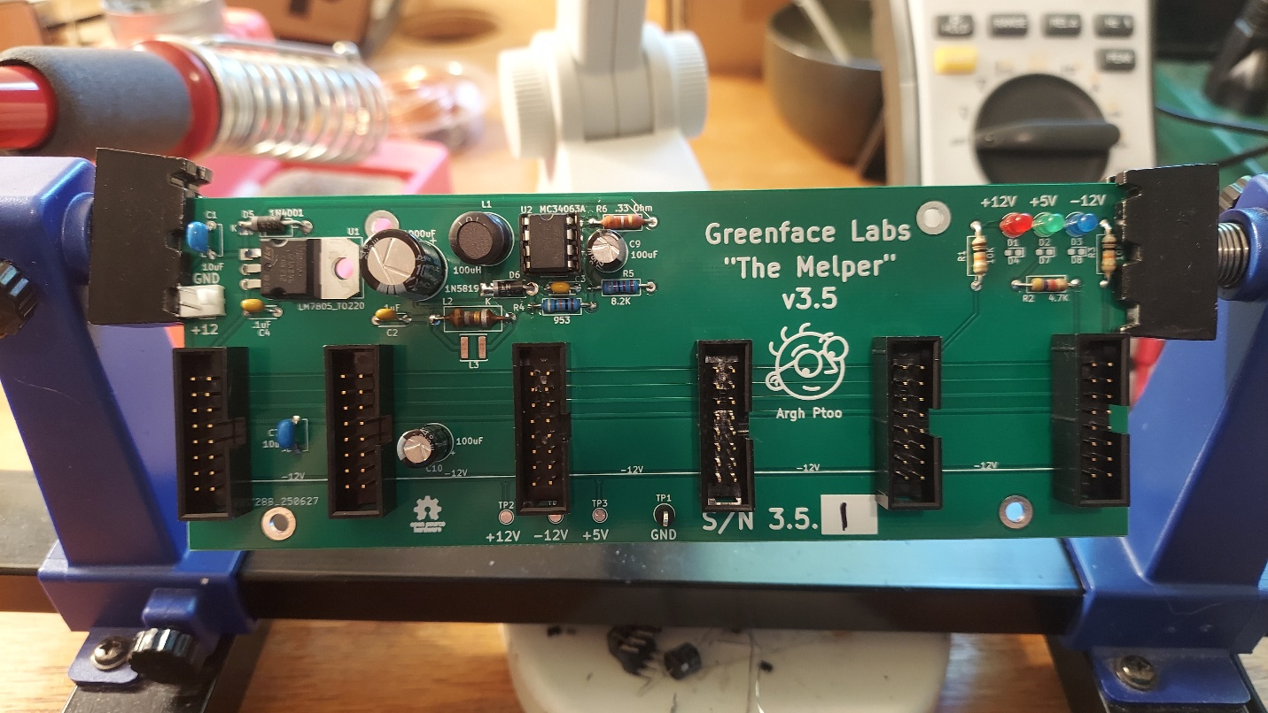
We feel it is best practice to leave component leads going straight through the board rather than bending them. This makes it much easier to remove components if rework is required later. Several techniques can be used to hold the component in place while soldering depending on the component. If you are unsure about this, using a practice soldering board is recommended.

Testing
- Visual Inspection: Examine the Melper for misplaced components, cold solder joints or solder bridges.
- Electrical Testing: Use a multimeter to verify the three voltage rails. The test points make measuring easier.
  - Apply +12V power source to the input connector, J7.
  - Verify that all three power monitor LEDs are on.
  - +12V should remain within specs for the source used
  - -12V and +5V should be within the voltage range indicated in the specs that are published on the Melper web page.
- Functional Testing:
  - Put one of your modules in your new case and try it out.
    - Make sure this module does not require more current than the Melper can supply.
  - If the module doesn’t work try swapping modules and double-checking everything.
  - A complete troubleshooting guide is beyond the scope of this document. If you need help please Contact - Greenface Labs.

Tips and Best Practices
- Work in a clean, well-lit, well-ventilated area.
- Wear eye-safety gear, such as goggles, when soldering and trimming leads to protect yourself from sputtering/splashing solder and flying bits of metal.
- If this is one of your first builds, practice soldering on a spare board or dedicated practice board to improve your technique before starting the Melper assembly.
  - This kit from Amazon looks good and cheap: Soldering Practice Kit
- Keep a “measure twice, cut once” attitude.
- Always prefer the best results over the quickest results. (harder than it sounds!)

Disclaimer
The above text is our best recommendations for safely building a functional product. Greenface Labs cannot guarantee or be held liable for the safety of the builder or the success of the project based on these recommendations.
We also understand that much of this may be daunting to the beginner who is starting with little or no equipment. However, the Melper can be successfully built using just a soldering iron and a cutter to trim the leads. If the lights light up, then it probably works.

