The Bonkulator

User Manual

Greenface Labs -- 2023

Table of Contents

Description 3

Quick Start 3

Overview 5

Signals 5

Functions 5

Controls 5

Features 6

Front Panel 7

Open-Source Project 8

Operation 9

General Operation 9

Screen Saver 10

Output Details 11

Waveform Details 13

Settings Details 15

Remote Modes 17

WiFi 17

Terminal Mode 20

Software Update 23

Disaster Recovery 23

# Description

The Bonkulator is a 14HP Eurorack module that generates signals that can be used to modulate voltage-controlled functions such as VCO, VCF, VCA, etc... Eight independent outputs can be triggered by any of four trigger inputs and can also be modulated by the two input signals. In addition to the front panel controls, the Bonkulator provides a Web interface via WiFi and a Terminal interface via USB. These interfaces enhance the user experience and bring a greater level of controllability to the module.

# Quick Start

The Bonkulator can be used in an endless variety of ways, but here is a great way to start exploring. These instructions are for use with a Moog Mother-32 but can be easily adapted to most modular synthesizers. Addition of an Echo module is highly recommended.

#### Mother-32 Set-up

* VCA Mode – ON (do not use the envelope generator)
* VCO Mod Amount – 50%
* VCO Mod Dest - Frequency
* VCF Mode – Low Pass
* VCF Mod Polarity – +
* LFO Wave – triangle
* LFO Rate – 30%
* Cutoff – 50%
* Resonance – 20%
* Sustain – Off
* Frequency – 50%
* Pulse Width – 50%
* VCO Wave - Pulse
* Octave – 4
* Note – 8

#### Bonkulator Set-Up

* Both (common settings)
  + Waveform: Ramp
  + Init Delay: 00000
  + Active Time: 03010
  + Idle Time: 00000
  + Repeat: 00000
  + T0: Enabled
  + T1: Disabled
  + T2: Disabled
  + T3: Disabled
  + CV0: Off
  + CV1: Off
  + Scale: see below
  + Offset: 000
  + Randomness: 00
  + Quantize: No
  + Idle Value: 2048
  + Clock: Internal
  + Range: +/-5V
* Output 0
  + Scale: 100
* Output 1
  + Scale: -100

Connect the Bonkulator Output 0 to the M-32 VCO 1V/Oct input and the VCF Cutoff input. Connect Output 1 to the M-32 LFO Rate input. Press Trigger 0 on the Bonkulator and you should hear a sound much like that found [here](https://www.greenfacelabs.com/wp-content/uploads/2022/07/bonkulator_quick_start.mp3). Experiment with the various Output parameters. Try increasing the Randomness on Output 0 to 20.

# Overview

The Bonkulator is a Eurorack module that fits into a 3U x 14HP slot. It features 8 programmable outputs and 6 programmable inputs. The front-panel user controls consist of a 128×64 pixel 2-color OLED display, a rotary encoder and arrow buttons for adjusting parameters. There is also a button for each trigger and output.

Pressing the output buttons brings up the configuration menu for each output. Outputs have many parameters. Among them are the Waveform to be sent and its Active Time. Select which triggers activate the output in the Output configuration menu. Complete information on all the parameters can be found in the Output Details section of this document.

Pressing the Adjust Knob activates various functions of the Bonkulator. The use of this button is context-sensitive and is only active within the Settings function. Pressing and holding this knob for longer than 2 seconds brings up the Settings function.

In addition to the front panel controls, the Bonkulator provides WiFi and Terminal interfaces. The WiFi interface is a REST API and the Terminal interface is ANSI X3.64 via the Arduino micro-USB connector. These interfaces greatly extend the usefulness and capabilities of the Bonkulator. Scripting, patch management, dedicated GUIs and even Internet-connected IoT apps are now possible. And using a remote interface means that you no longer have to adjust tiny dials amid a forest of patch cords. This benefit cannot be fully appreciated until it is experienced directly.

## Signals

* Outputs (8) – Analog signal (+/- 5 volt or 0-10V). Built-in and programmable waveforms.
* Triggers (4) – Digital signal that is activated by a 0 to +5V transition.
* CV (2) – Analog signal input. Range: +/- 5 volt

## Functions

* Output (0-7) – For configuring the 8 outputs
* Settings – For module configuration, WiFi , factory reset, etc.

## Controls

* Output Buttons (0-7) – For selecting from the 8 outputs
* Trigger Buttons (0-3) – For manual triggering
* Move Buttons (^v<>) – For navigating the display.
* Adjust Rotary Encoder – For adjusting selected parameter
* Activate Push Button – Push the Adjust knob to activate functions
* More controls are available via Web and Terminal interfaces

## Features

* A 128x64 two-color OLED graphic display enhances usability
* Web and Terminal interfaces provide rich user experiences with the addition of computer resources like a keyboard, mouse, display and scripting.
* All settings are stored in FRAM memory so that they are retained when power is off
* Inputs and Outputs are protected against damage during typical use
* Output and Input LED indicators show voltage levels present at the jacks
* Trigger Indicator LEDs show if any Outputs have been activated by that trigger
* Output range is switchable: +/-5V or 0-10V (board models 4.0 and later)
* An Expansion module is available that provides an external USB interface with some interesting extra features. See “The BonkDaddy”.

## Front Panel

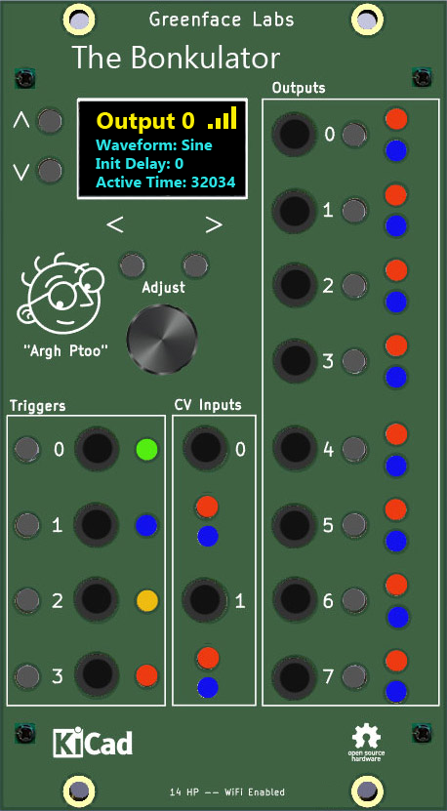

Figure 1 - Front Panel

## Open-Source Project

The Bonkulator is an Open-Source project that has an Arduino RP2040 at its core. The code is written in C++ and makes use of several public domain code libraries for managing the various purchased hardware components such as the display and the FRAM non-volatile memory.

Because it is Open Source, in addition to being used by musicians and sound designers to create new and amazing sounds, the Bonkulator can be used by students and entrepreneurs to create new, amazing modules. And, of course, the open-source community will generally improve the product as times goes along. Links to the design repositories can be found on the Bonkulator web page.

# Operation

## General Operation

The typical procedure for using the Bonkulator involves choosing a set of waveforms that are needed for a particular application. Then a set of triggers are defined and the various parameters for each waveform are entered. Once configured, the Bonkulator reacts to trigger signals, sending the waveform for each Output that was triggered.

* The Output is selected using the Output buttons.
  + Terminal uses the **‘f’** command.
  + Web Interface has dedicated Function buttons.
  + Each Output has several parameters.
  + Waveforms are selected as one of the parameters
  + Choose from 7 pre-installed waveforms and 8 user-defined waveforms.
* Parameters are adjusted using the arrow keys and the Adjust knob.
  + Parameters are selected using the **up** and **down** arrows.
  + Digit to be adjusted is selected by using the **right** and **left** arrows.
  + When entering strings, holding the right or left arrow down for 2 seconds inserts (right) or deletes (left) a character.
  + Use the Adjust knob to increment and decrement the selected digit.
  + Parameter values may be directly entered using the Terminal or Web Interface.
* Enable Triggers for each Output that is to be used
  + Outputs can be triggered by any or all of the four triggers.
  + Triggers T0 – T3 can be either ENABLED or DISABLED. They are set as above.
* Operation of each Output is triggered by a variety of methods.
  + Pressing the selected trigger button. (Manual trigger)
  + Receiving a low to high transition on the selected Trigger jack.
  + Terminal uses the ‘**!**’ key to trigger the selected trigger.
  + Web Interface has a dedicated Trigger button for each trigger.
* If an Output is already triggered, receiving a trigger command will stop the output.
  + Trigger signals effectively toggle the Output state. (Triggered or Idle)
* Many parameters can be modulated by the two input signals.
  + Set CV0 and CV1 to select the modulation target (scale, offset, active time, idle value, randomness or off).
  + CV In jacks have a range of -5V to +5V
  + The sample period for the CV inputs is approximately 20ms. There is no filtering at the input to the converter, so frequencies above 5Hz will produce unpredictable modulation. Could be interesting…
  + If both CVs are specified, the effect is to cascade CV1 after CV0

## Screen Saver

In order to maximize display life, the display will turn off after a set time. The default time is 15 minutes. The time can be set in the Settings function with a range of 1 to 9999 minutes.

Press any button or send the ‘z’ command to bring the display back.

# Output Details

The Output signal ranges from -5.33V to +5.33V or from 0 to 10.66V. (see Range setting)

When the Output isn’t active, the **Idle Value** is sent. Use Output parameters to select the Idle Value.

Web mode has a dedicated slider control for several parameters, and Terminal mode uses the *S, O* and *c* keys followed by a number. See the table of remote commands for more details.

The Bonkulator Outputs have several parameters. Details for each parameter follow. A star(*) next to the name indicates that output is not calibrated.

1. Waveform – These are the signals that can be assigned to the outputs
   1. Fifteen waveforms are available, seven are factory-installed and eight are user-defined. Waveforms are stored as 128 values that range from 0-1023. Depending on the chosen Active Time, 10 to 128 of these values will be used to create the output signal.
   2. The factory-installed waveforms are: Sine, Haystack, Ramp, Pyramid, Pulse, Maytag, and Toggle.
   3. The user-defined waveforms can be entered by the following methods:
      1. Manually via the front panel controls
      2. Via script using either Terminal mode or a Web Interface macro
      3. Recorded from the CV0 input
2. Init Delay – The time in milliseconds to delay before sending the Waveform
   1. Range 0 to 65535 msecs
3. Active Time/Parts – The length in milliseconds of the waveform when in Internal clock mode or the number of samples to be used when in External clock mode
   1. Active Time ranges from 10 msecs – 65535 msecs
   2. Parts ranges from 10 to 128
   3. When in Internal clock mode, the Active Time affects the number of samples used and thus the sample rate.
      1. When the Active Time is a multiple of 128, the number of samples used will be the full 128.
      2. When the Active Time is less than 128, the number of samples will equal the Active Time.
      3. When the Active Time is greater than 128, the number of samples will be the result of a best-fit algorithm.
   4. When in External clock mode, the Delay and Repeat settings are ignored
4. Idle Time – The time in milliseconds to delay before repeating the Waveform
   1. Range 0 to 65535 msecs
5. Repeat – The number of times to repeat the waveform
   1. Range 1 to 65535
   2. Set Repeat to 0 to repeat forever.
6. T0 thru T4 – These are the Trigger/Clock inputs
   1. Each of the four triggers can be either Enabled or Disabled. That means that every output can be triggered by as many as four different trigger signals.
   2. Each trigger can be manually activated by pressing the associated button.
   3. Triggers are activated by a rising edge 5V signal at the input.
   4. In Internal clock mode, triggers toggle the trigger state of the output. So, if an output is Idle, receiving a trigger will activate the output. If the output is already active, a trigger will stop sending the waveform and will put the output into the Idle state.
   5. When in External clock mode, every trigger merely sends the next output sample.
7. CV0 & CV1 – These are the control voltage inputs.
   1. They can be set to modulate the following Output parameters:
      1. Scale – Range .01x – 100x
         1. -5 V = .01x
         2. 0V = 1x
         3. 5V = 100x
      2. Offset – Range +/-10.66V
         1. Output is offset by 2.13 times the input voltage.
      3. Active Time – Range .1x thru 10x
      4. Idle Value
      5. Randomness
   2. A star (*) next to the name indicates that input is not calibrated.
   3. Additionally, a change to the CV input can cause a trigger. Select *Trigger* as the CV target to do this.
8. Scale
   1. Full scale signal is +/-5.33V or 0-10V depending on Output Range setting
   2. Scale ranges from -100% to 100%
   3. Negative values invert the signal
9. Offset
   1. Range - +/-100%
   2. 100% = 10.66V
10. Randomness – 0 to 100%
11. Quantize - Yes/No
12. Idle Value
    1. The Idle Value is sent when the Output is not active.
    2. It is also sent during the Idle Time period.
    3. Idle Value of 0 corresponds to Output voltage of -5.33V
    4. Idle Value of 4095 corresponds to Output voltage of 5.33V
    5. Idle Value of 2048 corresponds to Output voltage of 0.0V
13. Clock
    1. Internal – The next sample is sent based on the Active Time setting.
    2. External – The next sample is sent on the rising edge of the enabled trigger.
14. Range
    1. +/-5V (Default)
    2. 0-10V (board models 4.0 and later)
15. Trigger Control
    1. Trigger Hold-off
       1. Suppresses triggers for set time after receiving a trigger.
       2. Range 0-65535ms
    2. Trigger Skip
       1. Skips set number of triggers
       2. Range 0-65535ms
    3. Trigger Density
       1. Randomly accepts a percentage of triggers
       2. Range 0-100%

# Waveform Details

The Bonkulator has seven factory-installed and eight user-defined waveforms. The user-defined waveforms are managed in the Settings section where the initial names shown below may be changed.

1. Sine – Classic Sine Wave
2. Haystack – First half of Sine wave
3. Ramp – Asymmetrical sawtooth
4. Pyramid – Symmetrical sawtooth
5. Pulse – The Pulse is formed by the waveform transitioning from the Active Value to the Idle Value
   1. **Idle Time** must be non-zero for a pulse to form
   2. **Offset** is disabled for this waveform
   3. A variety of pulse shapes can be formed by adjusting **Scale** and **Idle Value**
6. Maytag – A random sequence
7. Toggle – Not a waveform exactly, Toggle switches between the scaled value and the Idle Value on every transition of the trigger input
8. User Wave 0-7
   1. User Waves are managed in Settings
   2. Default is flat line
   3. User Waves can be manually entered point-by-point or recorded at CV0

# Settings Details

The Settings function displays information about the Bonkulator as well as allowing some adjustments to various system parameters. Refer to the table below.

|  |  |  |  |
| --- | --- | --- | --- |
| **Parameter** | **Min** | **Max** | **Sub Menu** |
| Version | -- | -- |  |
| Name | -- | -- |  |
| Encoder Type | Normal | Reverse |  |
| WiFi | Enabled | Disabled | Press Activate |
| Screen Saver | 1 | 9999 |  |
| Waveforms | Wave 0 | Wave 7 | Press Activate |
| Reset | -- | -- | Press Activate |
| Calibrate | Inputs | Outputs | Press Activate |

Notes:

1. **Version** shows the software version number. This is useful when communicating about bugs and questions.
2. **Name**
   1. The Name is displayed on boot-up and is displayed in the remote screens.
   2. This helps keep track of which unit is associated with which screen when there are multiple units installed.
3. **Encoder Type** takes the two types of rotary encoder into account. This makes them easier to purchase if one type is unavailable. If your Adjust knob is working opposite as it should, this is the setting that corrects it.
4. **WiFi** can be disabled here if you want to turn it off but retain your password.
5. **Screen Saver** prolongs the life of the OLED display. The screen will blank after the set number of minutes. Press any button to bring the display back.
6. **Waveforms** is where User Waveforms are managed. Each waveform contains 128 samples. Waveforms can be entered manually or recorded from CV0. Press Activate after selecting the waveform to bring up the Manage Waveform menu.
   1. **Name** – Enter a meaningful name for your waveform
   2. **Index** – For manual entry. Range 0:128
   3. **Value** – For manual entry. Range 0:4095 (see Output Range)
      1. Displays current value at the element pointed to by Index.
      2. New values are entered by pressing Activate.
      3. Pressing Activate also increments Index.
      4. Value of 0 corresponds to negative full scale
      5. Value of 4095corresponds to positive full scale
      6. Value of 2048 corresponds to mid scale
   4. **Sample Time** – This is the time between samples in milliseconds. Calculate using this formula: length of waveform to be sampled in milliseconds / 128
   5. **Record On** – The event that starts the recording of a waveform
      1. **Immediate** – Starts recording when Activated
      2. **Trigger** – Waits for a trigger on any trigger input
      3. **+Change** - Waits for a positive change in the voltage to start recording
      4. **-Change** - Waits for a negative change in the voltage to start recording
   6. **Note** – The WiFi interface allows for point and click setting of the Index and Value. This greatly speeds up entering new waveforms.
7. **Reset** brings the Bonkulator’s parameters back to their factory defaults. Note that WiFi parameters are unaffected.
   1. **Parameters**
   2. **Input Corrections**
   3. **Output Corrections**
   4. **All**
8. **Calibrate** is where the 8 output and 2 input signal paths are calibrated.
   1. **Inputs** – Requires DC voltage source, accuracy .1%
      1. First apply 0VDC to input and adjust Offset to get a correct reading.
      2. Apply 4VDC to input and adjust Scale to get a correct reading.
      3. Test other voltages to verify accuracy. (note that full scale is +/-4.967V)
      4. Set Calibrated to Yes when done.
   2. **Outputs** – Requires DC Voltmeter, accuracy .1%
      1. Adjust Offset until voltage at Output is as close to zero as possible.
      2. Adjust Scale until voltage at Output is as close to 5.333 as possible.
      3. Set Calibrated to Yes when done.

# Remote Modes

## WiFi

The Bonkulator is equipped with a 2.4GHz WiFi interface. When connected to your network, you can control the Bonkulator using the [Web Interface](https://www.greenfacelabs.com/bonkulator-control/) (see example screen below).

WiFi can be disabled in the Settings function. Make sure it is enabled before proceeding in the connection process.

#### Connecting to WiFi

1. Enter WiFi function and press Activate to scan for networks.
2. Use the up and down arrow keys to select your network. Press Activate.
3. Use the right and left arrow keys with the Adjust control to select each character of your password. Press Activate when your password is entered. Note: It is much easier in Terminal mode. Type your password preceded by $, then press Enter.

The Bonkulator will try to connect using the password that you entered. If successful, the screen will display the connection data. This includes the connection status, the IP it can be found at and the signal strength. The signal strength will also be displayed in the upper right corner of the display as 1-4 bars. The signal strength display is shown in most functions.

If the connection fails, the Bonkulator will give its best explanation of why it failed.

The Bonkulator remembers its connection and will reestablish it if the power is recycled.

Visiting the WiFi function again while connected will display the connection data. Press Activate to re-enter the scan for networks screen.

If the Bonkulator connects to the network, but the Web app has trouble connecting to the Bonkulator, it often helps to recycle the power to the Bonkulator. Try the Web app again after the Bonkulator restarts and re-connects to WiFi.

#### Using WiFi

The Bonkulator’s Web Interface was designed to resemble the physical front panel. However, because the Web Interface enjoys the added functionality a computer brings, it has significant differences. Please refer to Fig. 2 below.

While you can still adjust parameters a digit at a time, you can now enter parameters from the keyboard by first clicking on the parameter then using the dedicated entry field.

Adjusting parameters digit by digit is possible by using the right and left arrows to select the digit and using the Inc and Dec buttons to increment and decrement the digit.

When entering User Waveforms, you can click on the graph to set the Index or Value. This saves a lot of time over manual entry.

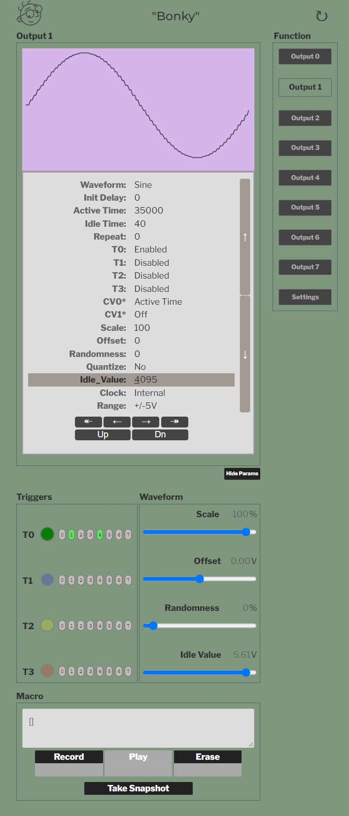

Figure Web Interface Example

## Terminal Mode

Terminal mode is accessed via the MicroUSB connector on the Arduino that is on the bottom of the Bonkulator. It is always available and cannot be turned on or off.

Use a terminal emulation program like PuTTY that has VT-100 mode. The Bonkulator is set to run at 115200 baud but will adapt to the PuTTY settings.

#### Terminal Example Screen

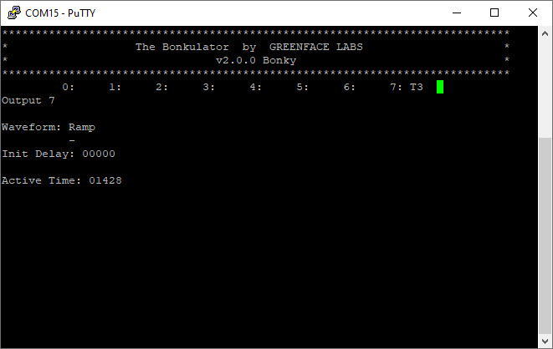

Figure 3 – Example Terminal Interface Screen

The Terminal screen essentially shows a copy of the user display with the addition of a product identification header that includes the software version and the unit’s name.

Below the product identification header is a status line that usually shows the state of the outputs. If an output is active, the status line will show which trigger activated that output.

Important! Only connect USB to a powered-up system. Otherwise, the 5V power from the USB will try to power the entire rack. And that’s not good. So, please disconnect the USB cable before you turn off the power.

You can get around this by using the BonkDaddy which disconnects the USB power when the Bonkulator is turned off.

#### Bonkulator Remote Commands

|  |  |  |  |
| --- | --- | --- | --- |
| **Command** | **Front Panel** | **Terminal** | **Web** |
| Previous Parameter | ^ | [A | ^ |
| Next Parameter | v | [B | v |
| Next Digit | > | [C | > |
| Previous Digit | < | [D | < |
| Increment Digit | Adjust clockwise | u | Inc |
| Decrement Digit | Counter-clockwise | d | Dec |
| Settings Function | Press & Hold ADJ | * | Settings |
| Disable Displays |  | Z |  |
| Restore Displays |  | z | Refresh Browser |
| Trigger Selected |  | ! | Use T0-T3 |
| Go To Function | Press Output | fx | Click Fxn Name |
| Select Parameter |  | px | Click on Param |
| Select Digit# |  | :xx |  |
| Enter Parameter |  | xxx… | Use Param Input |
| Enter Parameter (alt) |  | #xxx… | Use Param Input |
| Enter String |  | $xx… | Use Param Input |
| Idle Value |  | Vxxxx |  |
| Offset | Use Adj | Oxxxx | Use Offset slider |
| Scale | Use Adj | Sxxx | Use Scale slider |
| Randomness | Use Adj | Rxx | Use Random slider |
| Set DAC |  | =xxxx |  |
| Quantization Off |  | Q0 |  |
| Quantization On |  | Q1 |  |
| Print WiFi Status |  | W |  |
| Display Off |  | J0 |  |
| Display On |  | J1 |  |
| Select Trigger |  | tx |  |
| Clear Trigger |  | cx |  |
| Disable Selected Trig |  | T0x |  |
| Enable Selected Trig |  | T1x |  |
| Toggle Selected Trig |  | T2x |  |
| Disable All Triggers |  | T3 |  |
| Trigger All Triggers |  | T4 |  |
| Clear All Triggers |  | T5 |  |
| Trigger Report |  | T6 |  |
| Gen Macro Selected |  | M0 |  |
| Gen Macro Input Cal |  | M1 |  |
| Gen Macro Output Cal |  | M2 |  |
| Gen Macro User Wave |  | M1x |  |
| Dump Waveform |  | Dx y |  |
| Comment (for scripts) |  | / |  |

Notes:

* Under the hood, the Web interface uses the same command characters as the Terminal
* Commands with yellow background require the user to press Enter when using a terminal. **Not** **Required** when sending via Web interface.
* Parameters and digits may be navigated in Terminal mode using the arrow keys.
* Go To Function – x means to enter a single digit in the range of 0-8. The numbers 0 – 7 denote Outputs and 8 denotes Settings.
* Select Parameter – x means a single digit in the range of 0-n, where n = the number of parameters for a chosen function minus 1.
* Enter Parameter – xxxx means up to 4 digits depending on the parameter. The range also depends on the parameter.
* Enter Parameter Alt – Start with # followed by desired number. Terminate with carriage return.
* Enter String – Start with $ followed by desired string. Terminate with carriage return.
* Disable Displays - Z is used to speed up remote scripting.
* Restore Displays – z restores display that has been disabled by command or has been turned off due to inactivity.
* Idle Value – xxxx ranges from -5478 to +5478 or 0 to 10956 depending on output range setting. This number, divided by 1000, is the actual output voltage.
* Offset – xxxx ranges from -100 to +100
* Scale – xxxx ranges from -100 to +100
* Randomness – xx ranges from 0 to 99
* Set DAC – xxxx ranges from 0 – 4095. This sets the Idle Value of the selected output.
* Display On (J1) and Display Off (J0) just affect the OLED display. Turning off the OLED display noticeably speeds up response when using the terminal interface.
* Select Trigger – x denotes trigger number (0 – 3). This command affects other trigger commands.
* Clear Trigger – x denotes Output (0-7)
* Disable/Enable/Toggle Selected Trigger – x denotes Output (0-7)
* Gen Macro – These commands are used to capture the parameter settings for scripting. See below section for more details.
* Gen Macro User Wave - x denotes wave number.
* Dump Waveform - x denotes Output (0-7). This sends the 128 values to the terminal. If y is present, it dumps the reference waveform, which is the waveform before parameters are applied (scale, offset, etc.)
* Comment – the / character causes the following text up until the carriage return to be ignored.

#### Generating Parameter Macros

Software updates often contain new features that affect EEPROM allocation and thus will require initialization of the EEPROM when installed. This means that all parameters, user waveforms and calibration data will be lost and must be re-entered.

Parameter Macros are a way of minimizing the impact of this condition. Parameter Macros are created using Terminal Mode. When a Macro is created, it will be sent to the terminal screen where it can be copied and pasted into a text file for later use.

To run the Macro, merely paste it into the Terminal screen. Do this after a software update and whenever you need to set parameters to a known state. It is recommended that Calibration data macros only be run after a software update or if calibration data is lost or corrupted.

Macros are initiated by the ‘M’ character followed by a number that signifies the operation.

* M0 generates a macro that contains the parameters for the currently selected function.
* M1 generates a macro that contains the Input calibration data
* M2 generates a macro that contains the Output calibration data
* M10 – M17 generate macros that contain the User Waveform data. The selected waveform will equal the entered number – 10. I.e., M15 denotes User Waveform 5.

# Software Update

When a software update becomes available, it will be posted on the website as a zipped package. The package contains 6 files. Unzip these into an empty folder on your machine.

1. arduino-cli.exe
2. Bonkulator.ino.bin
3. Bonkulator.ino.elf
4. Release.txt
5. Update.bat
6. Blink.ino.elf.uf2 (for disaster recovery)

These files work for the Windows OS.

Follow these steps to update the code. This procedure ensures that your rack won’t be inadvertently powered by the USB +5 volt supply.

1. Note: If the update changes the EEPROM storage mapping, the unit will automatically initiate a Software Reset. Any stored settings will be lost, so make sure to save these settings before updating if they are important. See Generating Parameter Macros
2. Turn off power to the rack and remove the Bonkulator.
3. Leaving the power cable connected, place the Bonkulator on a non-conductive surface. Make sure nothing touches the Bonkulator that might cause a short.
4. Re-power the rack and plug micro-USB cable into the Bonkulator.
5. Run update.bat. It will show available COM ports. Choose by entering the number of the port.
6. If it connects properly, you will see Windows announce a new drive has been mounted. The code is copied to this drive. If the update succeeds, the Bonkulator will reboot as normal with the new software installed and the drive will be removed. You can see the new version number in the Settings function.
7. Note that an upload generates a file named: Bonkulator.ino.elf.uf2

## Disaster Recovery

When things go wrong, as they sometimes do, the Bonkulator might become unresponsive. When this happens, the program must be reset. Usually recycling the power* will fix the problem, but occasionally things have gone so bad that the code must be reloaded.

Usually, following the above update process will work. But occasionally things might have gone so bad that a hardware reset must be performed. There is a reset button on the Arduino 33 IoT. Pressing this twice quickly will force the Arduino into bootloader mode. You will see the yellow LED pulsate to indicate when the Arduino is in bootloader mode. The update process should work at this time.

If pressing the reset button doesn’t work, put a jumper onto J20 and press reset again. This should open a drive on your computer. When this happens, remove the jumper. Drag the file Blink.ino.elf.uf2 to the drive. Once loaded, you should see the Arduino blink some LEDs. The normal update process should now work.

Please contact Greenface Labs directly if this doesn’t work.

*Make sure to unplug the USB cable before removing power.