The Spankulator

User Manual

Greenface Labs -- 2021

Table of Contents

Quick Start 3

Overview 4

Features 4

Signals 4

Operation 7

General Operation 7

Open Source Project 6

Trigger 9

Repeat Mode 9

CV Scale 9

Sig In 10

Screen Saver 10

Function Details 11

Up 12

Down 13

Stretch 14

Toggle 15

Maytag 16

LFO 17

User 19

Bounce 21

WiFi 22

Terminal Mode 24

Settings 27

# Quick Start

The Spankulator can be used in an endless variety of ways, but here is a great way to start exploring. These instructions are for use with a Moog Mother-32 but can be easily adapted to most modular synthesizers.

#### Mother-32 Set-up

* VCA Mode – EG (use the envelope generator)
* VCO Mod Amount – Zero
* VCF Mode – Low Pass
* VCF Mod Source – EG
* VCF Mod Amount – 0%
* Cutoff – 200Hz
* Resonance – 50%
* Attack – 5%
* Decay 10%
* Sustain – Off
* Frequency – 50%
* Pulse Width – 50%
* VCO Wave - Pulse
* Octave – 4
* Note – 8

#### Spankulator Set-Up

* Fxn – Down (use default parameters as shown in images below)
* Start Pulse Len – 100
* End Pulse Len – 10
* Num Pulses – 10
* Randomness – 0
* Initial Delay 100
* Repeat – On
* CV Scale – 50%

Connect the Spankulator Trig Out to the M-32 Gate Input, Tog Out to the M-32 VCF Cutoff Input and CV Out to the M-32 VCO Lin Input. Press Trigger on the Spankulator and you should hear a sound much like that found [here](https://www.greenfacelabs.com/posts/spankulator-quick-start-example/).

# Overview

The Spankulator is a WiFi-enabled multi-function Eurorack module. Its main function is to generate a trio of coordinated analog and digital signals which can be used in an endless variety of ways. While each output generates familiar signals, it is the coordination of these signals and the methods of control that make the Spankulator special.

## Signals

* Trig Out – Digital signal that consists of pulses of varying width.
* Tog Out – Digital signal that toggles at the end of every sequence.
* CV Out – Analog signal (+/- 5 volt) that depends on the Function. Usually, it is relative to the pulse width of the Trig Output. This signal is modified using the CV control.
* Trigger In – Digital input. Operation is triggered with a 0 to 5 volt transition on this input. This also serves as the External Clock when Ext Clk mode is enabled.
* Sig In – Analog signal input. Range: +/- 5 volt

## Functions

* 5 Spank types – Up, Down, Stretch, Toggle and Maytag
* LFO with 4 waveforms – Sine, Inv Sine, Ramp Up, Ramp Down
* Bounce – A DVM plus a quantizable sample and hold. DC and AC modes
* User Mode – For sending sequences of Spanks and/or LFO bursts
* WiFi Mode – For configuring WiFi connection
* Settings – For module configuration, factory reset, etc.

## Features

* 128x64 graphic display enhances usability
* Web and Terminal interfaces provide rich user experiences with the addition of computer resources like a keyboard, mouse, display and scripting.
* All settings are stored in Flash memory so that they are retained when power is off
* Selectable Single Shot or Repeat mode
* CV scale, offset and value are independently controllable
* CV Out can be Smooth or Quantized
* Randomness can be added to most function ranging from 0 to 99%
* External Clock mode
* Inputs and Outputs are protected against damage during typical use

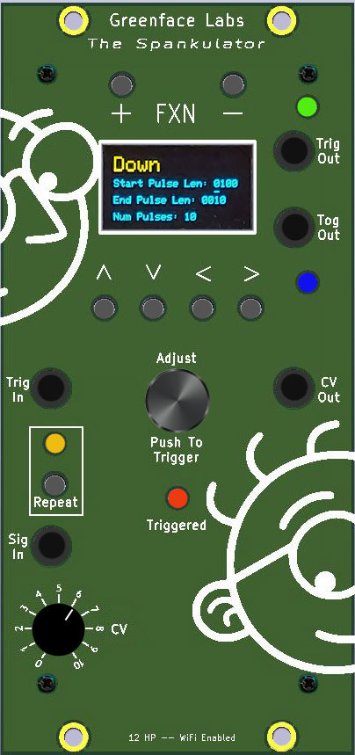

Figure - Front Panel

## Open-Source Project

The Spankulator is an Open-Source project that has an Arduino 33 IoT at its core. The code is written in C++ and makes use of several public domain code libraries for managing the various purchased hardware components such as the display and the FRAM non-volatile memory.

Because it is Open Source, in addition to being used by musicians and sound designers to create new and amazing sounds, the Spankulator can be used by students and entrepreneurs to create new, amazing modules. And, of course, the open-source community will generally improve the product as times goes along. Links to the design repositories can be found on the Spankulator web page.

# Operation

## General Operation

(Please see the Terminal and Web Interface sections for more details)

* The Function is selected using the **+** and **–** buttons.
  + Terminal uses the **+** and **–** keys.
  + Web Interface has dedicated Function buttons.
  + Each function has one or more parameters.
* Parameters are adjusted using the arrow keys and the Adjust knob.
  + Parameters are selected using the **up** and **down** arrows.
  + Digit to be adjusted is selected by using the **right** and **left** arrows.
  + When entering strings, holding the **right** or **left** arrow down for 2 seconds inserts (right) or deletes (left) a character.
  + Use the Adjust knob to increment and decrement the selected digit.
  + Parameter values may be directly entered using the Terminal or Web Interface.
* Operation of each function is triggered by a variety of methods.
  + Pressing the Adjust button.
  + Receiving a low to high transition on the Trig In jack.
  + Terminal uses the **!** key to trigger.
  + Web Interface has a dedicated Trigger button.
* Trigger may be single-shot or repetitive.
  + Press the **Repeat** button to toggle the Repeat mode.
  + Terminal uses the * key to toggle Repeat mode.
  + Web Interface has a dedicated **Repeat** button.
* CV Out amplitude, offset and value can be adjusted by a variety of methods.
  + Use the **CV** potentiometer. Select adjust function in **Settings**.
  + Terminal uses the **S**, **O** and **c** keys plus up to four digits. (Use the **z** key to refresh the screen after setting this parameter to see the result.)
  + Web Interface has a dedicated **Slider** control for each function.
* CV Quantization can be selected by the following methods.
  + Select in **Settings**.
  + Terminal uses **q0** to turn Quantization OFF.
  + Terminal uses **q1** to turn Quantization ON.

## Trigger

The Spankulator is controlled by the user issuing Commands. Commands are initiated by pressing the front panel buttons or by using the Web or Terminal interfaces. Regardless of the source of the command, it will be called either a command or a keypress in this document.

The various functions that the Spankulator performs are called “Spanks” and will be referred to as such in this document.

All the Spankulator’s functions are activated by a trigger. Triggers can come from various sources:

* Pushing the Trigger (Adjust) knob.
* Receiving a 0 to 5V transition on the Trig In jack.
* Receiving a Trigger command from either the Web or Terminal interface

When a Trigger is received, the Spankulator will execute a Spank that sends pulses at the Trig Out jack and varying voltage levels at the CV Out jack. When the Spank ends, the Tog Out jack will switch polarity from one to zero or vice versa.

## Repeat Mode

If Repeat is set to OFF, the Spankulator will remain in whatever condition it was in when the Spank ended until it receives another Trigger.

If Repeat is set to ON, the Spank will continuously repeat.

In either case, receipt of another Trigger or Command will interrupt the Spank, stopping execution until a new Trigger is received.

The Trigger Indicator will be activated when a trigger is received and will be turned off when the trigger ends. The Trigger Indicator is a Red LED on the front panel and is a widget in the Web Interface. It is textually indicated on the Status line in Terminal mode.

## CV Out

The CV Out signal ranges from -5V to +5V. The range can be adjusted from 0 to 100% by using the CV control. Use Settings to select Scale as the Adjust Function.

The CV Out signal can be offset by -5V to +5V. The offset can be adjusted using the CV control. Use Settings to select Offset as the Adjust Function.

When the Trigger isn’t active, the CV Out value can be directly set using the CV control.

Use Settings to select Value as the Adjust Function.

Web mode has a dedicated slider control for each CV parameter, and Terminal mode uses the S, O and c keys followed by a number. See the table of remote commands for more details.

## Sig In

The Signal In jack has a range of -5V to +5V. It is used by the Bounce function. Signals at this input currently have no effect in other functions.

This signal is split into two parts, one AC coupled, and the other DC coupled. These signals are then scaled and biased to the 0 to 3.3V signal that the Arduino requires. More details about the Bounce function can be found later in this document.

## Screen Saver

In order to maximize display life, the display will turn off after a set time. The default time is 15 minutes. The time can be set in the Settings function with a range of 1 to 9999 minutes.

Press any button or push the Trigger knob to bring the display back.

# Function Details

The Spankulator has ten functions. These are listed below with their associated command index. Details for each function follow.

1. Up
2. Down
3. Stretch
4. Toggle
5. Maytag
6. LFO
7. User
8. Bounce
9. Web
10. Settings

## Up

Up Spanks send a sequence of pulses that increase in width to Trig Out.

The voltage level at CV Out is proportional to the current pulse width plus or minus a value that is calculated from the Randomness parameter. The voltage will be at the minimum when the Spank starts and will increase to the maximum when the Spank completes. This range and the mid-point can be adjusted by using the CV control.

|  |  |  |  |
| --- | --- | --- | --- |
| **Parameter** | **Min** | **Max** | **Default** |
| End Pulse Len | 10 | 9999 | 100 |
| Start Pulse Len | 10 | 9999 | 10 |
| Num Pulses | 2 | 99 | 10 |
| Randomness | 0 | 99 | 0 |
| Initial Delay | 0 | 9999 | 100 |

The figure below illustrates an Up Spank with the default settings. The yellow trace is Trig Out and the purple trace is CV Out.

Figure - Default Up Spank

## Down

Down Spanks send a sequence of pulses that decrease in width to Trig Out.

The voltage level at CV Out is proportional to the current pulse width plus or minus a value that is calculated from the Randomness parameter. The voltage will be at the maximum when the Spank starts and will decrease to the minimum when the Spank completes. This range and the mid-point can be adjusted by using the CV control.

|  |  |  |  |
| --- | --- | --- | --- |
| **Parameter** | **Min** | **Max** | **Default** |
| End Pulse Len | 10 | 9999 | 10 |
| Start Pulse Len | 10 | 9999 | 100 |
| Num Pulses | 2 | 99 | 10 |
| Randomness | 0 | 99 | 0 |
| Initial Delay | 0 | 9999 | 100 |

The figure below illustrates a Down Spank with the default settings. The yellow trace is Trig Out and the purple trace is CV Out.

Figure - Default Down Spank

## Stretch

Stretch Spanks send a sequence of pulses that are the same width to Trig Out. Each pulse is preceded by a delay which is set by the user.

The voltage level at CV Out is set by the user. Level 1 sets the voltage during the pulse and Level 2 sets the voltage during the delay.

|  |  |  |  |
| --- | --- | --- | --- |
| **Parameter** | **Min** | **Max** | **Default** |
| Pulse Length | 10 | 9999 | 10 |
| Delay | 10 | 9999 | 100 |
| Num Pulses | 2 | 99 | 1 |
| Level 1 | 0 | 1023 | 1023 |
| Level 2 | 0 | 1023 | 512 |

The figure below illustrates a Stretch Spank with the default settings. The yellow trace is Trig Out and the purple trace is CV Out.

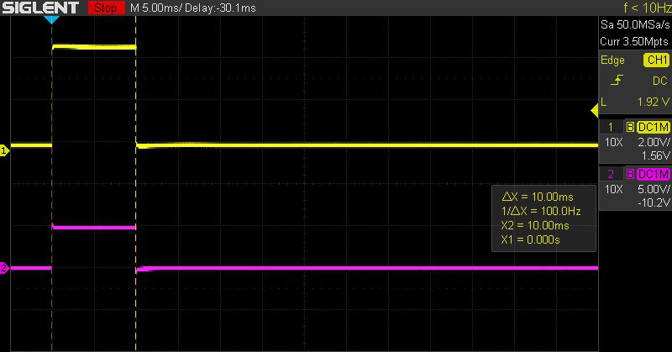

Figure - Default Stretch Spank

Notes: CV Output levels can be calculated using this formula: n = 102.3*V +512 rounded down to the nearest integer. Where n is the value to enter in Level 1 or 2 and V is the desired output voltage. V ranges from -5V to +5V.

## Toggle

Toggle Spanks send a HIGH, LOW or the opposite of what is currently there to Trig Out.

The voltage level at CV Out is set by the user. Hi Level sets the voltage when the output goes HIGH and Lo Level sets the voltage when low.

|  |  |  |  |
| --- | --- | --- | --- |
| **Parameter** | **Min** | **Max** | **Default** |
| Delay | 1 | 9999 | 100 |
| Hi Level | 0 | 1023 | 1023 |
| Lo Level | 0 | 1023 | 0 |
| State | LO | HI | Toggle |

The figure below illustrates a Toggle Spank with the default settings. The yellow trace is Trig Out and the purple trace is CV Out.

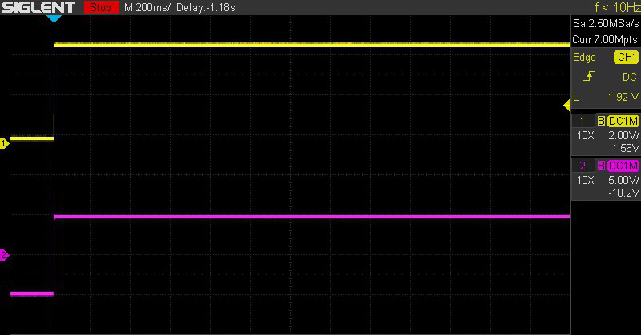

Figure - Default Toggle Spank

Notes: Toggle mode is useful for setting the output to a known state. Trig Out can be set LO, HIGH or Toggled to the opposite of what it currently is. The levels at CV Out can be set in a similar fashion to Stretch Spanks.

## Maytag

Maytag Spanks send a sequence of pulses of random width to Trig Out. The timing between pulses is determined by Pulse Len. The pulses are sent after the Initial Delay.

The voltage level at CV Out is proportional to the current pulse width plus or minus a value that is calculated from the Randomness parameter. The range and the mid-point can be adjusted by using the CV control.

|  |  |  |  |
| --- | --- | --- | --- |
| **Parameter** | **Min** | **Max** | **Default** |
| Pulse Len | 10 | 9999 | 100 |
| Initial Delay | 0 | 9999 | 500 |
| Num Pulses | 2 | 99 | 20 |

The figure below illustrates a Maytag Spank with the default settings. The yellow trace is Trig Out and the purple trace is CV Out.

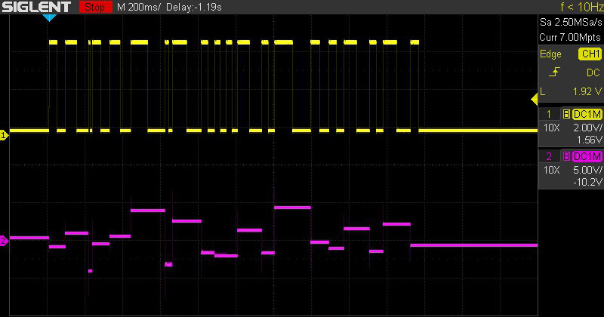

Figure - Default Maytag Spank

## LFO

LFO Spanks send a Sine wave, an Inverse Sine wave (cosine), a Ramp-Up or a Ramp-Down wave to CV Out. This signal is modified by the Randomness parameter. Each LFO Spank also sends a pulse to Trig Out where the width is equal to the length of the LFO period.

The voltage level at CV Out is 10V peak to peak. The range and the mid-point can be adjusted by using the CV control. The Period is in milliseconds.

|  |  |  |  |
| --- | --- | --- | --- |
| **Parameter** | **Min** | **Max** | **Default** |
| Period | 2 | 9999 | 10 |
| Waveform | N/A | N/A | SINE |
| Randomness | 0 | 99 | 0 |

The figure below illustrates an LFO Spank with the default settings. The yellow trace is Trig Out and the purple trace is CV Out.

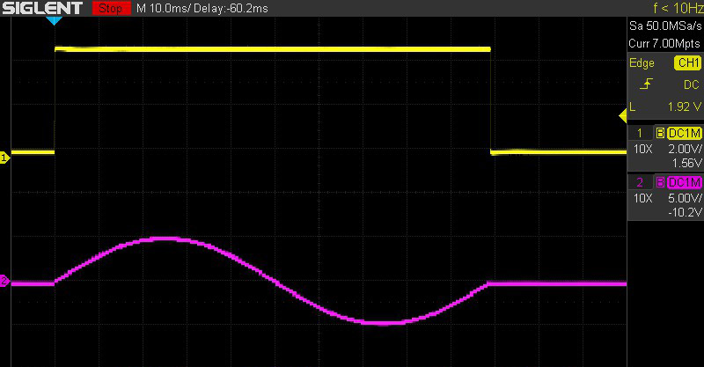

Figure - Default LFO Spank

The LFO function displays the waveform when CV adjustments are made. Press any key to return to the parameter display. The Web interface shows the waveform continuously. An example of this is shown in the figure below.



Figure

Notes:

The LFO is compute intensive when triggered. Please make changes only when trigger is not active.

When in Repeat mode, the waveform will be interrupted by the system in its basic loop. This interruption can be minimized by disabling WiFi in the Settings function.

## User

The User function sends a sequence of Spanks. The User sequence is entered using the right and left arrow keys to select the sequence element and the Adjust knob to enter the Spank at the selected element. Sequence elements are deleted by choosing the blank Spank.

User Spanks

U – Up

D – Down

S – Stretch

T – Toggle

M – Maytag

L - LFO

Entering a Spank copies the main Spank parameters into the User Spank. For example, entering a ‘U’ will copy the parameters from the Up Spank into the User mode parameters at the position the U was entered. Once entered, these parameters can be adjusted. Each User Spank is a separate entity and can be edited without affecting other User Spanks or the Spank that was the initial source of the parameter data.

It is important to note that changing an element of the User sequence will overwrite all the data at the selected element with the data from the newly entered Spank.

Use the down arrow to edit an element’s parameters. When in edit mode, the sequence highlight character will change from an underscore (_) to a caret (^). The underscore will be used to highlight the edited parameter. Use the arrow keys to edit the various parameters and to return to editing the sequence.

The figure below illustrates a User sequence of DUSTM using default settings for all Spanks in the sequence. The yellow trace is Trig Out and the purple trace is CV Out.

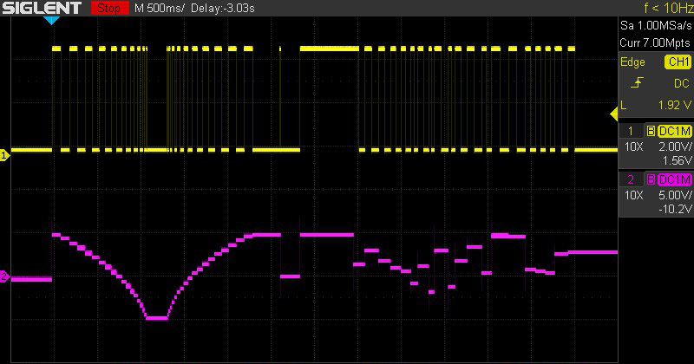

Figure - Example User Sequence

## Bounce

The Bounce function essentially is a Sample & Hold with extended features. Bounce operates in four modes: DC, DC Quantized, AC and AC Quantized. It measures the voltage at Sig In when a Trigger occurs and then “bounces” that voltage to CV Out. It also generates a 732Hz PWM signal at Trig Out with the duty-cycle proportional to the measurement.

When used in AC mode, Bounce acts as an Envelope Follower.

|  |  |  |
| --- | --- | --- |
| **Mode** | **4% Duty Cycle** | **96% Duty Cycle** |
| DC | -4.6V | +4.6V |
| AC | 0V | 10V pk-pk |
| DC Quantized | -4.6V | +4.6V |
| AC Quantized | 0V | 10V pk-pk |

The basic accuracy of the measurement is 1%

AC is measured as True RMS. For a Sine wave this is $\frac{Vpk}{2*\sqrt{2}}$ (Freq: 200Hz – 2000Hz)

Note that the Bounce function operates independently of the Quantize parameter in Settings.

## WiFi

The Spankulator is equipped with a 2.4GHz WiFi interface. When connected to your network, you can control the Spankulator using the [Web Interface](http://www.greenfacelabs.com/spankCP) (see example screen below).

WiFi can be disabled in the Settings function. Make sure it is enabled before proceeding in the connection process.

#### Connecting to WiFi

1. Enter WiFi function and press Trigger to scan for networks.
2. Use the up and down arrow keys to select your network. Press Trigger.
3. Use the right and left arrow keys with the Adjust control to select each character of your password. Press Trigger when your password is entered. Note: It is much easier in Terminal mode. Type your password preceded by $, then press Enter.

The Spankulator will try to connect using the password that you entered. If successful, the screen will display the connection data. This includes the connection status, the IP it can be found at and the signal strength. The signal strength will also be displayed in the upper right corner of the display as 1-4 bars. The signal strength display is shown in most functions.

If the connection fails, the Spankulator will give its best explanation of why it failed.

The Spankulator remembers its connection and will reestablish it if the power is recycled.

Visiting the WiFi function again while connected will display the connection data. Press Trigger to re-enter the scan for networks screen.

Re-scanning networks will reset the password, so it must be entered again to connect.

#### Using WiFi

The Spankulator’s Web Interface was designed to resemble the physical front panel. However, because the Web Interface enjoys the added functionality a computer brings, it has significant differences. Please refer to the following image.

Instead of Fxn+ and Fxn- buttons, there is a dedicated button for each function.

While you can still adjust parameters a digit at a time, you can now enter parameters from the keyboard by first clicking on the parameter then using the dedicated entry field.

Adjusting parameters digit by digit is possible by using the right and left arrows to select the digit and using the Inc and Dec buttons to increment and decrement the digit.

Clicking on the Trig Out and Tog Out indicators changes the state of those outputs.

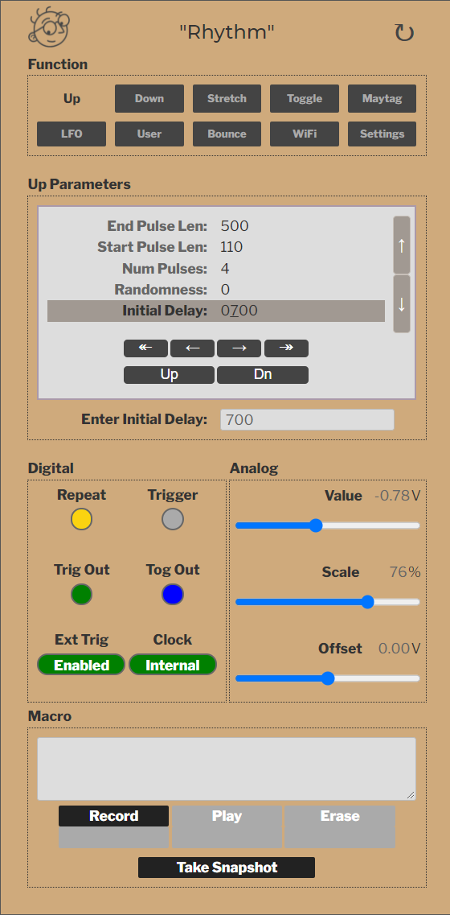

Figure - Web Interface Example

## Terminal Mode

Terminal mode is accessed via the MicroUSB connector on the Arduino that is on the bottom of the Spankulator. It is always available and cannot be turned on or off.

Use a terminal emulation program like PuTTY that has VT-100 mode. The Spankulator is set to run at 115200 baud but will adapt to the PuTTY settings.

Please refer to the table of commands that follows this section.

#### Terminal Example Screen

Figure - Terminal Interface Screen

Important! Only connect USB to a powered-up system. Otherwise, the 5V power from the USB will try to power the entire rack. And that’s not really good. So, please disconnect the USB cable before you turn off the power.

#### Commands

|  |  |  |  |
| --- | --- | --- | --- |
| **Command** | **Front Panel** | **Terminal** | **Web** |
| Next Function | + | + | Next |
| Previous Function | - | - | Prev |
| Previous Parameter | ^ | [A | ^ |
| Next Parameter | v | [B | v |
| Next Digit | > | [C | > |
| Previous Digit | < | [D | < |
| Increment Digit | Adjust clockwise | u | Inc |
| Decrement Digit | Counter-clockwise | d | Dec |
| Toggle Repeat | Repeat | * | Repeat |
| Toggle Trigger | Push Adjust | ! | Trigger |
| Disable Displays |  | Z |  |
| Restore Displays |  | z | Refresh Browser |
| Go To Function |  | fx | Click Fxn Name |
| Select Parameter |  | px | Click on Param |
| Select Digit# |  | :xx |  |
| Enter Parameter |  | xxxx | Use Param Input |
| CV Offset | Use Adj | Oxxxx | Use Offset slider |
| CV Scale | Use Adj | Sxxxx | Use Scale slider |
| CV Out (scaled) |  | Cxxxx |  |
| CV Out (unscaled) |  | cxxxx | Use Value Slider |
| Select User Seq | Use Arrow Keys | s | Use Arrow Keys |
| Display Off |  | J0 |  |
| Display On |  | J1 |  |
| Trigger Off |  | t0 |  |
| Trigger On |  | t1 |  |
| Trigger Toggle |  | t2 |  |
| Tog Out Off |  | T0 |  |
| Tog Out On |  | T1 |  |
| Tog Out Toggle |  | T2 |  |
| Quantization Off |  | q0 |  |
| Quantization On |  | q1 |  |
| Digital Out Off |  | G0 |  |
| Digital Out On |  | G1 |  |
| Digital Out Toggle |  | G2 |  |
| Repeat Off |  | r0 |  |
| Repeat On |  | r1 |  |
| Repeat Toggle |  | r2 |  |
| Use Internal Clock |  | K0 |  |
| Use External Clock |  | K1 |  |
| Toggle Ext Clock |  | K2 |  |
| Disable Triggers |  | D0 |  |
| Enable Triggers |  | D1 |  |
| Toggle Trig Enable |  | D2 |  |
| Reset Triggers |  | D3 |  |
| Enable Ext Trigger |  | E0 |  |
| Disable Ext Trigger |  | E1 |  |
| Toggle Ext Trigger |  | E2 |  |

Notes:

* Commands with yellow background require the user to press Enter when using a terminal. **Not** **Required** when sending via Web (REST interface).
* CV Scale – xxxx means up to 4 digits in the range of 0-1023
* Go To Function – x means to enter a single digit in the range of 0-9
* Select Parameter – x means a single digit in the range of 0-n, where n = the number of parameters for a chosen function minus 1.
* Enter Parameter – xxxx means up to 4 digits depending on the parameter. The range also depends on the parameter.
* Under the hood, the Web interface uses the same command characters as the Terminal
* Disable Displays (Z) is used to speed up remote scripting. Restore Displays by using the command ‘z’. These commands affect both the OLED display and the remote terminal.
* Display On (J1) and Display Off (J0) just affect the OLED display. Turning off the OLED display noticeably speeds up response when using the terminal interface.

## Settings

The Settings function displays information about the Spankulator as well as allowing some adjustments to various system parameters. Refer to the table below.

|  |  |  |  |
| --- | --- | --- | --- |
| **Parameter** | **Min** | **Max** | **Default** |
| Version | -- | -- | Displays version# |
| Clock | Internal | External | Internal |
| Encoder Type | Normal | Reverse | Normal |
| WiFi | Enabled | Disabled | Enabled |
| Screen Saver | 1 | 9999 | 15 |
| Reset | -- | -- | Push Trigger |
| Calibrate | -- | -- | Push Trigger |

Notes:

1. **Version** shows the software version number. This is useful when communicating about bugs and questions.
2. **Clock** can be set to External. In this case pulse lengths are irrelevant, but the levels at CV Out will be the same as they would in Internal mode. Feed the External Clock signal into Trig In.
3. **Encoder Type** takes the two types of rotary encoder into account. This makes them easier to purchase if one type is unavailable. If your Adjust knob is working opposite as it should, this is the setting that corrects it.
4. **WiFi** can be disabled here if you want to turn it off but retain your password.
5. **Screen Saver** prolongs the life of the OLED display. The screen will blank after the set number of minutes. Press any button to bring the display back.
6. **Reset** brings the Spankulator’s parameters back to their factory defaults. Note that WiFi parameters are unaffected.
7. **Calibrate** is a factory-only setting. Do not use.

## Software Update

When a software update becomes available, it will be posted on the website as a zipped package. The package contains 3 files. Unzip these into an empty folder on your machine.

1. Bossac.exe
2. Spankulator.ino.bin
3. Update.bat

These files work for the Windows OS. Mac and Linux users must install the GUI version of bossac and use that instead. Bossa can be found at: <https://www.shumatech.com/web/products/bossa>

Follow these steps to update the code. This procedure ensures that your rack won’t be inadvertently powered by the USB +5 volt supply.

1. Note: If the update changes the EEPROM storage mapping, the unit will automatically initiate a Software Reset. Any stored settings will be lost, so make sure to save these settings before updating if they are important.
2. Turn off power to the rack and remove the Spankulator.
3. Leaving the power cable connected, place the Spankulator on a non-conductive surface. Make sure nothing touches the Spankulator that might cause a short.
4. Re-power the rack and plug micro-USB cable into the Spankulator.
5. Run update.bat. It will show available COM ports. Choose by entering the number of the port.
6. If it connects properly, you will see a bunch of text being printed to the screen. This can generally be ignored. If the update succeeds, the Spankulator will reboot as normal with the new software installed. You should see the new version number in the greet screen.

## Crash Recovery

When things go wrong, as they sometimes do, the Spankulator might become unresponsive. When this happens, the program must be reset. Usually recycling the power* will fix the problem, but occasionally things have gone so bad that the code must be reloaded.

Usually, following the above update process will work. But occasionally things might have gone so bad that a hardware reset must be performed. There is a reset button on the Arduino 33 IoT. Pressing this twice quickly will force the Arduino into bootloader mode. You will see the yellow LED pulsate to indicate when the Arduino is in bootloader mode. The update process should work at this time. Please contact Greenface Labs directly if this doesn’t work.

*Make sure to unplug the USB cable before removing power.