Exercise 1:
Step 5:
Some XML application:
- XUL:
- which stands for XML User Interface Language, is a user interface markup language developed by Mozilla. XUL is an XML dialect for writing graphical user interfaces, enabling developers to write user interface elements in a manner similar to web pages.
- XUL applications rely on the Mozilla codebase (or a fork of it); the most prominent example is the Firefox browser.
- Usage:
XUL can only be used with the Mozilla codebase (or a fork of it) because the Gecko engine does the XUL rendering.
Application programmers need to define a XUL interface as three discrete sets of components:
- Content: the XUL document(s), whose elements define the layout of the user interface
- Skin: the CSS and image files, which define the appearance of an application
- Locale: the files containing user-visible strings for easy software localization
XUL defines a wide range of elements, which roughly belong to the following types:
- Top-level elements: window, page, dialog, wizard, etc.
- Widgets: label, button, text box, list box, combo box, radio button, check box, tree, menu, toolbar, group box, tab box, color-picker, spacer, splitter, etc.
- Box model: box, grid, stack, deck, etc.
- Events and scripts: script, command, key, broadcaster, observer, etc.
- Data source: template, rule, etc.
- Others: overlay, iframe, browser, editor, etc.
The default behavior of XUL widgets can be altered with XBL bindings.
- Example:
This example shows three buttons stacked on top of each other in a vertical box container:
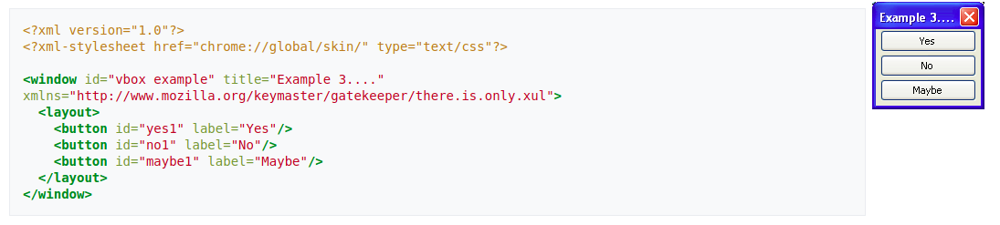
- EPUB:
- EPUB is the most widely supported vendor-independent XML-based (as opposed to PDF) e-book format; that is, it is supported by almost all hardware readers, except for Kindle.
- Implement:
An EPUB file is an archive that contains, in effect, a website. It includes HTML files, images, CSS style sheets, and other assets. It also contains metadata. EPUB 3.2 is the latest version. By using HTML5, publications can contain video, audio, and interactivity, just like websites in web browsers.
An example file structure:
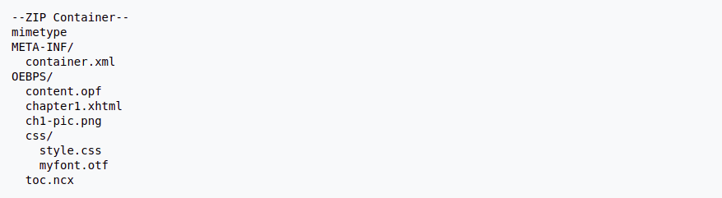
An example container.xml, given above file structure:
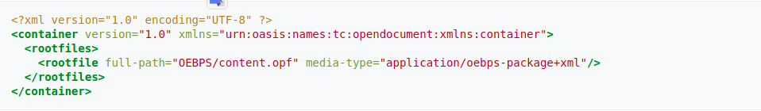
- ATOM:
- The name Atom applies to a pair of related Web standards. The Atom Syndication Format is an XML language used for web feeds, while the Atom Publishing Protocol (AtomPub or APP) is a simple HTTP-based protocol for creating and updating web resources.
- An example of a document in the Atom Syndication Format:

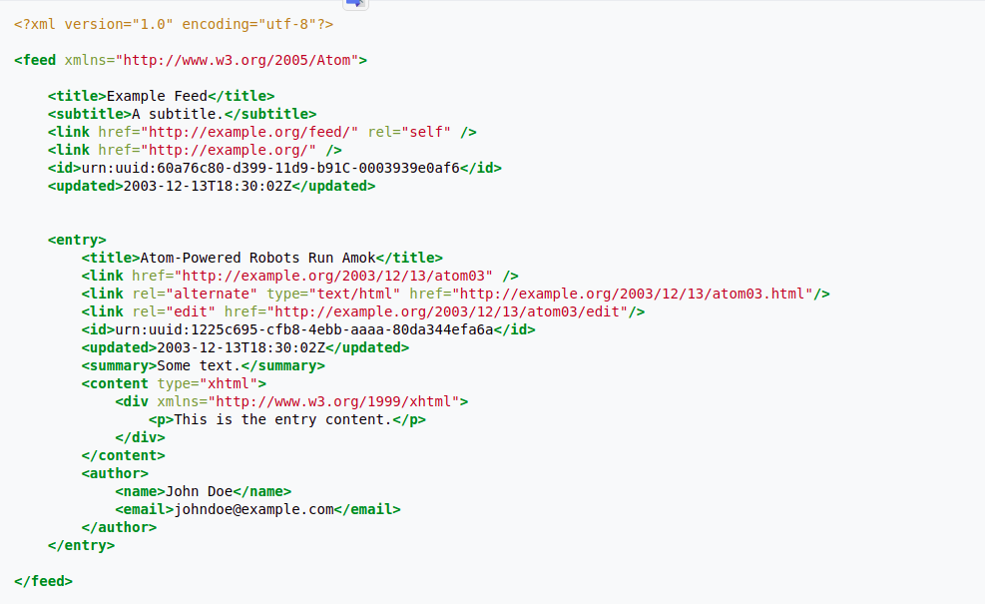
- Android SDK:
- SDK is a term used by Microsoft, Sun Microsystems, and several other companies. This is an abbreviation for the phrase Software Development Kit – a set of software development tools. The SDK includes one or more APIs, programming tools, documentation, and other things that are needed to be able to create applications for software packages or platforms through a programming language such as (Java, C#) , C++, Objective-C, ...).
- Android SDK: platform application development toolkit android
- Currently the Android SDK application package is an Android emulator for PC computers. Android SDK is an Android virtual machine used on PC, which helps you to program Android applications on PC and also functions like a real machine. In the list there are versions for Windows, Mac OS X and even Linux.
- XBRL:
- XBRL or eXtensible Business Reporting Language is a software standard that was developed to improve the way in which financial data is communicated, making it easier to compile and share this data. Notably, eXtensible Business Reporting Language is an implementation of XML (extensible markup language), which is a specification that is used for organizing and defining data online.
- XBRL uses tags to identify each piece of financial data, which then allows it to be used programmatically by an XBRL-compatible program. XBRL allows for easy transmission of data between businesses.
- How it work:
Often termed “bar codes for reporting”, XBRL makes reporting more accurate and more efficient. It allows unique tags to be associated with reported facts, allowing:
- people publishing reports to do so with confidence that the information contained in them can be consumed and analysed accurately
- people consuming reports to test them against a set of business and logical rules, in order to capture and avoid mistakes at their source
- people using the information to do so in the way that best suits their needs, including by using different languages, alternative currencies and in their preferred style
- people consuming the information to do so confident that the data provided to them conforms to a set of sophisticated pre-defined definitions

