R07921001 李尚倫 PA#1 Sorting Report

1. Comparison table of selection sort, merge sort, quick sort, and heap sort

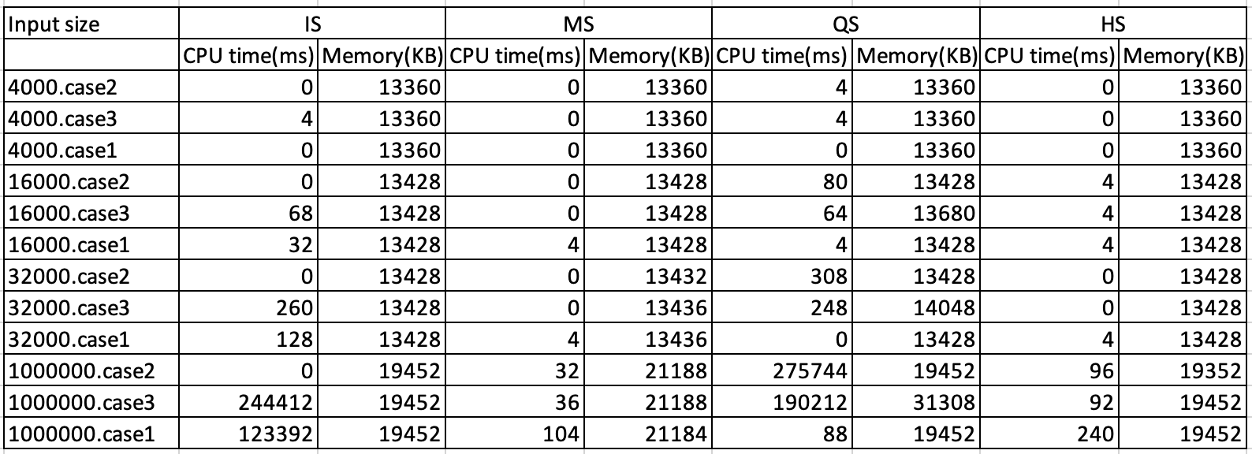

2. Comparison chart of selection sort, merge sort, quick sort, and heap sort CPU time(ms) on different case and input size.

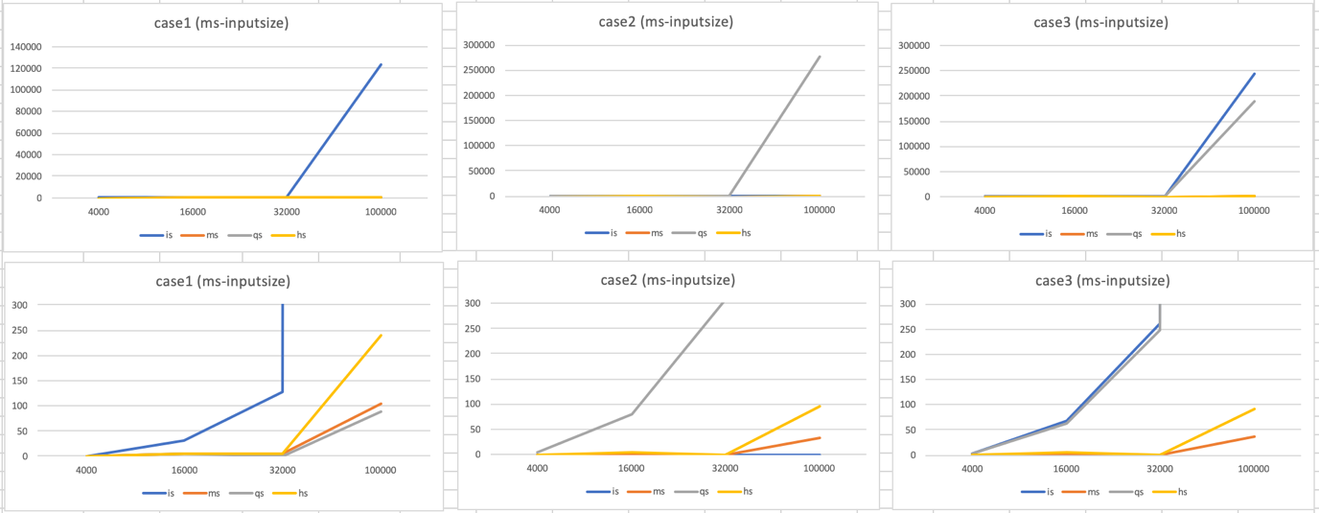

Case1 represents test case in random order, case2 is test case in increasing order, and case3 is test case in reverse order.

For the best case, all the numbers are sorted in increasing order which is case2. 在best case方面，理論上根據下表insertion sort有最好的計算複雜度，O(n)是線性的，其他三種則都是O(nlogn)，而在實際實作後由上圖可知，除了insertion sort較不符合預期的結果外，其餘都和理論相符。推測可能是insertion sort在實作partition時的方法有多種，我所使用的hoare partition並不能達到預期的效果。

For the worst case, all numbers are sorted in descending order which is case3. 在worst case方面，理論上根據下表insertion sort和quick sort的計算複雜度都不太好，是O(n^2)，其他兩者都是O(nlogn)，而在實際實作後由上圖可知，結果與理論相符。

For the average case, numbers are in random order which is case1. . 在average case方面，理論上根據下表insertion sort的計算複雜度不太好，是O(n^2)，其餘都是O(nlogn)，而在實際實作後由上圖可知，結果與理論相符。

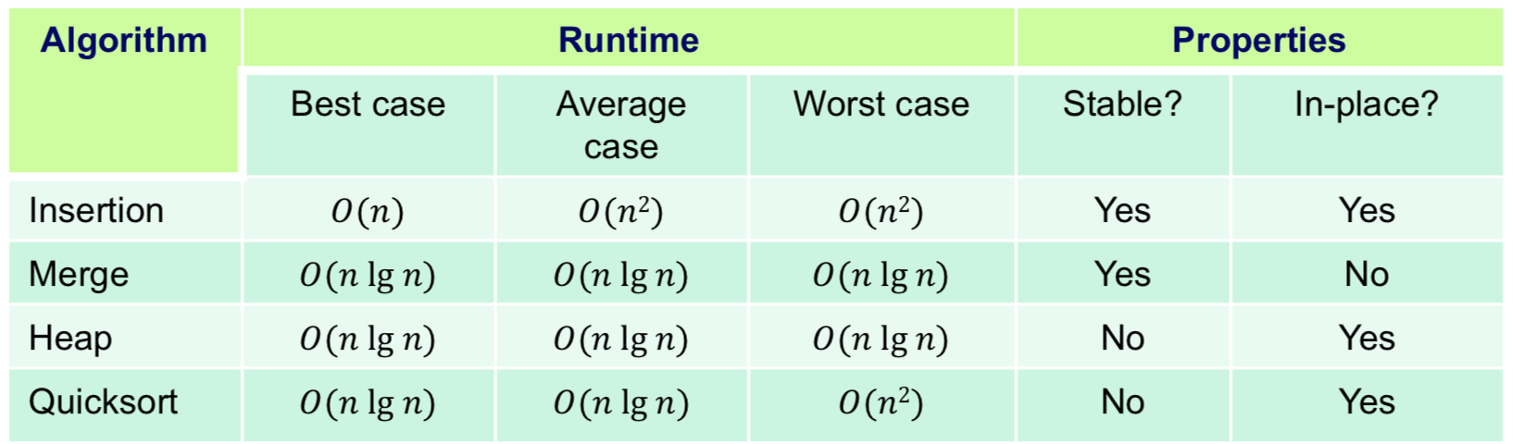

3. More details of implementation on program and experiment can be found at README.md in my submitted tar file

or <https://github.com/shannon112/AlgorithMew/blob/master/PA1/README.md>