**Tables & Figures**

**Table 1**. List and description of deliverables with the status of each task.

|  |  |  |
| --- | --- | --- |
| **Deliverable** | **Description** | **Status** |
| **Task 1. Sequence and assemble a draft delta smelt genome + linkage map** | | |
| **Task 1.1 Linked-read sequencing (10X Genomics)** | | |
| a. Sample acquisition | Sample tissue of male (M) and female (F) fish. | Completed |
| b. Sequencing | 10X Chromium Library Prep | F Completed,  M Completed |
| Illumina NovaSeq Sequencing | F Completed,  M completed |
| c. Assembly | Supernova assembly | F Completed,  M Completed |
| Assembly QC | F Completed,  M Completed |
| tigmint assembly correction | In progress |
| **Task 1.2 Long-read sequencing (PacBio)** | |  |
| a. Sample preparation | Sample tissue and organs of male and female fish. | F completed,  M completed |
| b. Sequencing | PacBio Prep | F completed,  M completed |
| HiFi Sequencing | F in progress,  M completed |
| c. Assembly | Canu assembly | F in progress,  M completed |
| Assembly polishing | In progress |
| **Task 1.3 Hi-C Chromatin Conformation Capture & Sequencing (Phase Genomics)** | | |
| a. Sample preparation | Sample tissue and organs of male and female fish. | F completed,  M completed |
| b. Sequencing | Hi-C Library Prep | F completed,  M in progress |
| Deep Sequencing | F completed,  M in progress |
| c. Assembly | Salsa2 scaffolding | In progress |
| Assembly curation | In progress |
| **Task 1.4 High-density linkage map** | | |
| a. SNP Discovery | Sample tissue and organs of male and female fish. | In progress |
| b. Construction | Construction of a linkage map using HighMap | In progress |
| **Task 1.5 Map linked regions to reference genome** | | |
| a. Map regions | Align linked regions to genome | In progress |
| **Task 2. Estimate contemporary Ne using RAD-seq data & draft genome** | | |
| **Task 2.1 DNA collection and extraction** | | |
| a. Sample Collection | Collect samples from BY2017, BY2018 and BY2019 cohorts | Completed |
| b. DNA Extraction | Extract DNA from BY2017, BY2018 and BY2019 cohorts | BY2017 completed  BY2018 & BY2019 in progress |
| c. RAD-sequencing | Sequence BY2017, BY2018 and BY2019 cohorts | BY2017 completed  BY2018 & BY2019 in progress |
| **Task 2.2 Estimate Ne in BY2017, BY2018 and BY2019 cohorts** | | |
| a. RAD-sequencing data processing | Split, align and quality control all sequencing data | In progress |
| b. Estimation of Ne | Temporal Ne  LD Ne | In progress |
| **Task 3. Domestication selection** | | |
| **Task 3.1 Select individuals for RAD-seq analysis** | | |
| a. Determine domestication index (DI) | Calculate domestication index for each individual from each generation | Completed |
| b. Group individuals based on their DI | Assign individuals to three DI group: Low, medium and high | Completed |
| c. Determine recovery rate of each individual | Calculate recovery rate of each individual | Completed |
| d. Group individuals based on their recovery rate | Assign individuals to two groups: Low and high recovery rate | Completed |
| **Task 3.2 Preparation and sequencing of individuals** | | |
| a. Sample Collection | Collect samples from BY2008 to BY2015 cohorts | Completed |
| b. DNA Extraction | Extract DNA from BY2008 to BY2015 cohorts | Completed |
| c. RAD-sequencing | Sequence BY2008 to BY2015 cohorts | Completed |
| **Task 3.3 Population Genetic Analysis** | | |
| a. RAD-sequencing data processing | De-multiplexing  Quality filtering | Completed |
| a. Identifying SNPs of domestication selection | Genotype calling  Fst analysis between groups with completed reference genome assembly | In progress |
| d. Association study | GWAS between DI and recovery rate | In progress |
| **Task 4. Identification of sex specific markers** | | |
| **Task 4.1 Investigation of delta smelt genome** | | |
| a. RAD-sequencing data processing | De-multiplex | Completed |
| QC Sequencing data | Completed |
| b. Identification of sex marker(s) | GWAS in M vs F | Completed |
| Depth comparison | Completed |
| **Task 4.2 Fluidigm assay creation** | | |
| a. Submit sequences | Submit sex specific sequences to Fluidigm for SNP Type Assay design | In progress |
| b. Validation | Validation of SNP Assay | In progress |

**Table 2.** Table of tissue type and storage method of sampled delta smelt from three different trips. Included are the names referred to in the text. T= trip, F= female, M=male, BM = back muscle, SC = scales, IO = internal organ, FF = flash frozen, and PG = propylene glycol.

|  |  |  |  |  |  |
| --- | --- | --- | --- | --- | --- |
| **Trip Number** | **Sex** | **Sample Name** | **Tissue Type** | **Storage Method** | **Used for Sequencing** |
| 1 | F | T1F01 | Back muscle | Flash frozen | - |
| T1F02 | yes |
| T1F03 | - |
| M | T1M01 | Back muscle | Flash frozen | - |
| T1M02 | - |
| T1M03 | - |
| 2 | M | T2M01 | Back muscle | Flash frozen | - |
| T2M02 | - |
| T2M03 | - |
| 3 | F | T3F01_BM_PG | back muscle | propylene glycol | - |
| T3F01_BM_FF | back muscle | flash frozen | - |
| T3F01_IO_FF | internal organ | flash frozen | - |
| T3F01_SC_FF | scales | flash frozen | - |
| T3F02_BM_PG | back muscle | propylene glycol | - |
| T3F02_BM_FF | back muscle | flash frozen | - |
| T3F02_IO_FF | internal organ | flash frozen | - |
| T3F02_SC_FF | scales | flash frozen | yes |
| M | T3M01_BM_PG | back muscle | propylene glycol | - |
| T3M01_BM_FF | back muscle | flash frozen | - |
| T3M01_SC_FF | scales | flash frozen | - |
| T3M02_BM_PG | back muscle | propylene glycol | - |
| T3M02_BM_FF | back muscle | flash frozen | yes |
| T3M02_SC_FF | scales | flash frozen | - |
| 4 | M | T4M01_BM_FF | back muscle | flash frozen | - |
| T4M01_IO_FF | internal organ | flash frozen | yes |
| T4M01_SC_FF | scales | flash frozen | - |

**Table 3.** Table of raw data sequencing statistics.

|  |  |  |  |  |
| --- | --- | --- | --- | --- |
| **Sequencing Technology** | **Sequencing Company** | **Sex** | **Number of Runs** | **Coverage** |
| Linked Reads | 10X | M | 1 | 120 |
| Linked Reads | 10X | F | 1 | 80 |
| Long Reads | PacBio HiFi | M | 2 |  |
| Long Reads | PacBio HiFi | F | 3 |  |
| Hi-C | Phase | F | 1 |  |
| Hi-C | Arima | M | 1 |  |

**Table 4.** Table of assembly steps with corresponding metrics.

|  |  |  |  |  |
| --- | --- | --- | --- | --- |
| Software/Step | Metrics | | Male | Female |
| ipa | assembly metrics | N50 | 353,581 | 418,614 |
| L50 | 324 | 264 |
| # contigs | 2086 | 1805 |
| assembly length | 471,831,811 | 436,920,153 |
| BUSCO | complete | 88.00% | 89.00% |
| single | 79.50% | 87.40% |
| double | 8.50% | 1.60% |
| fragmented | 1.50% | 1.10% |
| scaff10x | assembly metrics | N50 | 1,188,596 | 1,392,224 |
| L50 | 106 | 80 |
| # contigs | 1106 | 1012 |
| assembly length | 471,929,811 | 436,999,453 |
| BUSCO | complete | 88.50% | 85.90% |
| single | 80.50% | 84.40% |
| double | 8.00% | 1.50% |
| fragmented | 1.10% | 3.10% |
| SALSA2 | assembly metrics | N50 | 2,749,144 | 4,383,157 |
| L50 | 38 | 26 |
| # contigs | 705 | 515 |
| assembly length | 472,145,811 | 437,264,453 |
| BUSCO | complete | 88.20% | 89.50% |
| single | 80.50% | 88.00% |
| double | 7.70% | 1.50% |
| fragmented | 1.10% | 0.80% |
| chromonomer | assembly metrics | N50 | 12,200,365 | 14,850,352 |
| L50 | 15 | 13 |
| # contigs | 549 | 376 |
| assembly length | 472,157,411 | 437,273,953 |
| BUSCO | complete | 88.40% | 89.30% |
| single | 81.20% | 87.70% |
| double | 7.20% | 1.60% |
| fragmented | 1.00% | 0.80% |

**Table 5.** Chromosome counts of delta smelt (*Hypomesus transpacficus*) inidicated 2n diploid number is 56

|  |  |  |  |  |  |  |
| --- | --- | --- | --- | --- | --- | --- |
|  |  |  |  |  |  |  |
| **2n Count:** |  | **54** | **55** | **56** | **Total # Cells** |  |
| **# Cells:** |  | 1 | 2 | 15 | 18 |  |
|  |  |  |  |  |  |  |
|  | | | | | |  |

**Table 6.** Table of the regions in the male genome assembly that contain putative Y sequences.

|  |  |  |
| --- | --- | --- |
| **Chromosome** | **Start** | **End** |
| lg09 | 21021012 | 21058853 |
| lg09 | 21028673 | 21060036 |
| lg09 | 21032415 | 21061475 |
| lg09 | 21041512 | 21085263 |
| lg09 | 21050628 | 21088126 |
| lg09 | 21055337 | 21076797 |
| lg17 | 8138840 | 8173464 |
| lg17 | 8150980 | 8182769 |
| lg17 | 8160327 | 8186257 |
| lg21 | 9824718 | 9865735 |
| lg21 | 9829062 | 9876304 |
| lg21 | 9829267 | 9852703 |
| lg21 | 9830489 | 9861772 |
| lg21 | 9830548 | 9877539 |
| lg21 | 9835162 | 9870510 |
| lg23 | 10574145 | 10610523 |
| scaffold_9 | 6162370 | 6193388 |
| scaffold_9 | 6164418 | 6207798 |
| scaffold_9 | 6166727 | 6189675 |
| scaffold_9 | 6190157 | 6225909 |
| scaffold_9 | 6198039 | 6236101 |
| scaffold_9 | 6207685 | 6244021 |
| scaffold_9 | 6207917 | 6235633 |
| scaffold_9 | 6234942 | 6302173 |
| scaffold_9 | 6273953 | 6369734 |
| scaffold_9 | 6288767 | 6323264 |
| scaffold_9 | 6293089 | 6319738 |
| scaffold_9 | 6308372 | 6343980 |
| scaffold_9 | 6311690 | 6398470 |
| scaffold_9 | 6336293 | 6369942 |
| scaffold_9 | 6342838 | 6380273 |
| scaffold_9 | 6349134 | 6399774 |
| scaffold_190 | 85866 | 106849 |

**Figure 1.** Workflow diagram for completion of assembling reference genome for delta smelt (Task 1). Both male and female delta smelt samples went through the pipeline separately to produce two reference genomes––one male and one female. All work was completed at the GVL unless otherwise noted. A.) Tissue from male and female delta smelt are sampled from the captive colony at the FCCL. B.) HMW DNA is extracted from the fish tissue samples. C.) Extracted DNA of sufficient length undergoes a library prep, subsequent sequencing and raw data quality control for each of the three NGS technologies (linked-read, long-read and hi-c). D.) Long-read sequencing data are assembled into individual draft genome. The draft genome is quality assessed by the software BUSCO13. E.) The long-read assembly is scaffolded using linked-read sequencing data to produce a consensus assembly. The quality of the consensus assembly is then assessed by the software BUSCO13. F.) Hi-c data connects long-range gaps in the linked- & long-read consensus assembly. The quality of the consensus assembly is then assessed by the software BUSCO13. G.) F.) Linkage map data further connects the hi-c, linked- & long-read consensus assembly. The quality of the consensus assembly is then assessed by the software BUSCO13. H.) Manual curation to produce a reference genome.

**Figure 2.** Pulse field gel images of extracted HMW gDNA from three sampling trips (“T”) and six rounds of extractions (“E”). Green boxes surround lanes from extracted samples usable for long-read and linked-read sequencing (extraction distribution centered ~ 50kb), yellow boxes surround lanes from samples with insufficient extraction lengths. A) T1, E1: one usable female sample (T1_F02); B) T2, E2: no usable samples; C) T2, E3: no usable samples; D) T2, E4: no usable samples; E) T3, E5: one usable male sample (T3M02_BM_FF); F) T3, E6: one usable female (T3F02_SC_FF).

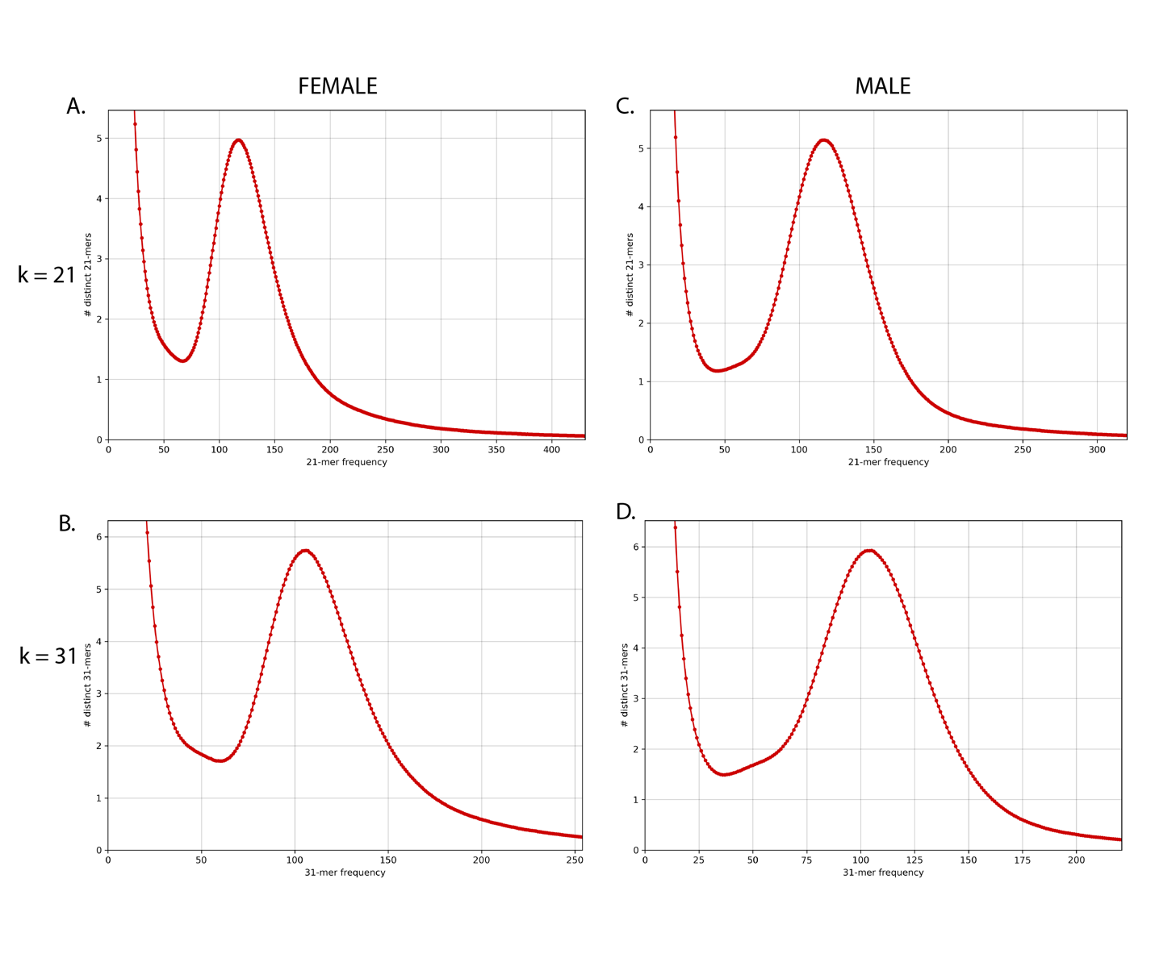

**Figure 3.** Linked-read k-mer spectra histogram of the number of distinct k-mers at different frequencies from male (A & B) and female (C & D) sequencing data. Histograms using k=21 (A & C), and k=31 (B & D). Uncontaminated samples are expected to have a single peak with a high abundance of k-mers at a very low frequency due to sequencer errors.

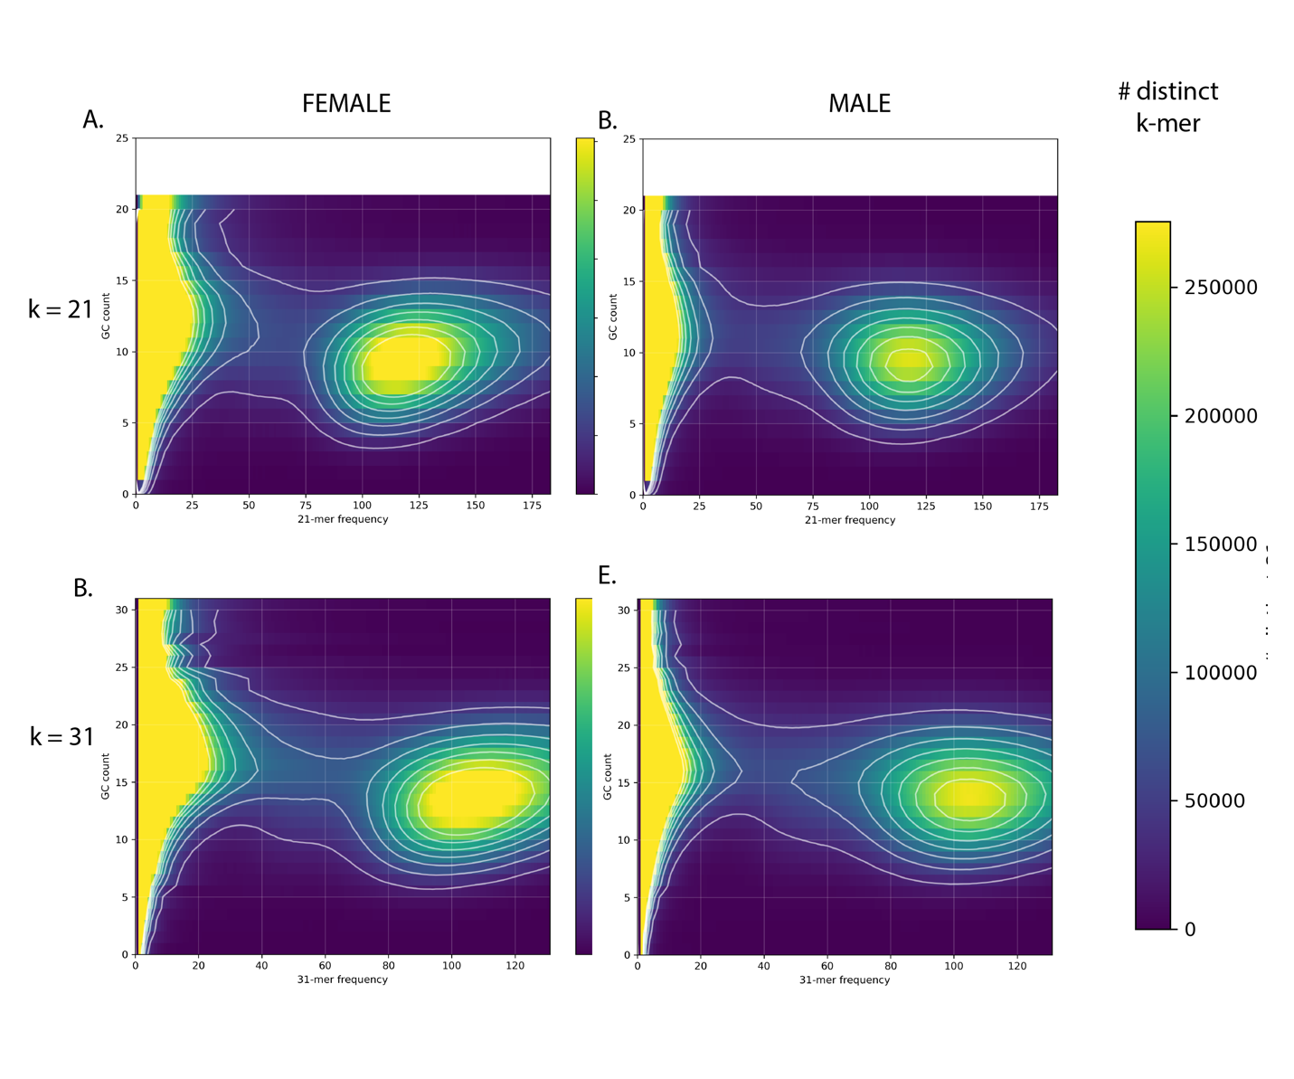

**Figure 4.** Plots of k-mer frequency (x-axis) vs GC count (y-axis) colored by the number of distinct k-mers used to detect bacterial and organelle contamination in linked-read sequence data. Blue indicate fewer distinct k-mers with a given GC count and frequency, while yellow indicates more distinct k-mers. Plots using k=21 (A & C), and k=31 (B & D). No indication of contamination was detected in female (A & B) and male (C & D) sequencing data.

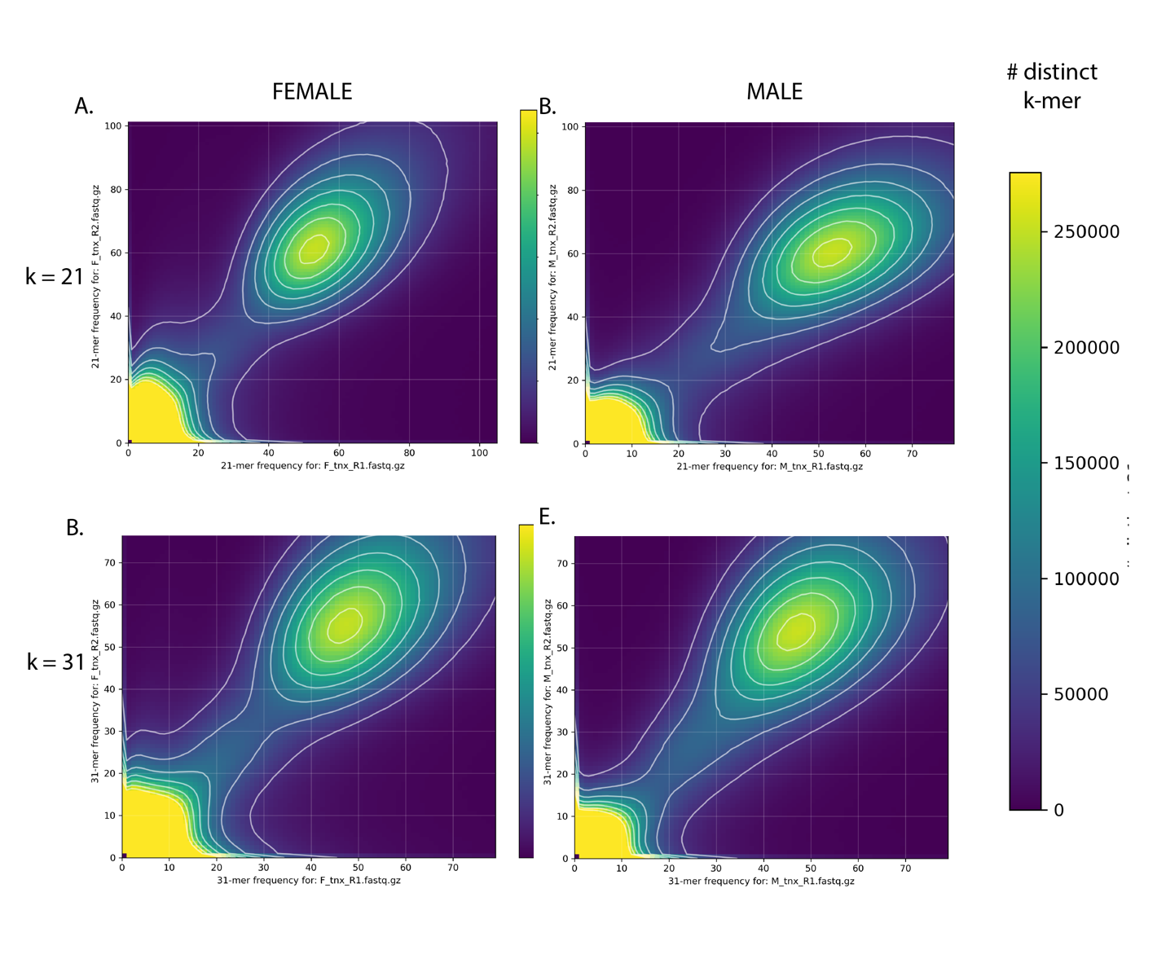

**Figure 5.** K-mer comparison plot of the number of distinct k-mers at different frequencies in linked-read sequence data from the female (A & B) or male (C & D) samples. Plots using k=21 (A & C), and k=31 (B & D). For all plots the R1 (x-axis) and R2 (y-axis) captures a slightly different information and no major sources of sequencing bias appear to occur.

**Figure 6.** Karyotype of metaphase stage mitotic cell from a male delta smelt showing 2n = 56 chromosomes. A.) unmodified image, no scale bar; B.) Adobe Photoshop modified image, plus scale bar (most journals want a scale bar; C.) Adobe Photoshop focused image, plus scale bar.



**Figure 7.** Multi-dimensional scaling of individual delta smelt from corresponding birth years for hybrid identification analysis.

**Figure 7.** Manhattan plots of each of the 28 male chromosomes. Location on the x axis and log10P significance on the y axis. Significant SNPs marked in blue.

**Figure 8**. Histogram of k-mer abundances in male and female sequencing data. The male sequencing data appears to have a more higher abundance k-mers while the female sequencing data has more lower abundance k-mers.

**Figure 9.** All k-mer abundances filtered through contigs containing five or more k-mers. Both female and male have a broad distribution of k-mers with 90-140 abundance, while male specific peak (in blue) can be seen from 30-70 abundance.

**Figure 10.** Male (x-axis) versus female (y-axis) median k-mer abundance on contigs with 5 or more k-mers. A.) All contigs containing 5 or more k-mers B.) Zoomed in view to show clear line of contigs with zero abundance in female sequencing data.