**Shifts in phenological mean and synchrony interact to shape competitive outcomes**

Shannon K. Carter a,1, Volker H.W. Rudolf a,2

1. Department of Biosciences, Program in Ecology and Evolutionary Biology, Rice University; 6100 Main Street, MS-170, Houston, TX 77005-1892, USA
2. Corresponding author

e: shannon.k.carter@rice.edu

t: +1 (512) 964-6386

1. volker.rudolf@rice.edu

**Keywords:** phenology, species interactions, competition, amphibians, phenological shifts, phenological distributions

**Abstract**

Phenological shifts have the potential to damage natural communities by disrupting important species interactions, but we currently have limited empirical work testing this idea. Using manipulative experiments, we investigate how two different kinds of phenological shifts (shifts in both the mean and synchrony of hatching) independently and interactively shape competitive interactions between populations of two larval amphibians. Our results indicate that shifts in phenological synchrony (which are commonly under-studied in phenology research) interact with shifts in phenological mean to strongly affect multiple important demographic rates (survival, biomass export, per capita mass, and emergence timing). Furthermore, phenological synchrony changed across ontogenetic stages (from hatching to emergence), indicating we cannot assume for phenological synchrony to be unchanging and unimportant. These results demonstrate the potential for phenological shifts to strongly alter species interactions, and in particular emphasize the importance of considering entire phenological distributions when linking phenology to species interactions.

**Introduction**

Phenologies, the seasonal timing of life history events, play an important role in driving the dynamics of natural systems because they determine when and at what stage or size individuals interact with other members of the community (Yang & Rudolf 2010; Thackeray *et al.* 2016). Mounting evidence shows that phenological shifts are a common response to climate change, and it is a major goal to understand how these shifts will impact species interactions in natural communities (Parmesan & Yohe 2003; Root *et al.* 2003; Menzel *et al.* 2006; Parmesan 2007). To address this issue, previous research has predominantly focused on shifts in the mean or first occurrence of a phenological event (Parmesan 2007)[more citations]. However, individuals within a species vary in their timing, creating a distribution of phenologies for a given life-history event at the population level (hereafter phenological synchrony) (Miller-Rushing *et al.* 2010; Rasmussen & Rudolf 2015). Importantly, the shape of this temporal distribution can change among years and is closely tied to changing weather patterns, including climate change (Wolkovich *et al.* 2014; Carter *et al.* 2018). Phenological events can only occur during certain favorable conditions, and contraction or expansion of this window of opportunity (e.g., short vs. long wet season) forces individuals to cluster their phenologies in time (resulting in high synchrony), or allows individuals to spread out temporally (low synchrony) (Menzel *et al.* 2006; Dunbar *et al.* 2009; CaraDonna *et al.* 2014). In the few studies where the entire phenological distribution is measured, shifts in phenological synchrony occur with equal or greater frequency relative to shifts in first or peak phenological events (CaraDonna *et al.* 2014; Carter *et al.* 2018). Even though shifts in phenological synchrony can be as common as shifts in phenological mean, the consequences for species interactions and regulation of communities remain poorly understood.

The importance of phenological synchrony for the regulation of natural populations becomes apparent when we consider how synchrony affects both the density of interacting individuals and per-capita interaction strength. Increasing the synchrony of a phenological event within a population increases the average density of interacting individuals (Loe *et al.* 2005; Koenig *et al.* 2015). While this numerical effect should increase intraspecific competition, phenological synchrony can also alter how much per-capita effects vary among individuals, i.e., competitive symmetry(Rudolf & Rasmussen 2013; Rasmussen & Rudolf 2015). Offspring that hatch at the same time will have similar sizes and thus have similar (symmetric) competitive abilities, while offspring that hatch earlier are typically competitively dominant over smaller conspecifics that hatch later (Connell & Slatyer 1977; Rudolf & Singh 2013; Rasmussen *et al.* 2014). Therefore, a low synchrony population should result in a low density population controlled by contest competition, while a high synchrony population should result in a high density population controlled by scramble competition (Nicholson 1954; Henson & Cushing 1996). These per capita differences in individuals comprising low vs. high synchrony populations also likely carry over to affect subsequent phenological stages. When competition is strong, per capita differences among individuals in low synchrony populations should result in higher survival of the earliest individuals (Rasmussen *et al.* 2014), potentially skewing the distribution of the next ontogenetic stage to be clustered around an early event. However, if competition is low, or if individuals are not plastic in their development rates, synchrony may be maintained from one ontogenetic stage to the next.

The picture is further complicated when we consider the role of phenological synchrony in a community context. Research on priority effects provides a strong foundation for understanding how relative mean phenological events affect species interactions (e.g., Sale 1977; MacArthur 1984; Tilman 1988; Fukami 2010), but little is known about the role of synchrony, or how these two aspects of phenology might interact (but see Rasmussen & Rudolf 2016). Considering two competing species, at least three major outcomes are possible. First, there may be no effect of synchrony. Effects of synchrony may be overwhelmed by stronger effects of relative mean arrival (i.e., an early arriver benefits from priority access to the resource). In this case, mean phenological events of populations are sufficient to predict outcomes and synchrony can be ignored. Second, mean and synchrony may have additive effects. Previous work has shown higher survival for low synchrony populations relative to high synchrony populations (Rasmussen & Rudolf 2015). If the effects of mean and synchrony are additive, we would then expect to see higher survival of low synchrony populations across a range of relative arrival times (Rasmussen & Rudolf 2016). Third, synchrony and mean might have interactive effects on competitive outcomes. Maintenance of individual variation in population traits is often explained as a bet hedging strategy (Wilbur *et al.* 2006; Tarazona *et al.* 2017; Rocha *et al.* 2018; Shima *et al.* 2018). If this is the case for phenology, for a low synchrony population, we would expect to see higher survival during late arrival relative to the competitor (worst scenario) but lower survival during early arrival (best scenario). In this case, synchrony would matter in cases where either species has an advantage of early arrival but would be unimportant when species arrived at the same time. However, we can also imagine a scenario where mean and synchrony interact but synchrony is most important when the species arrive at the same time. This would be the case if synchrony is most important when competition is highest, but loses importance when one species has an advantage of early arrival.

Here, we use mesocosm experiments to examine how different metrics (mean and synchrony) of phenology affects the outcome of competition between two amphibian species. Specifically, we altered the order of arrival (i.e., mean hatching date) between the two species and the phenological synchrony of one of the two species. This system allowed us to ask: (1) What are the independent and interactive effects of phenological mean and phenological synchrony on population demography and competitive interactions? (2) Does phenological synchrony change across ontogenetic stages?

**Materials and methods**

***Study system***

We studied the gray tree frog (*Hyla versicolor*) and its competitor the Southern Leopard frog (*Rana sphenocephala*) to determine effects of mean and synchrony of hatching phenology on the performance of *H. versicolor*. The chosen species are an ideal system for several reasons. First, they commonly co-occur throughout the southeastern United States and are resource competitors, both in larval and adult stages (Alford & Wilbur 1985). Second, both species show significant variation in the duration and seasonal timing of breeding (Carter *et al.* 2018), so we expect larval offspring to overlap at different times based on year-specific weather conditions. Third, we are able to delay egg hatching in both species, allowing us to experimentally manipulate phenology. Finally, amphibians exhibit a strong but highly variable phenological response relative to other taxa (Forchhammer *et al.* 1998; Blaustein *et al.* 2001; Parmesan 2006; Todd *et al.* 2010) and are declining globally (Bury 1999; Blaustein *et al.* 2001; Stuart *et al.* 2004; Grant *et al.* 2016), suggesting they should be a high priority for examining consequences of phenological shifts.

***Experimental system and design***

Egg clutches of *H. versicolor* and *R. sphenocephala* were collected from Davy Crockett National Forest on March 30, 2018. Initially, all clutches were maintained at 15°C to slow development. Then, 1-2 days prior to introduction to the experiment, batches of eggs were moved to warmer conditions (25°C) to induce hatching. This allowed us to introduce tadpole hatchlings of the same size (Gosner stage 25; ~2.1mm snout-to-vent length (SVL) for *H. versicolor* and ~4.4mm SVL for *R. sphenocephala*) on different days. These temperatures are well within the range these species would experience in ephemeral ponds in nature, and developmental assays have shown few negative side effects on performance for tadpoles reared at these temperatures (Moore 1939; Ballinger & McKinney 1966; Rudolf & Singh 2013; Rasmussen & Rudolf 2016). The experiment was a full 3 (phenological synchrony) x 3 (phenological mean) factorial design. To create our phenological synchrony treatments, we manipulated the variation in hatching date for *H. versicolor* around a mean hatching date, April 15, 2018. For high synchrony treatments, all *H. versicolor* hatched on April 15. For medium synchrony treatments, hatching occurred on three days from April 12 - April 18. For low synchrony treatments, hatching occurred on five days from April 9 - April 21. To create the phenological mean treatments, we manipulated the hatching date of *R. sphenocephala* to occur early (April 9), simultaneously (April 15) or late (April 21) relative to the mean hatching date of *H. versicolor*. All *R. sphenocephala* individuals for a given treatment hatched on a single day (treatments illustrated in Fig. S1). Control treatments lacked *R. sphenocephala*. For both species, a subset of individuals was photographed and measured before each introduction, which confirmed that individual body sizes were the same across all introductions (Fig. S2). There were six replicates per competition treatment and two replicates of control treatments, for a total of 60 experimental units.

After eggs hatched in lab, they were added to 360 L cattle tank mesocosms (hereafter tanks), which closely imitate the small ephemeral ponds in which these tadpoles develop in nature. Tanks were kept in ambient conditions in an open field in Houston, TX. One week prior to the first tadpole additions (April 2), we filled tanks with dechlorinated water and immediately covered each tank with 60% shade cloth to prevent external colonization. Five days prior to the first tadpole introductions (April 4), we added 400 mL concentrated phytoplankton and zooplankton inoculate and 4 L of dried leaf litter collected from margins of local ponds. These additions are aimed to recreate key aspects of natural pond conditions, providing food and habitat structure for the developing tadpoles. After tadpole hatchlings were added (April 9-April 21), tanks were monitored daily to collect *H. versicolor* metamorphs, which is the focal species of this study. Since *R. sphenocephala* development time is much slower, their metamorphosis was not captured. Metamorphs were weighed in lab and then released. The experiment ended September 14, 2018, at which point rate of metamorphosis had declined substantially to very low levels (only 1-2 metamorphs collected across all 60 tanks each day), so we were confident we captured the full emergence period for *H. versicolor* (Fig. S3). At the conclusion of the experiment (September 18 – September 20), tanks were emptied and all remaining tadpoles (mostly *R. sphenocephala*) were removed. Tadpoles removed at this point were photographed, measured (head width and SVL), and released. At this point, 22 *H. versicolor* (out of 2700 initially added) and 283 *R. sphenocephala* (out of 1620 initially added) were collected from the tanks. For *H. versicolor*, these remaining individuals were equally distributed across all treatments (χ211 = 16.19, *P* = 0.13)*. R. sphenocephala* survival varied across treatments and was analyzed as a response variable.

We used five response variables to quantify the effect of phenological mean and synchrony on performance of *H. versicolor*: (1) proportional survival (number of metamorphs collected divided by 45 hatchlings initially added), (2) total biomass export (cumulative mass of all metamorphs emerged from a tank), (3) mean per capita mass (the individual masses of all metamorphs from a tank), (4) mean emergence date (the date of metamorphosis for each individual from a tank), and (5) standard deviation of emergence date. The 22 *H. versicolor* tadpoles collected at the end of the experiment were not included in these analyses because the mass values of tadpoles and metamorphs are not comparable and these individuals did not have an emergence date. Lacking reliable estimates for four of the five response variables, we chose to omit them from all analyses. Together, these five variables give us a picture of per capita and numeric consequences of phenological mean and synchrony on key demographic rates of *H. versicolor*. Finally, we measured proportion *R. sphenocephala* survival as the number of tadpoles collected at the end of the experiment divided by 30 hatchlings initially added. However, *R. sphenocephala* survival is difficult to measure because of high mortality in metamorphosis. We believe that our *R. sphenocephala* survival is artificially low because we cannot detect when mortality is caused by starvation vs. failed metamorphosis (Fig. S6 and S7). Therefore, we do not think our *R. sphenocephala* survival data accurately reflects *R. sphenocephala*’s success or its effect on *H. versicolor* and focus our discussion only on data related to *H. versicolor*.

***Statistical analyses***

All analyses were performed in the R statistical computing environment (R Core Team 2017). We ran linear and generalized linear mixed models using the ‘lme4’ package (Bates *et al.* 2015) to analyze the independent and interactive effects of variation in *H. versicolor*’s mean hatching date relative to that of the competitor *R. sphenocephala* (categorical predictor with three levels: early, same, late) and phenological synchrony (categorical predictor with three levels: high, medium, low) on the five response variables detailed above. All response variables (except proportion *R. sphenocephala* survival) were scaled relative to the single species controls to allow us to partition the effects of phenological synchrony between population and community scales (i.e., intraspecific vs. interspecific competition). All models were tested with multiple error structures and selected based on fit with the data, which was normal error structure for all variables. For the standard deviation of emergence time model, assumption of equal variances across treatments was not met, so this model was reformulated in the ‘nlme’ package to account for unequal variance in phenological synchrony (Pinheiro *et al.* 2018). For all models, we included spatial block as a random effect, and analyzed significance of fixed effects and their interactions with analysis of variance tests with the ‘car’ package (Fox & Weisberg 2011).

**Results**

***Survival***

In control tanks lacking competitor *R. sphenocephala*, proportion survival of *H. versicolor* was lowest in low synchrony populations (0.58 ± 0.03), highest in medium synchrony populations (0.69 ± 0.03), and intermediate in high synchrony populations (0.62 ± 0.22) (Fig. 1F). When *R. sphenocephala* was present, the strength of interspecific competition (i.e., *H. versicolor* survival relative to competitor-free control) was driven by mean hatching date relative to competitor (χ22, 51 = 30.4, *P* < 0.0001), and the interaction between mean and synchrony (mean * synchrony: χ24, 51 = 11.7, *P* < 0.02), but not by synchrony independently (χ22, 51 = 3.15, *P* = 0.21) (Fig. 1A; Table 1). Thus, the effect of mean hatching time on *H. versicolor* survival depended on *H. versicolor* synchrony. For low and medium synchrony populations, *H. versicolor* survival declined as they hatched later relative to *R. sphenocephala*, as expected. However, high synchrony populations followed a different pattern—survival was lowest when *H. versicolor* and *R. sphenocephala* had the same mean hatching date and higher when either species hatched first. Synchrony had the most significant effect on survival when competitors hatched at the same time, ranging from 33% at high synchrony to 58% at medium synchrony (low synchrony survival was 49%). In contrast, synchrony had very little impact on survival when *H. versicolor* hatched late relative to *R. sphenocephala*. In these cases, survival was equally low, ranging from 37-42%, suggesting that strong competition made synchrony less important. Compared with competitor-free controls, *H. versicolor* survival was equal when they hatched before *R. sphenocephala*, but survival was always lower than that of controls when *H. versicolor* hatched at the same time as or after *R. sphenocephala.* This suggests that interspecific competition between *H. versicolor* and *R. sphenocephala* is negligible when *H. versicolor* hatches first.

***Biomass export***

For control tanks lacking *R. sphenocephala*, *H. versicolor* total biomass export (i.e., cumulative mass of all *H. versicolor* individuals that survived to metamorphosis within a tank) was similar across synchrony treatments (ranging from 5035 ± 1678 mg at high synchrony to 6127 ± 775 mg at low synchrony; Fig. 1F). Differences in survival were counteracted by opposing differences in individual body mass, thereby equalizing biomass across the three synchrony levels. When the interspecific competitor was present, the competitive effect (i.e., biomass relative to competitor-free controls) depended only on mean hatching time relative to competitor (χ22, 51 = 21.6, *P* < 0.0001), but not on phenological synchrony (χ22, 51 = 4.1, *P* = 0.13) or the interaction between them (χ24, 51 = 6.4, *P* = 0.17) (Fig. 1B; Table 1). The effect of mean hatching on biomass closely matched that on survival, with a decline in biomass as *H. versicolor* hatches later relative to *R. sphenocephala* for low and medium synchrony populations, but resulted in a U-shaped relationship for high synchrony populations. However, while mean and synchrony had synergistic effects on proportion survival (stats again), no significant interaction was detected for biomass. Again, we attribute this to compensatory dynamics—when survival was lower, individuals tended to be larger (Fig. 1C), thereby reducing differences in biomass across synchrony treatments, particularly when the competitors arrived at the same time. Similar to survival, biomass for tanks with competition closely matched single-species control values when *H. versicolor* hatched before *R. sphenocephala*, but were much lower when the species hatched at the same time or when *H. versicolor* hatched after *R. sphenocephala*, indicating that *H. versicolor* largely escaped competition with *R. sphenocephala* when it hatched early.

***Per capita mass***

In control tanks lacking *R. sphenocephala*, mean individual *H. versicolor* body mass decreased as hatching became more synchronized—individuals from low synchrony populations were 237 ± 54 mg while those from high synchrony populations were 177 ± 42mg (Fig. 1F). This pattern, coupled with the control results for survival, indicates intraspecific competitive mode varied across synchrony. Low synchrony populations showed a signature of contest competition (relatively few survivors, but with large individuals), while high synchrony populations showed a signature of scramble competition (relatively many survivors, but with small individuals). When the interspecific competitor was present, the competitive effect on *H. versicolor* mass depended on both mean hatching date and hatching synchrony, but not on the interaction between them (mean: χ22, 51 = 7.85, *P* = 0.02, synchrony: χ22, 51 = 120, *P* < 0.0001, mean * synchrony: χ24, 51 = 2.42, *P* = 0.66) (Fig. 1C; Table 1). The effect of mean was the same across synchrony levels: individual *H. versicolor* that hatched at the same time as competitor *R. sphenocephala* were smaller on average than those that hatched before or after their competitor (186-197 mg for early hatching, 178-186 mg for same hatching, 195-209 mg for late hatching).

***Emergence phenology (mean, variance, and distribution)***

For control tanks lacking competitor *R. sphenocephala*, time to emergence increased as hatching became more synchronized—individuals from low synchrony populations took on average 33 ± 10 days to emerge, while individuals from high synchrony populations took 56 ± 24 days to emerge (Fig. 1F). When the interspecific competitor was present, the competitive effect on time to emergence depended significantly on mean hatching relative to that of the competitor *R. sphenocephala*, with *H. versicolor* taking longer to develop when they hatch later than *R. sphenocephala* (χ22, 51 = 101, *P* < 0.0001). Hatching synchrony independently did not have a significant effect on time to emergence, but did interact with mean (synchrony: χ22, 51 = 0.84, *P* = 0.66, mean * synchrony: χ24, 51 = 10.1, *P* = 0.038) (Fig. 1D; Table 1). Emergence times for the three synchrony levels for any given hatching order were similar; however the shape of mean relationship was different for each synchrony: high synchrony was concave down, medium synchrony is linear, and low synchrony is concave up. Taken together, this indicates that hatching synchrony mediates the effect of mean hatching. For high synchrony populations, there is a cost in development time for arriving at the same time (91 ± 28 days) versus early (59 ± 25 days), but no additional cost if late (99 ± 22 days). On the other hand, for low synchrony populations, hatching earlier or at the same time as competitor results in the same development time (46 ± 22 days for early, 54 ± 25 days for same), but there is a cost when hatching late (84 ± 34 days).

Synchrony of timing at hatching was not maintained in the next phenological stage (measured as the standard deviation of individuals’ time to emergence). In fact, for control treatments lacking *R. sphenocephala*, synchrony at hatching was reversed at the emergence stage. Populations that hatched highly synchronized had more variation in emergence while populations that hatched with low synchrony emerged more highly synchronized (Fig. 2, Fig. 1F). When the interspecific competitor was present, standard deviation of emergence time depended on mean hatching relative to *R. sphenocephala*, hatching synchrony, and the interaction between synchrony and mean (mean: χ24, 51 = 9.34, *P* = 0.0094, synchrony: χ22, 51 = 12.4, *P* = 0.0020, mean * synchrony: χ24, 51 = 18.6, *P* = 0.00096) (Fig. 1E; Table 1). For medium and high synchrony populations, standard deviation of emergence was hump-shaped: highest when hatching coincided with competitor *R. sphenocephala*, and lower when either species hatched first. For populations that hatched with low synchrony, standard deviation increased as *H. versicolor* hatched later relative to *R. sphenocephala*. Across all treatments, synchrony of emergence was much lower than synchrony in hatching. While hatching spanned at most a 13-day window, the shortest period of emergence for any treatment was 88 days (for low synchrony *H. versicolor* populations that hatched before *R. sphenocephala*). Across all treatments, average duration of the emergence period was 111.3 days with a maximum of 129 days (for low synchrony populations of *H. versicolor* that hatched after *R. sphenocephala*). Commonly, emergence distributions had a bimodal shape, indicating two distinct cohorts of *H. versicolor* metamorphs arising from one cohort of *H. versicolor* hatchlings (Fig. 2; all treatments shown in Fig. S5).

**Discussion**

Climate change-induced phenological shifts are ubiquitous and have the potential to disrupt natural communities by changing the timing of species interactions (Parmesan & Yohe 2003; Miller-Rushing *et al.* 2010; Rudolf & Singh 2013). Shifts in mean and peak phenological date are well documented, and shifts in synchrony (individual variation around these metrics) have proven to be just as common in cases where they are measured (CaraDonna *et al.* 2014; Carter *et al.* 2018). However, we know little about how both types of phenological shifts interact to affect species interactions and natural communities. Using an empirical system, we found that shifts in phenological synchrony could have similar or even stronger effects than shifts in mean phenologies. Furthermore, effects of these two aspects of phenology were often synergistic. Therefore, making meaningful predictions about how phenological shifts will disrupt species interactions necessitates broadening our view of phenology to include phenological synchrony.

***Effects of synchrony on population demography and intraspecific competition***

The outcomes of species interactions depend on the abundance and per-capita effects of individuals (Werner & Gilliam 1984). Phenological synchrony can affect both because it affects the density and size structure of a population at any given point in time (Rasmussen & Rudolf 2015). Yet, few studies have examined the effect of phenological synchrony on population demography and species interactions (but see Rasmussen & Rudolf 2016). We expect low synchrony populations to have low density and much variation between individuals in size and thus competitive ability, potentially leading to contest competition where relatively few individuals monopolize the resource. High synchrony populations should have higher densities and little variation in body size among individuals, potentially leading to scramble competition where resources are divided more evenly amongst competitively equal individuals (Henson & Cushing 1996; Rasmussen & Rudolf 2015). Our results support these expectations—low phenological synchrony was associated with lower survival compared to [xxx], but surviving individuals were large and developed quickly while high synchrony resulted in higher survival but surviving individuals developed slowly and emerged at a small size.

These differences in intraspecific interactions carried over to affect the phenology of the next ontogenetic stage (emergence), where we saw a total reversal in phenological synchrony relative to the hatching stage. We propose that the strong size-mediated priority effects, which gave early hatching individuals an advantage in low synchrony populations, generated a bias in survival, leading to a synchronous and early emergence distribution. On the other hand, populations that hatched synchronously shifted to low synchrony emergence. We attribute this to the highly competitive environment of high synchrony populations. Limited resources were divided amongst more individuals, leading to a long interaction period and slow trickle of individuals emerging over a long period of time. Few studies have measured phenology (particularly phenological synchrony) across ontogeny (citation). Here, we show phenological shifts can be driven by biotic interactions, even in the absence of environmental forcing.

This result is likely to be seen in systems where competition is high and organisms’ development rates are plastic. Since strong intraspecific competition drove the reversal of synchrony across ontogeny, we only expect to see such a reversal in cases where resources are limited and competition among individuals is strong. Further, the reversal of synchrony requires individuals to be plastic in their development rates. We found large differences in emergence timing (ranging from 33.4 days on average for individuals from low synchrony populations to 55.8 days for individuals from high synchrony populations), which exacerbated the advantage of early individuals. In systems where development times are less flexible or even fixed, the effect might not be as strong. If instead of growing slower in low resource settings individuals died, we would expect synchrony to be maintained across ontogenetic stages because there would be an upper threshold for development time and the long tail of the emergence distribution for high synchrony hatching populations would be truncated (Fig. 2, control). It would be possible to test whether strong intraspecific competition drives phenological shifts in other natural populations without conducting manipulative experiments by measuring the phenological synchrony of natural populations at different phenological stages. It remains largely unknown what maintains phenology (either mean or synchrony) across ontogenetic stages and years. Data on phenological synchrony across ontogenetic stages could help determine what drives phenological shifts and predict which species are likely to shift the most.

***Effects of phenological shifts on interspecific competition***

Phenologies play a key role in shaping species interactions because they define when and for how long species are present in their environment and interact with other members of the community. Considering resource competitors, it is well known that order of arrival can strongly affect the interaction via size-mediated priority effects (citations). Provided they are not so early as to arrive before the resource does, typically the first arriving species has an advantage because of priority access to the resource (Sale 1977; Fukami 2010; Rasmussen *et al.* 2014). Consistent with these studies, when *H. versicolor* hatched before *R. sphenocephala*, survival was higher and individuals developed much faster (Fig. 1A, D). But few experimental studies have examined if or how phenological synchrony can change this relationship (citation). Synchrony could be unimportant, have additive effects with mean, or act synergistically with mean, and it is difficult to predict which is most likely. We found different patterns for the importance of mean and synchrony for different response variables, and interactions between mean and synchrony were common. Mean hatching affected all five attributes of *H. versicolor* we measured. For three of these attributes, there was an interaction between mean and synchrony, and for one, mean and synchrony had additive effects.

For individual body mass, mean and synchrony had additive effects. Across synchrony treatments, *H. versicolor* individuals were largest when arriving early or late relative to the competitor, but relatively smaller when arriving at the same time. We suggest that individuals were smallest when arriving at the same time as the interspecific competitor because this represented the most competitive environment, whereas in cases where either species arrived first, competition was lower (in ‘early’ cases because of hatching before heterospecific competitors and in the ‘late’ case because of high conspecific mortality, Fig. 2A). Interestingly, the demographic and competitive effects of synchrony on per capita mass perfectly opposed one another, such that the net effect of synchrony on *H. versicolor* mass at the community scale was negligible (Fig. S4, panel C). We expect this is because the presence of the competitor significantly reduced the advantage of early arriving individuals in low synchrony populations. In the absence of interspecific competitors, early arriving individuals from low synchrony populations monopolized the resource and grew large, increasing the average mass of the population. However, in the presence of a heterospecific competitor, this advantage was far reduced and no individuals reached the large size they could without heterospecific competitor. The competitive effect for high and medium synchrony treatments was minimal, likely because intraspecific competition was stronger in these cases, so the added pressure of interspecific competition did not significantly reduce any individual’s access to resources.

For survival, phenological mean and synchrony had interactive effects. Survival generally decreased as *H. versicolor* arrived later relative to competitor *R. sphenocephala*, but the rate of decline differed based on synchrony. Low synchrony seemed to serve as a bet hedging strategy, with the smallest difference in survival across different mean treatments, while medium and high synchrony populations of *H. versicolor* saw steeper declines in survival as they arrived later relative to *R. sphenocephala*. The largest difference between synchrony treatments occurred when *H. versicolor* and *R. sphenocephala* arrived at the same time, suggesting the effects of synchrony are greatest in highly competitive environments. Even though we did not detect a significant effect of synchrony on biomass, this is likely because of effects of synchrony on individual mass and survival counteracted each other. Compensatory dynamics between survival and individual mass led to relatively uniform biomass across synchrony treatments (Fig. 2F, survival, per capita mass, and biomass panels). In a community context, compensatory dynamics buffered biomass across different ecological contexts, thereby reducing differences between synchrony treatments.

**Conclusions**

Phenological shifts have been well documented and it is time to start linking these patterns to expected impacts in natural communities. We show that this requires expanding our typical treatment of phenology to include not just mean, peak, or onset of events, but also variation of individuals around these metrics. Phenological synchrony, in addition to or in interaction with mean, fundamentally changes intra- and interspecific interactions, in turn affecting population survival and composition. Because phenological synchrony and mean interact and have different effects on important numerical and per capita properties of populations, it will be difficult to predict the effect of phenology and phenological shifts on species interactions without knowing both aspects (mean and synchrony) of a population’s phenology. Further, synchrony changes across ontogeny and years—we should measure how it changes in more systems, as this might give clues for how species are responding to climate change phenologically and what the consequences might be.

**References**

Alford, R.A. & Wilbur, H.M. (1985). Priority Effects in Experimental Pond Communities: Competition between Bufo and Rana. *Ecology*, 66, 1097–1105.

Ballinger, R.E. & McKinney, C.O. (1966). Developmental temperature tolerance of certain anuran species. *J. Exp. Zool.*, 161, 21–28.

Blaustein, A.R., Belden, L.K., Olson, D.H., Green, D.M., Root, T.L. & Kiesecker, J.M. (2001). Amphibian Breeding and Climate Change. *Conserv. Biol.*, 15, 1804–1809.

Bury, R.B. (1999). A Historical Perspective and Critique of the Declining Amphibian Crisis. *Wildl. Soc. Bull. 1973-2006*, 27, 1064–1068.

CaraDonna, P.J., Iler, A.M. & Inouye, D.W. (2014). Shifts in flowering phenology reshape a subalpine plant community. *Proc. Natl. Acad. Sci.*, 111, 4916–4921.

Carter, S.K., Saenz, D. & Rudolf, V.H.W. (2018). Shifts in phenological distributions reshape interaction potential in natural communities. *Ecol. Lett.*, 21, 1143–1151.

Connell, J.H. & Slatyer, R.O. (1977). Mechanisms of Succession in Natural Communities and Their Role in Community Stability and Organization. *Am. Nat.*, 111, 1119–1144.

Dunbar, R.I.M., Korstjens, A.H., Lehmann, J. & British Academy Centenary Research Project. (2009). Time as an ecological constraint. *Biol. Rev. Camb. Philos. Soc.*, 84, 413–429.

Forchhammer, M.C., Post, E. & Stenseth, N.C. (1998). Breeding phenology and climate|[tdot]|. *Nature*, 391, 29–30.

Fukami, T. (2010). Community assembly dynamics in space. *Community Ecol. Process. Models Appl.*, 45–54.

Grant, E.H.C., Miller, D.A.W., Schmidt, B.R., Adams, M.J., Amburgey, S.M., Chambert, T., *et al.* (2016). Quantitative evidence for the effects of multiple drivers on continental-scale amphibian declines. *Sci. Rep.*, 6, 25625.

Henson, S.M. & Cushing, J.M. (1996). Hierarchical models of intra-specific competition: scramble versus contest. *J. Math. Biol.*, 34, 755–772.

Koenig, W.D., Knops, J.M.H., Carmen, W.J. & Pearse, I.S. (2015). What drives masting? The phenological synchrony hypothesis. *Ecology*, 96, 184–192.

Loe, L.E., Bonenfant, C., Mysterud, A., Gaillard, J.-M., Langvatn, R., Klein, F., *et al.* (2005). Climate predictability and breeding phenology in red deer: timing and synchrony of rutting and calving in Norway and France. *J. Anim. Ecol.*, 74, 579–588.

MacArthur, R.H. (1984). *Geographical Ecology: Patterns in the Distribution of Species*. Princeton University Press.

Menzel, A., Sparks, T.H., Estrella, N., Koch, E., Aasa, A., Ahas, R., *et al.* (2006). European phenological response to climate change matches the warming pattern. *Glob. Change Biol.*, 12, 1969–1976.

Miller-Rushing, A.J., Høye, T.T., Inouye, D.W. & Post, E. (2010). The effects of phenological mismatches on demography. *Philos. Trans. R. Soc. B Biol. Sci.*, 365, 3177–3186.

Moore, J.A. (1939). Temperature Tolerance and Rates of Development in the Eggs of Amphibia. *Ecology*, 20, 459–478.

Nicholson, A.J. (1954). An outline of the dynamics of animal populations. *Aust. J. Zool.*, 2, 9–65.

Parmesan, C. (2006). Ecological and Evolutionary Responses to Recent Climate Change. *Annu. Rev. Ecol. Evol. Syst.*, 37, 637–669.

Parmesan, C. (2007). Influences of species, latitudes and methodologies on estimates of phenological response to global warming. *Glob. Change Biol.*, 13, 1860–1872.

Parmesan, C. & Yohe, G. (2003). A globally coherent fingerprint of climate change impacts across natural systems. *Nature*, 421, 37–42.

Rasmussen, N.L. & Rudolf, V.H.W. (2015). Phenological synchronization drives demographic rates of populations. *Ecology*, 96, 1754–1760.

Rasmussen, N.L. & Rudolf, V.H.W. (2016). Individual and combined effects of two types of phenological shifts on predator-prey interactions. *Ecology*, 97, 3414–3421.

Rasmussen, N.L., Van Allen, B.G. & Rudolf, V.H.W. (2014). Linking phenological shifts to species interactions through size-mediated priority effects. *J. Anim. Ecol.*, 83, 1206–1215.

Rocha, O.J., Gómez, C., Hamrick, J.L., Trapnell, D.W., Smouse, P.E. & Macaya, G. (2018). Reproductive consequences of variation in flowering phenology in the dry forest tree *Enterolobium cyclocarpum* in Guanacaste, Costa Rica. *Am. J. Bot.*

Root, T.L., Price, J.T., Hall, K.R., Schneider, S.H., Rosenzweig, C. & Pounds, J.A. (2003). Fingerprints of global warming on wild animals and plants. *Nature*, 421, 57–60.

Rudolf, V.H.W. & Rasmussen, N.L. (2013). Population structure determines functional differences among species and ecosystem processes. *Nat. Commun.*, 4.

Rudolf, V.H.W. & Singh, M. (2013). Disentangling climate change effects on species interactions: effects of temperature, phenological shifts, and body size. *Oecologia*, 173, 1043–1052.

Sale, P.F. (1977). Maintenance of High Diversity in Coral Reef Fish Communities. *Am. Nat.*, 111, 337–359.

Shima, J.S., Noonburg, E.G., Swearer, S.E., Alonzo, S.H. & Osenberg, C.W. (2018). Born at the right time? A conceptual framework linking reproduction, development, and settlement in reef fish. *Ecology*, 99, 116–126.

Stuart, S.N., Chanson, J.S., Cox, N.A., Young, B.E., Rodrigues, A.S.L., Fischman, D.L., *et al.* (2004). Status and Trends of Amphibian Declines and Extinctions Worldwide. *Science*, 306, 1783–1786.

Tarazona, E., García-Roger, E.M. & Carmona, M.J. (2017). Experimental evolution of bet hedging in rotifer diapause traits as a response to environmental unpredictability. *Oikos*, 126, 1162–1172.

Thackeray, S.J., Henrys, P.A., Hemming, D., Bell, J.R., Botham, M.S., Burthe, S., *et al.* (2016). Phenological sensitivity to climate across taxa and trophic levels. *Nature*, advance online publication.

Tilman, D. (1988). *Plant Strategies and the Dynamics and Structure of Plant Communities*. Princeton University Press.

Todd, B.D., Scott, D.E., Pechmann, J.H.K. & Gibbons, J.W. (2010). Climate change correlates with rapid delays and advancements in reproductive timing in an amphibian community. *Proc. R. Soc. Lond. B Biol. Sci.*, rspb20101768.

Werner, E.E. & Gilliam, J.F. (1984). The Ontogenetic Niche and Species Interactions in Size-Structured Populations. *Annu. Rev. Ecol. Syst.*, 15, 393–425.

Wilbur, H.M., Rudolf, V.H.W., McNamara, A.E.J.M. & Whitlock, E.M.C. (2006). Life‐History Evolution in Uncertain Environments: Bet Hedging in Time. *Am. Nat.*, 168, 398–411.

Wolkovich, E.M., Cook, B.I., McLauchlan, K.K. & Davies, T.J. (2014). Temporal ecology in the Anthropocene. *Ecol. Lett.*, 17, 1365–1379.

Yang, L.H. & Rudolf, V.H.W. (2010). Phenology, ontogeny and the effects of climate change on the timing of species interactions. *Ecol. Lett.*, 13, 1–10.

**Citations not working with Zotero—add manually at end:**

Bates, D., Maechler, M, Bolker, B. & Walker, S. (2015). Fitting Linear Mixed-Effects Models Using lme4. Journal of Statistical Software, 67(1), 1-48.

Fox, J. & Weisberg, S. (2011). An R companion to applied regression. Second edition. Sage Publications, Thousand Oaks, California, USA.

R Core Team (2017). R: A language and environment for statistical computing. R Foundation for Statistical Computing, Vienna, Austria.

Pinheiro, J., Bates, D., DebRoy, S., Sarkar, D. & R Core Team (2018). nlme: Linear and Nonlinear Mixed Effects Models. R package version 3.1-137

**Figure 1:** Illustration of phenological treatments. Blue distributions represent *H. versicolor* and orange bars represent the relative timing of addition of competitor *R. sphenocephala*.

Phenological synchrony of **Hyla**

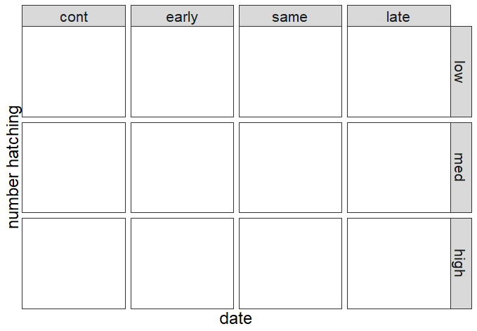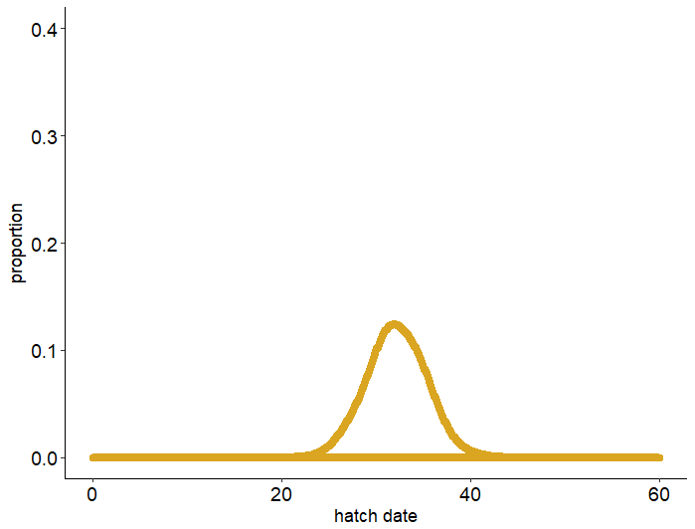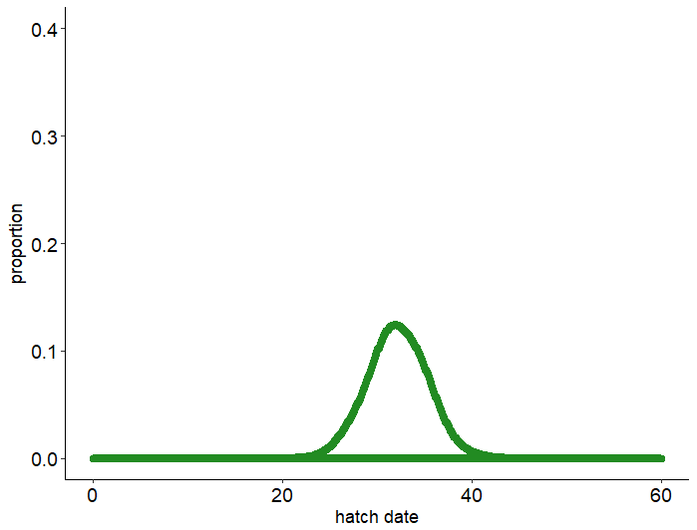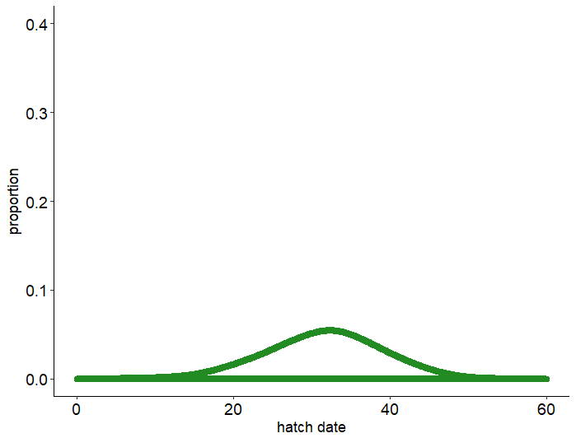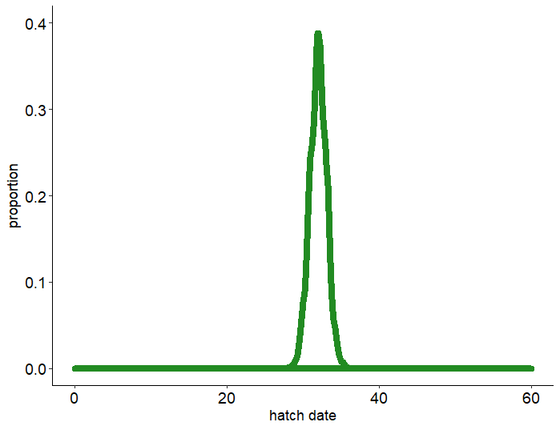

Phenological mean of **Hyla** (relative to **Rana**)

**Figure 2:** control means



**Figure 3:** Responses of populations of *H. versicolor* to experimental manipulations of mean hatching time relative to competitor *R. sphenocephala* and variation around mean hatching time. All points are scaled relative to the control value for a particular treatment and variable (control baseline represented by dashed black line in A-E) (A) proportion of *H. versicolor* tadpoles that survived to metamorphosis out of 45 initially introduced (B) Total biomass export (i.e., cumulative mass of all *H. versicolor* tadpoles that survived to metamorphosis) (C) average per capita mass of all *H. versicolor* metamorphs (D) average number of days from mean hatching time to emergence for all *H. versicolor* individuals. (E) standard deviation in time to emergence for all *H. versicolor* individuals. (F) values for control tanks (lacking competitor R. sphenocephala at all synchrony levels for each response variable. Points represent means (from 6 replicates for A-E and 2 replicates for F) ± 1 standard error.



**Figure 4:** Distributions of emergence phenology for populations of *H. versicolor*. Dark green distribution on top represents treatments with high synchrony hatching and light green distributions underneath represent low synchrony hatching. Rows represent mean hatching time relative to competitor, *R. sphenocephala* (control lacked *R. sphenocephala*). Stacked distributions show replicate treatments. Only low and high synchrony treatments are shown to maximize readability. Distributions for all treatments are shown in Figure S2.



**Table 1:** Statistical results of generalized linear mixed models testing independent and interactive effects of phenological mean and phenological synchrony on multiple aspects of the competitive interaction between species *H. versicolor* and *R. sphenocephala*.

|  |  |  |  |  |  |  |
| --- | --- | --- | --- | --- | --- | --- |
| **Response Variable** | **Explanatory Variables** | | | | | |
|  | **Mean** | | **Synchrony** | | **Mean * Synchrony** | |
|  | χ22, 51 | *P* | χ22, 51 | *P* | χ24, 51 | *P* |
| Proportion survival | 30.4 | 2.5e-7 | 3.15 | 0.21 | 11.7 | 0.02 |
| Total biomass export | 21.6 | 2.0e-5 | 4.14 | 0.13 | 6.40 | 0.17 |
| Mean per capita mass | 7.85 | 0.02 | 120 | <2e-16 | 2.42 | 0.66 |
| Mean days to emergence | 101 | <2e-16 | 0.84 | 0.66 | 10.1 | 0.038 |
| S.D. days to emergence | 9.34 | 0.0094 | 12.4 | 0.0020 | 18.6 | 0.00096 |

**Table S1:**

|  |  |  |  |  |  |  |  |  |  |  |  |  |  |  |  |  |  |  |
| --- | --- | --- | --- | --- | --- | --- | --- | --- | --- | --- | --- | --- | --- | --- | --- | --- | --- | --- |
|  |  |  | **Experiment day/date** | | | | | | | | | | | | | | |  |
|  |  |  | **-7** | **-6** | **-5** | **-4** | **-3** | **-2** | **-1** | **0** | **1** | **2** | **3** | **4** | **5** | **6** | **7** |  |
| **SP** | **MEAN** | **SYNC** | **8-Apr** | **9-Apr** | **10-Apr** | **11-Apr** | **12-Apr** | **13-Apr** | **14-Apr** | **15-Apr** | **16-Apr** | **17-Apr** | **18-Apr** | **19-Apr** | **20-Apr** | **21-Apr** | **22-Apr** | **REPS** |
| HV | early | high |  |  |  |  |  |  |  | 45 |  |  |  |  |  |  |  | 6 |
| RS | early | high |  |  |  |  |  |  |  |  |  |  |  |  |  | 30 |  |
| HV | early | med |  |  |  |  | 15 |  |  | 15 |  |  | 15 |  |  |  |  |
| RS | early | med |  |  |  |  |  |  |  |  |  |  |  |  |  | 30 |  |
| HV | early | low |  | 9 |  |  | 9 |  |  | 9 |  |  | 9 |  |  | 9 |  |
| RS | early | low |  |  |  |  |  |  |  |  |  |  |  |  |  | 30 |  |
| HV | same | high |  |  |  |  |  |  |  | 45 |  |  |  |  |  |  |  |
| RS | same | high |  |  |  |  |  |  |  | 30 |  |  |  |  |  |  |  |
| HV | same | med |  |  |  |  | 15 |  |  | 15 |  |  | 15 |  |  |  |  |
| RS | same | med |  |  |  |  |  |  |  | 30 |  |  |  |  |  |  |  |
| HV | same | low |  | 9 |  |  | 9 |  |  | 9 |  |  | 9 |  |  | 9 |  |
| RS | same | low |  |  |  |  |  |  |  | 30 |  |  |  |  |  |  |  |
| HV | late | high |  |  |  |  |  |  |  | 45 |  |  |  |  |  |  |  |
| RS | late | high |  | 30 |  |  |  |  |  |  |  |  |  |  |  |  |  |
| HV | late | med |  |  |  |  | 15 |  |  | 15 |  |  | 15 |  |  |  |  |
| RS | late | med |  | 30 |  |  |  |  |  |  |  |  |  |  |  |  |  |
| HV | late | low |  | 9 |  |  | 9 |  |  | 9 |  |  | 9 |  |  | 9 |  |
| RS | late | low |  | 30 |  |  |  |  |  |  |  |  |  |  |  |  |  |
| HV | NA | high |  |  |  |  |  |  |  | 45 |  |  |  |  |  |  |  | 2 |
| RS | NA | high |  |  |  |  |  |  |  |  |  |  |  |  |  |  |  |
| HV | NA | med |  |  |  |  | 15 |  |  | 15 |  |  | 15 |  |  |  |  |
| RS | NA | med |  |  |  |  |  |  |  |  |  |  |  |  |  |  |  |
| HV | NA | low |  | 9 |  |  | 9 |  |  | 9 |  |  | 9 |  |  | 9 |  |
| RS | NA | low |  |  |  |  |  |  |  |  |  |  |  |  |  |  |  |

**Figure S2:** Headwidths of a subsample of individuals of each species measured the day they were added to the tanks.

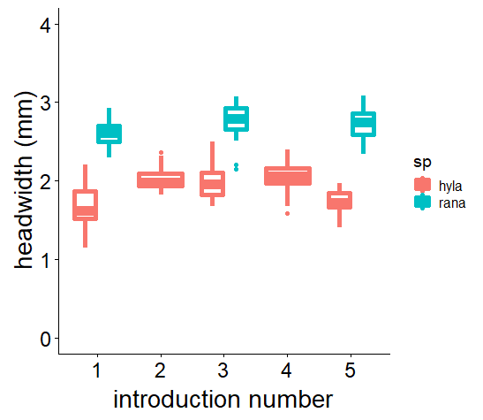

**Figure S3:** Cumulative number of *H. versicolor* metamorphs collected (across all treatments) through the course of the experiment. The experiment ended September 14, at which point we were confident virtually all *H. versicolor* individuals had either emerged or died.

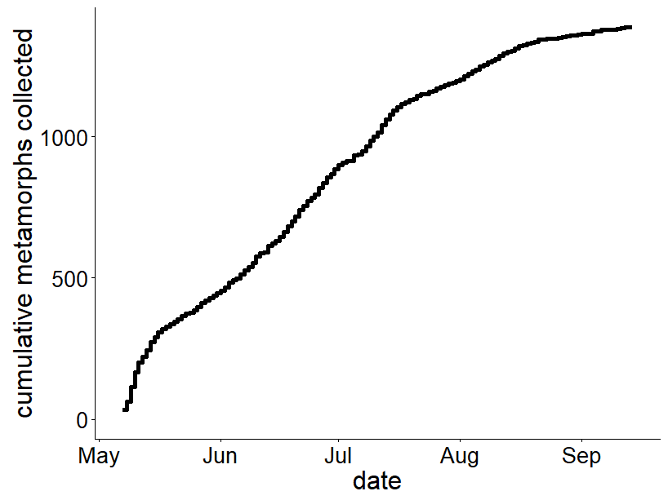

**Figure S4:** Responses of populations of *H. versicolor* to experimental manipulations of mean hatching time relative to competitor *R. sphenocephala* and variation around mean hatching time. (A) proportion of *H. versicolor* tadpoles that survived to metamorphosis out of 45 initially introduced (B) Total biomass export (i.e., cumulative mass of all *H. versicolor* tadpoles that survived to metamorphosis) (C) average per capita mass of all *H. versicolor* metamorphs (D) average number of days from mean hatching time to metamorphosis for all *H. versicolor* individuals. (E) standard deviation in time to metamorphosis for all *H. versicolor* individuals. Points represent means (from 6 replicates) ± 1 standard error. Colored dash lines represent control means (from tanks lacking competitor *R. sphenocephala*) for each synchrony level

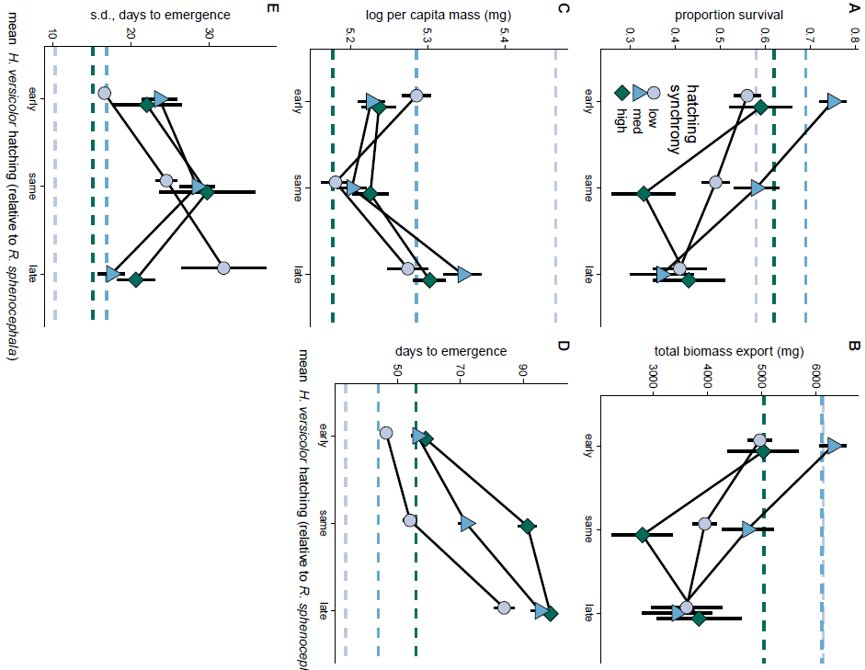

**Figure S5:** Distributions of emergence phenology for populations of *H. versicolor* after experimental manipulations of hatching phenology. Columns show different mean hatching times relative to competitor *R. sphenocephala* (controls lacked *R. sphenocephala*) and rows show synchrony of individuals around the mean hatching time. Colors indicate replicates for each treatment.

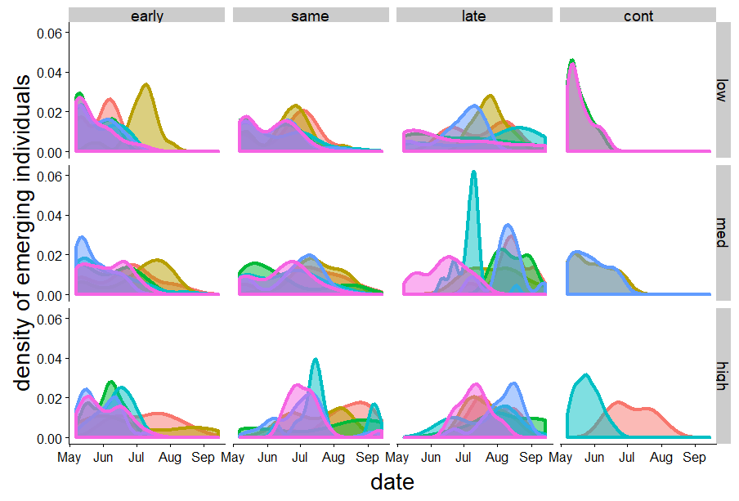

**Figure S6:** Responses of survival of *R. sphenocephala* to experimental manipulations of mean hatching time relative to competitor *H. versicolor* and variation around mean hatching time in *H. versicolor* populations. Points represent means (from 6 replicates) ± 1 standard error. Across treatments, *R. sphenocephala* survival was low (17.9%) and depended on mean hatching, synchrony of *H. versicolor* hatching, and the interaction between mean and synchrony (mean: χ22, 51 = 8.4, *P* = 0.015, synchrony: χ24, 51 = 82.6, *P* < 0.0001, mean * synchrony: χ24, 51 = 38.8, *P* < 0.0001, Fig. S6). *R. sphenocephala* survival was uniformly low (under 20%) for all but two treatments. When *R. sphenocephala* and *H. versicolor* hatched at the same time and *H. versicolor* hatching synchrony was either low or medium, *R. sphenocephala* was much higher (39% for medium synchrony and 41% for low synchrony). However, *R. sphenocephala* survival is difficult to measure because of high mortality in metamorphosis. We believe that our *R. sphenocephala* survival is artificially low (especially for the ‘late’ treatments when *R. sphenocephala* arrived first) because many individuals failed to successfully metamorphose. This is supported by a low number of *R. sphenocephala* metamorphs collected through the duration of the experiment (only 8, and half of those already dead when collected), and a low correlation between *R. sphenocephala* and *H. versicolor* survival (R2 = 0.019, t52 = 1.02, *P* = 0.31, Fig. S7).

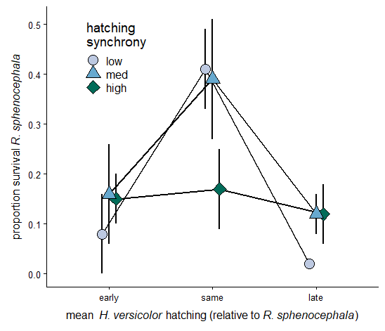

**Figure S7:** Correlation between proportion of surviving *H. versicolor* and *R. sphenocephala* individuals. Lack of negative correlation here suggests that *R. sphenocephala* survival estimates were artificially low due to high mortality in metamorphosis. Each point represents a tank.

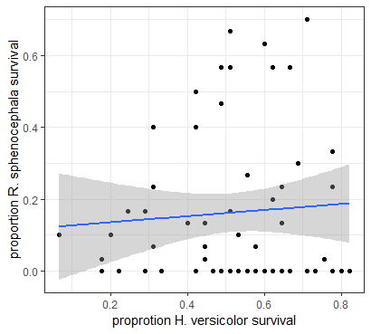

Things that could be included:

**Introduction:**

Because the numerical and per capita effects oppose one another—high synchrony resulting in many small individuals vs. low synchrony resulting in fewer large individuals—net effects on population growth rates and survival are difficult to intuit.

Measuring the shapes of phenological distributions across ontogenetic stages could indicate whether this mechanism is occurring.

[some of these ideas should be saved for discussion]

It is also largely unknown how phenological synchrony is maintained from one ontogenetic stage to the next. An underlying assumption is that synchrony is constant and can be ignored, but few studies have actually measured phenological synchrony across ontogenetic stages. For low synchrony populations, we expect large per capita differences between individuals (with early individuals stronger than later). If resources are limited, this will result in higher survival of the earliest individuals, potentially skewing the distribution of the next ontogenetic stage to be clustered around early event. But we might also expect synchrony to be maintained if individuals aren’t plastic in their developmental rates and competition isn’t that strong so that there’s high survival for all individuals. Maybe we expect synchrony maintained if they’re early, but synchrony skewed to early individual if they’re at the same time or late relative to competitors

Shifts in synchrony and mean occur with similar frequency and concomitantly in nature, but we don’t know how these types of shifts interact

**Methods:**

* Comparative natural history of the two species. Stronger resource acquisition, faster development, etc
* Natural history of broader study system and ponds where the species are found

Differences from Rasmussen & Rudolf 2016:

* Use absolute phenology, not size surrogate
* Competition, not predation
* Distribution across ontogeny

**Discussion:**

Since we only followed these populations through two phenological stages, we do not necessarily know if the shift in phenology from hatching to emergence would be maintained to hatching again the next year. It is possible that across subsequent stages, phenology would shift back to more closely resemble hatching phenology of the previous year, but it is unlikely it would shift all the way back

It is important to measure phenological synchrony and how it changes across ontogenetic stages and years since synchrony is important for determining the nature and strength of intraspecific competition.

First, the effects of arrival order could overwhelm the effects of synchrony, making synchrony unimportant at the community scale. Alternatively, the effects of order and synchrony could be additive. In single species tanks, we saw higher survival of high synchrony populations. If effect of order and synchrony are additive, we would expect to see higher survival of high synchrony populations across a range of relative arrival times. Finally, effects of synchrony and order could be interactive, whereby the effect of synchrony depends on the order of arrival.

This is likely because when *H. versicolor* hatched at the same time as *R. sphenocephala*, individuals faced the strongest competitive environment and greatest resource limitation. When *H. versicolor* hatched early, individuals had priority access to food, so could grow larger. When *H. versicolor* hatched late, *H. versicolor* survival was low, so those individuals that did survive would face lower intraspecific competition and this may have enabled them to grow larger. The competitive effect of synchrony counteracted demographic effects measured in the controls. Individual *H. versicolor* from high synchrony populations were slightly larger than their competitor-free counterparts, individuals from medium synchrony populations were slightly smaller, and individuals from low synchrony populations were significantly smaller. Together, these competitive effects perfectly counteracted the demographic effects measured in the controls, such that the absolute effect of synchrony appears to be negligible (Fig. S3, panel C).