**Shifts in phenological distributions reshape interaction potential in natural communities**

Shannon K. Carter a,1, Daniel Saenz b,2, Volker H.W. Rudolf a,3

1. Department of Biosciences, Program in Ecology and Evolutionary Biology, Rice University; 6100 Main Street, MS-170, Houston, TX 77005-1892, USA
2. USDA Forest Service Southern Research Station, 506 Hayter St. Nacogdoches, TX 75965, USA. dsaenz@fs.fed.us
3. Corresponding author

e: shannon.k.carter@rice.edu

t: +1 (512) 964-6386

1. dsaenz@fs.fed.us
2. volker.rudolf@rice.edu

**Running title:** Phenological distribution & interaction potential

**Keywords:** phenology, temporal overlap, species interactions, interaction potential, climate change, amphibians

**Type of article:** Letters

**Counts:**

Abstract: 145 words. Main text: 3,772 words

47 References

6 Figures, 1 table, 0 text boxes

**Author contributions:** DS collected and processed the data, SKC & VHWR designed research, SKC analyzed data, SKC & VHWR wrote the paper.

**Data accessibility:** The data supporting the results will be archived in Dryad

**Abstract**

Climate change has changed the phenologies of species worldwide but it remains unclear how these phenological changes will affect species interactions and structure of natural communities. By using a novel approach to analyze long-term data of 66 frog species pairs across eight communities, we demonstrate that phenological shifts can significantly alter the interaction potential of coexisting competitors. Importantly, these changes in interaction potential were mediated by non-uniform, species-specific shifts in phenological distributions and consequently could not be captured by metrics traditionally used to quantify phenological shifts. Ultimately, these non-uniform shifts in the distributions of phenologies increased the interaction potential for 25% of species pairs, altering temporal community structure and potentially increasing interspecific competition in this system. These results demonstrate the potential of phenological shifts to reshape species interactions and temporal structure of natural communities, emphasizing the importance of considering entire phenological distributions of natural populations.

**Introduction**

Global changes in climate have led to significant spatiotemporal restructuring of natural communities around the world (Parmesan & Yohe 2003; Menzel *et al.* 2006; Chen *et al.* 2011). Changes in the seasonal timing of species life history events (phenological shifts) are among the best-documented of these ecological responses to climate change (Fitter & Fitter 2002; Walther *et al.* 2002; Parmesan & Yohe 2003; Brown *et al.* 2016). Species tend to advance their timing in response to warming temperatures, but there is substantial variation in the rate and even direction of shifts across co-occurring species (Dunn & Winkler 1999; Root *et al.* 2003; Parmesan 2007; Thackeray *et al.* 2016), and these species-specific phenological responses can alter the timing of species interactions (Edwards & Richardson 2004; Clausen & Clausen 2013; Kudo & Ida 2013). Given the importance of biotic interactions in structuring natural communities and ecosystem processes, these phenology-driven changes are expected to have profound ecological effects (Kudo *et al.* 2004; Memmott *et al.* 2007; Both *et al.* 2009; Yang & Rudolf 2010).

Phenological shifts can impact species interactions by shifting the temporal overlap between interacting populations (Visser & Both 2005). Simply construed, temporal overlap is the period of time when two individuals are present in a given phenological stage and can interact with each other. However, individuals within a population vary in their phenologies. At the species level we therefore need to consider the distribution of all phenologies within a population to determine the potential of a species to interact with others. For example, consider a population A that overlaps with population B for a 15-day period. The encounter probability, and thus interaction potential, between the two populations will clearly be much greater if 80% of population A’s individuals are present during that period than if only 5% are present. However, to date most phenological research has summarized a population’s phenology into a single metric (e.g., first flowering date, seasonal peak abundance) and rarely considers entire phenological distributions (but see CaraDonna et al. 2014). As a consequence, we know very little about the phenological distributions of species and how they change over time. Yet this knowledge is key for determining how phenology shapes temporal overlap of species and predicting how species interactions will be affected by climate change (Miller-Rushing *et al.* 2010; CaraDonna *et al.* 2014; Rasmussen & Rudolf 2015).

The link between phenological shifts and temporal overlap will depend on how two populations’ phenological distributions shift relative to one another (Holbrook & Schmitt 1989; Lawler & Morin 1993; Russell & Louda 2004). Two major scenarios are possible (Fig. 1). First, the shape of both distributions can stay uniform but shift forward or backward in time (compare Fig. 1a and Fig. 1b). In this case, a single metric (e.g. first, peak, last) is a sufficient summary and temporal overlap (indicated by the shaded area of intersection between the two curves) will be correlated with the relative timing of the single metric. Alternatively, the shape of either one (Fig. 1c) or both (Fig. 1d) distributions can shift non-uniformly (e.g., first, peak, and last phenological event do not shift at an equal rate across years). In this scenario, single metrics would poorly represent the phenological distribution, and therefore over- or under-estimate changes in temporal overlap between populations. Thus, we need to know which types of shifts (uniform or non-uniform) are most common in a given community to identify appropriate metrics for quantifying phenological shifts and predicting their impact on temporal overlap. In cases where non-uniform shifts in distributions are frequent, it will only be possible to make meaningful predictions about changes in interaction potential by considering the entire distribution of phenological events (CaraDonna *et al.* 2014).

Here, we use a novel approach that considers the entire phenological distributions of interacting species to test how phenological shifts alter interaction potential of species in natural communities. Specifically, we analyzed a unique long-term abundance-based frog calling phenology dataset to map precise phenological distributions of individual species within and across multiple communities over time (see Fig. 2 for an example). This is an apt system for linking phenological shifts to species interactions because these frogs can compete locally in a number of ways: through vocal interference and/or for resources both directly as adults and indirectly through their offspring (Alford & Wilbur 1985; Schwartz 1987; Morin *et al.* 1990). This system allowed us to assess: (i) How consistent are phenological distributions across years and species? (ii) How do inter-annual shifts in phenological distributions affect temporal overlap of potential competitors? (iii) Are there long-term trends indicating changes in interaction potential, and what are the most powerful metrics to detect these long-term trends? We found that phenological distributions shifted greatly among sites and through time, ultimately increasing the temporal overlap and interaction potential of competitors in the long term.

**Materials and methods**

**Study site and dataset:**

We analyzed high-resolution frog calling data (coincident with breeding phenology) collected from audio recorders installed at eight ponds in northeast Texas. Ponds ranged in area from 35 m2 to 1720 m2 with an average of 380 m2. Maximum depth of the ponds ranged from 1.5-4.0 m. The farthest ponds were separated by 34 km and the average distance between ponds was 17 km. The recorders collected calling data six times a day (9:00pm, 10:00pm, 11:00pm, 12:00am, 1:00am, 2:00am) for a one-minute interval, from May 2000 – December 2015 Recordings were processed manually with sonogram reference, and number of calls for 12 species (*Hyla versicolor, Hyla cineria, Bufo valliceps, Bufo woodhouseii, Rana catesbeiana, Rana clamitans, Rana sphenocephala, Gastrophryne carolinensis, Pseudacris crucifer, Pseudacris triseriata, Acris crepitans, Rana palustris*) were recorded. Number of calling individuals (with a maximum of five) for each species was recorded for each time point. Up to five conspecific individuals could be distinguished by differences in frequency and volume of their calls. Missing data (due to broken recorders) was recorded as NA.

The eight ponds are clustered at two distinct sites—Davy Crockett National Forest (DC) and Stephen F. Austin Experimental Forest (SFA)—which vary in some key ways. The ponds in SFA are on average smaller and unable to support fish, while those in DC are large enough to support fish communities (most commonly mosquitofish, green sunfish, and largemouth bass). Furthermore, despite being separated by < 30 km, the sites can differ significantly in daily and annual average weather conditions. DC was on average 0.5-1.0° C warmer every year than SFA (See Figure S1 in Supporting Information). Annual rainfall totals for the two sites on average was equal (mean ± SEM; 103.8 ± 26 cm/year at DC, 104.2 ± 29 cm/year at SFA), but within a year, they differed by as much as 91 cm (in 2002, SFA had 141 cm precipitation and DC had 50 cm) (see Figure S2).

Amphibians are an apt system for studying phenology for several key reasons. First, their reproduction is timed by a suite of climate cues, including temperature, precipitation, and air pressure (Blankenhorn 1972; Pechmann *et al.* 1989); thus their phenological distribution is largely determined by year-specific weather conditions (Díaz-Paniagua 1992; Saenz *et al.* 2006). Second, different species respond to different environmental cues, and thus are expected to show different phenological responses, which could temporally restructure the community (Oseen & Wassersug 2002; Saenz *et al.* 2006). Finally, amphibians exhibit a strong but highly variable phenological response relative to other taxa (Forchhammer *et al.* 1998; Blaustein *et al.* 2001; Parmesan 2007; Todd *et al.* 2010), and are declining globally (Blaustein *et al.* 1994; Bury 1999; Stuart *et al.* 2004; Grant *et al.* 2016), suggesting they should be a high priority for examining causes and consequences of phenological shifts.

**Data processing and analysis:**

To link phenology to temporal overlap, we did pairwise comparisons of the phenological distributions for co-occurring species (resulting in 15 years x 8 ponds x 66 species pairs = 7,920 comparisons). To make each phenological distribution, we smoothed scatter plots of number of calls over time using the lowess function (f = 1/50, iter = 3, delta = 4) in the stats package of R version 3.2.2 (sample plots in Fig. 2). These lowess settings showed variation on a 2-3 day scale, but smoothed within-day noise. Sensitivity analyses with different values for the lowess settings gave qualitatively similar results. For each pair of species at the same site and year, we estimated three values: days difference in first calling date, days difference in median calling date, and temporal overlap. The cumulative number of calls throughout a year was used to calculate first and median calling date for each distribution. We defined first calling date as the day when five cumulative calls had been recorded to exclude individual early calling outliers unrepresentative of the bulk of the population’s phenology. Sensitivity analysis indicated that results were qualitatively similar using smaller or larger calling buffers. Median calling date was the day of year on which 50% of the year’s calls had been recorded. For days-difference in first and median calling date, we simply subtracted the first (or median) calling date of species A minus the first (or median) calling date of species B, and standardized by dividing by the total length of the calling period for the focal species. For temporal overlap, we calculated the integrated area of intersection between lowess distribution curves. We standardized temporal overlap by dividing the area of intersection by the total area under the curve of the focal species’ phenological distribution. This enabled comparisons by giving a standardized encounter probability. We considered species pairs that did not exhibit ≥ 15% overlap in at least 15 of the 120 year-ponds non-overlapping and removed them from the analysis. We also removed any year-ponds in which one or both species did not call, leaving us with 2,010 unique comparisons for analysis.

To test whether non-uniform shifts in species phenologies altered temporal overlap of interacting species pairs (question ii), we fit linear models to assess how well relative timing in single metrics (first and median calling date) between two species predicted their temporal overlap. Linear mixed effect models were fit using the lmer function in the lmerTest package of R. Temporal overlap between two species was predicted by days difference in single phenological metrics (e.g., first/median calling date for species A – first/median calling date for species B) across years for each species pair with pond as a random effect. This resulted in 48 linear regressions.

To test for long-term phenological trends indicating changes in interactions potential (question iii), we again fit linear mixed effect models using the lmer function of lmerTest. First, temporal overlap between two species was predicted by year with pond as a random effect for all species pairs. In order to compare ability of single metrics vs. distributions to measure phenological shifts, we repeated the analysis but with difference in first calling date between two species as dependent variable.

**Results**

Phenological distributions differed substantially across years and sites, and species differed in how consistent their distributions were year to year. Of the 12 anuran species represented in our dataset, *Rana sphenocephala*’sphenological distribution varied the most—the duration of its calling period ranged from 2-325 days long (mean ± SEM; 177 ± 90 days; Fig. 3), with a median calling date ranging from Julian date 36-304 (mean ± SEM; 160 ± 89 days; Fig. 4). *Rana palustris* had the most consistent distribution, though still demonstrated significant variation: its calling period ranged from 2-37 days long (mean ± SEM; 14 ± 10 days; Fig. 3) with median calling date ranging from Julian date 46-84 (mean ± SEM; 69 ± 11 days; Fig. 4). Because of the difference in shape and consistency of phenological distributions between these two species across space and time, temporal overlap spanned the entire possible range from 0% to 100%. The phenological distributions for the remaining 10 species were more consistent than *R. sphenocephala* but less consistent than *R. palustris* (summary of each species phenology in Figures 3 & 4 and Table S4).

Since species’ phenological distributions varied significantly, temporal overlap between competitors changed dramatically across space and time and could not be captured by relative timing of single metrics. Out of 48 unique species pairs examined, only 14% (7/48) showed a significant relationship (p < 0.05) between difference in first calling date (e.g., between species A and B) and temporal overlap (Fig. 5a, Table S1). This does not include adjusted alpha levels for multiple comparisons, so the proportion of significant results is hardly more than we would expect by chance. Thus, difference in first call date was not predictive of temporal overlap, indicating non-uniform shifts in the phenological distribution between species. Furthermore, among the 7 significant correlations, 3 were negative (increasing difference in start date associated with decrease in temporal overlap) and 4 were positive (increasing difference in start date associated with increase in temporal overlap), further suggesting that many of the significant relationships were driven by chance. Difference in median calling date was somewhat better at predicting overlap, with 23% (11/48) of regressions indicating a significant relationship, with 10 negative slopes and 1 positive (Fig. 5b, Table S1). Together this indicates that relative timing of single metrics mostly failed to describe temporal overlap between species because of significant non-uniformity in the distribution of phenologies across years in this system (i.e., as represented in Fig. 1c, d). Figure 2 provides extreme example of our raw data exemplifying the incongruence between phenological onset and temporal overlap.

Despite significant interannual variation in species phenological distributions and a relatively short time series, we did detect some directional phenological shifts in this system. However, these trends were only detectable when considering the entire phenological distribution. Only one species (*Gastrophryne carolinensis*) showed a significant shift in first or median calling date through the 15 year period (advancing 2.3 ± 0.72 days in first calling and 1.5 ± 0.67 days in median calling—remaining trends for single species summarized in Table S3). Difference in first calling date grew significantly shorter over the 15 year period for 10% (5/48) of species pairs (Fig. 6a, Table S2). The remaining 90% of species pairs showed no significant directional change in relative start date (Fig. 6a, Table S2). Temporal overlap revealed a more robust pattern, with 25% (12/48) of species pairs showing a significant positive trend (i.e., convergence of phenologies leading to more overlap over time) (Fig. 6b, Table S2). Notably, all but 1 species pair that showed a significant convergence of start dates also showed a significant increase in overlap. The trend for first date and overlap were consistent, with first dates moving closer together and temporal overlap increasing, which both suggest that species phenologies are growing more similar over time.

**Discussion**

Phenological shifts are among the best-documented ecological responses to climate change, yet we currently know little about how these shifts affect species interactions. This link is essential as we aim to predict how phenological shifts will impact natural systems. While previous studies have provided important evidence documenting phenological shifts, they typically rely on single metric summaries of population phenology. By taking a novel approach that accounts for a population’s whole phenological distribution, we demonstrate that phenological distributions can vary substantially across space and time. Importantly, this variation was species-specific, leading to shifts in the temporal overlap between interacting species, thereby altering the interaction potential among coexisting competitors. Furthermore, phenologies of many competitors converged over time suggesting that competition is likely to increase with climate change. Interestingly, because these shifts were mediated by changes in the “shape” of phenological distributions (Fig. 1) these shifts could not be detected with single metrics (e.g. first or median calling date). Overall, these results indicate that phenological shifts can fundamentally alter ecological interactions and structure of natural communities, and emphasize the need to consider whole population phenology in order to reliably detect these changes.

A species’ phenological distribution determines its temporal and numerical overlap with co-occurring species, and therefore should be fundamentally important for shaping species interactions (Visser & Both 2005; Yang & Rudolf 2010). Phenological shifts could alter temporal overlap in a number of ways, depending on how species shift relative to one another (possible scenarios shown in Fig. 1). We found the cases outlined in Fig. 1c and 1d the most common (i.e., one or both population’s phenological distributions shifts non-uniformly). Thus, shifts in the temporal overlap of species frequently occurred because of shifts in the distribution of phenologies. As a consequence of this variation, single metrics failed to adequately capture variation in phenological distributions within and across species (as illustrated in Fig. 1d). Overall, these results emphasize the importance of accounting for the entire distribution of species phenologies to quantify and predict how phenological shifts may alter species interactions.

The reasons behind unequal shifts in phenological distributions among species (i.e., as shown in Fig. 1d) is still unknown, but likely connected to differences in seasonal niches of species and what abiotic cues species rely on. Species in our dataset occupy a range of seasonal niches and their breeding phenologies are triggered by different abiotic factors (Dayton & Fitzgerald 2001; Kopp & Eterovick 2006; Saenz *et al.* 2006). For instance, calling phenologies of some species are strongly associated with rainfall (e.g., *B. valliceps, B. woodhousii, H. versicolor, G. carolinensis*), while others more strongly rely on temperature (*P. crucifer*, *P. triseriata*, and *R. palustris*) (Saenz *et al.* 2006). Therefore, a population’s phenological distribution in a given year and place is shaped by an interaction between that species’ life history strategy, season-specific weather conditions, and long term weather trends. Phenological distributions might be more uniform across time and space if phenology is determined by a more consistent cue (e.g., photoperiod), and/or if populations are composed of the same individuals year-to-year (e.g., perennial plants). In these systems, it may take longer to see non-uniform shifts in species’ phenological distributions. However, in a community context, there will be many species with varied life histories and seasonal niches, and it is highly unlikely that each population’s distribution will change in exactly the same way. For instance, in long-lived perennial plants, a system much more predictable than our anuran system, species differ substantially in how the phenological distribution changes over time (measured by the rate of at which first, peak, and last flowering dates change over time; ref. 19). Therefore, unequal shifts in phenological distributions are unlikely to be unique to amphibians and instead are bound to occur in a wide range of animals and plant systems.

Directional shifts in the relative phenologies of interacting species over time could either increase or decrease the potential for species interactions and thus have important long term consequences for community structure and species coexistence (Suttle *et al.* 2007). We observed significant restructuring of species overlap in our amphibian community. In our system, temporal overlap significantly increased for 25% of competitor pairs over the 15 year period. We were unable to directly link this trend to a climate driver, but speculate it could be due to changing precipitation patterns. Throughout the United States, droughts have been more severe, interspersed with rare mass flooding events (Melillo *et al.* 2014; Murdock & Brenner 2016). Since breeding is highly associated with rain for many amphibian species (Saenz *et al.* 2006), our speculation is that species phenologies converge to coincide with these few rain events (Nally *et al.* 2017). In this system, frogs can compete locally in a number of ways. For example, acoustic interference between heterospecifics can make calls more difficult for females to distinguish and localize (Jones 1966; Schwartz 1987). Additionally, both adults and their tadpole offspring can compete locally for common resources (Alford & Wilbur 1985). Previous studies suggest that interspecific competition increases when hatching phenologies converges; thus, regardless of the underlying mechanism, the convergence in phenologies of competitors in our system could increase the strength of interspecific competition (Alford & Wilbur 1985; Morin *et al.* 1990). This could cause long-term changes in abundance and potentially persistence of amphibians and significantly impact the community’s stability and response to climate change (Suttle *et al.* 2007).

The significant convergence of phenologies in our study also emphasizes that considering the whole distribution of phenologies is a powerful tool to detect phenological trends over shorter time series. Current methods rely on single metrics because this data is easier to attain and may be the only data available for many systems (Miller-Rushing *et al.* 2008). However, these metrics represent only a single or few individuals, and thus are highly sensitive to outliers and may misrepresent the bulk of the population. As a consequence, long time series data are needed to detect trends using single metrics, but such long-term datasets are rare, especially for animals. In addition, a single metric cannot capture all changes in the distribution of phenologies and thus miss important phenological changes. For instance, the first day of flowering may advance faster or slower than the peak flowering date of a population (CaraDonna *et al.* 2014). Our results indicate that considering the whole population substantially increases power of shorter time series data to detect phenological trends. Only one species (*G. carolinensis*; advancing 2.3 ± 0.72 days per year in first calling date and 1.54 ± 0.67 days per year in median calling date) showed a shift in phenological first or median over time (see Table S3). However, we observed an increase in temporal overlap for 25% of species when considering pairwise interactions. So by relying on single metrics, we would underestimate the prevalence of phenological shifts in this system and would not predict any changes in temporal community overlap. Collecting the high temporal resolution data necessary to describe phenological distributions remains a challenge in many systems, but may be more feasible with advances in citizen science, remote sensing, and eDNA. These approaches allow wide scale sampling over time without overly burdening any single researcher.

Now that phenological responses to climate change have been well-documented, the crucial next step is to understand and predict the consequences of this pattern. Our study clearly indicates that because phenological distributions change non-uniformly, we need to expand on traditional single metric approaches and instead consider the entire distribution of phenological events represented in a population. Important next steps in phenology research will be to first identify which factors determine shifts in species’ phenological distributions, and then determine whether systematic patterns could be used to extrapolate and predict phenological changes across taxa and ecosystems. In addition, we need experimental studies that determine how changes in the distributions are linked to outcomes of species interactions. Combining both research venues will then allow us to create a mechanistic framework to link climate mediated changes in phenologies to the dynamics and structure of natural communities.

**Acknowledgements**

The authors thank Cory Adams, James Childress, and Alexandria Bryant for contributing in the field and lab. Additional thanks to Amy Dunham, Nick Keiser, and Tom Miller for comments on the data analysis and manuscript. This work was supported by NSF DEB-1256860 and NSF DEB- 0841686 to V.H.W. Rudolf.

The authors declare no conflict of interest.

**References**

1.  
Alford, R.A. & Wilbur, H.M. (1985). Priority Effects in Experimental Pond Communities: Competition between Bufo and Rana. *Ecology*, 66, 1097–1105

2.  
Blankenhorn, H.J. (1972). Meteorological variables affecting onset and duration of calling in Hyla arborea L. and Bufo calamita calamita Laur. *Oecologia*, 9, 223–234

3.  
Blaustein, A.R., Belden, L.K., Olson, D.H., Green, D.M., Root, T.L. & Kiesecker, J.M. (2001). Amphibian Breeding and Climate Change. *Conserv. Biol.*, 15, 1804–1809

4.  
Blaustein, A.R., Wake, D.B. & Sousa, W.P. (1994). Amphibian Declines: Judging Stability, Persistence, and Susceptibility of Populations to Local and Global Extinctions. *Conserv. Biol.*, 8, 60–71

5.  
Both, C., Van Asch, M., Bijlsma, R.G., Van Den Burg, A.B. & Visser, M.E. (2009). Climate change and unequal phenological changes across four trophic levels: constraints or adaptations? *J. Anim. Ecol.*, 78, 73–83

6.  
Brown, C.J., O’Connor, M.I., Poloczanska, E.S., Schoeman, D.S., Buckley, L.B., Burrows, M.T., *et al.* (2016). Ecological and methodological drivers of species’ distribution and phenology responses to climate change. *Glob. Change Biol.*, 22, 1548–1560

7.  
Bury, R.B. (1999). A Historical Perspective and Critique of the Declining Amphibian Crisis. *Wildl. Soc. Bull. 1973-2006*, 27, 1064–1068

8.  
CaraDonna, P.J., Iler, A.M. & Inouye, D.W. (2014). Shifts in flowering phenology reshape a subalpine plant community. *Proc. Natl. Acad. Sci.*, 111, 4916–4921

9.  
Chen, I.-C., Hill, J.K., Ohlemüller, R., Roy, D.B. & Thomas, C.D. (2011). Rapid Range Shifts of Species Associated with High Levels of Climate Warming. *Science*, 333, 1024–1026

10.  
Clausen, K.K. & Clausen, P. (2013). Earlier Arctic springs cause phenological mismatch in long-distance migrants. *Oecologia*, 173, 1101–1112

11.  
Dayton, G.H. & Fitzgerald, L.A. (2001). Competition, predation, and the distributions of four desert anurans. *Oecologia*, 129, 430–435

12.  
Díaz-Paniagua, C. (1992). Variability in timing of larval season in an amphibian community in SW Spain. *Ecography*, 15, 267–272

13.  
Dunn, P.O. & Winkler, D.W. (1999). Climate change has affected the breeding date of tree swallows throughout North America. *Proc. R. Soc. Lond. B Biol. Sci.*, 266, 2487–2490

14.  
Edwards, M. & Richardson, A.J. (2004). Impact of climate change on marine pelagic phenology and trophic mismatch. *Nature*, 430, 881–884

15.  
Fitter, A. h. & Fitter, R. s. r. (2002). Rapid Changes in Flowering Time in British Plants. *Science*, 296, 1689–1691

16.  
Forchhammer, M.C., Post, E. & Stenseth, N.C. (1998). Breeding phenology and climate|[tdot]|. *Nature*, 391, 29–30

17.  
Grant, E.H.C., Miller, D.A.W., Schmidt, B.R., Adams, M.J., Amburgey, S.M., Chambert, T., *et al.* (2016). Quantitative evidence for the effects of multiple drivers on continental-scale amphibian declines. *Sci. Rep.*, 6, 25625

18.  
Holbrook, S.J. & Schmitt, R.J. (1989). Resource Overlap, Prey Dynamics, and The Strength of Competition. *Ecology*, 70, 1943–1953

19.  
Jones, M.D.R. (1966). The Acoustic Behaviour of the Bush Cricket Pholidoptera Griseoaptera. *J. Exp. Biol.*, 45, 31–44

20.  
Kopp, K. & Eterovick, P.C. (2006). Factors influencing spatial and temporal structure of frog assemblages at ponds in southeastern Brazil. *J. Nat. Hist.*, 40, 1813–1830

21.  
Kudo, G. & Ida, T.Y. (2013). Early onset of spring increases the phenological mismatch between plants and pollinators. *Ecology*, 94, 2311–2320

22.  
Kudo, G., Nishikawa, Y., Kasagi, T. & Kosuge, S. (2004). Does seed production of spring ephemerals decrease when spring comes early? *Ecol. Res.*, 19, 255–259

23.  
Lawler, S.P. & Morin, P.J. (1993). Temporal Overlap, Competition, and Priority Effects in Larval Anurans. *Ecology*, 74, 174–182

24.  
Melillo, J.M., Richmond, T.T. & Yohe, G. (2014). Climate change impacts in the United States. *Third Natl. Clim. Assess.*

25.  
Memmott, J., Craze, P.G., Waser, N.M. & Price, M.V. (2007). Global warming and the disruption of plant–pollinator interactions. *Ecol. Lett.*, 10, 710–717

26.  
Menzel, A., Sparks, T.H., Estrella, N., Koch, E., Aasa, A., Ahas, R., *et al.* (2006). European phenological response to climate change matches the warming pattern. *Glob. Change Biol.*, 12, 1969–1976

27.  
Miller-Rushing, A.J., Hoye, T.T., Inouye, D.W. & Post, E. (2010). The effects of phenological mismatches on demography. *Philos. Trans. R. Soc. B Biol. Sci.*, 365, 3177–3186

28.  
Miller-Rushing, A.J., Inouye, D.W. & Primack, R.B. (2008). How well do first flowering dates measure plant responses to climate change? The effects of population size and sampling frequency. *J. Ecol.*, 96, 1289–1296

29.  
Morin, P.J., Lawler, S.P. & Johnson, E.A. (1990). Ecology and Breeding Phenology of Larval Hyla Andersonii: The Disadvantages of Breeding Late. *Ecology*, 71, 1590–1598

30.  
Murdock, M. & Brenner, J. (2016). Texas Coastal Bend Regional Climate Change Vulnerability Assessment

31.  
Nally, R.M., Horrocks, G.F.B. & Lada, H. (2017). Anuran responses to pressures from high-amplitude drought–flood–drought sequences under climate change. *Clim. Change*, 141, 243–257

32.  
Oseen, K.L. & Wassersug, R.J. (2002). Environmental factors influencing calling in sympatric anurans. *Oecologia*, 133, 616–625

33.  
Parmesan, C. (2007). Influences of species, latitudes and methodologies on estimates of phenological response to global warming. *Glob. Change Biol.*, 13, 1860–1872

34.  
Parmesan, C. & Yohe, G. (2003). A globally coherent fingerprint of climate change impacts across natural systems. *Nature*, 421, 37–42

35.  
Pechmann, J.H.K., Scott, D.E., Gibbons, J.W. & Semlitsch, R.D. (1989). Influence of wetland hydroperiod on diversity and abundance of metamorphosing juvenile amphibians. *Wetl. Ecol. Manag.*, 1, 3–11

36.  
Rasmussen, N.L. & Rudolf, V.H.W. (2015). Phenological synchronization drives demographic rates of populations. *Ecology*, 96, 1754–1760

37.  
Root, T.L., Price, J.T., Hall, K.R., Schneider, S.H., Rosenzweig, C. & Pounds, J.A. (2003). Fingerprints of global warming on wild animals and plants. *Nature*, 421, 57–60

38.  
Russell, F.L. & Louda, S.M. (2004). Phenological synchrony affects interaction strength of an exotic weevil with Platte thistle, a native host plant. *Oecologia*, 139, 525–534

39.  
Saenz, D., Fitzgerald, L.A., Baum, K.A. & Conner, R.N. (2006). Abiotic correlates of anuran calling phenology: the importance of rain, temperature, and season. *Herpetol. Monogr.*, 20, 64–82

40.  
Schwartz, J.J. (1987). The Function of Call Alternation in Anuran Amphibians: A Test of Three Hypotheses. *Evolution*, 41, 461–471

41.  
Stuart, S.N., Chanson, J.S., Cox, N.A., Young, B.E., Rodrigues, A.S.L., Fischman, D.L., *et al.* (2004). Status and Trends of Amphibian Declines and Extinctions Worldwide. *Science*, 306, 1783–1786

42.  
Suttle, K.B., Thomsen, M.A. & Power, M.E. (2007). Species Interactions Reverse Grassland Responses to Changing Climate. *Science*, 315, 640–642

43.  
Thackeray, S.J., Henrys, P.A., Hemming, D., Bell, J.R., Botham, M.S., Burthe, S., *et al.* (2016). Phenological sensitivity to climate across taxa and trophic levels. *Nature*, advance online publication

44.  
Todd, B.D., Scott, D.E., Pechmann, J.H.K. & Gibbons, J.W. (2010). Climate change correlates with rapid delays and advancements in reproductive timing in an amphibian community. *Proc. R. Soc. Lond. B Biol. Sci.*, rspb20101768

45.  
Visser, M.E. & Both, C. (2005). Shifts in phenology due to global climate change: the need for a yardstick. *Proc. R. Soc. Lond. B Biol. Sci.*, 272, 2561–2569

46.  
Walther, G.-R., Post, E., Convey, P., Menzel, A., Parmesan, C., Beebee, T.J.C., *et al.* (2002). Ecological responses to recent climate change. *Nature*, 416, 389–395

47.  
Yang, L.H. & Rudolf, V.H.W. (2010). Phenology, ontogeny and the effects of climate change on the timing of species interactions. *Ecol. Lett.*, 13, 1–10

**Figure Legends**

**Figure 1:** Conceptual representation of temporal co-occurrence of two species under historic conditions and three hypothetical phenological shifts. (a) historic phenology (b) a shift in which one population’s phenology advances relative to the other, but the distributions (“shape”) remains constant (c) one species’ phenology remains unchanged but the distribution of the other species changes (e.g. first event advances faster than peak or last) (d) The distributions of both species change, but species A and B change differently. In the case of (b), relative timing of a single metric can be used to predict change in temporal overlap, but in cases (c) and (d), a single metric would provide erroneous estimates. In these cases, the whole phenological distribution would need to be considered to predict change in temporal overlap.

**Figure 2:** Phenological distributions and temporal overlap for *R. clamitans* and *H. versicolor* in two contexts. These phenological distributions were made for each pairwise combination of the 12 frogs in each of the 8 ponds and each of the 15 years in the dataset, resulting in 2,010 plots. In this example, temporal overlap between *R. clamitans* and *H. versicolor* (indicated by the area of intersection between the two curves) is equal in the two contexts, but in (a) the species start calling on the same day while in (b) the onset of their calling periods is separated by 160 days. Dashed lines mark the first day of calling.

**Figure 3:** Variation in the length of calling periods for each species, pooling across all 8 ponds and all 15 years.

**Figure 4:** Seasonal calling windows for each species. Width of the bubble represents probability of calling on that day, pooling all 8 ponds across all 15 years.

**Figure 5:** Linear regression coefficients for models of temporal overlap predicted by single metrics, (a) difference in start date, (b) difference in median date, for 48 pairs of competing anurans (letters represent first initial of genus and first and second letter of species name; focal species listed first). Colored dots represent temporal overlap for one of eight ponds regressed across years and black diamonds represent averages of all ponds ± 1 SE. Marginal histogram represents the distribution of all regression coefficients. A negative regression slope indicates that relative timing of start or median accurately summarize temporal overlap, while a 0 or positive slope indicates these metrics poorly summarize temporal overlap.

**Figure 6:** Linear regression coefficients for models of shifting phenological metrics over the 15 year study period (a, using difference in start date; b, using difference in temporal overlap) for 48 pairs of competing anurans. Colored dots represent overlap at one of eight ponds regressed through years and black diamonds represent averages of all ponds ± 1 SE. Marginal histogram represents the distribution of all regression coefficients. For difference in calling onset (a), a *negative* regression coefficient indicates phenologies converging over time. For temporal overlap (b), a *positive* regression coefficient indicates phenologies converging over time. First phenological dates got significantly closer for 5/48 species pairs. Temporal overlap became significantly greater for 12/48 species pairs.

**Fig. 1**

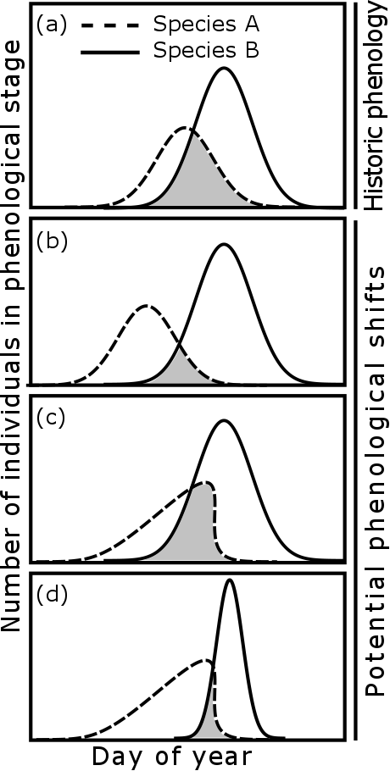

**Fig. 2**

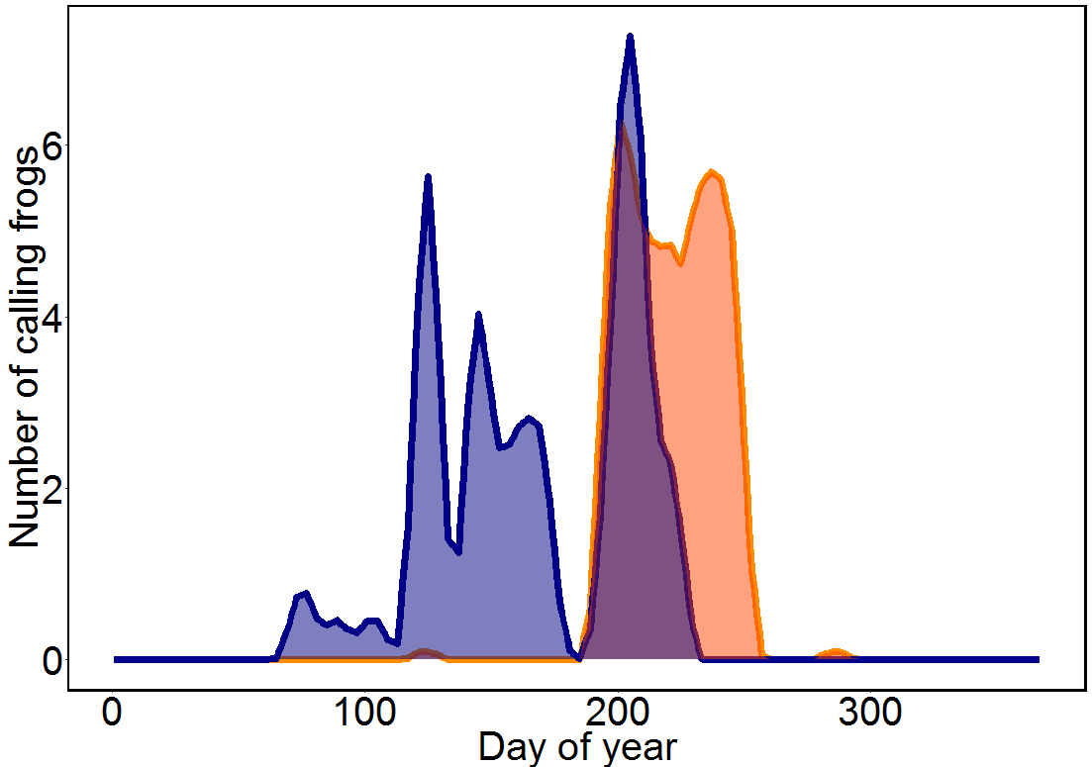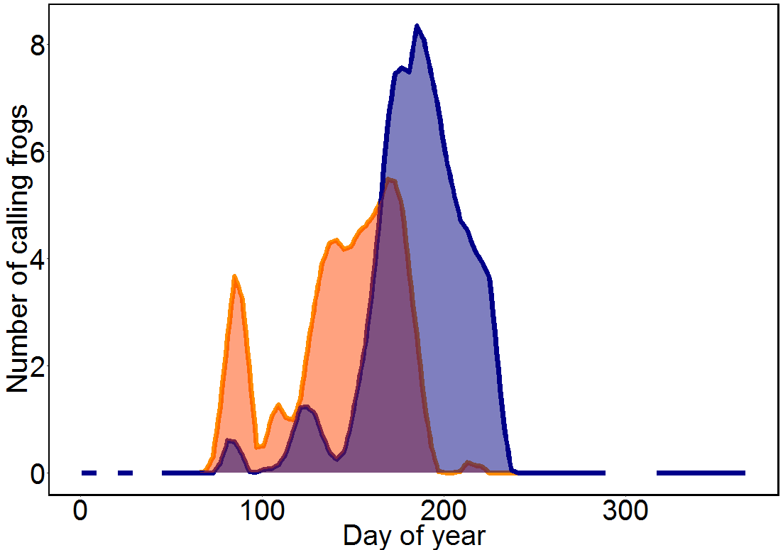

1. **2007, Pond 4**

**(b) 2012, Pond 1**

*Rana clamitans*

*Hyla versicolor*

**Fig. 3**

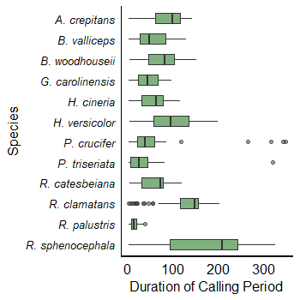

**Fig. 4**

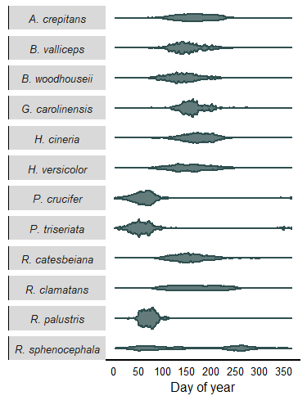

**Fig. 5**

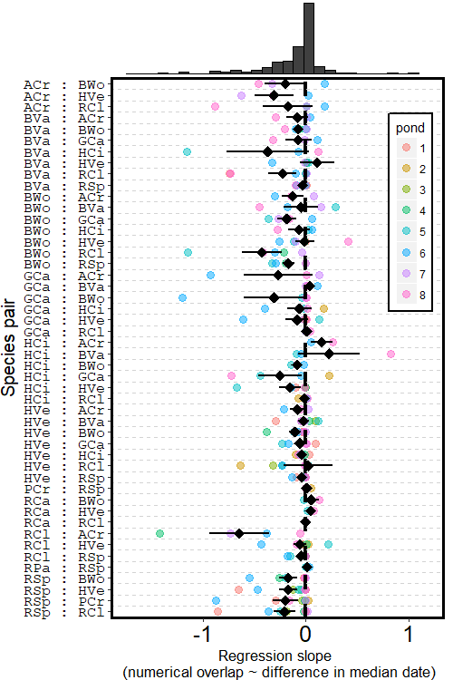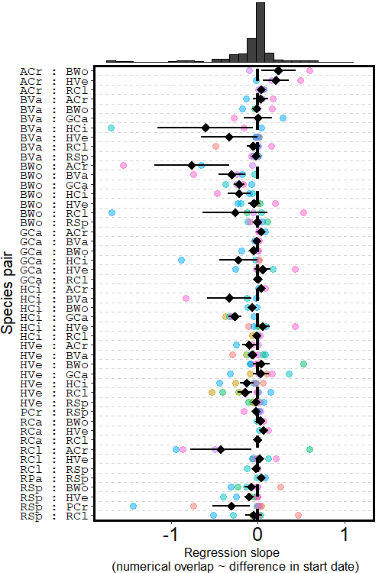

(a)

(b)

**Fig. 6**

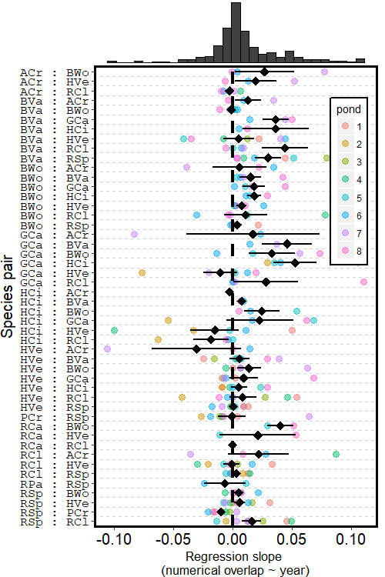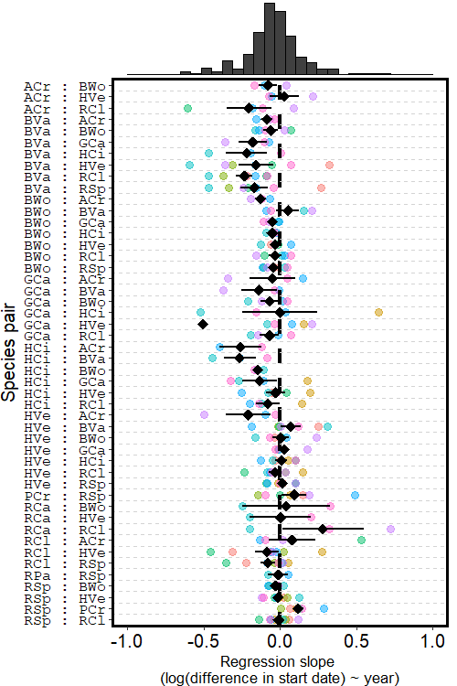

(a)

(b)