# **CT404 Graphics & Image Processing – Canvas Game Project**

# **Shannon Moran**

# **11394476**

* **Game**

Bomberman

* **Controls**

Arrow keys - move the player

Space bar - plant a bomb

* **About**

The aim of the game is to get the highest score. The score increases with each level reached and resets if the player dies. The best score is stored and shown on the right hand side of the game in the Title & Score section of the game, beneath the current score.

The player, i.e. Bomberman, has to blow up enemies without dying from either coming in contact with an enemy or getting blown up by a bomb. Only one bomb can be planted at once, so each bomb has to be tactically planted. All enemies have to be blown up to unlock the door to the next level. The door is hidden behind one of the barricades, which can also be blown up. The number of enemies increases with each level to equal the level the player is on, i.e. level 1 has 1 enemy, level 2 has 2 enemies, and so on.

* **Game Screen Layout**

|  |  |
| --- | --- |
| Map | Title & Score |
| Information | |

* **Game Features**
* Game starting + barricade spawning constraints

The player always spawns in the top left corner of the map and always has room to escape possible surrounding barricades, as shown in the worst possible case of barricade spawning below. Enemies cannot spawn in the top left 3x3 section of the playable map which gives the player a ‘safe zone’ when spawning.

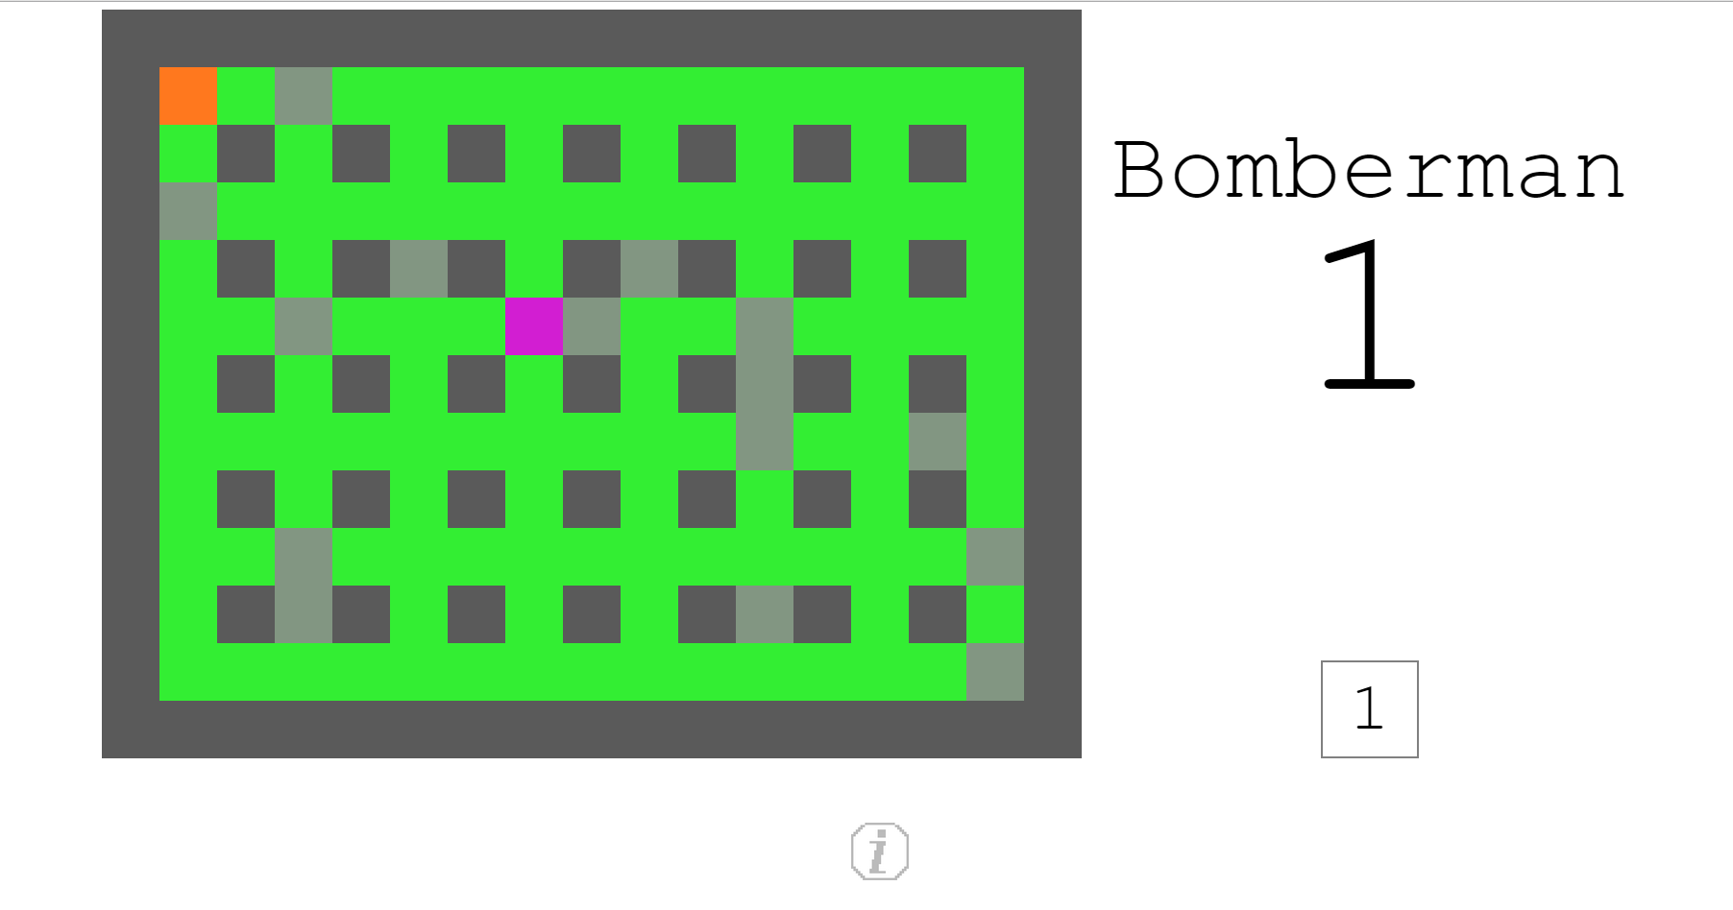

* Bomb explosion effect

When a bomb explodes it creates a very minimal explosion effect that last for a sixth of a second. This explosion effect highlights the explosion range of the bomb, and can be seen below to the right of the player’s position.

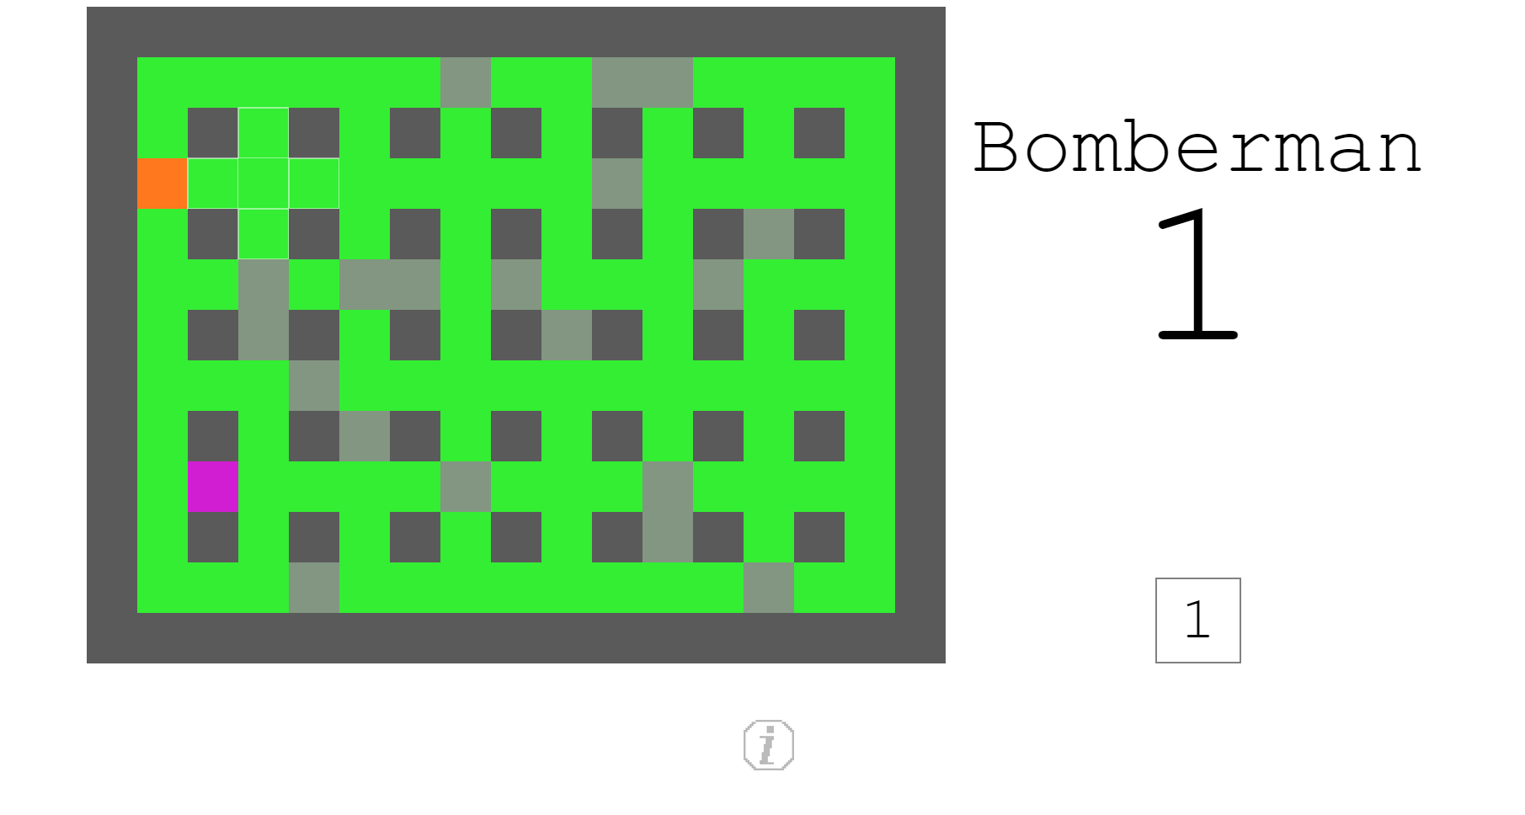

* Game over animation

If the player collides with an enemy or gets blown up by a bomb, a red circle animation begins at the position of the player, expanding to completely cover the map before beginning a new game.

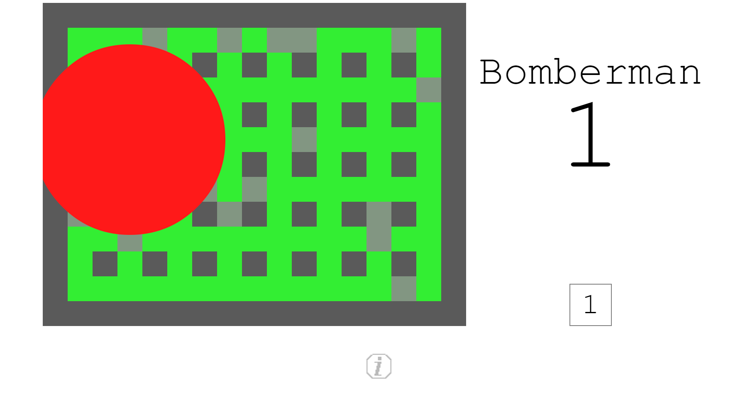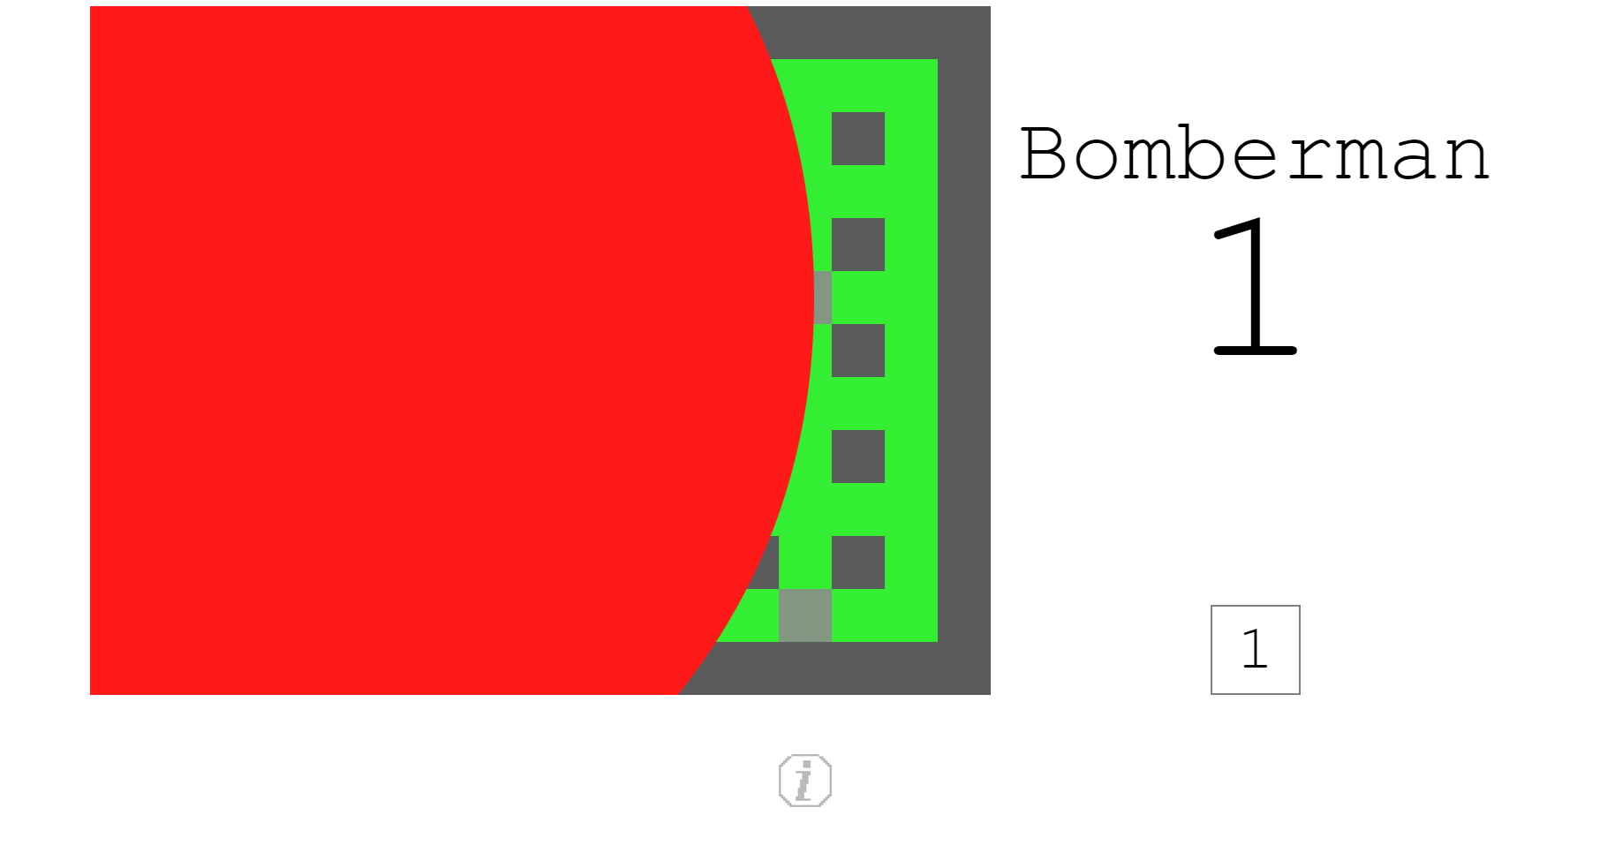

* Door locking & unlocking

If the player finds the door before all enemies are blown up, the door is shown with a locked lock on it to signify that it is locked. The player cannot go into the position of the door if it is locked, and enemies can never go into the position of the door. Once all enemies are blown up, the door unlocks, signified by the open lock.

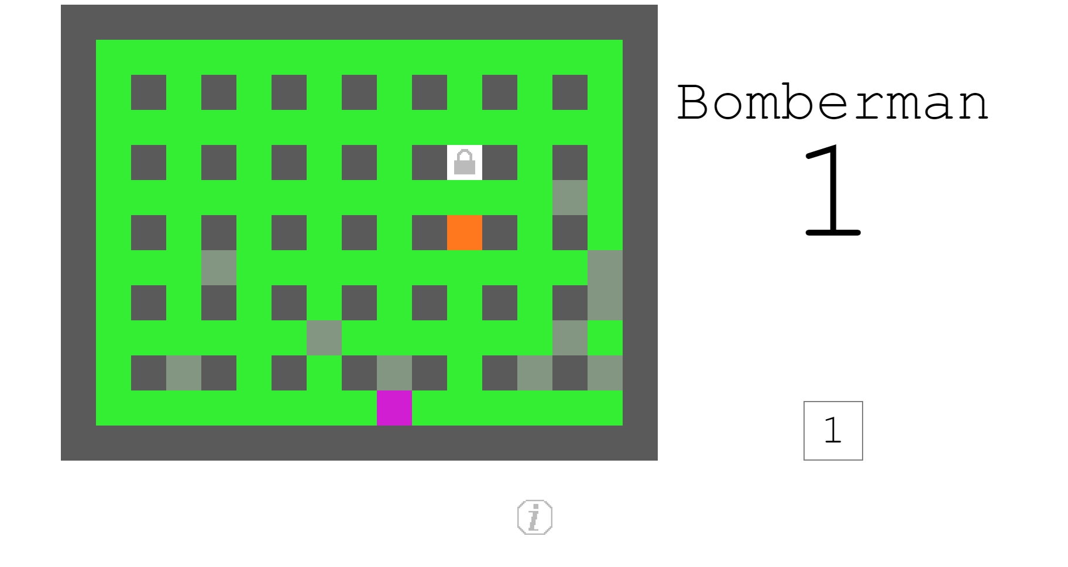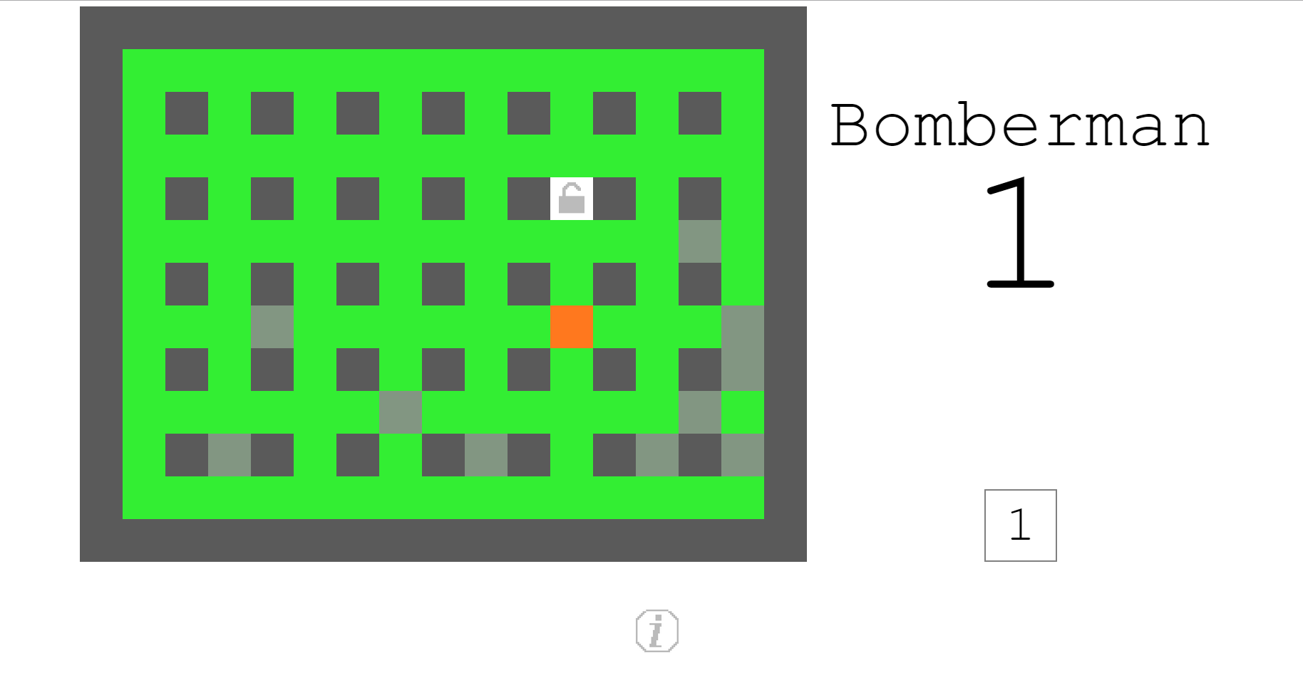

* Door entry animation

When the player goes through a door, a yellow circle animation begins at the position of the player (will be the same position as the door), expanding to completely cover the map before beginning a new level.

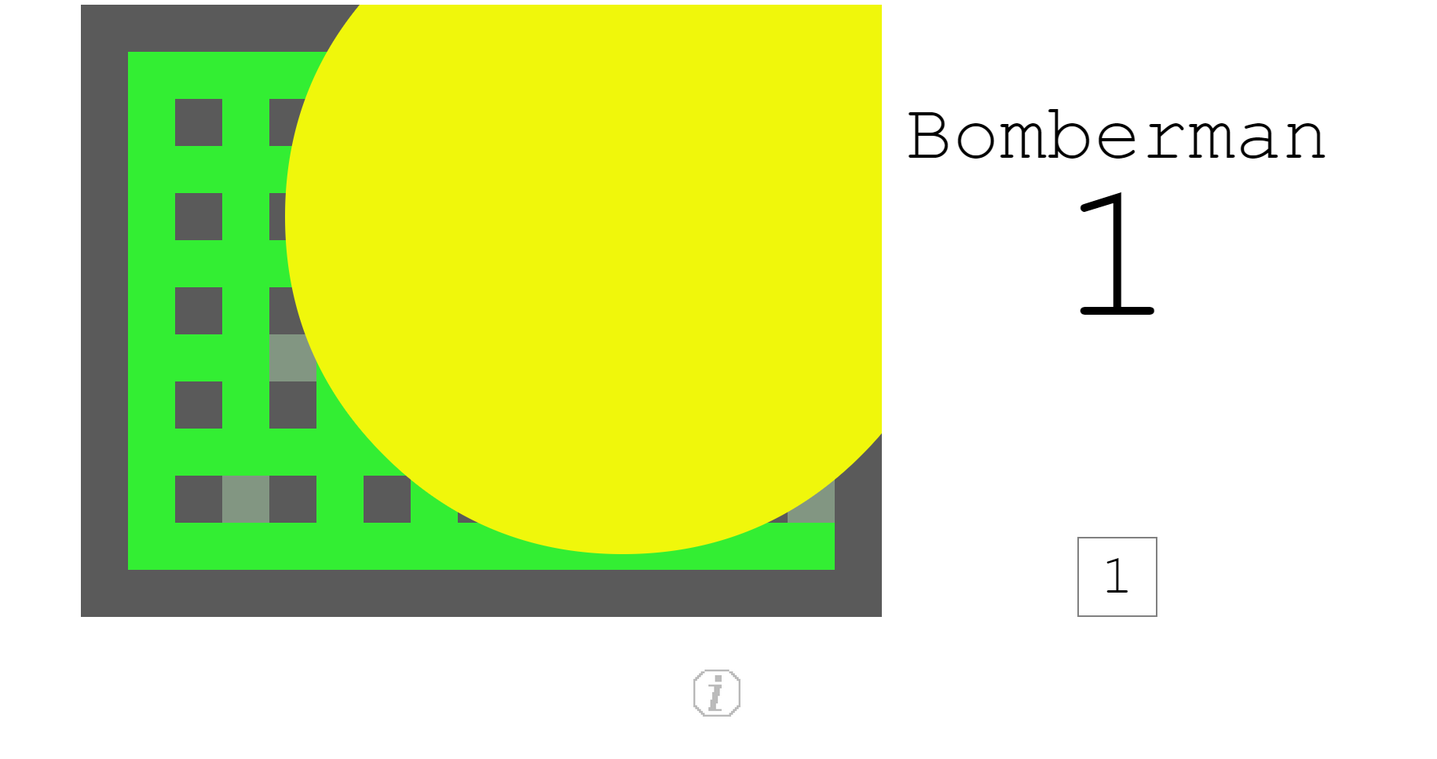

* Enemy on top of bomb

When an enemy is on top of a bomb, the enemy’s colour brightens slightly to signify this.

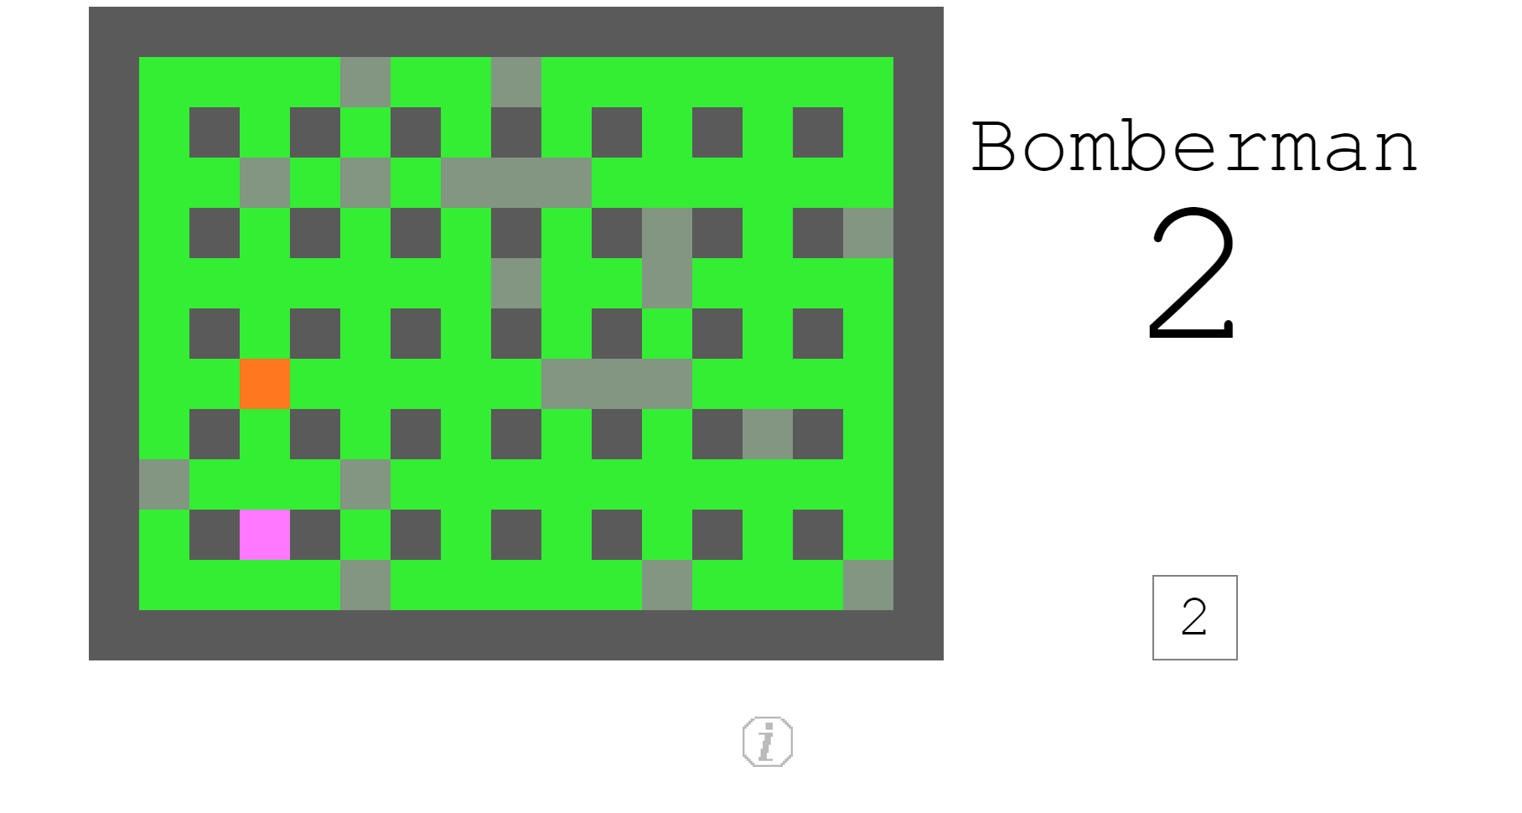

* Player on top of a bomb

When a player is on top of a bomb, the player’s colour brightens slightly to signify this.

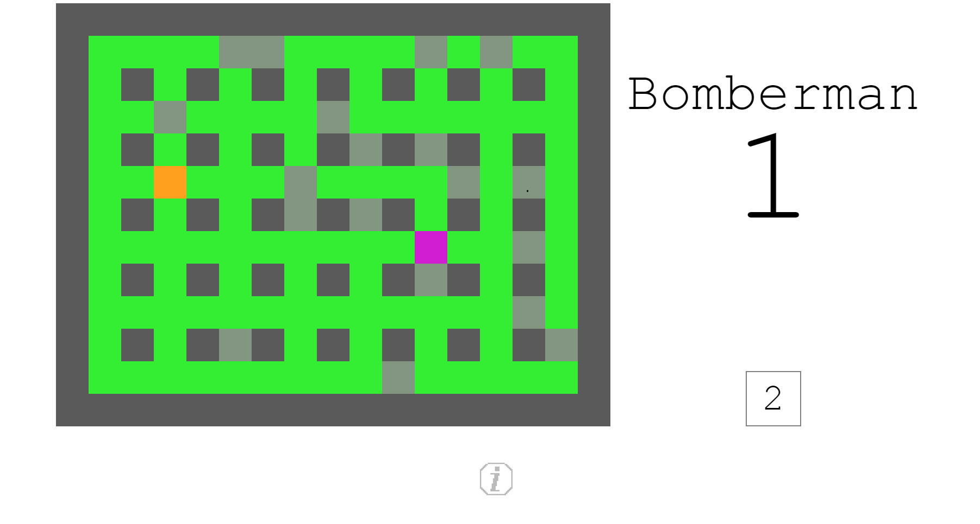

* High score save

The highest score is saved in the box at the bottom of the Title & Score section of the game. This will increment as this highest score is surpassed.

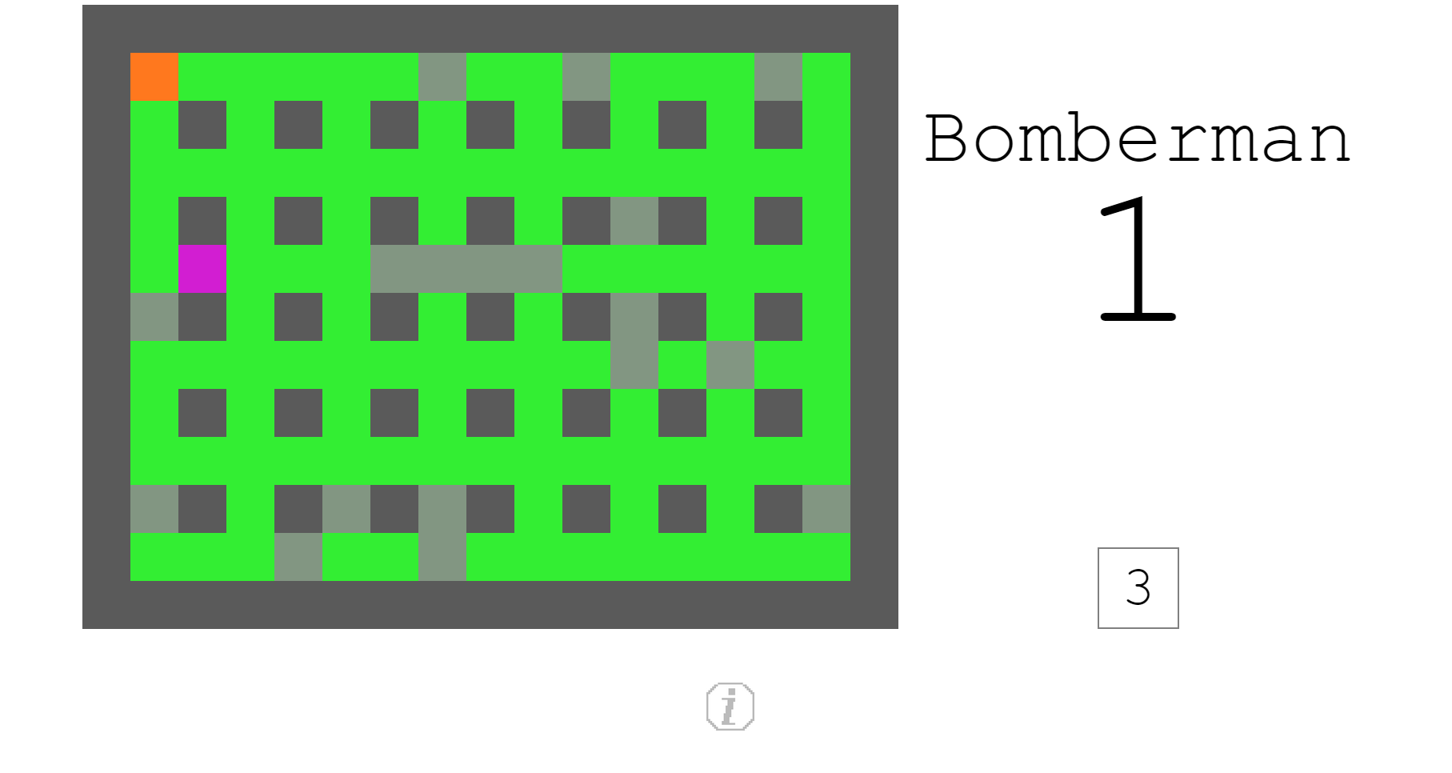

* Information button

The information button is located in the Information section of the game. Once clicked, it will expand an area with information about the game. I implemented it in this way to keep with the minimal theme of the game. This animation is created using jQuery, specifically using the Accordion API.

