Training the SequentialTransformer Model using the CIFAR-10 dataset

Intially dataset is downloaded and the loaded.

The model with trianing parameters of 1.78 million.

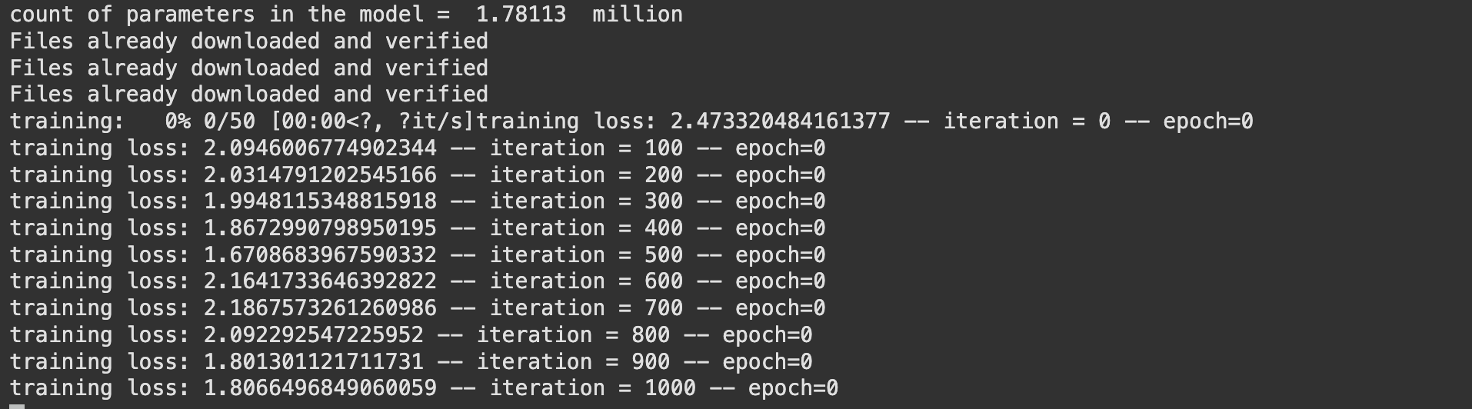

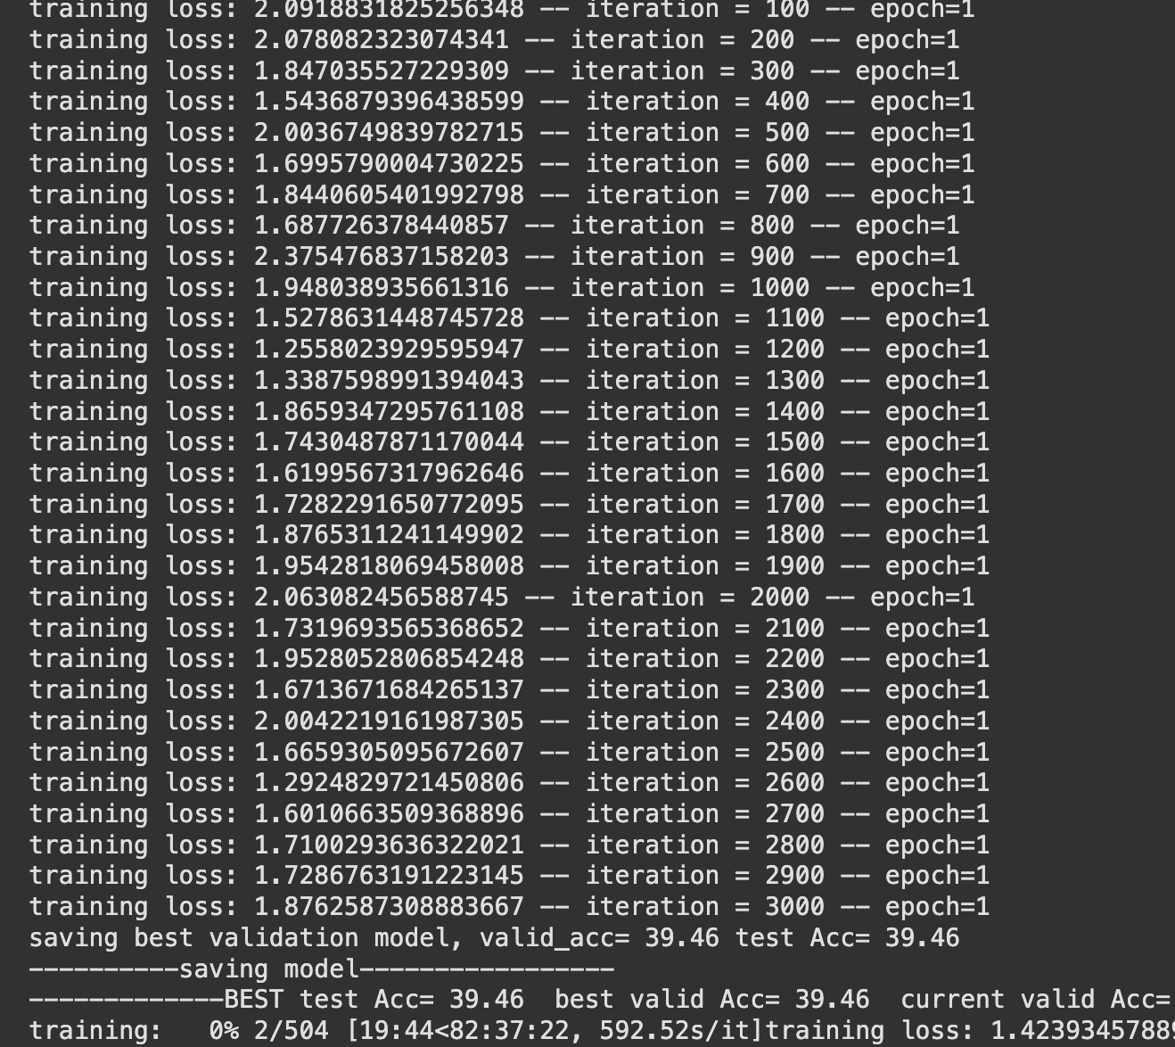

Currently the training accuracy of the model is around 39.5%, But further training the accuracy of the model would be achieved to 57%. Due to lack of the resources, I couldn't run the model for longer.

1. For modifying the sequence length from 1024 to 1025, this could be achieved by modifying the hyperparameters in the "SequentiualTransformerMain.py" file by doing the below.

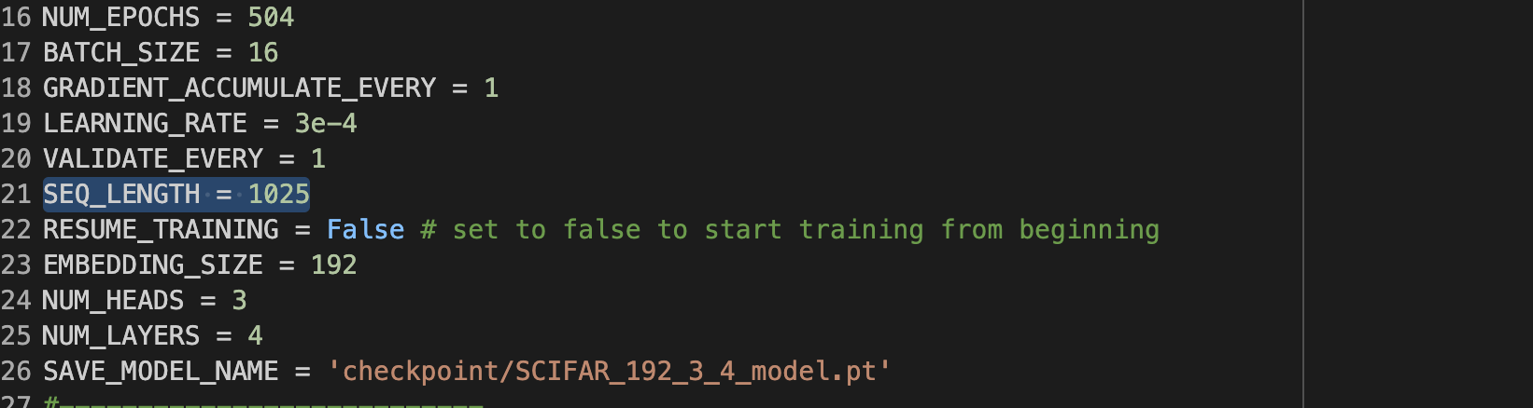

2. For performing transformations on the input data by converting the input image from grey scale to color we change the loader from "1" to "3"

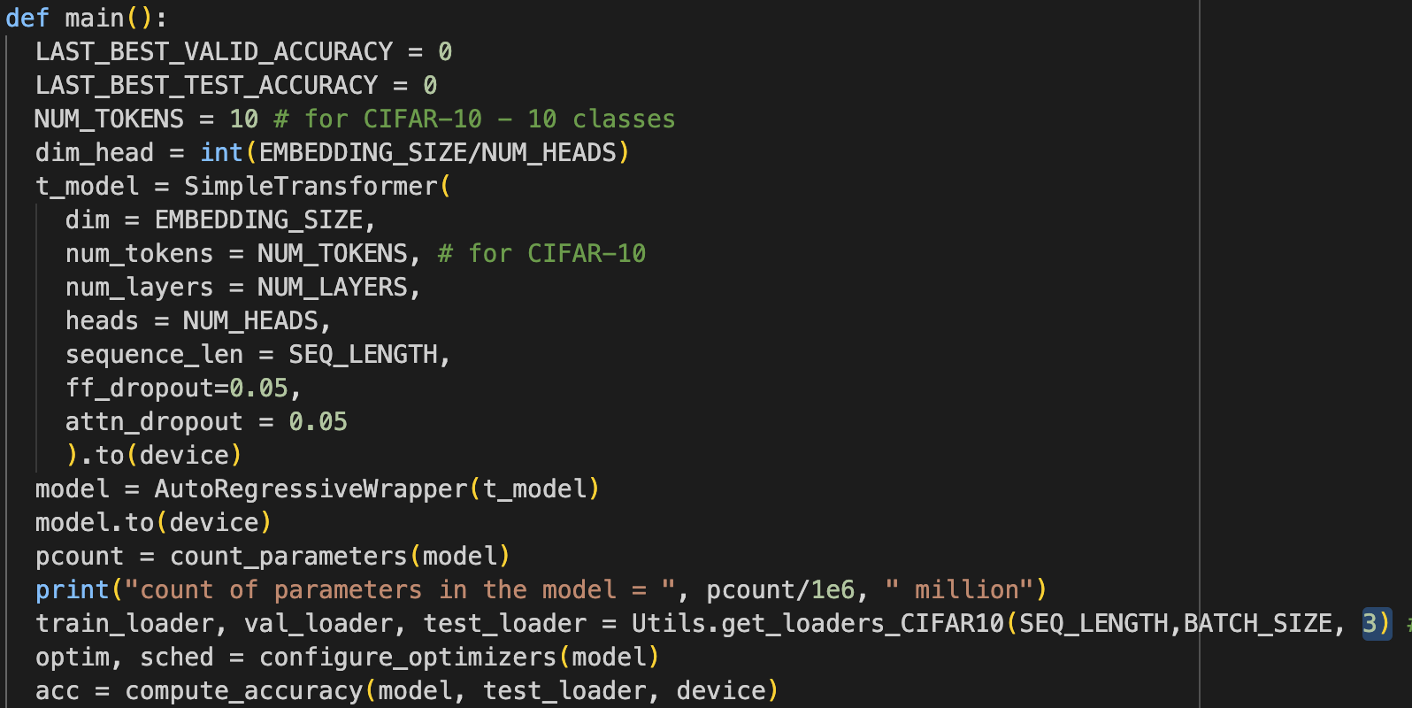

3. For performing on the MNIST data, we add add the scripts of MNIST to the Utils.py file.

MNIST processing function is added here.

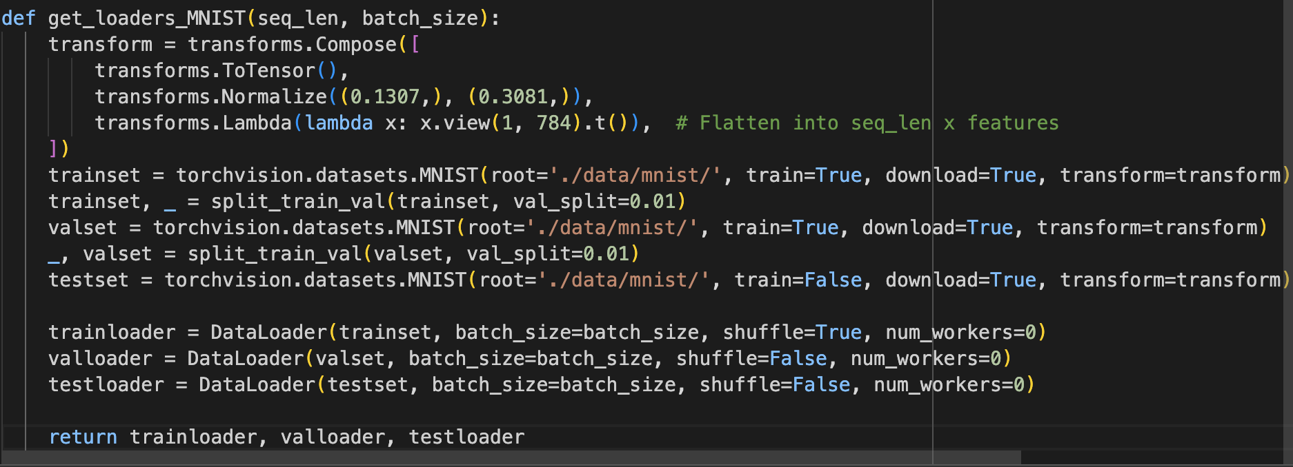

Due to lack of GPU compute resources, I couldn't report the complete acccuracy of the trained model. But the complete working code is integrated as per requested questions in the assignment.