Started downloading the CIFAR-10 dataset for training the twins model.

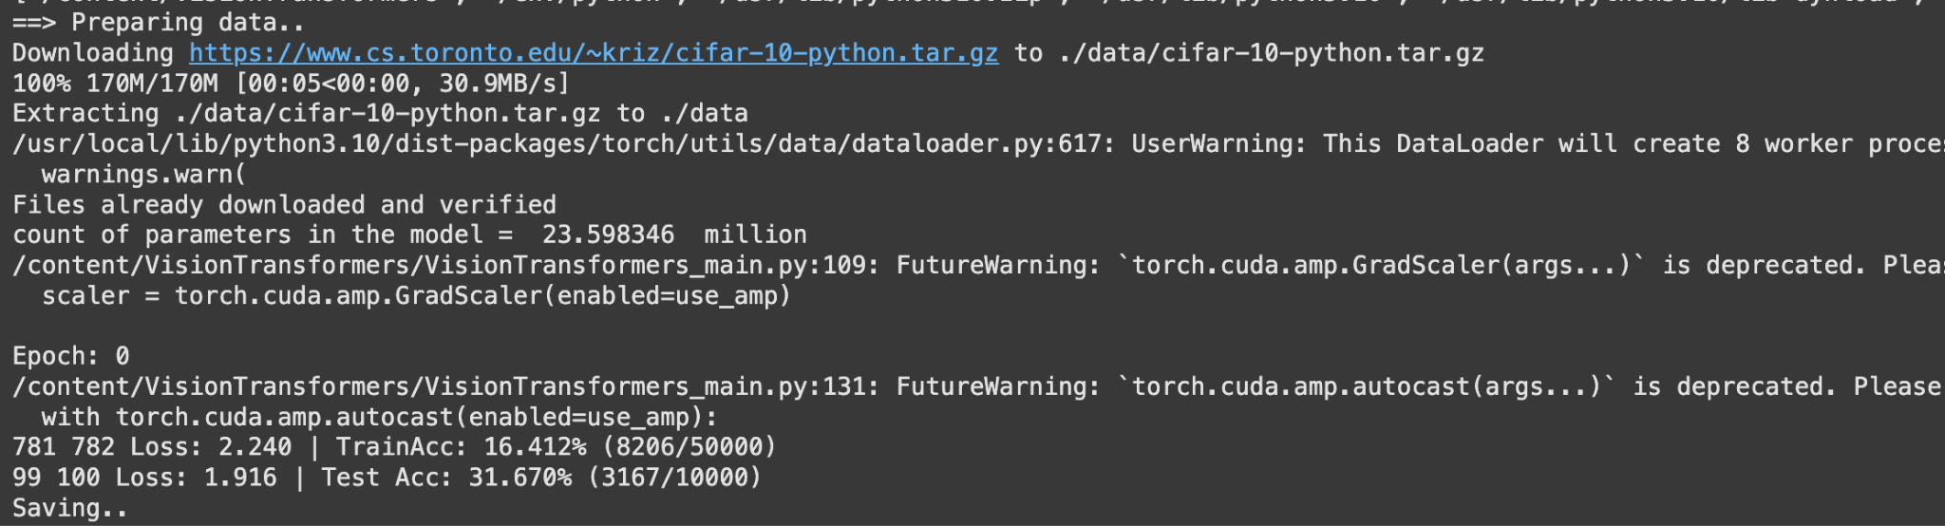

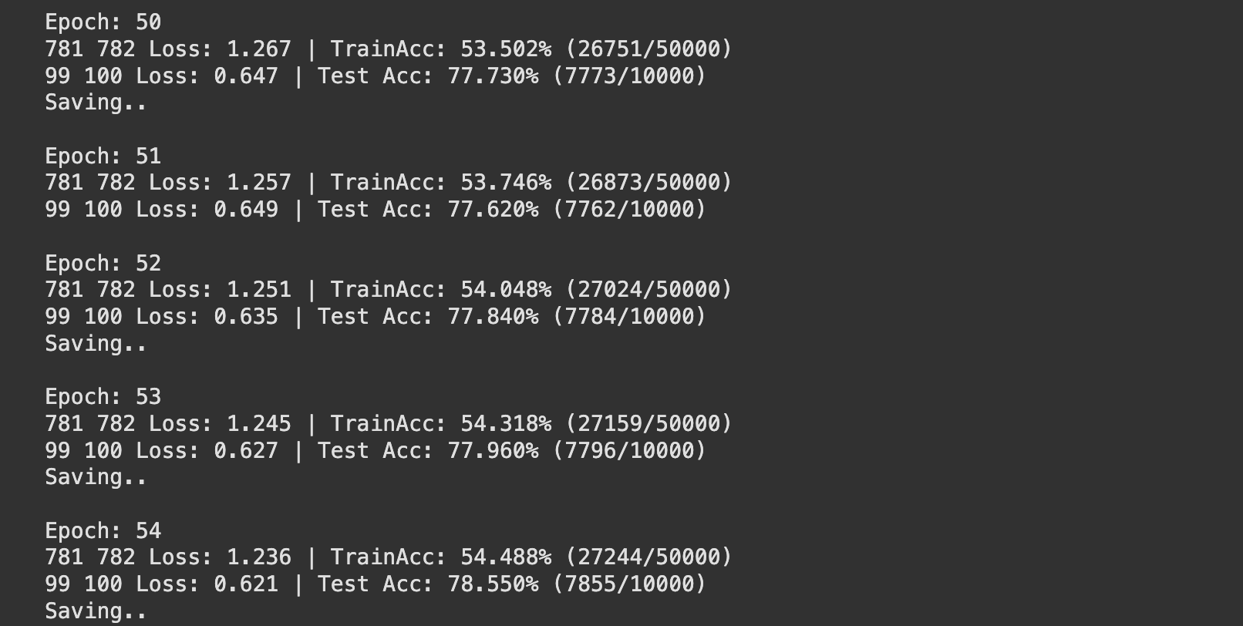

After training for around 54 epochs the training accury is around 55% and the testing accuracy is around 78%. Due to lack of compute resources, I couldn't run completly.