**Product Sales Analysis**

**Introduction:**

**Product sales analysis is a critical component of any business's strategy and decision-making process. It involves the systematic examination and evaluation of a company's sales data and performance to gain insights into how well a product or product line is performing in the market. This analysis helps businesses make informed decisions to enhance sales, optimize their product offerings, and increase profitability..**

**we embark on a journey to delve into the analysis of Product Sales. Gathering data on product sales is the starting point. This data includes information on the quantity of products sold, revenue generated, and other relevant metrics. Sales data is usually collected over specific periods, such as daily, monthly, quarterly, or annually.**

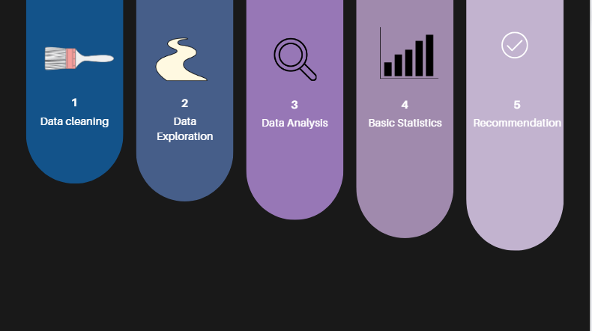

**Step 1: Data Collection:**

First we need a data set to analysis.As we get the data form kaggle,we don’t need to worry about the data collection.Otherwise we need to collect data from companies,peoples etc,.

**Step 2: Data Exploration**

Clean the data to ensure its quality. This step includes handling missing values, removing duplicates, addressing inconsistencies, and verifying the accuracy of data entries.

**Handling Missing Values:** Identify and address data points with missing values. You can choose to remove rows with missing data, fill in missing values with reasonable estimates, or use imputation techniques.

**Outlier Detection and Handling:** Identify and address outliers, which are data points that significantly deviate from the majority of the data. Depending on the context, outliers can be removed or treated to minimize their impact.

**Data Validation:** Check for data that doesn't conform to expected formats**.** This may include data types, ranges, or formats, and errors should be corrected.

**Deduplication:** Detect and remove duplicate records in the dataset, ensuring that each data point is unique.

**Normalization and Standardization**: If necessary, transform data to a common scale to facilitate comparisons. This is particularly relevant when working with features measured in different units.

**Handling Categorical Data**: Convert categorical data into a numerical format, such as one-hot encoding, to make it suitable for analysis.

**Step 3Trend Analysis:**

**Analyzing sales trends over time is crucial. This involves identifying seasonal fluctuations, growth trends, and any sudden spikes or declines in sales. It can help predict future sales patterns**

**Smooth Data:**

**Sometimes, sales data can be noisy, making it difficult to spot trends. Smoothing techniques like moving averages or exponential smoothing can help you identify underlying patterns by removing short-term fluctuations.**

**Calculate Growth Rates: For growth trends, calculate the growth rate over specific time intervals (e.g., monthly or yearly). This will help you quantify the rate of change in sales.**

**Statistical Analysis: You can use statistical techniques such as regression analysis to identify relationships between sales and other factors, like marketing spend, economic indicators, or product features. This can help explain and predict sales trends.**

**Seasonal Decomposition: If you notice seasonal patterns, decompose the data to separate the trend, seasonal, and residual components. This can provide a clearer view of the underlying trend and seasonal effects.**

**Comparative Analysis: Compare the sales trends of different products or product categories. This can help you allocate resources, adjust marketing strategies, and make product management decisions.**

**Qualitative Analysis: Combine quantitative analysis with qualitative insights. Understand external factors like market conditions, customer preferences, or competitive actions that may have influenced sales trends.**

**Step 4: Identify Your Competitors: Start by identifying your direct and indirect competitors. Direct competitors are businesses offering similar products or services to the same target audience. Indirect competitors may offer different products or services but still compete for your customers' budget.**

**Gather Information: Collect information about your competitors. Sources of data can include their websites, annual reports, press releases, social media, customer reviews, and industry reports. Key areas to focus on include:**

**Products/Services: What products or services do they offer? How do these compare to yours in terms of features, quality, and pricing?**

**Market Share: What is their market share, and how has it changed over time?**

**Pricing Strategies: How do they price their products or services? Are there discounts or bundling strategies in place?**

**Target Audience: Who are their primary customers, and how do they reach them?**

**Marketing Strategies: What marketing channels and tactics do they use? What is their messaging and branding?**

**Distribution Channels: How do they distribute their products or services? Do they have partnerships or exclusive agreements?**

**Strengths and Weaknesses: What are their competitive advantages and weaknesses in the market?**

**Customer Feedback: Analyze customer reviews and feedback to understand their strengths and weaknesses from a customer perspective.**

**SWOT Analysis: Conduct a SWOT (Strengths, Weaknesses, Opportunities, Threats) analysis for each competitor. This will help you summarize their competitive position and potential areas for strategy development.**

**Benchmarking: Compare your own business metrics (such as revenue, profit margins, and market share) to those of your competitors. Identify areas where you outperform them and areas where you need improvement.**

**Step 5: Market Trends:**

**Identify Relevant Data Sources: Start by identifying sources of information that provide insights into your industry or market. These sources may include industry reports, trade publications, market research firms, government data, and social media.**

**Industry Reports and Publications: Subscribe to or access industry-specific reports, magazines, and publications. These often provide in-depth analysis of current trends, emerging technologies, and market forecasts.**

**Market Research: Consider commissioning or purchasing market research reports that focus on your target market. These reports typically contain valuable data and insights about customer behavior, competitive landscape, and growth opportunities.**

**Customer Feedback: Regularly collect and analyze feedback from your customers. Their preferences, complaints, and suggestions can provide valuable insights into emerging trends and areas for improvement.**

**Step 6: Conclusion:**

**In conclusion, staying ahead in the business world requires a multifaceted approach that includes product sales analysis, competitor analysis, and monitoring market trends. These strategic practices are essential for understanding your market, optimizing your products and services, and adapting to ever-changing consumer preferences**