C# 程式作業 #1 B05203008 化學三 廖哲宏

1. **動機**

在思考作業主題時，我認為要做一個程式應用，就要做一個真的切合實際用處的程式，因此單獨寫一個程式而不與網路資料結合的話，應用性就少了一些。最近我在google play上下載了一個APP，是可以自動對獎電子發票，並結合戶頭直接將獎金轉進戶頭，我認為這個應用程式非常實用，所以我借用了這個概念，做了一個簡易的兌獎存儲程式。雖然流程、作法及功能不盡然相同，但大致上概念是相近的。

1. **構想解說**

程式一共分成兩個部分：兌獎及存提款。存提款的部分非常簡單，即用一個variable存目前存款，並讓使用者輸入存提款內容，再從存款中扣除。兌獎方面較為複雜，首先讓使用者輸入一或多個發票號碼，再從財政部公布的中獎發票號碼網頁上擷取內容，並提取發票號碼進行兌獎。對完獎後告知使用者中獎資訊，並直接將獎金存入使用者存款，並輸出存款明細。

1. **程式測試規畫**
2. 輸入非對獎或存提款之字串
3. 對獎時輸入非8位數字或是非數字
4. 存提款時輸入非數字
5. 提出超過存款之金額
6. **流程圖**

Long money = 0

**Main()**

Input：(Prizing/Banking/q)

return

Console.WriteLIne(“byebye”)

Console.WriteLIne(“請輸入(Prizing/Banking/q!!!)”)

Prizing(money)

Banking(money)

q

其他

Banking

Prizing

**Banking(money)**

**long** deposit = 0

**bool** entered = true

Console.WriteLine(“請輸入金額 (欲提款請輸入負值)”)

**try :** deposite = Convert.ToInt32(input)

entered = true

**catch :** Concole.WriteLine(“請輸入數字”)

entered = false

**T**

**F**

**! entered**

money = ChangeMoney(money, deposit)

**ChangeMoney(money, deposit)**

money-deposit < 0

輸出錯誤訊息，return

money += deposit

輸出存款明細

**T**

**F**

**Prizing(money)**

**List<string>** prizes

**List<string>** candidate

**bool** prized = false

**string** foo = ””

**long** deposit

Console.WriteLine(“請輸入發票號碼，輸入完畢請輸入q”)

foo = Console.ReadLine()

foo.length == 8

Console.WriteLine(“請輸入8位數字！”)

True

False

False

foo == “q”

candidate.Add(foo)

True

prizes.GetString()

foo = Compare(candidate, prizes)

根據foo內容判斷中哪些獎，若沒中則輸出”銘謝惠顧”。

根據foo內容判斷中哪些獎，若沒中則輸出”銘謝惠顧”。

money = ChangeMoney(money, deposit)

**GetString()**

**List<string>** prizes

**string** html = URLrequest()

**string** reg1~4 = (正則表示法之開獎號碼在html之位置)

利用正則表示法將各獎獎項號碼從html中提取並存入prizes回傳

**string** html

**string** url = http://invoice.etax.nat.gov.tw/ “”

**URLrequest()**

自財政部稅務入口網擷取HTML格式內文，回傳html字串

**Compare(prizes, candidate)**

**string** output = “”

**i<candidate.length**

**Int i =0**

**i++**

string cand = candidate[i]

j<prizes.length

int j =0

j++

有中獎？

output += j

傳回output

**T**

**F**

1. **結構圖**

**Main()**

**Prizing()**

**Banking()**

**GetString()**

**Compare()**

**ChangeMoney()**

**URLrequest()**

1. **程式列表**
2. **Main()**
3. **void Prizing(ref long money)**
4. **void Banking(ref long money)**
5. **long GetString()**
6. **long ChangeMoney(long money, long deposit)**
7. **List<string> Compare(List<string> prizes, List<string> candidate)**
8. **程式測試執行結果,**

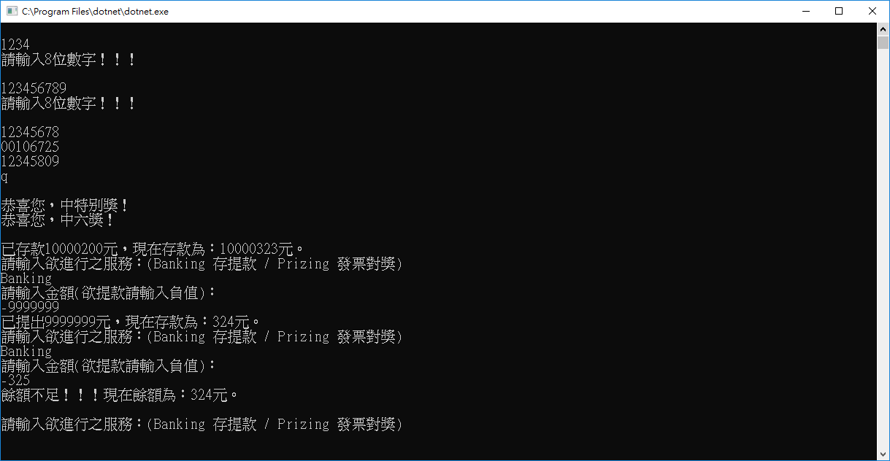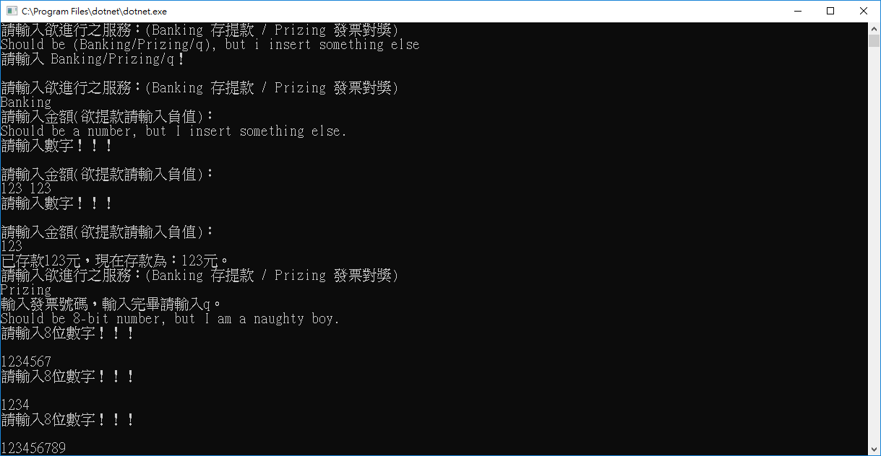

**d**

1. **參考文獻**
2. Regular expression : <https://dotblogs.com.tw/johnny/archive/2010/01/25/13301.aspx>
3. 參考code : URLrequest() 擷取網頁內容：<http://zetcode.com/articles/csharpreadwebpage/>
4. **程式碼**

*(註；程式碼在word檔格式極其醜陋，建議可以複製到IDE上再閱讀XD)*

using System;

using System.Net;

using System.IO;

using System.Text.RegularExpressions;

using System.Collections.Generic;

namespace hw_01

{

class Program

{

// 取得發票對獎號碼

static List<string> GetString(){

List<string> prizes = new List<string>();

string html = URLrequest();

Match block = Regex.Match(html, @"display: special(.*?)領獎期間自");

//特別獎[0]

string reg =">特別獎<(.*?)</span>";

Match special = Regex.Match(block.Value, @reg);

prizes.Add(special.Value.Substring(66, 8));

//特獎[1]

string reg2=">特獎<(.*?)</span>";

Match best = Regex.Match(block.Value, @reg2);

prizes.Add(best.Value.Substring(65, 8));

//頭獎[2:4]

string reg3="newFirstPrize(.*?)</span>";

Match first = Regex.Match(block.Value, @reg3);

prizes.Add(first.Value.Substring(30, 8));

prizes.Add(first.Value.Substring(39, 8));

prizes.Add(first.Value.Substring(48, 8));

//二獎~六獎

for (int i=0; i<5; i++){

prizes.Add(first.Value.Substring(31+i, 7-i));

prizes.Add(first.Value.Substring(40+i, 7-i));

prizes.Add(first.Value.Substring(48+i, 7-i));

}

//加開六獎[20, 21]

string reg4="newAddSixPrize(.*?)</span>";

Match six = Regex.Match(block.Value, @reg4);

prizes.Add(six.Value.Substring(31, 3));

prizes.Add(six.Value.Substring(35, 3));

/*----- debugging -----*/

//foreach(string i in prizes) Console.WriteLine("prizes:"+i);

return prizes;

}

// 取得財政部兌獎網站資料內容

static string Compare(List<string> prizes, List<string> candidate){

string output = "";

for (int i=0; i<candidate.Count; i++){

string cand=candidate[i];

for (int j = 0; j<prizes.Count; j++){

if (Regex.IsMatch(cand, Regex.Escape(prizes[j])+@"\z")){

output += (j+" ");

break;

}

}

}

return output;

}

// 程式碼來源：http://zetcode.com/articles/csharpreadwebpage/

// 取得網站內文全文

static string URLrequest(){

string html = "";

string url = "http://invoice.etax.nat.gov.tw/";

HttpWebRequest request = (HttpWebRequest) WebRequest.Create(url);

using (HttpWebResponse response = (HttpWebResponse) request.GetResponse())

using (Stream stream = response.GetResponseStream())

using (StreamReader reader = new StreamReader(stream))

{

html = reader.ReadToEnd();

}

return html;

}

// 處理發票兌獎主程式

static void Prizing(ref long money){

List<string> candidate = new List<string>();

List<string> prizes = new List<string>();

string foo = "";

bool prized = false;

long deposit = 0;

Console.WriteLine("輸入發票號碼，輸入完畢請輸入q。");

// 取得使用者發票資訊

while(foo!="q"){

foo= Console.ReadLine();

if (foo.Length == 8){candidate.Add(foo);}

else if (foo!="q") {Console.WriteLine("請輸入8位數字！！！\n");}

}while(foo!="q");

Console.WriteLine("");

// 取得財政部發票兌獎資訊

prizes = GetString();

/*----- 開始兌獎 -----*/

foo = Compare(prizes, candidate);

foreach (string i in foo.Split(" ")) {

switch (i){

case "0": {Console.WriteLine("恭喜您，中特別獎！");deposit+=10000000; prized = true; break;}

case "1": {Console.WriteLine("恭喜您，中特別獎！");deposit+=2000000; prized = true; break;}

case "2": case "3":

case "4": {Console.WriteLine("恭喜您，中頭獎！");deposit+=200000; prized = true; break;}

case "5": case "6":

case "7": {Console.WriteLine("恭喜您，中二獎！");deposit+=40000; prized = true; break;}

case "8": case "9":

case "10": {Console.WriteLine("恭喜您，中三獎！");deposit+=10000; prized = true; break;}

case "11":case "12":

case "13": {Console.WriteLine("恭喜您，中四獎！");deposit+=4000; prized = true; break;}

case "14":case "15":

case "16": {Console.WriteLine("恭喜您，中五獎！");deposit+=1000; prized = true; break;}

case "17":case "18": case "19": case "20":

case "21": {Console.WriteLine("恭喜您，中六獎！");deposit+=200; prized = true; break;}

}

}

// 將獎金存入money

if (!prized){ Console.WriteLine("可惜沒中~~再接再厲!!");}

Console.WriteLine();

money = ChangeMoney(money, deposit);

//return money;

}

// 存提款程式

static long ChangeMoney(long money, long deposit){

// 存提款

if (money+deposit < 0){

Console.WriteLine("餘額不足！！！現在餘額為："+Convert.ToString(money)+"元。\n");

return money;

}

else money += deposit;

// 輸出存提款明細

if (deposit>0) Console.WriteLine("已存款"+Convert.ToString(deposit)+"元，現在存款為："+Convert.ToString(money)+"元。");

else if (deposit<0) Console.WriteLine("已提出"+Convert.ToString(-deposit)+"元，現在存款為："+Convert.ToString(money)+"元。");

else Console.WriteLine("存款為："+Convert.ToString(money)+"元。\n");

return money;

}

// 存提款主程式

static void Banking(ref long money){

bool entered = true;

long deposit=0;

// 取得存提款款項

do{

Console.WriteLine("請輸入金額(欲提款請輸入負值)：");

try{ // try this code

deposit = Convert.ToInt64(Console.ReadLine());

entered = true;

}

catch{ // if failed, then exectue this code

Console.WriteLine("請輸入數字！！！\n");

entered=false;

}

}while (!entered);

//存提款

money = ChangeMoney(money, deposit);

//return money;

}

// 主控制程式

static void Main(string[] args)

{

long money = 0;

while (true){

Console.WriteLine("請輸入欲進行之服務：(Banking 存提款 / Prizing 發票對獎)");

string service = Console.ReadLine();

switch (service){

case "Banking": Banking(ref money);break;

case "Prizing": Prizing(ref money);break;

case "q": Console.WriteLine("ByeBye!"); return;

default : Console.WriteLine("請輸入 Banking/Prizing/q！\n");break;

}

}

}

}

}