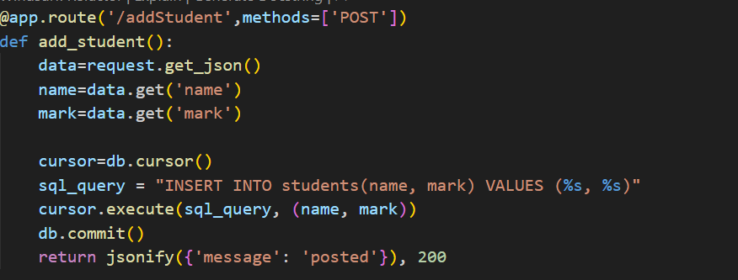

In Postman we give input payload as follows:

{

“name”:”Ram”,

“mark”:100

}

In python code request.get_json() method gets the data from postman stores it in data.

From that we store that data into the database.

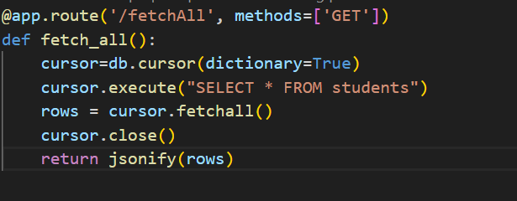

In this scenario the input payload in Postman will be empty.

We extract rows from db and return them as dictionary to postman.

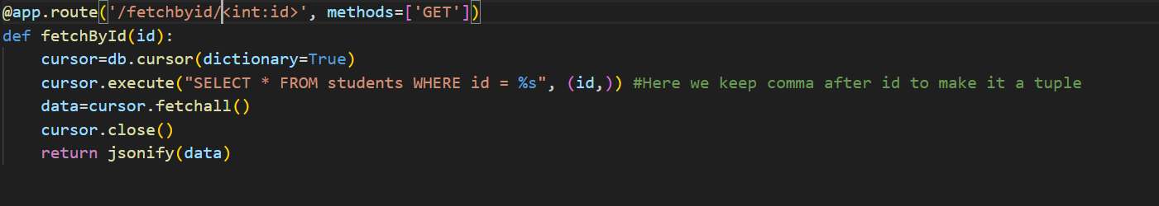

Here we are fetching by a specific id.