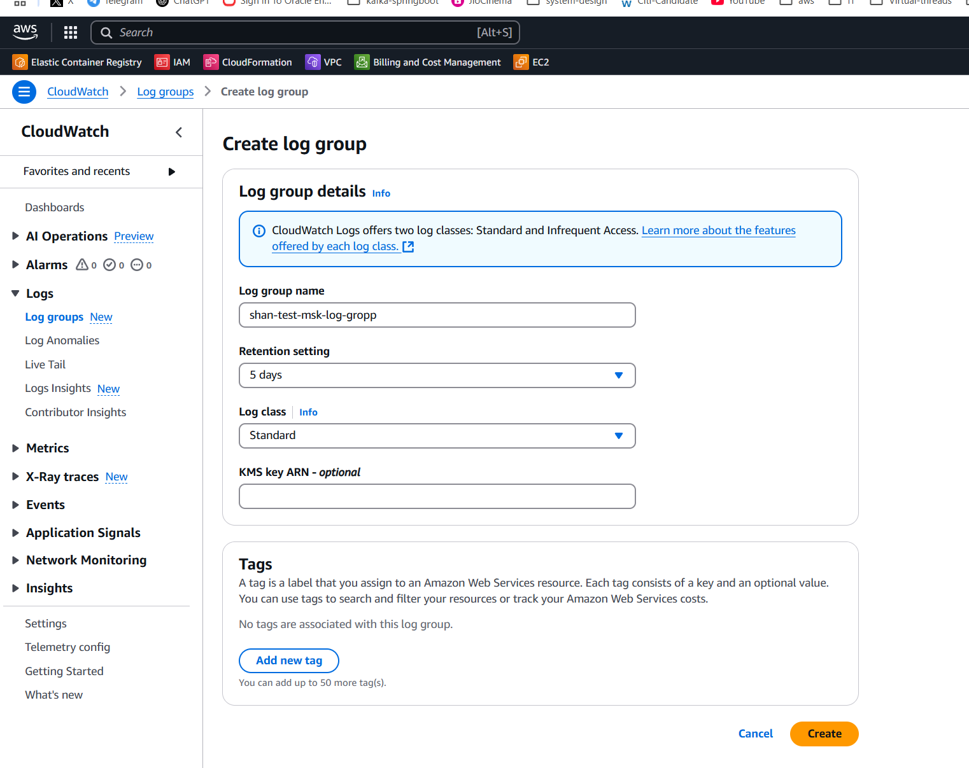

the below picture is aws Create log group. there "KMS key ARN - optional" is given, what values we need to give for "KMS key ARN - optional"

**ChatGPT said:**

The **"KMS key ARN - optional"** field in AWS CloudWatch log group creation is used to specify an AWS Key Management Service (KMS) key for encrypting log data. If you want to use KMS encryption, you need to provide the **Amazon Resource Name (ARN)** of a KMS key.

**How to find the KMS key ARN:**

1. **Go to the AWS KMS Console**:
   * Open the AWS Management Console.
   * Navigate to **AWS Key Management Service (KMS)**.
2. **Find or Create a KMS Key**:
   * If you already have a KMS key for CloudWatch logs, find it in **Customer Managed Keys**.
   * If not, create a new key:
     + Select **Create Key** → Choose **Symmetric** encryption.
     + Define **Key Administrators** and **Key Users** (IAM roles/users).
     + Complete the setup.
3. **Copy the KMS Key ARN**:
   * Select the key from the list.
   * Copy the **Key ARN** (e.g.,

ruby

CopyEdit

arn:aws:kms:us-east-1:123456789012:key/abcd1234-a123-456b-789c-12345678abcd

1. **Paste it into the "KMS key ARN - optional" field**:
   * Enter the copied ARN into the **"KMS key ARN - optional"** field in CloudWatch log group creation.

If you don’t need encryption, you can leave this field empty.

4o

**You said:**

how to create " KMS key for CloudWatch logs"

**ChatGPT said:**

To create a **KMS key for CloudWatch Logs**, follow these steps:

**Step 1: Open AWS KMS Console**

1. Sign in to the **AWS Management Console**.
2. Navigate to **Key Management Service (KMS)**:
   * Open the AWS **KMS Console**: [AWS KMS Console](https://console.aws.amazon.com/kms).

**Step 2: Create a New KMS Key**

1. Click on **"Create a key"**.
2. **Key Type**:
   * Choose **Symmetric** (recommended for CloudWatch Logs).
   * Click **Next**.
3. **Key Usage**:
   * Select **Encrypt and Decrypt**.
   * Click **Next**.
4. **Key Alias**:
   * Provide a name (e.g., cloudwatch-logs-key).
   * Click **Next**.

**Step 3: Define Key Administrators & Users**

1. **Key Administrators** (optional but recommended):
   * Select IAM users/roles who can manage the KMS key.
   * Click **Next**.
2. **Key Users** (required for CloudWatch Logs):
   * Select IAM users/roles that will **use** the key to encrypt CloudWatch Logs.
   * Ensure that CloudWatch Logs service role (logs.amazonaws.com) has permission to use the key.

**Step 4: Review and Create the Key**

1. Review the key configuration.
2. Click **Finish** to create the key.

**Step 5: Get the KMS Key ARN**

1. In the KMS Console, find your newly created key.
2. Copy the **KMS Key ARN** (e.g.,

ruby

CopyEdit

arn:aws:kms:us-east-1:123456789012:key/abcd1234-a123-456b-789c-12345678abcd

1. Use this ARN when creating the **CloudWatch log group**.

**Step 6: Attach IAM Permissions (If Needed)**

If your CloudWatch service role doesn’t have access to the KMS key, attach the following policy to its IAM role:

json

CopyEdit

{

"Version": "2012-10-17",

"Statement": [

{

"Effect": "Allow",

"Action": [

"kms:Decrypt",

"kms:GenerateDataKey"

],

"Resource": "arn:aws:kms:us-east-1:123456789012:key/abcd1234-a123-456b-789c-12345678abcd"

}

]

}

Replace the **ARN** with your actual **KMS Key ARN**.

**Step 7: Use the Key in CloudWatch**

* When creating a CloudWatch **log group**, paste the KMS Key ARN into the **"KMS Key ARN - optional"** field.

That's it! Your CloudWatch logs will now be encrypted using your KMS key. 🚀

4o

**You said:**

hwo to "Ensure that CloudWatch Logs service role (logs.amazonaws.com) has permission to use the key."

**ChatGPT said:**

To ensure that **CloudWatch Logs service (logs.amazonaws.com)** has permission to use the KMS key, you need to update the **KMS key policy** to allow CloudWatch Logs to encrypt and decrypt logs.

**Step 1: Open the AWS KMS Console**

1. Sign in to the **AWS Management Console**.
2. Navigate to **AWS Key Management Service (KMS)**:
   * Open the **AWS KMS Console**: [AWS KMS Console](https://console.aws.amazon.com/kms).
3. Find the **KMS key** you created for CloudWatch Logs.
4. Click on the key to open its details.
5. Go to the **Key Policy** tab.

**Step 2: Edit the KMS Key Policy**

1. Click **Edit** on the key policy.
2. Add the following policy to allow **CloudWatch Logs** to use the key:

**KMS Key Policy for CloudWatch Logs**

json

CopyEdit

{

"Version": "2012-10-17",

"Id": "cloudwatch-logs-kms-policy",

"Statement": [

{

"Effect": "Allow",

"Principal": {

"Service": "logs.amazonaws.com"

},

"Action": [

"kms:Encrypt",

"kms:Decrypt",

"kms:GenerateDataKey",

"kms:DescribeKey"

],

"Resource": "*"

}

]

}

**Step 3: Save and Apply the Policy**

1. Click **Save Changes**.
2. Ensure that the updated policy is applied.

**Step 4: Verify CloudWatch Logs Access**

* Try creating a **CloudWatch Log Group**.
* Use the **KMS Key ARN** when creating the log group.
* Check CloudWatch Logs to confirm that logs are encrypted using the KMS key.

✅ **Now CloudWatch Logs can encrypt and decrypt logs using your KMS key!** 🚀

4o

**You said:**

is this arn is different from the KMS be created for MSK provisioned under "Encryption" - "Use customer managed key" when a KMS key created

**ChatGPT said:**

Yes, the **ARN of the KMS key for CloudWatch Logs** is different from the **ARN of the KMS key created for Amazon MSK (Managed Streaming for Apache Kafka)** under **"Encryption" → "Use customer managed key"**.

**Differences Between the Two KMS Keys**

| **Feature** | **KMS Key for CloudWatch Logs** | **KMS Key for Amazon MSK** |
| --- | --- | --- |
| **Purpose** | Encrypting CloudWatch Logs data | Encrypting Amazon MSK data (at-rest and in-transit) |
| **Who Uses the Key?** | CloudWatch Logs service (logs.amazonaws.com) | MSK service (kafka.amazonaws.com) |
| **KMS Key ARN Example** | arn:aws:kms:us-east-1:123456789012:key/abcd1234-logs-key | arn:aws:kms:us-east-1:123456789012:key/abcd1234-msk-key |
| **KMS Key Policy** | Allows logs.amazonaws.com to encrypt/decrypt logs | Allows kafka.amazonaws.com to encrypt/decrypt MSK data |
| **Created Under** | AWS KMS, used in CloudWatch Log Group settings | AWS KMS, used in MSK Encryption settings |

**Key Takeaways**

1. **Different Purpose** → The KMS key for CloudWatch Logs encrypts log data, while the KMS key for MSK encrypts Kafka topics and traffic.
2. **Different Service Principals** →
   * CloudWatch Logs requires logs.amazonaws.com to have access.
   * MSK requires kafka.amazonaws.com to have access.
3. **Different ARNs** → Even if both keys are created under **AWS KMS**, they will have different ARNs.

**Do You Need Two Separate KMS Keys?**

* **Yes**, because CloudWatch Logs and MSK serve different purposes, and AWS best practices recommend using separate keys for different services.
* However, if you want **a single KMS key** for both, you must **update the key policy** to grant access to both **CloudWatch Logs** and **MSK**.

Would you like help updating a single KMS key policy to support both services? 🚀

4o

**You said:**

any cdk code on typescript to cretae " KMS Key for CloudWatch Logs"

**ChatGPT said:**

Yes! Below is an AWS **CDK (TypeScript)** script to create a **KMS key** for **CloudWatch Logs** with the necessary permissions for logs.amazonaws.com.

**CDK Code (TypeScript)**

typescript

CopyEdit

import * as cdk from 'aws-cdk-lib';

import * as kms from 'aws-cdk-lib/aws-kms';

import * as iam from 'aws-cdk-lib/aws-iam';

import * as logs from 'aws-cdk-lib/aws-logs';

import { Construct } from 'constructs';

export class CloudWatchLogsKmsStack extends cdk.Stack {

constructor(scope: Construct, id: string, props?: cdk.StackProps) {

super(scope, id, props);

// Create a KMS Key for CloudWatch Logs

const cloudWatchKmsKey = new kms.Key(this, 'CloudWatchLogsKmsKey', {

enableKeyRotation: true,

alias: 'cloudwatch-logs-key',

description: 'KMS key for encrypting CloudWatch Logs',

});

// Add a Key Policy to allow CloudWatch Logs to use this key

cloudWatchKmsKey.addToResourcePolicy(

new iam.PolicyStatement({

effect: iam.Effect.ALLOW,

principals: [new iam.ServicePrincipal('logs.amazonaws.com')],

actions: [

'kms:Encrypt',

'kms:Decrypt',

'kms:GenerateDataKey',

'kms:DescribeKey',

],

resources: ['*'],

})

);

// Create a CloudWatch Log Group and use the KMS Key for encryption

new logs.LogGroup(this, 'EncryptedLogGroup', {

logGroupName: 'my-cloudwatch-log-group',

encryptionKey: cloudWatchKmsKey,

retention: logs.RetentionDays.ONE_WEEK, // Adjust as needed

});

// Output the KMS Key ARN

new cdk.CfnOutput(this, 'CloudWatchKmsKeyArn', {

value: cloudWatchKmsKey.keyArn,

description: 'ARN of the KMS Key used for CloudWatch Logs encryption',

});

}

}

**How This Works**

✅ **Creates a KMS Key** (cloudwatch-logs-key)  
✅ **Adds IAM permissions** for logs.amazonaws.com to use the key  
✅ **Creates a CloudWatch Log Group** encrypted with the KMS key  
✅ **Outputs the KMS Key ARN**

**Deployment Steps**

1. **Initialize a new CDK project** (if not already set up):

sh

CopyEdit

mkdir my-cdk-project && cd my-cdk-project

cdk init app --language=typescript

1. **Install required CDK dependencies**:

sh

CopyEdit

npm install @aws-cdk/aws-kms @aws-cdk/aws-logs @aws-cdk/aws-iam

1. **Replace lib/my-cdk-project-stack.ts with the above CDK code.**
2. **Deploy the stack**:

sh

CopyEdit

cdk synth # Synthesize the CloudFormation template

cdk deploy # Deploy to AWS

**Next Steps**

* You can **use the KMS Key ARN** when creating a CloudWatch log group manually.
* Modify the **retention policy** if needed.
* Add **additional IAM roles** if required.

Let me know if you need any modifications! 🚀

4o

**You said:**

i could nto see "logs.amazonaws.com" in key users when creating a kms key

**ChatGPT said:**

You're right! **logs.amazonaws.com (CloudWatch Logs service)** does not appear as a selectable user in the **KMS Key Users** section when creating a KMS key in the AWS console.

Instead, you need to **manually update the KMS Key Policy** to allow CloudWatch Logs to use the key.

**How to Allow CloudWatch Logs to Use the KMS Key**

**Step 1: Open the KMS Key Policy Editor**

1. Go to the **AWS KMS Console**:  
   👉 [AWS KMS Console](https://console.aws.amazon.com/kms).
2. Find and **select** the KMS key you created for CloudWatch Logs.
3. Click on the **"Key Policy"** tab.
4. Click **Edit**.

**Step 2: Add CloudWatch Logs Permissions**

Add the following **policy statement** inside the "Statement" array of your key policy:

json

CopyEdit

{

"Effect": "Allow",

"Principal": {

"Service": "logs.amazonaws.com"

},

"Action": [

"kms:Encrypt",

"kms:Decrypt",

"kms:GenerateDataKey",

"kms:DescribeKey"

],

"Resource": "*"

}

**Step 3: Save the Policy**

1. Click **Save Changes**.
2. This grants **CloudWatch Logs (logs.amazonaws.com)** permission to use the KMS key for encryption and decryption.

**Why Can't You Select logs.amazonaws.com in KMS Users?**

* The **Key Users** section in AWS KMS only allows **IAM users, roles, and AWS accounts**.
* CloudWatch Logs is an **AWS service**, not an IAM entity, so it needs **explicit permissions** in the **KMS Key Policy** instead.

**Step 4: Use the KMS Key in CloudWatch Logs**

Now, when you create a **CloudWatch Log Group**, you can:

* Set the **KMS Key ARN** in the **"KMS Key ARN - optional"** field.
* CloudWatch Logs will be able to **encrypt** and **decrypt** logs using this key.

**✅ Final Check**

To confirm it's working:

1. Go to **CloudWatch Logs**.
2. Try creating a log group with the **KMS Key ARN**.
3. Ensure logs are written without errors.

Let me know if you need help! 🚀