**gRPC - Protocol Buffers (Protobuf) Explained with Practical Examples**

<https://www.youtube.com/watch?v=wcY7bvyE4q4&list=PLVz2XdJiJQxw0f6wXQCdWKabLdqSzGA0X&index=4>

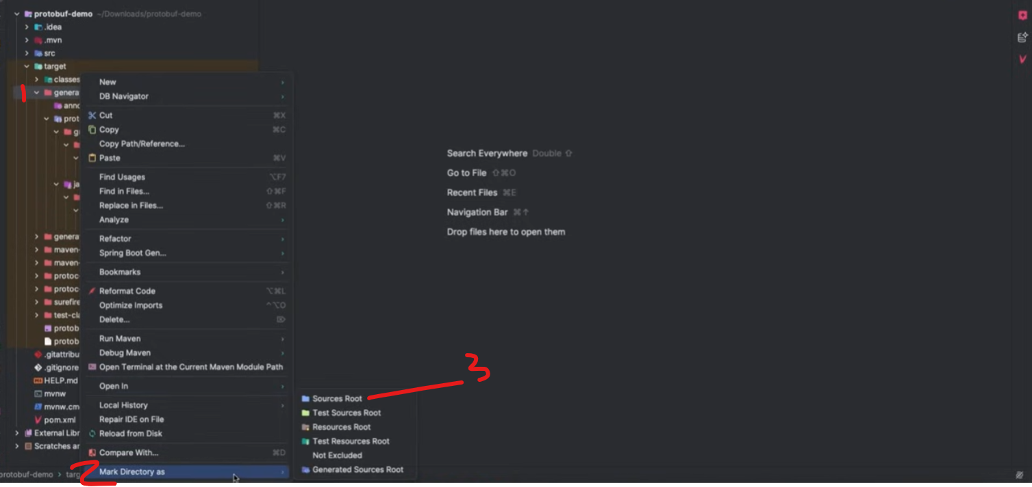

**Spring Boot + gRPC | Build Your First Microservice | Unary RPC Server Example**

