Scaling & Architecture, Day 5/25: Rate Limiting 🧵

The most dangerous traffic spike I've seen in my career didn't come from a DDoS attack.
It came from us.
Someone on the team scheduled a batch job that hit our own API. 400,000 requests in 90 seconds. No rate limiting in place. The API folded. Every real user got 503s for almost 10 minutes.
That's the thing about rate limiting. Most people think it's about blocking bad actors. Hackers. Scrapers. Bots.
It's not. Or at least, that's not the main reason you need it.
Rate limiting is about one thing: your system has a capacity. A maximum number of requests it can handle per second before things start breaking. Rate limiting is how you enforce that limit before everything falls over.
Three things you need to understand:
1. The algorithms - how do you actually count and limit requests?
2. The layers - where in your system do you enforce limits?
3. The response - what happens when someone hits the limit?
Let me go through each one.
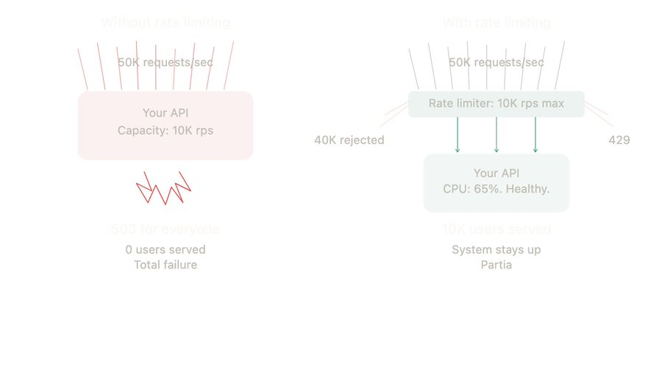

The three algorithms
There are three main ways to count and limit requests. They all answer the same question differently: "has this client sent too many requests?"
1. Token bucket
Imagine a bucket that holds 10 tokens. Every second, 1 new token is added. Every request consumes 1 token. If the bucket is empty, the request is rejected.
What makes it interesting: the bucket can accumulate tokens. If nobody makes requests for 10 seconds, the bucket fills up to 10 tokens. Then a burst of 10 requests goes through instantly.
So it allows short bursts while enforcing an average rate over time.
This is what AWS, Stripe, and most major APIs use. It's the default choice for a reason. Simple to implement, handles bursty traffic well, and easy for clients to understand.

2. Sliding window

Count the number of requests in a rolling time window. "Max 100 requests per 60 seconds" means: at any given moment, look back 60 seconds and count. Over 100? Rejected.
No burst allowance. It's strict and smooth. If you sent 100 requests in the last 60 seconds, you wait. Doesn't matter if they were spread out or all at once.
Good for APIs where you genuinely can't handle ANY burst. Payment endpoints. Login attempts. Anything where a sudden spike is dangerous regardless of the average rate.
3. Leaky bucket
Requests go into a bucket (queue). The bucket "leaks" at a constant rate. If the bucket is full, new requests are dropped.
Think of it like a funnel. No matter how fast you pour water in, it drips out at the same speed. Always.
This gives you the smoothest possible output rate. Zero bursts. Totally predictable throughput. Used when your downstream system literally cannot handle any variation in request rate.

Which one to use?

Honestly, for most APIs: token bucket. It handles real-world traffic patterns (which are naturally bursty) without being overly strict.
Sliding window if you need strict per-window limits (auth endpoints, payment APIs).
Leaky bucket if you need perfectly smooth throughput (rate-sensitive downstream systems)

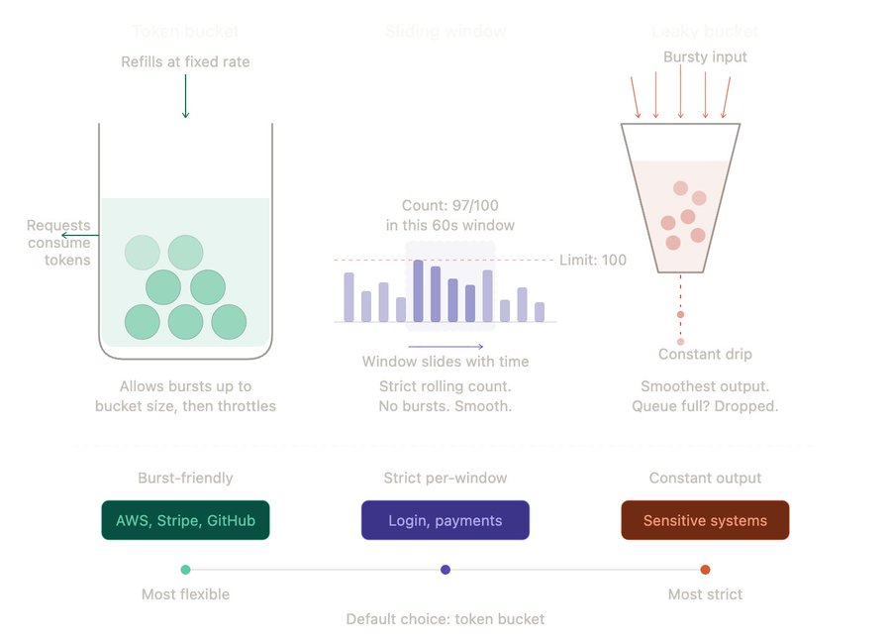
Picking the algorithm is half the decision. The other half is: where do you enforce the limit?
Most teams slap rate limiting at the API gateway and call it done. That's one layer. Production systems need at least two. Here's why.
Layer 1: API Gateway (the front door)
This is your first line of defense. Every request passes through here. Set global rate limits: "no client can exceed 1000 requests per minute."

This catches:
- Runaway scripts
- Misconfigured clients
- Basic abuse
- Your own batch jobs (ask me how I know)

Tools: Kong, NGINX, AWS API Gateway, Cloudflare. All have rate limiting built in.

Layer 2: Per-service limits (noisy neighbour protection)
You have 10 microservices. Your search service can handle 5000 rps. Your export service can handle 50.
Without per-service limits, one client hammering /export at 200 rps takes that service down. And because /export is down, health checks fail, the circuit breaker trips, and suddenly other things start breaking too.
Per-service rate limits prevent one endpoint from eating the capacity of another.
Layer 3: Per-user limits (fair usage)
One user is making 10,000 API calls per minute. Every other user is making 50. Without per-user limits, that one power user is consuming 99% of your capacity.
Per-user limits: "each API key gets 100 requests per minute." Fair. Predictable. No single user can starve everyone else.
This is also where you differentiate pricing tiers. Free tier: 100 rpm. Pro: 1000 rpm. Enterprise: 10,000 rpm. Rate limiting is literally your pricing enforcement.
Layer 4: Per-endpoint limits (not all endpoints are equal)
Your /search endpoint can handle 10,000 rps. It's fast, cached, lightweight.
Your /generate-report endpoint does a 30-second database aggregation. It can handle maybe 10 concurrent requests before the database starts crying.
Same global rate limit for both? That's a disaster waiting to happen. The heavy endpoints need tighter limits.
The rule: at minimum, use two layers. Gateway-level for global protection. Per-endpoint or per-user for granular control.
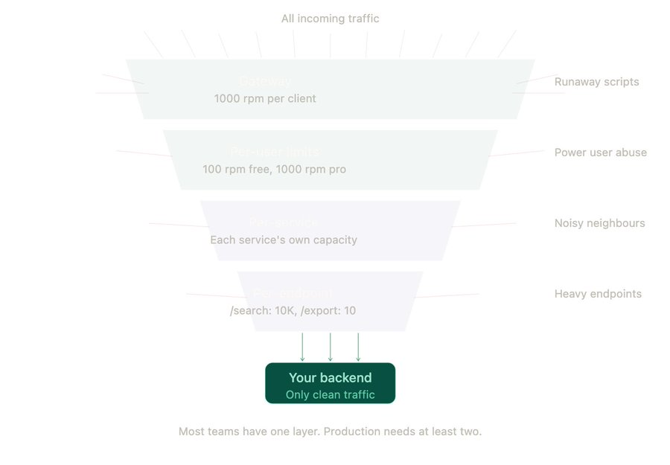
Ok so you've set up rate limiting. A client hits the limit. Now what?
This part matters more than people think. A bad rate limit response turns a small problem into a much bigger one.
The basics: 429 Too Many Requests
When a client exceeds the limit, return HTTP 429. Not 500. Not 503. Specifically 429. It tells the client "you sent too many requests" which is very different from "the server is broken."
Always include these headers in the response:
- X-RateLimit-Limit: 100 (your max per window)
- X-RateLimit-Remaining: 0 (how many left)
- Retry-After: 30 (when to try again, in seconds)

This is basic courtesy. Without these headers, the client has no idea what happened or when to retry. They'll just keep hammering you. Making things worse.

The retry storm problem
This is the part that bites people.
1,000 clients hit your rate limit at the same time. All get a 429. All have a retry set to "try again in 5 seconds." Five seconds later, all 1,000 retry at the exact same moment. Another wave of 429s. Retry again. Same thing. Over and over.
This is called a retry storm. And it can be worse than the original traffic spike.
The fix: exponential backoff + jitter
Instead of "retry in 5 seconds," tell clients to:
- 1st retry: wait 1 second + random jitter (0 to 500ms)
- 2nd retry: wait 2 seconds + random jitter
- 3rd retry: wait 4 seconds + random jitter
- Max 3-5 retries, then give up
The jitter is the key part. It spreads the retries out randomly so they don't all land at the same time. Without jitter, exponential backoff alone still creates waves. With jitter, the retries are smoothly distributed.
One more thing: don't rate limit your health checks
Seen this happen. Team set up aggressive rate limiting at the gateway. Load balancer health checks hit the same gateway. Health checks got rate limited. Load balancer thought the service was down. Pulled it out of rotation. Actual outage caused by rate limiting the wrong thing.
Whitelist your health check endpoints. Always
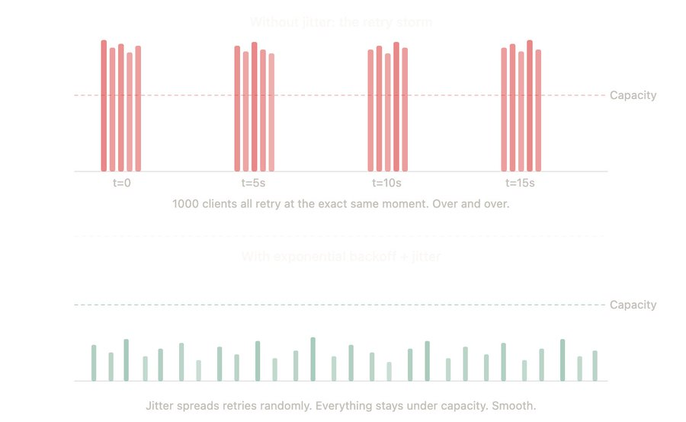
Alright. Let me put this together with some practical stuff you can actually use.
Where to store the counters?
Your rate limiter needs to track "how many requests has this client sent in the last N seconds?" That counter has to live somewhere.
Redis is the go-to. It's fast (in-memory), supports atomic increments, and has built-in TTL for expiring old counters. Most rate limiting libraries (like express-rate-limit, rack-attack, bucket4j) use Redis under the hood.
In-memory (local to each app instance) works if you have a single server. The moment you have multiple instances behind a load balancer, local counters don't work. User sends 50 requests to Instance A, 50 to Instance B. Each instance thinks they sent 50. Neither triggers the limit of 100. Use Redis.
How to set the right limits?
This is the part everyone struggles with. Here's what I do:

1. Measure first. Before setting any limits, measure your actual traffic patterns. What's the average rps? What does a normal spike look like? What's the max your system can handle before latency degrades?
2. Set limits above normal, below breaking. If your normal peak is 500 rps and your system breaks at 2000 rps, set the limit somewhere around 1000-1500 rps. Enough headroom for organic growth. Tight enough to prevent meltdown.
3. Start lenient, tighten later. It's better to start with generous limits and tighten based on data than to start strict and break real users' workflows on day one.
4. Monitor the 429 rate. If more than 1-2% of requests are getting 429'd, either your limits are too tight or you have a client that needs throttling. Either way, investigate.
Quick decision cheat sheet:

- Endpoint type → Algorithm → Limit example
- Public API → Token bucket → 100 rpm per API key
- Login/auth → Sliding window → 5 attempts per minute
- Search → Token bucket → 30 rps per user
- Heavy export/report → Leaky bucket → 2 concurrent per user
- Webhooks (outgoing) → Leaky bucket → Constant 50 per second
- Internal service-to-service → Token bucket → 5000 rps per service

One last thing: rate limiting is not a security solution. It slows down attackers. It doesn't stop them. If someone is actually attacking your system, you need a WAF, IP blocking, and proper auth. Rate limiting buys you time. That's all.

That's Day 5. Rate limiting.
