6: API Gateway.

Scaling & Architecture, Day 6/25: API Gateway 🧵
Most people describe an API gateway as "a fancy reverse proxy."
That's like calling a hospital reception desk "a fancy door." Technically the request goes through it. But a LOT is happening before it reaches the other side.
Here's the actual job of an API gateway:
It's the single entry point for all client traffic into your system. Every request from every client (mobile app, web app, third-party integration, internal service) goes through the gateway first.
Why does that matter?
Because without a gateway, every one of your backend services needs to handle its own:
- Authentication
- Rate limiting
- Logging
- CORS
- Request validation
- Protocol translation

That's the same boilerplate code duplicated across 10, 20, 50 services. Every team implements it slightly differently. Some forget to add rate limiting. Some have a logging gap. One team's auth check has a bug that the others don't.
The gateway centralises all of that into one layer. Your backend services do one thing: business logic. Nothing else. The gateway handles everything that happens before the request reaches them.
That's not a "fancy proxy." That's the difference between a system that's manageable and one that's a maintenance nightmare.

Let me break down what it actually does. 👇

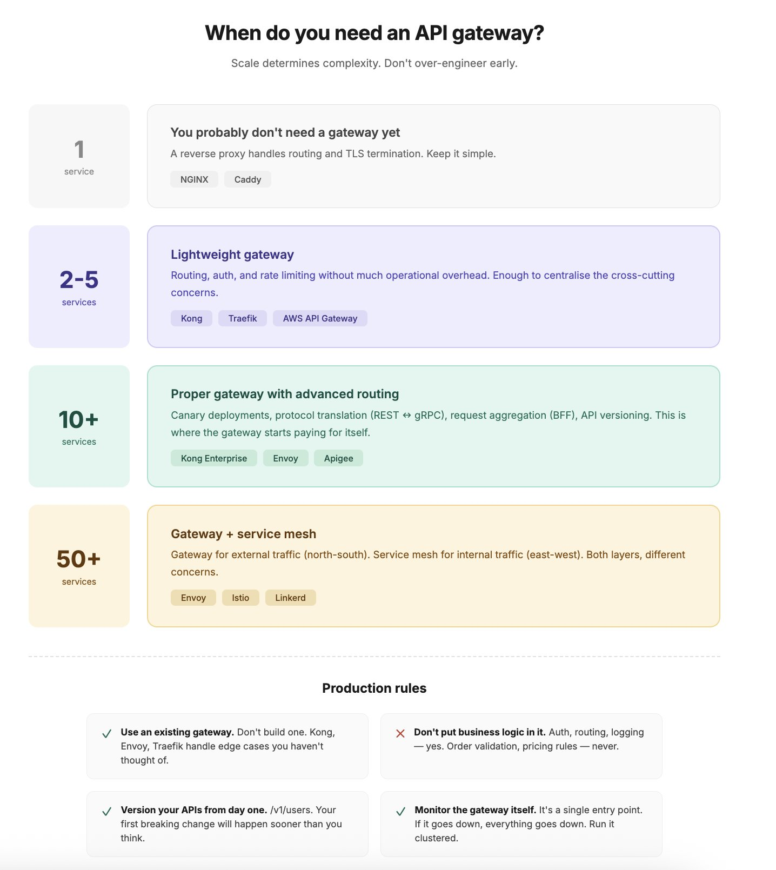

The six jobs of an API gateway

In practice, a production API gateway is handling all of these on every single request:
1. Authentication and authorisation
Client sends a request with a JWT or API key. The gateway validates it before the request goes anywhere. Invalid token? 401 right there. No need for your order service to check auth. No need for your search service to check auth. The gateway already did it.
This alone saves you from the nightmare of "wait, does the notification service even check tokens?"

2. Rate limiting
We covered this on Day 5. The gateway is the natural place for your first layer of rate limiting. Global limits, per-client limits, per-tier limits. All enforced before any backend service is touched.

3. Request routing
This is the core job. The gateway looks at the incoming request and decides which backend service handles it.

/api/users/ goes to the user service.
/api/orders/ goes to the order service.
/api/search/ goes to the search service.
The client doesn't know (or care) that you have 15 different services behind the scenes. They see one API. The gateway makes that possible.

4. Protocol translation
Your public API speaks REST (because browsers and mobile apps expect it). Your internal services speak gRPC (because it's faster for service-to-service calls). The gateway translates between them.

Client sends a REST request. Gateway converts it to a gRPC call to the internal service. Service responds in gRPC. Gateway converts it back to JSON and sends it to the client.
Neither side knows about the other's protocol. Clean separation.

5. Response caching
If your /api/products endpoint returns the same data for every request, why forward it to the backend every time? The gateway can cache the response and serve it directly. We talked about this in the CDN thread (Day 2). The gateway is another caching layer between the CDN and your services.

6. Logging and observability
Every request passes through the gateway. That makes it the perfect place to log everything. Request IDs, client info, latency, response codes, payload sizes. One place. One format. Complete visibility into what's hitting your system.

Without this, you're piecing together logs from 15 different services trying to trace one user's request. With it, you have a single pane of glass
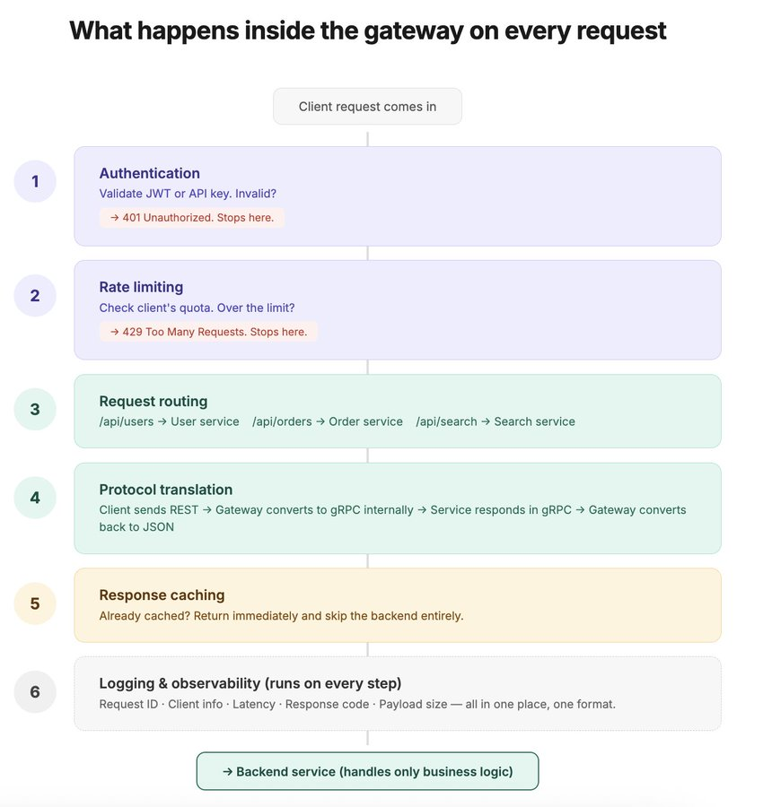

Routing patterns: the part that gets interesting at scale

Basic path-based routing (/users goes here, /orders goes there) is table stakes. Every gateway does this. But production systems need more.

Header-based routing
Route based on request headers, not just the path. Same endpoint, different backends depending on who's calling.
API version in the header? Route Accept: application/v2+json to the v2 service while v1 clients still hit the old one. No URL changes. No breaking existing integrations.
Device type? Mobile clients get routed to a lightweight API that returns smaller payloads. Desktop clients get the full response.

Weighted routing / canary deployments
You just deployed a new version of the order service. Instead of sending all traffic to it and praying, you tell the gateway: send 5% of traffic to the new version. 95% stays on the old one.
Monitor for 30 minutes. Error rate looks good? Bump to 25%. Then 50%. Then 100%.
If anything goes wrong at 5%, you flip it back to 0%. Only 5% of users were affected. Not 100%.
This is one of the most practical uses of an API gateway that most teams underutilise. Deploying without a canary is just hoping.

Request aggregation (BFF pattern)
Your mobile app needs data from three services to render one screen: user profile from the user service, recent orders from the order service, recommendations from the recommendation service.
Without a gateway: the mobile client makes 3 separate API calls over a cellular connection. Slow.
With a BFF (Backend for Frontend) pattern at the gateway: the client makes 1 call. The gateway fans out to all three services in parallel internally (fast data centre network), aggregates the responses, and returns a single payload to the client.
One round trip instead of three. On a mobile connection, that's the difference between 200ms and 800ms.
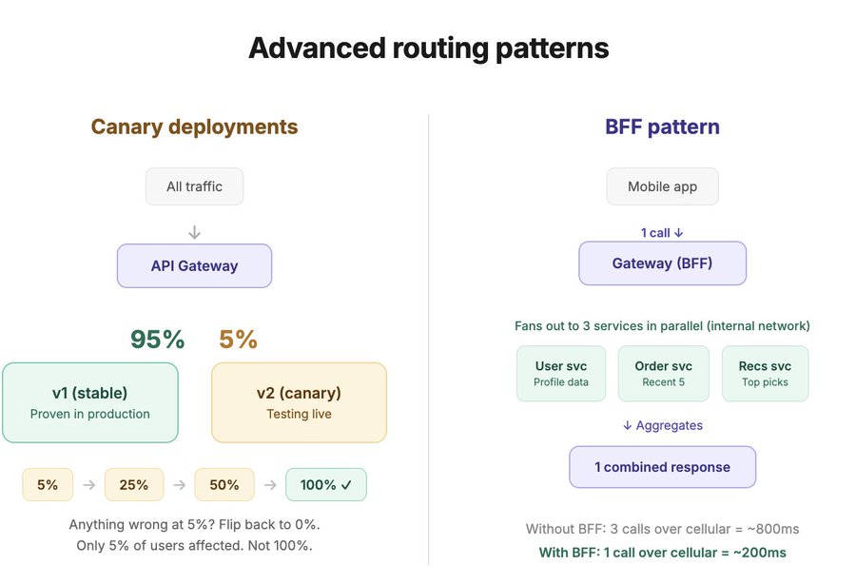

API gateway vs service mesh
People confuse these all the time. They overlap but they solve different problems.
API gateway = north-south traffic
North-south means traffic coming IN from external clients to your system. The gateway sits at the edge. It handles auth, routing, rate limiting, protocol translation. It's the front door.
Every system with more than one backend service needs an API gateway. This is not optional at scale.
Service mesh = east-west traffic
East-west means traffic flowing BETWEEN your internal services. Service A calling Service B. Service B calling Service C.

A service mesh (Istio, Linkerd) adds a sidecar proxy to every service that handles mTLS (encryption between services), retries, circuit breaking, load balancing, and observability for internal calls.
Your application code doesn't change. The mesh handles all the networking concerns between services transparently.
When do you need each?
API gateway: the moment you have external clients hitting your backend. So basically always.
Service mesh: when you have 20+ services calling each other and you need consistent security, observability, and resilience policies across all of them. Before that, it's overkill. At 5 services, handle retries and circuit breaking in your application code. At 50 services, that stops being practical.
The common pattern at scale:
External client hits the API gateway (north-south). Gateway routes to the right service. That service calls other services through the service mesh (east-west). Two layers. Different concerns. Both important.
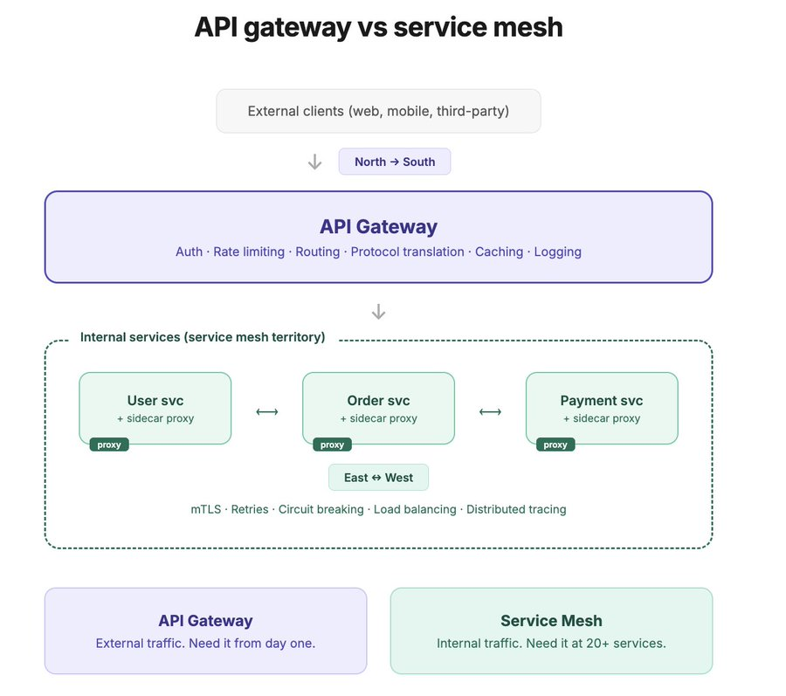
Production tips from building with API gateways for 10+ years
1) Pick a gateway, not build one. Unless you're at massive scale with very specific needs, use an existing solution. Kong, AWS API Gateway, NGINX, Envoy, Traefik.
They handle edge cases you haven't thought of yet. I've seen teams spend 6 months building a custom gateway and end up with something worse than Kong's free tier.

2) Don't put business logic in the gateway. The gateway should handle cross-cutting concerns (auth, rate limiting, routing, logging). The moment you start putting order validation or pricing rules in the gateway, you've created a god service that every team depends on and nobody owns. Keep it thin.

3) Version your APIs from day one. /v1/users. Put it in the URL or the header. Either way, the gateway should route v1 and v2 independently. Your first breaking API change will happen sooner than you think. If you haven't versioned, that change becomes a coordination nightmare across every client.
4) Set up health checks through the gateway. The gateway should know which backends are healthy and stop routing to unhealthy ones. This sounds obvious but I've seen gateways happily forwarding requests to a service that's been returning 503s for 20 minutes because nobody configured health check routing.
5) Monitor the gateway itself. The gateway is a single point of entry. If it goes down, everything goes down. Run it in a cluster (multiple instances behind a load balancer). Monitor its latency (it adds 1-5ms per request, if it's adding 50ms something is wrong). Alert on its error rate.

The quick decision framework:
a) One backend service? You probably don't need a gateway yet. A reverse proxy (NGINX) is fine.
b) 2-5 services? A lightweight gateway (Kong, Traefik) gives you routing, auth, and rate limiting without much overhead.
c) 10+ services with external clients? A proper gateway with canary routing, protocol translation, and request aggregation. This is where it starts paying for itself.
d) 50+ services? Gateway for external traffic. Service mesh for internal traffic. Both.
