Partitioning
https://x.com/system_monarch/status/2068372412681613477
Scaling & Architecture, Day 10/25: Partitioning 🧵
Yesterday we covered sharding. Splitting data across multiple database servers. Powerful but complex. Hard to undo.
Today is its quieter, simpler, more practical cousin: partitioning.
Partitioning is splitting a large table into smaller pieces within the SAME database. Same server. Same backups. Same connection pool. No distributed systems complexity at all.
Here's a scenario I've seen at least 5 times in my career:
Team has an orders table with 400 million rows. Queries are getting slower every month. Someone suggests sharding. The team spends 3 months planning a sharding strategy, building a routing layer, testing cross-shard queries.
Then someone else says "wait, have we tried partitioning the table by date?"
They partition it. Queries on recent data now skip scanning 380 million old rows. Response time drops from 8 seconds to 200ms. The sharding project gets quietly shelved.
That's the thing about partitioning. It's not exciting. Nobody writes blog posts about it. But it solves real performance problems with almost zero risk.
Three types of partitioning. Let me walk through each one. 👇
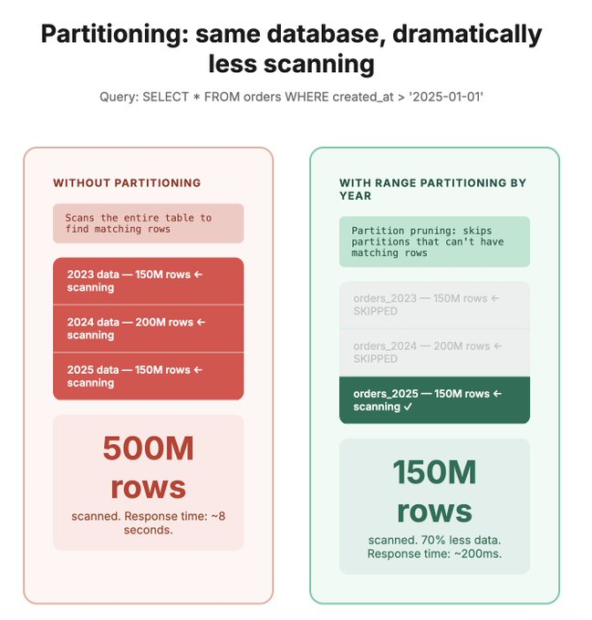

The three types of table partitioning
Postgres, MySQL, and most modern databases support these natively. You define the partition strategy, the database handles the rest.
1. Range partitioning
Split the table by a range of values. Most commonly: dates.
orders_2023 → all orders from 2023
orders_2024 → all orders from 2024
orders_2025 → all orders from 2025

When you query `WHERE created_at BETWEEN '2025-01-01' AND '2025-03-31'`, Postgres knows it only needs to scan the 2025 partition. It skips 2023 and 2024 entirely. This is called partition pruning and it's where the magic happens.
Use this when: your queries almost always include a date range or a numerical range in the WHERE clause. Time-series data, logs, orders, events, transactions.
2. List partitioning
Split by specific discrete values.
orders_india → country = 'IN'
orders_us → country = 'US'
orders_europe → country IN ('DE', 'FR', 'UK', 'NL')
When you query `WHERE country = 'IN'`, only the India partition is scanned.
Use this when: you filter by a column with a small number of known values. Country, region, status, category, tenant ID in a multi-tenant system.
The risk: uneven partition sizes. If 60% of your data is India, that partition is huge while others are tiny. Not necessarily a problem, but be aware of it.
3. Hash partitioning
Hash a column value and distribute rows across N partitions. `hash(user_id) % 4` gives you 4 roughly equal partitions.

partition_0 → hash(user_id) % 4 = 0
partition_1 → hash(user_id) % 4 = 1
partition_2 → hash(user_id) % 4 = 2
partition_3 → hash(user_id) % 4 = 3

The database handles the hashing automatically. You just define the number of partitions.
Use this when: you need even distribution but don't have a natural range or list to split on. Or when your goal is to reduce lock contention on high-write tables by spreading writes across partitions.
The tradeoff: range queries (WHERE created_at BETWEEN x AND y) will hit ALL partitions because the hash scatters data randomly. Only point lookups benefit.

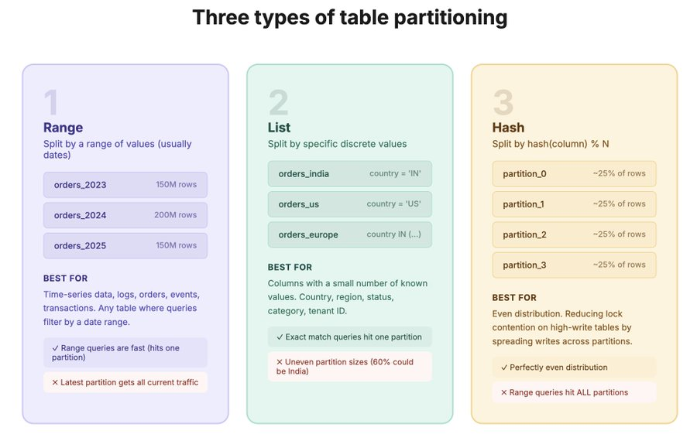

Partition pruning: where the actual performance gain comes from
This is the most important concept to understand about partitioning. Without pruning, partitioning is just organisational. With pruning, it's a performance multiplier.
Here's what happens step by step:

Without partitioning:
You have 500 million rows in one orders table. You run:
`SELECT FROM orders WHERE created_at > '2025-01-01'`
Postgres scans all 500 million rows (or at least does an index scan across the full table). Even with a good index, the index itself is huge. Maintenance is slow. Vacuum takes forever.
With range partitioning by year:
Same query. Postgres looks at the WHERE clause. Sees `created_at > '2025-01-01'`. Knows that only the 2025 partition contains matching rows. Skips 2023 and 2024 entirely. Scans maybe 80 million rows instead of 500 million.
That's not a small improvement. That's scanning 84% less data.
How to verify pruning is working:
Run EXPLAIN on your query. Look for "Partitions pruned" or check which partitions are actually being scanned. If you see all partitions being scanned, your WHERE clause isn't matching the partition key. Fix that.
EXPLAIN SELECT FROM orders WHERE created_at > '2025-01-01';
If the plan shows only the 2025 partition being scanned, pruning is working. If it shows all partitions, something is off. Common causes:
1. Your WHERE clause doesn't include the partition key. If you partition by created_at but query by user_id, the database can't prune. It has to check every partition.
2. Type mismatch. Partition key is a DATE but you're comparing to a TIMESTAMP. The database can't prune because the types don't match exactly.
3. Functions on the partition key. `WHERE EXTRACT(YEAR FROM created_at) = 2025` breaks pruning because you're applying a function to the column. Use `WHERE created_at >= '2025-01-01' AND created_at < '2026-01-01'` instead.

The rule: your most common queries must include the partition key in the WHERE clause. If they don't, partitioning won't help. Choose your partition key based on how you query, not how you think the data should be organised.

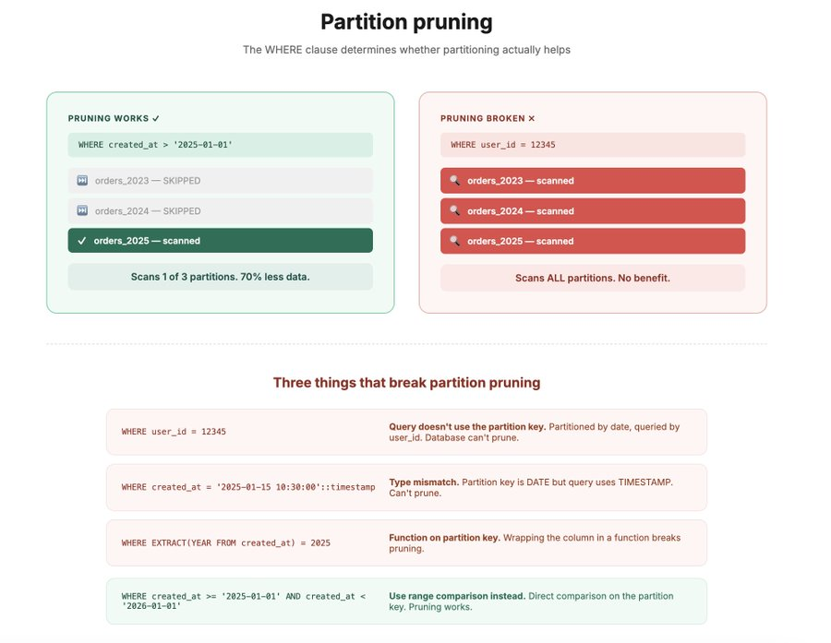

When partitioning helps and when it doesn't
Partitioning is powerful but it's not a universal fix. Let me be specific about where it works and where it doesn't.
Partitioning helps when:
1. Large tables with time-based queries. Orders, events, logs, transactions. You almost always query recent data. Partition by month or year. Old partitions are rarely touched.
2. Data retention and cleanup. Need to delete all orders older than 3 years? Without partitioning: DELETE FROM orders WHERE created_at < '2022-01-01'. On 500M rows, this takes hours and locks the table. With partitioning: DROP PARTITION orders_2021. Takes milliseconds. No locks. No vacuum needed. This alone is worth partitioning for.
3. Index maintenance. On a 500M row table, index rebuilds and VACUUM operations are slow and resource-intensive. On individual partitions, they're fast because each partition is smaller. You can even run maintenance on one partition at a time without affecting the others.
4. Parallel query execution. Postgres can scan multiple partitions in parallel, using multiple CPU cores. On a single massive table, it's single-threaded (mostly). Partitioning enables parallelism for free.
5. Hot/cold data separation. Recent data (hot) on fast SSDs. Old data (cold) on cheaper storage. Different tablespaces for different partitions. Optimise storage costs without application changes.
Partitioning does NOT help when:
1. Your queries don't filter on the partition key. If you partition by date but your queries filter by user_id, the database scans every partition. You've added complexity for zero benefit.
2. The table is small. Under 10 million rows? Partitioning overhead (query planning across partitions) might actually make things slower. A good index on a 10M row table is fast enough.
3. You need cross-partition joins. Joining two partitioned tables on different partition keys is messy. The database can't prune either side efficiently.
4. You think it replaces indexing. Partitioning reduces the amount of data scanned. Indexes help find specific rows within that data. You need both. Partitioning without proper indexes is still slow. Just less slow.

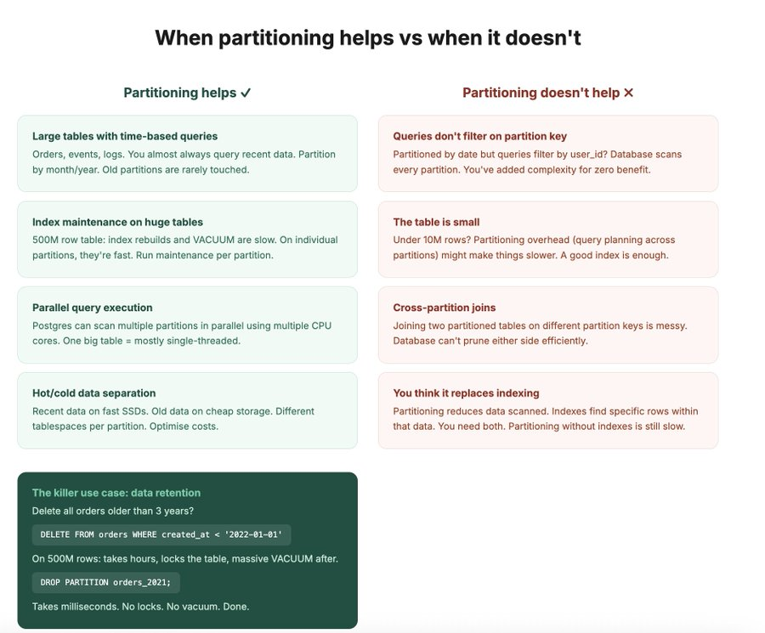

Practical implementation tips
Here's the stuff I wish someone told me before my first partitioned table.
Start with monthly or yearly partitions. Don't over-partition. If you create daily partitions for a table with 1000 rows per day, you now have 365 tiny partitions that add query planning overhead for no benefit. Match partition granularity to your data volume.
Rough guideline:
- Under 1M rows per partition → partitions are too small, go coarser
- 1M to 100M rows per partition → sweet spot
- Over 500M per partition → might be too large, go finer
Create future partitions in advance. If you partition by month, make sure next month's partition exists before next month starts. If it doesn't, inserts will fail. Automate this. pg_partman for Postgres is great for this.
Always include the partition key in your PRIMARY KEY. In Postgres, the primary key must include the partition key. This trips people up. If you partition by created_at, your primary key becomes (id, created_at) instead of just (id). Plan for this.
Monitor partition sizes. If one partition is 10x larger than the others, you have a skew problem. With list partitioning on country, this is common. Either accept it or rethink the partition key.
Don't mix partitioning strategies. In Postgres you can do sub-partitioning (range by year, then hash by user_id within each year). It works. It's also a maintenance nightmare. Keep it simple unless you have a very specific reason.
The decision framework:
Table under 10M rows → Don't partition. Index properly.
Table 10M-500M rows, time-based queries → Range partition by month/year
Table 10M-500M rows, filtered by category/region → List partition
High-write table with lock contention → Hash partition to spread writes
Table over 500M, exhausted partitioning → Now consider sharding (Day 8)

