Queueing
https://x.com/system_monarch/status/2068609326844203020
Picking up my Scaling & Architecture series. Today is Day 11: Queueing.
That http://Healthcare.gov meltdown? The core problem was brutally simple
The core problem is always the same: everything is synchronous. Every step in the request has to finish before the user gets a response.
One slow step (payment gateway taking 2 seconds, email service being flaky) and the whole thing backs up.
A queue flips this on its head.
Your API accepts the request, drops it into a queue, and returns "accepted" to the user immediately.
The actual work happens in the background. At its own pace. One message at a time.
The queue doesn't make your system faster. It makes the failure graceful. Instead of 14,000 requests crushing your backend simultaneously,
you get 14,000 messages sitting in a buffer, processed steadily at whatever rate your system can handle.
An uncontrollable spike becomes a controllable stream.
There's a lot more to this though. Different queue types, delivery guarantees, and a bunch of production gotchas that will absolutely bite you.
Let me walk through all of it. 👇
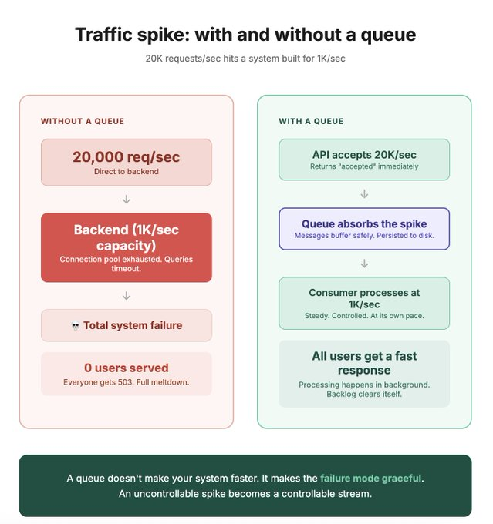

How message queues actually work
Three components. That's it.
Producer — the thing that creates messages. Your API receives an order, creates a message like `{order_id: 12345, action: "process"}`, and puts it in the queue.
Queue — the buffer in the middle. Stores messages until a consumer picks them up. Messages are persisted (usually to disk), so even if the queue restarts, messages aren't lost.
Consumer — the thing that processes messages. Pulls a message from the queue, does the work (charge the card, send the email, update the inventory), and acknowledges completion. The queue then deletes that message.
Simple. But this simple pattern gives you some powerful things:
1. Decoupling
The producer doesn't know or care who consumes the message. Your order API doesn't know that there's an email service, an inventory service, and an analytics service all listening. It just drops the message and moves on.
Want to add a new consumer later? Just subscribe. No changes to the producer. No deploy. No coordination.
2. Load levelling
Your producer can spike to 20K messages per second. The consumer processes at 1K per second. The queue absorbs the difference. Think of it like a dam on a river. The river (traffic) varies wildly. The outflow (processing) is steady.
3. Retry and reliability
Consumer crashes mid-processing? The message goes back to the queue (it was never acknowledged). Another consumer picks it up. No message lost. No manual intervention.
Compare this to a synchronous HTTP call where the caller retries blindly and you get duplicate charges or duplicate emails. The queue handles this for you.
4. Processing guarantees
This is the part most people skip:
- At-most-once: message delivered once or not at all. No duplicates. Possible message loss. Fast. (Redis pub/sub default)
- At-least-once: message always delivered. Might be duplicated. No loss. (SQS, RabbitMQ default)
- Exactly-once: message delivered exactly once. No loss, no duplicates. Hard to achieve. Expensive. (Kafka with transactions, within limits)
Most production systems use at-least-once and make their consumers idempotent (processing the same message twice produces the same result). This is simpler than chasing exactly-once semantics.
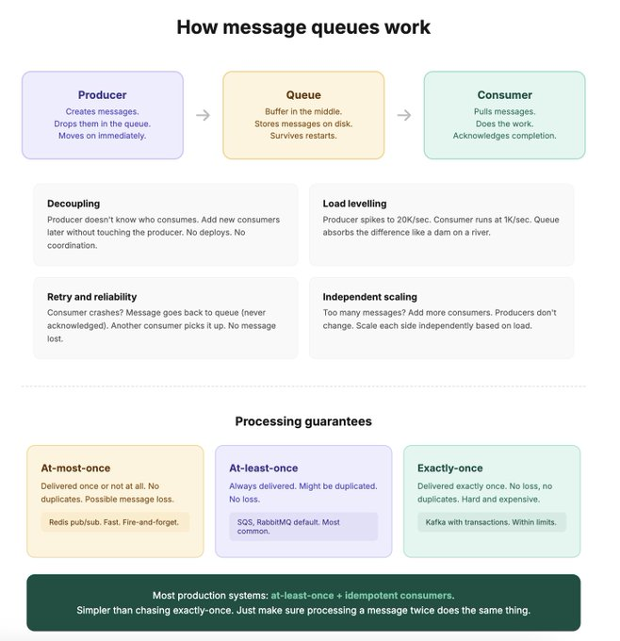
Kafka vs RabbitMQ vs SQS
People treat these as interchangeable. They're not. They solve different problems differently.
RabbitMQ — the task distributor
Traditional message broker. Push-based. The broker pushes messages to consumers. Once a consumer acknowledges a message, it's deleted from the queue.
Think of it like a to-do list. Task goes on the list. Someone picks it up and does it. Once done, it's crossed off. Gone.
Good for:
- Task distribution (send this email, process this payment, resize this image)
- Work queues where each task should be processed by exactly one worker
- Low latency (messages delivered in milliseconds)
Not great for:
- Replaying old messages (they're deleted after acknowledgement)
- Multiple consumers reading the same message independently

Kafka — the event log
Distributed log. Pull-based. Messages are written to a topic (partitioned, replicated). Consumers pull at their own pace. Messages are NOT deleted after consumption. They're retained for a configurable period (days, weeks, forever).
Think of it like a newspaper archive. Everyone can read it. At their own pace. Going back as far as they want. The articles don't disappear when someone reads them.
Good for:
- Event streaming (user signed up, order placed, payment processed)
- Multiple consumers reading the same events independently (email service, analytics, search index all consuming the same events)
- Replaying events (new service wants to process all historical events? just start from the beginning)
- High throughput (millions of messages per second)
Not great for:
- Simple task queues (overkill)
- Low-latency message delivery to a single consumer (RabbitMQ is faster for this)
SQS — the managed easy button
AWS's managed queue. No servers to maintain. No clusters to configure. No replication to worry about.
Standard queue: at-least-once, best-effort ordering. FIFO queue: exactly-once, guaranteed ordering.
Good for:
- "I just need async processing and I don't want to manage infrastructure"
- Lambda triggers (message arrives, Lambda runs, processes it)
- Teams that don't have the ops capacity for Kafka or RabbitMQ
Not great for:
- Event replay (messages deleted after processing)
- Multi-consumer fan-out (need SNS in front for that)
- Very high throughput (SQS has limits, though they're generous)

The quick decision:
Need a task queue for background jobs? RabbitMQ or SQS.
Need event streaming with replay and multiple consumers? Kafka.
Don't want to manage infrastructure? SQS.
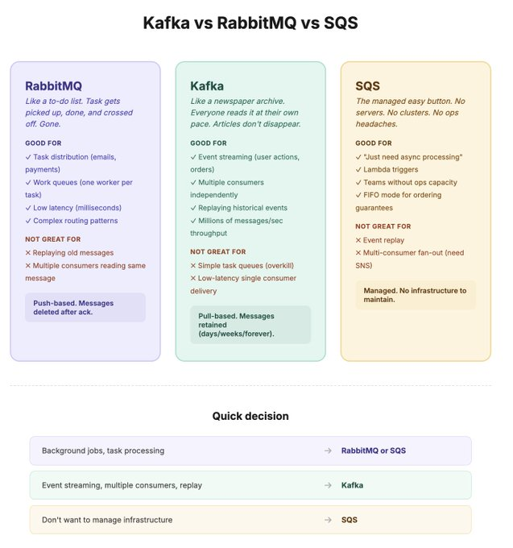
Production gotchas: backpressure, dead letter queues, and idempotency
These are the three things that separate "we use a queue" from "we use a queue in production and it works."

1. Backpressure
Your producer is generating 10K messages per second. Your consumer processes 1K per second. The queue is growing by 9K per second.
For a short spike, this is fine. The queue absorbs it and the consumer catches up when traffic drops.
For a sustained imbalance? The queue grows until it hits its storage limit and starts dropping messages. Or it gets so large that consumers can never catch up. You've turned a spike into a permanent backlog.
How to handle it:
- Monitor queue depth. Alert when it exceeds a threshold. If the queue is consistently growing, you need more consumers, not more queue.
- Auto-scale consumers. Queue depth > 10K? Spin up more consumer instances. Queue depth < 1K? Scale back down.
- Reject at the source. If the queue is dangerously full, the producer should return 503 (service unavailable) instead of accepting more work it can't process.
2. Dead letter queues (DLQ)
A consumer picks up a message. Tries to process it. Fails. Message goes back to the queue. Consumer picks it up again. Fails again. And again. And again.
This is a poison message. Maybe the data is malformed. Maybe a dependency is down. Whatever the reason, this message will never succeed. And it's blocking the queue.
A dead letter queue catches these. After N failed attempts (usually 3-5), the message is moved to a separate DLQ instead of being retried forever.
Your main queue keeps flowing. The poison messages are isolated. You debug them later from the DLQ when things are calm.
Every production queue should have a DLQ. No exceptions. I've seen teams where one malformed message blocked processing for 4 hours because there was no DLQ and it kept getting retried.
3. Idempotent consumers
At-least-once delivery means a message CAN be delivered twice. Maybe the consumer processed it but crashed before acknowledging. The queue sends it again.

If your consumer is "charge the customer's card," processing it twice means charging them twice. That's a support call and a refund.
Idempotent consumers: processing the same message twice produces the same result as processing it once.

How to implement:
- Store a message ID in your database. Before processing, check: "have I seen this ID before?" Yes? Skip it.
- Use database upserts instead of inserts. If the record already exists, update it instead of creating a duplicate.
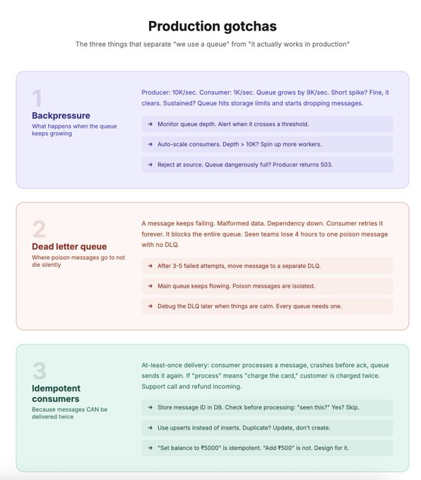
- Design your operations to be naturally idempotent. "Set balance to ₹5000" is idempotent. "Add ₹500 to balance" is not.

When to use queues and when not to
Queues are powerful but they add complexity. Every time you put a queue between two components, you've introduced eventual consistency, a new failure mode, and something else to monitor.
Use a queue when:
1. The work doesn't need to happen right now. Email sending, PDF generation, image resizing, analytics writes, push notifications. The user doesn't need to wait for these.
2. Your producer and consumer have different throughput. API handles 10K rps. Payment processing handles 100 rps. The queue bridges the gap. Without it, either the API slows to match payments or payments get overwhelmed.
3. You want to decouple services. Order service shouldn't know or care about the email service, inventory service, and analytics service. Publish an event. Let consumers figure it out.
4. You need reliability on a critical path. Payment message goes into a persistent queue. Even if the payment processor is temporarily down, the message survives. When it comes back, the message is processed. No lost payments.
5. You're absorbing traffic spikes. Flash sales, viral content, scheduled batch jobs. The queue converts an uncontrollable spike into a controllable stream.

Don't use a queue when:
1. The user needs an immediate response. User clicks "buy" and needs to see a confirmation with their order number? That's synchronous. Don't queue it.
2. The overhead isn't worth it. If your traffic is predictable and your system handles it fine without a queue, adding one just adds complexity. YAGNI.
3. You need strong consistency. Queues introduce eventual consistency. If the user writes data and immediately reads it back, a queue-based architecture might show stale state. (Sound familiar? Same problem as replication lag from Day 9.)
4. You're using it to avoid fixing the actual bottleneck. If your database is slow, a queue in front of it just delays the problem. Fix the database first.

A pattern that works great:
Synchronous for the fast path. Asynchronous for everything else.
User places an order:
- Synchronous: validate payment, create order record, return confirmation. User sees a result in 500ms.
- Queue: send confirmation email, update analytics, notify warehouse, generate invoice. All happen in the background over the next few seconds.
The user gets a fast response. The heavy work happens after they've moved on. 