Microservices
https://x.com/system_monarch/status/2069105325735817236
Amazon Prime Video moved their video monitoring tool from microservices to a monolith in 2023. Costs dropped 90%. The internet lost its mind. "Even Amazon is ditching microservices?" Here's what happened
That Prime Video story? It wasn't surprising to anyone who's actually built and maintained microservices in production. I've seen the same pattern play out at two different companies I've worked at.
Team reads the Netflix blog. Gets excited. Splits the monolith into 20+ services.
Six months later, a junior engineer can't ship a simple feature without understanding the entire distributed system. Debugging means tracing requests through 8 services. The infra bill has tripled. Nobody is moving faster. Everyone is moving slower.
Microservices are not an upgrade. They're a tradeoff.
Monolith problems:
- Deployments are scary
- One team blocks another
- Scaling means scaling everything
Microservice problems:
- Network calls replace function calls
- Debugging crosses 15 services
- One outage cascades into six others
- Your infra bill triples
Neither is "better." The right choice depends on your team size, your org structure, and your actual bottleneck.
But most teams don't adopt microservices because they have the problem microservices solve. They adopt them because they think that's what "real" engineering looks like.
Let me break down when they actually help, when they hurt, and how to think about this properly. 👇
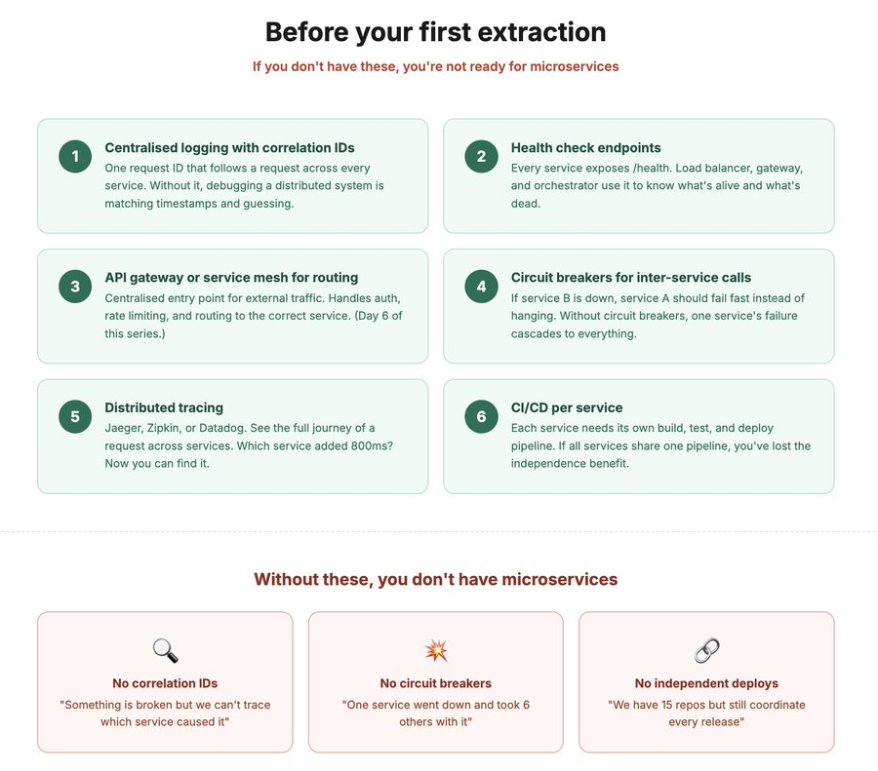

Microservices solve an organisational problem, not a technical one.
Read that again. It's the most important sentence in this thread.
Here's what I mean:
You have 40 engineers. 6 teams. Each team owns a different part of the product. Auth team. Payments team. Search team. Notifications team.
In a monolith, all 6 teams commit to the same codebase. Team A merges a change. Team B's tests break. Team C is blocked waiting for a deploy that includes Team D's half-finished feature. Everyone's stepping on each other.
Deploys become a coordination exercise. "Can we deploy today?" requires a Slack thread with 15 people.
Microservices fix this by giving each team their own service. Their own repo. Their own deploy pipeline. Their own release schedule.
Team A deploys 5 times a day. Team B deploys once a week. Neither blocks the other. Neither breaks the other's tests. Neither waits for the other's approval.
This is the actual value of microservices. Independent deployment by independent teams.
If you have 4 engineers and one team, you don't have the organisational problem. You have a codebase that one team owns and can deploy whenever they want. A monolith does this perfectly.
The rule I tell people: one team, one service. If a service is owned by two teams, it's the wrong boundary. If one team owns four services, you probably have four modules pretending to be services. 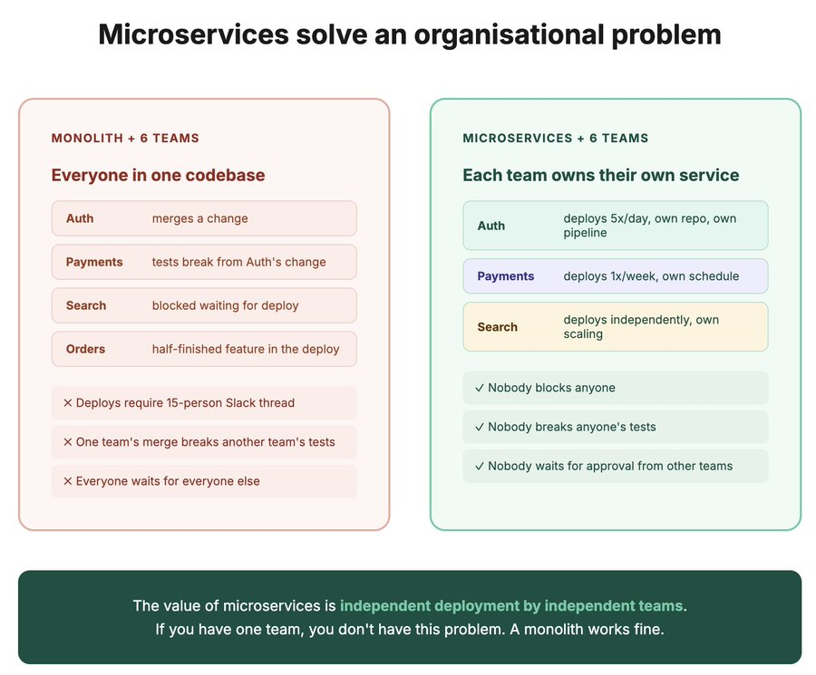
The real costs nobody mentions in the "microservices vs monolith" blog posts
When you split a monolith into microservices, you gain independence. But you also gain all of this:
1. Network calls replace function calls
In a monolith, the order module calls the user module. It's a function call. Nanoseconds. Always works.
In microservices, the order service calls the user service over HTTP or gRPC. That's 1-10ms. It can fail. It can timeout. The user service can be down. The network between them can be congested. You now need retry logic, circuit breakers, and fallbacks for what used to be a function call.
2. Distributed transactions are a nightmare
In a monolith: begin transaction, charge the card, update inventory, create the order, commit. One database, one transaction, ACID guarantees.
In microservices: payment service charges the card. Inventory service updates stock. Order service creates the record. Each has its own database. If the inventory update fails after the card is charged, you need a saga pattern with compensating actions (refund the card). This is genuinely hard to get right.
3. Debugging becomes detective work
User reports a bug: "my order was charged but I didn't get a confirmation." In a monolith, you grep the logs. One log file. One request ID. Done.
In microservices, that request touched the API gateway, auth service, order service, payment service, inventory service, notification service, and analytics service. You need distributed tracing (Jaeger, Zipkin) and correlation IDs across all of them. Without it, you're matching timestamps across 7 different log streams and praying.
4. Operational overhead multiplies
One monolith = one deploy pipeline, one monitoring dashboard, one set of alerts, one database to backup.
15 microservices = 15 deploy pipelines, 15 monitoring dashboards, 15 sets of alerts, possibly 15 databases. Each needs health checks. Each needs auto-scaling rules. Each needs on-call rotation.
I've seen teams where 60% of engineering time went to infrastructure instead of features. That's the hidden cost.

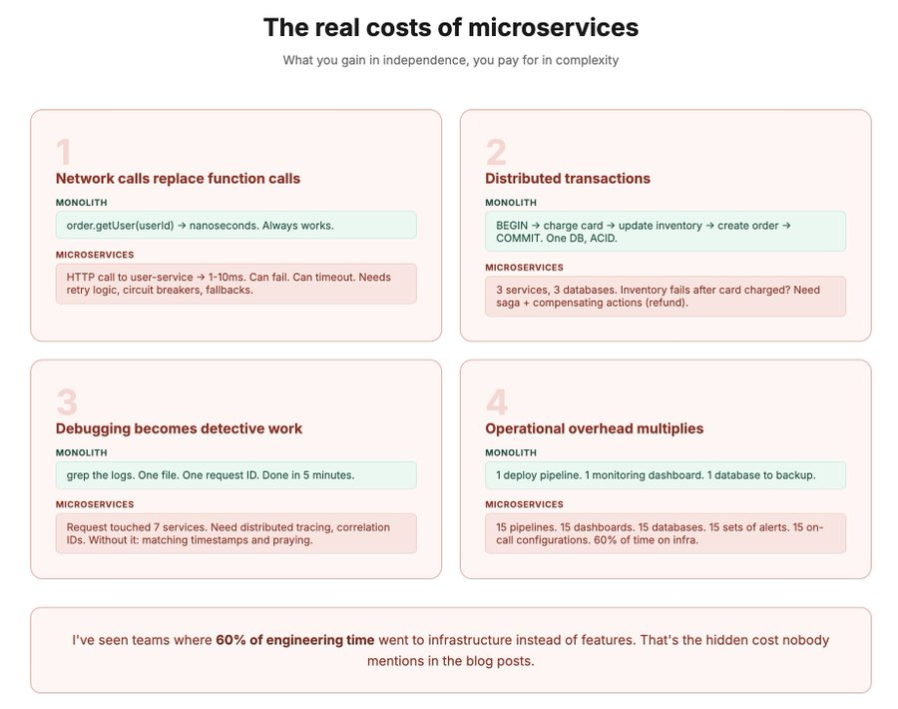

When microservices actually make sense
Not theory. Practical signals from my experience:
You need microservices when:
1. Multiple teams need to deploy independently. This is the #1 signal. If deploys require cross-team coordination, if one team's release blocks another, if merge conflicts across teams are a daily thing. You have the organisational scaling problem that microservices solve.
2. Different parts of your system have wildly different scaling needs. Your search service needs 50 instances to handle query load. Your user profile service needs 2. In a monolith, you scale the entire thing to handle search. In microservices, you scale just search. Big cost savings.
3. Different parts need different tech stacks. Your ML team wants Python. Your API team uses Go. Your analytics pipeline uses Spark. Microservices let each team use the right tool. A monolith forces everyone onto one stack.
4. Fault isolation is critical. If the recommendation engine crashes, it shouldn't take down checkout. Separate services mean separate failure domains. One service dies, the rest keep running (if you've built circuit breakers and graceful degradation properly).
You DON'T need microservices when:
1. You have one team. Fewer than 10 engineers, one team owning the whole product? A well-structured monolith with clean module boundaries will let you move faster. Way less overhead. Way simpler debugging.
2. You're early stage. Your product is still changing shape every month. Microservice boundaries drawn today will be wrong in 6 months when the product pivots. Refactoring module boundaries in a monolith is a Tuesday. Refactoring service boundaries in microservices is a multi-quarter migration.
3. Your bottleneck is product, not engineering scale. If you're struggling with what to build, not how to build it,
microservices won't help. They solve engineering throughput problems, not product-market fit problems. 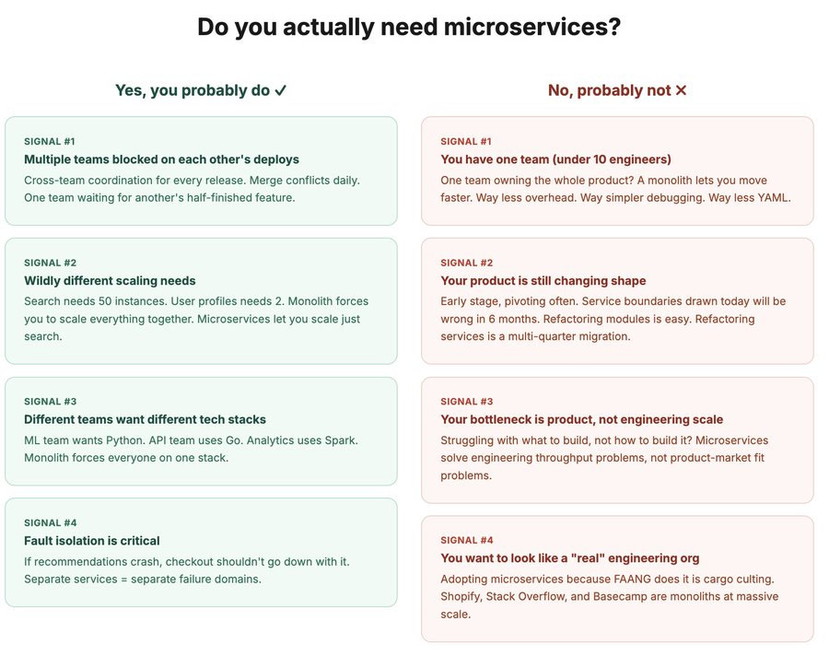

The practical path: start monolith, extract when it hurts
This is the advice I give every team I talk to. And it's boring. And it works.
Phase 1: Well-structured monolith
Clean module boundaries. Order module talks to user module through a defined interface, not by directly querying each other's database tables. Each module could theoretically be a service, but right now it's just good code organisation.
This is what Shopify does at billions of dollars of GMV. What Stack Overflow does serving millions of developers. What Basecamp does running a profitable business with a small team. Monolith is not a dirty word.
Phase 2: Extract the first service when you feel real pain
Common first extractions:
- Auth/identity (shared across everything, rarely changes, clear boundary)
- Email/notification (async, independent, doesn't need to be in the request path)
- File upload/media processing (CPU intensive, different scaling profile)
Extract one service. Get comfortable with the operational overhead. Service discovery. Health checks. Monitoring. Retries. Then extract the next one.
Phase 3: Extract more as the team grows
Each team gets their own service as the org scales. The service boundary mirrors the team boundary. This is Conway's Law in practice: your architecture will eventually reflect your org chart. Use that instead of fighting it.
What to have in place before your first extraction:
- Centralised logging with correlation IDs
- Health check endpoints on every service
- A service mesh or API gateway for routing
- Circuit breakers for inter-service calls
- Distributed tracing (Jaeger, Zipkin, or Datadog)

If you don't have these, you're not ready for microservices. You're just splitting a monolith into a distributed mess.
