Sharding
https://x.com/system_monarch/status/2067617710306160692
Scaling & Architecture, Day 8/25: Sharding 🧵

There's a moment in every growing system's life where someone says "the database is too slow" and someone else says "we need to shard."
And most of the time, that's the wrong call. Not because sharding doesn't work. It works great.
But because there are 4 cheaper things you should try first, and most teams skip straight to the hard one.
But when you actually DO need sharding, it's the most consequential database architecture decision you'll make.
Because unlike most other scaling decisions, sharding is really hard to undo.
Adding a cache? You can remove it tomorrow. Adding a read replica? Easy to tear down. Sharding your database across 16 nodes?
You've just changed the fundamental structure of how your data is stored and queried. Reversing that is a multi-month migration project.

So let me cover this properly:
1. What sharding actually is (and how it's different from partitioning)
2. The three main strategies for distributing data
3. How to choose a shard key (this is where most teams mess up)
4. When to actually shard vs when to do something simpler
What is sharding and how is it different from partitioning?

People confuse these constantly. They're related but they solve different problems at different levels.

Partitioning = splitting data within one database.
You have a 500 million row orders table. You partition it by date. Orders from 2024 live in one partition. Orders from 2025 live in another. All on the same database server.
When you query "get orders from last month," Postgres only scans the recent partition. Skips the other 490 million rows. Big performance win. Zero distributed systems complexity. No network hops. No coordination.
Sharding = splitting data across multiple database servers.
You have more data (or more traffic) than one server can handle. So you spread it across multiple independent database instances. User IDs 1-1M go to Shard 1. User IDs 1M-2M go to Shard 2. And so on.
Each shard is its own database. Its own hardware. Its own connection pool. Its own backups.
Why this difference matters:
Partitioning gives you better query performance on a single machine. It's low-risk, reversible, and doesn't change your application architecture much.
Sharding gives you horizontal scalability. But it introduces distributed systems problems:
- Cross-shard queries become expensive (or impossible)
- Joins across shards don't work the way you expect
- Transactions across shards need distributed coordination
- Rebalancing data when you add a new shard is painful
The rule: partition before you shard. If partitioning solves your problem, you just avoided months of distributed systems headaches.

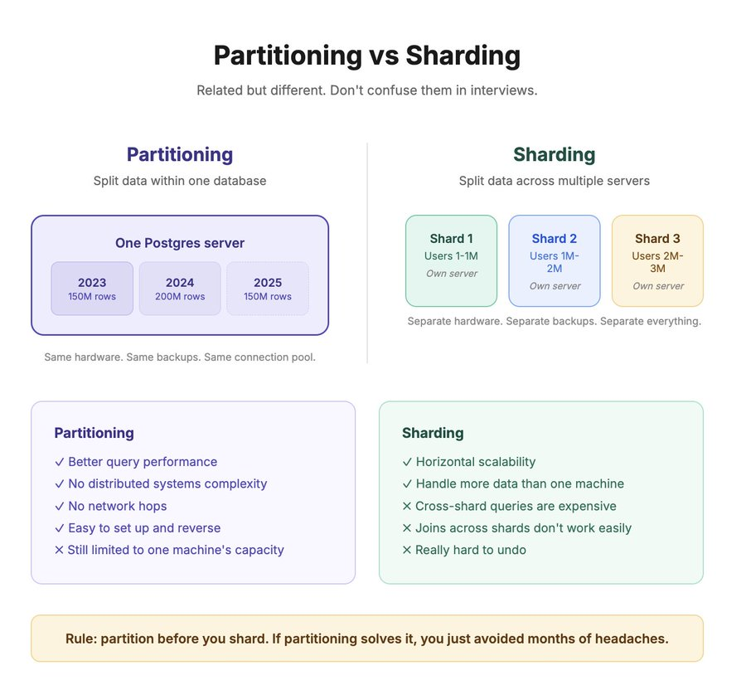

The three sharding strategies
Once you've decided you actually need to shard, you need to decide HOW to split the data across servers. Three main approaches:
1. Range-based sharding
Split data by a range of values. Users A-H go to Shard 1. Users I-P go to Shard 2. Users Q-Z go to Shard 3.
Or by date: January data on Shard 1, February on Shard 2, etc.

The good: range queries are fast. "Get all orders from March" hits exactly one shard. Simple to understand and implement.
The bad: hotspots. If most of your users have names starting with S, Shard 3 is overloaded while Shard 1 is sitting idle. Time-based ranges are even worse. The "current month" shard gets all the traffic while historical shards do nothing.

2. Hash-based sharding
Take the shard key (like user_id), hash it, and use modulo to pick a shard. hash(user_id) % number_of_shards = target shard.
The good: even distribution. The hash function spreads data uniformly regardless of the actual values. No hotspots. If you have 4 shards, each gets roughly 25% of the data.
The bad: range queries are destroyed. "Get all orders from March" now has to hit every single shard because orders are scattered randomly. Adding a new shard means rehashing and moving data around (unless you use consistent hashing, which we'll cover later in the series).
3. Directory-based sharding
Maintain a lookup table that maps each key to its shard. user_id 12345 → Shard 3. user_id 67890 → Shard 1.
The good: maximum flexibility. You can move individual records between shards without changing the strategy. Great for handling hotspot users (move the heavy user to a dedicated shard).
The bad: the lookup table is a single point of failure AND a bottleneck. Every read and write needs to check the directory first. If it goes down, nothing works. Needs its own caching and replication strategy.
Most teams in practice: hash-based sharding with consistent hashing. It gives you even distribution and handles adding/removing shards without reshuffling everything.
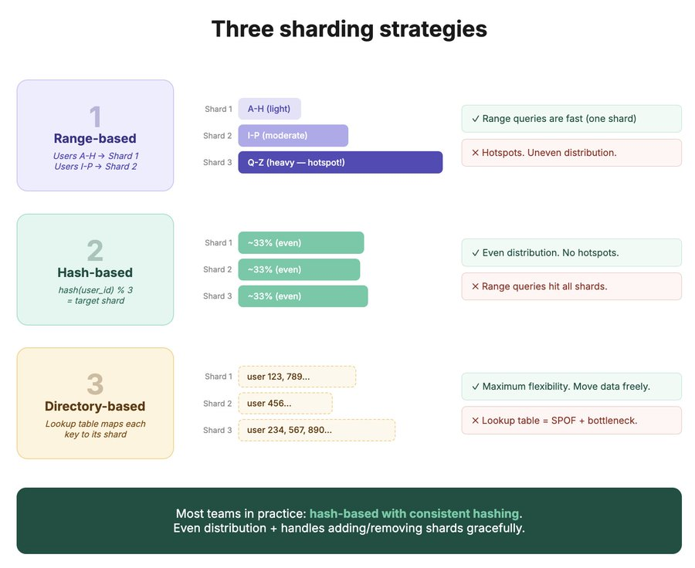

Choosing the shard key
This is the decision that matters most. Get it wrong and you're resharding everything in 18 months. Get it right and you don't think about it for years.
The shard key determines which shard a piece of data lives on. It also determines which queries are fast and which ones become painful.
Rule 1: Shard on the field you query by most
If 90% of your queries include a user_id in the WHERE clause, shard by user_id. That way most queries hit exactly one shard.
If you shard by user_id but most of your queries filter by order_date, every query has to fan out to all shards and aggregate results. That's the worst case.
Rule 2: High cardinality
The shard key needs lots of unique values. Sharding by country sounds logical until you realise 60% of your users are in India. One shard gets 60% of the traffic. That's not sharding. That's creating a bottleneck with extra steps.
Rule 3: Even distribution
The key should spread data evenly across shards. user_id works because it's usually sequential or random. created_date doesn't because all current traffic hits the newest shard.
Rule 4: Avoid cross-shard operations
If your app frequently needs to join orders with user profiles, both should be on the same shard. This means sharding both tables by user_id. That way an order and its user always live together. No cross-shard joins.
This is called "co-located data" and it's the difference between a sharded system that works and one that's constantly doing expensive scatter-gather queries.

Common shard keys by domain:
- Multi-tenant SaaS → tenant_id (all of one customer's data on one shard)
- Social media → user_id (all of a user's posts, likes, follows together)
- E-commerce → customer_id (all orders, cart, wishlist together)
- Time-series/analytics → time bucket + hash (distribute evenly while keeping time ranges queryable)
- Chat/messaging → conversation_id (all messages in one chat on one shard)

The mistake I've seen the most: picking a shard key that makes writes fast but makes the most common read pattern a cross-shard scatter-gather. Always optimise for reads. Writes are usually less frequent.

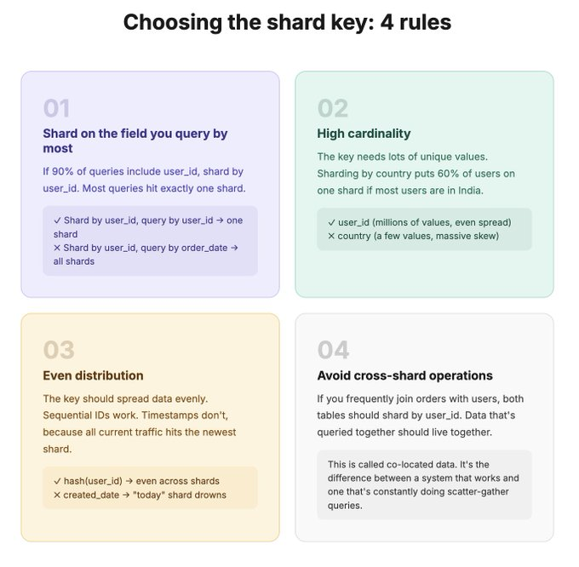
When to actually shard (and what to try first)
Here's the thing. Sharding is powerful but it comes with real costs:
- Application complexity goes up significantly
- Cross-shard queries become painful
- Operational overhead (managing multiple database instances, backups, monitoring per shard)
- Schema changes need to be coordinated across all shards
- Debugging is harder because data is spread out

So before you shard, try these in order:
Step 1: Optimise your queries.
Run EXPLAIN ANALYZE on your slow queries. Add indexes. Fix the N+1 queries. Remove unnecessary JOINs. I've seen teams cut query times by 90% with just this. No infrastructure changes at all.
Step 2: Add connection pooling.
PgBouncer or HikariCP. Your database supports 100 max connections. Without pooling, each app instance opens its own connections. With pooling, 100 connections serve thousands of concurrent requests. Massive improvement, 30 minutes of setup.
Step 3: Add read replicas.
If your workload is read-heavy (and most are), send reads to replicas and writes to the primary. This alone can 5-10x your read capacity. Postgres streaming replication makes this straightforward.
Step 4: Partition large tables.
500 million row table? Partition by date or range. Queries on recent data skip scanning old partitions entirely. Still one database. Still simple.
Step 5: Vertical scaling.
Sounds unsexy but doubling your database server's RAM and CPU is literally zero code changes. If your database is 50GB and your server has 32GB RAM, upgrading to 64GB means the OS page cache holds almost everything in memory. (Remember Day 3? The OS page cache is doing invisible work for you.)
Step 6: NOW consider sharding.
You've done all of the above and you're still hitting limits. Your database is too large for one machine. Your write throughput exceeds what a single primary can handle. Your data set can't fit in memory even with a big server.
THAT is when you shard. Not before.
A rough heuristic:
If your database is under 500GB and you have fewer than 10,000 write operations per second, you probably don't need sharding. The steps above will get you far.
If your database is multiple terabytes with tens of thousands of writes per second, and you've exhausted the options above, sharding is the right move.
