Scaling & Architecture, Day 9/25: Replication
https://x.com/system_monarch/status/2067990363969925169

If your data lives on one machine and that machine dies, your data is gone. Or at the very least, you're offline until you restore from a backup.
And restoring a 200GB backup takes time. A lot of time. Your users are staring at a blank screen the whole while.
Replication solves this. Instead of one copy of your data, you keep multiple copies on different machines. Different racks. Different data centres. Maybe different continents.
But replication isn't just about surviving hardware failure. It's also:
- Read scaling. Send reads to replicas, writes to the primary. Instant 5-10x read capacity.
- Geographic performance. Replica in Mumbai serves Indian users. Replica in Frankfurt serves European users. Lower latency for everyone.
- Zero-downtime maintenance. Need to upgrade the database? Promote a replica to primary, upgrade the old one, add it back as a replica. Users never notice.
The catch? Replication introduces a new problem that doesn't exist with a single database: replication lag.
The gap between when data is written to the primary and when it shows up on the replica.
That gap is where your data lies to you. Let me explain.
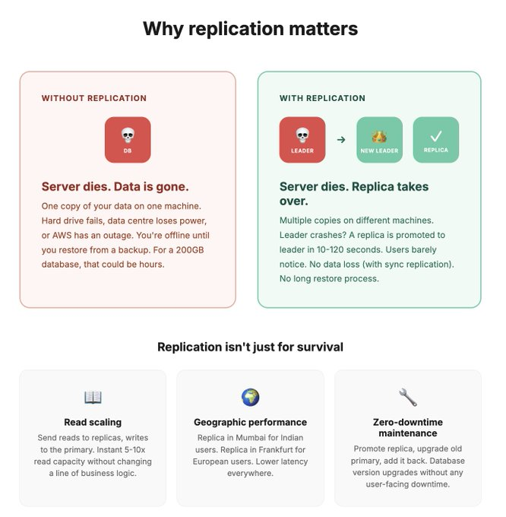
How replication works:
1 - leader-follower
The most common replication setup. One leader (primary) handles all writes. One or more followers (replicas) receive copies of those writes and handle reads.
Here's the actual flow:
1. Client writes "update balance to ₹5000" to the leader
2. Leader writes it to its own storage
3. Leader streams the change to all followers via the WAL (Write-Ahead Log)
4. Each follower applies the change to its own storage
5. Now all copies have the updated balance
Step 3 is where it gets interesting because there are different ways to handle it. And that choice changes everything about your system's behaviour.
Synchronous replication
The leader waits for AT LEAST one follower to confirm it received the change before telling the client "write successful."
Leader: "Here's the new data"
Follower: "Got it, written to disk"
Leader to client: "Done, write confirmed"
What you get: Strong consistency. If the leader dies right after confirming, the follower has the data. No data loss.
What you pay: Slower writes. Every write waits for a network round trip to the follower. If the follower is in a different region, that's 50-100ms added to every write. If the follower goes down, writes either block or fail.
Asynchronous replication
The leader confirms the write immediately, then streams the change to followers in the background. Doesn't wait for them.
Leader to client: "Done, write confirmed"
Leader to follower: (sends data in background, whenever)
Follower: (applies it eventually)
What you get: Fast writes. The client doesn't wait for followers. Write latency is just the leader's local write time.
What you pay: Possible data loss. If the leader dies before the change reaches the follower, that write is gone. The follower gets promoted to leader, but it's missing the most recent writes.

What most production Postgres setups actually use:
semi-synchronous.
One follower is synchronous (guarantees at least one copy). The rest are asynchronous (for speed). If the synchronous follower goes down, one of the async followers gets promoted to synchronous.
Best of both worlds. You get durability (one confirmed copy) without the latency of waiting for all replicas.
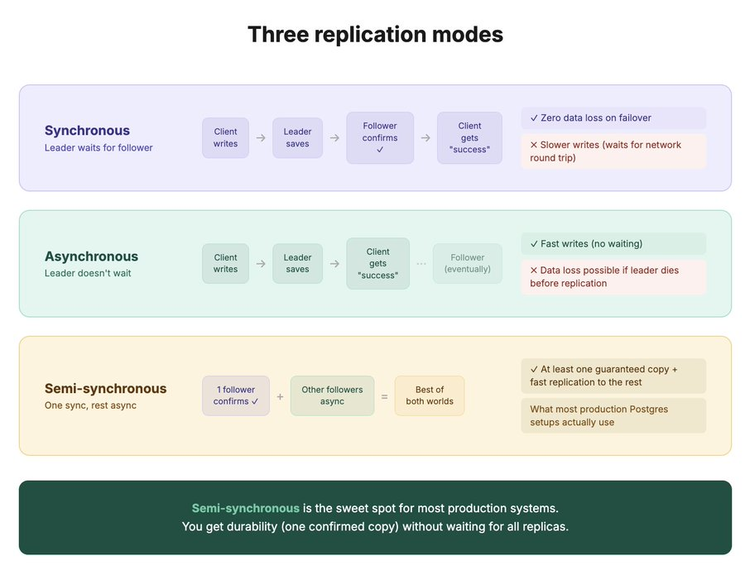

Replication lag: the silent gap where your data lies
This is the part that causes the most production bugs. And it's subtle.
With asynchronous replication (which most read replicas use), there's always a delay between a write hitting the leader and that write appearing on the follower. This delay is called replication lag.
In normal conditions, it's milliseconds. Under heavy load or network congestion, it can be seconds or even minutes.
Here's why that matters with a real scenario:
1. User updates their profile name to "Puneet" (write goes to leader)
2. User immediately refreshes the page (read goes to a replica)
3. The replica hasn't received the update yet
4. User sees their OLD name

They just changed their name and the app is showing the old one. They think the update didn't save. They try again. And again. They file a support ticket saying the app is broken.

This is called "read-your-own-writes" inconsistency. And it's one of the most common bugs in systems with read replicas.

How to fix it:
Option 1:
Route the user's own reads to the leader. After a write, for the next few seconds, send that specific user's reads to the leader instead of a replica. They always see their own changes. Other users read from replicas normally.
Option 2:
Causal consistency. Track the write's position in the WAL. When reading from a replica, wait until the replica has caught up to at least that position. If it hasn't, either wait briefly or fall back to the leader.

Option 3:
Just use the leader for reads that matter. The profile page after an edit? Read from the leader. The public feed? Read from a replica. Not every read needs the same consistency guarantee.
The rule of thumb: monitor your replication lag. Alert on it. If it's consistently above 1 second, something is wrong.
Either the replica is under-provisioned, the network is congested, or the leader is generating WAL faster than the replica can apply it.

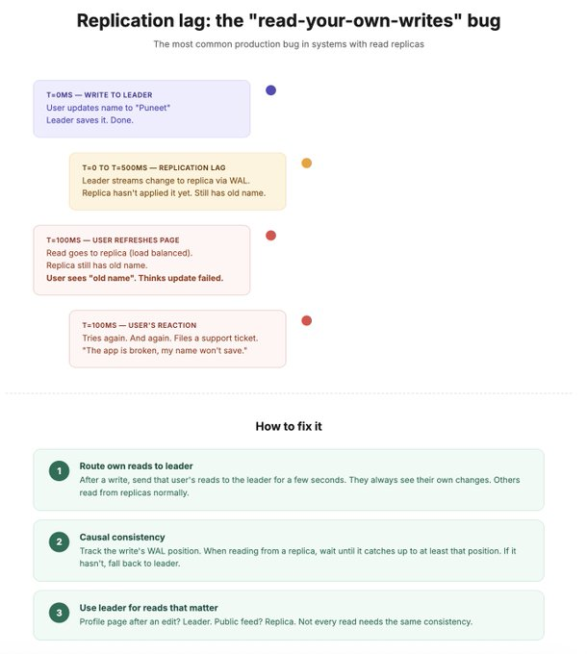

Failover: what happens when the leader dies
This is the moment replication proves its value. The leader crashes. Now what?
Automatic failover (what most managed services do):
1. Followers detect the leader is unresponsive (missed heartbeats)
2. An election happens. The follower with the most up-to-date data becomes the new leader.
3. All other followers start replicating from the new leader
4. DNS or the connection pool is updated to point to the new leader
5. The application reconnects and continues
In managed services like AWS RDS, this happens in 30-120 seconds. In a well-configured self-managed setup with tools like Patroni, it can be under 10 seconds.
The scary parts nobody warns you about:
Split brain.
The old leader comes back after a network partition. It thinks it's still the leader. The new leader also thinks it's the leader.
Now you have two leaders accepting writes independently. Data diverges. This is one of the worst situations in distributed systems.
Fix: fencing.
The moment a new leader is elected, the old leader must be forcefully prevented from accepting writes.
Either kill its process, revoke its network access, or use a STONITH mechanism ("Shoot The Other Node In The Head"). Yes, that's a real term.
Data loss window.
With async replication, the new leader might be missing the last few writes from the old leader. Those writes are gone.
For most applications, losing a few hundred milliseconds of writes during a failover is acceptable. For financial systems, it's not. That's why critical systems use synchronous replication despite the latency cost.

Connection storms.
After failover, every application instance simultaneously tries to reconnect to the new leader. 500 connections all at once. The new leader hasn't warmed up yet. It gets crushed.
Fix:
connection pooling (PgBouncer) between the application and the database. The pooler manages the reconnection storm. Applications reconnect to the pooler. The pooler reconnects to the new leader once. Smooth.
Test your failover. Quarterly. In staging. With a runbook. If you haven't tested failover, you don't have failover. You have a theory.
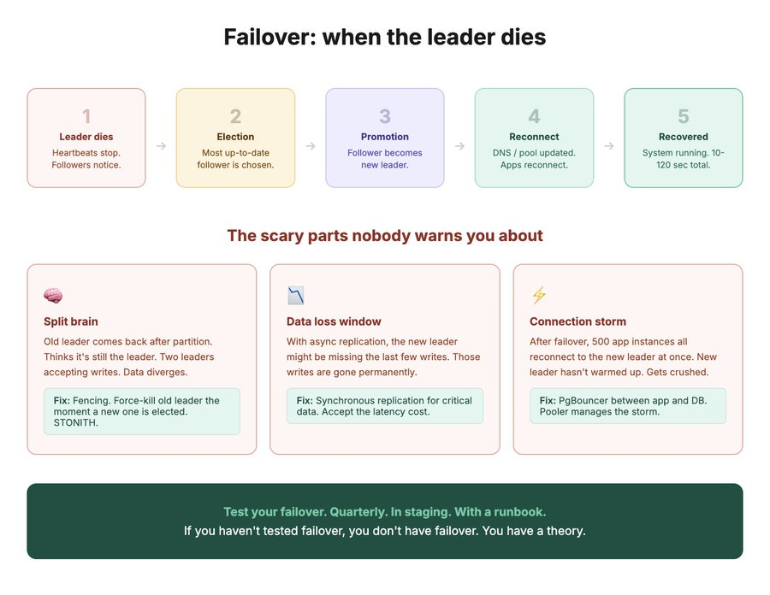

Replication topologies and when to use each
Beyond simple leader-follower, there are a few topologies you should know:
Single leader, multiple followers (the standard)
One primary. 2-5 read replicas. Writes go to the primary. Reads spread across replicas.
Use this for: most applications. Read-heavy workloads (and most are). When you need geographic replicas for latency.
This is the default for a reason. Simple, well-understood, supported by every managed database service.

Multi-leader (leader-leader)
Two or more nodes accept writes independently. Each replicates its writes to the others.
Use this for: multi-region setups where users in both regions need low-latency writes. Think: a global app where users in India and users in the US both need to write data without crossing the ocean for each write.
The tradeoff: write conflicts. Two users update the same record on different leaders at the same time. Now you need a conflict resolution strategy. Last-write-wins. Merge. Application-level resolution. All of them have edge cases. This gets complicated fast.
Leaderless (Dynamo-style)
No leader at all. Any node can accept reads and writes. Writes go to multiple nodes simultaneously. Reads query multiple nodes and resolve conflicts.
Cassandra and DynamoDB use this approach. The consistency level is tunable per operation (write to 2 out of 3 nodes, read from 2 out of 3).
Use this for: very high availability requirements where you can tolerate eventual consistency. The system never goes down because there's no single leader to fail.
The practical takeaway:
Most teams should start with single-leader replication. It handles 90% of use cases. Don't go multi-leader or leaderless unless you have a clear reason (multi-region writes or extreme availability requirements).

When choosing replication mode:
- Reads are slow? Add read replicas. Send reads to followers.
- Need zero data loss on failover? Synchronous replication (or semi-sync).
- Need fast writes? Asynchronous replication. Accept the small data loss risk.
- Multi-region writes? Multi-leader. Budget time for conflict resolution.
- Can't have any downtime ever? Leaderless. Accept eventual consistency.

