LOAD BALANCING: Day 1/25
Your load balancer is lying to you.
It says traffic is "balanced." What it really means is: requests are being distributed. Whether they're distributed well is a completely different question.
I've seen a system with 4 servers where Server 3 was at 95% CPU while Server 1 sat at 12%. The load balancer said everything was fine.
A load balancer doesn't know what's happening inside your servers. It doesn't know one request takes 2ms and the next takes 12 seconds.
Your choice of algorithm, layer, and health check strategy is the difference between actual balance and the illusion of it.
Let me break it down. 🧵Your load balancer is lying to you.

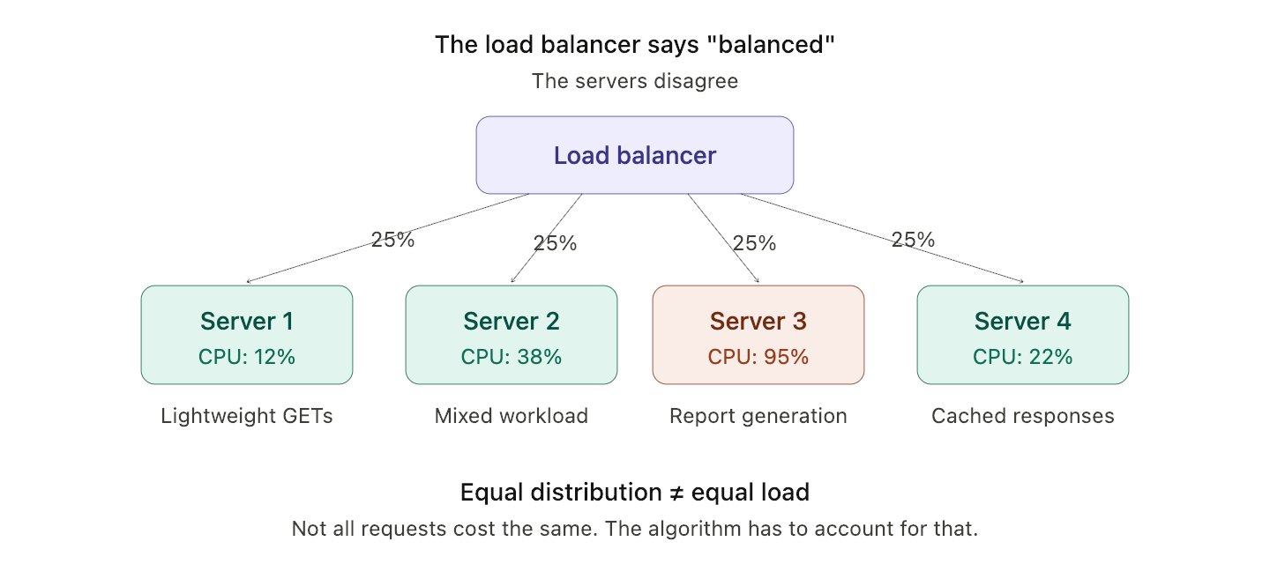

The algorithms:
1) Round-robin → Requests go to servers in rotation. Server 1, 2, 3, 4, 1, 2, 3...
Dead simple. Zero awareness of server state. If Server 3 is drowning, it still gets its turn. Works when all requests cost roughly the same and all servers are identical. Falls apart the moment either assumption breaks.
2) Least connections → Send to whichever server has the fewest active connections.
Smarter. But it still doesn't know that Server 3's 2 connections are both running 30-second report exports while Server 1's 15 connections are all sub-millisecond health checks. Connection count ≠ actual load.
3) Weighted round-robin → Assign weights manually. Server with 8 cores gets 4x the traffic of the server with 2 cores.
Better for heterogeneous hardware. Problem: weights are static. Your traffic patterns aren't. Someone has to tune these, and in practice nobody revisits them after the initial setup.
4) IP hash → Hash the client IP, route to the same server every time.
Gives you sticky sessions without session stores. But one corporate NAT with 10,000 employees behind one IP address just created a hotspot.
5) Least response time → Route to the server responding fastest right now.
The closest thing to "actually aware of server state." Factors in real latency, not just connection count. This is what most production setups should graduate to and most never do.
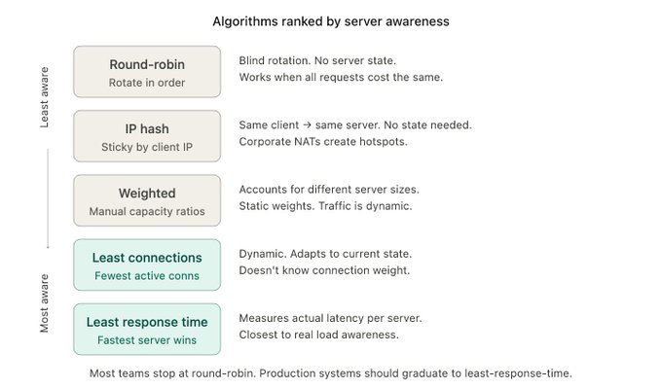

Layer 4 vs Layer 7 (the thing most people skip)
There are two fundamentally different kinds of load balancers, and they operate at different layers of the network stack:
Layer 4 (Transport) → Works at TCP/UDP level. Sees source IP, destination IP, port numbers. That's it.
Makes routing decisions based on connection metadata without ever reading the request body.
Fast. Cheap. Dumb. Doesn't know if it's routing an API call or an image download. Doesn't know the URL, the headers, or the cookies.
Use for: high-throughput, protocol-agnostic balancing. TCP pass-through. When you need raw speed and don't need content-aware routing.
Layer 7 (Application) → Works at HTTP level. Reads the full request: URL path, headers, cookies, even the body.
This is where the real power is:
→ Route /api/ to backend service, /static/ to CDN origin
→ Route premium users to beefier servers based on a cookie
→ A/B test by routing 5% of traffic to a canary based on the URL
→ Terminate TLS and inspect the request before forwarding
Slower per-request. Way more powerful. This is what NGINX, HAProxy (in HTTP mode), ALB, and Envoy do.
Most production systems use both: L4 in front for raw throughput and connection distribution, L7 behind it for intelligent routing.
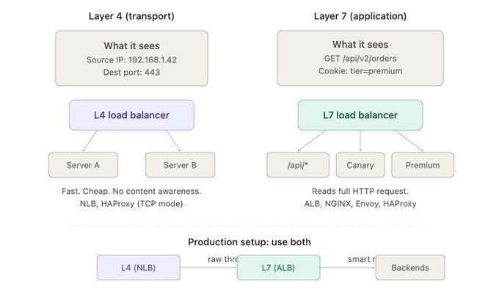

Health checks (when servers die silently)
Your load balancer can only route to servers it thinks are alive.
The word "thinks" is doing a lot of heavy lifting there.
Health checks come in two flavors:
Active health checks → The load balancer pings each server at a fixed interval. "Are you alive?" If the server responds 200 OK, it stays in the pool. If it fails N consecutive checks, it's pulled out.
Simple. But there's a gap: if your interval is 10 seconds and your server dies at second 1, you're sending 9 seconds of traffic to a dead server. Users see errors.
Shorter intervals = faster detection = more network overhead. Tradeoff.
Passive health checks → The load balancer watches actual traffic responses. If a server starts returning 500s or timing out on real requests, it's flagged unhealthy.
No polling overhead. Detection is based on real failures. But it needs actual traffic to detect the problem, a server with no requests won't be caught.
The real production setup: both.
Active checks for baseline "are you there?" detection. Passive checks for "you're alive but broken" detection.
And here's the part nobody remembers to configure: the recovery policy. When a server comes back, do you slam it with full traffic immediately? Or ramp up gradually?
Most load balancers support slow-start. Most teams never enable it. The server comes back, gets crushed with backlog, and dies again.
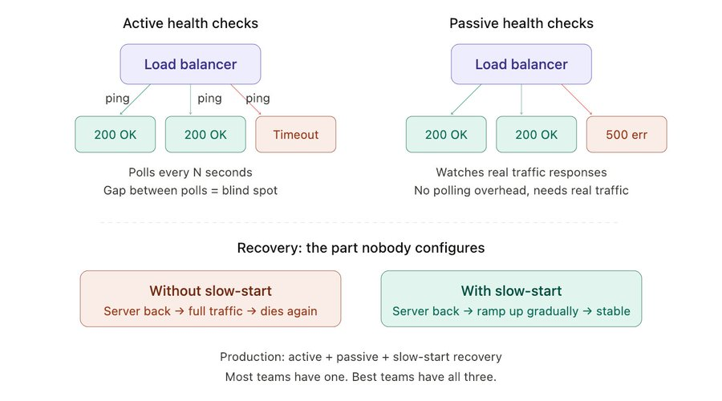
Production lessons + what to do with this
So here's how to actually think about load balancing when you're designing or reviewing a system:
Step 1 → Know your traffic profile.
Are all requests roughly the same weight? Round-robin is fine. Are some requests 1000x more expensive? You need least-response-time or weighted routing.
Step 2 → Pick your layer.
Serving static content + APIs from the same domain? You need L7 to route by path. Pure TCP passthrough for databases or message brokers? L4 is faster and simpler.
Step 3 → Configure health checks properly.
Active + passive. Tune the interval. Set a sane failure threshold (3 consecutive failures, not 1). Enable slow-start recovery. Test what happens when a server goes down.
Step 4 → Monitor the balancer itself.
Load balancers can become bottlenecks. Track: connection count per backend, request distribution variance, 5xx rate per target, and latency added by the balancer itself.
Step 5 → Revisit every 6 months.
Your traffic patterns change. Your server fleet changes. That config you set in January might be completely wrong by July.
The load balancer is the first thing traffic hits and the last thing most teams think about. Don't be that team.

