Day 2/25: CDN
Most people think CDN = "makes images load faster."
That is like saying a seatbelt = "a piece of fabric."
Technically true. Completely misses the point.
A CDN is a network of servers sitting in cities all over the world. User in Mumbai? Served from Mumbai. User in Berlin? Served from Berlin. Your actual server in Virginia doesn't even hear about it.
But the real magic is not speed. It's protection.
Quick math:
- 10,000 requests/sec hitting your app
- CDN handles 92% of them at the edge
- Your backend sees ~800
That's it. 800. The other 9,200 never touch your infra.
Your origin should be handling:
- Cache misses
- Writes
- Truly dynamic stuff
Everything else? Answered before it reaches your data centre.

The teams that scale best aren't the ones with the fanciest backends. They're the ones who figured out how to keep traffic away from the backend.
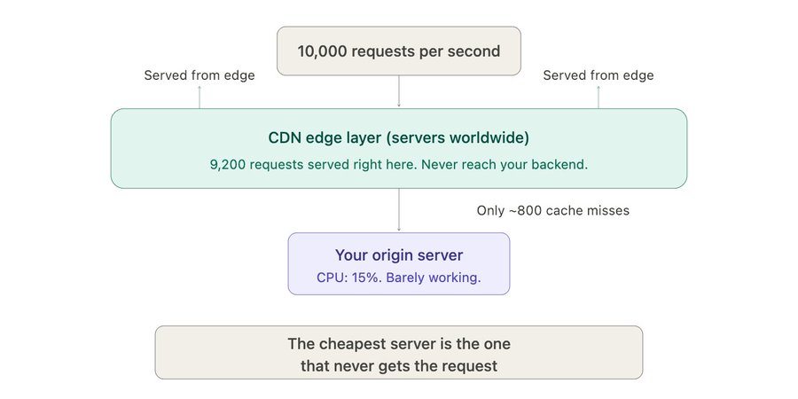
How does content actually end up on those edge servers?
1. Pull-based (what 95% of teams use)
Edge server starts empty. First user in Mumbai requests something. Edge doesn't have it. Goes to your origin, grabs it, caches it, serves it.
Every user after that in Mumbai? Instant. Served from cache.
The catch: that first user pays a penalty. Their request does a full round trip to origin. Could be 200-300ms extra. Everyone after them gets the fast version though.
For most apps this is totally fine. Set it up once, forget about it.
2. Push-based (for big moments)
YOU push content to all edges before anyone asks for it. Pre-warm the cache.
When do you need this?
- Game launches (5M players downloading the same patch file)
- Live events (millions hitting one page at the same second)
- Anything where that first-request penalty is a disaster
One thing people miss: how does the user even reach the right edge?
When the browser does a DNS lookup, the CDN's DNS (Anycast/GeoDNS) routes them to the closest PoP by actual network latency. Not just geography.
Mumbai user might hit Singapore if the Mumbai node is overloaded. Totally automatic. You never configure this.

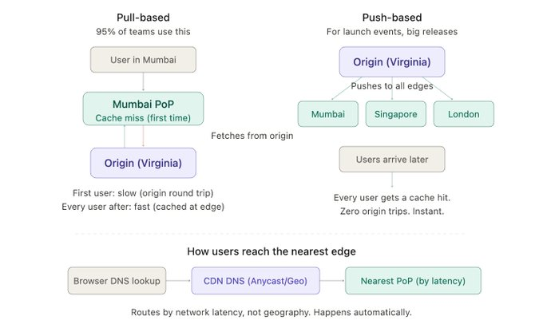
One metric tells you if your CDN is doing its job:
Cache hit ratio = requests served from edge / total requests
Here's the rough scale:
- Below 80% → your CDN is an expensive proxy doing very little
- 85-90% → solid, most good production systems sit here
- 95%+ → your origin is basically retired
Most teams cache images, CSS, JS and call it a day. They plateau around 65% and wonder why the origin is still getting hammered.
Because they're missing the stuff that looks dynamic but isn't.
Things you should be caching that you probably aren't:
1. API responses — if /api/products returns the same JSON for everyone, why is it hitting your backend every time? 30 second TTL. Done. I've seen this single change drop origin traffic from 10K rps to 300.
2. HTML fragments — your header, footer, nav. Same for every user. Cache them separately at the edge.
3. GraphQL results — tricky because POST, but Fastly and CloudFront can cache by request body hash. Turns a 200ms query into 5ms.
4. Per-cohort data — "all premium users see the same dashboard layout." You're not caching per-user. You're caching per-tier using Vary headers.
5. DNS + TLS — people forget this. DNS lookup: 50ms. TLS handshake: 50-100ms. CDN edge handles both locally. That's 100-200ms off every first connection.
Getting to 95% isn't about caching more file types. It's about spotting the things that look dynamic but are actually the same for everyone (or for a whole group).

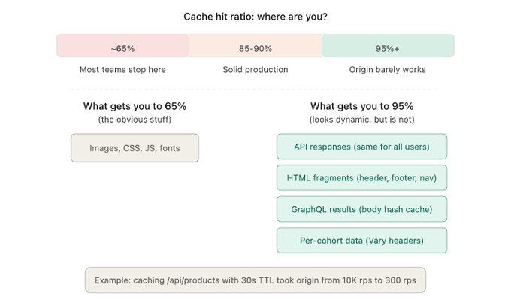

Caching at the CDN? Easy.
Knowing when to clear it? That's where it gets fun.
Scenario: you deploy a bug fix. API now returns corrected data. But CDN edges worldwide are still happily serving the old, broken response. And they'll keep doing it until the cache expires.
Three ways to deal with this:
1. TTL-based expiry (the simple one)
Set a timer. Content expires automatically.
Some rules of thumb:
- Changes every few hours → 5 min TTL
- Changes daily → 1 hour TTL
- Versioned assets (app-v2.3.1.js) → 1 year (filename changes with each version, so it doesn't matter)
The tradeoff: if TTL is 60 seconds, users might see stale data for up to 60 seconds after a change. That's it. For 80% of use cases, totally fine.
2. Purge API (the manual override)
Force-clear content from all edges immediately. Every CDN has this. CloudFront invalidations, Fastly instant purge, Cloudflare cache purge.
The catch: if you purge 10,000 URLs after a deploy, all edges suddenly have empty caches. They ALL go fetch from origin at the same time. Thundering herd. Your origin gets crushed.
Good for: targeted fixes on a few URLs.
Bad for: bulk clearing after every deploy.
3. Stale-while-revalidate (the one you should actually use)
This is my go-to for almost everything:
Cache-Control: max-age=60, stale-while-revalidate=30
What this means:
- Content is fresh for 60 seconds
- After that, serve the stale version instantly to the user
- But in the background, go fetch the fresh version from origin
- Next user gets the updated content
User never waits. Ever. Freshness catches up within seconds. No thundering herd.
If you take one thing from this entire thread: use stale-while-revalidate. It fixes 90% of CDN cache headaches.
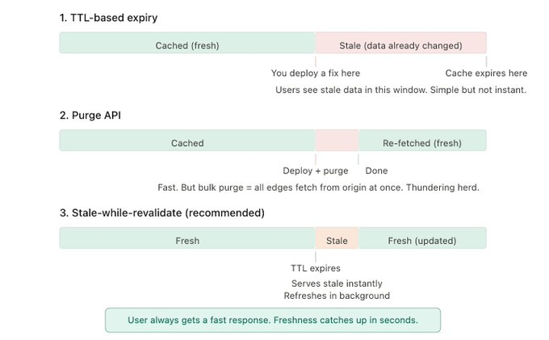

Where CDNs are heading (and why it changes how you architect things):
Traditional CDN → cache files at the edge
Modern CDN → run actual code at the edge
Cloudflare Workers, Lambda@Edge, Fastly Compute, Vercel Edge Functions. These let you run logic at the CDN layer:
- Auth validation — token expired? Return 401 at the edge. Backend never knows someone tried.
- A/B testing — route 5% of traffic to a variant by modifying the response at the edge. Zero backend changes.
- Geo-personalisation — different pricing, language, content based on location. All at the edge.
- Response transforms — Client A wants 5 fields, Client B wants 12. Transform the same cached response differently per client.
This blurs the line between "CDN" and "distributed app server." Your origin handles writes and heavy computation. The edge handles everything else.
How I think about CDN when designing a system:
1. What's the read-to-write ratio? If it's anywhere near 100:1 (most systems), the CDN is your most important layer. Full stop.
2. Classify content by change frequency:
- Never changes → long TTL
- Changes hourly → short TTL + stale-while-revalidate
- Changes per-request → don't cache (or cache per-cohort)
3. Measure cache hit ratio every week. Below 85%? You're leaving free performance on the table.
4. Move read-heavy, latency-sensitive logic to the edge. Auth checks. Geo-routing. Response transforms.
A CDN is not something you bolt on when the site gets slow. It's architecture decision you make on day one.
