Caching.

Day 3 of the Scaling & Architecture series.
I'll discuss the actual 5 layers where caching happens in a production system.
Most engineers know maybe 2 of them. The other 3 are doing work behind the scenes that you've probably never configured and thought about.
One of them is invisible. Your OS is doing it right now without you asking.
Layer 1: Browser cache
This is the fastest cache in existence. Literally 0ms. No network call. No server involved. The browser already has the data sitting on the user's device.
How it works:
Your server sends a response with a Cache-Control header. That header tells the browser "you can keep this for X seconds, don't bother asking me again."
Example:
Cache-Control: max-age=86400 (cache for 24 hours)
Browser sees this, stores the response locally. Next time the user needs it? Loaded from disk. Instant.
What to cache here:
- CSS, JS bundles (version them in the filename: app-v2.4.js)
- Images, fonts, icons
- API responses that don't change often (product listings, config data)
What NOT to cache here:
- User-specific data (you'll serve user A's data to user B if they share a device)
- Anything that needs to be fresh within seconds
The gotcha most people hit: you cached app.js with a 1 year TTL. Now you deploy a fix. Users still have the old file. Their browser won't even check for updates because the TTL hasn't expired.
Fix: version your filenames. app-v2.4.js becomes app-v2.5.js. New filename = new cache entry. Old one just expires naturally.

Layer 2: CDN edge
I covered this in depth yesterday (Day 2), so quick recap:
CDN = servers in cities around the world. User request gets answered by the nearest server instead of traveling to your origin.
Key numbers:
- Latency: 5-20ms (vs 200-300ms to origin)
- Good cache hit ratio: 85-90%
- Great cache hit ratio: 95%+
What to cache here: everything from Layer 1 PLUS API responses, HTML fragments, and per-cohort content using Vary headers.
The big difference between Layer 1 and Layer 2:
Browser cache is per-user. Only that one user benefits.
CDN cache is per-region. ONE cache fill serves thousands of users in that area.
So even if the browser cache misses, the CDN probably has it. Two layers of defense before anything reaches your server.
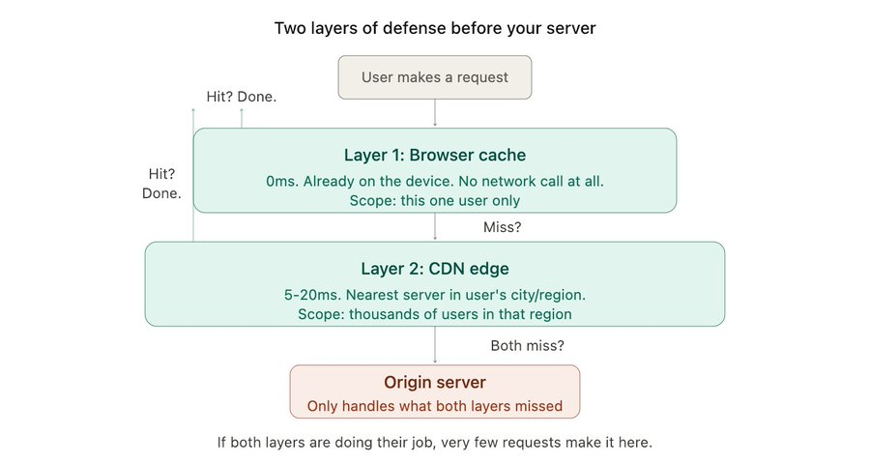

Layer 3: Application cache (Redis / Memcached)
Ok this is the one everyone knows. The one people mean when they say "let's add caching."
But honestly? Most teams use it wrong. They throw Redis in front of their database and call it a day. Then wonder why it doesn't help much.
Let me break down how to actually think about it.
What it does:
Your app stores frequently-accessed data in an in-memory store (Redis, Memcached). Reading from memory is ~1-5ms. Reading from a database is 20-100ms. That's a 10-50x speedup.
The pattern that works (cache-aside):
1. App gets a request
2. Check Redis: "do I have this?"
3. YES → return it (cache hit, 1-2ms)
4. NO → query the database, store result in Redis, return it
5. Next request for same data → step 3 (fast path)
Simple. Effective. This is what 90% of teams should start with.
What to put in it:
- Results of expensive queries (aggregations, joins across big tables)
- Session data
- Frequently accessed objects (user profiles, product details, configs)
- Computed results (leaderboards, recommendation lists, feed rankings)
- Rate limiting counters
What NOT to put in it:
- Data that changes every request (you'll invalidate more than you serve)
- Very large objects (eating up memory for stuff that's rarely accessed)
- Data where staleness = real money lost (use the database directly)
Redis vs Memcached:
People ask this all the time. Simple answer:
Memcached: pure key-value. Multi-threaded. Dead simple. If all you need is "store this string, get this string," it's faster and lighter.

Redis: key-value PLUS data structures. Sorted sets, lists, pub/sub, Lua scripting. If you need a leaderboard, a rate limiter, a queue, or anything beyond simple get/set, Redis.
Most teams pick Redis because it does everything. That's fine. But if you're running a massive session cache and literally just need get/set at high throughput, Memcached is worth considering.
The mistake I see most often:
Teams cache everything with a 1 hour TTL and never think about invalidation. Then users see stale data and they blame caching itself.
Caching isn't the problem. Lazy TTLs are the problem. More on invalidation in tomorrow's thread (Day 4).
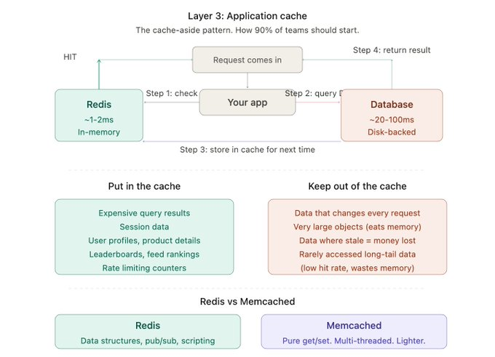
Layer 4: Database query cache
This one is sneaky. It exists inside your database and most engineers don't even know it's there.
MySQL:
MySQL (before 8.0) had a built-in query cache. Exact same SQL query comes in? Returns the cached result without re-executing. Zero work.
Sounds amazing but it had a brutal flaw: any write to a table invalidated ALL cached queries for that table. On a write-heavy system, the cache was getting blown up constantly. MySQL 8.0 removed it entirely because it caused more problems than it solved.

Postgres:
Postgres doesn't have a traditional query cache. But it has something arguably more useful:
- Prepared statements: parse and plan the query once, execute many times. Skips the parsing and planning overhead on repeat queries. This matters when you're running the same query shape thousands of times per second.
- Shared buffers: Postgres keeps frequently accessed data pages in shared memory. Not exactly a "query cache" but it means hot data stays in RAM within the database process itself.
- Connection-level caches: each connection caches catalog lookups, parsed queries, and execution plans. This is why connection pooling (PgBouncer) matters. Long-lived connections = warm caches. New connections start cold.
The practical takeaway:
You probably won't configure this layer directly. But you should understand it exists because it explains why:
- Your second run of a query is faster than the first
- Connection pooling has such a big impact on performance
- Write-heavy workloads don't benefit much from query caching

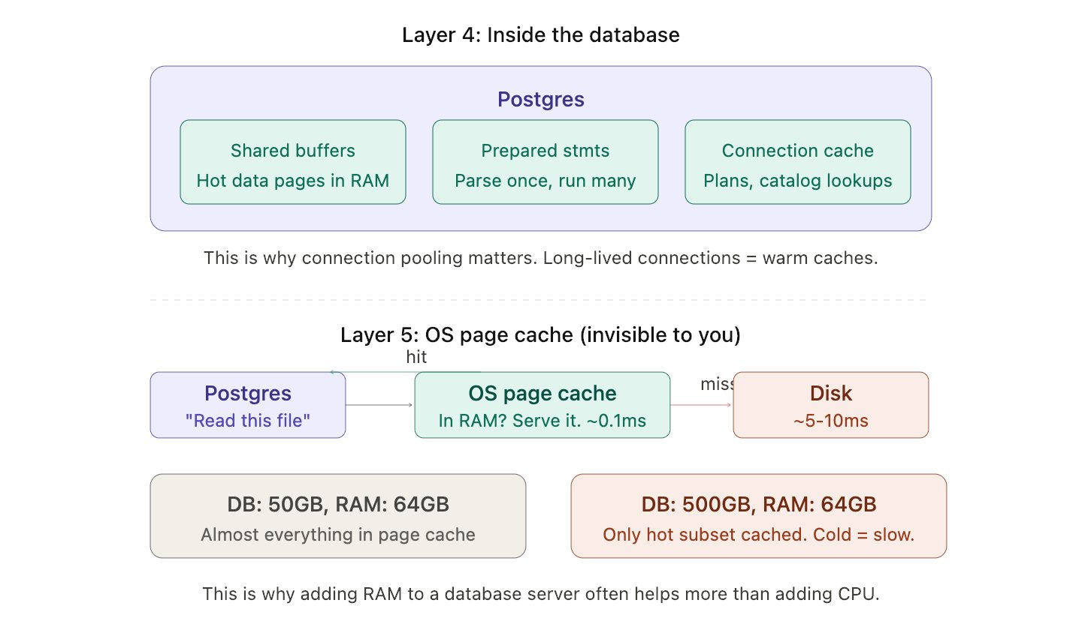
Layer 5: OS page cache
This one blew my mind when I first learned about it.
Your operating system is already caching your database's disk reads. Without you doing anything. Without you configuring anything.
Here's what happens:
1. Postgres asks the OS to read a data file from disk
2. OS reads it from disk (~5-10ms)
3. OS stores a copy in RAM (the "page cache")
4. Next time Postgres asks for the same file? OS serves it from RAM (~0.1ms)
This is why a database that "fits in memory" is fast even without Redis. The OS page cache is doing the heavy lifting behind the scenes.
Why this matters:
- If your database is 50GB and your server has 64GB RAM, almost everything lives in the page cache. Reads are basically memory-speed.
- If your database is 500GB and your server has 64GB RAM, only the hot subset is cached. Cold reads still hit disk.
- This is why adding more RAM to a database server often helps more than adding more CPU.

The hidden trap:
Other processes on the same server compete for page cache.
Running a memory-hungry batch job on your database server? It evicts your database pages from cache. Suddenly all queries slow down.
This is why production databases run on dedicated machines.

Architect Decision
Right. So you've got 5 layers. How do you actually use this?
Not by turning all of them on and hoping for the best. That's how you get stale data everywhere and zero idea which layer is serving what.
Here's how I think about it:
Start from the top. Layer 1 (browser) and Layer 2 (CDN) are the cheapest wins. They require almost no code changes. Just headers.
Before you add Redis, ask yourself: can I solve this with a Cache-Control header? If your API response doesn't change for 30 seconds, a single header does what Redis would do, with zero infrastructure.
Only add Layer 3 (Redis) when you need it. Specifically when:
- The same expensive query runs hundreds of times per second
- You need to cache computed results (not raw DB rows)
- You need shared state across multiple app instances (sessions, rate limits)
- Your database is the bottleneck and you've already optimised queries + added indexes
Layer 4 and 5, just understand they exist. You won't configure them directly most of the time. But knowing about them explains weird stuff. Like why a query is fast the second time. Or why your database gets slow when someone runs a batch job on the same server.
The question to ask for each piece of data:
1. How often does this change?
2. How many people see the exact same version?
3. What's the cost of showing stale data for 30 seconds?
If it changes rarely, lots of people see the same thing, and 30 seconds of staleness doesn't matter? Cache it as close to the user as possible.
If it changes constantly, is unique per user, and staleness = lost money? Don't cache it. Just make the query fast.
Everything else falls somewhere in between. And that's where your judgment as an engineer matters.
Quick cheat sheet:
Scenario → Best layer
1) Static assets (CSS/JS/images) → Browser + CDN
2) API response same for everyone → CDN (short TTL)
3) Expensive computed result → Redis
4) Frequently accessed DB rows → Redis + DB shared buffers
5) User session data → Redis
6) Data that must be real-time → Don't cache. Optimise the query.
