**Assignment for implementing below scenarios in outlook.com on mobile version of website:**

**Scenarios:**

**1. Add a contact in outlook:**

**i. Go to people module (by clicking the icon in bottom) after performing the prerequisites and click the plus button on the top right corner.**

|  |  |  |  |  |
| --- | --- | --- | --- | --- |
| S.no | Error scenario | How it should have been handled according to you | How it is currently being handled | Possible reasons for deviation of your preferences from the current way of handling |
| 1 | No check when user enters numbers in first name and last name field | When user enters numbers in names field the error message should say only characters – alphabets are allowed | Even when user enters numbers in names field it is accepting as contact | No check is implemented to check value entered in these fields |
| 2 | No check when user enters words in phone number field | When user enters words in phone number field the error message should say only numbers are allowed | The add contact is accepting if the user enters words in phone number field | No check is implemented to check value entered in these fields |
| 3 | No check when user enters special characters in first name and last name field | When user enters special characters in names field the error message should say only– alphabets are allowed | Even when user enters special characters in names field it is accepting as contact | No check is implemented to check value entered in these fields |

Supporting screenshots for error scenarios:

1 and 2 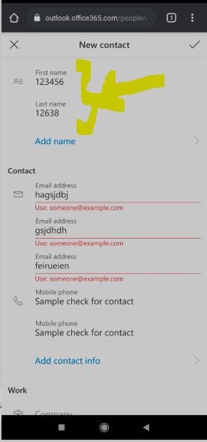

3 