**Assignment for implementing below scenarios in outlook.com on mobile version of website:**

**Scenarios:**

**1. Compose an email in outlook:**

**i. Go to mail (by clicking in bottom menu bar) after performing the prerequisites and click the plus button on the top right corner.**

**Scenario 1:**

Horizontal Scroll down option missing for viewing the attached images

For example, while creating a mail the user might directly start attaching image from mobile device but

Once the user attaches the image, but the user cannot scroll up/down to see the full image user has attached

**Scenario 2:**

Even if the user has added more than 3 images only 1 image is seen and getting added in that mail.

**Scenario 3:**

Unable to delete the attached image is user wishes to delete the image by mistake

**Scenario 4:**

Vertical scroll down option missing for files added using attachment option

**Scenario 5:**

Even if the user has added more than 3 images only 1 image is seen and getting added in that mail.

1. Unable to delete the attached image is user wishes to delete the image by mistake
2. Vertical scroll down option missing for files added using attachment option

For example, while creating a mail the user attaches 5 attachment (JPG) files but there is no vertical scroll down to see the name of 5 files instead only the last added file name is available to view no option to see the other 4 added file names 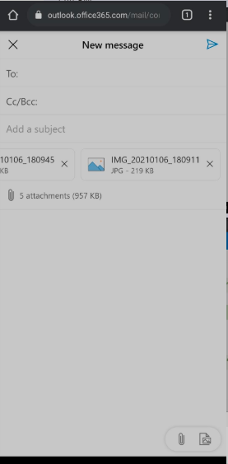

**Scenario 6:**

**cc/bcc option is getting clickable only once**

The cc/bcc option is getting clickable only once i.e., first time it expands and shows cc and bcc in two different line

But when we click it next time it is not responding.

**Scenario 7:**

Unable to attach multiple images together through attachments – when there is “n” number of images needs to send the user should be notified only 1 image can be selected at a time or else user keeps on selecting multiple images but then at the end only 1 image is getting attached