**Assignment for implementing below scenarios in outlook.com on mobile version of website:**

**Scenarios:**

**1. Create an event in outlook calendar:**

**i. Go to calendar module (by clicking the icon in the bottom bar with the current date mentioned) after performing the prerequisites and click the plus button on the top right corner.**

Scenario 2:

|  |  |  |  |  |
| --- | --- | --- | --- | --- |
| S.no | Error scenario | How it should have been handled according to you | How it is currently being handled | Possible reasons for deviation of your preferences from the current way of handling |
| 1 | Event creation for past dates is allowed | Event creation should not be allowed for past dates only today and future dates should be selected. | No error message or alert to indicate past date is being selected for event creation | No check is being implemented for the date field in event |
| 2 | Multiple events for same time are allowed | More than one event can’t be allowed in a specific time frame – even if this functionality is allowed there should be warning to user saying that already existing event is present for the same time duration | Warning message should be given if a user creates multiple events for the same time duration | No check implemented for the time assigned for an event. |
| 3 | Empty title for an event is allowed | Event can’t be blank at least single word or a character should be added in title | No error message when user leaves the title of event empty | Add title field should have check if left empty, this check is not implemented |
| 4 | Numbers are allowed in title | Event can’t have any number as title, even if number is allowed user should be alerted title can be alpha numerical but not just numerical | No error or warning message when user enters number in title field | Add title field should have check the value type, this check is not implemented |

Supporting screenshots for error scenarios:

1 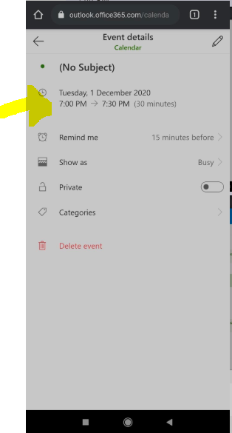

2 and 3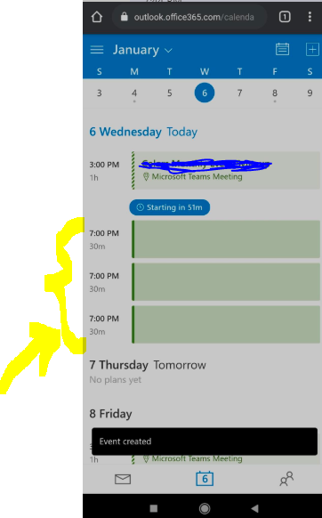

4 