fig3_byte_size.svg

fig3_byte_size.emf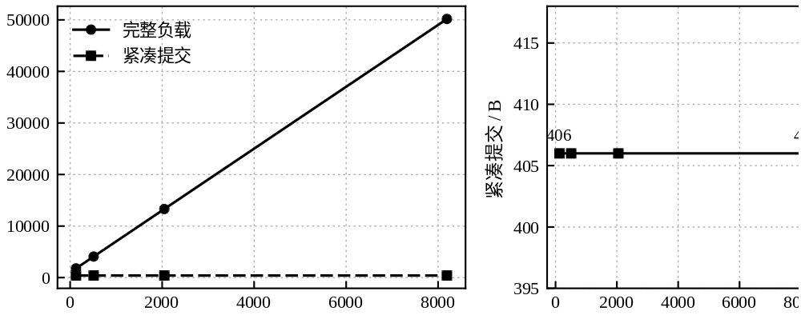

fig1_architecture.svg

fig1_architecture.emf