Mapping the CD4⁺ T-cell ICB-Resistance State to Perturb-seq Regulators
A Figure-5-style reproduction of the genome-scale CD4⁺ Perturb-seq analysis, reframed around a checkpoint-immunotherapy responder-vs-non-responder (R-vs-NR) signature in melanoma.

Project overview
This project asks a translational question on top of a genome-scale CD4⁺ T-cell Perturb-seq atlas: which single-gene knockdowns reproduce the transcriptional state that separates immune-checkpoint-blockade (ICB) non-responders from responders in melanoma? The published source analysis builds a young-vs-old "aging" signature and finds the perturbations that recreate it. We kept the same modeling machinery but swapped the target signature for a clinically defined one — the CD4⁺ program that distinguishes patients whose melanoma responds to ICB from those whose does not. The output is a ranked list of regulators whose loss pushes healthy CD4⁺ cells toward the non-responder state, and, at the actionable end, a set of already-approved drugs that hit the responder-reproducing axis.

What we investigated
We defined a CD4⁺ R-vs-NR gene signature from a melanoma ICB single-cell cohort, then trained a regularized regression model to predict that signature from the perturbation effects of ~2,600 gene knockdowns measured across three CD4⁺ culture conditions (resting, 8-hour and 48-hour stimulation). Two questions organized the work:
- Can a healthy-donor perturbation atlas predict the clinical resistance signature at all, and how well relative to a fair statistical ceiling?
- Which specific regulators reproduce the resistance vs the response state, and are any of them druggable with existing compounds?

Data
Cohort | Accession | Compartment | Platform | CD4 cells | Samples (R / NR)
Sade-Feldman melanoma | GSE120575 | Tumor | Smart-seq2 TPM | 5,391 | 43 (16 R / 27 NR)

A third cohort (Yost BCC/SCC, GSE123813) had clean CD4 subsets but its response labels were locked in an unreachable supplementary table this session, so it was deferred.

How it was done
- Signature. CD4⁺ cells isolated from the cohort, pseudobulked per patient, DESeq2 non-responder-vs-responder; per-gene z-score = log₂FC / lfcSE — identical to the source paper's definition.
- Perturbation matrix. The genome-scale CD4⁺ Perturb-seq atlas (GWCD4i.DE_stats), subset to the 7,874 knockdown×condition profiles passing the ≥10-DE-gene filter; z-score layer, on-target (cis) diagonal effects masked.
- Model. Perturb2StateModel (ElasticNet + TruncatedSVD PCA, 5-fold cross-validation) regressing the signature onto the perturbation matrix, fit separately per culture condition.

Figure 5 — summary of results
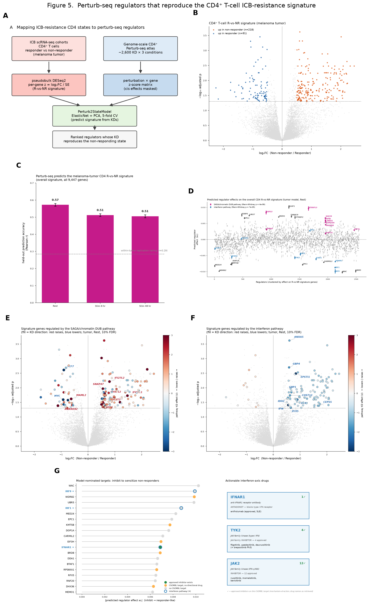
Figure 5. Perturb-seq regulators that reproduce the CD4⁺ T-cell ICB-resistance signature. (A) Analysis schematic. (B) R-vs-NR signature volcano (melanoma tumor): 218 genes up in non-responders, 91 up in responders. (C) Held-out prediction accuracy per condition, against the within-tumor replication ceiling (r=0.29). (D) Predicted regulator effects, with the SAGA/chromatin-DUB and interferon pathways highlighted. (E, F) Signature genes controlled by the SAGA and interferon pathways, colored by knockdown direction. (G) Model-nominated targets and the approved interferon-axis drugs that hit them.

What we found

1. The melanoma-tumor CD4⁺ resistance signature recapitulates known ICB-resistance biology.
A CD38⁺CD39⁺ "T-eee" exhaustion program (mean z ≈ +1.7) and a cytotoxic-CD4 program (mean z ≈ +2.0) are up in non-responders, while responders show the LEF1 / TCF7 / FOXP1 stem-memory program. In the volcano, 218 genes are up in non-responders and 91 up in responders (Panel B).

2. The healthy-donor Perturb-seq atlas predicts the tumor signature strongly (Panels C, D).
Held-out Pearson r | Rest | Stim 8 hr | Stim 48 hr
Tumor CD4⁺ | 0.57 | 0.51 | 0.51

Every model clears the within-tumor discovery-vs-replication ceiling (patient split, r = 0.29). In plain terms: a perturbation atlas built entirely from healthy-donor CD4⁺ cells reproduces the melanoma resistance state better than one half of the melanoma cohort predicts the other half. That is the central positive result — cell-intrinsic transcriptional regulators, mapped in healthy cells, carry real information about the clinical resistance program.

3. Two opposing pathways drive the axis (Panels D–F).
Two pathways dominate the tumor model, in opposite directions:
- Reproduce the RESISTANCE state (knockdown → non-responder-like): ELOF1 and the SAGA deubiquitinase pathway (ATXN7L3 / USP22 / SGF29), plus LIN37, FUBP1, YTHDF2. Signed knockdown analysis shows the SAGA pathway natively restrains the proliferation program — losing it raises the resistance genes.
- Reproduce the RESPONSE state (knockdown → responder-like): the interferon pathway leads — IRF9 and IRF1 rank high, with IFNAR1 and BRD8 just outside the top 10 (WAC, WDR82, UBR5, MED24, EPC1, KMT5B, DOP1A, CARMIL2 fill out the list). Native interferon signaling activates the resistance/proliferation program, so inhibiting this axis pushes cells toward the responder state.
Both pathways converge on the same shared cell-cycle/proliferation genes that define the R-vs-NR axis, but with opposite regulatory sign — interferon knockdown lowers them, SAGA knockdown raises them.

4. The responder-reproducing axis is druggable with approved compounds (Panel G).
Because a small-molecule inhibitor mimics a knockdown, the response-reproducing (negative-coefficient) regulators are the ones worth inhibiting to sensitize non-responders. Screening these against ChEMBL, the druggable candidates all fall on the interferon / JAK-STAT axis: IFNAR1 (anifrolumab, an approved antagonist antibody), TYK2 (approved JAK-family inhibitors: filgotinib, upadacitinib, deuruxolitinib) and JAK2 (12 approved inhibitors including ruxolitinib, momelotinib, baricitinib). The SAGA pathway, by contrast, is both the wrong therapeutic direction (inhibiting it would worsen resistance) and essentially undruggable.

Why it matters
The finding is that a genome-scale perturbation atlas built in healthy CD4⁺ T cells contains enough regulatory information to reconstruct a clinical ICB-resistance state — and to nominate the specific genes that drive it. This reframes response prediction as a mechanistic problem rather than a purely correlational biomarker search: instead of only asking "which genes differ between responders and non-responders," we can ask "which regulators, if perturbed, would move a patient's CD4⁺ cells toward the responding state."
The practical payoff is that the model lands on an actionable, already-approved axis: interferon / JAK-STAT inhibitors are candidate sensitizers for ICB non-responders, a directly testable combination hypothesis rather than a novel-target program.

Limitations
- Single tumor cohort. The signature rests on one melanoma dataset (43 samples); replication is a within-cohort patient split, not a second independent tumor cohort.
- Healthy-donor atlas vs the tumor microenvironment. The Perturb-seq atlas is from in-vitro-stimulated healthy-donor CD4⁺ cells; it cannot contain microenvironmental signals (hypoxia, adenosine, chronic antigen). Nominated regulators are hypotheses about cell-intrinsic control, not validated TME drivers.
- Drug nomination is directional, not preclinical. The ChEMBL matches identify approved compounds against the right targets and direction; they are a starting point for combination hypotheses, not evidence of efficacy.

Key deliverables
- figure5_composite.png — the 7-panel Figure 5 (A schematic, B volcano, C accuracy, D regulator effects, E/F pathway volcanoes, G drug targets).
- CD4_RvsNR_signature.csv — tumor signature, discovery, and split-replication z-scores.
- ranked_regulators.csv — ElasticNet regulator coefficients (tumor), all regulators.
- pert2state_models.pkl — the fitted models (three culture conditions).

