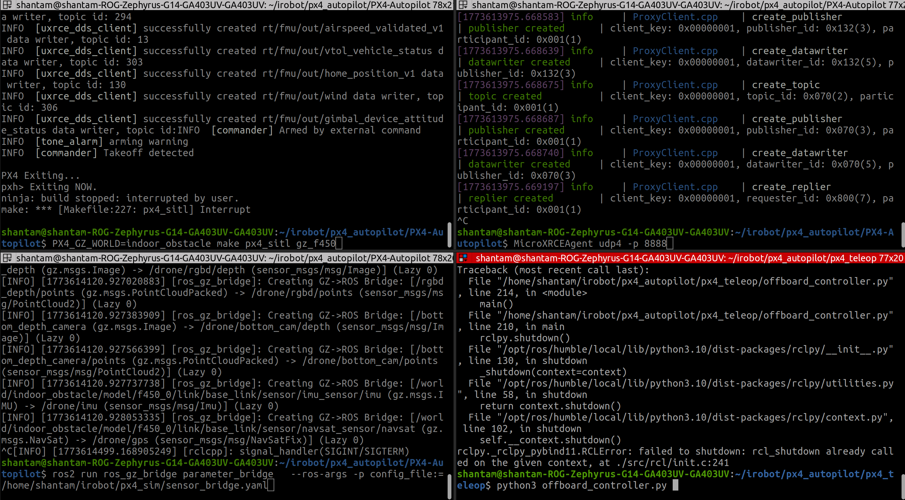
Main setup commands.

1. PX4_GZ_WORLD=indoor_obstacle make px4_sitl gz_f450
make px4_sitl is standard to initiate px4 instance.

-> PX4_GZ_WORLD : this is the world you wish to load in gazebo.

I have used custom obstacle course, with random objects inside the room.

Path: PX4-Autonomous/Tools/simulation/gz/worls/world_name.sdf (indoor_obstacle.sdf)

-> gz_f450 is custom drone setup.

There are a lots of existing drone setups with different sensor arrays mouted on x500. I took inspiration from existing x500 model, changed weight dimenstions and coordinates for motor mounts.

Path: PX4-Autonomous/Tools/simulation/gz/models/f450_base/model.sdf
PX4-Autonomous/Tools/simulation/gz/models/f450_base/model.config

then we need to define airframe and add it to cmake list.

1. PX4-Autopilot/ROMFS/px4fmu_common/init.d-posix/airframes/CmakeLists.txt
PX4-Autopilot/build/px4_sitl_default/rootfs/etc/init.d-posix/airframes/4022_gz_f450
2. PX4-Autopilot/ROMFS/px4fmu_common/init.d-posix/airframes/4022_gz_f450
3. PX4-Autopilot/build/px4_sitl_default/rootfs/etc/init.d-posix/airframes/4022_gz_f450

model.sdf defines all the sensors, camera links, camera config and motor links

airfram: set default values for px4 params

Installation of this module: https://github.com/PX4/PX4-Autopilot

2.MicroXRCEAgent udp4 -p 8888
No customization required.
Automatically converts internal px4 params and outputs to ros2 topics.
Also required when running px4 on actual hardware.
Installation: https://micro-xrce-dds.docs.eprosima.com/en/latest/installation.html

3. ros2 run ros_gz_bridge parameter_bridge --ros-args -p config_file:=/home/shantam/irobot/px4_sim/sensor_bridge.yaml
This creates a bridge bw gazebo published topics (simulated sensors) to ros2 topics
This is probably not required in HITL
Use: gz topic –list
to check all gazebo topics published by gz harmonic simulation environment for all defined sensors in model.sdf
Installation: specifically install the bridge for gz harmonic
sudo apt install gz-harmonic ros-humble-ros-gzharmonic ros-humble-ros-gzharmonic-bridge

4. python3 offboard_controller.py, teleop_keyboard.py

These files are used to send commands to px4 via ros2 topic. You need below packages to be build and sources before controlling px4 values from ros2
- https://github.com/PX4/px4_ros_com
- https://github.com/PX4/px4_msgs

Pull and build the main packages (compatible with PX4-AUTOPILOT)

Sample Screenshots:
Drone without landing stand spawn: cam
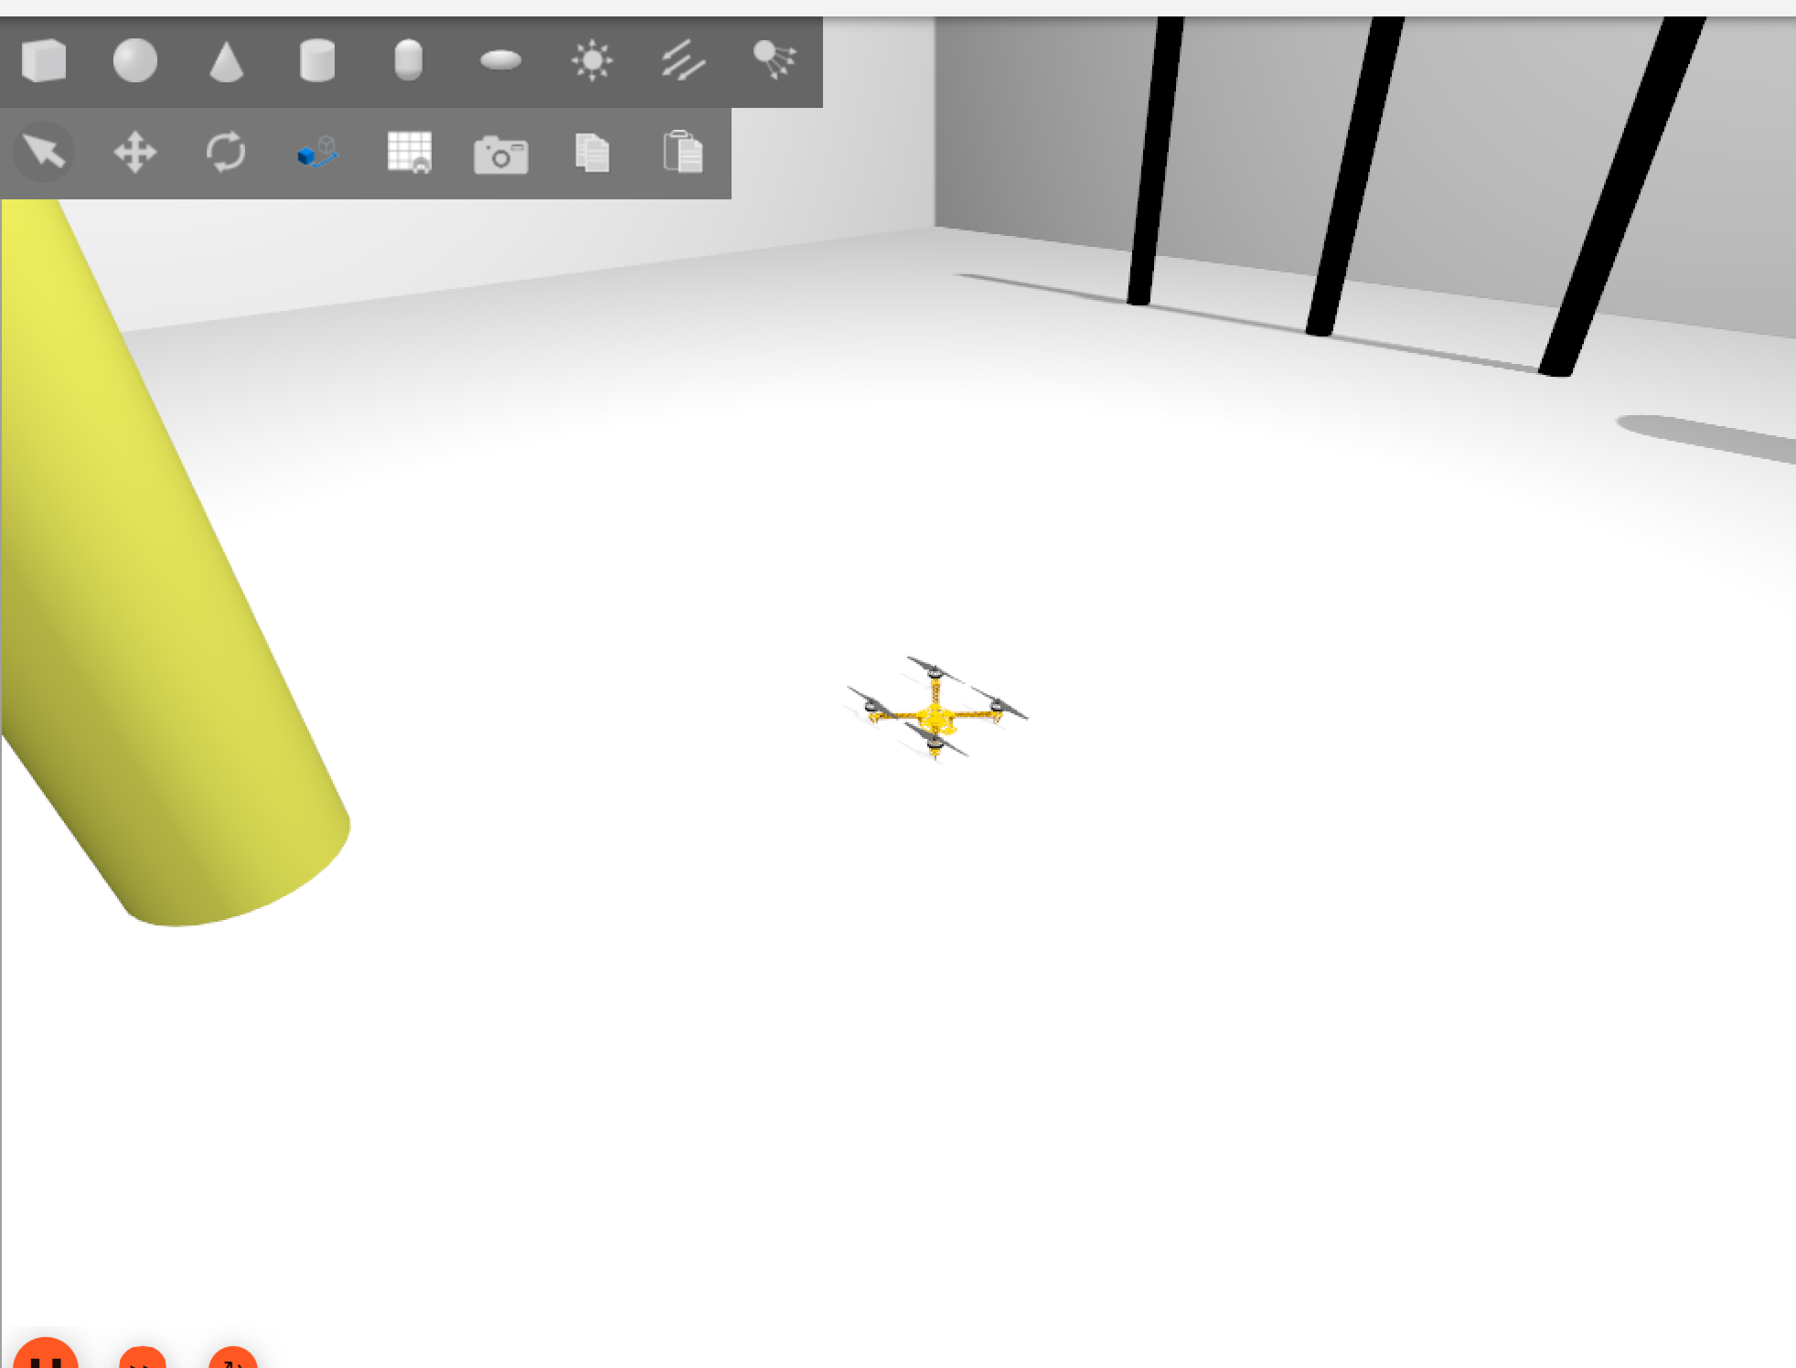
ros2 topics bridged from px4:
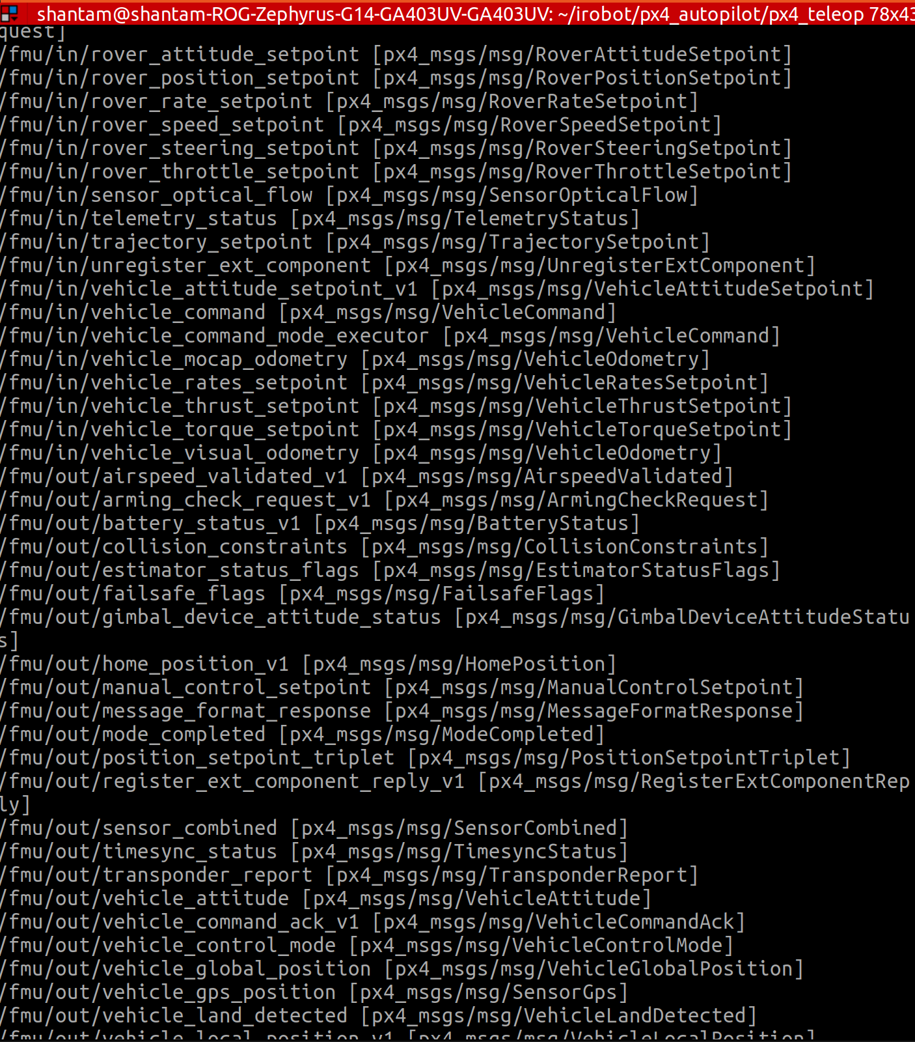
Sensor topics:
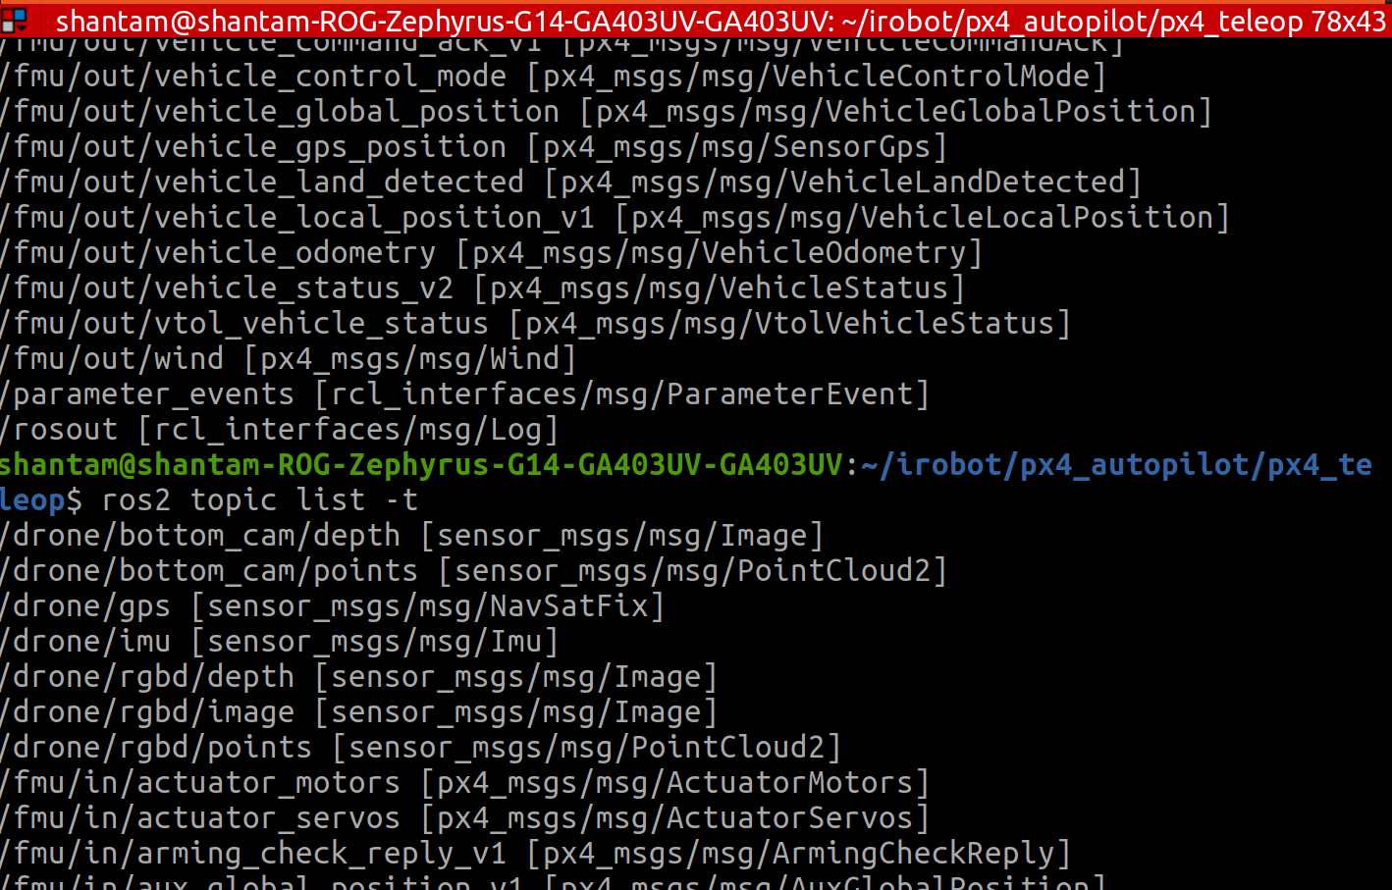
Teleops:
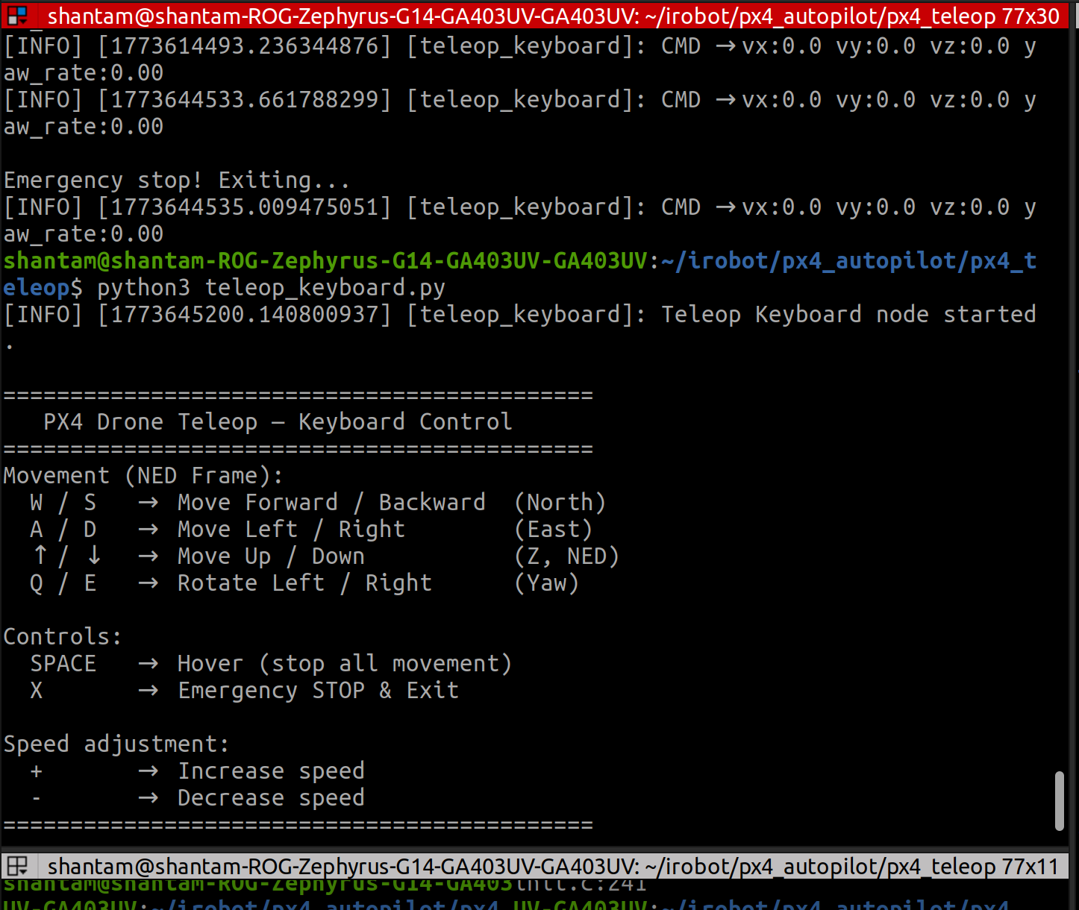
Takeoff:

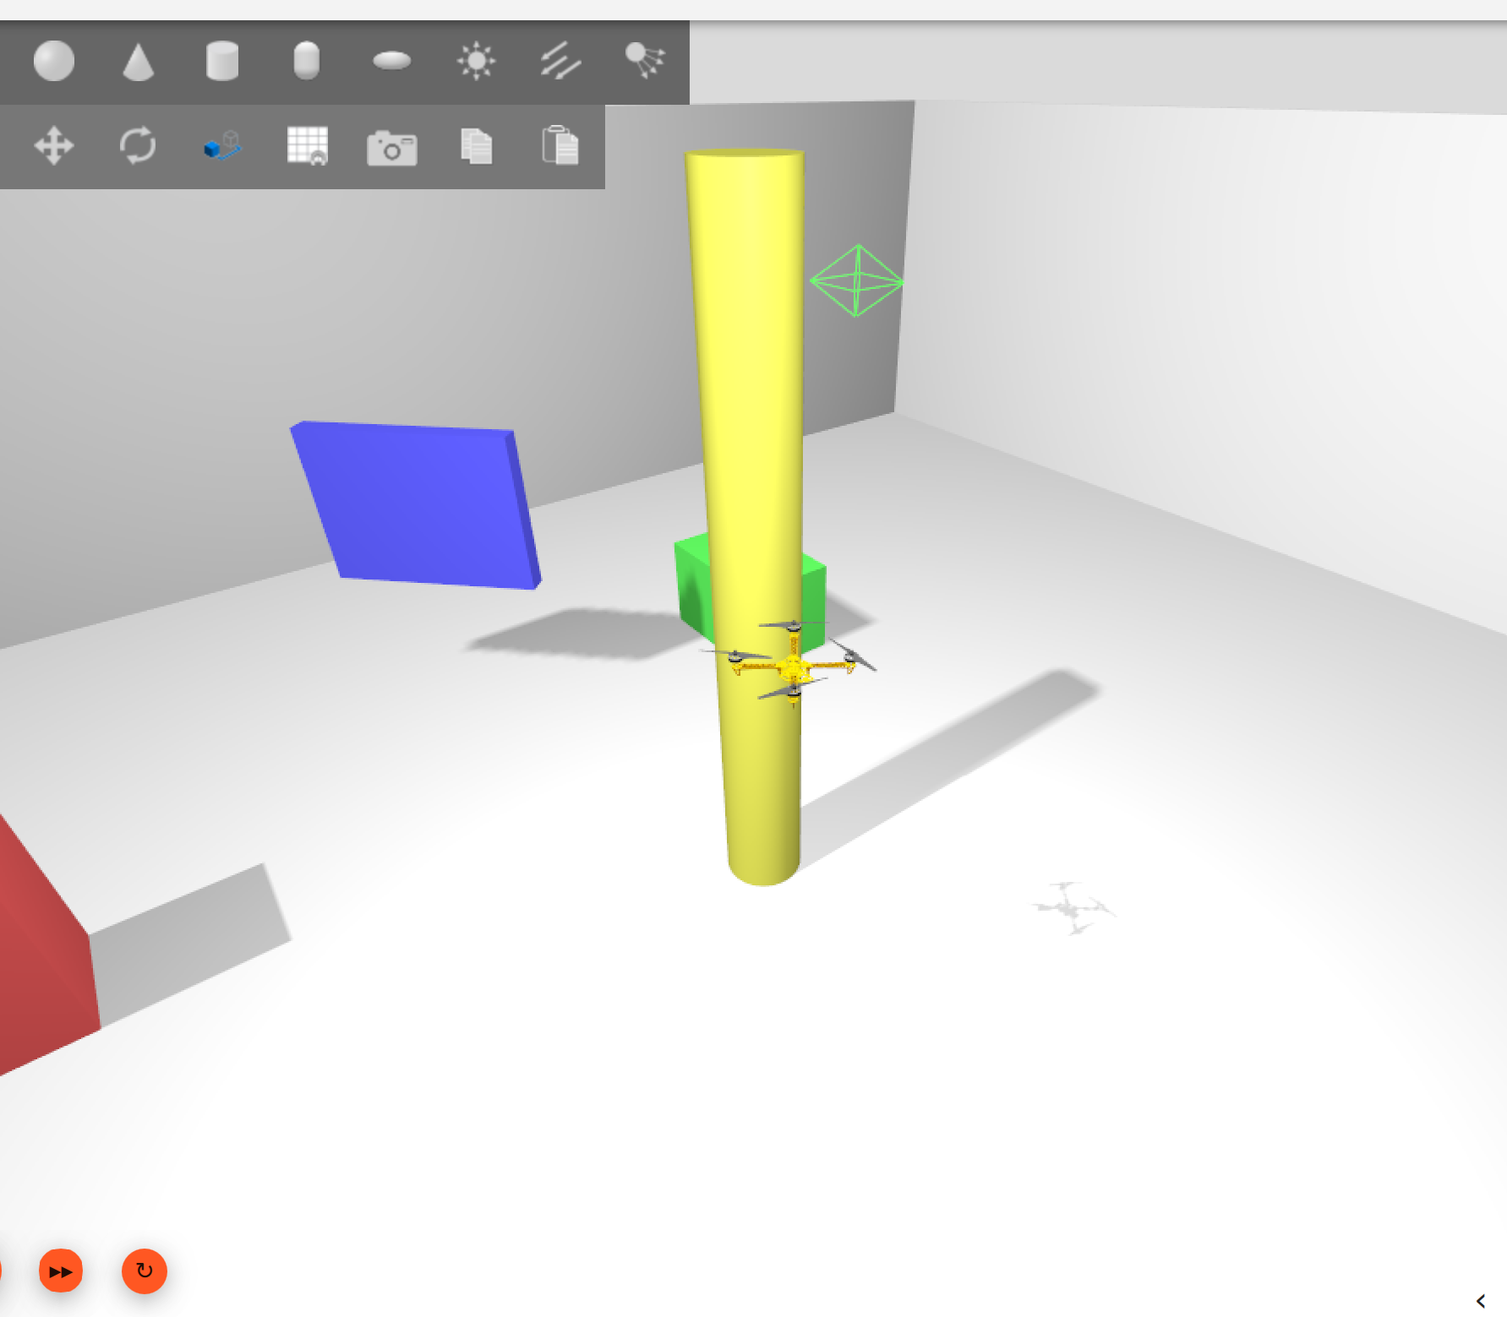
Rviz sensor visuals:

