ESP32-based Smart Air Purifier with IoT Integration
Vishwesh Deshmukh Srushti Chavan Ridham Chhajer Purva Chavan
VIT, VIT, VIT, VIT,
Pune, India. Pune, India. Pune, India. Pune, India.

Pratibha Chavan Shantanu Chavre Manthan Chidrewar
VIT, VIT, VIT,
Pune, India. Pune, India Pune, India.

Department of Engineering, Sciences and Humanities (DESH)
Vishwakarma Institute of Technology, Pune, Maharashtra, India

Abstract — Air Pollution has become a major crisis in today’s world. Making it harder for infants, elderlies and weak immune to live. The adverse effect cause by the prolong exposure to this polluted air leads to increase in the rate thyroid disease, lungs cancer and respiratory illness, along with the decrease rate of the average lifespan by up to 12 years of these people. The increased need of being able to breathe clean air in the environment. This air purifier having AQI detection and automatic turn on and off feature according to the AQI level. The MQ-2 and DHT11 sensor used to detect smoke (CO2 (Carbon dioxide), NO2(nitrogen dioxide)), (carbon monoxide) CO and humidity, temperature respectively. The ESP32 microcontroller is used to collect real-time AQI data and transmit it to filter control by IoT extension. This creates a sense of knowing about the overall picture of the air quality and it effect on health. This IoT-based system can be used for the application in homes, offices, hospital, industrial spaces improving indoor air quality while ensuring efficient energy usage

Keywords — IoT, Air Purifier, Automation, Air Pollution, ESP32.

INTRODUCTION
Air pollution remains a cause for concern, affecting living conditions as well as environments for work. To promote health safety of an individual, proper systems of air purification must be put in place. This Air Purifier project aims to design an air filtration system with integrated air quality monitoring that utilizes filtration with DHT11 sensor. The filter captures the polluted air with help of exhaust fan and outputs purified air. The DHT11 sensor wirelessly communicates real-time air quality index and environmental parameter readings to a custom mobile application for further analysis.
To improve circulation of air decompression of air is achieved by an exhaust fan integrated into the filters. The focus of this research is to make air purifier and it’s data easily available to mass on a individual level. The data received through the processed IoT extension enables optimizing the air cleaning techniques which include sensor monitoring and app analysis. This research creates a base for efficient systems for air quality control management. The public health issue of indoor air quality (IAQ) is importantly notable in cities and populated industrial areas where the content of hazardous particles like PM, VOCs, and CO2 are increasing at a heavy rate.
The emitted VOCs, CO2, and other toxic gases are great threat to human life. With IoT and the enhancement in the efficiency for adaptive air quality monitoring systems. This will make people more familiar to air purifier and the it’s need in the daily life. Removing the air directly from the room through an exhaust vent using condition for this purification purpose can drastically save energy and cost efficient. The filter used in this system is simple and majorly blocks odors and particle large as around PM₁₅ to more. Airflow rates will be changed depending on the pollution concentration and temperature which the fan can set anywhere there is detectable pollution.

LITERATURE REVIEW
[2]"Design and Development of Activated Carbon-Based Solar Air Purifier”:
There is an air purification system having the working on cleaning air with help of exhaust fan and HEPA filter but this filter is renewable energy-powered that is solar powdered. Ther no application related to informing the user about the air condition and also not mentions of automation.
Our system uses an IoT application and ESP32 for data transmission and receiving. Smart Automation like turning on and off through mobile application along with alerting SMS.

[1]"Air Quality-Monitoring System Based on Raspberry Pi and Arduino Hardware-Programmable Platform":
A System built having base of uses Raspberry Pi 4 and Arduino Uno air quality monitoring and along with the regular generic air purifier construction. Lacks cloud-based data, power not optimized.
Our system uses an IoT application and ESP32 for data transmission and receiving. Smart Automation like turning on and off through mobile application along with alerting SMS.

[3]"Large-scale Air Purifier System with Intelligent Sensor Frequency Conversion Control":
Creation of a generic air purifier on a larger scale using sensors also A touch-screen interface allows users to switch between automatic, manual, and timer modes for better control. Lack of IoT integration also the availability of sensors limits for Nitrogen and it’s oxides mostly.
Our system uses an IoT application and ESP32 for data transmission and receiving. Smart Automation like turning on and off through mobile application along with alerting SMS.

[5]"The IoT and Cloud Based Smart Home Automation for a Better Energy Efficiency":
The smart home automation system using IoT and cloud technologies for monitoring and control of home appliances through a cloud-based database. There is no dynamic power efficient feature, response time to sudden environmental changes is limited due to predefined decision models.
Our system uses an IoT application and ESP32 for data transmission and receiving. Smart Automation like turning on and off through mobile application along with alerting SMS.

[4]"Real Time Analysis of Air Pollution Prediction using IoT":
This paper presents an IoT-based monitoring and purification system designed using Raspberry Pi along with multi-stage air filtration process and data is stored in an SQLite database and uploaded to a web server for monitoring and analysis. It does not includes real-time alerts for dangerous air quality levels, the energy efficiency of the purification process is not optimized.
Our system uses an IoT application and ESP32 for data transmission and receiving. Smart Automation like turning on and off through mobile application along with alerting SMS.

METHODOLOGY

Materials/Components
- MQ2 Gas Sensor – Detects gases like LPG, CO, smoke, and methane.
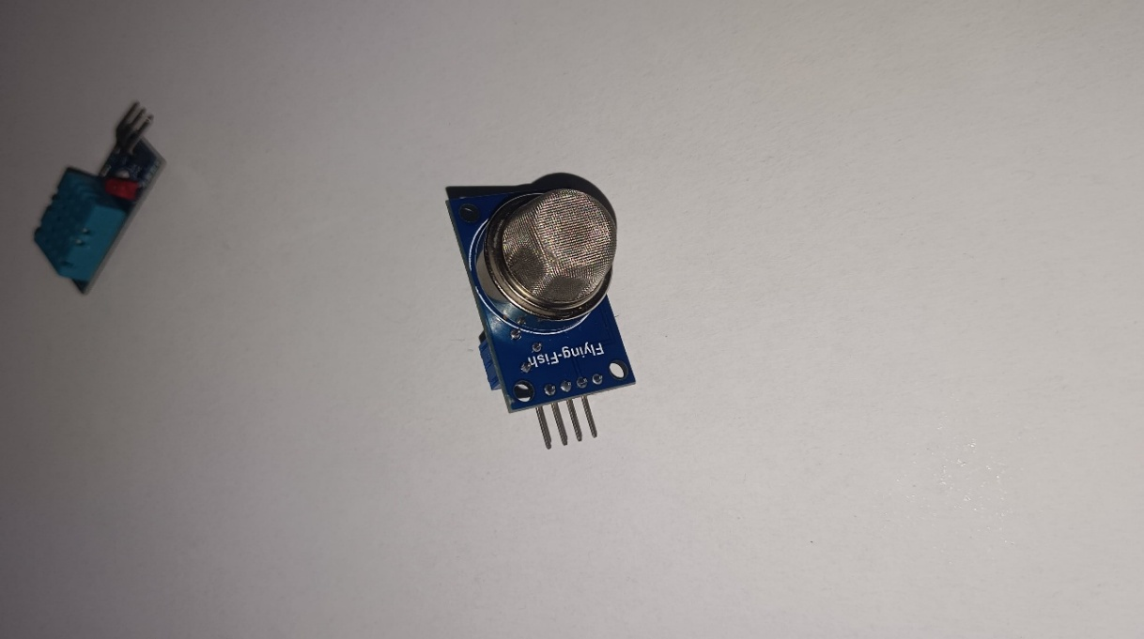

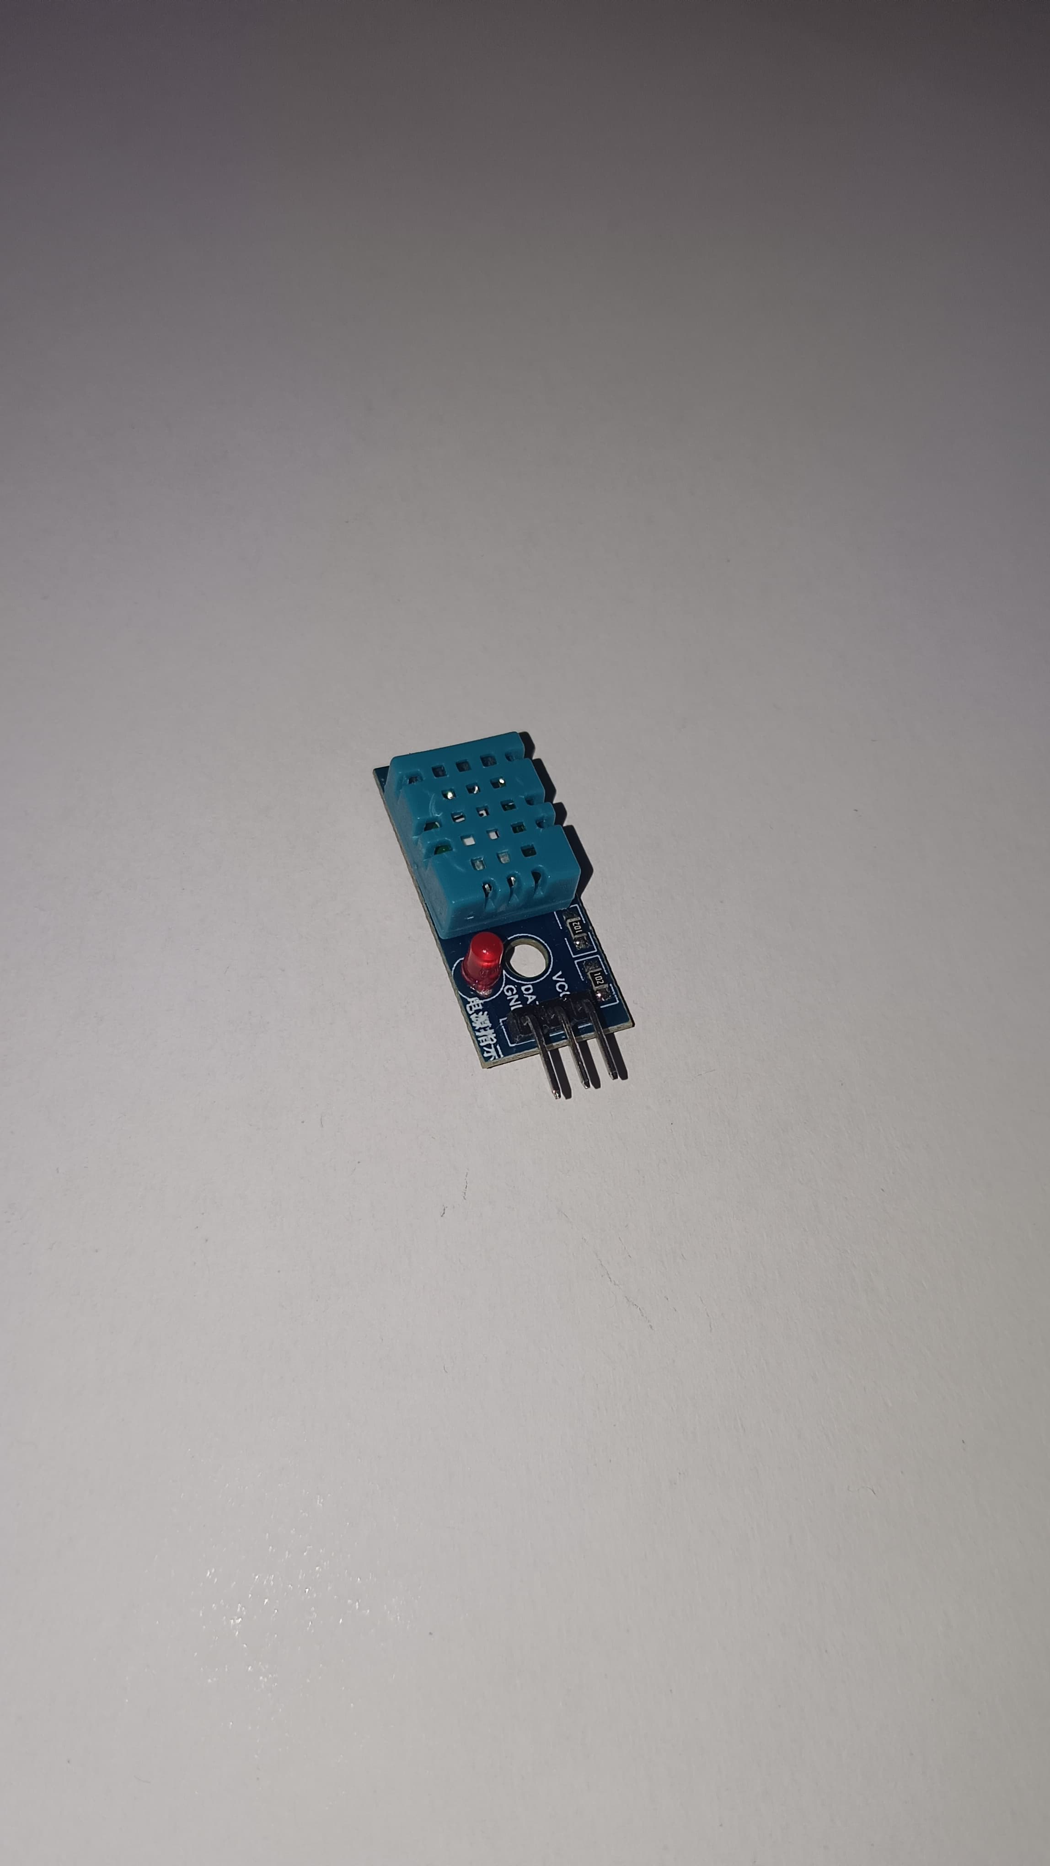
- DHT11 Temperature & Humidity Sensor – Measures temperature and humidity with decent accuracy.

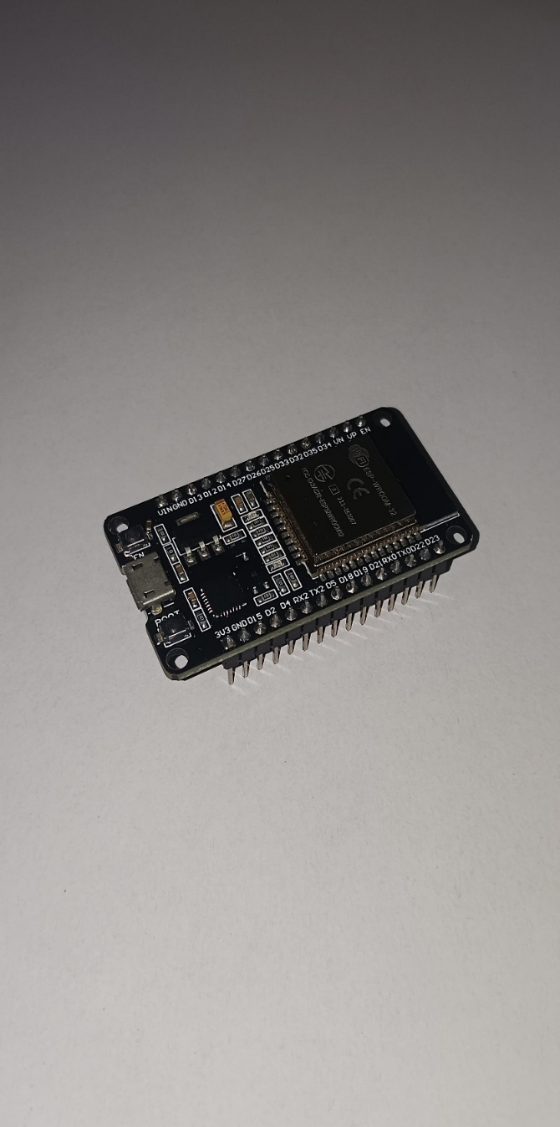
- ESP32 Dev Module V1 – A microcontroller with WiFi and Bluetooth capabilities, ideal for IoT and real-time data processing.

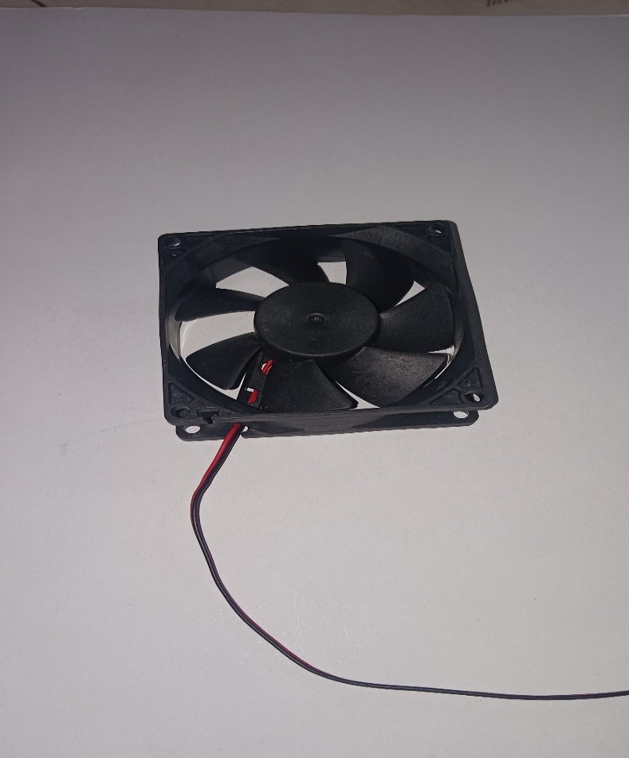
- Exhaust Fan – Used for air circulation and ventilation, helps remove pollutants or excess heat.

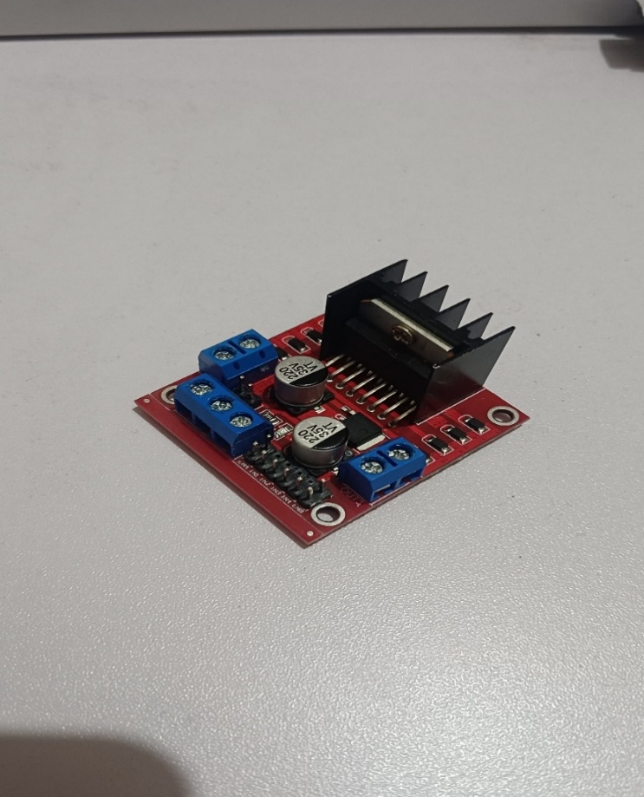
- L298 Motor Driver – A stepper motor controller that provides control signals for precise motor movement in automation systems.

- Servo Motor – A motor with precise angular control.
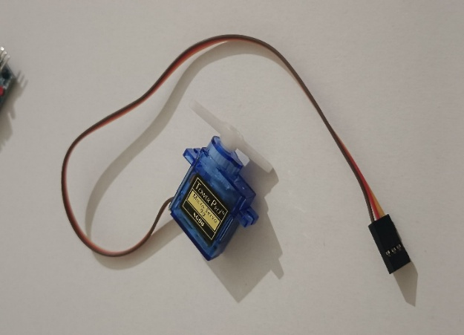

SYSTEM ARCHITECTURE
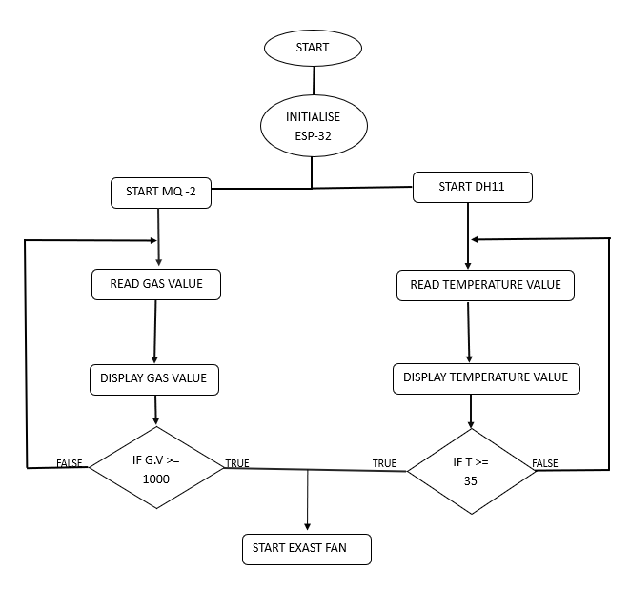
- Flowchart
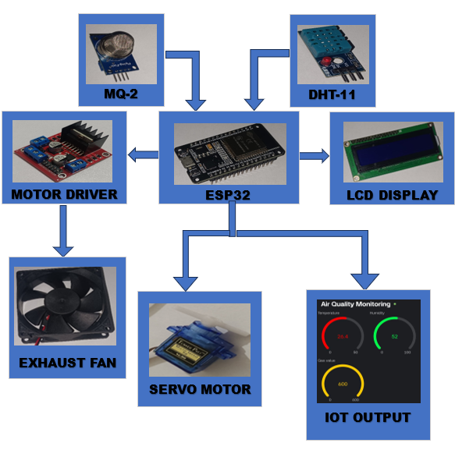
- Block diagram
- Connectivity Diagram
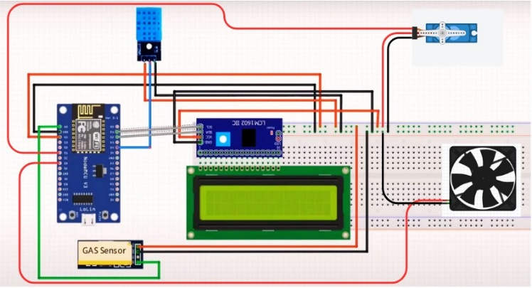

Results and Discussions
As soon as the air purification system is on the detection the temperature and air quality is displayed on LCD. Along with that exhausting the harmful air had started and the changes before and after the clearing of the gas can be seen on the IoT Platform.
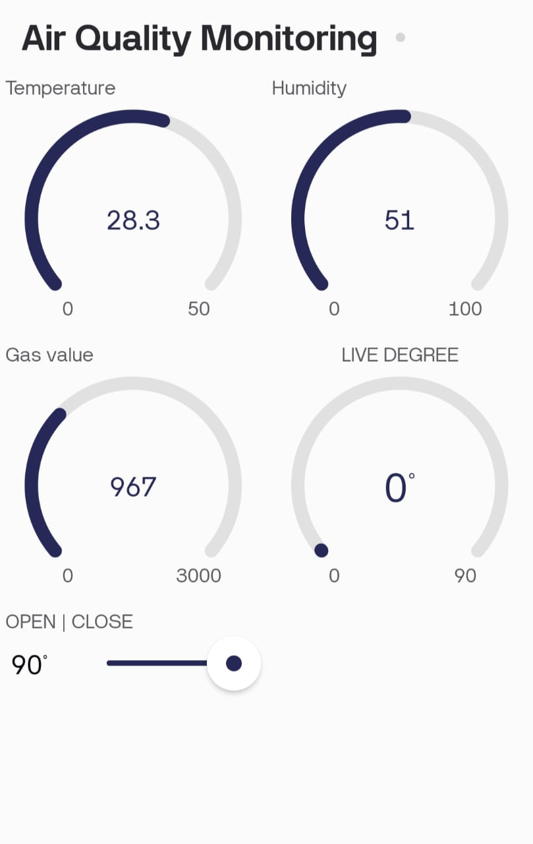

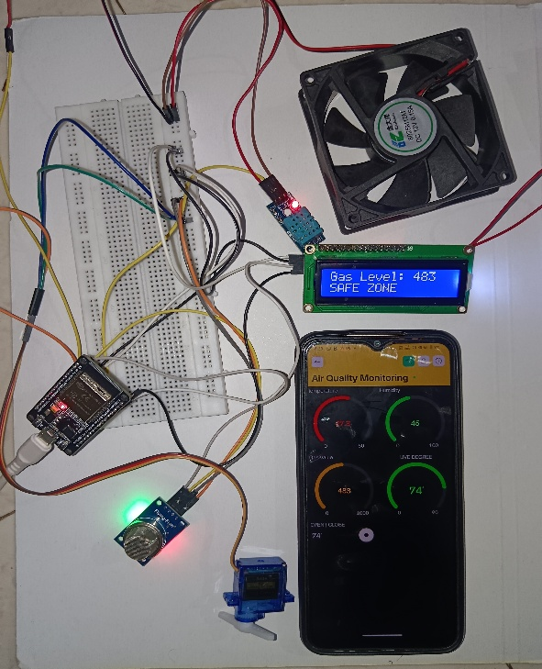

Future Scope
Development of more accurate and compact air quality sensors to detect pollutants like CO₂, CO, VOCs, PM2.5, and allergens. Cloud-based storage and analytics for long-term air quality tracking and pattern identification. Monthly and yearly air quality reports for users to track improvements.
AI-generated recommendations for air quality enhancement (e.g., adding indoor plants, adjusting ventilation). Voice-controlled air monitoring insights and automation through AI assistants.

Conclusion
In conclusion, air pollution severely impacts health, reducing life expectancy and increasing respiratory diseases. This IoT-based air purifier, equipped with MQ-2 and DHT-11 sensors and an ESP32 microcontroller, detects harmful gases and displays them along with AQI levels. By temperature reading fire detection can be easy. By providing real-time air quality monitoring and filtration along with smart automation, it enhances indoor air quality in homes, offices, hospitals, and industries.

References
- "Air Quality Monitoring System Based on Raspberry Pi and Arduino Hardware-Programmable Platform" by Ivan Rudavskyi, Oleksandr Stepanov, and Halyna Klym: .
- Design and Development of Activated Carbon-Based Solar Air Purifier" by Prof. 1Reshma P Eldho, Prof. 2Ms. Ragasudha C.P, Durga Rani, Anand Prakash Tiwari, Mohammed Ashraf, Akanksha.:
- "Large-scale Air Purifier System with Intelligent Sensor Frequency Conversion Control" by Tsung-Hui Cheng, Zhi-Hua Chen, Chu-Chun Song, Ming-Hung Lin, Chien-Hao Chen, and Wen-Ping Chen:
- "Real Time Analysis of Air Pollution Prediction using IoT" by Niranjan D.K and N. Rakesh
- The IoT and Cloud Based Smart Home Automation for a Better Energy Efficiency" by Rosida Nur Aziza, Puji Catur Siswipraptini, Malik Abdul Jabbar, Riki Ruli Siregar.

