SAVITRIBAI PHULE PUNE UNIVERSITY

A PROJECT REPORT ON

QUERIUS

BY

Student Name: Shantanu Jain

Roll No:
3363

Student Name: Sudarshan Agrawal

Roll No:
3368

Student Name:
Tejas Srivastava

Roll No:
3371

Student Name:
Anuja Watpade

Roll No:
3376

Under the Guidance of

Prof. Arundhati A. Chandorkar
Class: TE 3


Pune Institute of Computer Technology
Dhankawadi, Pune-411043



Pune Institute of Computer Technology
DEPARTMENT OF COMPUTER ENGINEERING

CERTIFICATE

This is to certify that the Project Entitled

QUERIUS

Submitted by

Student Name: Shantanu Jain Roll No: 3363

Student Name: Sudarshan Agrawal Roll No: 3368

Student Name: Tejas Srivastava Roll No: 3371

Student Name: Anuja Watpade Roll No: 3376

is a bona de work carried out by Students under the supervision of Prof. Arundhati A. Chandorkar and it is submitted towards the partial fulfillment of the requirement of Bachelor of Engineering (Computer Engineering).

Signature of Internal Examiner Signature of External Examiner

PROJECT APPROVAL SHEET

QUERIUS

Is successfully completed by

Student Name: Shantanu Jain

Student Name:
Sudarshan Agrawal

Student Name:
Tejas Srivastava

Student Name:
Anuja Watpade

Roll No: 3363

Roll No:3368

Roll No:3371

Roll No:3376

at

DEPARTMENT OF COMPUTER ENGINEERING

PUNE INSTITUTE OF COMPUTER TECHNOLOGY

SAVITRIBAI PHULE PUNE UNIVERSITY, PUNE

ACADEMIC YEAR 2017-2018

Prof. Arundhati A. Chandorkar | Dr. Rajesh Ingle
Internal Guide | H.O.D
Dept. of Computer Engg. | Dept. of Computer Engg.

Abstract

The purposes of this project are:
1.To learn how to develop a real-time Android application.
2.To map the requirements of the project into the design and implement
it using the development tool i.e. Android Studio.

Our Application ‘Querius’ tries to solve the problems faced by students raised at the time when students are doing self-study at their home. If any student has any doubts related or not related to college syllabus, he/she can login into Querius and ask a question publicly which will be visible to all the people available on our application. He/She can get responses from students as well as from teachers. Querius not only focuses on better student-teacher interaction but also better student-student interaction.

We provide a list of categories from which students can ask their doubts/queries. Students can also view the queries asked by other students under that category. People on Querius have an option to either ask a query, answer a query, upvote(like) an already answered query and comment on a query as well.

Querius also provides the functionality to follow other people whether it be a teacher or student. In this way, a user can view all the activities of the people whom they are following.

Acknowledgments

It gives us great pleasure in presenting the preliminary project report on `QUERIUS'.

We would like to take this opportunity to thank our internal guide Prof. Arundhati A. Chandorkar for giving us all the help and guidance we needed. We are really grateful to her for her kind support. Her valuable suggestions were very helpful.

We are also grateful to Prof. Rajesh Ingle, Head of Computer Engineering Department, Pune Institute of Computer Technology(PICT) for his indispensable support, suggestions.

Shantanu Jain
Sudarshan Agrawal
Tejas Srivastava
Anuja Watpade
(T.E. Computer Engg.)

Contents

- Introduction
- Need or Motivation
- PROPOSED MATHEMATICAL MODEL
- DESIGN AND ANALYSIS OF SYSTEM
- DISCUSSION ON IMPLEMENTATION RESULTS
- conclusion and future enhancement
- references

QUERIUS

Abstract:

Our Application ‘Querius’ tries to solve the problems faced by students raised at the time when are students are doing self-study at their home. Querius not only focuses on better student-teacher interaction but also better student-student interaction. Advantage of our application is that students won’t disturb their teachers by asking them their doubts frequently over the phone or by messages.

Keywords: Problems faced, self-study, interaction, student-teacher, teacher-teacher.

- Introduction

Our Application provides a user-friendly platform for interaction between teachers and students. It gives a platform to students to ask their queries to teachers or discuss with their friends. In this way, Querius will not only help students to improve the interaction with their teachers but also helps to improve their academic performance.

- Need or motivation

The need or motivation to build this kind of application was that students can’t ask their queries directly to teachers by calling them or texting them as this does not form a better impression of a student to call/text a particular teacher frequently. They have to wait for the next working day of college and then ask their doubts to the teachers. So, by means of this application, students can ask their queries as and when required and teachers or other students can answer these queries whenever they are free.

- DESIGN AND ANALYSIS OF SYSTEM

Our Application uses a 3-tier architecture. It includes – The database, PHP scripts and Retrofit Library. The database used is MySQL. To fetch information from our database, we are using PHP scripts. PHP scripts links the android application to the database and in our android application, we are using retrofit to fetch information from our database with the help of PHP scripts in the form of JSON.
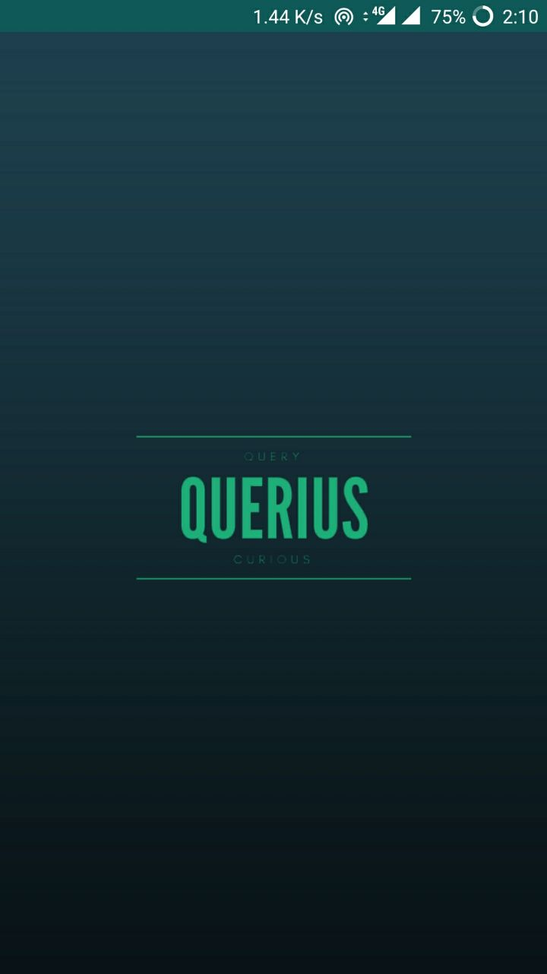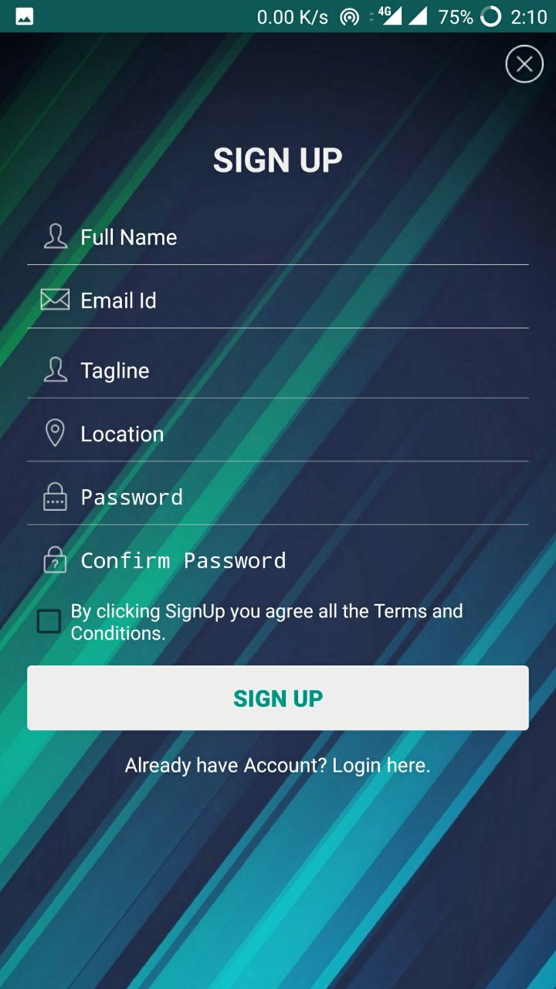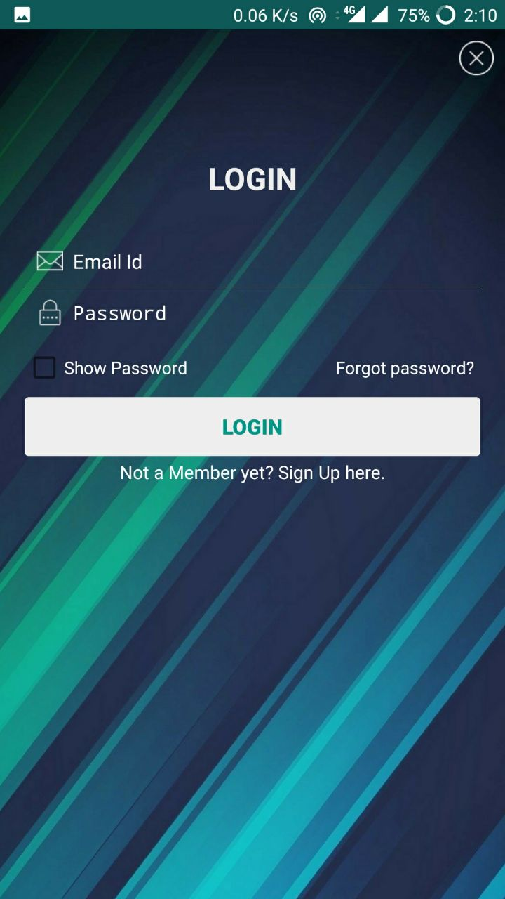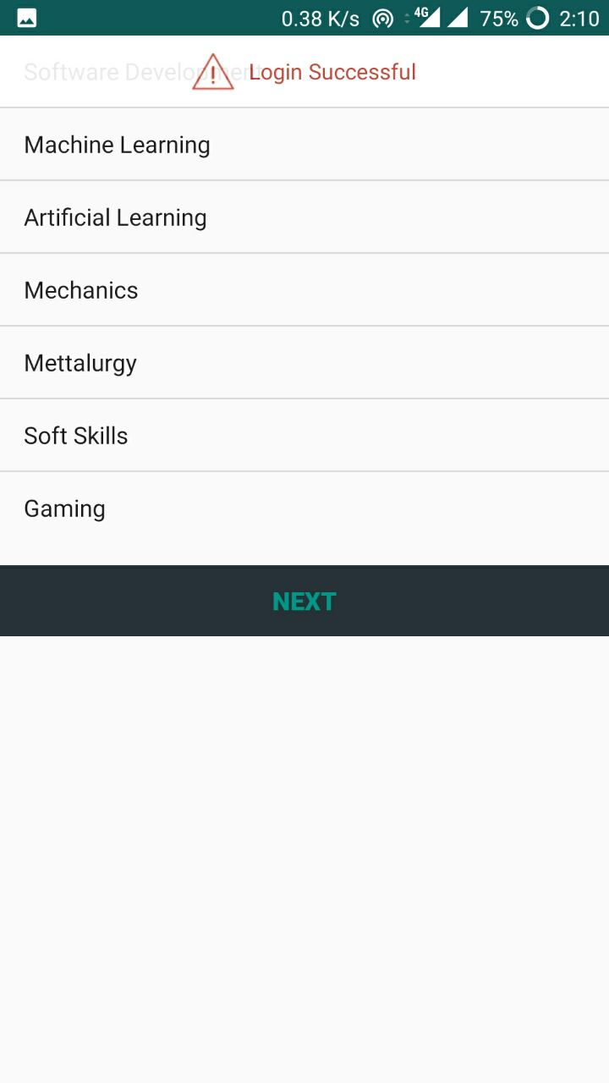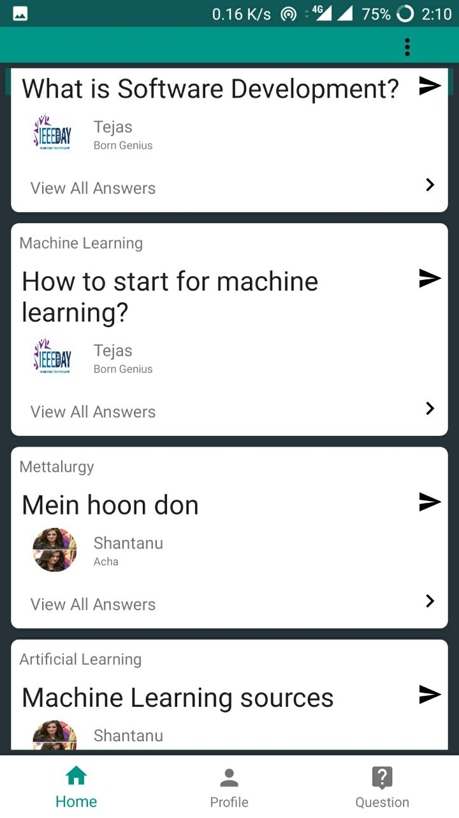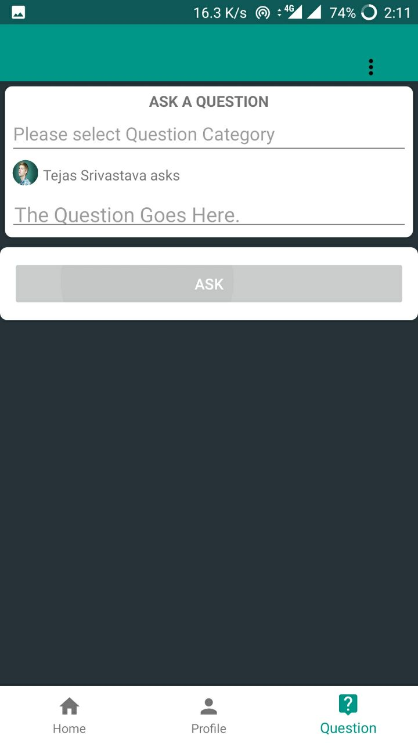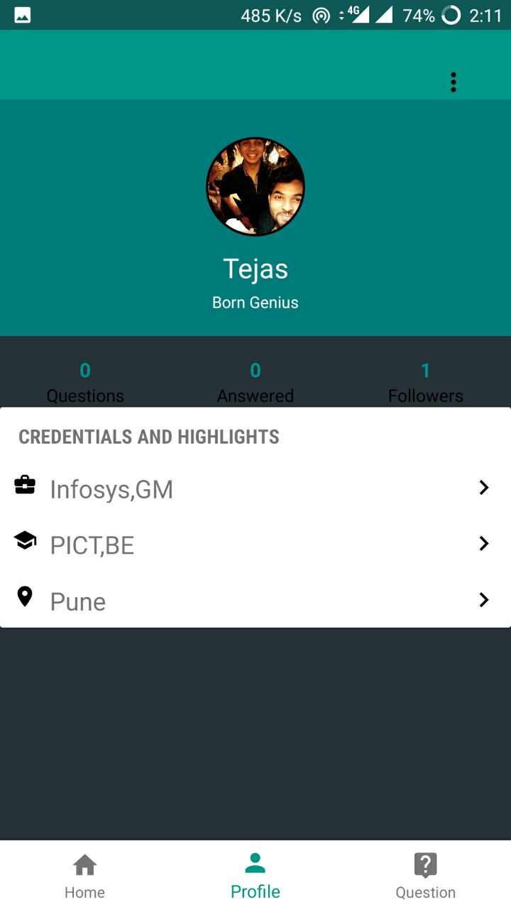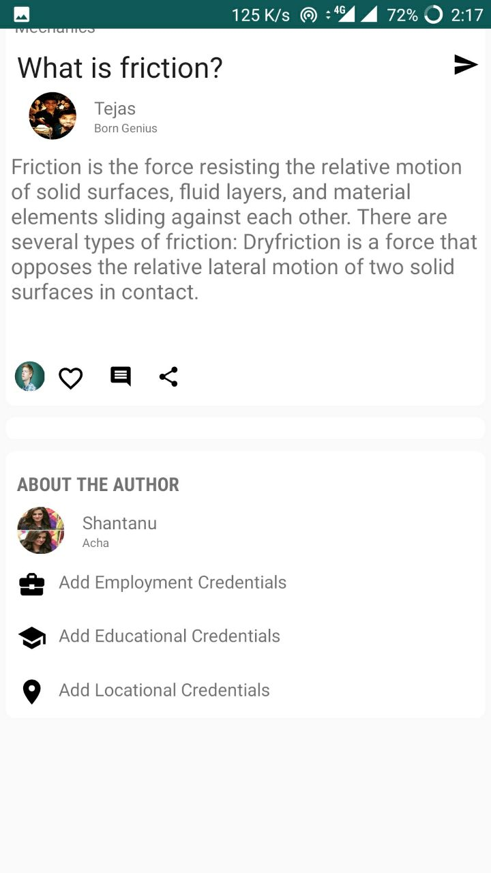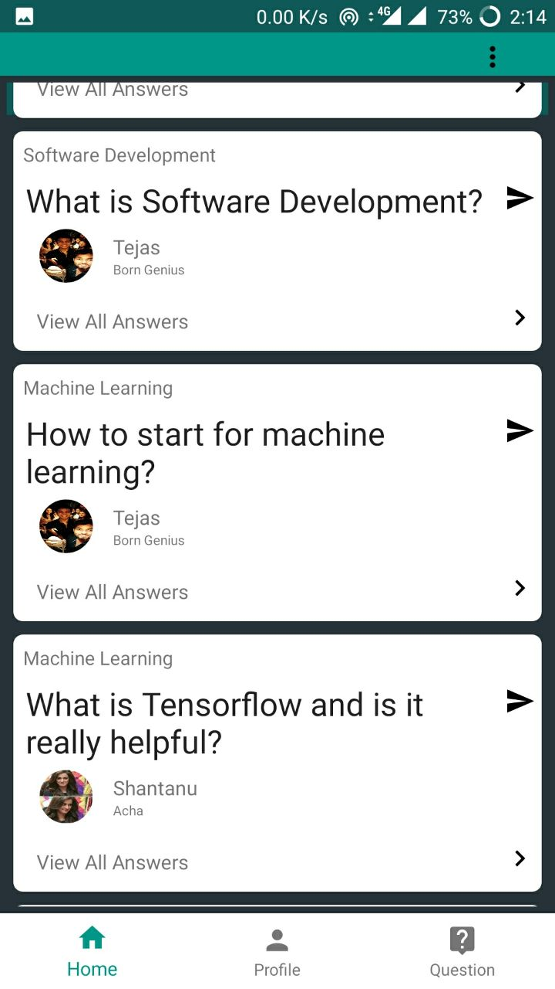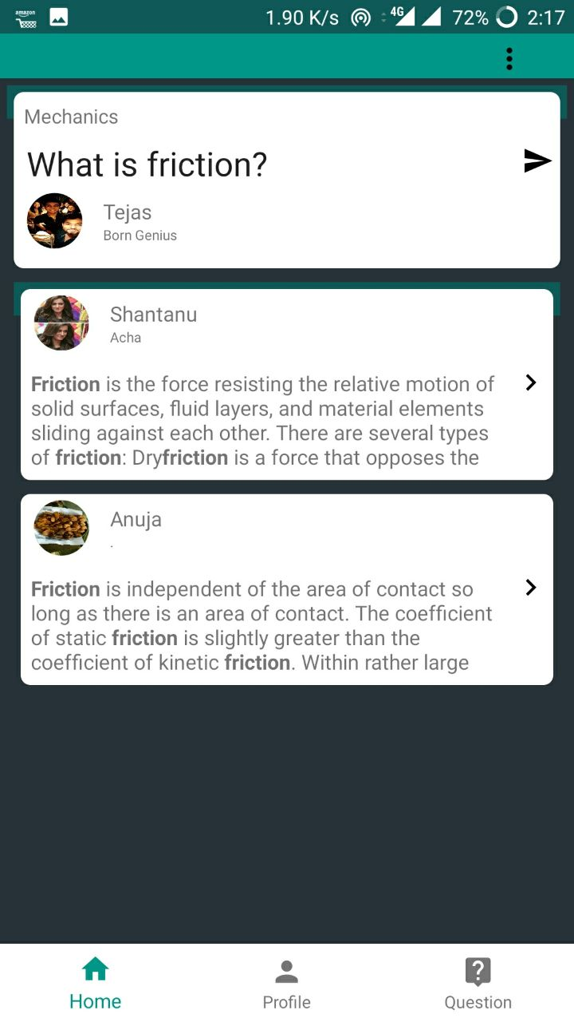
- DISCUSSION ON IMPLEMENTATION OF RESULTS

The results of our application can be discussed as follows:
Firstly, a user will login into his personal account. If the user does not have an account created, then he can create his personal account first and then login into his account. If a user forgets his password, our application will send him an email on his registered email id with his password.
Secondly, if a user is logging into his/her account for the first time, he/she will be asked to select the categories he/she is interested in and will be shown the questions according to the categories selected by user. If a user is not logging into his/her account for the first time, then he/she will be taken to the home-screen of our application where he/she will be shown the questions which are updated dynamically according to the categories selected by user.
Thirdly, the user can surf through our application accordingly. If he/she has answered a question, then he will receive a notification if his/her answer has been upvoted by anyone or commented upon by anyone.
Fourthly, if a user wants to answer a question, then a complete text editor is provided to user which will include all types of text formatting operations which will help user to improve the readability of the user’s answers.
To put all these results in a nutshell, Querius provides a completely user-friendly platform for all its users to interact with each other efficiently.

- conclusion and future enhancement

To conclude, we successfully implemented and tried to develop an Android app which helped us to play around the varied features of Android. We created an user-friendly app which if deployed would prove to be helpful for the consumers because of its functionalities.

- references
1.Android MySQL Tutorial:
https://www.youtube.com/playlist?list=PLshdtb5UWjSppGmM3IdygV6RusjU3KjlZ
2.Android Developer's Site:
https://developer.android.com/index.html

