July 13, 2018

Shantanu Kamble

EPita | Msc spring 2018

kambleshan04@gmail.com

Identity access management

user guide

Table of Contents

**1.** **Purpose** 2

**2.** **Introduction** 2

**3.** **Operations** 3

**3.1** **Launching the application** 3

**3.2** **Create Operation** 5

**3.3** **Search Operation** 6

**3.4** **Update Operation** 7

**3.5** **Delete Operation** 8

**3.6** **Exit the Application** 9

## **Purpose**

The purpose of this document is to provide information on various operations in Identity and Access Management project.

## **Introduction**

The identity and access management project implements basic features of CRUD system. The different operations in scope of this project are:

* Creating an Identity
* Searching an Identity
* Updating an Identity
* Deleting an Identity

The Identity related data is stored in the database table named IDENTITIES, which has the below structure.

|  |  |  |  |
| --- | --- | --- | --- |
| Column name | Data type | Length | Description |
| IDENTITY_ID | Integer | 10 | This Id is a unique identifier for an identity |
| IDENTITY _DISPLAYNAME | Varchar | 55 | This is the display name for an identity |
| IDENTITY _EMAIL | Varchar | 55 | This is the email for an identity |
| IDENTITY_UID | Varchar | 55 | This is the unique id for an identity |

## **Operations**

Start by executing the Launcher class in the package fr.epita.iam.launcher.

### **Launching the application**

* + 1. Before executing the Launcher, the user needs to set VM arguments. To do this, right-click on the Launcher file, go to “Run As” and then click on “Run Configurations..” Go to the “Arguments” tab and set the VM arguments: -Dconf.file.path=”src/db-config.properties” as shown in below screenshot. And then click on “Apply”.

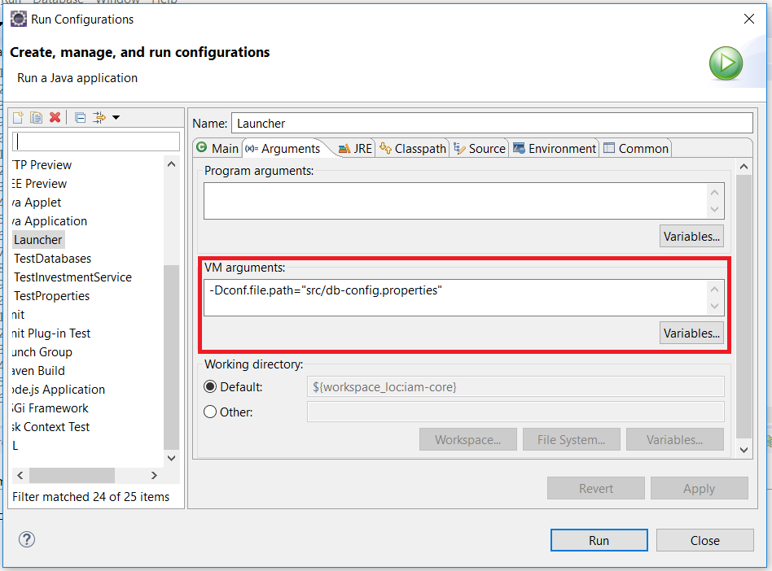

* + 1. To execute the Launcher using Eclipse, right-click on the file name, go to “Run As” and then click on “Java Application”

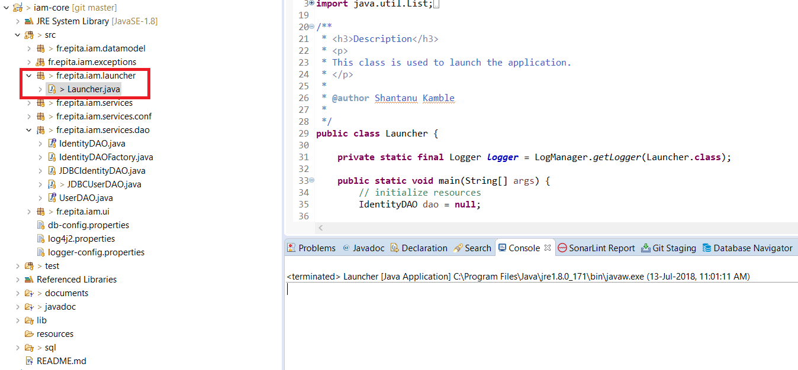

* + 1. A welcome screen will be shown, see below screenshot.

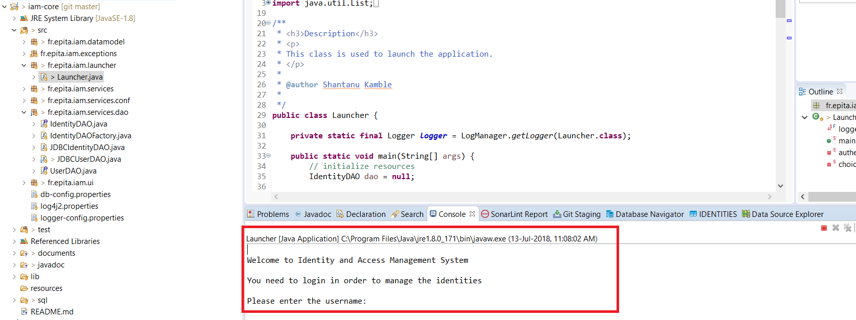

* + 1. Enter the username and press Enter. Then enter the password and again press Enter.

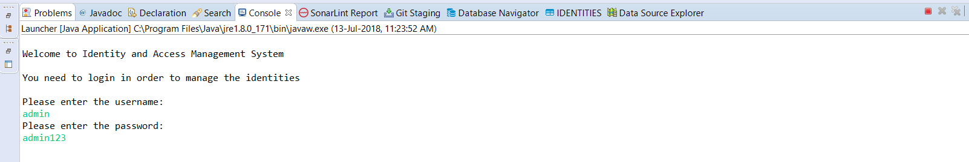

* + 1. After successful authentication, the user will be shown various options for identity management.

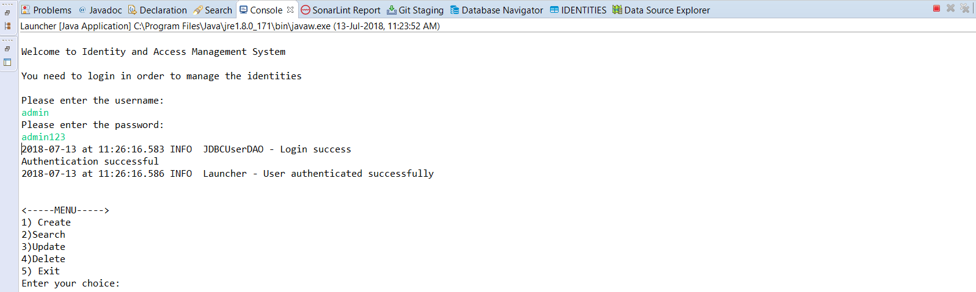

### **Create Operation**

* + 1. For creating an identity, choose the 1st option and press Enter. The user will need to input some details related to the identity to be created.

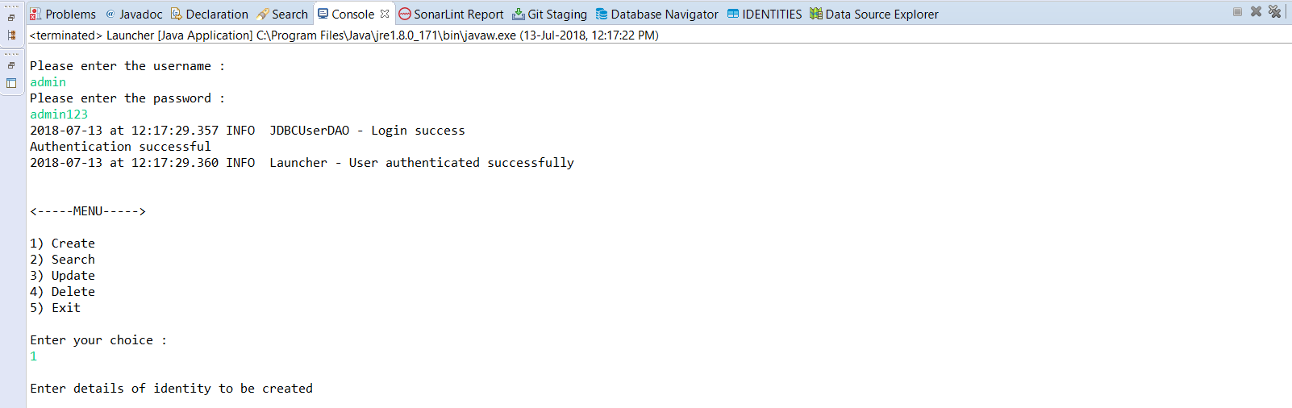

* + 1. The user needs to input display name, email id and the uid (i.e. unique id for identity). After inputting all the details, the identity is created successfully in database.

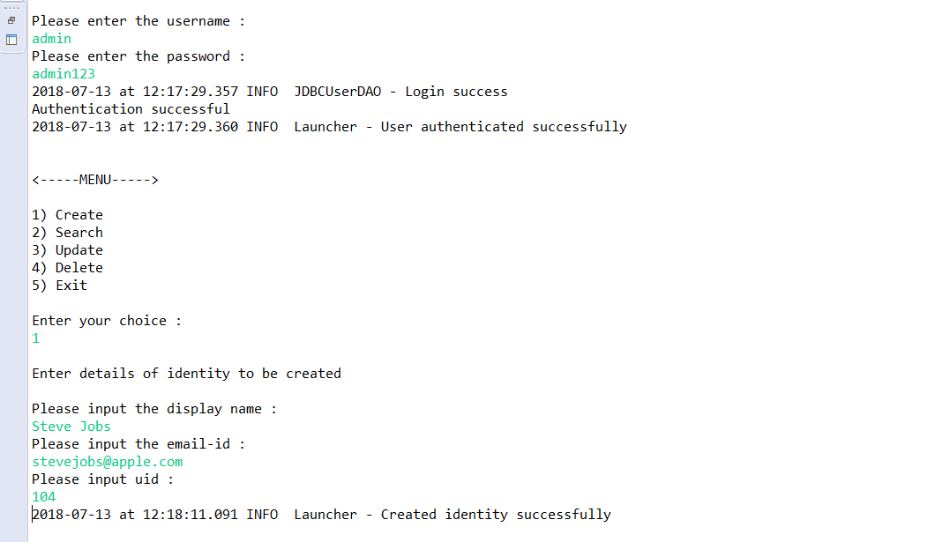

* + 1. A new entry for identity is created in the database.

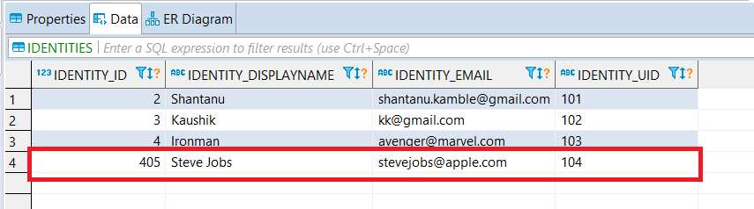

### **Search Operation**

* + 1. For searching an identity, choose the 2nd option and press Enter. The user will need to input some details related to the identity to be searched.

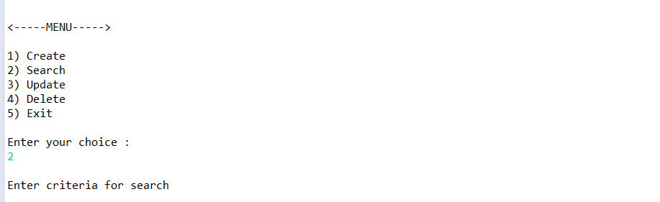

* + 1. The user needs to input the search criteria like display name and email id. After providing the details, below output is shown.

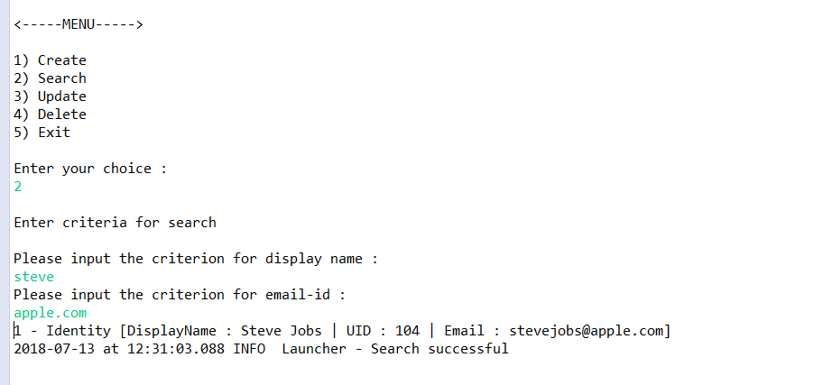

### **Update Operation**

* + 1. For updating an identity, choose the 3rd option and press Enter. The user will need to input some details related to the identity to be updated.

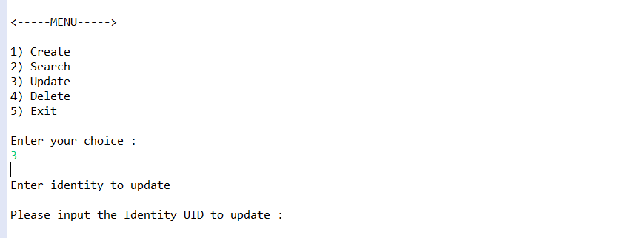

* + 1. The user needs to input the update details like uid (of the identity to be updated), updated display name and updated email id. After providing the details, below output is shown.

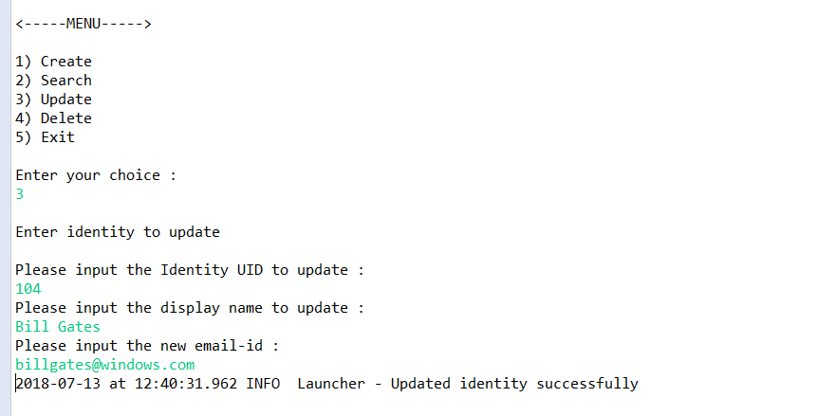

* + 1. The updated data is stored in the database.

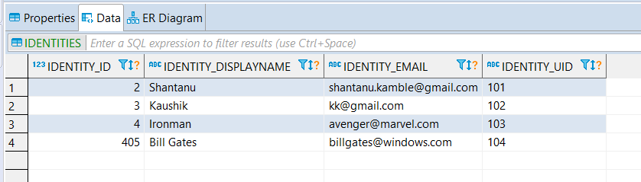

### **Delete Operation**

* + 1. For deleting an identity, choose the 4th option and press Enter. The user will need to input some details related to the identity to be deleted.

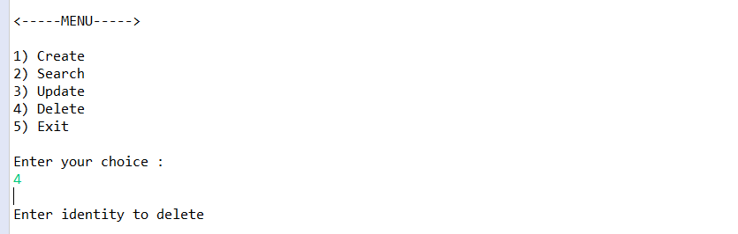

* + 1. The user needs to input the deletion details like uid (of the identity to be updated). After providing the required details, below output is shown.

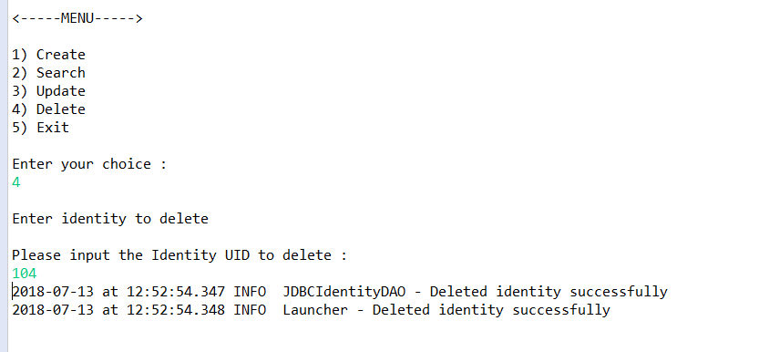

* + 1. The database view before deletion.

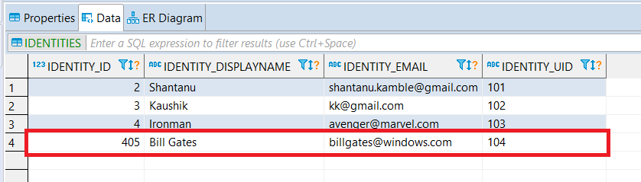

* + 1. The database view after identity is deleted.

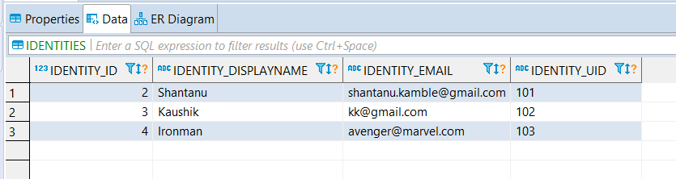

### **Exit the Application**

* + 1. To exit the application, select the 5th option and press Enter.

