Quiz Management

User Guide

Shantanu KAMBLE

EPITA | MSc Spring 2018

kambleshan04@gmail.com

Contents

1. Purpose 2

2. Introduction 2

3. Pre-requisites 3

4. Operations 4

4.1 Launching the application 4

4.2 Create operation 5

4.3 Search operation 6

4.4 View All operation 7

4.5 Update operation 8

4.6 Delete operation 9

# 1. Purpose

The purpose of this document is to provide information on various operations in the Quiz Management project.

# 2. Introduction

The quiz management project implements basic features of CRUD system. The different operations in scope of this project are:

* Creating an MCQ
* Searching for an MCQ
* Updating an MCQ
* Deleting an MCQ
* Displaying all the MCQs

The application has two tables: QUESTION and MCQCHOICE

QUESTION table:

|  |  |  |  |
| --- | --- | --- | --- |
| Column name | Data type | Length | Description |
| ID | Integer |  | This Id is a unique identifier for a question |
| QUESTIONLABEL | Varchar | 255 | This is the label name for a question |

MCQCHOICE table:

|  |  |  |  |
| --- | --- | --- | --- |
| Column name | Data type | Length | Description |
| ID | Integer |  | This Id is a unique identifier for MCQ choice |
| QUESTION_ID | Integer |  | This is the id of the question to which the choice is linked. |
| CHOICELABEL | Varchar | 255 | This is the label name for a choice |
| VALID | Boolean |  | This specifies whether the choice is valid or not |

# 3. Pre-requisites

You need to create a Derby database in order to run the application.

Properties:

* Database: quiz
* URL: jdbc:derby://localhost:1527/quiz;create=true
* Username: root
* Password: root

*Sample Screenshot for reference:*

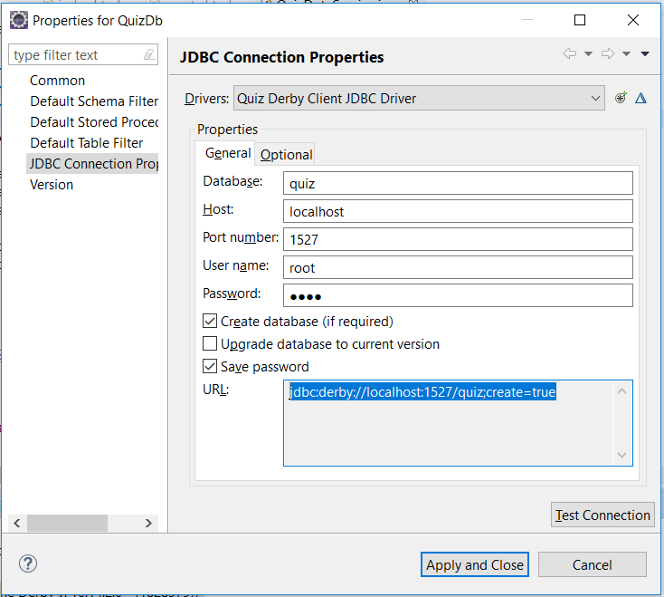

# 4. Operations

Pull the following 3 projects from Git repository: [*https://github.com/shantanu04*](https://github.com/shantanu04)*/Quiz-Management*

* quiz-core-sk (project containing core functionality)
* quiz-restful (project containing the REST services)
* quiz-web (project to display the User Interface)

Import the above projects into your Eclipse workspace.

As the “quiz-core-sk” project is a maven project, you need to build it by,

1. Right-click on the project name
2. Go-to Run As🡪 Maven install

Follow the same steps for building the “quiz-restful” project.

## 4.1 Launching the application

4.1.1 After a build success, the projects “quiz-restful” and “quiz-web” need to be run on the Tomcat server.

Steps:

1. Right-click on the project name
2. Go-to Run As🡪 Run on Server

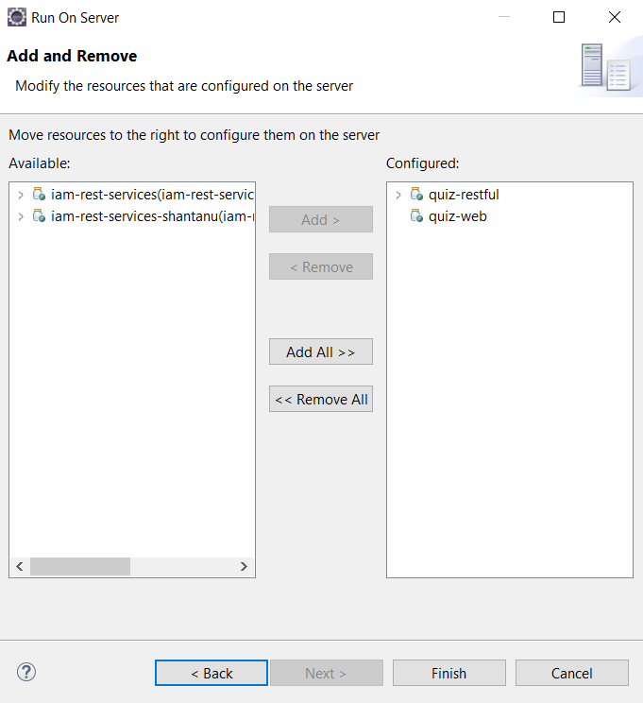

4.1.2 After the project is deployed on the server, go to the below URL:

[*http://localhost:8080/quiz-web/*](http://localhost:8080/quiz-web/)

The below screen will be displayed:

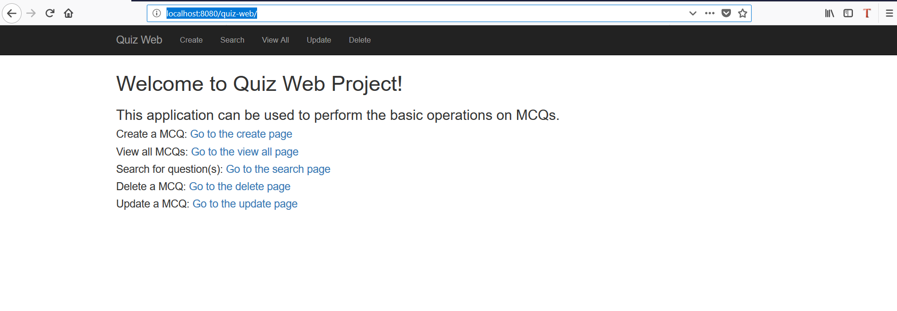

## 4.2 Create operation

4.2.1 The following screen is presented for creating an MCQ.

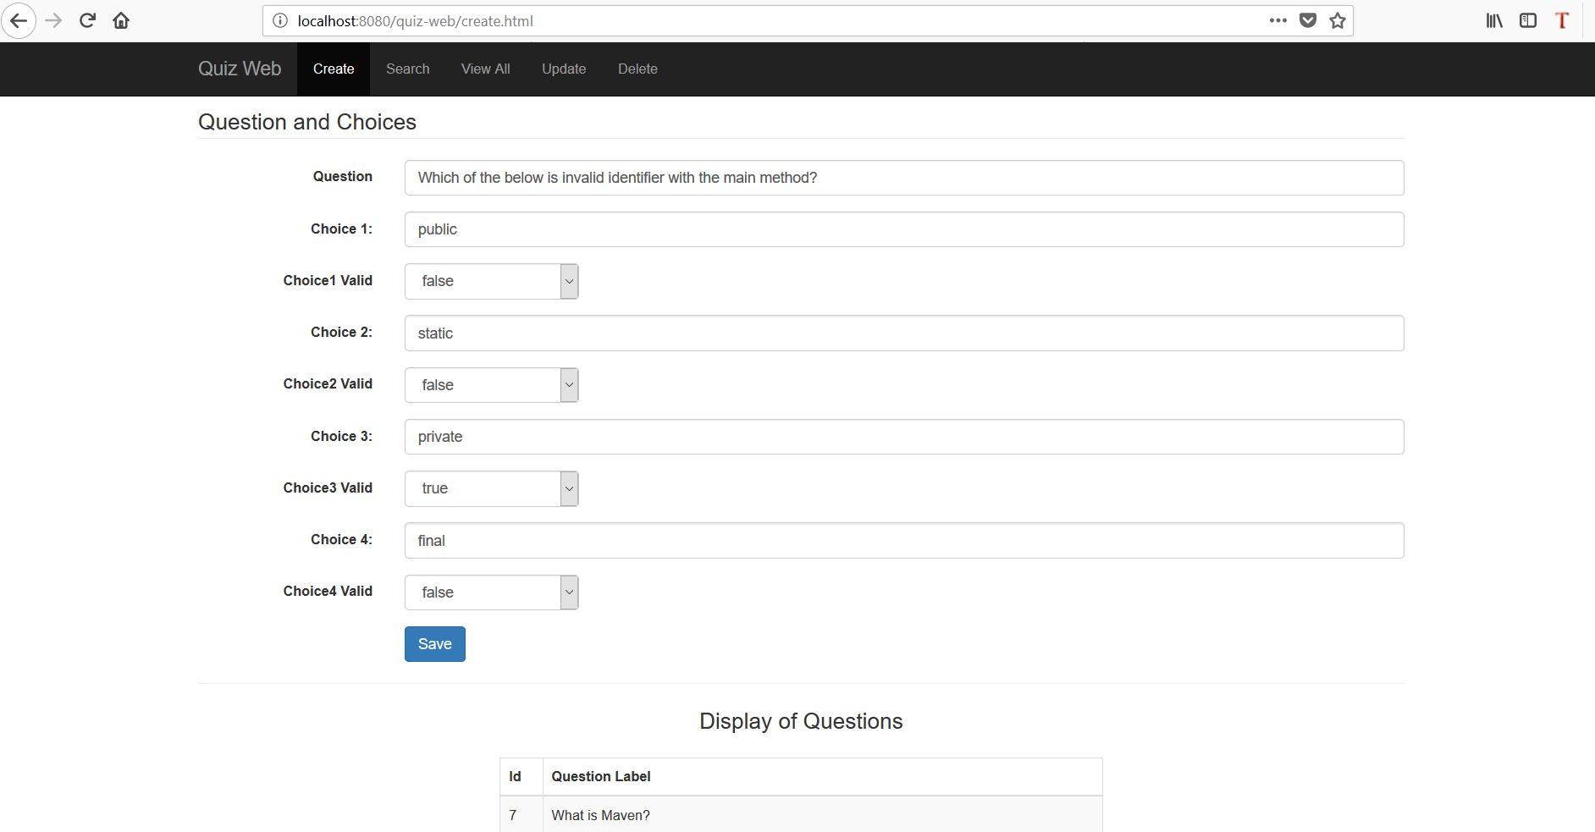

4.2.2 The user needs to give the question details and MCQ choices and then click on “Save”.

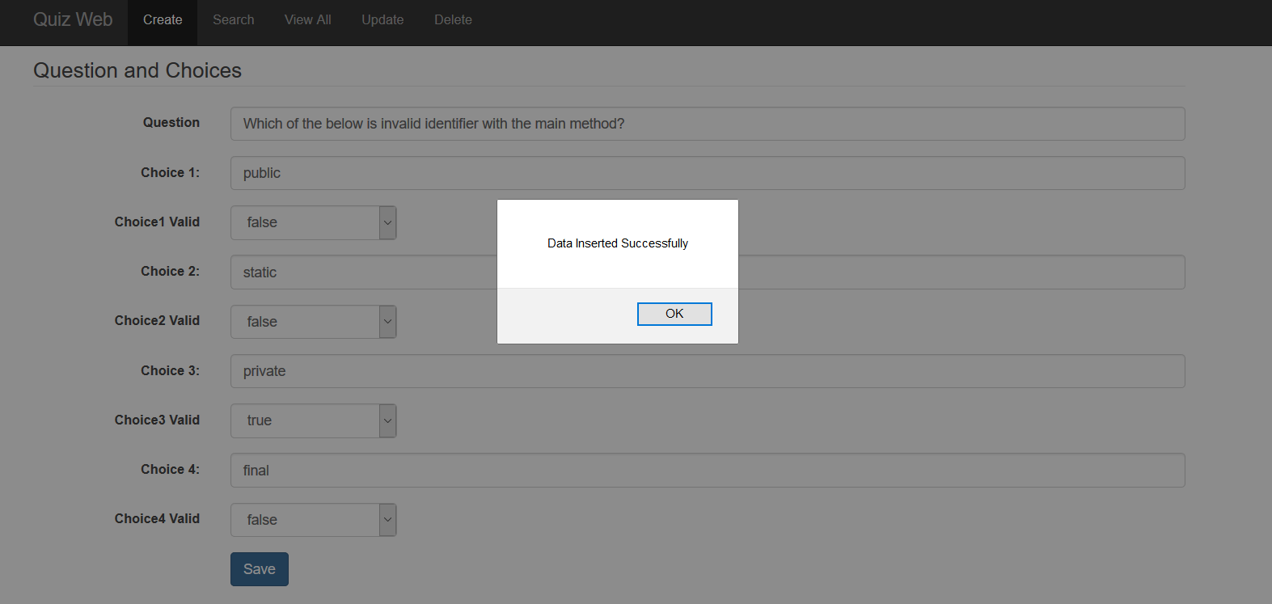

## 4.3 Search operation

4.3.1 For the search operation, the user needs to enter the search string in the Search box.

For example: “main method” as shown in below screenshot.

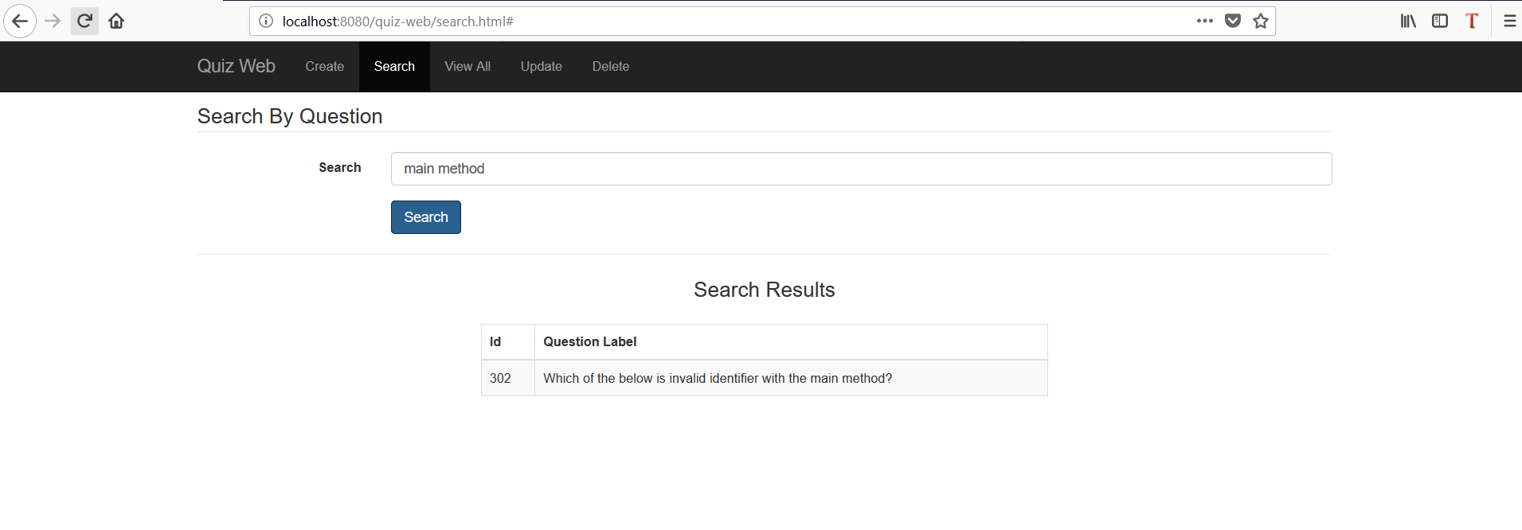

## 4.4 View All operation

4.4.1 This operation will display all the Questions and Answers (MCQ choices).

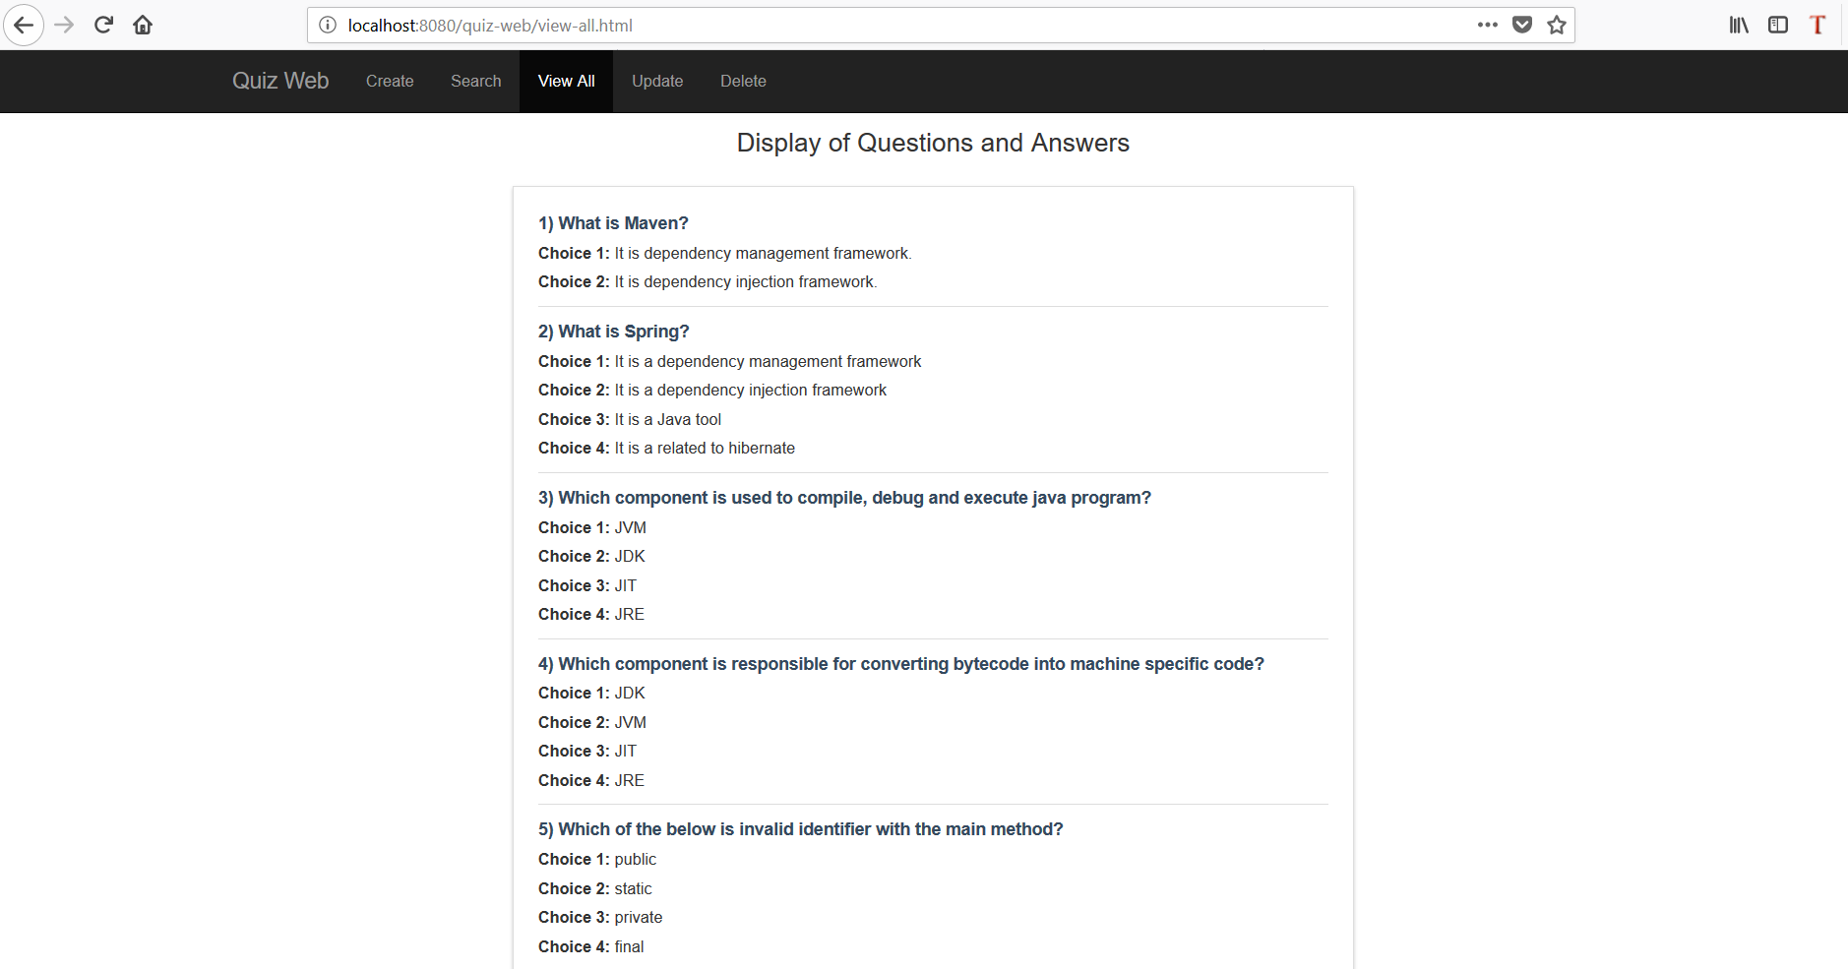

## 4.5 Update operation

4.5.1 The user can use this page to update the Question as well as the MCQ choices as shown in below screenshot.

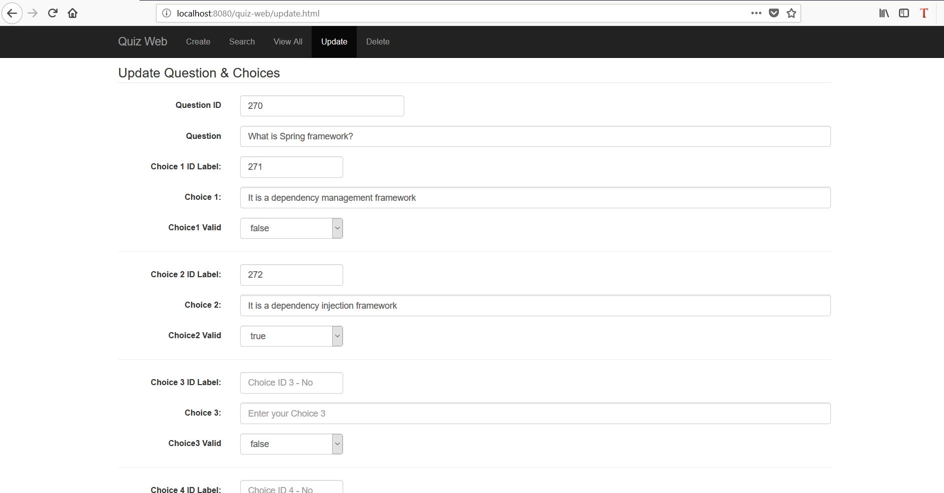

4.5.2 The user can see below alert when the data is updated successfully.

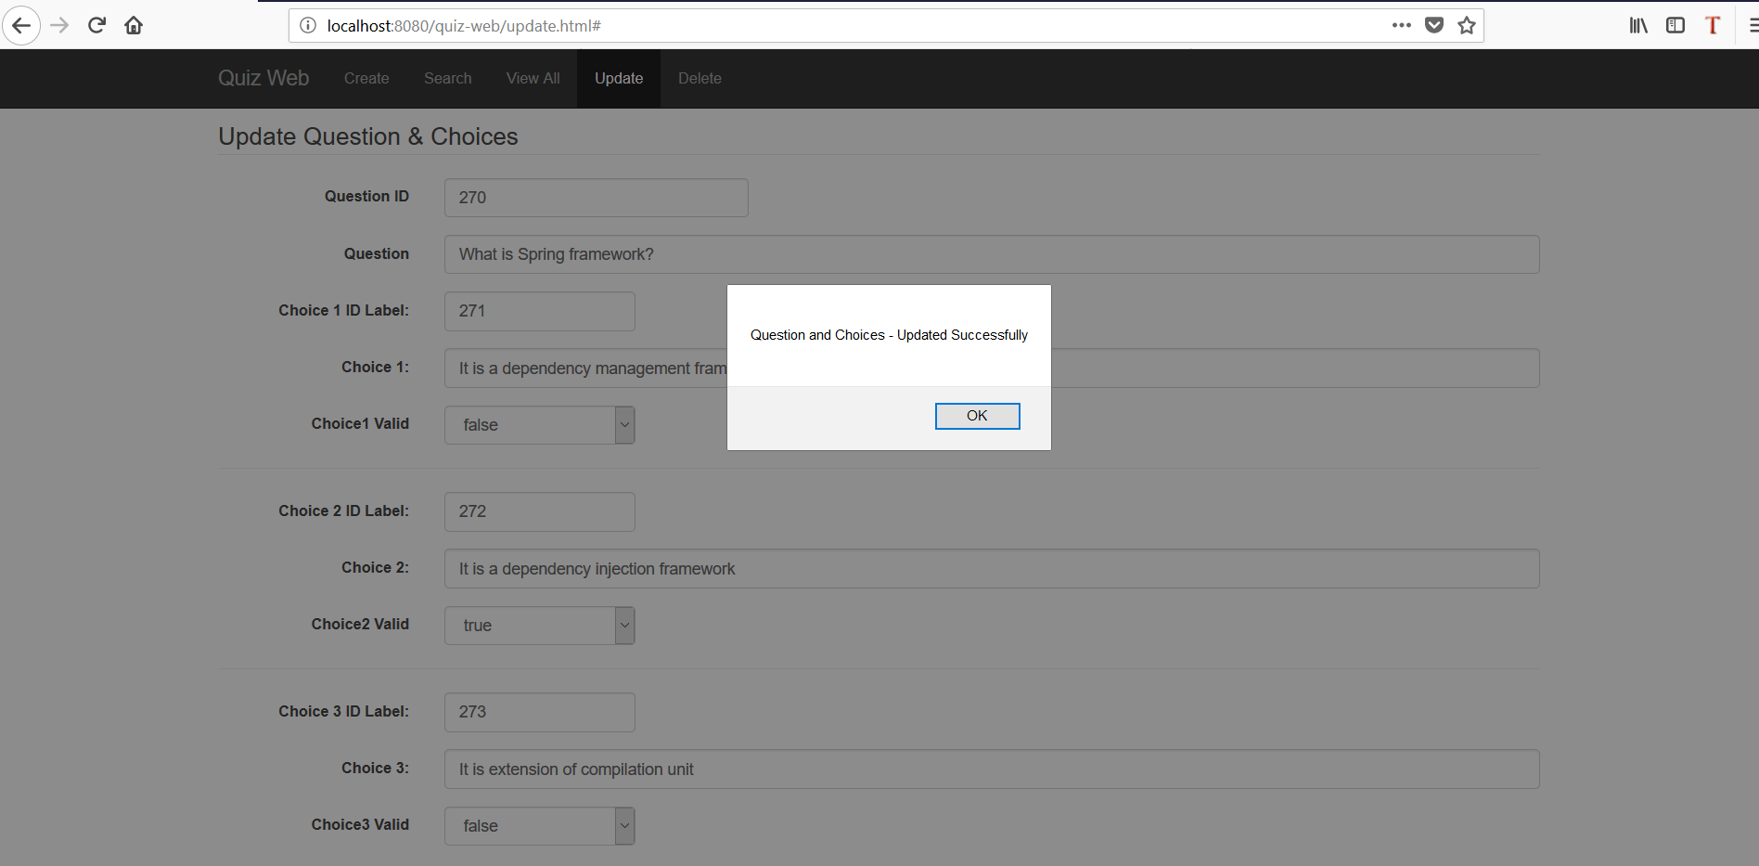

## 4.6 Delete operation

4.6.1 The user can delete the question and the related choice by just giving the question-id in the “ID” field. For example: ID = 302.

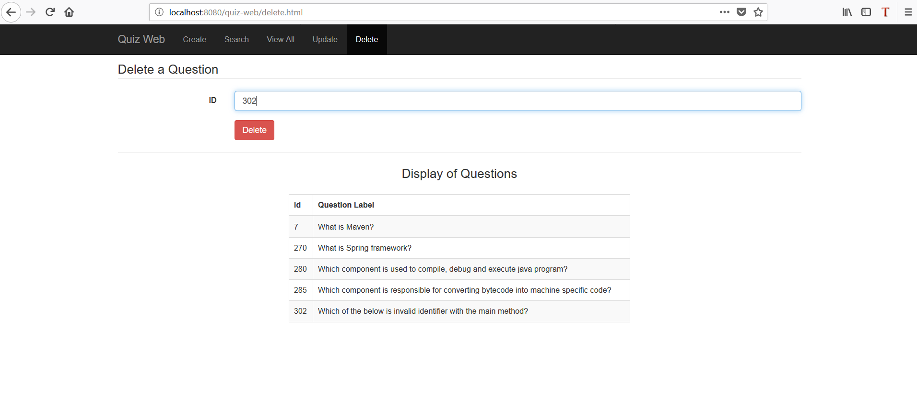

4.6.2 The below alert is shown on successful deletion.

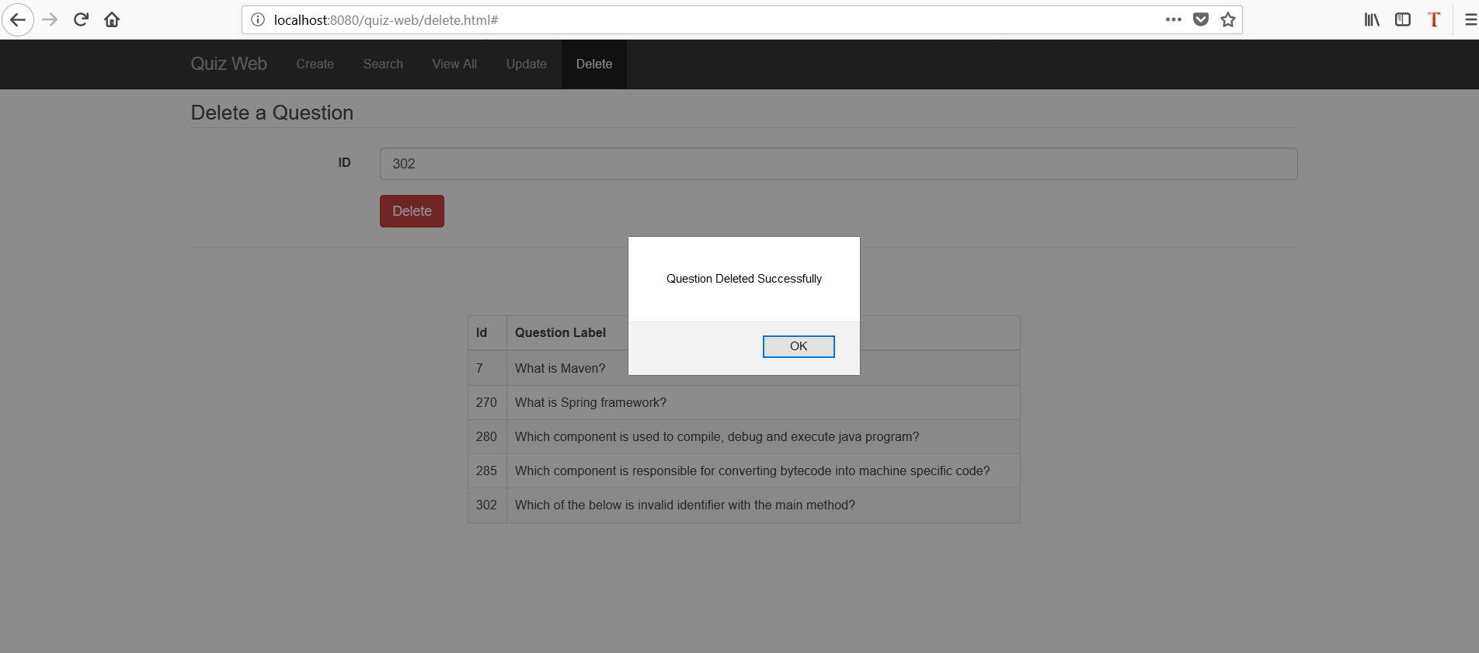

4.6.3 The below screenshot shows that the question with “ID= 302” is deleted successfully by having a look at all the questions in the table.

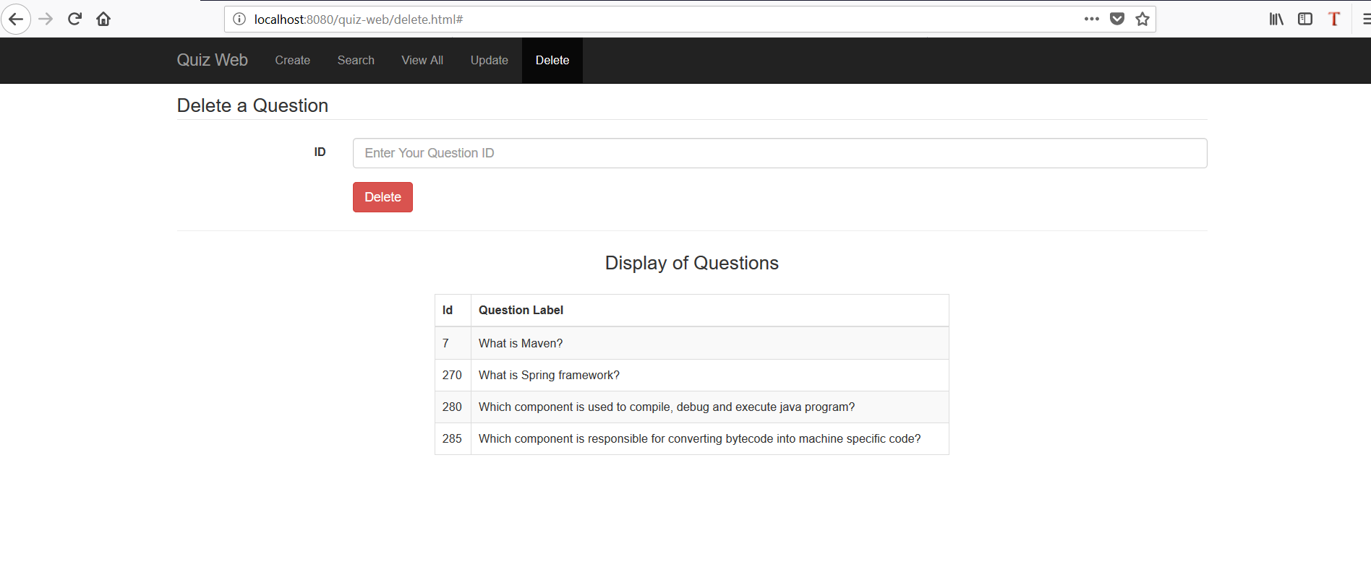

--- END ---