**Quiz – Manager (PHP Application):**

**1) As a student, I can record online an SQL evaluation, so that the trainer will correct it semi-automatically.**

@startuml

== run evaluation ==

Participant Browser

Participant JS

Participant View

Participant Controller

Participant Model

Participant DBMS

Browser -> Controller: GET evaluation-{id}

Controller -> Model: Evaluation::get($id)

Model -> DBMS: SELECT ... FROM evaluation JOIN sql_quiz JOIN quiz_db

DBMS -> Model: rows

Controller -> View: evaluation_view.php must send the trainee_id (taken in the session)

View -> Browser: diagram, title, scheduled_at, ending_at + start button

== start ==

Browser -> Controller: POST sheet-by-{traineeId}-on{evalId}

Controller -> Model: Sheet::update($traineeId, $evalId)

Model -> DBMS: UPDATE sheet ...

Controller -> Model: ...getQuestions($quizId)

Controller -> View: sheet-student.php

View -> Browser: list of questions with form

== answer ==

JS -> Controller: PUT answer-by-{traineeId}-on-{questionId}-for-{evalId}

Controller -> Model: SqlAnswer::update($traineeId, $questionId, $evalId, $answer)

Model -> DBMS: UPDATE sql_answer SET ... WHERE ...

Controller -> JS: status + message

JS -> Browser: feedback

== at any moment ==

Browser -> Controller: my-evaluations

@enduml

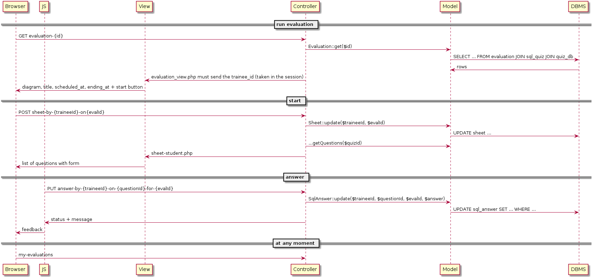

**2) As a trainer, I can list my evaluations recently passed by the students, so that I can see or validate their notes.**

participant Browser  
participant JS  
participant View  
participant Controller  
participant Model  
participant DBMS

View -> Controller: GET all evaluation-{evalId}  
Model -> DBMS: SELECT-{group_id}-{scheduled_at}-{ending_at}-{completed_at} FROM sql_evalution WHERE-{trainer_id}  
Model -> View: list trainer evaluations

== Mark completed ==  
JS -> Controller: PUT-{validated_at}-from-evalution-{evalId}  
Model -> DBMS: execute the query in the related DB  
Model -> DBMS: required trigger to check all copies are corrected or not  
Controller -> JS: 204 ok.

== display list of question and notes for corrected copy ==  
Browser -> JS: GET list of question  
Model -> DBMS: SELECT {evalution_id}-{question_id}-{user_id} FROM evalution-sql_quiz_question-trainee WHERE user_id=trainee_id  
Controller -> Browser: Corrected copies within all list of question

== display the average note ==  
Browser -> Controller: GET average notes-{completed_at}  
Controller -> Model: query to check copies are completed or not  
Model -> DBMS: SELECT ending_at FROM evalution WHERE ...(required trigger to ckeck copies are corrected or not  
Controller -> JS: calculated average notes

== display copies of each student ==  
Browser -> Controller: GET copies of each student-{group_id}  
Model -> DBMS: SELECT {group_id} FROM evalution WHERE ...  
Controller -> Browser: list of students with copies

@enduml

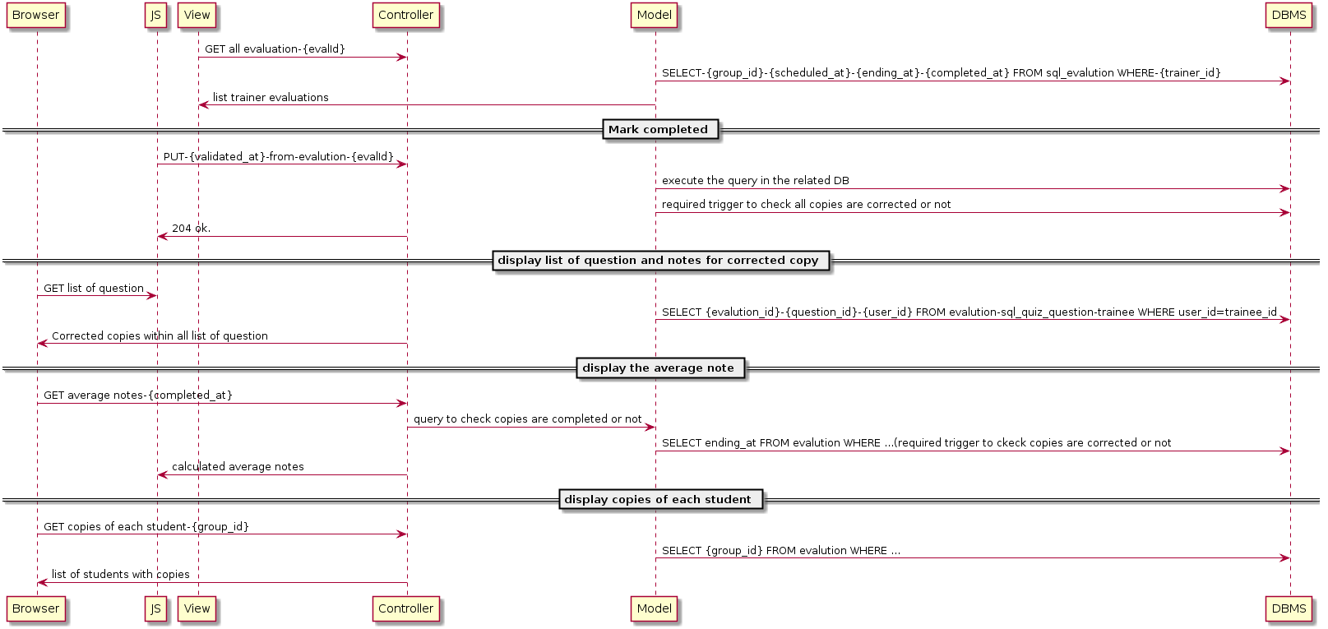

**3) As a trainer, I can correct online a student evaluation, so that I am helped by the application.**

== The complete set of questions is displayed ==

participant Browser  
participant JS  
participant View  
participant Controller  
participant Model  
participant DBMS

View -> Controller: GET all questions{question_id}

Model -> DBMS: SELECT-{*} FROM sql_question WHERE-{trainer_id}-{question_id}

Controller -> Browser: list trainer questions

== If the class evaluation is not completed, I can validate or invalidate any question in the student copy, or I can delay its correction. ==

JS -> Controller: GET copy of evaluation

Model -> DBMS: SELECT {*} FROM {evaluation}...

DBMS -> Controller: GET results of query

Controller -> View: Display query results

JS -> Controller: PUT-{corrected_at}-from-evalution-{evalId}

Model -> DBMS: execute the query in the related DB

Model -> DBMS: required trigger to check all copies are corrected or not

Controller -> JS: 204 ok or transaction complete

== When I validate or invalidate a question, or delay its correction, the change is immediately recorded (if I reload the page, its state remains the same). ==

JS -> Controller: PUT a question status as {validate}-{invalidate}-{delay}

Model -> DBMS: UPDATE sql_quiz_question WHERE {quiz_id}-{question_id}; SELECT FROM { evaluation} WHERE {group_id}-{trainer_id}-{quiz_id}..

DBMS -> Model: GET results of the query

Controller -> Browser: display question status

Controller -> JS: 204 or ok

== The application shows if an answer is considered correct by the application and by myself ==

JS -> Controller: GET correct answer

Controller -> DBMS: SELECT answer FROM sql_answer WHERE {question_id}-{trainee_id}-{evaluation_id}

DBMS -> Controller: Return results of the query

Controller -> Browser: Displaying the correct answer

Controller -> JS: 204 or ok

== The application displays the total student note, according to the correctness rule above ==

JS -> Controller: GET total student note according to the correctness

Model -> DBMS: SELECT SUM(give_correct_result) FROM sql_answer WHERE {trainee_id}+{evaluation_id}

DBMS -> Controller: return results to server

Controller -> JS: Calculated the Total Notes

JS -> Browser: Displaying the total notes computed

== The student copy is marked as completed when and only when I have completed all of its questions ==

JS -> Controller: PUT-{validated_at}-from-evalution-{evalId}

Model -> DBMS: Execute the query in the related DB

Model -> DBMS: Execute the required trigger to check if all copies are corrected or not

Server -> JS: Return 204 if ok else the necessary error code

== A click on a question displays the page correcting this question, all students included (see next feature) ==

Browser -> Controller: GET copies of questions for each student-{group_id}{evaluation_id}{question_id}{trainee_id}

Model -> DBMS: SELECT {group_id}+{evaluation_id}+{question_id}+{trainee_id} FROM evalution WHERE ...

DBMS -> Controller: Return results of the query

Controller -> Browser: list of questions for each student

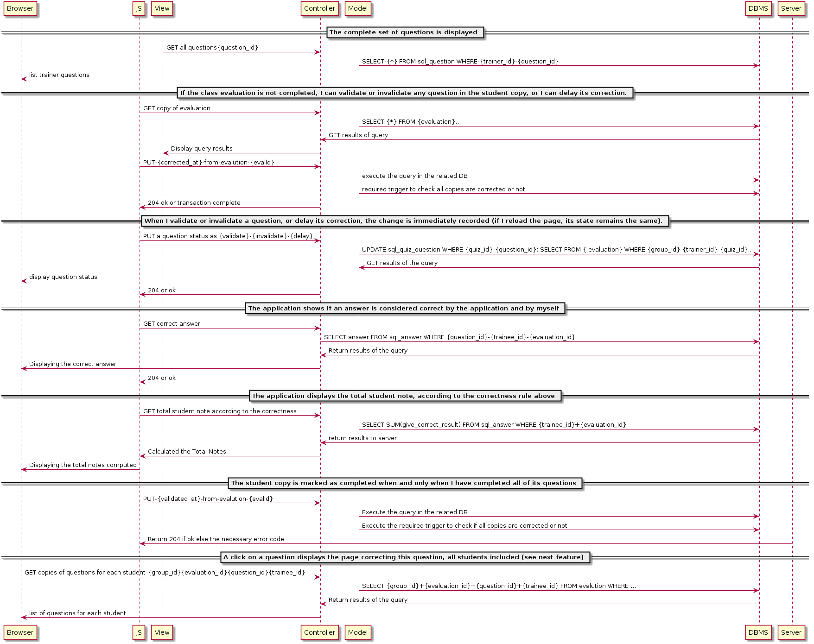

**4) As a trainer, I can correct online a question, all students included, in order to be equitable for all students and concentrated on the question.**

@startuml

participant Browser

participant JS

participant View

participant Controller

participant Model

participant DBMS

== All the Questions ==

View -> Controller: GET all the questions-{question_id}

Model -> DBMS: SELECT-{question_id}-{question_name} from question

DBMS -> Model : Fetches the list of questions

Controller -> View: Displays the list of questions

== Answers for the Question ==

View -> Controller: GET all the answers-{question_id}

Model -> DBMS: SELECT-{question_id}-{valid_answer} from answers

DBMS -> Model : Fetches the list of valid Answers

Controller -> View: Displays the list of valid answers for the question

== Sheet and student mapping ==

View -> Controller: GET sheets for the student-{user_id}

Model -> DBMS: SELECT-{sheet_id}-{user_id}-{result} from sheet where user_id={user_id}

DBMS -> Model : Fetches the sheet with answer and results.

Controller -> View: Displays the sheet with answer and results.

== Validate or Invalidate ==

JS -> Controller: PUT sheet {sheet_id}-{question_id}-{valid_flag=SET/RESET}

Model -> DBMS: UPDATE sheet_id, question_id with the details and store the data

Controller -> View: Returns Updated sheet

@enduml